In maintaining a functional democratic society, should suffrage be considered a civic right or responsibility?
Content | This instructional task engages students in content related to the following grade-level expectations:  - C.5.1: Distinguish between personal, political, and economic rights of citizenship  - C.5.2: Differentiate between civic duties and responsibilities, including various forms of civic  participation  - C.5.3: Describe how civil rights have evolved over time to include diverse groups of citizens
Claims | In this instructional task, students develop and express claims through discussions and writing which they examine how citizens can participate responsibly and effectively in American civic and political life to catalyze a successful democratic society.
Unit Connection | This instructional task helps students explore and develop claims around the content from unit 4:  - How are the rights, responsibilities, and duties of citizens similar and different? (C.5.1, C.5.2)  - How does informed citizenship support democratic government? (C.5.2)  - How have civil rights evolved over time for different groups? (C.5.3)
Supporting Question 1 |  |  |  | Supporting Question 2 |  | Supporting Question 3 |  | Supporting Question 4
What would be the purpose of former First Lady Roosevelt arguing these four basic rights? |  |  |  | How has the idea and application of universal suffrage evolved in American society? |  | What segments of society have the lowest voter turnout? |  | What are basic components of democracy?
12 Formative  Performance Task |  |  |  | Formative  Performance Task |  | Formative  Performance Task |  | Formative  Performance Task
Students will read, determine, and discuss the four basic rights outlined by Eleanor Roosevelt. |  |  |  | Students will create a timeline which portrays the evolution of suffrage for minority groups in America. |  | Students will interpret and analyze data to determine which segments of society are not active in their civic duties and draw conclusions as to how this affects democracy. |  | Students will analyze the reading to draw differences between governments in place in Europe and the United States.
Featured Source |  |  |  | Featured Source |  | Featured Source |  | Featured Source
Source A: Four Basic Rights, 1944, Eleanor Roosevelt |  |  |  | Source B: The Fight for the Right to Vote in the United States, TED-Ed |  | Source C: Who Votes and Who Doesn’t? (pages 13-15), ETS |  | Source D: “Democracy in America”, Alexis de Tocqueville, vol. 1, Ch. 13, Part I, read up to the section titled “Influence which the American Democracy has exercised on the laws relating to election”
Summative  Performance Task |  | Suffrage is an essential aspect of a functional democracy. However, voter turnout is habitually low in elections. Using the sources and your knowledge of civics, write a letter to a political figure in which you argue whether or not suffrage should be considered a civic right or responsibility in order to maintain a functioning democratic society.

Formative Performance Task 1
Supporting  Question | Why would be the purpose of former First Lady Roosevelt arguing these four basic rights?
Formative Performance Task | Students read, determine, and discuss the four basic rights outlined by Eleanor Roosevelt.
Featured Source | Source A: Four Basic Rights, 1944, Eleanor Roosevelt
Content and Claims | In this formative performance task, students read and analyze the letter from former First Lady Eleanor Roosevelt to gain insight of the four basic rights of every citizen in a democracy. (C.5.2, 5.3)

Featured Source

Source A: Four Basic Rights, 1944, Eleanor Roosevelt
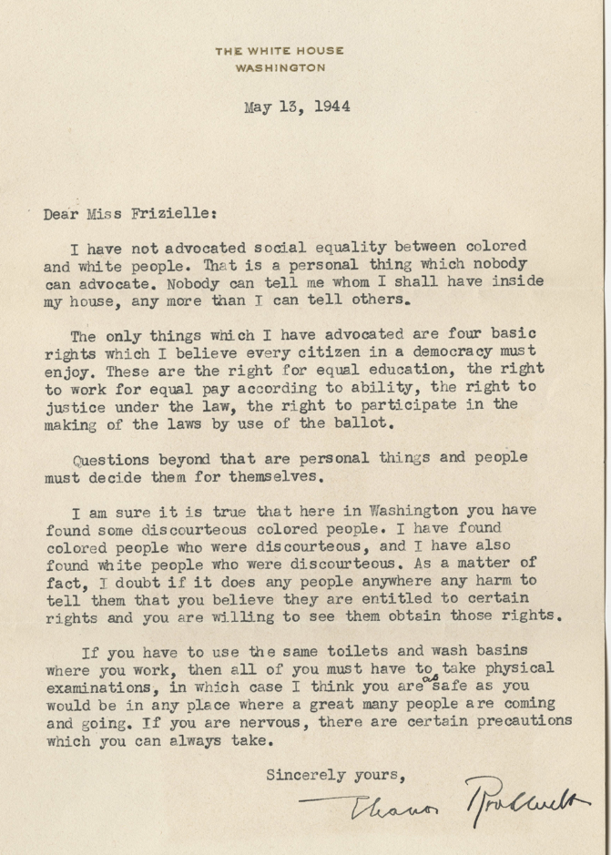

Steps
- Present students with the document for independent reading.
- With a partner, students complete a graphic organizer by writing, in their own words, the four basic rights outlined by Eleanor Roosevelt. A sample graphic organizer is included below.
- With their partner, students will choose one of the four rights they believe is most important to a functioning democratic society and explain why.
- Conduct a discussion about what it means for something to be inevitable. Some focus questions to guide the discussion include:
- Who wrote this document? When was it written? Is this a primary or
secondary source? What else is going on in America at the time this letter was written
(socially and politically)?
- Ensure students understand the meaning of difficult words like: advocate, justice,
ballot, democracy, discourteous/courteous, and precautions.
- Ask students to explain which of the four basic rights they believe is most important in a
democratic society. Facilitate discussion amongst students to defend their stances.
- How can the “right to equal education” build a foundation for active citizens?
- To what extent does the “right to work for equal pay” effect different minority groups? In
particular, which groups would have advocated for equal pay?
- Do these minorities receive equal pay for equal work today? Justify your reasoning.
- Why would Eleanor Roosevelt mention the “right to justice under the law”? Looking at
the date this letter was written, what else is going on that would prompt her to mention
this right?
- Based off prior knowledge, what forms of discrimination did “colored people” face in the United States?
- Why did Eleanor Roosevelt, in her answer to Miss Frizielle, distinguish between public discrimination
and personal/social interaction between races?

Eleanor Roosevelt’s Four Basic Rights, 1944
1
2
3
4

Student Look-Fors
- In the graphic organizer, student responses should identify the four basic rights. A sample completed graphic organizer is included below.
Eleanor Roosevelt’s Four Basic Rights, 1944
1 | equality in education
2 | working for equal pay
3 | equality and fairness under the laws
4 | right to vote so people can have a say in laws being made

- Student engagement in the discussion should include (but not limited to) the following:
  - Author: Eleanor Roosevelt, Date: May 13, 1944, Source: Primary, Historical Context: World War II, beginning stages of the Civil Rights Movement
  - Better educated citizens are generally more informed and politically active, citizens are more interested in politics, etc.
  - May elude to poll taxes placed on African American
  - Groups that may have advocated for equal pay: African Americans, women, Latinos, etc.
  - Students should be able to justify their opinion on whether or not minorities receive equal pay for equal work (Yes- students may reference affirmative action; No- arguments may vary)
  - Students may mention other things happening at this time that are impacting the “right to justice under the law”:
    - unjust rulings in Civil Rights cases (Plessy v. Ferguson)
    - making reference to Jim Crow Laws
    - Executive Order 8802
    - Smith v. Allwright
    - Race riots occurring
    - Discrimination
    - segregation

Formative Performance Task 2
Supporting Question | How has the idea and application of universal suffrage evolved in American society?
Formative Performance Task | Students create a timeline which portrays the evolution of suffrage in America.
Featured Source | Source B: The Fight for the Right to Vote in the United States, TED-Ed
Content and Claims | In this formative performance task, students view a video and create a timeline to increase their understanding on how the ideals of universal suffrage have evolved in the United States over time. (C.5.1)

Featured Source
Source B: The Fight for the Right to Vote in the United States, TED-Ed

Steps
- Before watching the video, provide students with the supporting question. Allow them 5-10 minutes to brainstorm their ideas using prior knowledge.
- View the video.
- Provide the students with the timeline below and have them record and describe important suffrage information at each date.

Suffrage Timeline

Student Look-Fors
- After viewing the video, students should be able to record important suffrage events on their timeline.

Formative Performance Task 3
Supporting  Question | What segments of society have the lowest voter turnout?
Formative Performance Task | Students interpret and analyze data to determine which segments of society are not active in their civic duties and draw conclusions as to how this affects democracy.
Featured Source | Source C: Who Votes and Who Doesn’t? (pages 13-15), ETS
Content and Claims | In this formative performance task, students interpret data to determine which segments of society have low voter turnout and recognize patterns of factor contributing to low voter turnout. (C.5.2, C.5.3)

Featured Source
Source C: Who Votes and Who Doesn’t? (pages 13-15), ETS
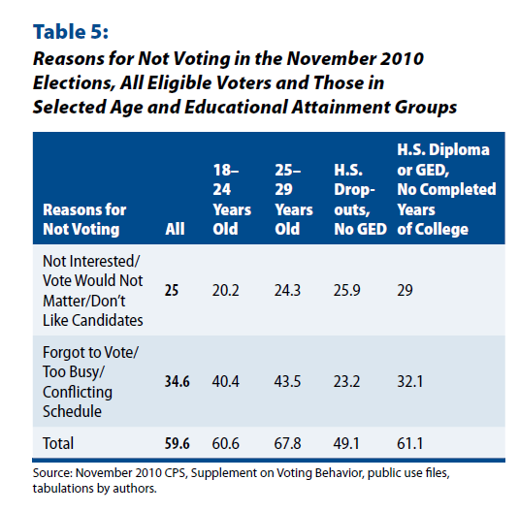

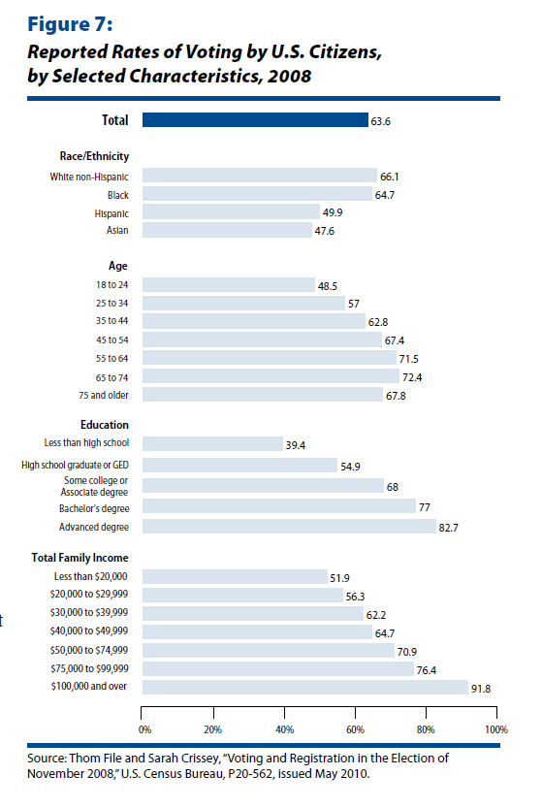

Steps
- Give students time to read and analyze each table on their own. Be sure to point students’ attention to titles and dates.
- Have students record their answer to the following questions independently.
Table 5:
  - In the November 2010 election, which reason for not voting was the highest?
  - Of all those who did not vote, what percentage made up the ones who were high
school drop outs with no GED?
  - Create a list of three ways to increase voter turnout in elections and explain why this
strategy would be effective.
Figure 7:
- What total percentage of the population voted in 2008?
- Which ethnicity had the highest percentage of voter turnout?
- Which age group had the highest percentage of voter turnout?
- Which degree level had the highest percentage of voter turnout?
- Which total family income had the highest percentage of voter turnout?
- For each category (ethnicity, age, degree, and family income) make one prediction as to why the group with the highest percentage turnout was more likely to vote.

Student Look-Fors
1. After interpreting the data, students should be able to recognize factors contributing to low voter turnout. Some examples include:
  - low levels of education
  - low socio-economic status
  - age
- Students should also be able to determine the two leading factors of reasons why citizens do not vote are apathy and scheduling/timing conflicts.

Formative Performance Task 4
Supporting  Question | What are basic components of democracy?
Formative Performance Task | Students analyze the reading to draw differences between governments in place in Europe and the United States.
Featured Sources | Source D: “Democracy in America”, Alexis de Tocqueville, vol. 1, Ch. 13, Part I, read up to the section titled “Influence which the American Democracy has exercised on the laws relating to election”
Content and Claims | In this formative performance task, students analyze the perceptions of democracy in both Europe and America.

Featured Sources
Source D: “Democracy in America”, Alexis de Tocqueville, vol. 1, Ch. 13, Part I, read up to the section titled “Influence which the American Democracy has exercised on the laws relating to election”

Steps
- Provide students with access to the excerpt to read.
- Model annotation strategies with your students to facilitate their reading comprehension.
- As students read, have them annotate the text using the following protocol:
  - BOX unknown words
  - UNDERLINE important information
  - CIRCLE action verbs
  - Denote with a “?” unclear ideas
  - Pencil in the margins thoughts and connections
- After reading and annotating, have students list with a partner the defining characteristics/components of democracy.
- Then, have students compare and contrast the differences in American democracy and European democracy using a graphic organizer such as a Venn diagram. A sample Venn diagram is included below.

Compare and Contrast: European and American Democracies

Student Look-Fors
- Students should identify the defining characteristics/components of democracy. Possible Responses (but not limited to):
  - universal suffrage
  - natural course
  - choices made by the people
- Students should compare and contrast the differences in American democracy and European democracy. A sample completed Venn diagram is included below.

- lower classes tend to envy higher classes
- fosters a passion for equality
- systems for elections

- unrestricted activity
- reign without obstacle
- universal suffrage
- “able” men not always at the forefront of affairs

  - conflicting principles (principles of democracy v. passion for democracy)
- despotic (in France specifically)

Summative Performance Task
Compelling Question | In maintaining a functioning democratic society, should suffrage be considered a civic right or responsibility?
Summative Performance Task | Suffrage is an essential aspect of a functional democracy. However, voter turnout is habitually low in elections. Using the sources and your knowledge of civics, write a letter to a political figure in which you argue whether or not suffrage should be considered a civic right or responsibility in order to maintain a functioning democratic society.

Teacher Overview
In this summative performance task, students are asked to write a response to the compelling question using evidence from the sources they explored throughout the four formative performance tasks.
Throughout this instructional task, students have explored the role of civic rights and responsibilities within a functional democracy; this information will be an essential part of a well-developed essay. Before the summative performance task, it may be helpful for students to review the sources provided and the writing/graphic organizers created during the formative assessment tasks. Doing so should help them to develop their interpretations and to highlight the appropriate examples and details to support their arguments.

Student Prompt
Suffrage is an essential aspect of a functional democracy. However, voter turnout is habitually low in elections. Using the sources and your knowledge of civics, write a letter to a political figure in which you argue whether or not suffrage should be considered a civic right or responsibility in order to maintain a functioning democratic society.

Student Look-Fors
- Student responses should indicate that they have gleaned appropriate content from each of the sources from the formative assessment tasks:
  - Source A: The four basic rights outlined by former First Lady Eleanor Roosevelt are: right to equal education, the right to work for equal pay according to ability, the right to justice under the law, and the right to participate in the making of the laws.
  - Source B: In the United States, suffrage was only granted to white, male landowners. Gradually suffrage was extended to white males and then all males. However, African American males were still faced with obstacles when voting which hindered their participation. Women were then granted the right to vote in 1920. In conjunction with the Civil Rights era, African Americans were granted truly full suffrage with the passage of the Voting Rights Act of 1965.
  - Source C: The portion of the population most likely to not vote exhibits the following characteristics: low income, between the ages of 18-25, low level of education, and/or of Asian descent.
  - Source D: Universal suffrage is required to make democracy successful.

- Student responses should pull in relevant information beyond that present in the sources to support their claim. Some examples of outside information include:
  - Difference in civic rights and responsibilities
  - Reference to rights granted under the Bill of Rights
  - Reference to Supreme Court Cases Plessy v. Ferguson and/or Brown v. Board of Education.
  - Racial and gender discrimination (politically)
  - Reference to 15th and 19th Amendments

