How do I affect the world around me?
Content | This instructional task engages students in content related to the following grade-level expectations:  - 1.3.7 Explain ways in which people rely on the environment to meet the basic human needs of food, clothing, and shelter  - 1.3.10 Predict ways human actions impact the environment
Claims | In this instructional task, students develop and express claims through discussions and writing which explain how people use and impact the environment.
Unit Connection | This instructional task helps students explore and develop claims around the content from unit 4:  - How do people impact the environment? (1.3.10)
Supporting Question 1 |  |  | Supporting Question 2 |  | Supporting Question 3 |  | Supporting Question 4
Why is it important to keep water clean? |  |  | How does trash sometimes end up in the ocean? |  | How does pollution in the oceans caused by humans hurt marine life? |  | What actions can be taken to help clean the oceans?
Formative  Performance Task |  |  | Formative  Performance Task |  | Formative  Performance Task |  | Formative  Performance Task
Students will recognize that people need fresh clean water for survival. |  |  | Students will identify patterns of how trash ends up in the ocean and how this impacts the water environment. |  | Students will justify the importance of protecting the water in which humans and animals rely upon. |  | Students will differentiate ways in which people impact the environment.
Featured Source |  |  | Featured Source |  | Featured Source |  | Featured Source
Source A: “A Clean Drink of Water,” ReadWorks |  |  | Source B: “Garbage in the Ocean,” ReadWorks |  | Source C: “Our Debris is filling the Sea,” National Ocean Service |  | Source D: Polluted Oceans, National Geographic
Summative  Performance Task | Using the sources and your knowledge of water pollution, write a letter to a friend. In your letter, explain how the beach in the image was impacted by people. What is one action people can take to make the beach cleaner?  Source E: Source Pollution, NOAA

Formative Performance Task 1
Supporting Question | Why is it important to keep water clean?
Formative Performance Task | Students will recognize that people need fresh clean water for survival.
Featured Source | Source A: “A Clean Drink of Water,” ReadWorks
Content and Claims | This formative task requires students to explain how people are dependent upon water for survival and some people do not have access to clean, fresh drinking water. (1.3.7)

Featured Source

Source A: “A Clean Drink of Water,” ReadWorks

Steps
- With a partner, have students read “A Clean Drink of Water.”
- Conduct a class discussion about the key details in the passage. During the discussion, create class “notes” (i.e., charts) to track student responses. Students can use these notes as the complete the written task. Possible guiding questions include:
  - How does the environment help to support our basic needs?
  - What are some ways in which people can help save the environment from trash and waste?
  - Why is it important that we take care of the environment?
  - Why is it necessary to have clean water provided by the environment?
- Have students write a minimum of 3 sentences to explain the problem faced by the people in South America the solution, and if the solution was effective.

Student Look-Fors
- Student responses show an understanding that people need fresh, clean water to drink.
  - Students are able to list multiple uses for water (cooking, cleaning, drinking, bathing, etc.)
  - Students understand that not all people in the world have access to clean fresh water on a daily basis.
  - Student responses clearly explain the necessity of clean water.
  - Written response should follow English Language Arts standards for written expression at 1st grade level.
- Student exemplar: Many people in South America do not have clean drinking water. Clean water is important because it is needed to drink and cook. It is also needed to bath. People sent empty tanks to help them catch clean rainwater. This has helped them to get the clean water they need.
Formative Performance Task 2
Supporting Question | How does trash sometimes end up in the ocean?
Formative Performance Task | Students will identify patterns of how trash ends up in the ocean and how this impacts the water environment.
Featured Source | Source B: “Garbage in the Ocean,” ReadWorks
Content and Claims | In this formative performance task, students discuss how trash ends up in the ocean and what can be done to minimize this from happening. (1.3.10)

Featured Source
Source B: “Garbage in the Ocean,” ReadWorks

Steps
- Read “Garbage in the Ocean” aloud to the class.
- Conduct a discussion about the key details in the passage. During the discussion, create class “notes” (i.e., charts) to track student responses. Some sample questions for discussion:
  - Impact means to change or to effect. In this passage, how does people impact the ocean?
  - How does garbage end up in the ocean?
  - What is a garbage patch?
  - How does a gyre become a garbage patch?
  - Look at the picture. How does the garbage affect the land as well as the ocean?
- As a class, write a paragraph that describes the process for how trash ends up the in the ocean and its effects on animals.

Student Look-Fors
- Students are able to orally make a claim on how people have impacted the environment through litter and garbage, supported with grade level appropriate evidence.
- Student has presented information appropriate to first grade skills and standards in written expression, and speaking and listening skills.

Formative Performance Task 3
Supporting Question | How does pollution in the oceans caused by humans hurt marine life?
Formative Performance Task | Students will justify the importance of protecting the water in which humans and animals rely upon.
Featured Source | Source C: “Our Debris is filling the Sea,” National Ocean Service
Content and Claims | This formative performance task requires students to apply knowledge of water pollution to determine negative effects to people and animals. (1.3.10)

Featured Source
Source C: “Our Debris is filling the Sea,” National Ocean Service

Steps
- Watch the video “Our Debris is filling the Sea.”
- Conduct a class discussion about the key details in the passage. Possible guiding questions include:
  - What is debris? Give some examples of debris you see in your everyday life.
  - How are oceans becoming polluted?
  - List the ways polluted oceans affect the lives of people and different animals?
  - How can we preserve the ocean habitats?
- Give each student or group of students an animal that lives in or near water. Have each group discuss how that animal depends on the ocean and how garbage could harm them. Have each group of students create a picture of their animal and how it is affected by pollution. Have each group to share their picture with the class and have to them to explain how their drawing reflects that animal being impacted by pollution.

Student Look-Fors
- Students make claims appropriate to how an animal is being harmed due to pollution (trapped in nets, eating plastic, poison, etc.)
- Students support claim with specific evidence from source document.
- Drawings should clarify ideas, thoughts, and feelings about how the animals are affected by pollution.

Formative Performance Task 4
Supporting Question | What actions can be taken to help clean the oceans?
Formative Performance Task | Students will differentiate ways in which people impact the environment both negatively and positively.
Featured Sources | Source D: Polluted Oceans, National Geographic
Content and Claims | In this formative performance task, students explore various ways in addition to litter that people pollute the oceans. (1.3.10)

Featured Sources
Source D: Polluted Oceans, National Geographic

Steps
- Show students the source photographs.
- Have a class discussion in which students explain how the environment is being affected by people. Possible guiding questions include:
  - What things do you notice about the environment?
  - In what ways has the environment been impacted?
  - What are the people doing in the picture? Are they helping or hurting the environment?
- Have students draw two pictures. The first picture illustrates one way people help the environment and the second picture illustrates one way people hurt the environment. Then have students write at least 2 sentences to describe each picture and explain how people can help and hurt the environment.

Student Look-Fors
- Students should be able to clearly express an understanding of one way people help and hurt the oceans
  - Pollution comes from trash, litter, oil spills, etc.
  - People can help by picking up the trash, helping to save animals, working to clean beaches, etc.
- Written response should follow English Language Arts standards for written expression at 1st grade level.

Summative Performance Task
Compelling Question | How do I affect the world around me?
Summative Performance Task | Using the sources and your knowledge of water pollution, use evidence from the image to write a letter to a friend explaining how the current condition of this beach was impacted by people, the effects to both people and animals, and at least one course of action to correct the current situation.
Featured Sources | Source E: Source Pollution, NOAA

Teacher Overview
In this summative performance task, students are asked to write a letter using evidence from the sources they explored throughout the four formative performance tasks.
Throughout this instructional task, students have explored how people impact the world around them; this information will be an essential part of a well-written letter. Before the summative performance task, it may be helpful for students to review the sources provided and the writing/graphic organizers created during the formative assessment tasks. Doing so should help them to develop their interpretations and to highlight the appropriate examples and details to support their writing.

Student Prompt

Review the image of the beach in source E.
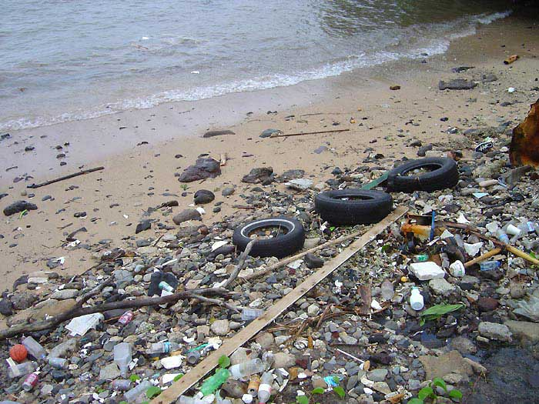

Write a letter to a friend. In your letter, answer the following questions:

How was the beach in this picture impacted by people?

How might the pollution on the beach hurt people and animals?

What is one action your friend can take to make the beach a better place?

Student Look-Fors
- Scoring Notes
- Student response should reflect on how people have impacted the beach in the image.
- The letter should also reflect upon how people and animals depend upon the ocean.
- At least one plan of action should be described to help reverse the pollution (clean up, pass new laws, help animals caught in trash, recycle more, etc.)
- Student has provided impacts that are logical for first grade.
- Written response should follow English Language Arts standards for written expression at 1st grade level.
- A strong response:
  - References documents appropriately
      - People need clean, fresh water to live. People use water for drinking, cooking, bathing. (Source A)
      - Garbage from land often ends up in the ocean. (Source B and C)
      - Garbage in the ocean hurts the environment because animals become sick or hurt by the trash. (Source B, C, and D)

  - Applies the provided evidence as well as additional information about how people impact the environment
    - Students may discuss other ways animals and people are negatively impacted by pollution in ocean (people can get sick, no healthy seafood to eat, etc.)

