Assurance Schedules
Contact List

Schedule | Contact Information
1 | Paula.Matherne@la.gov
2 | Michael.Zanovec@la.gov
3 | Michael.Zanovec@la.gov
4 | Michael.Zanovec@la.gov
5 | Michael.Zanovec@la.gov
6 | LDEdata@la.gov
7 | Kristina.Bradford@la.gov
8 | N/A
9 | Kristina.Bradford@la.gov

Schedule 1: General Fund Instructional and Support Expenditures and
Certain Local Revenue Sources for the Year Ended June 30, 2014-2015
General Fund Instructional and Support Expenditures
and Certain Local Revenue Sources
For the Year Ended June 30, 2014-2015
 |  | Column A |  | Column B
General Fund Instructional and Equipment Expenditures
General Fund Instructional Expenditures:
Teacher and Student Interaction Activities:
Classroom Teacher Salaries |  | $XXX
Other Instructional Staff Activities |  | XXX
Instructional Staff Employee Benefits |  | XXX
Purchased Professional and Technical Services |  | XXX
Instructional Materials and Supplies |  | XXX
Instructional Equipment |  | XXX
Total Teacher and Student Interaction Activities |  |  |  | $XXX
Other Instructional Activities |  |  |  | XXX
Pupil Support Services |  | XXX
Less: Equipment for Pupil Support Services |  | XXX
Net Pupil Support Services |  |  |  | XXX
Instructional Staff Services |  | XXX
Less: Equipment for Instructional Staff Services |  | XXX
Net Instructional Staff Services |  |  |  | XXX
School Administration |  | XXX
Less: Equipment for School Administration |  | XXX
Net School Administration |  |  |  | XXX
Total General Fund Instructional Expenditures (Total of Column B) |  |  |  | $XXX
Total General Fund Equipment Expenditures (Object 730; Function Series 1000-4000) |  |  |  | $XXX
Certain Local Revenue Sources
Local Taxation Revenue:
Constitutional Ad Valorem Taxes |  |  |  | $XXX
Renewable Ad Valorem Tax |  |  |  | XXX
Debt Service Ad Valorem Tax |  |  |  | XXX
Up to 1% of Collections by the Sheriff on Taxes Other than School Taxes |  |  |  | XXX
Sales and Use Taxes |  |  |  | XXX
Total Local Taxation Revenue |  |  |  | $XXX
Local Earnings on Investment in Real Property:
Earnings from 16th Section Property |  |  |  | $XXX
Earnings from Other Real Property |  |  |  | XXX
Total Local Earnings on Investment in Real Property |  |  |  | $XXX
State Revenue in Lieu of Taxes:
Revenue Sharing - Constitutional Tax |  |  |  | $XXX
Revenue Sharing - Other Taxes |  |  |  | XXX
Revenue Sharing - Excess Portion |  |  |  | XXX
Other Revenue in Lieu of Taxes |  |  |  | XXX
Total State Revenue in Lieu of Taxes |  |  |  | $XXX
Nonpublic Textbook Revenue |  |  |  | $XXX
Nonpublic Transportation Revenue |  |  |  | $XXX
Schedule 2: Education Levels of Public School Staff
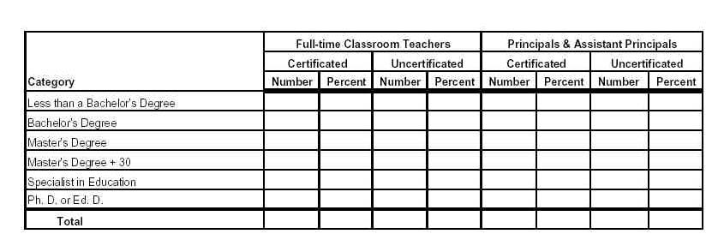

Note 1: Prorated headcounts should be used to reflect employees who are performing multiple functions. Instructions for calculating prorated headcounts may be found on the LDOE Website in the Evolution/Calculation of PEP-Based Salary Averages http://www.louisianabelieves.com/resources/library/data-center under Evolution Calculations of PEP-Based Salary Averages

Note 2: October 1, 2014 PEP data should be used to prepare this schedule. You can find your district’s total number of principals, assistant principals, and full time classroom teachers within the latest Summary of Reported Personnel, available from the INSIGHT Portal (see the end of this document for directions to that feature.)
Note 3: For auditing purposes, Districts should provide their outside auditors with a listing (containing all relevant data) of the employees that went into development of Schedule 2.

Guidance on how to develop Schedule 2:

AFSR Cross-reference: Section II, Item 16, produced by:

1. Input File: October Profile of Educational Personnel (PEP) file (after all corrections).

2. Exclusions:

a. Exclude any records identified by LDOE edits as containing error(s) or for employees identified as being on sabbatical leave as of the reporting date (sabbatical code 1 or 3 in Staff Record).

b. Exclude any records for post-secondary, contracted services, and/or third-party contract employees (employee status code = 02, 03, or 04 in Staff Record). Note: Direct employees of Type 1, 3, and 4 charter schools are considered/reported as school board employees (status code = 01) by the 'parent' or chartering school district through which the charter school's state funding flows.

2. Selection:

a. Exclude any records identified by LDOE edits as containing error(s) or for employees identified as being on sabbatical leave as of the reporting date (Code 1 or 3 in Staff Record).

b. Select only from school district and or state employee records (i.e., employee status code = 01, 05 or 06, including employees of the district's Type 1, 3, or 4 charter schools); and

c. Select all error-free/non-sabbatical Principals (object-function: 111-2410) and Assistant Principals (object-function: 111-2420); and

d. Select only full-time/error-free/non-sabbatical Classroom Teachers (object-function: 112-1000 series, with type employee = F).

3. Process: Generate the sum of *prorated headcounts of Principals, Assistant Principals, and full-time Classroom Teachers with subtotals by:

a. PEP teaching certificate field either contains entry (i.e., w/certificate) or is blank (w/o certificate); and

b. Breakdown of PEP education level code by:
1) 12 = Doctorate
2) 11 = Specialist in Education
3) 10 = Master's Degree + 30
4) 09 = Master's Degree
5) 08 = Bachelor's Degree
6) 01-07 = Less Than Bachelor's Degree

*Prorated headcounts can be found from http://www.louisianabelieves.com/resources/library/data-center under Teacher Salaries + Headcounts

Schedule 3: Number and Type of Public Schools
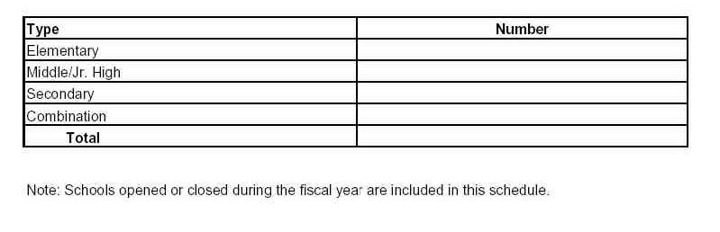Schedule 4: Experience of Public Principals, Assistant Principals, and Full Time Classroom Teachers
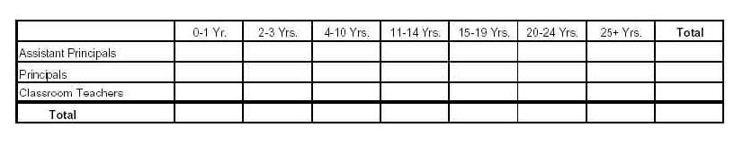
Note 1: Prorated headcounts should be used to reflect employees who are performing multiple functions. Instructions for calculating prorated headcounts may be found on the LDOE Website in the Evolution/Calculation of PEP-Based Salary Averages http://www.louisianabelieves.com/resources/library/data-center under Evolution Calculations of PEP-Based Salary Averages.

Note 2: October 1, 2014 PEP data should be used to prepare this schedule. You can find your district’s total number of principals, assistant principals, and full time classroom teachers within the latest Summary of Reported Personnel, available from the INSIGHT Portal (see the end of this document for directions to that feature.)
Note 3: For auditing purposes, Districts should provide their outside auditors with a listing (containing all relevant data) of the employees that went into development of Schedule 4.
Guidance on how to develop Schedule 4

AFSR Cross-reference: Section II, Item 7 produced by:

1. Input File: October Profile of Educational Personnel (PEP) file (after all corrections).

2. Selection:

a. Exclude any records identified by LDOE edits as containing error(s) or for employees identified as being on sabbatical leave as of the reporting date (Code 1 or 3 in Staff Record).

b. Select only from school district and or state employee records (i.e., employee status code = 01, 05 or 06, including employees of the district's Type 1, 3, or 4 charter schools); and

c. Select all error-free/non-sabbatical Principals (object-function: 111-2410) and Assistant Principals (object-function: 111-2420); and

d. Select only full-time/error-free/non-sabbatical Classroom Teachers (object-function: 112-1000 series, with type employee = F).

3. Process: Generate the sum of *prorated headcounts of Principals, Assistant Principals, and full-time
Classroom Teachers with breakdown of PEP years of experience into:

a) 0-1 years
b) 2-3 years
c) 4-10 years
d) 11-14 years
e) 15-19 years
f) 20-24 years
g) 25 years and up

*Prorated headcounts can be found from http://www.louisianabelieves.com/resources/library/data-center under Teacher Salaries + Headcounts

Schedule 5: Public School Staff Data: Average Salaries
 | All Classroom Teachers | Classroom Teachers Excluding ROTC, Rehired Retirees, and Flagged Salary Reductions
Average Classroom Teachers Salary Including Extra Compensation
Average Classroom Teachers Salary Excluding Extra Compensation
Number of Teacher Full-Time Equivalents (FTEs) used in Computation of Average Salaries

Note: Figures reported include all sources of funding (i.e., federal, state, and local) but exclude stipends and employee benefits.
Generally, retired teachers rehired to teach receive less compensation than non-retired teachers; some teachers may have been
flagged has receiving reduced salaries (e.g., extended medical leave); and ROTC teachers usually receive more compensation
because of a federal supplement. For these reasons, these teachers are excluded from the computation in the last column. This
schedule excludes day-to-day substitutes, temporary employees, and any teachers on sabbatical leave during any part of the school
year.

Guidance on how to develop Schedule 5

AFSR Cross-reference: Section III, Quick Reference Table F produced by:

1. Input File: End-of-Year (30-June) Profile of Educational Personnel (PEP) file (after all corrections).

2. Selection:

a. Exclude any records identified by LDOE edits as containing error(s) or for employees identified as being on sabbatical leave during any part of the year (Code 1, 2, or 3 in Staff Record).

b. Select only from school district and or state employee records (i.e., employee status code = 01, 05 or 06, including employees of the district's Type 1, 3, or 4 charter schools); and

c. Select all error-free/non-sabbatical Classroom Teachers (object-function: 112-1000 series w/ either type employee code).

3. Set-Up: Ensure that all salary elements, PIP entitlement, and calculated FTE for
each employee meeting selection criteria have been prorated to the individual site-
positions records (all jobs/locations) for that employee using the attached
procedures, which are an extract from LDOE Website in the Evolution/Calculation of PEP-Based Salary Averages http://www.louisianabelieves.com/resources/library/data-center under Evolution Calculations of PEP-Based Salary Averages
Note: Do not round the resulting FTE counts.

4. Process (Initial): For each selected Classroom Teacher (i.e., individual having one
or more site-position records with object-function 112-1000 series and meeting
remaining criteria, above), calculate or set the following data elements:

a. Calculate/obtain the prorated Full-Time Equivalent (FTE) for each teacher
site-position record.
Note: Do not round the resulting FTE counts.

b. Salary With Extra Compensation = All prorated salary amounts from
selected sit-position records, PLUS prorated PIP Salary.

c. Salary Without Extra Compensation = Prorated PEP Base Salary +
Extended Employment Salary

d. ROTC/Rehire/Salary Reduction Flag =

"Yes" if object-function combination = "112-1450" OR if the Retiree
Return To Work
Code is not blank OR if the Salary Reduction Code is not blank;
OTHERWISE:

'No" if object-function combination not equal "112-1450" AND the
Retiree Return To Work Code is blank AND the Salary Reduction
Code is blank.

4. Process (final): Calculate each of four average salary amounts as follows:

a. *All Classroom Teachers: For all selected records (i.e., ignoring content of the
ROTC/Rehire/Salary Reduction Flag), accumulate Total FTE-1, Total Salary
With Extra Compensation-1, and Total Salary Without Extra Compensation-1.
Calculate two average salaries for all classroom teachers:

1) Average w/Extra Comp-1 = Total Salary With Extra Compensation-1
divided by Total FTE-1.

2) Average w/o Extra Comp-1 = Total Salary Without Extra Compensation-1
divided by Total FTE-1.

b. *Classroom Teachers Excluding ROTC/Rehires/Salary Reduction: For all
selected records with ROTC/Rehire/Salary Reduction Flag = No,
accumulate Total FTE-2, Total Salary With Extra Compensation-2, and Total
Salary Without Extra Compensation-2. Calculate two average salaries for
classroom teachers excluding ROTC, salary reductions, & rehires:

1) Average w/Extra Comp-2 = Total Salary With Extra Compensation-2
divided by Total FTE-2.

2) Average w/o Extra Comp-2 = Total Salary Without Extra Compensation-2
divided by Total FTE-2.

*Reminder: Records for employees who were in sabbatical leave status during any
part of the year or any post-secondary, contract services, and/or third-party contract
employees (i.e., employee status codes 02, 03, or 04) will be eliminated in Para 2,
that is: before the calculation of FTE and salary amounts used in this process.

Schedule 6: Class Size Characteristics
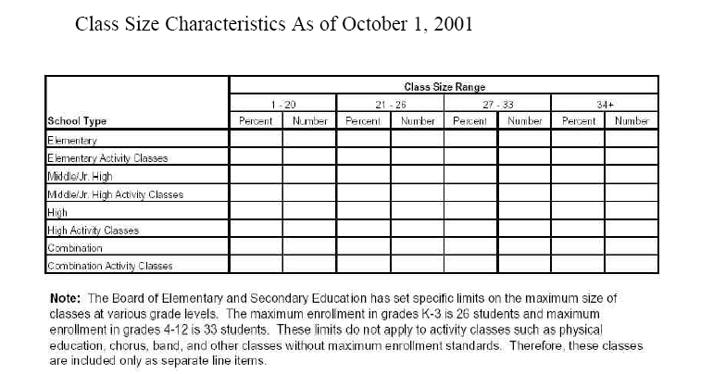
Class Size Characteristics as of October 1, 2014

NOTE: October 1, 2014 data should be used to prepare this schedule. LEADS version of Class Size reports will be available on district sFTP beginning July 8, 2015. File names are “LEACode_LEAName_2014_Class Size Site Level Report,” and “LEACode_LEAName_2014_Class Size for Auditors.” Contact LDEData@la.gov with any questions.
Schedule 7: Louisiana Educational Assessment Program (LEAP)
Please submit “all testers” LEAP scores for 2013, 2014 and 2015.
(Test results from previous reporting years can be viewed here: http://www.louisianabelieves.com/resources/library/test-results)

District Achievement Level Results | English Language Arts |  |  | Mathematics
 | 2015 | 2014 | 2013 | 2015 | 2014 | 2013
Grade 4 Students | Percent | Percent | Percent | Percent | Percent | Percent
Advanced
Mastery
Basic
Approaching Basic
Unsatisfactory
Total

District Achievement Level Results | Science |  |  | Social Studies
 | 2015 | 2014 | 2013 | 2015 | 2014 | 2013
Grade 4 Students | Percent | Percent | Percent | Percent | Percent | Percent
Advanced
Mastery
Basic
Approaching Basic
Unsatisfactory
Total

District Achievement Level Results | English Language Arts |  |  | Mathematics
 | 2015 | 2014 | 2013 | 2015 | 2014 | 2013
Grade 8 Students | Percent | Percent | Percent | Percent | Percent | Percent
Advanced
Mastery
Basic
Approaching Basic
Unsatisfactory
Total

District Achievement Level Results | Science |  |  | Social Studies
 | 2015 | 2014 | 2013 | 2015 | 2014 | 2013
Grade 8 Students | Percent | Percent | Percent | Percent | Percent | Percent
Advanced
Mastery
Basic
Approaching Basic
Unsatisfactory
Total
Schedule 8: Graduation Exit Examination (GEE)

N/A: GEE is no longer administered

Schedule 9: iLEAP Tests
2005 was the last year of Iowa testing, from 2006 onwards iLEAP has taken its place. Please submit iLEAP scores for 2013, 2014 and 2015.
(Test results from previous reporting years can be viewed here: http://www.louisianabelieves.com/resources/library/test-results)

District Achievement Level Results | English Language Arts |  |  | Mathematics
 | 2015 | 2014 | 2013 | 2015 | 2014 | 2013
Grade 3 Students | Percent | Percent | Percent | Percent | Percent | Percent
Advanced
Mastery
Basic
Approaching Basic
Unsatisfactory
Total

District Achievement Level Results | Science |  |  | Social Studies
 | 2015 | 2014 | 2013 | 2015 | 2014 | 2013
Grade 3 Students | Percent | Percent | Percent | Percent | Percent | Percent
Advanced
Mastery
Basic
Approaching Basic
Unsatisfactory
Total

District Achievement Level Results | English Language Arts |  |  | Mathematics
 | 2015 | 2014 | 2013 | 2015 | 2014 | 2013
Grade 5 Students | Percent | Percent | Percent | Percent | Percent | Percent
Advanced
Mastery
Basic
Approaching Basic
Unsatisfactory
Total

District Achievement Level Results | Science |  |  | Social Studies
 | 2015 | 2014 | 2013 | 2015 | 2014 | 2013
Grade 5 Students | Percent | Percent | Percent | Percent | Percent | Percent
Advanced
Mastery
Basic
Approaching Basic
Unsatisfactory
Total

District Achievement Level Results | English Language Arts |  |  | Mathematics
 | 2015 | 2014 | 2013 | 2015 | 2014 | 2013
Grade 6 Students | Percent | Percent | Percent | Percent | Percent | Percent
Advanced
Mastery
Basic
Approaching Basic
Unsatisfactory
Total
District Achievement Level Results | Science |  |  | Social Studies
 | 2015 | 2014 | 2013 | 2015 | 2014 | 2013
Grade 6 Students | Percent | Percent | Percent | Percent | Percent | Percent
Advanced
Mastery
Basic
Approaching Basic
Unsatisfactory
Total

District Achievement Level Results | English Language Arts |  |  | Mathematics
 | 2015 | 2014 | 2013 | 2015 | 2014 | 2013
Grade 7 Students | Percent | Percent | Percent | Percent | Percent | Percent
Advanced
Mastery
Basic
Approaching Basic
Unsatisfactory
Total
District Achievement Level Results | Science |  |  | Social Studies
 | 2015 | 2014 | 2013 | 2015 | 2014 | 2013
Grade 7 Students | Percent | Percent | Percent | Percent | Percent | Percent
Advanced
Mastery
Basic
Approaching Basic
Unsatisfactory
Total

Attachment: Procedures For Employee Counts/Salary Averages
(Ref. http://www.louisianabelieves.com/resources/library/data-center under Evolution Calculations of PEP-Based Salary Averages

Headcount:

Public school employees reported within the Profile of Educational Personnel (PEP) system are each represented by a single staff record from the submitting local educational agency (LEA), together with one or more site-position records that report the applicable salary and time worked (by site) for each job performed by the employee. Jobs are defined by entry of object and function code combinations from the Louisiana Accounting and Uniform Governmental Handbook. Job locations are identified using site codes assigned within the Sponsor/Site System (SPS) database. To quantify or weight information extracted from the PEP database, each employee is assigned a "headcount" of one (1) that is prorated to subordinate site-position records using the ratio of: minutes worked reported for that site-position record, divided by the total of minutes worked reported by all site-position records for the employee.

Example: An employee works a total of 76,440 minutes. Half of the total minutes are at Church Point High School (Site Code 001005) as a guidance counselor (113-2122); with the remaining time worked at Crowley High School (Site Code 001007), split equally between teaching gifted/talented courses (112-1220) and industrial arts (112-1350). The employee's headcount would be prorated as follows:

Site Code Object Function Minutes Worked Percent Headcount

001005 113 2122 38,220 50% 0.50
001007 112 1220 19,110 25% 0.25
001007 112 1350 19,110 25% 0.25

Employee Total 76,440 100% 1.00

Full-Time Equivalent (FTE):

The employee headcount provides some measure for a "snapshot in time" such as the Fall (October) PEP submission and for prorating/weighting each individual's data; however, the measure is less useful when applied to cumulative data such as the end-of-year (EOY) PEP report and/or to quantify staff employment over the school year. The need for a "man-year" measurement led to calculating employee full-time equivalents (FTE), whereby a value (1.0 or less) is assigned each staff member by comparing the employee's minutes worked to the applicable contract year.

The PEP system includes self-reporting of the contract year against which the employee's actual or projected work may be measured. The contract year is obtained by multiplying contract days by the workday minutes, which produces (if the data are properly reported) the total available annual minutes under the contract(s) for the class of employees to which the reported employee is assigned. A minimum length for the school year (in minutes) is also established so that employees normally hired for a short period of time (e.g., seasonal grounds workers), or a short period each day (e.g., 1-2 hours daily clerical work), are not counted in FTE calculations as full-year employees; nor are their partial-year or partial-day salaries treated as a full year's pay. A minimum year of 63,720 minutes is set for certificated staff positions based upon: thirty hours per week (i.e., guidelines to qualify for employee benefits) and a legislated minimum school year of 177 instructional days. The minimum year for non-certificated positions is set at 42,501 minutes predicated on: needing over twenty hours per week (i.e., 20.01 hours/week) to qualify for retirement system entry, and the minimum school year of 177 instructional days. Once established, an employee's FTE is prorated to each subordinate site-position record based upon the minutes worked reported for that site-position record, compared to the total of minutes worked reported by all site-position records for the employee.

Example: A staff member is employed under a contract covering 200 days with a normal workday of seven hours (i.e., 420 minutes). The employee works a total of 182 days (i.e., 76,440 minutes). Half of the total are at Church Point High School (Site Code 001005) as a guidance counselor (113-2122); and the remaining half at Crowley High School (Site Code 001007), split equally between teaching gifted/talented courses (112-1220) and industrial arts (112-1350). The employee's FTE would be calculated and prorated as follows:

Annual
Available Minutes = 200 Contract Days times 420 Workday Minutes = *84,000 Minutes

[*Note: If result less than minimum year, use 63,720 minutes or 42,501 minutes.]

Employee FTE = ** 76,440 Total of Minutes Worked = 0.91
84,000 Annual Available Minutes

[**Note: If total of Minutes Worked equal to or greater than Annual Available
Minutes, set FTE = 1.]

Site-Position FTE (proration):

Site Code Object Function Minutes Worked Percent Headcount FTE

001005 113 2122 38,220 50% 0.50 0.4550
001007 112 1220 19,110 25% 0.25 0.2275
001007 112 1350 19,110 25% 0.25 0.2275

Employee Total 76,440 100% 1.00 0.9100

Annualizing Salaries and Calculating Average Salaries:

Except for PIP entitlements, all PEP salary data are available from site-position records. The data consist of three salary types (base pay, extra compensation, and extended employment compensation); and, for each employee, are identified to one or more specific job(s) by entry of applicable object and function code combinations. If an employee performs the same function at more than one location, multiple site-position records with the same object and function code combination will be reported; in which case, the related salary data reported for that function may be spread between the several records or may be lumped into one of the site-position records. The PIP entitlement is reported in the staff record.

From October 1, 2002 through September 30, 2006, salary average and annualizing calculations used the salary data as reported within each site-position record, plus proration of the PIP entitlement to each site-position record on the same basis as headcount (above). A shortcoming was that the "cost" of a multi-sited employee might be over or understated within a salary average or total calculation depending upon selection criteria (e.g., for teacher salary average by site) and how the related data were reported (e.g., salary lumped into one site-position record). Beginning October 1, 2006, salary average and annualizing calculations used salary and PIP amounts which had been totaled for the individual, then prorated to each related site-position record as done for headcount and FTE

An annualized salary is calculated for each job held by an employee (i.e., each object and function code combination for that individual) by: summing the site-position record prorated salary entries and prorated PIP entitlement for each object-function combination reported for the employee, then dividing the result by the sum of the prorated FTE for the same records. The annualized salary is used in establishing lows and highs when comparing the same type positions.

Calculating average salaries from PEP data is accomplished by: establishing the criteria for selecting and/or excluding site-position records from the calculation; identifying the type prorated salaries to be used (i.e., base pay, extra compensation, extended employment compensation, and/or PIP); summing the selected prorated salary data and the prorated FTE associated with each selected site-position record; then dividing the sum of the selected prorated salaries by the sum of the selected prorated FTE. Criteria used for salary averages in this document are:

Selected - All salary elements, including PIP entitlement. (Benefits and stipends are excluded.)

Excluded - All employees in sabbatical level status (either semester); all ROTC staff (function code 1450); and all teachers (object code 112) who are rehired retirees.

Note: Beginning 2006-2007, any equivalent salary averages calculated from end-of-year PEP data would also exclude any employees flagged with a salary reduction code.

Where to Find the Summary of Reported Personnel as of October 2013
This year, you should use the LDOE’s new INSIGHT data warehouse to access the Summary of Reported Personnel Report, to view your district’s October 1 PEP (Budgeted) data. Staff counts and educational levels from this report can be used to help reconcile the data from your local system(s) that are used to complete Schedules 2 and 4, and accompany your districts audit for the 2014-2015 fiscal year.

The URL for the INSIGHT Portal is https://insight.doe.louisiana.gov/SitePages/Home.aspx. Once there, you will be asked to enter your user ID and password, which is the same ID and password that you use to get to the LEADS Portal. If you do not have permissions, you should contact your local Security Officer immediately.

Once all security has been validated, you will be presented with the INSIGHT Portal home page:

Your home page may look slightly different, depending on your security level. If the large blue button to the right does not have the word REPORTS displayed on it, then you have permissions to the Portal, but not to reports; you should contact your local Security Officer immediately (request permissions to LDS).

At this point, you should left-click the blue REPORTS button. You will be taken to the reports request page. Scroll down the list of reports until you get to the FINANCIAL REPORTS group. In that list, you should find one marked SUMMARY OF REPORTED PERSONNEL:

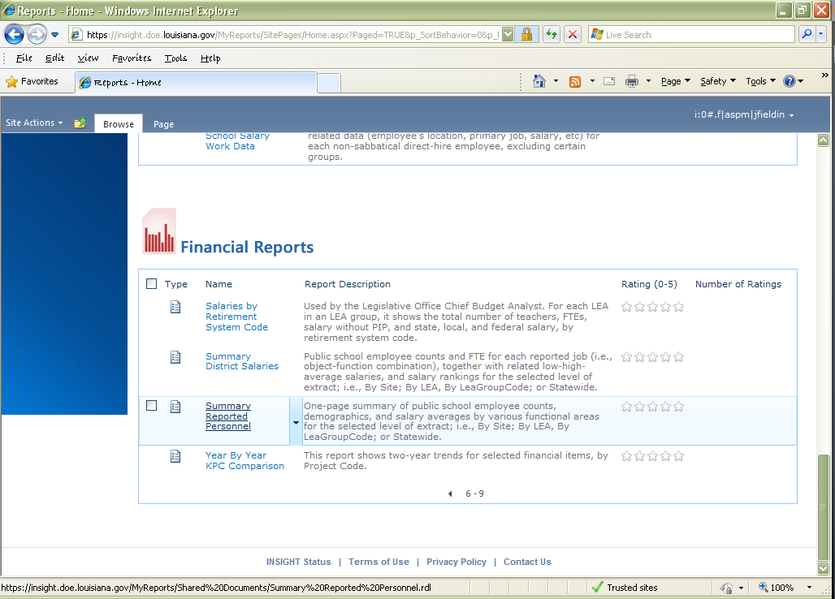

Note that you may have to go to the second page of Financial Reports to get to this one (click the paging arrow at the bottom of the Financial Reports group).

For the purposes of the Audit Assurances, you should select the following parameters:

SCHOOL YEAR 2014-2015

PROCESSING PERIOD October

DISTRICT TYPE Either ALL or the grouping of which you are a member

LEVEL Select the level at which you submit your AFR (i.e., city/parish districts and RSD-LDE would select “LEA (sponsor)-Level Data”, while lab schools and charters would select “Site-level Data”)

Finally, press the APPLY button on the lower right. The report will then be produced.

You may view it online, or, to bring it up in Excel, simply left-click the down-arrow near the ACTION button (on the top left), hover over EXPORT, and select Excel:

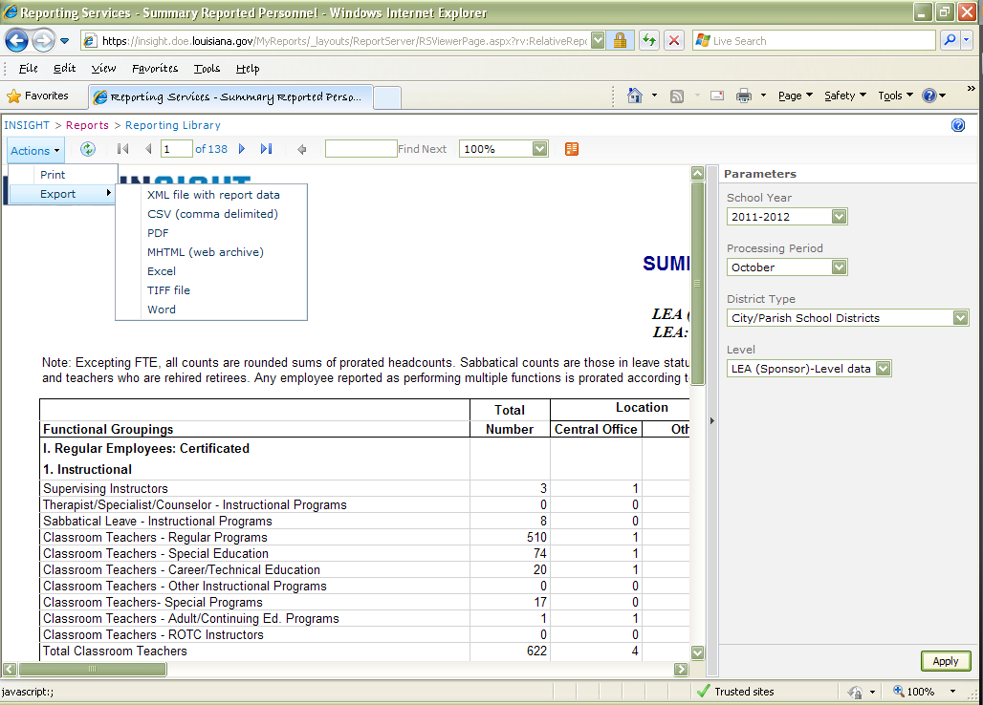

Once in Excel, you’ll probably want to freeze the headings to ease readability as you scroll down the report.

