For 2017-18 school year, LDOE is updating the Special Education Reporting (SER) system for individualized education plans (IEP). These changes will affect the Accommodations and Act 833 portions of the IEP form.

**Accommodations**

**What’s the Impact:**

* + Any changes made will impact new IEPs as well as any amended IEPs.
  + SER users will receive a message letting them know of the accommodation selections previously made for the student so they can make the appropriate selections on the new IEP Accommodations form.

**What’s Changed:**  Changes will be made to the Accommodations page in order to more accurately reflect the individual accommodations or modifications available to students in the classroom and on statewide assessments. The changes are described below:

Original Header Layout

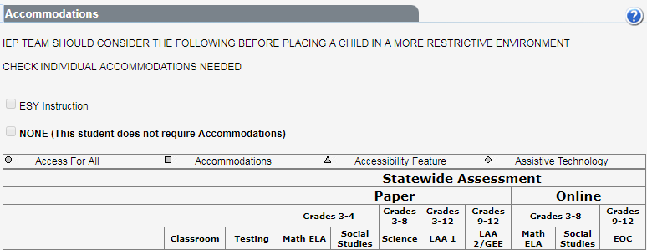

Revised Header Layout

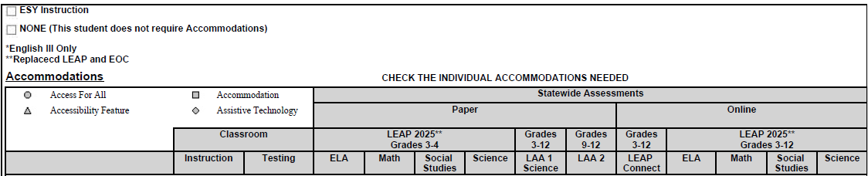

* + **Classroom** section modified to include accommodations for *Instruction* and *Testing*
    - Classroom/Testing accommodations are now indicated separately from Statewide Assessments accommodations
  + **Statewide Assessments** section
    - ELA and Math columns have been separated for Paper and Online
    - LEAP & EOC columns have been combined into LEAP 2025. *(LEAP 2025 is the new name for both LEAP and EOC).*
    - Online section: LEAP Connect has replaced the ELA/Math LAA1
    - Paper: LAA1 Science is still available on paper.

**Read Aloud** Section of the Accommodations form has been restructured

* + Eliminated: Math, All content, and ELA Read Aloud
* Added: *Kurzweil, Recorded Voice File* and *Text-to-Speech, Human* (except reading comp sections)

Other IEP Form Changes

* Braille has been removed, but Unified English Braille (UEB) remains
* Accommodations for *Communication Assistance Script* have been added
* Online English III is the only test that can have dictionary/thesaurus
* Transition Page / LRE Page / GSI Page: These changes will appear throughout the IEP.
* From - Individual Graduation Plan for LAA 1 to Individual Graduation Plan for LEAP Connect
* From – Education/Career Plan for LAA 1 to Education/Career Plan for LEAP Connect
* Program / Services Page: Assessments
* From LAA 1 to LEAP Connect

**Act 833**

**What’s the Impact:**

* + The *Goal Summary Form* will automatically populate/collect the “Educational Need Area”, “Content Area”, and “Course” from each instructional plan page that has “Act 833 Applied” selected.
  + If “Act 833 Applied” is selected on the *Instructional Plan* page*,* as changes are made to the page, those changes will be reflected on the *Goal Summary Form.*
  + Once the *Goal Summary Form* has been created, changes may be made after the IEP has been submitted to SER without amending the IEP.
  + When it is time to write a new IEP for the student, the *Goal Summary Form* must be filled out in its entirety before a new IEP can be submitted to SER, otherwise error message *I068-Goal Summary Form on a previous IEP has not been completed.*

**What’s Changed:** Changes will be made to determine if the student is meeting the objectives and goals written on each *Instructional Plan* page once **Act 833 applied** is selected. The changes are described below:

* For new IEPs, a *Goal Summary Form* will be created automatically once the educational need area is indicated, the content area is chosen, and Act 833 Applied is selected and saved on the *Instructional Plan* page.

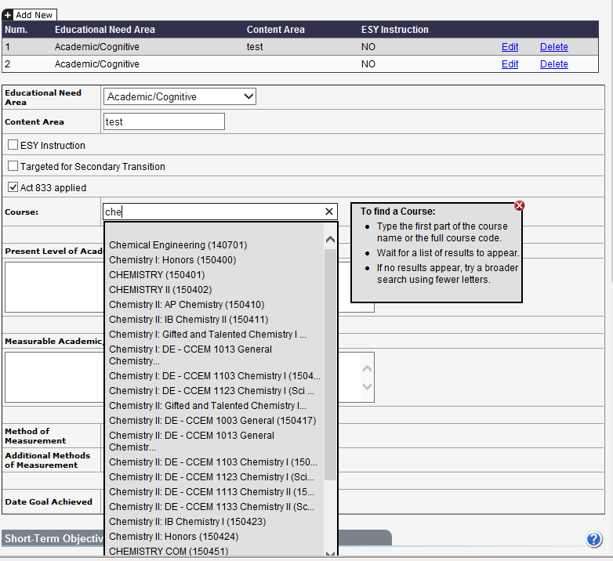

* On the *Goal Summary Form* you will have to indicate if the goal where Act 833 was applied was met by marking **Yes** or **No** and clicking the save button. This information will not automatically populate from the *Instructional Plan* page.
* If **Yes** or **No** is not an option, a choice of **N/A** has been provided. The choice of N/A can be used in situations such as:
  + An instructional plan was mistakenly created and Act 833 applied was selected. In this situation:
    - The LEA has the option to delete the *Instructional Plan* page.
    - N/A will be checked as the reason why Act 833 was not met for the deleted page, (in other words the page will not be deleted).
  + A student transferred out of the class.
  + A student dropped the class.
  + The student did not use the provisions provided on the IEP and completed the course via the traditional method or standard.
* To verify graduation exit:
  + Student must be exited from SIS with Exit Reason Code “04” [Diploma]
  + Student must have a transcript that meets all course credit requirements and assessment requirements
  + Student must have taken all EOCs to earn credit for EOC-eligible courses.

