Setting up IE to use Compatibility View
Compatibility View may be a solution for those IE users experiencing problems viewing LDOE web pages. Problems rendering all or parts of a web page can occur when newer browsers try to display sites that are built with older programming components.

For IE 8 thru IE 10
Users can enable compatibility view for a website by clicking the “Compatibility View” icon to the right of the address bar.

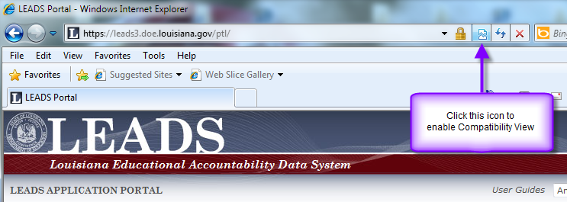

The browser should reload the page and begin displaying the page in compatibility view mode.

For IE 11
For IE 11 Microsoft removed the Compatibility View button from the address bar but there is an alternate method to turn on compatibility for a website. (This process can also be used in IE8 thru IE10).

First, Click the “Tools” button on the menu bar, and then select the “Compatibility View Settings” option.
Then, in the text box under “Add this website”, type Louisiana.gov and click the “Add” button.
Finally, close the Compatibility View Settings dialog box and close IE 11. Restart IE.

