Title: Use a number line for multiplication of fractions and whole numbers

Lesson Objective: In this lesson you will learn how to multiply a whole number and fraction by using a number line.

Common Core Standard
4.NF.4b Decompose a fraction into a sum of fractions with the same denominator in more than one way, recording each decomposition by an equation. Justify decompositions, e.g., by using a visual fraction model.

Use the video at:

http://learnzillion.com/lessons/2938

Use the questions on the left, pausing the video or stopping the slideshow, to check for understanding and engage students at each section of the lesson.

Warm-Up | Notes
What does $3 x \frac{1}{2}$ mean?  How do you use a number line to multiply a whole number and a fraction? | Consider giving students a chance to practice: show $3 x \frac{1}{2}$ using a number line.
Let’s Review | Notes
How can we divide 2 into unit fractions? Try showing the unit fraction $\frac{1}{4}$ on a number line, from 0 to 2.  How many 4ths are equal to 1?  How many 4ths are equal to two?  How many 4ths are equal to 1$\frac{1}{2}$ ?  Try drawing a number line from 0 to 2 divided into a different unit fraction. | Ask this question before showing slides 3 and 4:  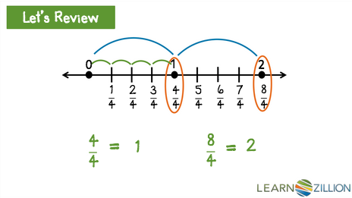  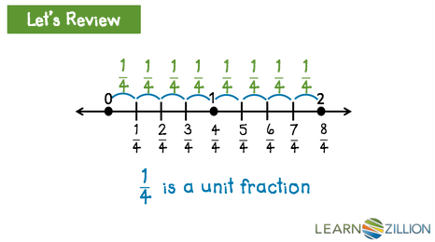
Core Lesson | Notes
How much is 3 x $\frac{2}{5}$ ? Use pictures to show how you know.  Where does your answer fall on a number line? Is it greater than 1? Less than 1? Greater than 2? Less than 2? Is it closer to 2 or 1? | Encourage students to apply their knowledge of multiplication (as repeated addition) to solve this problem.
Cory’s bread recipe calls for $\frac{2}{3}$ cup of flour (to make 1 loaf). He wants to triple the recipe and make 3 loaves. How much flour does he need?  What does this word problem tell us?  What is the problem asking us to find?  How can we set up the problem? | Encourage students to apply their knowledge of multiplication, set up the equation, and use number lines and visual models to find the product. Use the guiding questions at left.
Post-Core Lesson | Notes
Tricia is building a bookshelf that will have $\frac{5}{6}$ yards of wood for each shelf. She has already finished the top, bottom, and sides of the bookshelf but needs enough wood for 3 shelves. How much wood does she need?  What does this word problem tell us?  What is the problem asking us to find?  How can we set up the problem? | Encourage students to visualize the problem using the guiding questions at left.
Practice
Download the practice sheet for this lesson on the lesson plan page.

Differentiation
During the lesson and practice, identify students who are struggling. See below for interventions:

Students do not equate fractions with equal numerator and denominator to 1 (3.NF.3c):

http://learnzillion.com/lessons/1737

Students do not understand whole numbers can be expressed as fractions (3.NF.3c)

http://learnzillion.com/lessons/1738

Students struggle to multiply using number lines (3.OA.1):

http://learnzillion.com/lessons/3416

