*Organization for Introduction*

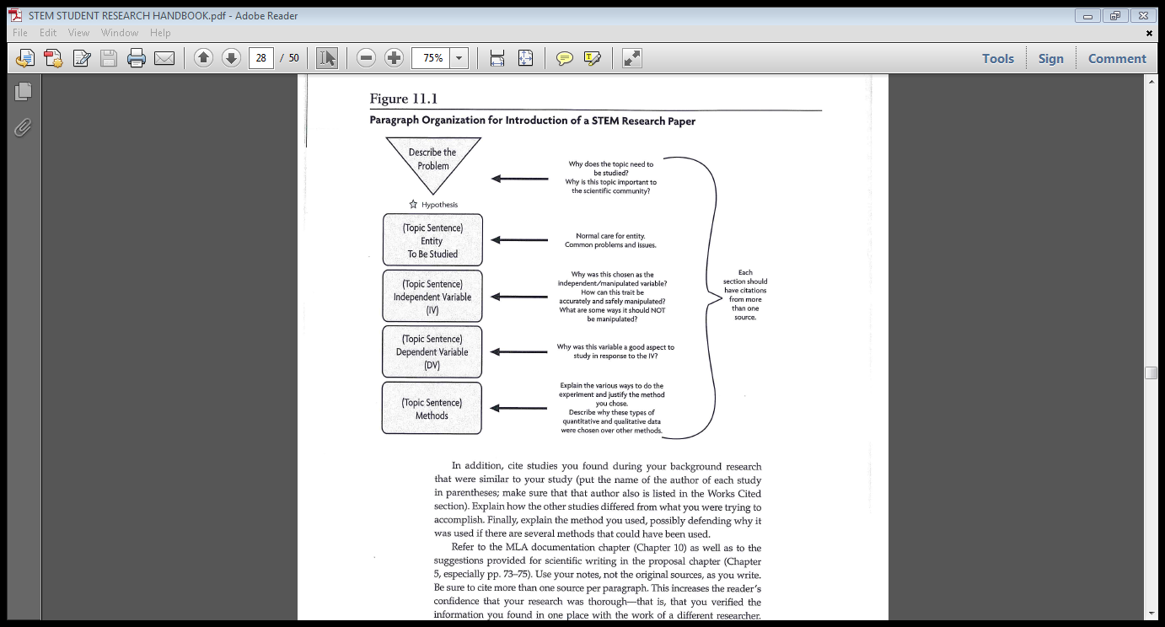

**Describe the Problem:**

**(Topic Sentence) Entity to be Studied:**

**(Topic Sentence) Independent Variable:**

**(Topic Sentence) Dependent Variable:**

**(Topic Sentence) Overview of Method used to test the hypothesis:**