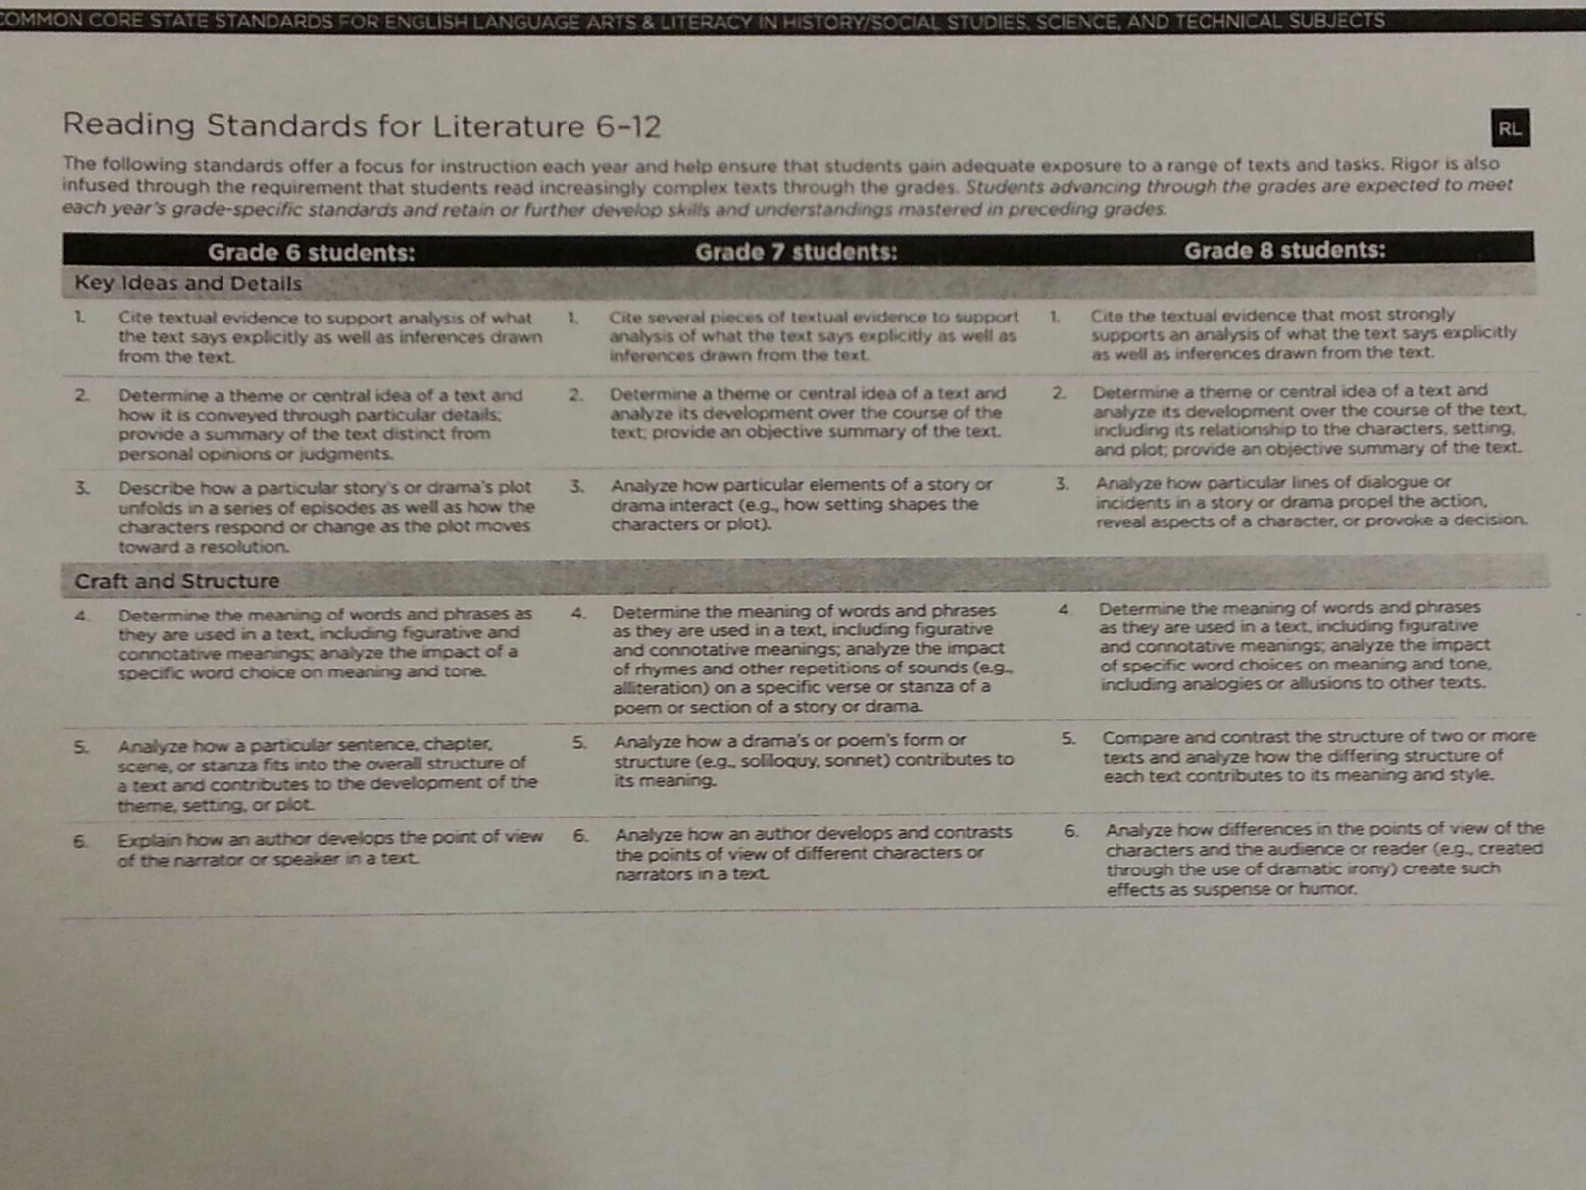
Close Reading
Targeted Skills & Model Answer Features

Standard RL 8.1 | Model Answers
- Cite textual evidence  - Support details from the text  - Be explicit (straight forward and clear)  - Provide analysis writing (relate it to something meaningful)  - Make inferences (infer, guess, predict, suppose) | - Topic Sentence  - Support Sentence  - Relevance  - Justification  - Conclusion
RACES | Close Reading Rubric
R- restate the question without answering it  A – answer the question with TWO personal beliefs/opinions  C – cite evidence (2 things)  E – explain how their opinion is supported by the evidence  S – write a summary statement without repeating anything from above | - Answer – Answer is correct and completely addresses ALL parts of the question.  - Inference – Supports the text with analysis through relevant and meaningful inferences.  - Supporting Evidence – Cites (2 or more) strong pieces of textual evidence and justifies its relevance.

*MY Goal for the iLEAP/LEAP Test is:

Teacher: ________________________________________ Observer: ______________________________________

Subject: ________________________ Grade: ______ Period: _____ Date: _________________________________

Contributing Factors | Critical Attributes
- Refer to the ELA school-wide learning target.  - Read the reading standards to the students.  - Have the standards and step posted on chart paper in your classroom.  - Have the Digging Deeper handout posted on chart paper in your classroom.  - As students read, keep the teacher talk to a minimum so they can concentrate. Quietly praise students efforts as they are reading, provide academic feedback, and encourage weak readers.  - Announce remaining time limits (10 minutes, 5 minutes).  - Give a closing review of the process if time allows using the steps listed on the Close Reading and Digging Deeper posters. Answer any questions the students may have.  *Close Reading Targets  Reading Standards:  RI 6.1, RI 6.2, RI 6.3  Close Reading Process - Chunk 1  # 1. Read.  # 2. Read again. (Circle vocabulary and underline details.)  # 3. Read one more time. (Write questions and interpretations in the margins.) | - Set the learning goal:  - Academic feedback (praise and constructive comments)  - Establish high expectations.  - Refer to the students as scholarly, bright, and intelligent.  - Give a clear definition of the Close Reading Strategy using the DIGGING DEEPER handout.  - Model the strategy using a short reading passage or math word problem. [When you plan for this, use some of the questions from the ASCD article.]  - Provide a personal illustration to make it relevant for the students to understand the concept of digging deeper.  - Explain, in detail, each stage in the Digging Deeper handout.  - Before releasing students to read, make sure they have a clear understanding and all questions have been answered. There will be no student talking during the process except for 1 to 2 opportunities for you to praise and encourage their efforts and for time limit reminders.  - Interacting with the text:  - Read.  - Read. Circle vocabulary and underline key details.  - Read. Write questions and interpret concepts in the margins.  - Collect all materials at the end of the session.  Contributing Factors: influence, impact, promote, aid, or support the learning.  Critical Factors: are significant, vital, important, essential, or key, necessary to facilitate the learning.

