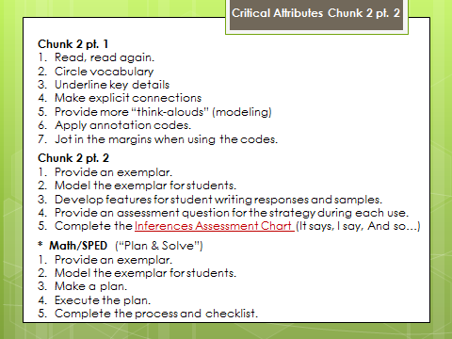

**Chunk 2 pt. 1**

1. Read, read again.
2. Circle vocabulary
3. Underline key details
4. Make explicit connections
5. Provide more “think-alouds” (modeling)
6. Apply annotation codes.
7. Jot in the margins when using the codes.

**Chunk 2 pt. 2**

1. Provide an exemplar.
2. Model the exemplar for students.
3. Develop features for student writing responses and samples.
4. Provide an assessment question for the strategy during each use.
5. Complete the **Inferences Assessment Chart** (It says, I say, And so…)

**\* Math/SPED** (“Plan & Solve”)

1. Provide an exemplar.
2. Model the exemplar for students.
3. Make a plan.
4. Execute the plan.
5. Complete the process and checklist.

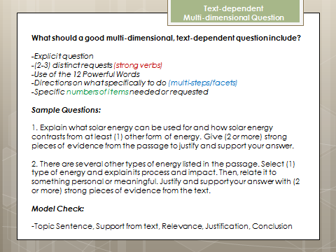

**What should a good multi-dimensional, text-dependent question include?**

*-Explicit question*

*-(2-3) distinct requests (strong verbs)*

*-Use of the 12 Powerful Words*

*-Directions on what specifically to do (multi-steps/facets)*

*-Specific numbers of items needed or requested*

***Sample Questions:***

1. Explain what solar energy can be used for and how solar energy contrasts from at least (1) other form of energy. Give (2 or more) strong pieces of evidence from the passage to justify and support your answer.

2. There are several other types of energy listed in the passage. Select (1) type of energy and explain its process and impact. Then, relate it to something personal or meaningful. Justify and support your answer with (2 or more) strong pieces of evidence from the text.

***Model Check:***

-Topic Sentence, Support from text, Relevance, Justification, Conclusion