Algebra I
Louisiana Student Standards: Companion Document for Teachers

This document is designed to assist educators in interpreting and implementing Louisiana’s new mathematics standards. It contains descriptions of each Algebra I standard to answer questions about the standard’s meaning and how it applies to student knowledge and performance. To ensure that descriptions are helpful and meaningful to teachers, this document also provides examples indicating how students might meet the requirements of a standard. Examples are samples only and should not be considered an exhaustive list.

This companion document is considered a “living” document as we believe that teachers and other educators will find ways to improve the document as they use it. Please send feedback to LouisianaStandards@la.gov so that we may use your input when updating this guide.

Additional information on the Louisiana Student Standards for Mathematics, including how to read the standards’ codes, a listing of standards for each grade or course, and links to additional resources, is available at
http://www.louisianabelieves.com/resources/library/k-12-math-year-long-planning.

Updated September 23, 2016. Click here to view updates.

Standards for Mathematical Practices
The Louisiana Standards for Mathematical Practice are expected to be integrated into every mathematics lesson for all students in grades K-12. Below are a few examples of how these practices may be integrated into tasks that high school students complete.

 | Louisiana Standards for Mathematical Practice (MP) for High School
 | Louisiana Standard |  | Explanations and Examples
 | HS.MP.1. Make sense of problems and persevere in solving them. |  | High school students start to examine problems by explaining to themselves the meaning of a problem and looking for entry points to its solution. They analyze givens, constraints, relationships, and goals. They make conjectures about the form and meaning of the solution and plan a solution pathway rather than simply jumping into a solution attempt. They consider analogous problems, and try special cases and simpler forms of the original problem in order to gain insight into its solution. They monitor and evaluate their progress and change course if necessary. Older students might, depending on the context of the problem, transform algebraic expressions or change the viewing window on their graphing calculator to get the information they need. By high school, students can explain correspondences between equations, verbal descriptions, tables, and graphs or draw diagrams of important features and relationships, graph data, and search for regularity or trends. They check their answers to problems using different methods and continually ask themselves, “Does this make sense?” They can understand the approaches of others to solving complex problems and identify correspondences between different approaches.
 | HS.MP.2. Reason abstractly and quantitatively. |  | High school students seek to make sense of quantities and their relationships in problem situations. They abstract a given situation and represent it symbolically, manipulate the representing symbols, and pause as needed during the manipulation process in order to probe into the referents for the symbols involved. Students use quantitative reasoning to create coherent representations of the problem at hand; consider the units involved; attend to the meaning of quantities, not just how to compute them; and know and flexibly use different properties of operations and objects.
 | HS.MP.3. Construct viable arguments and critique the reasoning of others. |  | High school students understand and use stated assumptions, definitions, and previously established results in constructing arguments. They make conjectures and build a logical progression of statements to explore the truth of their conjectures. They are able to analyze situations by breaking them into cases, and can recognize and use counterexamples. They justify their conclusions, communicate them to others, and respond to the arguments of others. They reason inductively about data, making plausible arguments that take into account the context from which the data arose. High school students are also able to compare the effectiveness of two plausible arguments, distinguish correct logic or reasoning from that which is flawed, and—if there is a flaw in an argument—explain what it is. High school students learn to determine domains, to which an argument applies, listen or read the arguments of others, decide whether they make sense, and ask useful questions to clarify or improve the arguments.
HS.MP.4. Model with mathematics. |  | High school students can apply the mathematics they know to solve problems arising in everyday life, society, and the workplace. By high school, a student might use geometry to solve a design problem or use a function to describe how one quantity of interest depends on another. High school students make assumptions and approximations to simplify a complicated situation, realizing that these may need revision later. They are able to identify important quantities in a practical situation and map their relationships using such tools as diagrams, two-way tables, graphs, flowcharts and formulas. They can analyze those relationships mathematically to draw conclusions. They routinely interpret their mathematical results in the context of the situation and reflect on whether the results make sense, possibly improving the model if it has not served its purpose.
HS.MP.5. Use appropriate tools strategically. |  | High school students consider the available tools when solving a mathematical problem. These tools might include pencil and paper, concrete models, a ruler, a protractor, a calculator, a spreadsheet, a computer algebra system, a statistical package, or dynamic geometry software. High school students should be sufficiently familiar with tools appropriate for their grade or course to make sound decisions about when each of these tools might be helpful, recognizing both the insight to be gained and their limitations. For example, high school students analyze graphs of functions and solutions generated using a graphing calculator. They detect possible errors by strategically using estimation and other mathematical knowledge. When making mathematical models, they know that technology can enable them to visualize the results of varying assumptions, explore consequences, and compare predictions with data. They are able to identify relevant external mathematical resources, such as digital content located on a website, and use them to pose or solve problems. They are able to use technological tools to explore and deepen their understanding of concepts.
HS.MP.6. Attend to precision. |  | High school students try to communicate precisely to others by using clear definitions in discussion with others and in their own reasoning. They state the meaning of the symbols they choose, specify units of measure, and label axes to clarify the correspondence between quantities in a problem. They calculate accurately and efficiently, expressing numerical answers with a degree of precision appropriate for the problem context. By the time they reach high school they have learned to examine claims and make explicit use of definitions.
HS.MP.7. Look for and make use of structure. |  | By high school, students look closely to discern a pattern or structure. In the expression x² + 9x + 14, older students can see the 14 as 2 × 7 and the 9 as 2 + 7. They recognize the significance of an existing line in a geometric figure and can use the strategy of drawing an auxiliary line for solving problems. They also can step back for an overview and shift perspective. They can see complicated things, such as some algebraic expressions, as single objects or as being composed of several objects. For example, they can see  5 – 3(x – y)² as 5 minus a positive number times a square and use that to realize that its value cannot be more than 5 for any real numbers x and y. High school students use these patterns to create equivalent expressions, factor and solve equations, and compose functions, and transform figures.
HS.MP.8. Look for and express regularity in repeated reasoning. |  | High school students notice if calculations are repeated, and look both for general methods and for shortcuts. Noticing the regularity in the way terms cancel when expanding (x – 1)(x + 1), (x – 1)(x² + x + 1), and (x – 1)(x³ + x² + x + 1) might lead them to the general formula for the sum of a geometric series. As they work to solve a problem, derive formulas or make generalizations, high school students maintain oversight of the process, while attending to the details. They continually evaluate the reasonableness of their intermediate results.

Modeling Standards
Modeling is best interpreted not as a collection of isolated topics but rather in relation to other standards. Making mathematical models is a Standard for Mathematical Practice, and specific modeling standards appear throughout the high school standards indicated by a star symbol (★).
What is Modeling?
Modeling links classroom mathematics and statistics to everyday life, work, and decision-making. Modeling is the process of choosing and using appropriate mathematics and statistics to analyze empirical situations, to understand them better, and to improve decisions. Quantities and their relationships in physical, economic, public policy, social, and everyday situations can be modeled using mathematical and statistical methods. When making mathematical models, technology is valuable for varying assumptions, exploring consequences, and comparing predictions with data.
A model can be very simple, such as writing total cost as a product of unit price and number bought, or using a geometric shape to describe a physical object like a coin. Even such simple models involve making choices. It is up to us whether to model a coin as a three-dimensional cylinder, or whether a two-dimensional disk works well enough for our purposes. Other situations—modeling a delivery route, a production schedule, or a comparison of loan amortizations—need more elaborate models that use other tools from the mathematical sciences. Real-world situations are not organized and labeled for analysis; formulating tractable models, representing such models, and analyzing them is appropriately a creative process. Like every such process, this depends on acquired expertise as well as creativity.
Some examples of such situations might include:
- Estimate how much water and food is needed for emergency relief in a devastated city of 3 million people, and how it might be distributed.
- Plan a table tennis tournament for 7 players at a club with 4 tables, where each player plays against each other player.
- Design the layout of the stalls in a school fair so as to raise as much money as possible.
- Analyze the stopping distance for a car.
- Model a savings account balance, bacterial colony growth, or investment growth.
- Engage in critical path analysis, e.g., applied to turnaround of an aircraft at an airport.
- Analyze the risk in situations such as extreme sports, pandemics, and terrorism.
- Relate population statistics to individual predictions.
In situations like these, the models devised depend on a number of factors: How precise an answer do we want or need? What aspects of the situation do we most need to understand, control, or optimize? What resources of time and tools do we have? The range of models that we can create and analyze is also constrained by the limitations of our mathematical, statistical, and technical skills, and our ability to recognize significant variables and relationships among them. Diagrams of various kinds, spreadsheets and other technology, and algebra are powerful tools for understanding and solving problems drawn from different types of real-world situations.
One of the insights provided by mathematical modeling is that essentially the same mathematical or statistical structure can sometimes model seemingly different situations. Models can also shed light on the mathematical structures themselves, for example, as when a model of bacterial growth makes more vivid the explosive growth of the exponential function.
The basic modeling cycle is summarized in the diagram. It involves (1) identifying variables in the situation and selecting those that represent essential features, (2) formulating a model by creating and selecting geometric, graphical, tabular, algebraic, or statistical representations that describe relationships between the variables, (3) analyzing and performing operations on these relationships to draw conclusions, (4) interpreting the results of the mathematics in terms of the original situation, (5) validating the conclusions by comparing them with the situation, and then either improving the model or, if it is acceptable, (6) reporting on the conclusions and the reasoning behind them. Choices, assumptions, and approximations are present throughout this cycle.
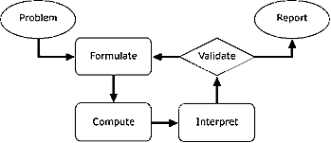
In descriptive modeling, a model simply describes the phenomena or summarizes them in a compact form. Graphs of observations are a familiar descriptive model—for example, graphs of global temperature and atmospheric CO₂ over time.
Analytic modeling seeks to explain data on the basis of deeper theoretical ideas, albeit with parameters which are empirically based; for example, exponential growth of bacterial colonies (until cut-off mechanisms such as pollution or starvation intervene) follows from a constant reproduction rate. Functions are an important tool for analyzing such problems.
Graphing utilities, spreadsheets, computer algebra systems, and dynamic geometry software are powerful tools that can be used to model purely mathematical phenomena (e.g., the behavior of polynomials) as well as physical phenomena).

Number and Quantity: The Real Number System (N-RN)
Use properties of rational and irrational numbers.
Louisiana Standard | Explanations and Examples
A1: N-RN.B.3. Explain why the sum or product of two rational numbers is rational; that the sum of a rational number and an irrational number is irrational; and that the product of a nonzero rational number and an irrational number is irrational. | Since every difference can be rewritten as a sum and every quotient as a product, this includes differences and quotients as well. Explaining why the four operations on rational numbers produce rational numbers can be a review of students understanding of fractions and negative numbers. Explaining why the sum of a rational and an irrational number is irrational, or why the product is irrational, includes reasoning about the inverse relationship between addition and subtraction (or between multiplication and addition).  Example:  - Explain why the number 2π must be irrational, given that π is irrational. Answer: if 2π were rational, then half of 2π would also be rational, so π would have to be rational as well.
A1: N-Q.A.1. Use units as a way to understand problems and to guide the solution of multi-step problems; choose and interpret units consistently in formulas; choose and interpret the scale and the origin in graphs and data displays. | Include word problems where quantities are given in different units, which must be converted to make sense of the problem. For example, a problem might have an object moving 12 feet per second and another at 5 miles per hour. To compare speeds, students convert 12 feet per second to miles per hour:  $\frac{12 ft.}{1 sec.}\frac{60 sec.}{1 min.}\frac{60 min.}{1 hour}\frac{1 mile}{5280 ft.}≈\frac{8.182 miles}{1 hour}$, which is more than 5 miles per hour.  Graphical representations and data displays include, but are not limited to: line graphs, circle graphs, histograms, multi-line graphs, scatterplots, box plots and multi-bar graphs.
A1: N-Q.A.2. Define appropriate quantities for the purpose of descriptive modeling. | Examples:  - What type of measurements would one use to determine their income and expenses for one month?  - How could one express the number of accidents in Louisiana?
A1: N-Q.A.3. Choose a level of accuracy appropriate to limitations on measurement when reporting quantities. | The margin of error and tolerance limit varies according to the measure, tool used, and context.  Example:  - Determining the price of gas by estimating to the nearest cent is appropriate because you will not pay in fractions of a cent when the cost of gas is $3.479 per gallon.

Algebra: Seeing Structure in Expressions (A-SSE)
Interpret the structure of expressions.
Louisiana Standard | Explanations and Examples
A1: A-SSE.A.1. Interpret expressions that represent a quantity in terms of its context.  - Interpret parts of an expression, such as terms, factors, and coefficients.  - Interpret complicated expressions by viewing one or more of their parts as a single entity. For example, interpret P(1+r)^{n} as the product of P and a factor not depending on P. | Students should understand the vocabulary for the parts that make up the whole expression and be able to identify those parts and interpret their meaning in terms of a context.  Students:  - Explain the difference between an expression and an equation.  - Use appropriate vocabulary for the parts that make up the whole expression.  - Identify the different parts of the expression and explain their meaning within the context of a problem.  - Decompose expressions and make sense of the multiple factors and terms by explaining the meaning of the individual parts.  Students recognize that the linear expression $mx+b$ has two terms; m is a coefficient, and b is a constant.  Students manipulate the terms, factors, and coefficients in more complicated expressions (for example, expressions including grouping symbols and variable exponents) to explain and interpret the meaning of the individual parts of an expression. They use the manipulated form to make sense of the multiple factors and terms of an expression. For example: An astronaut on Planet X, which has a lighter gravity than Earth, throws a ball vertically. The expression –$x^{2}+2x+3$ represents the height of the ball $x$ seconds after it was thrown. The expression $–(x-3)(x+1)$ represents the equivalent factored form. The zeroes of the function $y=- x^{2}+2x+3$ would then be $x=3$ and $x=-1$. The zero of 3 can be interpreted as the number of seconds it took for the ball to hit the ground (where the height, y, is zero). The $-1$ does not have meaning in the context of this problem since time cannot have a negative value.  Examples:  - The height (in feet) of a balloon filled with helium can be expressed as$(5 + 6.3s)$, where s is the number of seconds since the balloon was released. Identify and interpret the terms and coefficients of the expression.  - A company uses two different sized trucks to deliver sand. The first truck can transport 𝑥 cubic yards, and the second 𝑦 cubic yards. The first truck makes S trips to a job site, while the second makes 𝑇 trips. What do the following expressions represent in practical terms? See https://www.illustrativemathematics.org/content-standards/HSA/SSE/A/1/tasks/531 and http://www.mcphersonmath.com/2015/04/pta-series-1-establish-goals-to-focus.html.
A1: A-SSE.A.1 continued | Students interpret complicated expressions by viewing one or more of their parts as a single entity.  Examples:  - The expression 20(4$x$) + 500 represents the cost in dollars of the materials and labor needed to build a square fence with side length $x$ feet around a playground. Interpret the constants and coefficients of the expression in context. (Student views $mx$ in $mx+b$ as a single quantity.)  - A rectangle has a length that is 2 units longer than the width. If the width is increased by 4 units and the length increased by 3 units, write two equivalent expressions for the area of the rectangle. (The area of the rectangle is $\left(x+5\right)\left(x+4\right)=x^{2}+9x+20$. Students should recognize $\left(x+5\right)$ as the length of the modified rectangle and $\left(x+4\right)$ as the width. Students can also interpret $x^{2}+9x+20$ as the sum of the three areas (a square with side length x, a rectangle with side lengths 9 and x, and another rectangle with area 20 that have the same total area as the modified rectangle.)  - Given that income from a concert is the price of a ticket times each person in attendance, consider the equation $I=4000p-250p^{2}$ that represents income from a concert where p is the price per ticket. What expression could represent the number of people in attendance? (The equivalent factored form, $p(4000-250p)$, shows that the income can be interpreted as the price times the number of people in attendance based on the price charged. Students recognize $(4000-250p)$ as a single quantity for the number of people in attendance.)  - The expression $10,000{\left(1.055\right)}^{n}$ is the amount of money in an investment account with interest compounded annually for n years. Determine the initial investment and the annual interest rate. (The factor of 1.055 can be rewritten as (1 + 0.055), revealing the growth rate of 5.5% per year.)
A1: A-SSE.A.2. Use the structure of an expression to identify ways to rewrite it. For example,  see $x$⁴ – $y$⁴ as ($x$²)² – (y²)², thus recognizing it as a difference of squares that can be factored as  ($x$² – $y$²)($x$² + $y$²), or see 2$x$² + 8$x$as (2$x$)($x$) + 2$x$(4), thus recognizing it as a polynomial whose terms are products of monomials and the polynomial can be factored as 2$x$($x$+4). | Students should extract the greatest common factor (whether a constant, a variable, or a combination of each). If the remaining expression is quadratic, students should factor the expression further. Students also rewrite algebraic expressions by combining like terms for factors to reveal equivalent forms of the expression.  Examples:  - Factor $x^{3}-2x^{2}-35x.$  - Rewrite the expression $2{(x-1)}^{2}-4$into an equivalent quadratic expression of the form $ax^{2}+bx+c$.  - Rewrite the following expressions as the product of at least two factors and as the sum or difference of at least two totals.  - $x^{2}-25$  - ${5x}^{2}-15x+10$  - $3x+6x$

Algebra: Seeing Structure in Expressions (A-SSE)
Write expressions in equivalent forms to solve problems.
Louisiana Standard | Explanations and Examples
A1: A-SSE.B.3. Choose and produce an equivalent form of an expression to reveal and explain properties of the quantity represented by the expression.  - Factor a quadratic expression to reveal the zeros of the function it defines.  - Complete the square in a quadratic expression to reveal the maximum or minimum value of the function it defines.  c. Use the properties of exponents to transform expressions for exponential functions emphasizing integer exponents. For example, the growth of bacteria can be modeled by either f(t) = 3^{(t+2)} or g(t) = 9(3^{t}) because the expression 3^{(t+2)} can be rewritten as (3^{t})(3²) = 9(3^{t}). | Students factor quadratic expressions and find the zeroes of the quadratic function they represent. Students explain the meaning of the zeroes as they relate to the problem.  Examples:  - Express 2($x$³ – 3$x$² + $x$– 6) – ($x$ – 3)($x$+ 4) in factored form and use your answer to find the zeros.  - Write the expression below as constant times a power of $x$ and use your answer to decide whether the expression gets larger or smaller as $x$gets larger.  - The expression $-4x^{2} + 8x + 12$ represents the height of a coconut thrown from a person in a tree to a basket on the ground, where $x$ is the number of seconds.  - Rewrite the expression to reveal the linear factors.  - Identify the zeroes and intercepts of the expression and interpret what they mean in regards to the context.  - How many seconds is the coconut in the air?  Students use completing the square to rewrite a quadratic expression in the form $y=a(x-h)²+k$ to identify the vertex of the parabola $(h,k)$ and explain its meaning in context. This implies a thorough understanding of when it is appropriate to use vertex form; thus students should use this strategy when looking for the maximum or minimum value.  Example:  - The quadratic expression $–x²-24x+55$ models the height of a ball thrown vertically, Identify the vertex-form of the expression, determine the vertex from the rewritten form, and interpret its meaning in this context.  Students use properties of exponents to transform expressions for exponential functions.  Example:  - Ice Cream: https://www.illustrativemathematics.org/content-standards/HSA/SSE/B/3/tasks/551

Algebra: Arithmetic with Polynomials and Rational Expressions (A-APR)
Perform arithmetic operations on polynomials.
 | Louisiana Standard |  | Explanations and Examples
 | A1: A-APR.A.1. Understand that polynomials form a system analogous to the integers, namely, they are closed under the operations of addition, subtraction, and multiplication; add, subtract, and multiply polynomials. |  | The primary strategy for this cluster is to make connections between arithmetic of integers and arithmetic of polynomials. In order to understand this standard, students need to work toward both understanding and fluency with polynomial arithmetic. Furthermore, to talk about their work, students will need to use correct vocabulary, such as integer, monomial, polynomial, factor, and term.  Examples:  - Write at least two equivalent expressions for the area of the circle with a radius of $5x-2$ kilometers.  - Simplify each of the following:  - $\left(4x+3\right)-(2x+1)$  - $\left(x^{2}+5x-9\right)+2x(4x-3)$  - A town council plans to build a public parking lot. The outline below represents the proposed shape of the parking lot.  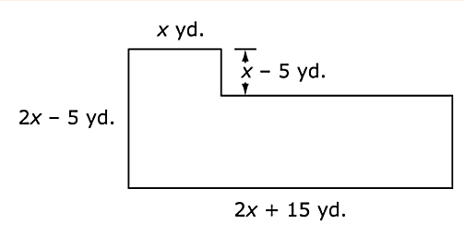  - Write an expression for the area, in square feet, of this proposed parking lot. Explain the reasoning you used to find the expression.  - The town council has plans to double the area of the parking lot in a few years. They plan to increase the length of the base of the parking lot by $p$ yards, as shown in the diagram below.  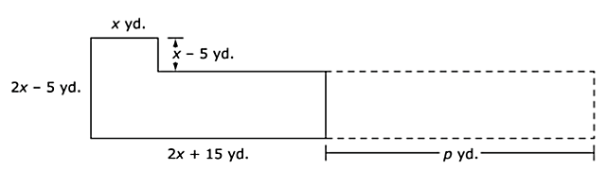  Write an expression in terms of $x$ to represent the value of $p$, in feet. Explain the reasoning you used to find the  value of $p.$

Algebra: Arithmetic with Polynomials and Rational Expressions (A-APR)
Understand the relationship between zeros and factors of polynomials.
Louisiana Standard |  | Explanations and Examples
A1: A-APR.B.3. Identify zeros of quadratic functions and use the zeros to sketch a graph of the function defined by the polynomial. |  | This standard calls for a sketch of the graph after zeros are identified. Sketching implies that the graph should be done by hand rather than generated by a graphing calculator.  Examples:  - Given the function$f(x)=2x^{2}+6x-3$, list the zeroes of the function and sketch the graph.  - Sketch the graph of the function $f(x)={(x+5)}^{2}$. How many zeros does this function have? Explain. How does the multiplicity relate to the graph of the function?

Algebra: Creating Equations (A-CED)
Create equations that describe numbers or relationships.
Louisiana Standard |  | Explanations and Examples
A1: A-CED.A.1. Create equations and inequalities in one variable and use them to solve problems. Include equations arising from linear, quadratic, and exponential functions. |  | Equations can represent real world and mathematical problems. Include equations and inequalities that arise when comparing the values of two different functions, such as one describing linear growth and one describing exponential growth.  Examples:  - To be considered a ‘fuel efficient’ vehicle, a car must get more than 30 miles per gallon. Consider a test run of 200 miles. How many gallons of fuel can a car use and be considered ‘fuel-efficient’?  - Given that the following trapezoid has an area of 54 cm², set up an equation to find the length of the base, and solve the equation.  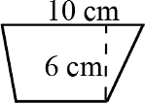  - Lava coming from the eruption of a volcano follows a parabolic path. The height h in feet of lava t seconds after it is ejected from the volcano is given by $h(t)=-t^{2}+16t+936$. After how many seconds does the lava reach its maximum height of 1000 feet?  - A rental agreement locks the monthly rent of an apartment to a constant value for one year. The average rate to rent an apartment is $750 per month and increases at an inflation rate of 8% per year. If inflation continues at the current rate, on which year will the rent be at least $1000 per month?
A1: A-CED.A.2. Create equations in two or more variables to represent relationships between quantities; graph equations on coordinate axes with labels and scales. |  | Students:  - Create equations in two variables.  - Graph equations on coordinate axes with labels and scales clearly labeling the axes, defining what the values on the axes represent and the unit of measure.  - Select intervals for the scale that are appropriate for the context and display adequate information about the relationship.  - Interpret the context and choose appropriate minimum and maximum values for a graph.  Linear equations can be written in a multitude of ways; $y=mx+b$ and $ax+by=c$ are commonly used forms (given that x and y are the two variables). Students should be flexible in using multiple forms and recognizing from the context, which is appropriate to use in creating the equation.  Examples:  - At a fundraising event, the FFA sold hot dogs for $1.50 and drinks for $2.00. The FFA earned $400 at the fundraiser.  - Write an equation to calculate the total of $400 based on the hot dog and drink sales.  - Graph the relationship between hot dog sales and drink sales.  - A spring with an initial length of 25 cm will compress 0.5 cm for each pound applied.  - Write an equation to model the relationship between the amount of weight applied and the length of the spring.  - Graph the relationship between pounds and length.  - What does the graph reveal about limitation on weight?  Quadratic equations can be written in a multitude of ways; $y=ax^{2}+bx+c$ and $y=k(x+m)(x+n)$ are commonly used forms (given that x and y are the two variables). Students should be flexible in using multiple forms and recognizing from the context, which is appropriate to use in creating the equation.  Examples:  - The cheerleaders are launching T-shirts into the stands at a football game. They are launching the T-shirts from a height of 3 feet off the ground and an initial velocity of 36 feet per second. What function rule shows a T-shirt’s height h related to the time t? (Use 16$t$² for the effect of gravity on the height of the T-shirt.)  - The local park is designing a new rectangular sandlot. The sandlot is to be twice as long as the original square sandlot and 3 feet less than its current width. What must be true of the original square lot to justify that the new rectangular lot has more area? Note: Students can construct the equations for each area and graph each equation. Students should select scales for the length of the original square and the area of the lots suitable for the context.
A1: A-CED.A.2. continued |  | Exponential equations can be written in different ways; $y=ab^{x}$and $y=a {(1±r)}^{x}$ are the most common forms (given that x and y are variables). Students should be flexible in using all forms and recognizing from the context which is appropriate to use in creating the equation.  Example:  - In a woman’s professional tennis tournament, the money a player wins depends on her finishing place in the standings. The first-place finisher wins half of $1,500,000 in total prize money. The second-place finisher wins half of what is left; then the third-place finisher wins half of that, and so on.  - Write a rule to calculate the actual prize money in dollars won by the player finishing in nth place, for any positive integer$n$.  - Graph the relationship between the first 10 finishers and the prize money in dollars.  - What pattern is indicated in the graph? What type of relationship exists between the two variables?

A1: A-CED.A.3. Represent constraints by equations or inequalities, and by systems of equations and/or inequalities, and interpret solutions as viable or non-viable options in a modeling context. For example, represent inequalities describing nutritional and cost constraints on combinations of different foods. | Students:  - Recognize when a constraint can be modeled with an equation, inequality, or system of equations/inequalities. These constraints may be stated directly or be implied through the context of the given situation.  - Create, select, and use graphical, tabular, and/or algebraic representations to solve the problem.  In Algebra I, focus on linear equations and inequalities. Students should approach optimization problems using a problem-solving process, such as using a table.  Examples:  - Represent constraints by a system of equations or inequalities.  A club is selling hats and jackets as a fundraiser. Their budget is $1500 and they want to order at least 250 items. They must buy at least as many hats as they buy jackets. Each hat costs $5 and each jacket costs $8.  - Write a system of inequalities to represent the situation.  - Graph the inequalities.  - Interpret solutions as viable or nonviable options in a modeling context.  A club is selling hats and jackets as a fundraiser. Their budget is $1500 and they want to order at least 250 items. They must buy at least as many hats as they buy jackets. Each hat costs $5 and each jacket costs $8.  - If the club buys 150 hats and 100 jackets, will the conditions be satisfied?  - What is the maximum number of jackets they can buy and still meet the conditions?

A1: A-CED.A.4. Rearrange formulas to highlight a quantity of interest, using the same reasoning as in solving equations. For example, rearrange Ohm’s law V = IR to highlight resistance R. | Students solve multi-variable formulas or literal equations for a specific variable.  In Algebra I, limit to formulas that are linear in the variable of interest, or to formulas involving squared or cubed variables. Explicitly connect this to the process of solving equations using inverse operations.  Examples:  - The Pythagorean Theorem expresses the relation between legs $a$ and $b$ of a right triangle and its hypotenuse c with the equation a² + b² = c².  - Why might the theorem need to be solved for $c$?  - Solve the equation for c and write a problem situation where this form of the equation might be useful.  - Solve for radius r.  - Motion can be described by the formula $s$ = $ut$+ $\frac{1}{2}at$², where t = time elapsed, u = initial velocity, a = acceleration, and s = distance traveled.  - Why might the equation need to be rewritten in terms of $a$?  - Rewrite the equation in terms of $a$.

Algebra: Creating Equations (A-REI)
Understand solving equations as a process of reasoning and explain the reasoning.
Louisiana Standard | Explanations and Examples

A1: A-REI.A.1. Explain each step in solving a simple equation as following from the equality of numbers asserted at the previous step, starting from the assumption that the original equation has a solution. Construct a viable argument to justify a solution method. | Students should focus on solving all applicable equation types presented in Algebra I and be able to extend and apply their reasoning to other types of equations in future courses.  Explain each step in solving a simple equation as following from the equality of numbers asserted at the previous step, starting from the assumption that the original equation has a solution.  - When solving equations, students will use the properties of equality to justify and explain each step obtained from the previous step, assuming the original equation has a solution, and develop an argument that justifies their method.  - For quadratic functions, justifications for steps to show zeros align with F.IF.C.8 and should include rewriting the equation into an equivalent form using factoring and using the multiplicative property of zero to write the equations that allow the zeros to be shown.  Examples:  - Assuming an equation has a solution; construct a convincing argument that justifies each step in the solution process. Justifications may include the associative, commutative, division and identity properties, combining like terms, etc.  Method 1: $$5\left(x+3\right)-3x=55$$ $5x+15-3x=55$ $2x+15=55$ $2x+15-15=55-15$ $2x=40$ $\frac{2x}{2}=\frac{40}{2}$ $x=20$ Method 2: $5\left(x+3\right)-3x=55$ $\frac{5\left(x+3\right)}{5}-\frac{3x}{5}=\frac{55}{5}$ $x+3-\frac{3}{5}x=11$ $\frac{2}{5}x+3=11$ $\frac{2}{5}x+3-3=11-3$ $\frac{2}{5}x=8$ $\frac{5}{2}\left(\frac{2}{5}\right)x=\frac{5}{2}(8)$ $x=20$  Justifications may include the associative, commutative, division and identity properties, combining like terms, etc.  - For quadratic examples, see Illustrative Math tasks posted at https://www.illustrativemathematics.org/content-standards/tasks/2144

Algebra: Creating Equations (A-REI)
Solve equations and inequalities in one variable.
Louisiana Standard | Explanations and Examples
A1: A-REI.B.3. Solve linear equations and inequalities in one variable, including equations with coefficients represented by letters. | Examples:  Solve:  - $\frac{7}{3}y-8=111$ - $3x>9$ - Solve$ax+7=12$ for$x$. - $\frac{3+x}{7}=\frac{x-9}{4}$ - $\frac{2}{3}x+9<18$ - Solve $(y-y_{1})=m(x-x_{1})$ for m.
A1: A-REI.B.4. Solve quadratic equations in one variable.  - Use the method of completing the square to transform any quadratic equation in $x$ into an equation of the form  ($x$– $p$)² = q that has the same solutions. Derive the quadratic formula from this form.  - Solve quadratic equations by inspection (e.g., for $x$² = 49), taking square roots, completing the square, the quadratic formula and factoring, as appropriate to the initial form of the equation. Recognize when the quadratic formula gives complex solutions and write them as “no real solution.” | Students should solve by factoring, completing the square, and using the quadratic formula. The zero product property is used to explain why the factors are set equal to zero. Students should relate the value of the discriminant to the type of root to expect. A natural extension would be to relate the type of solutions to $ax^{2}+bx+c=0$ to the behavior of the graph of $y=ax^{2}+bx+$c. Students in Algebra I should recognize when roots are complex and indicate that there are no real solutions rather than writing in $a±bi$ form.  Value of Discriminant Nature of Roots Nature of Graph  $b^{2}–4ac=0$ 1 real roots intersects $x$-axis once  $b^{2}–4ac>0$ 2 real roots intersects $x$-axis twice  $b^{2}–4ac<0$ 2 complex roots does not intersect $x$-axis  Examples:  - Determine the type of roots for the equation 2$x$² + 5 = 2$x$? Explain how you know.  - What is the nature of the roots of $x$² + 6$x$ + 10 = 0? Solve the equation using the quadratic formula and completing the square. How are the two methods related?

Algebra: Creating Equations (A-REI)
Solve systems of equations.
Louisiana Standard | Explanations and Examples
A1: A-REI.C.5. Prove that, given a system of two equations in two variables, replacing one equation by the sum of that equation and a multiple of the other produces a system with the same solutions. | The focus of this standard is to provide mathematical justification for the addition (elimination) method of solving systems of equations ultimately transforming a given system of two equations into a simpler equivalent system that has the same solutions as the original system. This work builds on student experiences in graphing and solving systems of linear equations from middle school to focus on justification of the methods used and includes cases where the two equations describe the same line (yielding infinitely many solutions) and cases where two equations describe parallel lines (yielding no solution), connecting to GPE.B.5, which requires students to prove the slope criteria for parallel lines.  Example:  - Use the system to explore what happens graphically with different combinations of the linear equations.  $\left\{\begin{matrix}2x+y=13 \\ x+y=10\end{matrix}\right.$  - Graph the original system of linear equations. Describe the solution of the system and how it relates to the solutions of each individual equation.  - Add the two linear equations together and graph the resulting equation. Describe the solutions to the new equation and how they relate to the system’s solution.  - Explore what happens with other combinations such as:  - Multiply the first equation by 2 and add to the second equation  - Multiply the second equation by -2 and add to the first equation  - Multiply the second equation by -1 and add to the first equation  - Multiply the first equation by -1 and add to the second equation  - Are there any combinations that are more informative than others?  - Make a conjecture about the solution to a system and any combination of the equations.
A1: A-REI.C.6. Solve systems of linear equations exactly and approximately (e.g., with graphs), focusing on pairs of linear equations in two variables. | The system solution methods can include but are not limited to graphical, elimination/linear combination, substitution, and modeling. Systems can be written algebraically or can be represented in context. Students may use graphing calculators, programs, or applets to model and find approximate solutions for systems of equations.  Examples:  - José had 4 times as many trading cards as Phillipe. After José gave away 50 cards to his little brother and Phillipe gave 5 cards to his friend for this birthday, they each had an equal amount of cards. Write a system to describe the situation and solve the system.  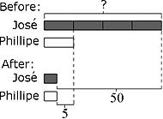  - A restaurant serves a vegetarian and a chicken lunch special each day. Each vegetarian special is the same price. Each chicken special is the same price. However, the price of the vegetarian special is different from the price of the chicken special.  - On Thursday, the restaurant collected $467 selling 21 vegetarian specials and 40 chicken specials.  - On Friday, the restaurant collected $484 selling 28 vegetarian specials and 36 chicken specials.  What is the cost of each lunch special?  - Solve the system of equation$s$. Use a second method to verify your answer.  $\left\{ \begin{aligned}x+y=11 \\ 3x – y = 5\end{aligned}\right.$

Algebra: Creating Equations (A-REI)
Represent and solve equations and inequalities graphically.
Louisiana Standard | Explanations and Examples
A1: A-REI.D.10. Understand that the graph of an equation in two variables is the set of all its solutions plotted in the coordinate plane, often forming a curve (which could be a line). | In Algebra I, students focus on linear, quadratic, and exponential equations and are able to adapt and apply that learning to other types of equations in future courses. Students can explain and verify that every point ($x,$ $y$) on the graph of an equation represents all values for $x$and $y$ that make the equation true.  Examples:  - Which of the following points are on the graph of the equation $-5x+2y=20?$ How many points are on this graph? Explain.  - $(4, 0)$  - $(0, 10)$  - $(-1, 7.5)$  - $(2.3, 5)$  - Verify that (-1, 60) is a solution to the equation $y=15{\left( \frac{1}{4} \right)}^{x}$. Explain what this means for the graph of the function.  - Given the graph of $g(x)$, provide at least three solutions to $g(x)=y$.  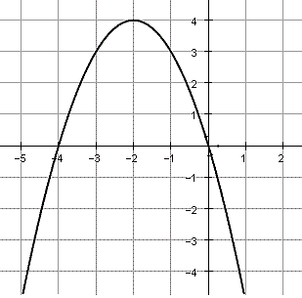
A1: A-REI.D.11. Explain why the x-coordinates of the points where the graphs of the equations $y = f(x)$ and $y = g(x)$ intersect are the solutions of the equation $f(x) = g(x)$; find the solutions approximately, e.g., using technology to graph the functions, make tables of values, or find successive approximations. Include cases where$f(x)$ and/or $g(x)$ are linear, polynomial, rational, piecewise linear (to include absolute value), and exponential functions. | Students understand that numerical solution methods (data in a table used to approximate an algebraic function) and graphical solution methods may produce approximate solutions, and algebraic solution methods produce precise solutions that can be represented graphically or numerically. Students may use graphing calculators or programs to generate tables of values, graph, or algebraic methods (including substitution and elimination for systems) to solve equations and systems of equations.  Examples:  - The functions $f\left(m\right)=18+0.4m$ and $g\left(m\right)=11.2+0.54m$give the lengths of two different springs in centimeters, as mass is added in grams, m, to each separately.  - Graph each equation on the same set of axes.  - What mass makes the springs the same length?  - What is the length at that mass?  - Write a sentence comparing the two springs.  - Solve the following systems of equations by graphing. Give your answer to the nearest tenth.  - $3\left(2^{x}\right)=6x-7$  - $10x+5=-x+8$  - Given the following equations determine the $x$-value that results in an equal output for both functions.  $$f(x) = 3x – 2$$  $$g(x) = {(x + 3)}^{2}-1$$  - Graph the following system and approximate solutions for $f(x)=g(x).$  $f\left(x\right)=\frac{x+4}{2-x}$ and $g\left(x\right)=x^{3}-6x^{2}+3x+10$

A1: A-REI.D.12. Graph the solutions to a linear inequality in two variables as a half-plane (excluding the boundary in the case of a strict inequality), and graph the solution set to a system of linear inequalities in two variables as the intersection of the corresponding half-planes. | Students may use graphing calculators, programs, or applets to model and find solutions for inequalities or systems of inequalities.  Examples:  - Graph the solution: $y$ < 2$x$+ 3.  - A publishing company publishes a total of no more than 100 magazines every year. At least 30 of these are women’s magazines, but the company always publishes at least as many women’s magazines as men’s magazines. Find a system of inequalities that describes the possible number of men’s and women’s magazines that the company can produce each year consistent with these policies. Graph the solution set.  - Graph the system of linear inequalities below and determine if (3, 2) is a solution to the system.  $$\left\{\begin{aligned}x-3y>0 \\ x+y≤2 \\ x+3y>-3\end{aligned}\right.$$  Solution:  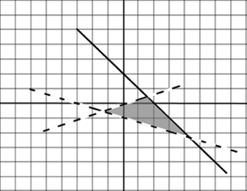  (3, 2) is not an element of the solution set (graphically or by substitution).

Functions: Interpreting Functions (F-IF)
Understand the concept of a function and use function notation.
Louisiana Standard | Explanations and Examples
A1: F-IF.A.1. Understand that a function from one set (called the domain) to another set (called the range) assigns to each element of the domain exactly one element of the range. If $f$is a function and $x$ is an element of its domain, then $f(x)$denotes the output of $f$corresponding to the input $x$. The graph of$f$ is the graph of the equation $y=f(x$). | Students use the definition of a function to determine whether a relationship is a function given a table, graph or words.  Example:  - Determine which of the following tables represent a function and explain why.  Table A Table B  $$x$$ $$y$$ $$r$$ $$T$$  0 1 0 0  1 2 1 2  2 2 1 3  3 4 4 5  Given the function $f(x)$, students explain that input values are guaranteed to produce unique output values and use the function rule to generate a table or graph. They identify $x$as an element of the domain, the input, and $f(x)$ as an element in the range, the output. The domain of a function given by an algebraic expression, unless otherwise specified, is the largest possible domain. Students recognize that the graph of the function,$f$, is the graph of the equation $y=f(x)$ and that $(x, f(x))$ is a point on the graph of $f$.  Example:  - A pack of pencils cost $0.75. If $n$ number of packs are purchased then the total purchase price is represented by the function $t(n) = 0.75n$.  - Explain why t is a function.  - What is a reasonable domain and range for the function t?  - Graph function t.
A1: F-IF.A.2. Use function notations, evaluate functions for inputs in their domains, and interpret statements that use function notation in terms of a context. | Use function notation and evaluate functions for inputs in their domains.  Examples:  - Evaluate $f\left(2\right)$ for the function $f\left(x\right)=5\left(x-3\right)+17$.  - Evaluate $f\left(2\right)$ for the function $f\left(x\right)=1200{(1+.04)}^{x}$.  Interpret statements that use function notation in terms of a context.  - You placed a yam in the oven and, after 45 minutes, you take it out. Let $f$ be the function that assigns to each minute after you placed the yam in the oven, its temperature in degrees Fahrenheit. Write a sentence for each of the following to explain what it means in everyday language.  - $f(0)=65$  - $f(5)<f(10)$  - $f(40)=f(45)$  - $f(45)>f(60)$  - The rule $f\left(x\right)=50{(0.85)}^{x}$represents the amount of a drug in milligrams$, f(x)$, which remains in the bloodstream after $x$ hours. Evaluate and interpret each of the following:  - $f(0)$  - $f(2)=k·f(1)$. What is the value of k?  - $f(x)<6$  - If $h(t)= -16t^{2} + 5t +7$ models the path of an object projected into the air where t is time in seconds and $h(t)$ is the vertical height in feet.  - Find $h(5)$ and explain the meaning of the solution.  - Find $t$ when$h(t) = 0$. Explain your reasoning.

A1: F-IF.A.3. Recognize that sequences are functions whose domain is a subset of the integers. Relate arithmetic sequences to linear functions and geometric sequences to exponential functions. | A sequence can be described as a function, with the input numbers consisting of a subset of the integers, and the output numbers being the terms of the sequence. The most common subset for the domain of a sequence is the Natural numbers {1, 2, 3, …}; however, there are instances where it is necessary to include {0} or possibly negative integers. Whereas, some sequences can be expressed explicitly, there are those that are a function of the previous terms. In which case, it is necessary to provide the first few terms to establish the relationship. Students recognize that arithmetic sequences are linear functions and geometric sequences are exponential functions. As such, consecutive terms in an arithmetic sequence have a common difference (e.g., 1, 3, 5, 7…is generated by adding 2 to the previous term; thus, the common difference is 2). Consecutive terms in a geometric sequence have the same ratio (e.g., 1, 3, 9, 27, 81 is generated by multiplying the previous term by a factor of 3; therefore, the comon ratio is 3:1).  Examples:  - A theater has 60 seats in the first row, 68 seats in the second row, and 76 seats in the third row. The number of seats in the remaining rows continue in this pattern  - Write the number of seats as a sequence.  - What is the domain of the sequence? Explain what the domain represents in context.  - Explain why the sequence is considered a function.  - Graph the function.  - Is the sequence arithmetic or geometric? Explain how you know.  - If the theater has 20 rows of seats, how many seats are in the twentieth row?  - Stocks of a company are initially issued at the price of $10. The value of the stock grows by 25% every year.  - Complete the table below to determine the value of the stock for 5 years. Round the value for each year to the nearest cent.  Solution:  Year Value Year Value  0 10 0 10.00  1 1 12.50  2 2 15.63  3 3 19.53  4 4 24.48  5 5 30.52  - Do the values represent an arithmetic sequence or a geometric sequence? Explain how you know.  - Graph the values in your table on a coordinate plane. Explain how the shape of the graph does or does not support your answer in part b.

Functions: Interpreting Functions (F-IF)
Interpret functions that arise in applications in terms of the context.
Louisiana Standard |  | Explanations and Examples
A1: F-IF.B.4. For linear, piecewise linear (to include absolute value), quadratic, and exponential functions that model a relationship between two quantities, interpret key features of graphs and tables in terms of the quantities, and sketch graphs showing key features given a verbal description of the relationship. Key features include: intercepts; intervals where the function is increasing, decreasing, positive, or negative; relative maximums and minimums; symmetries; and end behavior. |  | Students interpret the key features of the different functions listed in the standard. When given a table or graph of a function that models a real-life situation, explain the meaning of the characteristics of the table or graph in the context of the problem.  Key features  - of a linear function are slope and intercepts  - of a quadratic function are intervals of increase/decrease, positive/negative, maximum/minimum, symmetry, and intercepts  - of an exponential function include y-intercept and increasing/decreasing itervals  - of an absolute value include y-intercept, minimum or maximum, increasing or decreasing intervals, and symmetry  Examples:  - The local newspaper charges for advertisements in their community section. A customer has called to ask about the charges. The newspaper gives the first 50 words for free and then charges a fee per word. Use the table at the right to describe how the newspaper charges for the ads. Include all important information.  # of words 50 60 70 80 90 100  Cost ($) 0.00 0.50 1.00 1.50 2.00 2.50  - Suppose $h\left(t\right)= -5t^{2}+10t+3$ is an expression giving the height of a diver above the water (in meters),$t$ seconds after the diver leaves the springboard.  - How high above the water is the springboard? Justify your answer.  - When does the diver hit the water? Justify your answer.  - At what time on the diver's descent toward the water is the diver again at the same height as the springboard? Justify your answer.  - When does the diver reach the peak of the dive? Justify your answer.
A1: F-IF.B.4 continued |  | 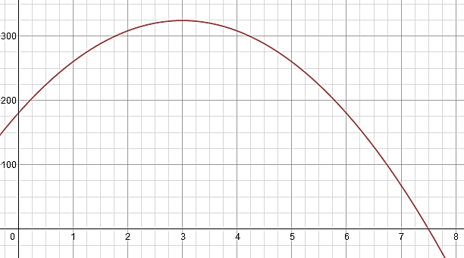  - The graph represents the height (in feet) of a rocket as a function of the time (in seconds) since it was launched. Use the graph to answer the following:  - What is the appropriate domain for t in this context? Why?  - What is the height of the rocket two seconds after it was launched?  - What is the maximum value of the function and what does it mean in context?  - When is the rocket 100 feet above the ground?  - When is the rocket 250 feet above the ground?  - Why are there two answers to part e but only one practical answer for part d?  - What are the intercepts of this function? What do they mean in the context of this problem?  - What are the intervals of increase and decrease on the practical domain? What do they mean in the context of the problem?  - Jack planted a mysterious bean just outside his kitchen window. Jack kept a table (shown below) of the plant’s growth. He measured the height at 8:00 am each day.  Day 0 1 2 3 4  Height (cm) 2.56 6.4 16 40 100  - What was the initial height of Jack’s plant?  - How is the height changing each day?  - If this pattern continues, how tall should Jack’s plant be after 8 days?  - The front of a camping tent can be modeled by the function $y=-1.4\left|x - 2.5\right|+3.5$ where $x$ and $y$are measured in feet and the $x$-axis represents the ground.  - Graph the function.  - What does the point (2.5, 3.5) represent in the context of the situation?  - What are the height and width of the tent?  - What are the intervals of increase or decrease?

A1: F-IF.B.5. Relate the domain of a function to its graph and, where applicable, to the quantitative relationship it describes. For example, if the function h(n) gives the number of person-hours it takes to assemble n engines in a factory, then the positive integers would be an appropriate domain for the function. | Students relate the domain of a function to its graph and, where applicable, the quantitative relationship it describes.  Examples:  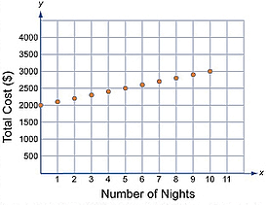  - An all-inclusive resort in Los Cabos, Mexico provides everything for their customers during their stay including food, lodging, and transportation. Use the graph below to describe the domain of the total cost function.  - Maggie tosses a coin off of a bridge into a stream below. The distance the coin is above the water is modeled by the equation $y=-16x^{2}+96x+112,$where x represents time in seconds. What is a reasonable domain for the function?  - Oakland Coliseum Problem: https://www.illustrativemathematics.org/content-standards/HSF/IF/B/5/tasks/631  - A hotel has 10 stories above ground and 2 levels in its parking garage below ground. What is an appropriate domain for a function, $T(n)$, that gives the average number of times an elevator in the hotel stops at the $n$^{th} floor each day? Students should recognize that$n=0$ is not in the domain. Buildings don’t have a 0 floor, so the domain is strictly $\{-2, -1, 1, 2, 3, 4, 5, 6, 7, 8, 9, 10\}$.

 | A1: F-IF.B.6. Calculate and interpret the average rate of change of a linear, quadratic, piecewise linear (to include absolute value), and exponential function (presented symbolically or as a table) over a specified interval. Estimate the rate of change from a graph. |  |  | The average rate of change of a function $y$= f($x$) over an interval $[a,b]$ is $\frac{Δy}{Δx}=\frac{f\left(b\right)-f\left(a\right)}{b-a}$  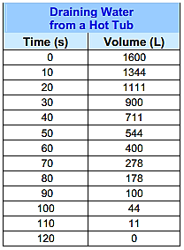  In addition to finding average rates of change from functions given symbolically, graphically, or in a table. Students may collect data from experiments or simulations (ex. falling ball, velocity of a car, etc.) and find average rates of change for the function modeling the situation.  Examples:  - The plug is pulled in a small hot tub. The table gives the volume of water in the tub from the moment the plug is pulled, until it is empty. What is the average rate of change between:  - 60 seconds and 100 seconds?  - 0 seconds and 120 seconds?  - 70 seconds and 110 seconds?  - Find the average rate of change in the quadratic over the interval $1≤x≤4$.  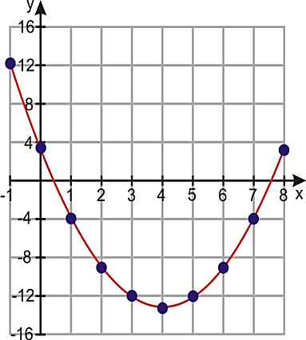  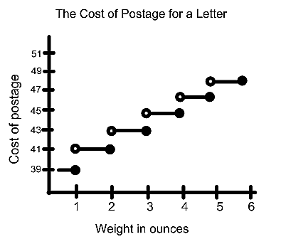  - Compare the rate of change for the cost of postage for a letter for the interval $1≤x≤2$ to the interval $3 ≤x≤6.$  - High School Gym Problem, Part D:  https://www.illustrativemathematics.org/content-standards/HSF/IF/B/6/tasks/577

Functions: Interpreting Functions (F-IF)
Analyze functions using different representations.
Louisiana Standard |  |  | Explanations and Examples
A1: F-IF.C.7. Graph functions expressed symbolically and show key features of the graph, by hand in simple cases and using technology for more complicated cases.  - Graph linear and quadratic functions and show intercepts, maxima, and minima.  - Graph piecewise linear (to include absolute value) and exponential functions. |  |  | Key characteristics include but are not limited to maxima, minima, intercepts, symmetry, end behavior, and asymptotes. Students may use graphing calculators or programs, spreadsheets, or computer algebra systems to graph functions.  Examples:  - Describe key characteristics of the graph of $f(x)=│x–3│+5$.  - Sketch the graph and identify the key characteristics of the function described below.  $f\left(x\right)= \left\{\begin{aligned}x+2 \text{ for} x ≥0 \\ x+5 \text{for} x <-1\end{aligned}\right.$  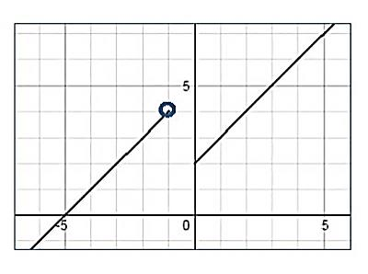  - Graph the function f($x$) = $2^{x}$by creating a table of values. Identify the key characteristics of the graph.
A1: F-IF.C.8. Write a function defined by an expression in different but equivalent forms to reveal and explain different properties of the function.  - Use the process of factoring and completing the square in a quadratic function to show zeros, extreme values, and symmetry of the graph, and interpret these in terms of a context. |  |  | Focus on factoring as a process to show zeroes, extreme values, and symmetry of the graph. Students should be prepared to factor quadratics in which the coefficient of the quadratic term is an integer that may or may not be the GCF of the expression. Students must use the factors to reveal and explain properties of the function, interpreting them in context. Factoring just to factor does not fully address this standard.  Example:  - The quadratic expression $-5x²+10x+15$ represents the height of a diver jumping into a pool off a platform. Use the process of factoring to determine key properties of the expression and interpret them in the context of the problem.
A1: F-IF.C.9. Compare properties of two functions (linear, quadratic, piecewise linear [to include absolute value] or exponential) each represented in a different way (algebraically, graphically, numerically in tables, or by verbal descriptions). For example, given a graph of one quadratic function and an algebraic expression for another, determine which has the larger maximum. |  |  | Examples:  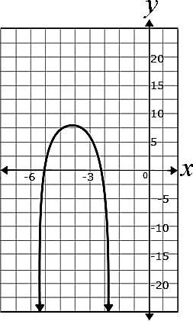  - Examine the functions below. Which function has the larger maximum? How do you know?  $$f\left(x\right)=-2x^{2}˗8x+20$$  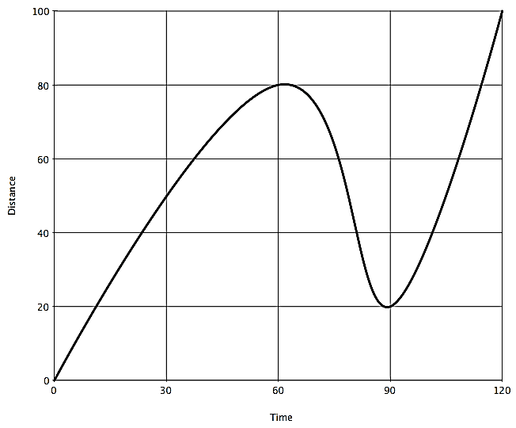  - Compare the properties of the two functions graphed below.  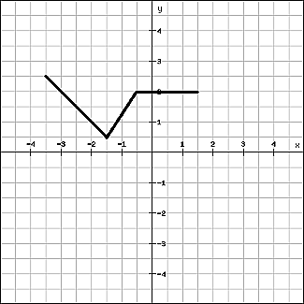

Functions: Building Functions (F-BF)
Build a function that models a relationship between two quantities.
Louisiana Standard |  | Explanations and Examples
A1: F-BF.A.1. Write a linear, quadratic, or exponential function that describes a relationship between two quantities.  - Determine an explicit expression, a recursive process, or steps for calculation from a context. |  | Students write functions that describe relationships. Students will  - Analyze a given problem to determine the function expressed by identifying patterns in the function’s rate of change.  - Specify intervals of increase, decrease, constancy, and relate them to the function’s description in words or graphically.  Examples:  - The height of a stack of cups is a function of the number of cups in the stack. If a 7.5” cup with a 1.5” lip is stacked vertically, determine a function that would provide you with the height based on any number of cups. Hint: Start with height of one cup and create a table, list, graph or description that describes the pattern of the stack as an additional cup is added.  - The price of a new computer decreases with age. Examine the table by analyzing the outputs.  - Informally describe a recursive relationship. Note: Determine the average rate at which the computer is decreasing over time.  - Analyze the input and the output pairs to determine an explicit function that represents the value of the computer when the age is known.  - Sidewalk Patterns from http://map.mathshell.org/tasks.php?unit=HA06&collection=9&redir=1  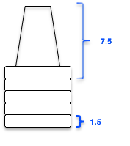  - Skeleton Tower: http://www.illustrativemathematics.org/illustrations/75
A1: F-BF.B.3. Identify the effect on the graph of replacing $f(x)$ by $f\left(x\right)+ k, kf(x), f(kx),$ and $f(x + k)$ for specific values of $k$(both positive and negative). Without technology, find the value of$k$ given the graphs of linear and quadratic functions. With technology, experiment with cases and illustrate an explanation of the effects on the graph that include cases where $f(x$) is a linear, quadratic, piecewise linear (to include absolute value), or exponential function. |  | Students may use graphing calculators or programs, spreadsheets, or computer algebra systems to graph functions.  Examples:  - Compare the shape and position of the graphs of $f\left(x\right)=x^{2}$ and $\left(x\right)=2x^{2}$, and explain the differences in terms of the algebraic expressions for the functions.  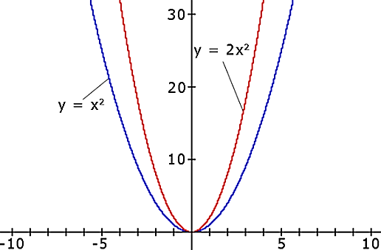  - Describe effect of varying the parameters a, h, and k have on the shape and position of the graph of $f\left(x\right)=a{(x-h)}^{2}+k$.  - Describe the effect of varying the parameters a, h, and k on the shape and position of the graph $f(x)=ab(x+h)+k$, orally or in written format. What effect do values between 0 and 1 have? What effect do negative values have?  - A single bacterium is placed in a test tube and splits in two after one minute. After two minutes, the resulting two bacteria split in two, creating four bacteria. This process continues.  - How many bacteria are in the test tube after 5 minutes? 15 minutes?  - Write a recursive rule to find the number of bacteria in the test tube from one minute to the next.  - Convert this rule into explicit form. How many bacteria are in the test tube after one hour?

Functions: Linear, Quadratic, and Exponential Models (F-LE)
Construct and compare linear, quadratic, and exponential models and solve problems.
Louisiana Standard | Explanations and Examples
A1: F-LE.A.1. Distinguish between situations that can be modeled with linear functions and with exponential functions.  - Prove that linear functions grow by equal differences over equal intervals, and that exponential functions grow by equal factors over equal intervals.  - Recognize situations in which one quantity changes at a constant rate per unit interval relative to another.  - Recognize situations in which a quantity grows or decays by a constant percent rate per unit interval relative to another. | Students may use graphing calculators or programs, spreadsheets, or computer algebra systems to model and compare linear and exponential functions.  Students distinguish between a constant rate of change and a constant percent rate of change.  Examples:  - Town A adds 10 people per year to its population, and town B grows by 10% each year. In 2006, each town has 145 residents. For each town, determine whether the population growth is linear or exponential. Explain.  - Sketch and analyze the graphs of the following two situations. What information can you conclude about the types of growth each type of interest has?  - Lee borrows $9,000 from his mother to buy a car. His mom charges him 5% interest a year, but she does not compound the interest.  - Lee borrows $9,000 from a bank to buy a car. The bank charges 5% interest compounded annually.  Students recognize situations where one quantity changes at a constant rate per unit interval relative to another.  Example:  - A streaming movie service has three monthly plans to rent movies online. Graph the equation of each plan and analyze the change as the number of rentals increase. When is it beneficial to enroll in each of the plans?  Basic Plan: $3 per movie rental  Watchers Plan: $7 fee + $2 per movie with the first two movies included with the fee  Home Theater Plan: $12 fee + $1 per movie with the first four movies included with the fee  Students recognize situations where one quantity changes as another changes by a constant percent rate.  - When working with symbolic form of the relationship, if the equation can be rewritten in the form $y=a{(1 ± r)}^{x}$, then the relationship is exponential and the constant percent rate per unit interval is r.  - When working with a table or graph, either write the corresponding equation and see if it is exponential or locate at least two pairs of points and calculate the percent rate of change for each set of points. If these percent rates are the same, the function is exponential. If the percent rates are not all the same, the function is not exponential.
A1: F-LE.A.1 continued | Examples:  - A couple wants to buy a house in five years. They need to save a down payment of $8,000. They deposit $1,000 in a bank account earning 3.25% interest, compounded quarterly. How long will they need to save in order to meet their goal?  - Carbon 14 is a common form of carbon which decays exponentially over time. The half-life of Carbon 14, that is the amount of time it takes for half of any amount of Carbon 14 to decay, is approximately 5730 years. Suppose we have a plant fossil and that the plant, at the time it died, contained 10 micrograms of Carbon 14 (one microgram is equal to one millionth of a gram).  - Using this information, make a table to calculate how much Carbon 14 remains in the fossilized plant after n number of half-lives.  - How much carbon remains in the fossilized plant after 2865 years? Explain how you know.  - When is there one microgram of Carbon 14 remaining in the fossil?
A1: F-LE.A.2. Construct linear and exponential functions, including arithmetic and geometric sequences, given a graph, a description of a relationship, or two input-output pairs (include reading these from a table). | Students use graphs, a verbal description, or two-points (which can be obtained from a table) to construct linear or exponential functions.  Example:  - Albuquerque boasts one of the longest aerial trams in the world. The tram transports people up to Sandia Peak. The table shows the elevation of the tram at various times during a particular ride.  Minutes into the ride 2 5 9 14  Elevation in feet 7069 7834 8854 10,129  - Write an equation for a function that models the relationship between the elevation of the tram and the number of minutes into the ride.  - What was the elevation of the tram at the beginning of the ride?  - If the ride took 15 minutes, what was the elevation of the tram at the end of the ride?  - After a record setting winter storm, there are 10 inches of snow on the ground! Now that the sun is finally out, the snow is melting. At 7 am there were 10 inches and at 12 pm there were 6 inches of snow.  - Construct a linear function rule to model the amount of snow.  - Construct an exponential function rule to model the amount of snow.  - Which model best describes the amount of snow? Provide reasoning for your choice
A1: F-LE.A.3. Observe using graphs and tables that a quantity increasing exponentially eventually exceeds a quantity increasing linearly, quadratically, or (more generally) as a polynomial function. | Examples:  - Compare the values of the functions $f(x)=2x$, $f(x)=2^{x}$, and $f(x)=x²$for $x≥0$.  - Kevin and Joseph each decide to invest $100. Kevin decides to invest in an account that will earn $5 every month. Joseph decided to invest in an account that will earn 3% interest every month.  - Whose account will have more money in it after two years?  - After how many months will the accounts have the same amount of money in them?  - Describe what happens as the money is left in the accounts for longer periods of time.

A1: F-LE.B.5. Interpret the parameters in a linear or exponential function in terms of a context. | Use real-world situations to help students understand how the parameters of linear and exponential functions depend on the context.  Examples:  - A plumber who charges $50 for a house call and $85 per hour can be expressed as the function  $y=85x+50$. If the rate were raised to $90 per hour, how would the function change?  - Lauren keeps records of the distances she travels in a taxi and what it costs:  Distance, d (miles) Fare, f (dollars)  3 8.25  5 12.75  11 26.25  - If you graph the ordered pairs $(d, f)$ from the table, they lie on a line. How can this be determined without graphing them?  - Show that the equation for Part a is $f=2.25d+1.5$.  - What do the 2.25 and the 1.5 in the equation represent in terms of taxi rides?  - A function of the form $f(n)=P{(1+r)}^{n}$ is used to model the amount of money in a savings account that earns 8% interest, compounded annually, where n is the number of years since the initial deposit.  - What is the value of r? Interpret what r means in terms of the savings account?  - What is the meaning of the constant P in terms of the savings account? Explain your reasoning.  - Will $n$ or $f(n)$ ever take on the value 0? Why or why not?  - The equation $y = 8,000{(1.04)}^{x}$ models the rising population of a city with 8,000 residents when the annual growth rate is 4%.  - What would be the effect on the equation if the city’s population were 12,000 instead of 8,000?  - What would happen to the population over 25 years if the growth rate were 6% instead of 4%?

Statistics and Probability: Interpreting Categorical and Quantitative Data (S-ID)
Summarize, represent, and interpret data on a single count or measurement variable.
Louisiana Standard | Explanations and Examples
A1: S-ID.A.2. Use statistics appropriate to the shape of the data distribution to compare center (median, mean) and spread (interquartile range, standard deviation) of two or more different data sets. | Given two sets of data or two graphs, students:  - Identify the similarities and differences in shape, center and spread.  - Compare data sets and summarize the similarities and difference between the shape, and measures of center and spreads of the data sets.  - Use the correct measure of center and spread to describe a distribution that is symmetric or skewed.  - Identify outliers and their effects on data sets.  The mean and standard deviation are most commonly used to describe sets of data. However, if the distribution is extremely skewed and/or has outliers, it is best to use the median and the interquartile range to describe the distribution since these measures are not sensitive to outliers.  Examples:  Day Tip Amount  Sunday $50  Monday $45  Wednesday $48  Friday $125  Saturday $85  - You are planning to take on a part time job as a waiter at a local restaurant. During your interview, the boss told you that their best waitress, Jenni, made an average of $70 a night in tips last week. However, when you asked Jenni about this, she said that she made an average of only $50 per night last week. She provides you with a copy of her nightly tip amounts from last week. Calculate the mean and the median tip amount.  - Which value is Jenni’s boss using to describe the average tip? Why do you think he chose this value?  - Which value is Jenni using? Why do you think she chose this value?  - Which value best describes the typical amount of tips per night? Explain why.  - Delia wanted to find the best type of fertilizer for her tomato plants. She purchased three types of fertilizer and used each on a set of seedlings. After 10 days, she measured the heights (cm) of each set of seedlings. The data she collected is shown below.  - Construct box plots to analyze the data.  - Write a brief description comparing the three types of fertilizer.  - Which fertilizer do you recommend that Delia use? Explain your answer.  Fertilizer A Fertilizer B Fertilizer C  7.1 6.3 1.0 11.0 9.2 5.6 10.5 11.8 15.5  5.0 4.5 5.2 8.4 7.2 12.1 14.7 11.0 10.8  3.2 4.6 2.4 10.5 14.0 15.3 13.9 12.7 9.9  5.5 3.8 1.5 6.3 8.7 11.3 10.3 10.1 15.8  6.2 6.9 2.6 17.0 13.5 14.2 9.5 13.2 9.7
A1: S-ID.A.3. Interpret differences in shape, center, and spread in the context of the data sets, accounting for possible effects of extreme data points (outliers). | Students understand and use the context of the data to explain why its distribution takes on a particular shape (e.g. is the data skewed? are there outliers?)  Examples:  - Why does the shape of the distribution of incomes for professional athletes tend to be skewed to the right?  - Why does the shape of the distribution of test scores on a really easy test tend to be skewed to the left?  - Why does the shape of the distribution of heights of the students at your school tend to be symmetrical?  Students understand that the higher the value of a measure of variability, the more spread out the data set is. Measures of variability are range (100% of data), standard deviation (68-95-99.7% of data), and interquartile range (50% of data).  Example:  - On last week’s math test, Mrs. Smith’s class had an average of 83 points with a standard deviation of 8 points. Mr. Tucker’s class had an average of 78 points with a standard deviation of 4 points. Which class was more consistent with their test scores? How do you know?  Students explain the effect of any outliers on the shape, center, and spread of the data sets.  Example:  The heights of Washington High School’s basketball players are: 5 ft. 9 in., 5 ft. 4 in., 5 ft. 7 in., 5 ft. 6 in., 5 ft. 5 in., 5 ft. 3 in., and 5 ft. 7 in. A student transfers to Washington High and joins the basketball team. Her height is 6 ft. 10 in.  a. What is the mean height of the team before the new player transfers in? What is the median height?  b. What is the mean height after the new player transfers? What is the median height?  c. What affect does her height have on the team’s height distribution and stats (center and spread)?  d. How many players are taller than the new mean team height?  e. Which measure of center most accurately describes the team’s average height? Explain.

Statistics and Probability: Interpreting Categorical and Quantitative Data (S-ID)
Summarize, represent, and interpret data on two categorical and quantitative variables.
Louisiana Standard | Explanations and Examples
A1: S-ID.B.5. Summarize categorical data for two categories in two-way frequency tables. Interpret relative frequencies in the context of the data (including joint, marginal, and conditional relative frequencies). Recognize possible associations and trends in the data. | When students are proficient with analyzing two-way frequency tables, build upon their understanding to develop the vocabulary.  - The table entries are the joint frequencies of how many subjects displayed the respective cross-classified values.  - Row totals and column totals constitute the marginal frequencies.  - Dividing joint or marginal frequencies by the total number of subjects define relative frequencies, respectively.  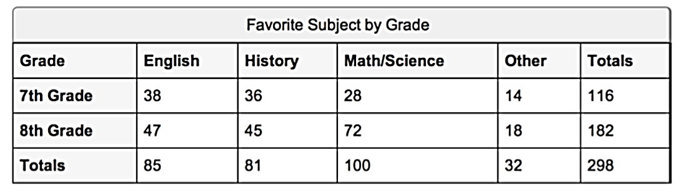  Conditional relative frequencies are determined by focusing on a specific row or column of the table and are particularly useful in determining any associations between the two variables.  Students are flexible in identifying and interpreting the information from a two-way frequency table. They complete calculations to determine frequencies and use those frequencies to describe and compare.  Example:  - At the NC Zoo 23 interns were asked their preference of where they would like to work. There were three choices: African Region, Aviary, or North American Region. There were 13 who preferred the African Region, 5 of them were male. There were 6 who preferred the Aviary, 2 males and 4 females. A total of 4 preferred the North American Region and only 1 of them was female.  - Use the information on the NC Zoo Internship to create a two way frequency table.  - Use the two-way frequency table from the NC Zoo Internship, calculate:  - the percentage of males who prefer the African Region  - the percentage of females who prefer the African Region  - How does the percentage of males who prefer the African Region compare to the percentage of females who prefer the African Region?  - 15% of the paid employees are male and work in the Aviary. How does that compare to the interns who are male and prefer to work in the Aviary? Explain how you made your comparison.

A1: S-ID.B.6. Represent data on two quantitative variables on a scatter plot, and describe how the variables are related.  - Fit a function to the data; use functions fitted to data to solve problems in the context of the data. Use given functions or choose a function suggested by the context. Emphasize linear and quadratic models.  - Informally assess the fit of a function by plotting and analyzing residuals.  - Fit a linear function for a scatter plot that suggests a linear association. | Students fit a function to the data and use functions fitted to data to solve problems in the context of the data. They use given functions or choose a function suggested by the context.  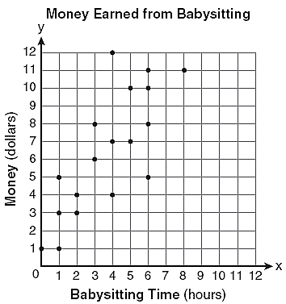  Example:  Which of the following equations best models the data?  $y=x$ $y=\frac{6}{5}x+2$ $y=\frac{3}{2}x+4$ $y=\frac{1}{4}x+4$  Students informally assess the fit of a function by plotting and analyzing residuals.  Year (0=1990) Tuition Rate  0 6546  1 6996  2 6996  3 7350  4 7500  5 7978  6 8377  7 8710  8 9110  9 9411  10 9800  A residual is the difference between the actual y-value and the predicted y-value ($y-\hat{y}$), which is a measure of the error in prediction. (Note: $\hat{y}$ is the symbol for the predicted y-value for a given x-value.) A residual is represented on the graph of the data by the vertical distance between a data point and the graph of the function.  A residual plot is a graph that shows the residuals on the vertical axis and the independent variable on the horizontal axis. If the points in a residual plot are randomly dispersed around the horizontal axis, a linear regression model is appropriate for the data; otherwise, a non-linear model is more appropriate.  Example:  The table to the left displays the annual tuition rates of a state college in the U.S. between 1990 and 2000, inclusively. The linear function $R\left(t\right)=326x+6440$ has been suggested as a good fit for the data. Use a residual plot to determine the goodness of fit of the function for the data provided in the table.  Students fit a linear function for a scatter plot that suggests a linear association.  Example:  - The data below give number of miles driven and advertised price for 11 used models of a particular car from 2002 to 2006.  - Use your calculator to make a scatter plot of the data.  - Use your calculator to find the correlation coefficient for the data above. Describe what the correlation means in regards to the data. (Connect to S.ID.8)  - Use your calculator to find an appropriate linear function to model the relationship between miles driven and price for these cars.  - How do you know that this is the best-fit model?
A1: S-ID.B.6. continued | Students fit a linear function for a scatter plot that suggests a linear association.  Example:  - The data in the chart give number of miles driven and advertised price for 11 used models of a particular car from 2002 to 2006.  - Use your calculator to make a scatter plot of the data.  - Use your calculator to find the correlation coefficient for the data above. Describe what the correlation means in regards to the data.  - Use your calculator to find an appropriate linear function to model the relationship between miles driven and price for these cars.  - How do you know that this is the best-fit model?  Distance(miles, in thousands) Price (dollars)  22 17,998  29 16,450  35 14,998  39 13,998  45 14,599  49 14,988  55 13,599  56 14,599  69 11,998  70 14,450  86 10,998  Speed, $x$ (mph) Mileage, $y$ (mpg)  15 22.3  20 25.5  25 27.5  30 29.0  35 28.8  40 30.0  45 29.9  50 30.2  55 30.4  60 28.8  65 27.4  70 25.3  75 23.3  Students fit a quadratic function for a scatter plot that suggests a quadratic association.  Example:  - A study was done to compare the speed $x$ (in miles per hour) with the mileage y (in miles per gallon) of an automobile. The results are shown in the table.  (Source: Federal Highway Administration)  - Use your calculator to make a scatter plot of the data.  - Use the regression feature to find a model that best fits the data.  - Approximate the speed at which the mileage is the greatest.

Statistics and Probability: Interpreting Categorical and Quantitative Data (S-ID)
Interpret linear models.
Louisiana Standard | Explanations and Examples
A1: S-ID.C.7. Interpret the slope (rate of change) and the intercept (constant term) of a linear model in the context of the data. | Students may use graphing calculators or software to create representations of data sets and create linear models and interpret them.  Example:  - Data was collected of the weight of a male white laboratory rat for the first 25 weeks after its birth. A scatterplot of the rat’s weight (in grams) and the time since birth (in weeks) shows a fairly strong, positive linear relationship. The linear regression equation $W=100+40t$ (where W = weight in grams and t = number of weeks since birth) models the data fairly well.  - What is the slope of the linear regression equation? Explain what it means in context.  - What is the y-intercept of the linear regression equation? Explain what it means in context.
A1: S-ID.C.8. Compute (using technology) and interpret the correlation coefficient of a linear fit. | Students may use graphing calculators or software to create representations of data sets and create linear models and interpret them. The correlation coefficient, r, is a measure of the strength and direction of a linear relationship between two quantities in a set of data. The magnitude (absolute value) of r indicates how closely the data points fit a linear pattern. If $r=1$, the points all fall on a line. The closer $\left|r\right|$ is to 1, the stronger the correlation. The closer $\left|r\right|$ is to zero, the weaker the correlation. The sign of r indicates the direction of the relationship, positive or negative.  Example:  - The correlation coefficient of a given data set is 0.97. List three specific things this tells you about the data.
A1: S-ID.C.9. Distinguish between correlation and causation. | Some data leads observers to believe that there is a cause and effect relationship when a strong relationship is observed. Students should be careful not to assume that correlation implies causation. The determination that one thing causes another requires a controlled randomized experiment.  Examples:  - A study found a strong, positive correlation between the number of cars owned and the length of one’s life. Larry concludes that owning more cars means you will live longer. Does this seem reasonable? Explain your answer.  - Choose two variables that could be correlated because one is the cause of the other; defend and justify selection of variables.  - Explore the website http://tylervigen.com/ for correlations for discussion regarding causation and association.

Date Edited | STandard Code | type of edit made
05-24-2016 | A1: F-IF.C.7 | Piecewise function example changed
06-13-2016 | A1: F-IF.A.2 | Corrected typographical error – “ham” should have been “yam”
09-23-2016 | A1: A-REI.A.1 | Added quadratic example
UpDATES: Algebra I Companion document for TeacherS

