DRC Student Correction System Online Cleanup FAQ
1. Why is the DRC Student Correction System Online Cleanup important?
This is the only opportunity that school systems will have to correct (a) impending zeros and (b) demographic information that may affect the calculation of the progress index. This process will also reduce the work that will need to be done during the late August certification of assessment data.
NOTE: Traditional data certification processes will continue. However, impending zeroes and incorrect or invalid names, student ID numbers (LASID), and dates of birth must be corrected before the next data certification window opens.
2. How do I access the DRC Student Correction System?
Users should first select the Student Management tab in the All Applications menu, then select Student Corrections System.
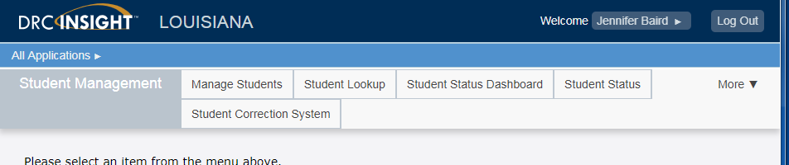
3. Who has access to the DRC Student Correction System?
All district and school test coordinators should have access to the Student Correction System. District test coordinators can assign additional permissions as needed. The schools can correct data directly in the system, and district test coordinators should approve the changes. However, the changes that a school submits will be applied by DRC even if the DTC does not approve them. Please note that changes made by any school can affect the district performance score.
4. Does a user need to upload documentation to make a correction?
No, unlike the La Data Review system, the DRC eDIRECT system does not accept documentation. However, schools and districts should always have the documentation that is required to apply accountability codes. The department will audit some of these codes.
5. Can the window for the DRC Student Correction System be extended?
No, the system will close at the end of the day on Monday, June 19. In order to meet reporting timelines for assessment results, extensions are not possible.

6. Will we have a file that contains test information?
Yes, DRC will provide data files in .csv format as outlined below:
- LEAP 2025 HS: File includes raw score, scale score and achievement level.
- LEAP 2025 Grades 3-8: File includes raw score flag of “Y” for students who have a raw score from the spring administration, but will not include any actual scores or achievement levels
- LEAP Connect: File includes raw score, scale score and achievement level.
7. Is there a guide to help navigate the system?
Yes, the directions for the Student Correction System are included in the eDIRECT User Guide for Common eDIRECT Tasks and Functions posted in eDIRECT on pages 136-144.
8. Why do my hand-coded testers appear in the system, even though they have no errors?
DRC provides information from hand-coded test documents in the Student Corrections System so that districts and schools can take a final look at the information. The only students who are receiving zeros will be listed in the impending zero report under the Test Results tab.
9. How can I check to see if all corrections have been submitted?
The Student Correction System provides a status report that displays the percentage of corrections that have been saved. See User Guide for complete instructions on page 144.
10. What should I do if I open the Student Correction System and find no errors to correct?
Celebrate! If no corrections are listed, then there were no hand-coded documents submitted by the site and DRC detected no errors from any of the following categories:
- Impending zero for a student who was expected to test and did not
- Invalid/incorrect name
- Invalid/incorrect state ID (LASID)
- Invalid/incorrect date of birth
- Invalid/incorrect demographics

