Unit 1
Unit2
Unit 3
Unit 4
Name________________________________________________ Date ________________
How Does the Environment Affect the Lives of People in Louisiana?
Introduction
Student Directions | Over the next two weeks, you will explore the sources in this packet to learn about the natural environment of Louisiana and how it has impacted the people who live there. At the end of the packet, you will express your understanding by writing an extended response that explains how geography and natural resources affect people in Louisiana. You will use relevant evidence from the sources that you read and studied to support the claims you make in your response. This packet includes three supporting questions which will help you develop your claim on how the environment affects the lives of people in Louisiana. After you read each text or analyze each image, you will be asked to answer questions about it. Some words are defined to help you better understand each source and answer the questions.

Lesson 1 – Setting the Context
Student Directions | Read the text and study Source A: Google Maps of New Orleans and Source B: Louisiana Natural Resources; then answer questions after each source.
Featured Sources | Source A: Google Maps of New Orleans  Source B: Louisiana Natural Resources

Maps are representations of an area or land. There are many types of maps. Political maps show state lines, cities, parish lines, and important bodies of water. These types of maps are called political maps because they provide information about the governmental boundaries of an area. The first image is a satellite photograph of New Orleans, Louisiana. The second image is a political map of the same area of land.

Source A: Google Maps of New Orleans, LA
Satellite Image of New Orleans, LA
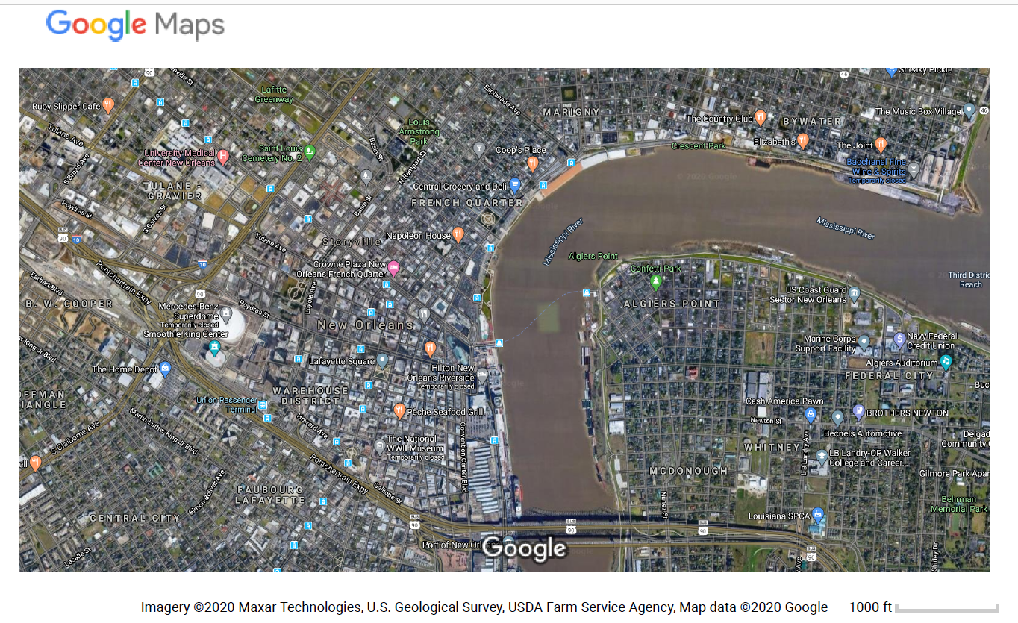
Map of New Orleans, LA
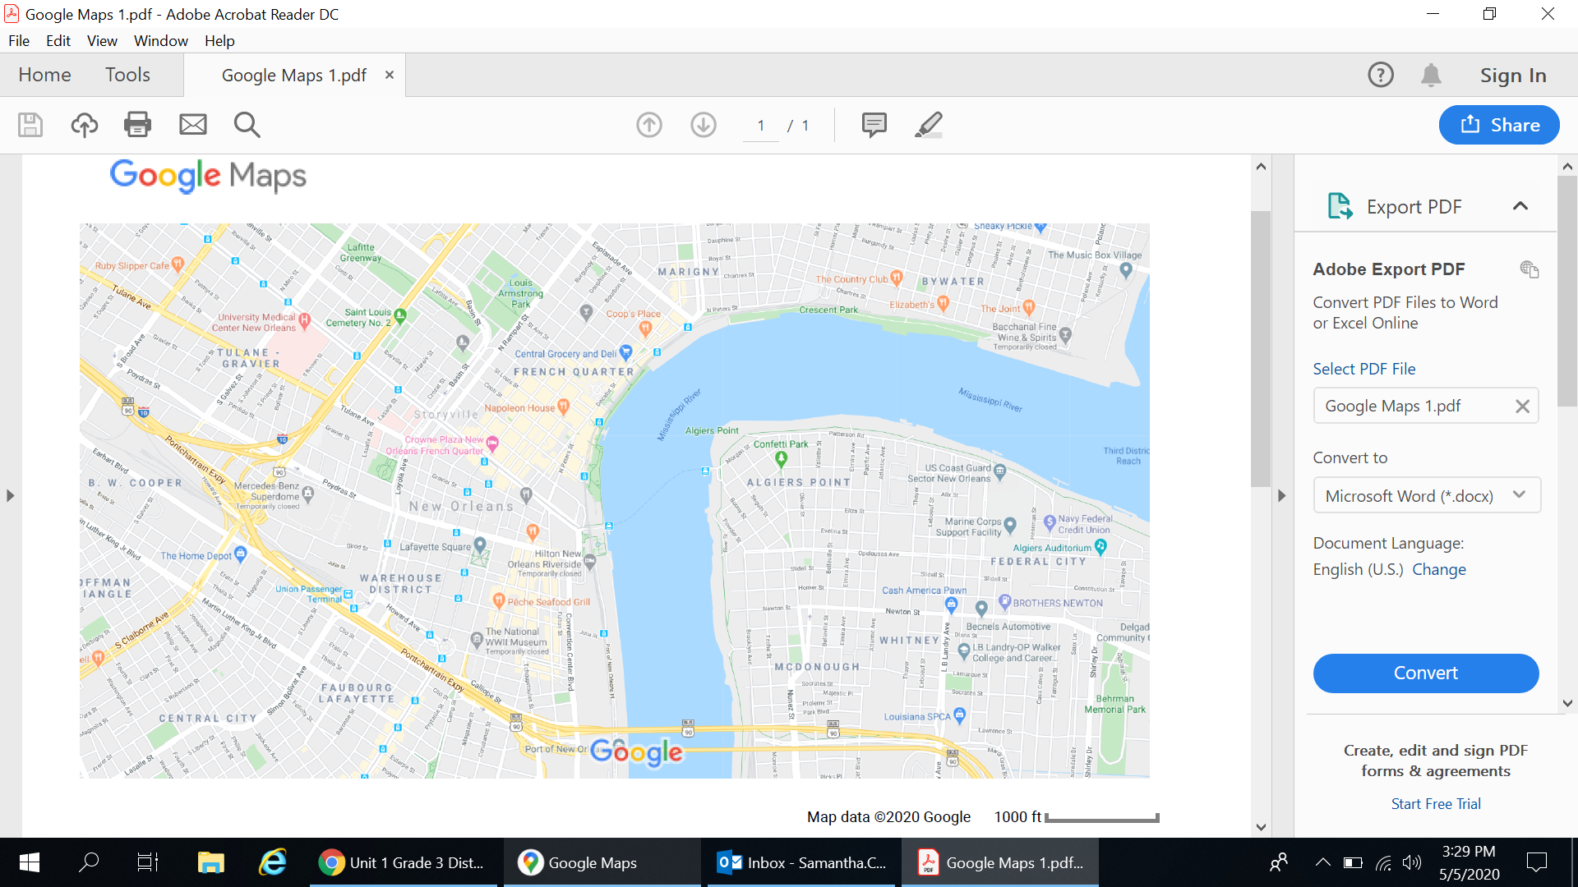
Compare the two images above. How are they similar? How are they different?

__________________________________________________________________________________________________

__________________________________________________________________________________________________

__________________________________________________________________________________________________

Some maps show physical features of land, such as rivers, lakes, and mountains. These maps are known as physical maps.

Look at the map below. This map shows some of the natural resources found in Louisiana. The map also shows some major bodies of water and cities.

Sometimes, maps provide information about an area using colors and symbols. Map legends, or map keys, are used to help us understand the information on a map.

Source B: Louisiana Natural Resources
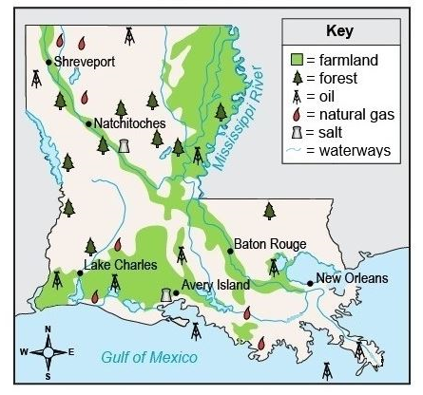
Using the map key, identify three natural resources located in Louisiana.

__________________________________________________________________________________________________

What does the color green (shaded area if black and white) represent on the map key?

__________________________________________________________________________________________

__________________________________________________________________________________________
Many maps also have a symbol called a compass rose. The compass rose is a tool that shows the directions of places on maps. The cardinal directions are north, south, east, and west. Intermediate directions—northeast, southeast, southwest, and northwest—are between the cardinal directions. Below is an example of a compass rose.
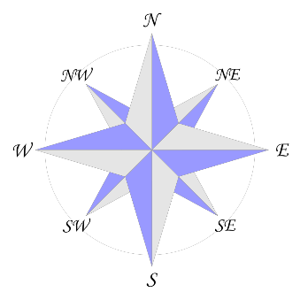
Source B: Louisiana Natural Resources

The compass rose can be used to identify the cardinal and intermediate directions of places on this map. For example, Natchitoches is located in the northwest part of the state. New Orleans is located in the southeast part of the state. The compass rose can also be used to determine where places are compared to other places on the map. For example, New Orleans is located east of Lake Charles and Shreveport is north of Lake Charles.

Using cardinal and intermediate directions, fill in the blanks below.
Baton Rouge is located __________________________ of New Orleans.
Avery Island is located __________________________ of Shreveport.
There are more forests found in the _________________________ part of the state.
Lesson 2 – Setting the Context
Student Directions | Study Source C in order to identify where you are on the map of Louisiana in relation to other parishes.
Featured Sources | Source C: Map of Louisiana Parishes

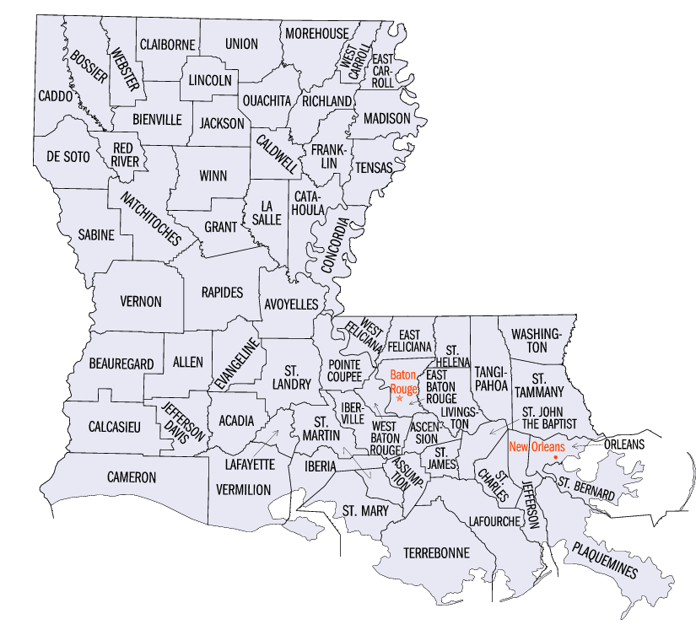
Source C: Map of Louisiana Parishes

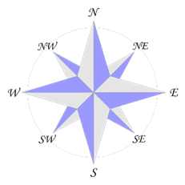

Use Source C and the compass rose to identify the cardinal and intermediate directions of your home in relation to the parishes below. Cardinal and intermediate directions are not always exact, but be as precise as possible. For example, using cardinal directions, St. Mary Parish is south of East Baton Rouge Parish. Using intermediate directions, St. Mary Parish is southeast of East Baton Rouge Parish.
*If your home parish is in the list below, think about where you are located within your own parish.
Parish | Cardinal Direction | Intermediate Direction
St. Landry
Cameron
Washington
Winn
Plaquemines

Lesson 3
Supporting Question 1: How do maps help us understand the physical environment?
Student Directions | Study Source D: Physical Map of Louisiana and Source E: Fishing Resources in Louisiana and complete the questions below the sources.
Featured Sources | Source D: Physical map of Louisiana  Source E: Fishing Resources in Louisiana

Source D: Physical Map of Louisiana Source E: Fishing Resources in Louisiana
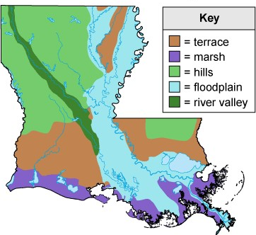
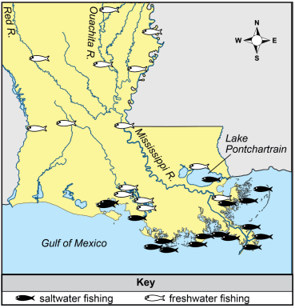

Use Sources D and E to answer the following questions.
*Notes: The physical map on the left shows the physical landform that is dominant in that area but does not show all physical features. The map on the right shows only one natural resource found in Louisiana—commercial fishing.
1. Describe the locations of two hilly areas within Louisiana using cardinal and intermediate directions.
2. Which major body of water is directly next to the marshes?
3. Which river made the river valley in Louisiana?
4. In what type of physical environment does fishing occur?
5. In which bodies of water does fresh water fishing occur in Louisiana? (Name two.)
6. In which bodies of water does salt water fishing occur? (Name two.)

Lesson 4
Supporting Question 1: How do maps help us understand the physical environment?
Student Directions | Study Source F: Images of Landforms and then complete the questions below each image. For the final question, draw on everything you have learned about maps and the physical environment.
Featured Sources | Source F: Images of Landforms
Source F: Images of Landforms
Marshes
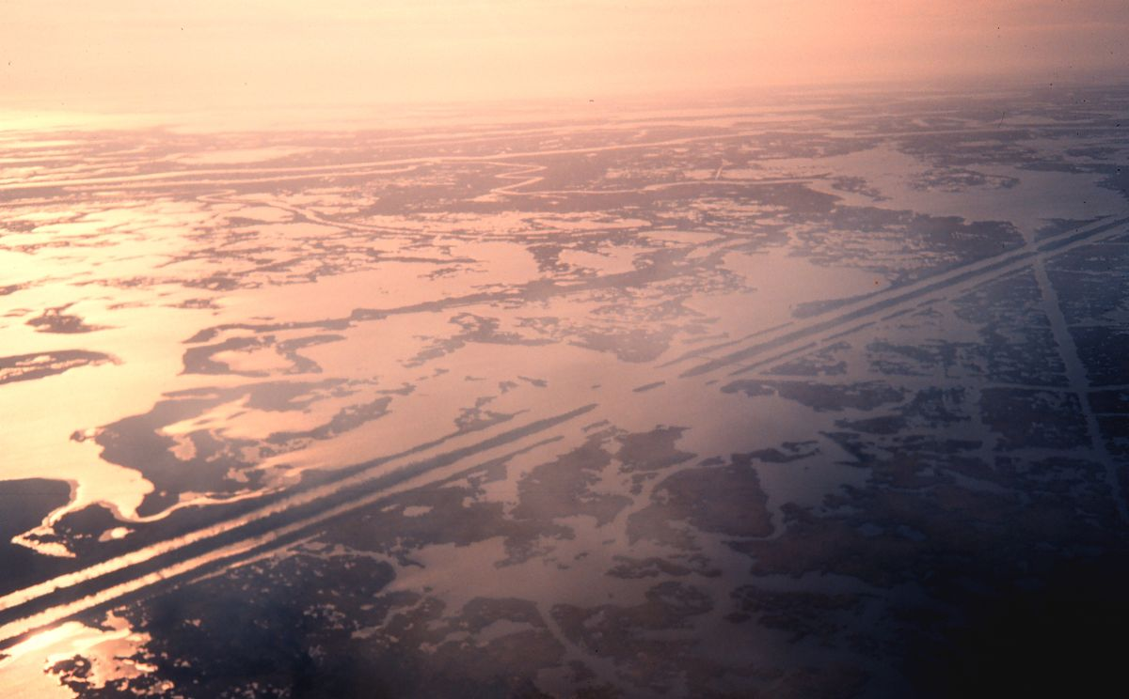
Describe the landform shown in the picture.
__________________________________________________________________________________________________

__________________________________________________________________________________________________

Why would people want to live on or near this landform?
__________________________________________________________________________________________________

__________________________________________________________________________________________________

Hills
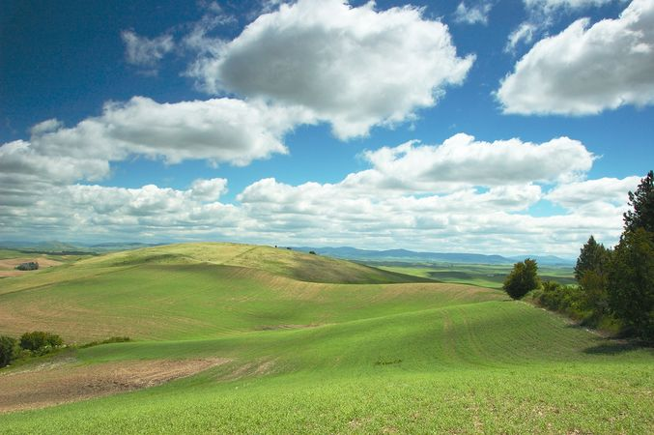

Describe the landform shown in the picture.

__________________________________________________________________________________________________

__________________________________________________________________________________________________
Why would people want to live on or near this landform?
__________________________________________________________________________________________________

__________________________________________________________________________________________________

__________________________________________________________________________________________________

__________________________________________________________________________________________________

River Valley
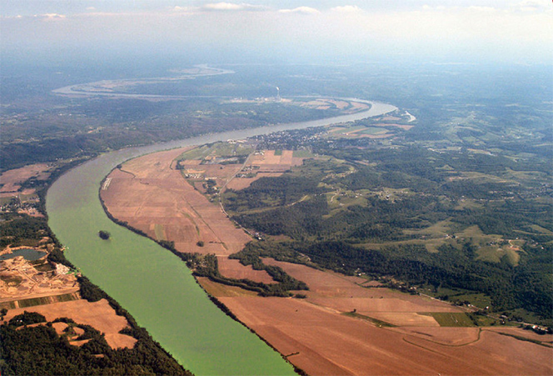
Describe the landform shown in the picture.

__________________________________________________________________________________________________

__________________________________________________________________________________________________
Why would people want to live on or near this landform?
__________________________________________________________________________________________________

__________________________________________________________________________________________________

__________________________________________________________________________________________________

__________________________________________________________________________________________________
Using the sources from lessons 3 and 4, write a paragraph answering the question: How do maps help us understand the physical environment?

__________________________________________________________________________________________________

__________________________________________________________________________________________________

__________________________________________________________________________________________________

__________________________________________________________________________________________________

__________________________________________________________________________________________________

__________________________________________________________________________________________________

__________________________________________________________________________________________________

__________________________________________________________________________________________________

Lesson 5
Supporting Question 2: What natural resources exist in Louisiana, and how have people used them?
Student Directions | Read Source G: “Natural resource facts for kids” and answer the questions below the text.
Featured Sources | Source G: “Natural resource facts for kids”

Source G: “Natural resource facts for kids”
Text | Vocabulary
A natural resource is anything that people can use which comes from nature. People do not make natural resources, but gather them from the earth. Examples of natural resources are air, water, wood, oil, wind energy, iron, and coal.  Supply  We often say there are two sorts of natural resources: renewable resources and non-renewable resources.  A renewable resource is one which can be restored. Renewable resources include crops, wind, water, hydroelectric power, fish, and sunlight. However, in some circumstances, even water is not renewable easily. Wood is a renewable resource, but it takes time to renew and in some places people use the land for something else. A perpetual resource has a never-ending supply. Some examples of perpetual resources include solar energy, tidal energy, and wind energy. | supply: the amount of a resource that is available  restored: replaced with new; renewed

Name one natural resource. Explain why it is considered a natural resource.

__________________________________________________________________________________________________

__________________________________________________________________________________________________

In your own words, what is a renewable resource?

__________________________________________________________________________________________________

__________________________________________________________________________________________________

Source G: “Natural resource facts for kids”
Text | Vocabulary
A non-renewable resource is a resource that cannot be restored, or a resource that would take a very long time to come back. For example, coal is a non-renewable resource. When we use coal, there is less coal afterward. Most natural resources are non-renewable. This means they will eventually run out.  One thing influencing supply of resources includes whether it is able to be recycled. Non-renewable resources cannot be recycled. For example, oil, minerals, and other non-renewable resources cannot be recycled. | recycled: a resource is returned to how it was before use

In your own words, what is a non-renewable resource?

__________________________________________________________________________________________________

__________________________________________________________________________________________________

__________________________________________________________________________________________________

Source G: “Natural resource facts for kids”
Text | Vocabulary
Demand  The demand for resources can change with new technology, new needs, and new costs. Sometimes resources go completely out of use if people do not need them anymore. Sometimes the demand of natural resources is very high, but availability of some is very low. This is the case with precious metals like gold.  Availability  All places have their own natural resources. When people do not have a certain resource they need, they can either replace it with another resource, or trade with another country to get the resource. People have sometimes fought to have them (for example, spices, water, arable land, gold, or petroleum).  When people do not have some natural resources, their quality of life be lowered. So, we need to protect our resources from pollution. For example, when they cannot get clean water, people may become ill. Many people carefully save their natural resources so others can use them in future. | Demand: the amount of desire people have for something.

In your own words, describe why natural resources are important to people.

__________________________________________________________________________________________________

__________________________________________________________________________________________________

__________________________________________________________________________________________________

__________________________________________________________________________________________________

__________________________________________________________________________________________________

__________________________________________________________________________________________________

__________________________________________________________________________________________________

__________________________________________________________________________________________________

Lesson 6
Supporting Question 2: What natural resources exist in Louisiana, and how have people used them?
Student Directions | Read the text and study Source H: Louisiana Population Map, Source I: Louisiana Natural Resources Map 1, and Source J: Louisiana Natural Resources Map 2 and then answer the questions below each.
Featured Sources | Source H: Louisiana Population Map  Source I: Louisiana Natural Resources Map 1  Source J: Louisiana Natural Resources Map 2

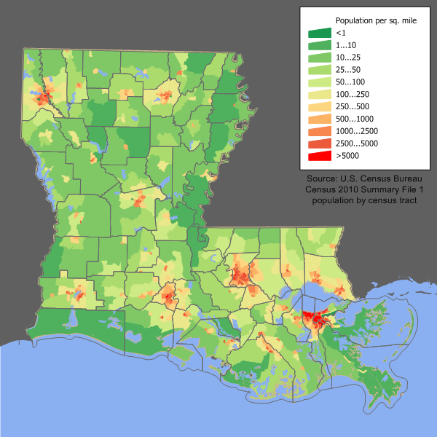
Today you will use maps that show natural resources (the physical environment) and a population map to learn about how the environment affects where people live. Population maps show how many people are located in an area.

In this population map of Louisiana, the areas of the state that have more people are colored red. The dark green areas are places where there are fewer people.

Population maps are useful because they can show how many people live in an area. People who live in the red parts of this map probably live in cities, also known as urban areas. Urban areas have more people living in a smaller area of land. People who live in the green areas live in more rural areas. In rural areas, people are more spread out than in urban areas. Therefore, there are fewer people in rural towns than in urban cities.

Source H: Louisiana Population Map Source I: Louisiana Resources Map 1

Using both maps, name two urban areas. Explain how you know these are urban areas.
Using both maps, is the population more urban or more rural in the areas with a lot of farmland? Why do you think that is?
Both Baton Rouge and New Orleans are located near a major river. Name the river.
Source J: Louisiana Resources Map 2

From what body of water does most of the state’s seafood come?
Using cardinal directions, from which part of the state does rice come?
Name one natural resource found in both north and south Louisiana.
Name one natural resource that is only present in the southern part of the state.

Using the sources from lessons 5 and 6, write a paragraph answering the following: Identify one natural resource found in Louisiana and then describe one way that people use it.

__________________________________________________________________________________________________

__________________________________________________________________________________________________

__________________________________________________________________________________________________

__________________________________________________________________________________________________

__________________________________________________________________________________________________

__________________________________________________________________________________________________

__________________________________________________________________________________________________

__________________________________________________________________________________________________

Lesson 7
Supporting Question 3: How do natural resources provide an income to the people of Louisiana?
Student Directions | Read the text and study Source K: Photographs of Louisiana Resources and then answer the questions after each photograph. Questions for the first photograph are completed as an example.
Featured Sources | Source K: Photographs of Louisiana Resources

The environment around us, including natural resources, affects the way we live. Many jobs in Louisiana depend on natural resources. There are people in Louisiana who earn their income working with natural resources such as oil and gas, seafood, and crops. For example, fishermen work in Louisiana’s waterways to catch seafood to sell to restaurants and grocery stores. Farmers grow crops like cotton to be sold and used to make fabrics and other goods. Farmers also grow crops for food, such as strawberries and rice. The natural gas and oil industries provide many people in Louisiana with jobs. Oil and natural gas are both found underground and are often found near each other. Oil is in great demand since it is used to make fuel for cars as well as other products people use every day. Loggers cut down trees so that they can sell timber. These activities provide an income for workers in Louisiana and supply useful resources to the people of Louisiana and around the world.

income: money earned from working
industries: activities that prepare goods to be sold
fuel: something that is burned to produce power; for most cars, gas is fuel
loggers: workers who cut down trees
timber: wood used for building

Source K: Photographs of Louisiana Resources

Gas Drilling - EXAMPLE

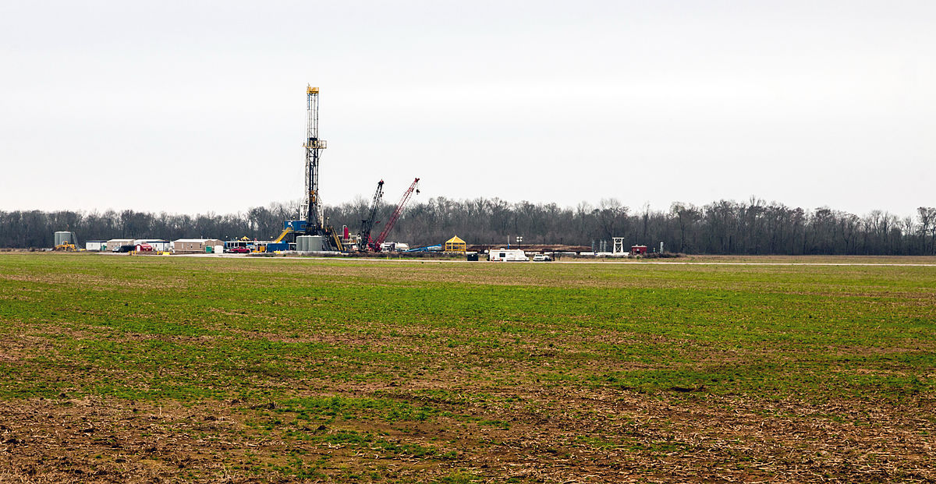

EXAMPLE
- Why do people want to buy this resource?

A: People use natural gas for heating and cooking in their homes.

What do workers need to do in order to collect this resource to be sold?

A: Workers use machines to remove the natural gas from the ground.

Using cardinal and intermediate directions, where do you think this resource is located?

A: This resource is probably located in the southern and southwestern parts of the state since that is where oil is found.

Crawfish

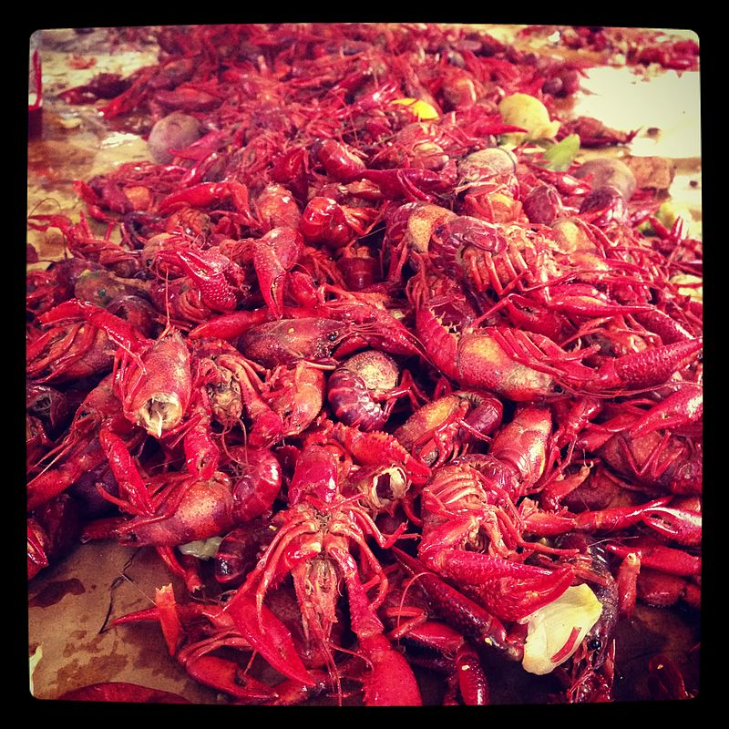
Why do people want to buy this resource?

__________________________________________________________________________________________

__________________________________________________________________________________________

What do workers need to do in order to collect this resource to be sold?

__________________________________________________________________________________________

__________________________________________________________________________________________

Using cardinal and intermediate directions, where do you think this resource is located?

__________________________________________________________________________________________

Cotton farm

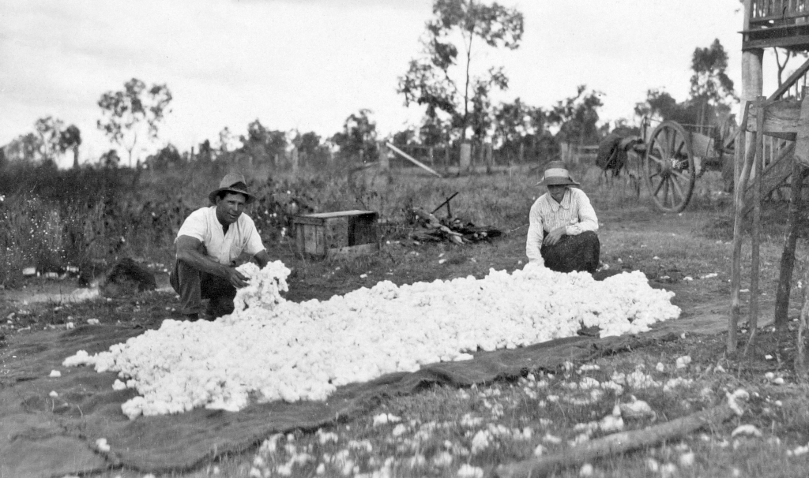

Why do people want to buy this resource?

__________________________________________________________________________________________

__________________________________________________________________________________________

What do workers need to do in order to collect this resource to be sold?

__________________________________________________________________________________________

__________________________________________________________________________________________

Using cardinal and intermediate directions, where do you think this resource is located?

__________________________________________________________________________________________

Oil Pump Jack

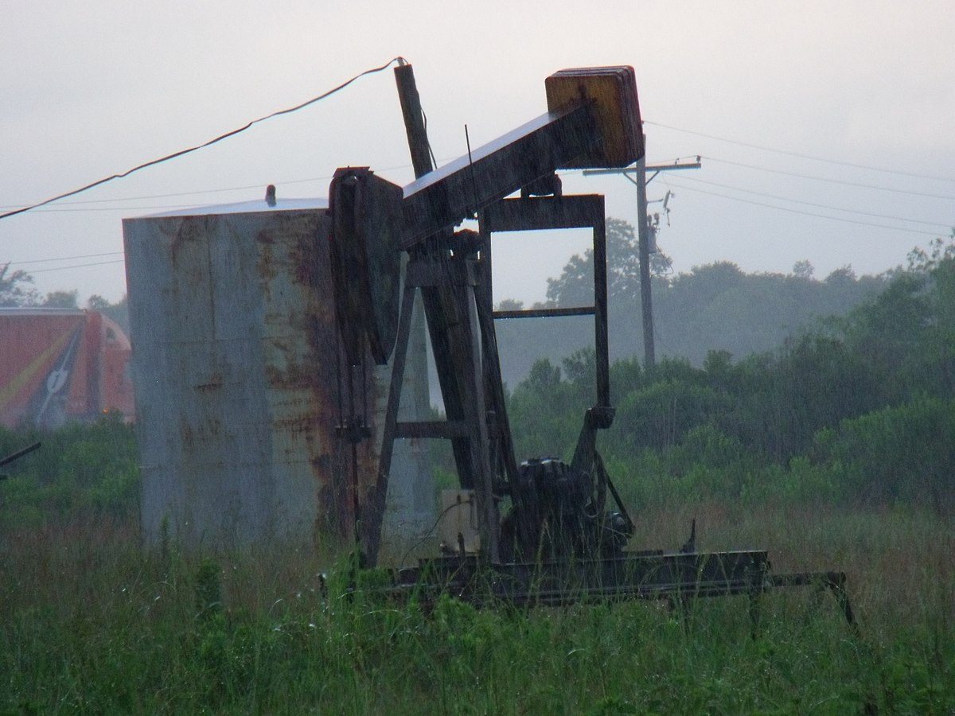

Why do people want to buy this resource?

__________________________________________________________________________________________

__________________________________________________________________________________________

What do workers need to do in order to collect this resource to be sold?

__________________________________________________________________________________________

__________________________________________________________________________________________

Using cardinal and intermediate directions, where do you think this resource is located?

__________________________________________________________________________________________

Timber

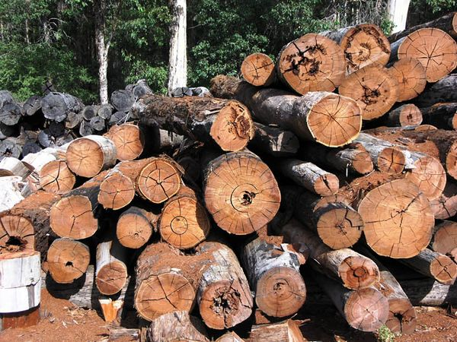

Why do people want to buy this resource?

__________________________________________________________________________________________

__________________________________________________________________________________________

What do workers need to do in order to collect this resource to be sold?

__________________________________________________________________________________________

__________________________________________________________________________________________

Using cardinal and intermediate directions, where do you think this resource is located?

__________________________________________________________________________________________

Crab

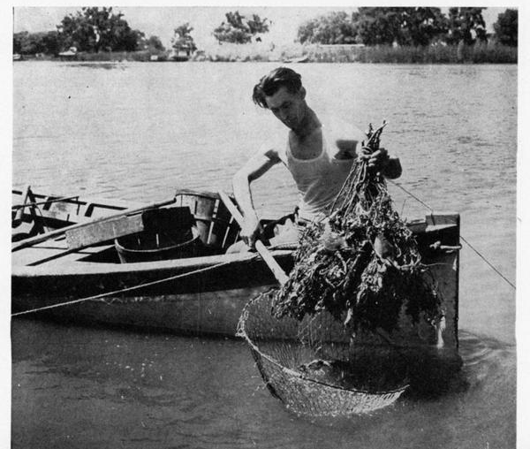

Why do people want to buy this resource?

__________________________________________________________________________________________

__________________________________________________________________________________________

What do workers need to do in order to collect this resource to be sold?

__________________________________________________________________________________________

__________________________________________________________________________________________

Using cardinal and intermediate directions, where do you think this resource is located?

__________________________________________________________________________________________

Lesson 8
Supporting Question 3: How do natural resources provide an income to the people of Louisiana?
Student Directions | Read Source Source L: “Commercial Fishing” and then answer the questions before and after the text.
Featured Sources | Source L: “Commercial Fishing”

Before you read: The following text is from the Louisiana Department of Wildlife and Fisheries (LDWF) website. This text provides information on the types of seafood and fish that make up the fishing industry in Louisiana. The natural resources discussed in this article include crab, shrimp, yellowfin tuna, and crawfish. Why do people want to buy these resources? What are these resources used for?

__________________________________________________________________________________________

__________________________________________________________________________________________

Source L: “Commercial Fishing”
Text | Vocabulary
LDWF’s mission to support commercial fishermen starts with managing the resource—ensuring that our fish and shellfish populations can reproduce and renew themselves before they are harvested. More than 70% of the seafood and other fisheries products landed in the Gulf each year comes through Louisiana, creating a total annual economic impact of nearly $2 billion. | LDWF: Louisiana Department of Wildlife and Fisheries  commercial fisherman: people who catch fish to sell in order to make money  harvested: removed from the natural environment  annual: something that happens every year
How much money does commercial fishing bring into Louisiana every year?

Source L: “Commercial Fishing”
Text | Vocabulary
Crab  Louisiana’s commercial blue crab fishery is the largest in both the Gulf and the United States and supplies about a quarter of the blue crab harvested in the United States. Louisiana's blue crab fishery has been certified as sustainable by multiple organizations.  Shrimp  White and brown shrimp support the most valuable and the second largest commercial fishery in Louisiana. Louisiana is the top harvester of shrimp in the Gulf and the United States.  Saltwater fish  Louisiana’s coastal waters provide some of the most productive natural habitats in the world, creating an environment that nurtures dozens of abundant inshore fish species from spotted seatrout and black drum to sheepshead and shark. These resources provide tremendous opportunities for commercial fishing, making Louisiana a major source of domestic seafood and other fisheries products for the United States. | sustainable: able to last over time

Why do you think it is important to make sure that Louisiana’s blue crabs and other types of seafood are sustainable?

__________________________________________________________________________________________

__________________________________________________________________________________________

__________________________________________________________________________________________

__________________________________________________________________________________________

Source L: “Commercial Fishing”
Text | Vocabulary
Crawfish  With more than 1,000 crawfish fishermen and more than 1,300 crawfish farmers, Louisiana leads the nation in crawfish production, supplying 100 to 120 million pounds per year.  Reptiles and Amphibians  Many Louisiana reptiles and amphibians are a source of commercial value, even those in your backyard. Frogs and turtles are a culinary tradition in Louisiana, and licensed commercial reptile and amphibian collectors occasionally sell snakes for meat. A couple dozen reptile and amphibian species are also valued as pets. | culinary: having to do with food

Name two reasons why reptiles and amphibians are bought by people.

__________________________________________________________________________________________

__________________________________________________________________________________________

__________________________________________________________________________________________

Using the sources from lessons 7 and 8, write a paragraph identifying one natural resource found in Louisiana, and then explain how that resource creates an income for people.

__________________________________________________________________________________________

__________________________________________________________________________________________

__________________________________________________________________________________________

__________________________________________________________________________________________

__________________________________________________________________________________________

__________________________________________________________________________________________

__________________________________________________________________________________________

__________________________________________________________________________________________

__________________________________________________________________________________________

__________________________________________________________________________________________

__________________________________________________________________________________________

__________________________________________________________________________________________

Lesson 9 – Summative Performance Task
Student Directions | Based on the sources from this packet and your knowledge of social studies, write an essay answering the following question: “How does the environment (including geography and natural resources) affect the lives of people in Louisiana?”

__________________________________________________________________________________________________

__________________________________________________________________________________________________

__________________________________________________________________________________________________

__________________________________________________________________________________________________

__________________________________________________________________________________________________

__________________________________________________________________________________________________

__________________________________________________________________________________________________

__________________________________________________________________________________________________

__________________________________________________________________________________________________

__________________________________________________________________________________________________

__________________________________________________________________________________________________

__________________________________________________________________________________________________

__________________________________________________________________________________________________

__________________________________________________________________________________________________

__________________________________________________________________________________________________

__________________________________________________________________________________________________

__________________________________________________________________________________________________

__________________________________________________________________________________________________

__________________________________________________________________________________________________

__________________________________________________________________________________________________

__________________________________________________________________________________________________

__________________________________________________________________________________________________

__________________________________________________________________________________________________

__________________________________________________________________________________________________

__________________________________________________________________________________________________

__________________________________________________________________________________________________

__________________________________________________________________________________________________

__________________________________________________________________________________________________

__________________________________________________________________________________________________

__________________________________________________________________________________________________

__________________________________________________________________________________________________

__________________________________________________________________________________________________

__________________________________________________________________________________________________

__________________________________________________________________________________________________

__________________________________________________________________________________________________

__________________________________________________________________________________________________

__________________________________________________________________________________________________

__________________________________________________________________________________________________

__________________________________________________________________________________________________

__________________________________________________________________________________________________

__________________________________________________________________________________________________

__________________________________________________________________________________________________

__________________________________________________________________________________________________
Name________________________________________________Date__________________

How have Indigenous cultures in Louisiana changed over time?
Introduction
Student Directions | Over the next two weeks, you will explore the sources in this packet to learn about the role Indigenous peoples have played in Louisiana’s history. This includes prehistoric settlements, cultures and societies before and after colonization, and American Indian Tribes in Louisiana today. At the end of the packet, you will express your understanding by writing an extended response answering the following question: How have Indigenous cultures in Louisiana changed over time? This packet includes three supporting questions which will help you develop your claim on how Indigenous cultures in Louisiana have changed over time. After you read each text or analyze each image, you will be asked to answer questions about it. Some words are defined to help you better understand each source and answer the questions. Some sources have digital extensions, which are optional sources you can explore if you have internet access.

Lesson 1 – Setting the Context
Student Directions | Read and study Sources A and B, then answer the guiding questions.
Featured Sources | Source A: Adapted from “Prehistoric Archaeology in Louisiana” by Rebecca Saunders  Source B: Image Bank: Examples of Archaeology in Louisiana
Optional Digital Resources | National Geographic Kids – All About Archaeology

The earliest humans to live on the land that would become Louisiana arrived in the area more than 13,000 years ago. Learning about this group of people can be challenging because they did not leave any written sources that scholars can read. Without written sources, scholars must use archaeology to understand the past. Source A describes what archaeology is and how it helps people today understand the past.

Source A: Adapted from “Prehistoric Archaeology in Louisiana” by Rebecca Saunders
Text | Vocabulary
Archaeology is the study of people in the past. Using the remains of broken tools, mounds of earth, foodstuff, and soil colors and textures, archaeology provides rich, physical information about early people whose histories are not recorded in written records. The stories of American Indian life in Louisiana before contact with Europeans are available through the study of prehistoric archaeology.  The different cultures that lived in Louisiana when Europeans arrived had very old roots. Stone spear points indicate that American Indians were in Louisiana at least as early as 13,500 years ago, when large animals, including mastodons, were commonplace.  As the last Ice Age ended and the climate warmed, American Indians adapted to many changes. These adaptations can be seen in changes in tools like spear and arrow points and pottery; in what they ate, in the styles of artwork that decorated everything from everyday cooking pots to beautiful artifacts; and in the shape and size of earthworks left behind.  Archaeologists divide Louisiana’s precolonial past into the large time periods named after a tribe or culture that was influential or important.  It is important to understand that the beginning and ending of each period and culture are not sudden. The categories are just tools archaeologists use to communicate with each other about facts they uncover. The time periods are: Paleoindian, Archaic, Woodland, and Mississippian—in that order. Taken together, these periods contain more than 13,500 years of history!  Cultures of the distant past are named by archaeologists, usually after a river or other natural or cultural feature in the area where sites are found. Tribal names are only known after European contact, and many of these names are not what the people called themselves. Historians and other social scientists call people that come from, or are native to a certain area, Indigenous or Indigenous people. However, when possible it is considered more appropriate to refer to any group of people by their specific community, or tribal name. | foodstuff: something that can be eaten  prehistoric: relating to a time before written records  mastodons: large, extinct elephant-like mammal  Ice Age: a long period of cooling of the Earth’s surface temperature  artifacts: an object made by a human being  earthworks: large man-made structures made of soil  precolonial: a time before the arrival of Europeans

What do the terms ‘Indigenous’ or ‘Indigenous people’ mean?

Source B: Image Bank: Louisiana Archeology

Image 1: Excavation of Indian mound in Catahoula Parish in 1939

Archeology is responsible for much of what we know about Indigenous prehistoric peoples. This photo is of archeologists uncovering a skeleton in a mound in Catahoula Parish. These large mounds built of soil were an important element in many Indigenous prehistoric cultures.

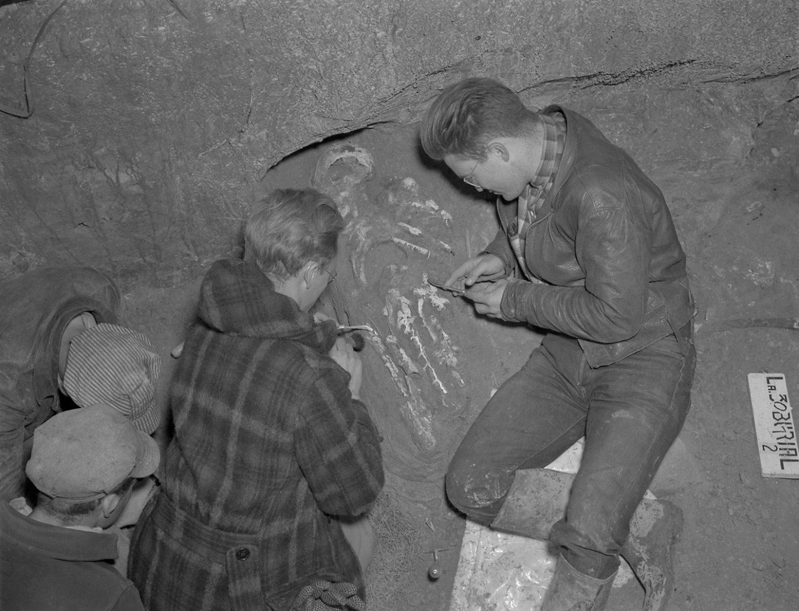

What are the archaeologists doing in the picture above?

Image 2: Excavation of Site in Natchitoches Parish

Excavation is an important step in the archaeological process. “Excavation” refers to the controlled, careful digging that takes place at a site. Indigenous people began living at this site about 2,000 years ago. Archaeologists discovered that the site was in use over a period of 500 years.

What is excavation and why is it an important part in the archeological process?

Image 3: Archaeologist Analyzing Pieces of Pottery

Analysis is another step in the process of making sense out of artifacts recovered during excavation. This photo is of an archaeologist analyzing pieces of pottery. He is using a book on pottery styles as a guide to identify the design of the pottery. This information helps him determine the time period the pottery is from. He is also using a tool called a rim chart to measure the broken piece. The rim chart gives the archaeologist an idea of the size of the pot before it was broken.

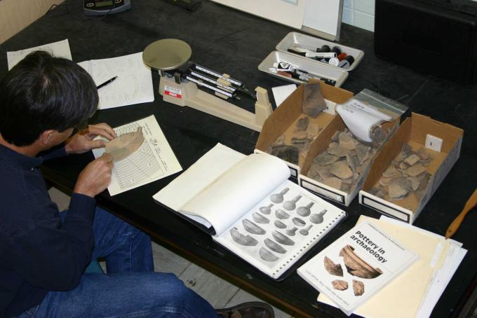

How is the archaeologist in the photo above analyzing the piece of pottery recovered from an excavation?

Image 4: Archaeologist Labeling Evidence

Archaeologists study people who lived long ago, the things they made, and the changes they made to the land. An archaeologist is like a detective, collecting evidence to understand what happened in the past. In this photo, an archaeologist is labeling artifacts from El Nuevo Constante, a Spanish shipwreck in the Gulf of Mexico.

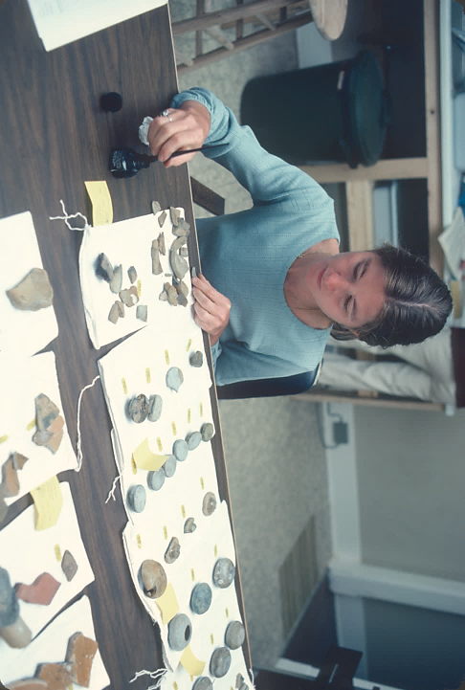

How are archaeologists similar to detectives?

Lesson 2 – Setting the Context
Student Directions | Read and study Sources C, D, E, and F, completing the guiding questions below each.
Featured Sources | Source C: Prehistoric Louisiana Migration Routes  Source D: Image Bank: Paleoindian Period  Source E: Image Bank: Archaic Period  Source F: Image Bank: Woodland Period
Source C: Prehistoric Louisiana Migration Routes
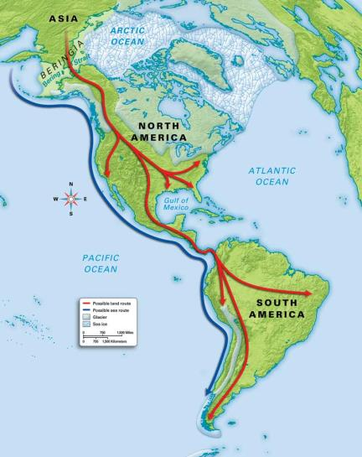
Migration means moving from one place to another, sometimes across long distances. Most archaeologists agree that people migrated from Asia to North America at different times and in different groups. One idea is that people walked across the Bering Land Bridge from Asia to Alaska. Later, archaeologists discovered other evidence that gave more clues about when and how people came to North America.
Location of ice bridge that humans used to cross in the Americas

Now, many archaeologists think that some people traveled across the land bridge, while others traveled along the coast in small boats. This image shows the two routes. Once people arrived in North America, they followed animals to various parts of the country. Louisiana had lots of trees and sources of water. It offered a variety of food items, as well as a milder climate than other parts of North America. Therefore, it is not surprising that some people decided to make Louisiana their home.

What are the two ways archaeologists believe humans came to North America?

Source D: Image Bank: Paleoindian Period

Image 1: Climate and Landscape

The earliest period of human settlement in Louisiana is called the Paleoindian period. The climate (weather conditions over a long period of time) of the Paleoindian period in Louisiana was cooler and wetter than our climate is today. Forests covered the land and seas were lower. This meant that dry land extended farther into the Gulf of Mexico than today. Large mammals, like mastodons and long-horn bison, roamed the land.

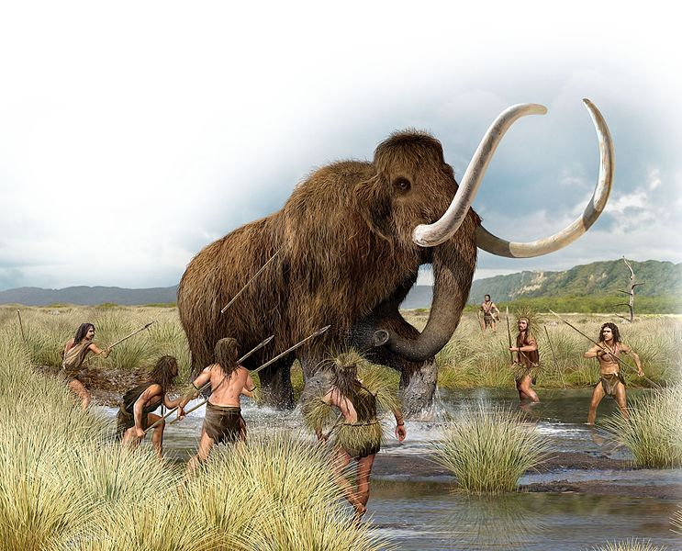

How was the climate of the Paleoindian period different from Louisiana’s climate today?

Image 2: Paleoindian Period – Tools and Weapons

Paleoindians used stone tools to hunt wild game. Louisiana does not have much stone naturally, so some of the stone came from the area now known as Texas. This means that people traveled between the two locations or that trading occurred. The stone points were medium to large and could be re-sharpened many times. Early in the Paleoindian period people hunted with spears. Later Paleoindians used spears and throwing sticks called “atlatls.”

How did people hunt during the Paleoindian period?

Source E: Image Bank: Archaic Period
Image 1: Archaic Climate

The next period of human settlement in Louisiana is called the Archaic period. During this period, Louisiana was warmer and drier than during the Paleoindian period. Forests continued to cover much of the land with prairies appearing in some areas. Seas were rising due to melting ice. By the end of the Archaic period, sea level was similar to coastlines today.

How did the climate of Louisiana change during the Archaic period?

Image 2: Archaic Period—Tools and Weapons

People living in the Archaic period made a wide variety of tools. Hunters used the atlatl, or throwing stick, to hunt deer and smaller mammals. The points attached to the atlatl dart were made of local stone and in a variety of styles. Stone tools were also used to prepare food and make other tools out of wood and bone. Sandstone was used to crack and grind nuts and seeds. Axes were often made by grinding a large stone into the right shape.

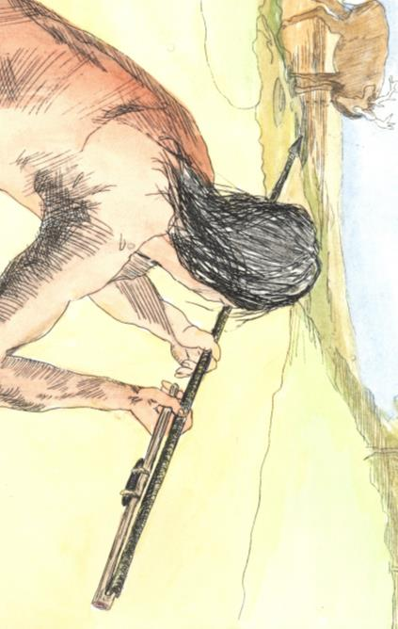

How did people use stone during the Archaic period?

Source F: Image Bank: Woodland Period

Image 1: Woodland People and Settlements

The Woodland period was a time of change for people and how they lived. The population grew during this period. In the beginning, most people lived in small camps like their Archaic ancestors. Later, many people lived in larger villages. For the first time, people made lots of pottery containers. They also started to grow plants for food. Archaeologists have found evidence of special ceremonies. Some of the artifacts from the period are like artifacts from other cultural groups that lived far away. This connection suggests that people and ideas were traveling long distances. People began to build cone-shaped burial mounds around 2,000 years ago. They also built flat-topped mounds. By the end of the period, flat-topped mounds were common. Mounds were built on each side of a central plaza where community events and ceremonies were conducted. The painting below shows one such ceremony might have looked like.

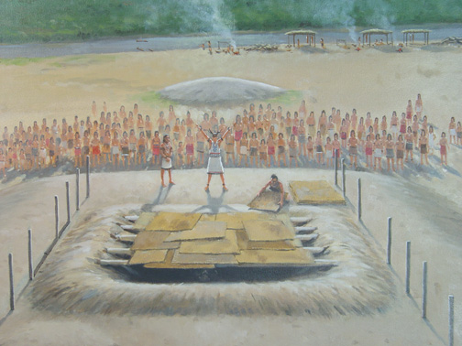

What were some of the major changes that occurred during the Woodland period?

Image 2: Woodland Weapons and Personal items

During the first part of the Woodland period, people hunted with the atlatl like they had in earlier periods. Then an important change happened around 1,500 years ago when the bow and arrow began to be used for hunting. Other stone tools, knives, scrapers, and drills remained similar to those of the Archaic period.

Woodland people used jewelry and other items to signify importance. Artifacts, such as beads made of stone or copper, ceramic pipes, and shell pendants, were buried with some people. The artifacts show that these individuals were important people in the community.

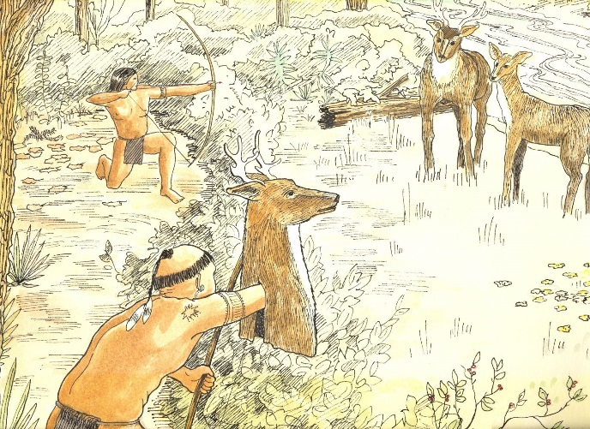
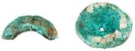

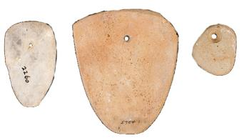

How did hunting change during the Woodland period?

What does the appearance of jewelry buried with certain individuals suggest?

Lesson 3 – What are the characteristics of the prehistoric cultures of Louisiana?
Student Directions | Study Sources G, H, and I and complete the guiding questions. Next, answer the after you read questions at the end of this lesson.
Featured Sources | Source G: Prehistoric American Indian Cultures in Louisiana Map  Source H: Adapted from “Poverty Point” by Rebecca Saunders  Source I: Image Bank: Poverty Point Culture

Source G: Prehistoric American Indian Cultures in Louisiana

The next two lessons will focus on three different prehistoric cultures in Louisiana: The Poverty Point, Tchefuncte, and Marksville cultures. Poverty Point culture reached its height during the late Archaic period, while the Tchefuncte and Marksville cultures occurred later in the Woodland period. This map shows the location of each of these settlements in modern-day Louisiana.
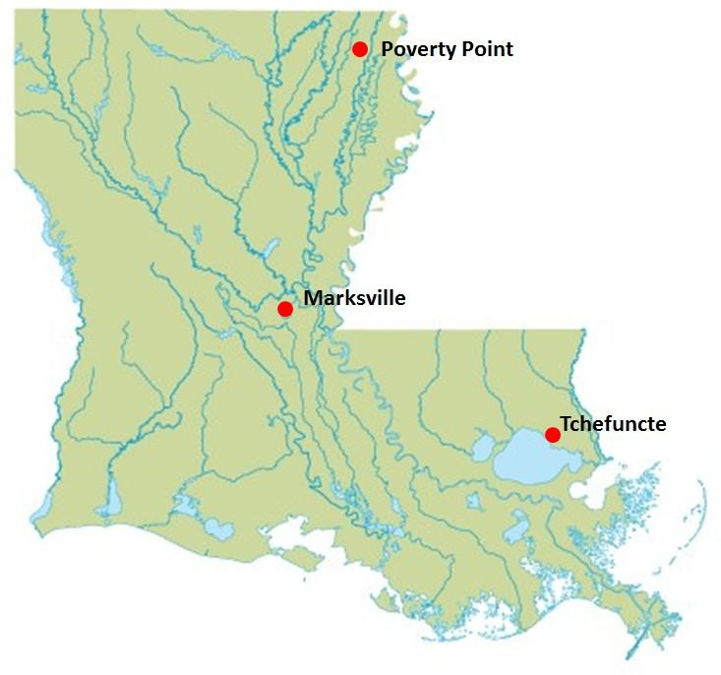
Using cardinal directions, describe the location of the Poverty Point, Marksville, and Tchefuncte settlements in relation to each other.

______________________________________________________________________________________

______________________________________________________________________________________

Source H: Adapted from “Poverty Point Culture” by Rebecca Saunders
Text | Vocabulary
Poverty Point culture can be described as a mound-building culture that developed a remarkable trade in high-quality stone. Archaeologists believe they likely traded stone for natural materials like feathers, hides, and wooden objects, but, if so, the evidence has disappeared with the passage of time. The center of the Poverty Point culture was an area in northeast Louisiana which consisted of a mound site and a community of smaller sites.  What we know about Poverty Point culture is based on a collection of artifacts found at the site itself. Some of the most famous artifacts are called Poverty Point Objects (PPOs). PPOs are about the size of modern charcoal bricks, and they may have been used as bricks. When hot PPOs are used in earth ovens, they stay warm for a long time and allow for slow, dry cooking of fish, meat, and other foods.  Poverty Point is also well known for its ornaments. Stone, notably red jasper, was made into tube-shaped beads and into the shapes of animals. Analysis of food remains from the sites surrounding Poverty Point show a mixed diet. Fish were the major source of protein. Nuts provided flour and oil, and local land and water plants added starchy seeds and nutritious leaves to the diet.  The vast earthworks of the Poverty Point site were not topped in size until the Mississippian culture built Cahokia near St. Louis more than two thousand years later.  In 2014, Poverty Point became the 1001st site on the UNESCO World Heritage List, a program that recognizes the world’s most important cultural and natural properties, meaning the site will be preserved for future generations to study and appreciate. Continuing archaeological research at the Poverty Point site and other associated sites will contribute to a better understanding of the Poverty Point culture. | nutritious: contains things necessary for growth and health  Cahokia: a large city with huge earthworks

Using Source H, what kind of artifacts have archaeologists recovered from Poverty Point, and what do they tell us about their community?

______________________________________________________________________________________

Source I: Image Bank: Poverty Point

Image 1: LiDAR map of Poverty Point

Large earth mounds are an important feature of Poverty Point. This is a LiDAR map of Poverty Point showing the mounds. LiDAR uses light in the form of laser pulses to make a three-dimensional image of the earth’s surface. Experts can take these images from an aircraft or from a satellite. Poverty Point people built five mounds at the site. They are labeled A, B, C, E, and F. Mound D was built nearly 2000 years later than the other mounds.

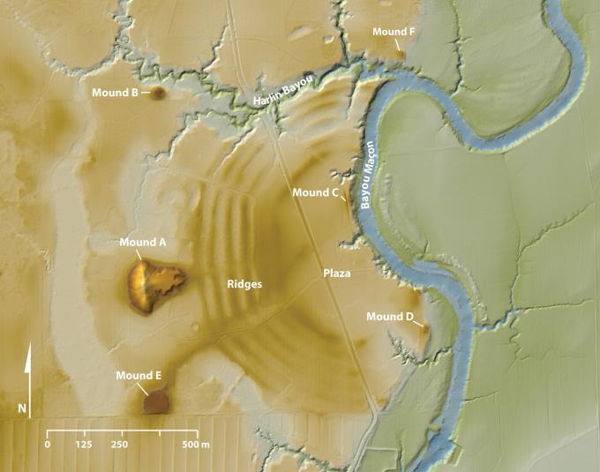

Describe the layout of the Poverty Point site as shown in the LiDAR image above.

Image 2 – Mound A, Poverty Point

Mound A is the largest mound at the site. Mound A measures 72 feet tall at its highest point and 710 feet long by 660 feet wide at the base. This is the size of a six- to seven-story building. It took over 312,000 cubic yards of soil to build Mound A. The people of Poverty Point would have used about 15.5 million basket loads of dirt that weighed 50 pounds each to build this mound. The mounds may have served as trading centers and/or as ceremonial or religious centers.
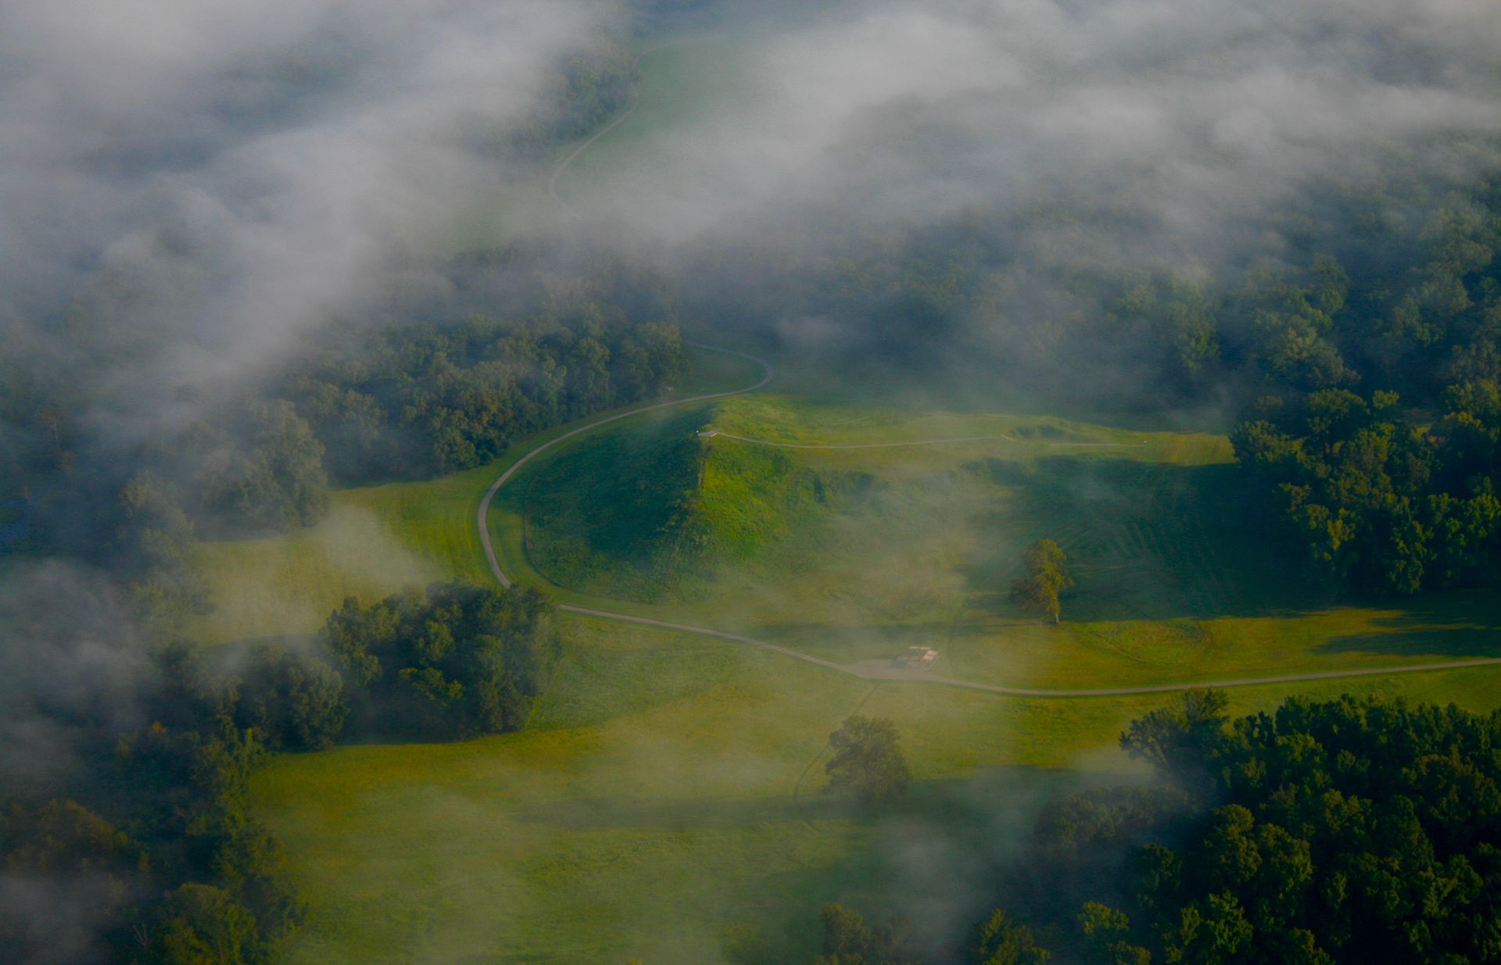
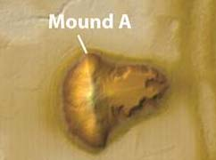

Describe the physical characteristics of Mound A. How do archaeologists think it was created?

Image 3: Poverty Point Hunter-gatherers

The people who built Poverty Point relied on hunting, fishing, and gathering wild plants for their food. They did not raise any crops or animals for food. Archaeologists describe these people as “hunter-gatherers.” Today, artists imagined Poverty Point people hunting and fishing for their food and painted these images.
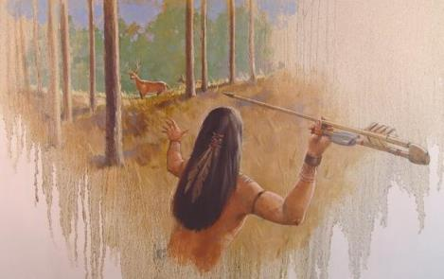

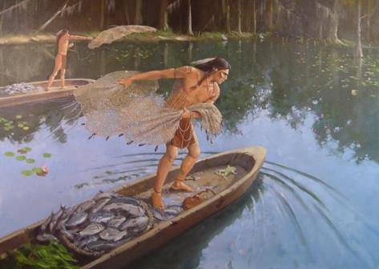

What types of food did the people of Poverty Point eat? How is this different from most modern-day people in Louisiana?

Image 4: Poverty Point Mounds and Ceremonies

Archaeologists have uncovered how people built the site and some activities that occurred at the site. For example, the people who built the earth mounds used baskets to carry soil. Artifacts left behind show that many people lived at the site. Some artifacts, such as human shaped stone figurines may have been for special purposes, like ceremonies.

Here are two paintings showing what life at Poverty Point might have been like. In the top picture, people are using basket loads of soil to build the earth mounds. The soil came from the ground near the mound that was being built. The other picture shows how the people of Poverty Point might have looked.
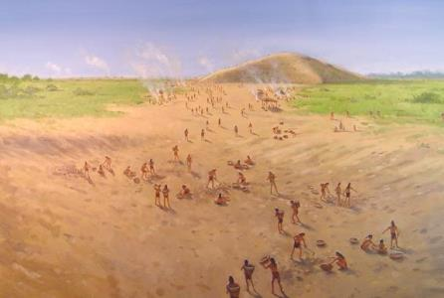

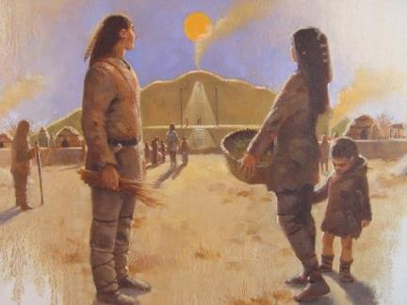

What do archaeologists think the mounds were used for?

______________________________________________________________________________________

______________________________________________________________________________________

Image 5

Archaeologists have found many different types of stone tools at the Poverty Point site. These items are made of stone that does not come from the area. The graphic below shows the variety of stone found at Poverty Point and the origin of each type of stone. This evidence suggests a long-distance trade network probably existed.
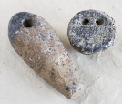

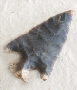
Gray Northern
Flint
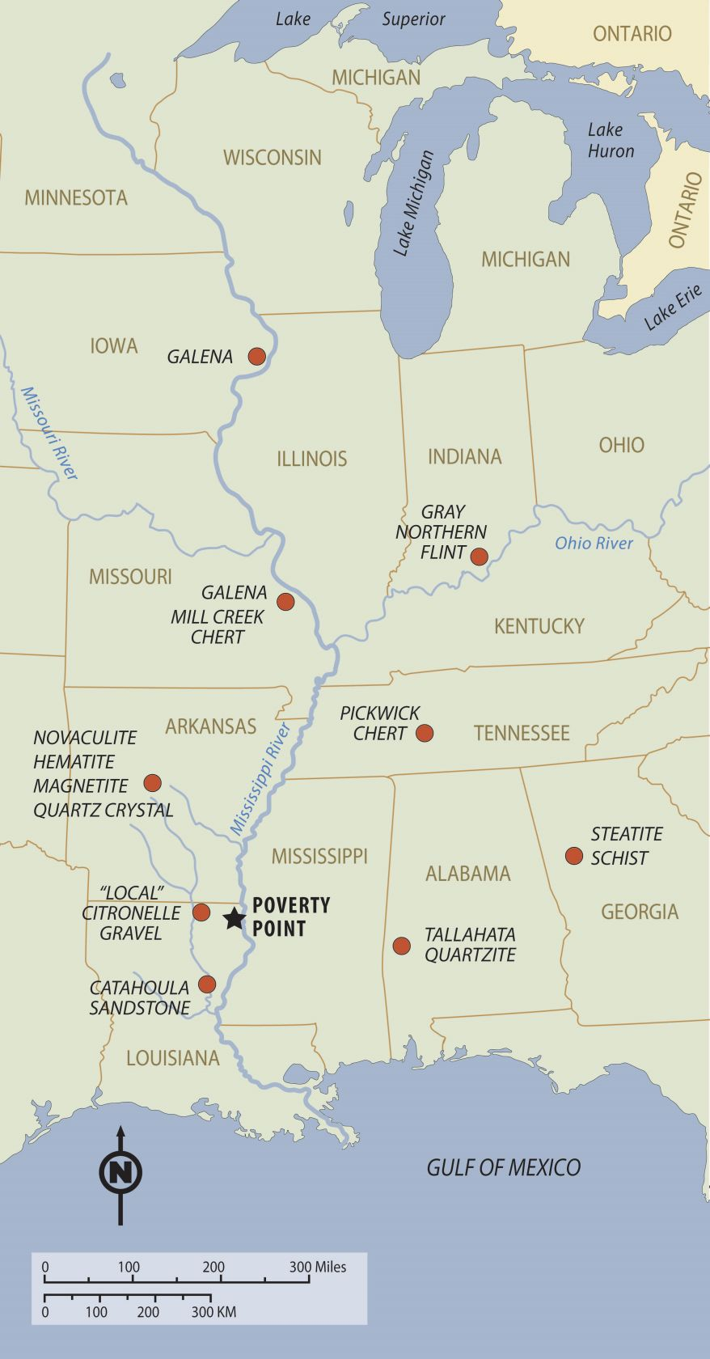

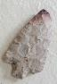
Mill Creek
Chert

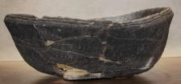
Steatite

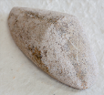
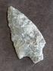
Catahoula Sandstone
Tallahata Quartzite

After you read:

Using Source H and the images in Source I, how were the mounds at Poverty Point likely built?

What do the variety of stones found at Poverty Point show about the people who lived there?

What purposes do archaeologists believe the mounds at Poverty Point served?

Lesson 4 – What are the characteristics of the prehistoric cultures of Louisiana?
Student Directions | Read and study Sources J, K, L, and M and complete the guiding questions. Next, complete performance task #1 at the end of this lesson.
Featured Sources | Source J: “Tchefuncte Culture” by Rebecca Saunders and Richard Weinstein  Source K: Tchefuncte Pottery Fragments  Source L: “Marksville Culture” by Rebecca Saunders  Source M: Marksville Burial Mound

Source J: Adapted from “Tchefuncte Culture” by Rebecca Saunders and Richard Weinstein
Text | Vocabulary
People named by archaeologists as members of the “Tchefuncte culture” lived in the Lower Mississippi River Valley and along the Gulf of Mexico from at least as early as 2,800 years ago during the Woodland period. Tchefuncte communities were present in most of Louisiana, southeastern Arkansas, along the coast of Mississippi, and in southeastern Texas.

Like the people of Poverty Point, the Tchefuncte were fishers, hunters, and gatherers. However, Tchefuncte peoples did not build massive earthworks or take part in extensive trade networks like the Poverty Point people did, and the Tchefuncte culture is considered somewhat different from the Poverty Point culture. Unlike the people at Poverty Point, who must have been aware of pottery but did not use it very much, Tchefuncte people made many different types of clay pots. In addition, Tchefuncte people built some of the earliest burial mounds in Louisiana.

Tchefuncte people lived in their settlements throughout the year. They harvested shellfish, mostly clams, and hunted many species of fish, mammals, birds, reptiles and amphibians. They also gathered a variety of plant foods.

How did the Tchefuncte people adapt to their environment?

Source K: Tchefuncte Pottery Fragments

The Tchefuncte culture were the first people in Louisiana to make large amounts of pottery. Pottery was made by coiling clay into a shape and then smoothing it to form a container. Since pottery making was still a new technology, the pottery broke easily and only pieces remain. More than 47,000 pieces of pottery were found at this site.

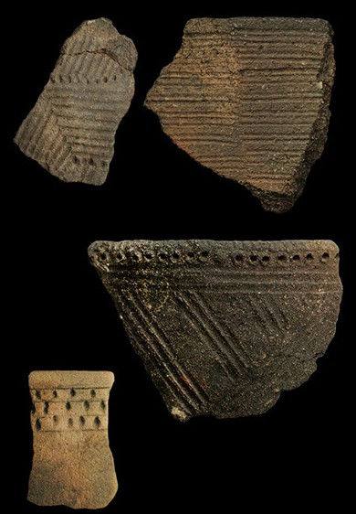

Based on Sources J and K, describe two characteristics of Tchefuncte culture.

Source L: Adapted from “Marksville Culture” by Rebecca Saunders
Text | Vocabulary
Marksville culture developed after the Tchefuncte during the Woodland period. Marksville culture shares many qualities of the Tchefuncte but with the addition of some new characteristics. These new characteristics come from another American Indian culture called the Hopewell tradition.  Although present at only a handful of sites in Louisiana, these Hopewell-related qualities can be seen in their ceremonial centers, mound burial, and grave goods.  The most recognizable Marksville artifacts are the pottery. Marksville pottery was different from Tchefuncte pottery because materials like sand, shells, or moss were added to the clay to create stronger pots.  Other than pottery, there were few changes in the Marksville technology. Because the basic hunting and gathering techniques did not change, most everyday items are very similar to Tchefuncte items.  Unfortunately, few Marksville sites have been excavated, so there is little information on daily life, including diet.  Tchefuncte burial practices also influenced Marksville culture; communal burials and burials in mounds became the normal practice. At one Marksville cultural site, called Big Oak Island, instead of plain single graves, there was a burial area containing the remains of over fifty individuals. These were accompanied by pottery with an interesting mix of characteristics. The pottery had Marksville designs with Tchefuncte-like techniques—clearly showing a changing culture. | diet: the kinds of food a person eats on a regular basis  communal: shared by all members of the community for common use

How were Marksville burials different from Tchefuncte burials?

Source M: Marksville Burial Mound

The Marksville people were influenced by another Indigenous culture called the Hopewell. One idea that spread through the Hopewell culture was a certain style of mound building. The Marksville people built mounds, sometimes in different colored soil. The mound shown here is a burial mound. Pottery recovered from mounds like this one show animal designs very similar to those in the Hopewell tradition.

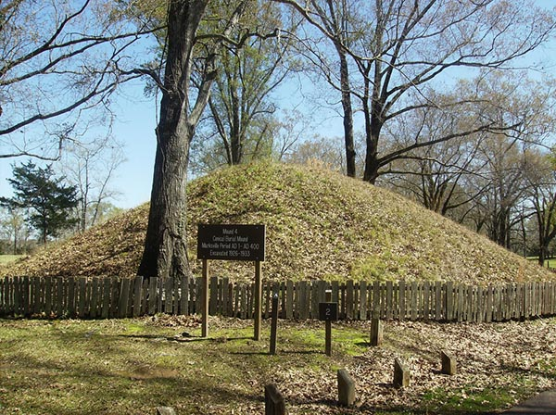

How can the influence of the Hopewell culture be seen in Marksville burial mounds?

Formative Performance Task #1 – Item Set
Student Directions | Using the sources from previous lessons, complete the multiple-choice questions below.

Source G: Prehistoric American Indian Cultures in Louisiana

_____ 1. What would be the best use for the map in Source G?

- to locate where some early Indigenous people lived in present-day Louisiana
- to find where Mt. Driskill is located
- to learn what early Native Americans ate
- to travel across Louisiana by water

_____ 2. Using Source G, which statement tells the directions needed when traveling from the Tchefuncte site to Poverty Point?

- northeast
- southwest
- northwest
- southeast

_____ 3. Using the map in Source G, what do all three settlements have in common?

- They were built in marshland for fishing.
- They were built on or near a water source.
- They were built in the north to avoid flooding.
- They were built on flat land for farming crops.

_____ 4. Why would early American Indians trade for goods found far away?

- American Indians did not want the goods produced using the natural resources found near their homes.
- Natural resources were the same everywhere, but the skills to create different goods were unique only to certain tribes.
- American Indians spent a lot of free time traveling across the middle of the country and
exchanging goods.
- Natural resources vary in different locations, and American Indians wanted goods
they could not find in their land.

Lesson 5 – What was life like for Indigenous peoples before and after colonization?
Student Directions | Read and study Sources N and O and complete the guiding questions for each.
Featured Sources | Source N: Map Bank  Source O: “Caddo Culture” by Rebecca Saunders and Jeffrey Girard

Source N: Map Bank

Image 1: Mississippian and related cultures

The last period of settlement in Louisiana before the arrival of explorers from Europe is called the Mississippian period. Three different Indigenous cultures were present in Louisiana during that time: the Caddo, the Plaquemine, and Mississippian cultures. This map shows the settlements of those cultures.

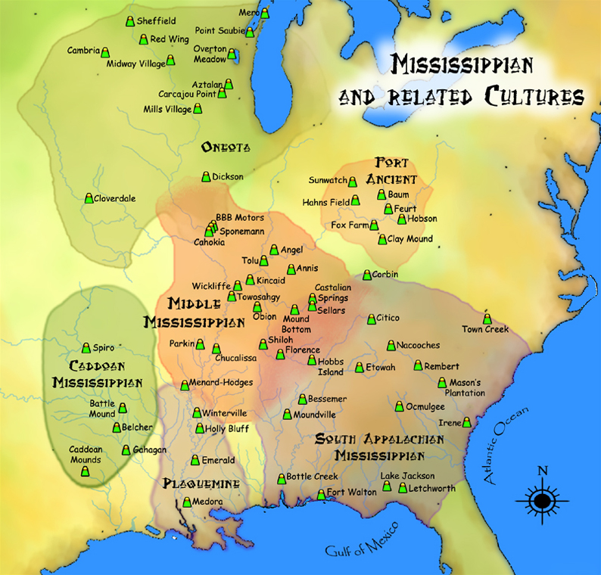
Archaeologists believe that Mississippian culture had a major impact on the Caddo and Plaquemine and can be seen in the presence of new types of pottery, larger and more complex ceremonial centers, and maize (corn) growing.
Guiding Questions
What three cultures were present in Louisiana during the Mississippian period?

____________________________

____________________________

____________________________

In what ways do archaeologists think the Mississippian culture influenced the Caddo and Plaquemine?

____________________________

____________________________

____________________________
Image 2: European Exploration and Colonization

In the late 1400s, European nations, including Spain and Portugal, began to explore, invade, and use force to take over land in the Americas, Africa, and Asia. The land that would become Louisiana was explored by Spain and then claimed by France, despite the fact that many different Indigenous nations lived in this area.

After claiming the area of Louisiana, France attempted to colonize the area. Colonization is a process of settling among the original Indigenous peoples while also trying to take control over them. The French settlers who came to this area were not prepared nor skilled to live in this region with its new climate, new types of food to grow, and new types of animals they encountered (such as alligators, which did not exist in France). French colonization had a mixed effect on the Tribes of Louisiana. Europeans introduced new diseases which killed many thousands of American Indians. However, both Europeans and American Indians benefited from each other through trade of goods.

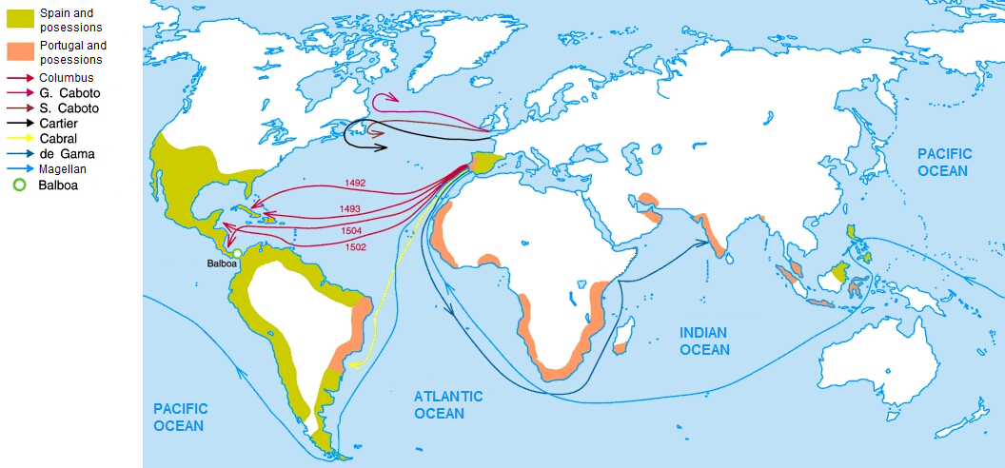

What did European countries begin to do in North and South America in the late 1400s?

Image 3: Native American Settlements 1500s
This map illustrates the general area where some Tribes in Louisiana lived in the early 1500s, around the time the Spanish began exploring North America. Other Tribes like the Coushatta would migrate to Louisiana in the 1700s as European settlement and colonization of other parts of North America forced them to move.

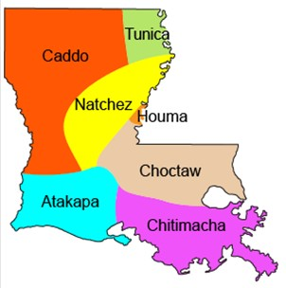

Despite being claimed by France, what Tribes already lived on the land that would become present-day Louisiana?

Source O describes how the Caddo people lived before European colonization and some of the effects of European contact and colonization.
Source O: Adapted from “Caddo Culture” by Rebecca Saunders and Jeffrey Girard
Text | Vocabulary
Archaeologists can trace goods from the Caddo culture back to at least 1,100 years ago. Most Caddo peoples lived in sedentary villages. In addition to fishing, hunting, and gathering, they grew corn and other crops. The Caddo were great traders, bringing in goods from Mississippian communities as well as from the southern plains and the Southwest.  Most prehistoric cultures have names that archaeologists gave to them. However, the name “Caddo” comes from the word Kadohadacho, meaning “real Caddo”. The Caddo raised corn, beans, and squash; they also hunted, fished, and collected wild plant foods such as nuts (hickory, pecan, walnuts, acorns), persimmons, purslane, wild grapes, and berries. Although deer was the most important meat source, fish and turtle were very important in the Caddo diet. The Caddo also hunted rabbit, squirrel, turkey, and other small mammals and birds.  Many archaeologists think Caddo pottery is the highest-quality pottery ever made in the prehistoric Southeast. This pottery has thin walls, is very polished, and has complex and precise designs.  Caddo in southern Arkansas and northeast Texas were visited by Spanish explorers in 1542. After contact with Europeans, the Caddo suffered disease and many deaths. But the Caddo survived and adapted, possibly because of their long success as traders. By 1700, many Caddo had horses, peach groves, and watermelon patches. The modern Caddo Nation has its headquarters near Binger in west central Oklahoma. Some Caddo, descendants of the Adai group, continue to reside in Louisiana. | sedentary: living in the same area throughout the year as opposed to moving around; usually achieved by farming  precise: very exact, accurate in detail

What types of agriculture did the Caddo practice?

2. How were the Caddo negatively affected by European contact?

3. What did the Europeans gain from the Caddo?

______________________________________________________________________________________

Lesson 6 – What was life like for Indigenous peoples before and after colonization?
Student Directions | Read and study Sources P, Q, R, and S and complete the guiding questions. Next, complete performance task #2 at the end of this lesson.
Featured Sources | Source P: Naniah Waiya Mound Photograph  Source Q: “Coushatta Tribe of Louisiana” by Sheri Shuck-Hall  Source R: “Jena Band of the Choctaw Indians” by Johnna Fisher (excerpts)  Source S: “The Tunica-Biloxi People – A Brief History” by John Barbary (excerpts)

Source P: Naniah Waiya Mound Photograph

The earliest account of the Choctaw Indians is believed to be about 1540, in parts of modern-day Mississippi and in the early 1700s near present-day Mobile, Alabama, Biloxi, Mississippi, and New Orleans, Louisiana. Inland from these settlements was a large tribe of Muskogean-speaking (a group of related Indigenous languages) people living in about 60 towns on the streams near the Pascagoula and Pearl Rivers.

The Choctaw developed an economy based on hunting and farming. Some Tribe members identify Naniah Waiya, in modern-day central Mississippi, as their tribal birthplace and spiritual center. The photograph below is of the Naniah Waiya Mound.

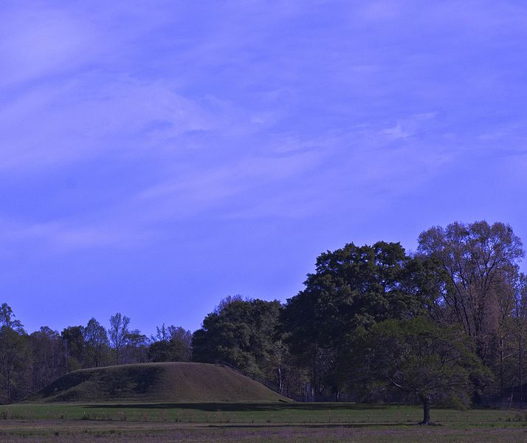

Source Q describes how the Coushatta people lived before European colonization and some of the effects that European contact and colonization had on them.

Source Q: Adapted from “Coushatta Tribe of Louisiana” by Sheri Shuck Hall
Text | Vocabulary
The Coushatta lived in the Tennessee River valley in large, settled villages during the Mississippian period. They often grew corn, hunted game animals, and gathered wild plants and fruits. After the Coushatta encountered Spanish explorers in 1540, they decided to move southward to avoid warfare, disease and the advance of traders and settlers.  By the year 1700, the Coushatta had migrated to live in present-day Alabama, allying themselves with a powerful group of Muskogean-speaking tribes that would later be known as the Creek Confederacy. By the 1750’s, the English and French began building colonies in the Southeast.  Their strategic location where three rivers came together gave them power when they negotiated with Europeans interested in trade. In 1717 the Coushatta showed their importance in the Southeast by inviting the French to build a trading post and fort in the heart of their territory. Over the years, many of the French stationed at the trading post married Coushatta women, building ties of kinship.  A war between France and England ended in 1763 and France lost. Many French fled west across the Mississippi River to Louisiana, and a group of Coushatta joined them. By 1805 the population of Coushatta and Alabama in Louisiana was at least 1,650. After the United States took over Louisiana, more conflict between new settlers and Americans Indians began. Many Coushatta moved to Spanish territory in present-day Texas to escape the attacks from American settlers. A smaller group remained near Caddo territory in northwest Louisiana. Coushatta people continue to live in Louisiana today, though most now live in Allen and Jefferson Davis parishes. | kinship:  relation or family

What influenced the Coushatta to migrate multiple times?

______________________________________________________________________________________

Source R was written by a current member of Jena Band of Choctaw Indians and describes some things that happened to the Choctaw Indians after the United States was established, including the Trail of Tears. The Trail of Tears is the name for a series of events, in which about 60,000 American Indians were forced to move their settlements from their family homelands to places west of the Mississippi chosen by the U.S. government. The forced migration caused suffering, disease, and starvation, with approximately 4,000 people dying before reaching the end of the journey. The Trail of Tears affected members of the Cherokee, Muscogee, Seminole, Chickasaw, and Choctaw nations.

Source R: “Jena Band of the Choctaw Indians” by Johnna Fisher (excerpts)
Text | Vocabulary
With the Treaty of Dancing Rabbit Creek in September 1830, the main group of Choctaws ceded all their land east of the Mississippi River to the [United States], with promises of better lands to the west.  After the Treaty of Dancing Rabbit Creek, the removal of the Choctaws from Mississippi to southern Oklahoma began under the Indian Removal Act, a law passed by the United States government. The Choctaw were told that they would be moved by wagon, beginning November 1, 1831. Many promises were made to the Choctaw, such as a place to live, livestock, gold, and weapons.  Boats were chosen as primary transportation. There were roughly 2000 Choctaws waiting to be put on the boats. Meanwhile, food supplies began to dwindle. During this time, it started snowing. Because there was no way to transport the Choctaw, they were forced to walk. Food was in short supply and supplies finally arrived after 8 days. Unfortunately, by this time, there had already been several deaths. An Arkansas reporter interviewed one of the chiefs who was quoted saying that the removal had become a “trail of tears and death,” and that’s where the title “Trail of Tears” came from. The “Trail of Tears” finally ended on January 1, 1834.  While most of the Choctaw people were removed from their land, some avoided resettlement. In early 1870, those who would become the Jena Choctaws began to move into Louisiana from southern Mississippi. One group moved into the Trout Creek area in LaSalle Parish and another into the Enterprise area in Catahoula Parish. By 1910, it was reported that only around 40 Choctaws remained in LaSalle and Catahoula Parishes. The Jena Choctaw children were not allowed to attend local schools. It wasn’t until Mrs. Charles Penick opened the Penick Indian School that they were allowed to attend school in 1932. Sadly, the school closed in 1938. The children were finally allowed to attend local schools in 1943, after World War II ended. | ceded: to give up land  transport: to take people from one place to another

Image 1: Penick School

This is the Penick Indian School that was run by Mrs. Charles Penick for the Choctaw children in the community. The school was open from 1932–1938. Due to a lack of money, the school was closed.

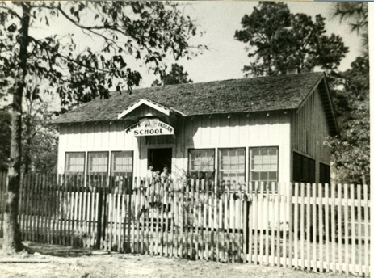

Use Sources Q and R to the answer the following guiding questions.

What was life like for the Choctaw before contact with the Europeans?

What happened to many Choctaw people as a result the Indian Removal Act?

Source S describes the Tunica-Biloxi Tribe of Louisiana, and some of the effects that colonization had on them.

Source S: Adapted from “The Tunica-Biloxi People – A Brief History” by John Barbry (excerpts)

The Biloxi inhabited the Pascagoula River region of the Gulf coast of [modern-day] Mississippi when French explorers first encountered them in 1699. Before this time, there is no definitive written record of Biloxi, at least not under the name “Biloxi.”

The Tunica had large influence on trade and culture in Arkansas, Louisiana, and Mississippi. The Tunica were skilled traders, especially in the manufacture and distribution of salt, a valuable item to both Indigenous peoples and Europeans. For example, salt was extremely important in the trade between the French and the various Caddo groups in northwestern Louisiana. After the United States bought Louisiana, the Tunica lost [most] of their land to French and American settlers. Since that time, the Tunica-Biloxi Tribe has dealt with racism, discrimination, and attacks on their cultural traditions. However, through strength and determination, the Tunica-Biloxi did not allow the total destruction of their language, religion, or tradition.

Below is the present-day flag of the Tunica-Biloxi Tribe with the motto “Cherishing Our Past, Building For Our Future.”

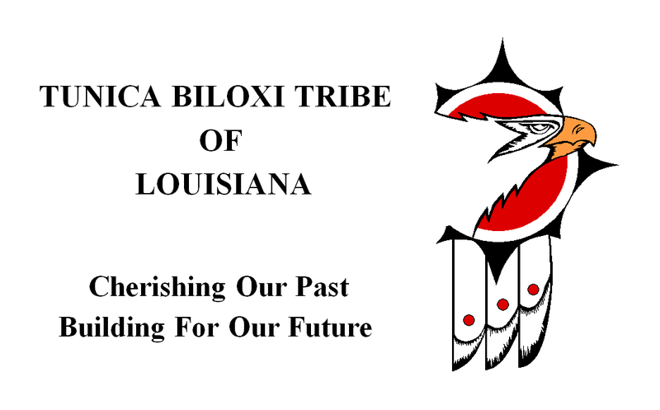

Formative Performance Task #2 – Constructed Response
Student Directions | Based on the sources, write a paragraph that describes two effects of colonization on Louisiana’s Indigenous people.

Lesson 7 – What are the challenges and opportunities for modern Tribes in Louisiana?
Student Directions | Read and study Sources T, U, and V while completing the guiding questions. Next, complete the after you read questions at the end of this lesson.
Featured Sources | Source T: “American Indians in the Twentieth-Century Louisiana” by Jay Precht  Source U: Jena Band of the Choctaw Tribes by Johnna Fisher  Source V: Coushatta Baskets
Optional Digital Extensions | PBS Newshour – In Louisiana, Rising Seas Threaten Native Americans’ Land
Source T gives a brief overview the history of American Indians in Louisiana in the last hundred years, leading up to modern times.

Source T: Adapted from “American Indians in Twentieth-Century Louisiana” by Jay Precht
Text | Vocabulary
The US government estimates that more than 26,000 Native Americans lived in Louisiana in 2008, and currently recognizes the authority of four Louisiana Tribes, the Chitimacha Tribe, Coushatta Tribe, Tunica-Biloxi Tribe, and Jena Band of Choctaw Indians, and the state recognizes ten additional Tribes, the United Houma Nation, Choctaw-Apache Tribe of Ebarb, Clifton Choctaw Tribe, Adai Caddo Tribe, Four Winds Tribe, Louisiana Choctaw Tribe, Pointe-Au-Chenes Indian Tribe (PACIT), and the Biloxi-Chitimacha Confederation of Muskogees (BCCM).  Culturally diverse with unique histories, American Indian communities in Louisiana have nevertheless experienced similar challenges and opportunities. Although many Tribes practiced agriculture for generations, lack of land and capital for equipment prevented Louisiana Tribes from establishing large farms or ranches in the twentieth century.  Timber companies bought up much of the land where the Coushattas lived in the early twentieth century and purchased mineral rights from those who refused to sell their land, clear-cutting it. The discovery of oil and gas on American Indian lands in the 1920s led to similar land loss through fraud and bullying.  Despite these challenges, Indians in Louisiana did farm. Tunica-Biloxi grew cotton, corn, and vegetables on small plots of land, and many Indians owned cows, horses, pigs, and chickens. Indians took jobs in the timber and oil industries and on farms.  They added to their incomes by cutting wood, picking cotton, harvesting swamp moss, gathering blackberries, hunting, fishing, trapping, shrimping, oystering, and tanning hides.  Today, American Indians in Louisiana run their own businesses and work in all areas of the economy. Three of the four federally recognized tribes in Louisiana have built and run successful casino gaming businesses. The revenues from that industry have allowed the Chitimacha, Coushatta, and Tunica-Biloxi to improve their standard of living, invest in their culture, and reclaim some of their land. | diverse: many different types  capital: money  timber: wood used for building  mineral rights: legal ownership of natural resources  fraud: lying in order to get something illegally

What economic challenges did American Indians in Louisiana face in the early 1900s?

How did Tribes change and adapt in the 20th century?

Source U: Jena Band of Choctaw Indians Gallery

Source U includes both a description of the modern Jena Choctaw Tribe, written by a current member of the Tribe, and photos representing Jena Choctaws.

“Jena Band of the Choctaw Indians” by Johnna Fisher
Text | Vocabulary
The last traditional Chief of the Jena Band of the Choctaw, William Lewis Sr., died in 1968. The first Tribal election was held in 1974 and Jerry D. Jackson was the first elected Chief and the Tribe was state recognized. At this time, the Tribe began to work towards federal recognition. On May 18, 1995, the Jena Band of Choctaw Indians received Federal Recognition and were able to receive federal funds to help Tribal members. In 1998, B. Cheryl Smith was elected as the first female Chief for the Tribe. In 2014 the first all-female council was elected. The Tribal government consists of the Chief and four council members.  Around 1978, the first Tribal Princess pageant was held. The pageant has continued through the years and is presently held every 2 years in September. In 2009 the Tribe hosted the 1st Annual Pow Wow in the Pines, which continues today. The dancers wear traditional clothing and dance various styles.  The Jena Choctaw are working for cultural revitalization. They have provided Tribal members the opportunity to learn cultural traditions, such as Traditional Choctaw social dancing, pow wow dance, beading, stickball, and language. With current Tribal members learning these traditions, it is hoped that they will continue to pass them on to the younger generations. The Tribe is very proud of its craftspeople from past to present. Different Tribal crafts include rivercane basket weaving, hide tanning, china berry necklaces, wood carving, pottery, beading, and the making of ribbon dresses. As of now, July 2020, the Jena Band of Choctaw Indians have 390 Tribal members. They have been at their current location in Trout, Louisiana, since 2002. | Chief: leader of a Tribe  federal recognition: Tribes that are recognized by the United States government as having inherent rights to self-govern and receive  certain federal benefits, services, and protections  revitalization: the action of putting new life into something

Image 1 - Jena Band of the Choctaw: Tanning Hides

Tribal Elder Anderson Lewis is shown in the photograph with his grandsons, Bill and Mike Fisher, and George Allen. Mr. Lewis is teaching a few of the Tribal youth the steps of tanning a hide. Mr. Lewis was well known for his hide tanning. He was a fluent Choctaw speaker and storyteller. The Choctaws paid for goods from local stores with skinned and tanned hides.

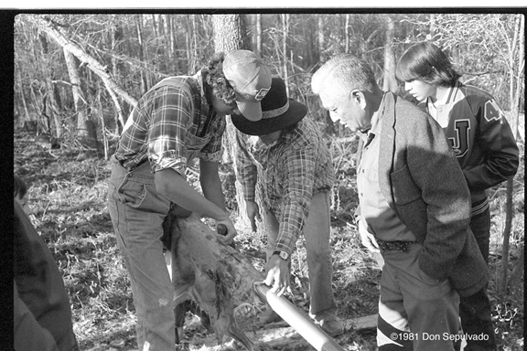

Image 2 – Jena Band of the Choctaw: China Berry Necklace

Tribal member Mary Jackson Jones is shown making traditional china berry necklaces. She was also known for making traditional ribbon dresses and was a fluent Choctaw speaker.

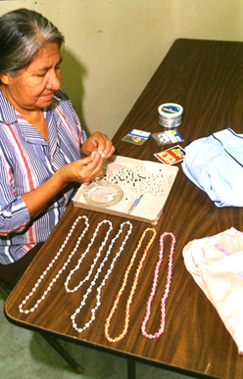

Source V: Coushatta Baskets by Teresa Parker Farris

Coushatta men and women have woven baskets for centuries, using materials such as white oak, sedge grass, swamp cane, and other locally available resources. The earliest baskets were used as containers for gathering and storing food and as items to trade for food and other necessities.

Long-leaf pine needles are gathered, dried, and then coiled into baskets using natural fibers and sewing needles. Finished baskets may be decorated with pinecones, brightly colored raffia flowers, and geometric designs. Baskets are also made in the shape of animals (known as effigy baskets).

In the latter part of the 20th century, several Coushatta basket-makers were recognized nationally and internationally for the quality of their artistry. Coushatta pine needle baskets have become highly prized and sought-after collectables. This photograph shows Lorena Langley by her craft table at the 1978 New Orleans Jazz & Heritage Festival. Langley and her family make traditional Coushatta Indian style pine-needle basketry.
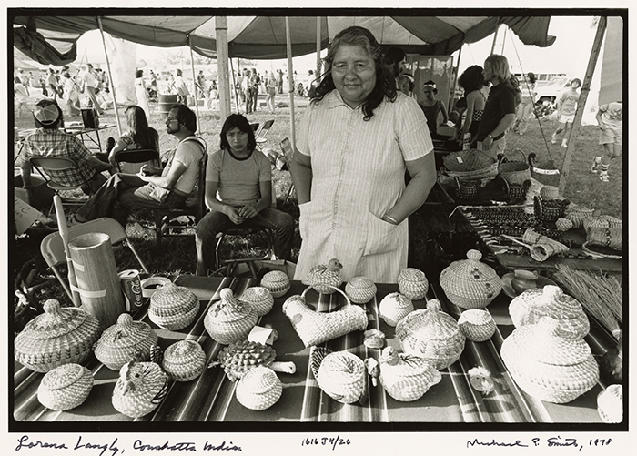
Guiding Questions
What were the earliest Coushatta baskets used for?

____________________________

____________________________

Describe two characteristics of a Coushatta basket.

____________________________

____________________________

____________________________

Lesson 8 – What are the challenges and opportunities for modern Tribes in Louisiana?
Student Directions | Read Sources W, X, and Y while completing the guiding questions. Next, complete performance task #3 at the end of this lesson.
Featured Sources | Source W: “Land loss” from PACtribe.com  Source X: Language and Culture Programs  Source Y: “State Recognition” from PACtribe.com

Source W: Land loss

The Pointe-au-Chien Indian Tribe (PACIT) in southern Louisiana is not protected by a levee and land loss has increased dramatically in recent years. The land loss is caused by the increased amounts of salt in the water, the loss of the barrier islands, and the lack of fresh water. These factors leave Pointe-au-Chien at risk for flooding. Multiple hurricanes have caused severe damage to homes in the past fifteen years. In 2008, the eye of Hurricane Gustav passed to the west of Pointe-au-Chien causing extreme wind and water damage to homes, and flood waters from Hurricane Ike caused another eight-foot storm surge in some parts of the community. Tribal members are adapting to the changing nature of their land by raising their homes, some as high as thirteen feet. This photo was taken in Pointe-aux-Chênes, Louisiana, in 2002. This Indian Tribe’s community was hit hard by a seven-foot tidal surge that accompanied Hurricane Lili.
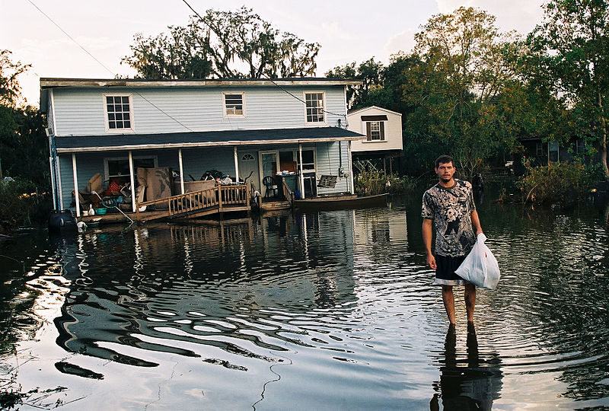
Guiding Questions
How do hurricanes and flooding affect American Indian communities (such as the PACIT) on the coast of Louisiana?

_____________________________

_____________________________

_____________________________

_____________________________

_____________________________

Source X: Language and Culture Programs

Image 1: Koasati Immersion Class
Some of Louisiana’s American Indians have maintained their languages. The Choctaw language survives in the Jena Band, but not among the other Choctaws in Louisiana, while the Koasati language is still used in the Coushatta community. Other American Indian nations have lost their native language. For some of these Tribes, such as PACIT, they still speak an Indian dialect of French, and others are trying to rediscover their languages using notes and recordings gathered by ethnologists and linguists (people who study language).

The Chitimacha Tribe has worked with Rosetta Stone to develop software to teach their language to Tribal members, and members of the Atakapa-Ishak Nation are attempting to reclaim their language using a dictionary created by the Bureau of Ethnology in the 1930s.

On June 19–20, 2014, McNeese education professor Dr. Michelle Haj-Broussard taught a class on how to teach Koasati in an immersion setting. Throughout the two-day workshop, Dr. Broussard taught students how to develop Koasati teaching materials, songs, and games that can be used to teach others about the Koasati language. Now, Coushatta Tribal members are teaching Koasati language classes to the next generation, and ensuring that the Koasati language continues to grow.

Image 2: 2016 Tunica-Biloxi Language and Culture Camp

This photo shows participants of the 2016 Tunica-Biloxi Language and Culture Camp, where youth learn Tunica language while focusing on various aspects of the natural environment as it relates to traditional culture. (photo courtesy of the Language and Culture Revitalization Program)

Guiding Questions
What American Indian languages are still spoken in Louisiana?

___________________________________________________________________________________

___________________________________________________________________________________

Why would American Indians want to preserve or rediscover the languages of their ancestors?

___________________________________________________________________________________

___________________________________________________________________________________

___________________________________________________________________________________

___________________________________________________________________________________

Source Y: State Recognition

Many American Indian groups have fought for years to be officially recognized by the Louisiana state government, though not all have. In June 2004, the Pointe-au-Chien Indian Tribe (PACIT), the Isle a Jean Charles Band of the Biloxi Chitimacha Confederation of Muskogee, the Bayou Lafourche Band of the Biloxi Chitimacha Confederation of Muskogee, and the Grand Caillou Dulac Band of the Biloxi Chitimacha Confederation of Muskogee (BCCM) were officially re-recognized as Tribal communities and recognized as Indian Tribes by the State of Louisiana. PACIT and BCCM members worked together to obtain state recognition. Tribes often seek state recognition because it acknowledges their historical and cultural contributions.

Why have American Indian communities in Louisiana worked for federal or state recognition?

Formative Performance Task #3 – Constructed Response
Student Directions | Based on the sources, write a paragraph that explains one challenge and one opportunity for American Indians living in modern-day Louisiana.

Lesson 8 - Summative Performance Task
Student Directions | Based on the sources from this packet and your knowledge of social studies, write an essay answering the framing question: How have Indigenous cultures in Louisiana changed over time?

Name__________________________________________________________ Date______
How Did European Exploration and Colonization Change Louisiana?

Introduction
Student Directions | Over the next two weeks, you will explore the sources in this packet to learn about European exploration around the Mississippi River, the establishment and consequences of French and Spanish colonial rule in Louisiana, and finally, the lasting cultural influences from African, American Indian, Cajun, French and Spanish peoples. At the end of the packet, you will express your understanding by writing an extended response answering the following question: How did European exploration and colonization change Louisiana?  This packet includes three supporting questions which will help you develop your claim on European exploration and colonization of Louisiana. After you read each text or analyze each image, you will be asked to answer questions about it. Some words are defined to help you better understand each source and answer the questions. Some sources have digital extensions, which are optional sources you can explore if you have internet access.

Lesson 1 – Setting the Context
Student Directions | Read Sources A, B and C while answering the guiding questions. Next, answer the after you read questions at the end of this lesson.
Featured Sources | Source A: “World Map”  Source B: “Age of Exploration”  Source C: Image Bank: Age of Exploration Technology

Source A: World Map

Beginning in the 15th century, Europeans started exploring parts of Europe, Africa, and Asia more. Some explorers thought there might be a quicker route to Asia by crossing the Atlantic, instead of the costly and long journey around Africa. What was on the other side the Atlantic Ocean was not yet fully understood, much less the civilizations that had developed there.

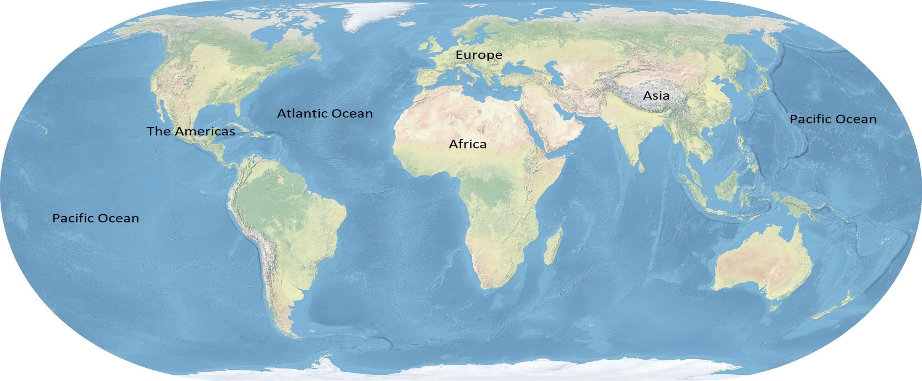

Source B: “Age of Exploration”
Text | Vocabulary
The Age of Exploration was a period of world history that started in the 15th century and continued into the 18th century. During this time, new technologies allowed Europeans to sail on exploration voyages around the world. Explorers discovered new routes to Asia and came into contact with North and South America, which were generally unknown to people in the Eastern Hemisphere at that time.  The Age of Exploration led to the first truly global turning point, the meeting of the “Old World” (Africa, Asia, and Europe) and the “New World” (North and South America).  For several years, Christopher Columbus requested the Spanish king and queen pay for an expedition that would find a new route to Asia. Columbus was finally given money to make the voyage and in 1492 he landed in the Caribbean. Believing he had arrived in India, he called the Indigenous peoples he met Indians. The Indigenous people were actually Tainos. His exploration started waves of European exploration and conquest in the New World. | global turning point: a time when a major change occurs in world history  expedition: a journey or voyage  Indigenous: earliest known people to inhabit an area  conquest: control over a people or place by use of force

Guiding Questions
Who was exploring during the Age of Exploration?

Where were they exploring during the Age of Exploration?

What continents make up the “Old World” and the “New World”?

The images and text in Source C explore the different technologies that made it possible for Europeans to sail across the Atlantic Ocean.

Source C: Image Bank: Age of Exploration Technology

Image 1: The Caravel
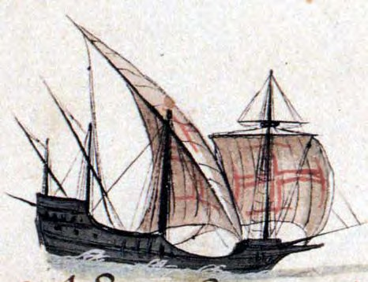
The caravel was a small, fast, and highly maneuverable (easy to steer) ship. It was developed in the 15th century by the Portuguese and used large triangular sails.

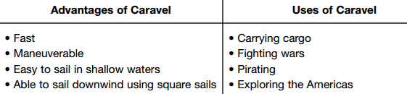

Guiding Questions
How did the caravel affect European exploration?

_____________________________________________________________________________________

_____________________________________________________________________________________

_____________________________________________________________________________________

Image 2: Astrolabe of Jean Fusoris

An astrolabe is a device that helps to determine location and the time of day by “sighting” a star through the astrolabe and using the markings on the device. The astrolabe was useful for navigation and determining distance traveled.

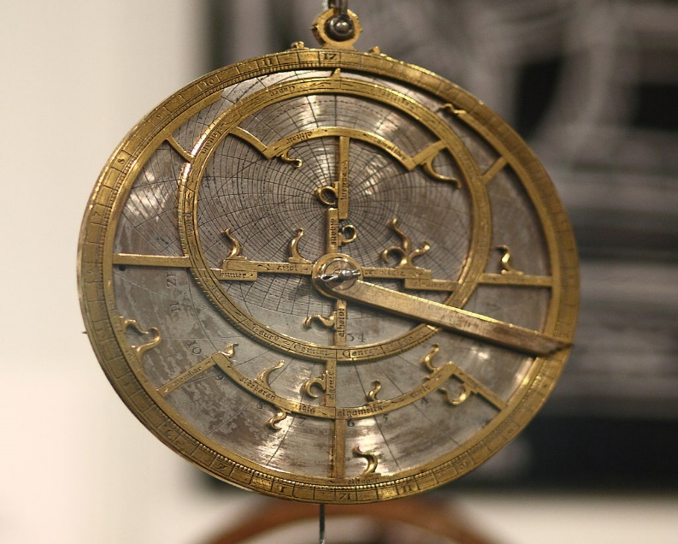

Guiding Questions
How did the astrolabe affect European exploration?
_____________________________________________________________________________________

_____________________________________________________________________________________

_____________________________________________________________________________________

_____________________________________________________________________________________

Image 3: Compass

The compass is a device that uses magnetic forces to help determine which direction is north. The compass helped travelers navigate, which was especially difficult at sea and on cloudy nights when stars could not be used. It was invented in China and its use spread to Western Europe through trade routes.

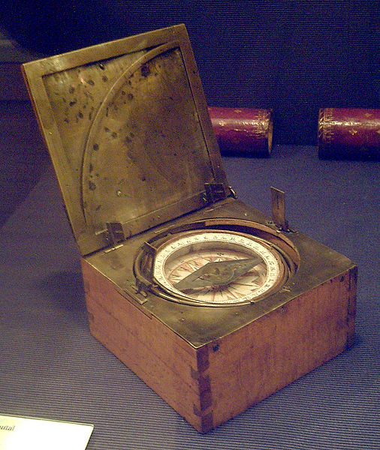

Guiding Questions
How did the compass affect European exploration?
_____________________________________________________________________________________

_____________________________________________________________________________________

_____________________________________________________________________________________

_____________________________________________________________________________________

Image 4: 1519 Portolan Chart of the Mediterranean Sea by Lopo Homem

Portolan charts were detailed charts or maps that provided navigators with valuable information like the shape of coastlines, distance between ports, and cardinal directions. Due to mathematical and scientific advances, sailors had much more accurate maps by the 15th century.

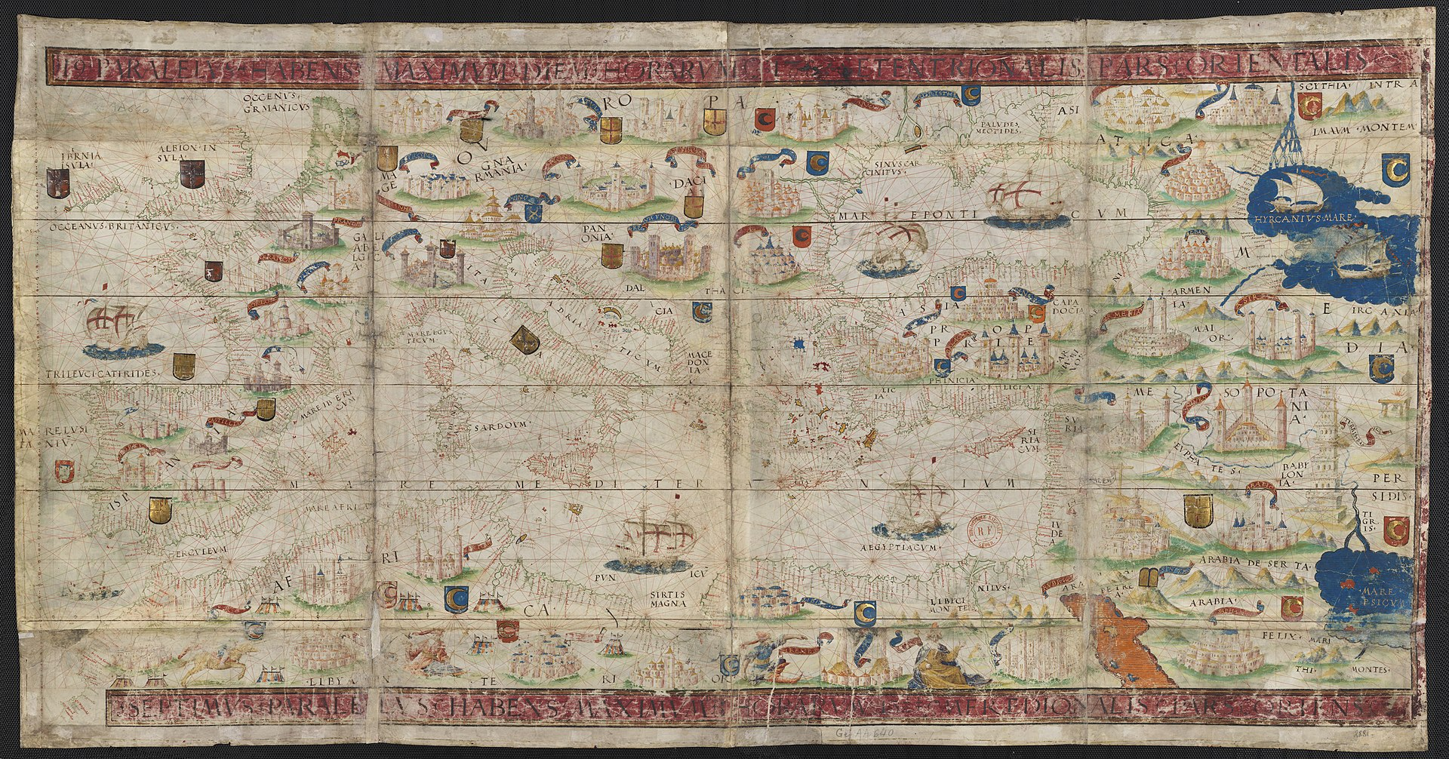

Guiding Questions
How did advances in mapping affect European exploration?

_____________________________________________________________________________________

_____________________________________________________________________________________

_____________________________________________________________________________________

_____________________________________________________________________________________

Lesson 2 – What caused Europeans to explore and settle around the Mississippi River?
Student Directions | Read and study Sources D, E, and F while answering the guiding questions.
Featured Sources | Source D: “Christopher Columbus's first landing in the Americas in 1492” by John Vanderlyn in 1847  Source E: “Hernando De Soto and Spanish Conquistadores seeing the Mississippi River for the first time” by William Henry Powell  Source F: “French Colonies in North America in 1642”

Source D: “Christopher Columbus's first landing in the Americas in 1492”, Painting by John Vanderlyn in 1847

This painting shows Christopher Columbus and his crew arriving in the New World. This painting illustrates some of the different motivations for European exploration and settlement. Columbus is shown planting a flag in the ground to claim the island for Spain. Soldiers behind him carry flags bearing a cross, symbolizing their religion, Christianity, which they hoped to spread in the New World.
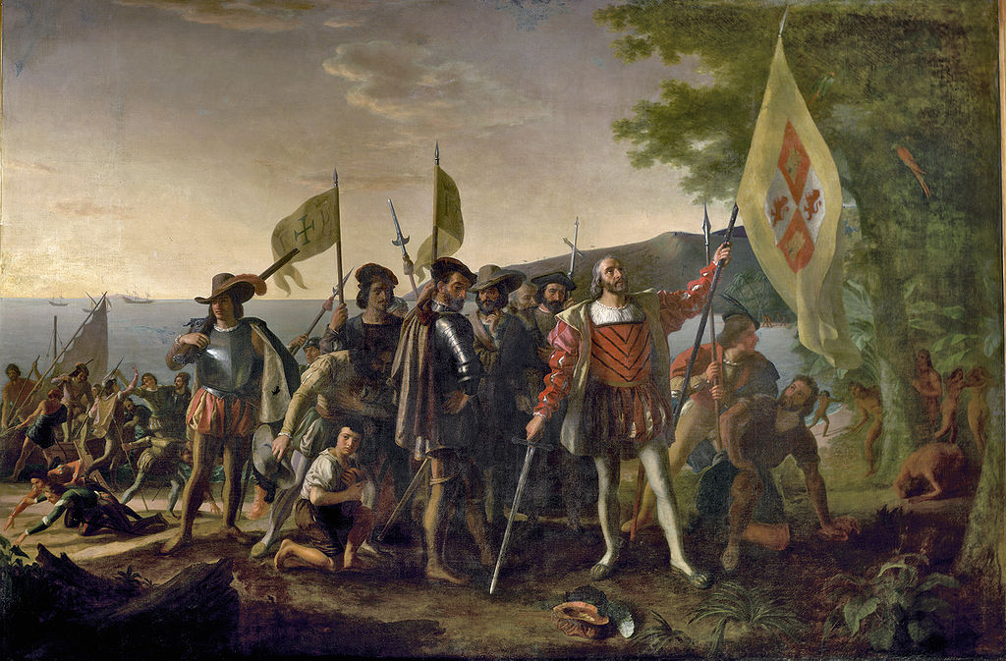
The island Columbus landed on was called Guanahani by its native people, the Taino. Columbus renamed it San Salvador. Before European arrival, the Taino were farmers and fisherman who the Spanish described as a peaceful people. Their population rapidly decreased due to disease, enslavement by the Spanish, and warfare with a neighboring tribe.

After Columbus’ voyage, Spain began conquering (taking by force) much of the New World. The discovery of gold and silver in South America made Spain extremely rich and provided an example that other European countries wanted to follow.

Guiding Questions
What motivated Columbus, and other Europeans, to explore and conquer parts of the New World?

_____________________________________________________________________________________

_____________________________________________________________________________________

_____________________________________________________________________________________

What did Columbus find in the New World? How did this affect Spanish and European interest in exploration?

_____________________________________________________________________________________

_____________________________________________________________________________________

_____________________________________________________________________________________

Source E: “Discovery of the Mississippi” by William Henry Powell

The Spanish first explored and settled in the Caribbean and South America. Spain’s continued search for gold and silver eventually led them to North America. In 1538, Hernando de Soto and his crew embarked on an expedition into the continent, beginning in modern-day Florida. Rumors of gold led the expedition to present-day Alabama and Mississippi, even though de Soto’s group was suffering injuries and deaths from fighting with Indigenous people. In June 1541, de Soto and the remaining crew reached the Rio del Espiritu Santo, later called the Mississippi River, near the mouth of the White River in present-day Arkansas. De Soto’s voyage marked the first European exploration of the lower Mississippi River. It would be more than a century before another group of Europeans reached its waters.

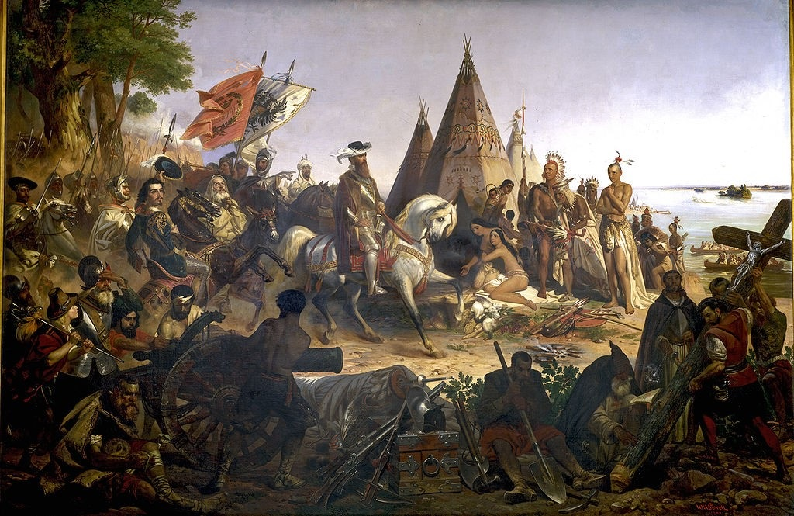

Guiding Questions
How does this painting of De Soto’s expedition represent the Spanish?

_____________________________________________________________________________________

_____________________________________________________________________________________

_____________________________________________________________________________________

How does the painting represent the views of Europeans towards Indigenous people?

_____________________________________________________________________________________

_____________________________________________________________________________________

_____________________________________________________________________________________

What was De Soto’s expedition searching for in North America?

_____________________________________________________________________________________

_____________________________________________________________________________________

_____________________________________________________________________________________

Source F: “French Colonies in North America in 1642”

While Spain conquered much of Central and South America, France had begun to explore and claim land in North America. By the 1640s the French had built permanent settlements in modern-day Canada and had begun exploring the Mississippi River in the north. The map below shows the location and dates of early French settlements in North America.

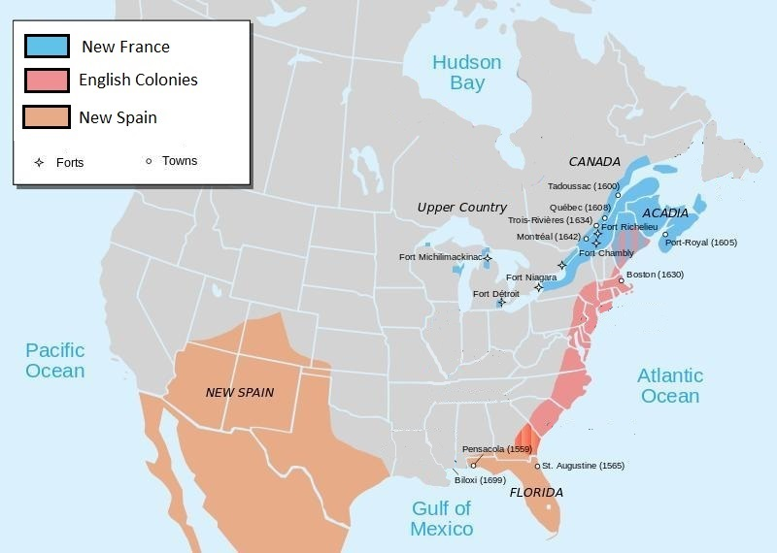

Guiding Questions
Where did France build permanent settlements in the New World?

_____________________________________________________________________________________

_____________________________________________________________________________________

_____________________________________________________________________________________

Lesson 3 – What caused Europeans to explore and settle around the Mississippi River?
Student Directions | Read Sources G, H and I while completing the guiding questions. Next, complete the after you read questions and performance task #1 at the end of this lesson.
Featured Sources | Source G: Adapted from “Early Exploration” by Michael T. Pasquier (excerpts)  Source H: "Taking possession of Louisiana and the River Mississippi, in the name of Louis XIV" by Jean-Adolphe Bocquin\ (1870)  Source I: “Carte de la Nouvelle France et de la Louisiane Nouvellement Découverte” by Louis Hennepin (1683)

In Source G you will read about French exploration into the lower part of the Mississippi River. The French had already been exploring and settling in what is modern-day Canada and in areas along the Mississippi River north of modern-day Louisiana.

Source G: Adapted from “Early Exploration” by Michael T. Pasquier (excerpts)
Text | Vocabulary
Sieur de La Salle, a former Jesuit from France, tried his hand at the trading of animal furs in the upper Mississippi River Valley during the late 1670s. After achieving little profit, La Salle looked for better business opportunities further south along the Mississippi River. In 1678 he started an expedition south. It was not until 1682 that La Salle, joined by his lieutenant Henri de Tonti, finally led an expedition that would pass the mouth of the Arkansas River, reach the Gulf of Mexico, claim the river and its drainage basin for the French empire, and name the region Louisiane after King Louis XIV.  After returning to France, a member of La Salle’s expedition published a book that featured a description of Louisiana. The book included a map titled “Carte de la Nouvelle France et de la Louisiane nouvellement découverte” (Source I) which was the first map to include the place-name Louisiane in a map of North America. | Jesuit: an order of Roman Catholic priests  drainage basin: an area of land where water collects and drains into a river, bay, or other body of water  New France: a loosely defined area of land in North America claimed by France

Guiding Questions
What land did La Salle claim for France?

_____________________________________________________________________________________

_____________________________________________________________________________________
Source H: "Taking possession of Louisiana and the River Mississippi, in the name of Louis XIV" by Jean-Adolphe Bocquin (1870)

This painting shows La Salle, sword in hand, reading a declaration while a group of people that includes French soldiers, a priest, and American Indian warriors and chiefs looks on. The river and an American Indian dwelling are seen in the background. Although La Salle claimed Louisiana for France, he was unable to hold the territory, as it was already inhabited by many Indigenous peoples.

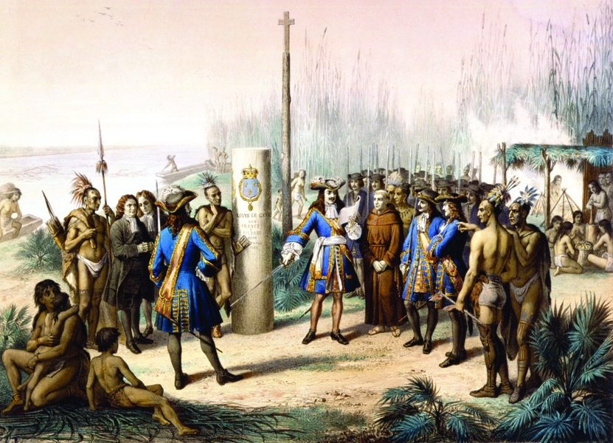

Guiding Questions
What difficulties did La Salle have with holding the territory around the Mississippi for France?

_____________________________________________________________________________________

_____________________________________________________________________________________

_____________________________________________________________________________________

Source I: “Carte de la Nouvelle France et de la Louisiane nouvellement découverte”

This image of a 1683 map was drawn by Louis Hennepin, a French fur trader who traveled with La Salle. It is the earliest map known to use the term “La Louisiane” (Louisiana). Before advances in transportation technology, rivers were the main way to transport goods. A permanent settlement near the mouth of the Mississippi would give France access to North America and the chance to gain wealth through the fur trade. It also gave them an advantage over their European rivals, the Spanish and English.

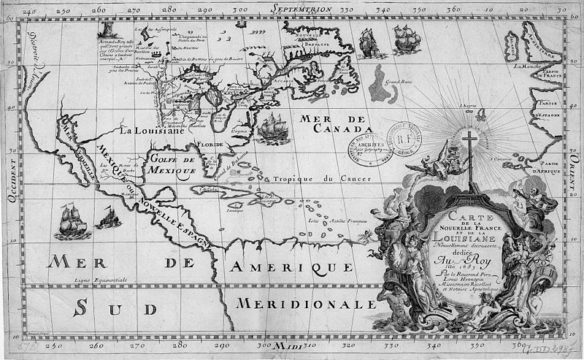
COURTESY OF LOUISIANA STATE MUSEUM Carte de la Nouvelle France et de la Louisiane Nouvellement decouverte. Hennepin, Louis (Cartographer)

Guiding Questions
Why did France want to claim the land around the Mississippi River?

_____________________________________________________________________________________

_____________________________________________________________________________________

_____________________________________________________________________________________

After you read:

Why is Hernando de Soto an important figure in the exploration of the Mississippi?

_____________________________________________________________________________________

_____________________________________________________________________________________

_____________________________________________________________________________________

Why is La Salle an important figure in the exploration of the lower Mississippi?

_____________________________________________________________________________________

_____________________________________________________________________________________

_____________________________________________________________________________________

Why were the Spanish and French interested in exploring and claiming the land around the Mississippi River?

_____________________________________________________________________________________

_____________________________________________________________________________________

_____________________________________________________________________________________

Formative Performance Task #1 – Constructed Response
Student Directions | Based on the sources, write a paragraph that describes two reasons Europeans were interested in exploring the Mississippi River.

Lesson 4 – How did French and Spanish colonization change Louisiana?
Student Directions | Read Sources J, K, L and M, and complete the guiding questions.
Featured Sources | Source J: Adapted from “Pierre Le Moyne D’Iberville” by Michael T. Pasquier (excerpts)  Source K: Document Bank: La Balise  Source L: Adapted from “Jean-Baptiste Le Moyne, Sieur de Bienville by Michael T. Pasquier (excerpts)  Source M: “Plan de la Nouvelle Orleans Capitale de la Louisiana” 1728

Source J explains how the first permanent French settlements in Louisiana were established. Settlement was part of a larger process called colonization. Colonization is when a country takes full or partial control over another country, typically a distant one, and sends settlers to occupy it. Colonizing an area usually involved enslaving its Indigenous population or forcing them off their land.

Source J: Adapted from “Pierre Le Moyne D’Iberville” by Michael T. Pasquier (excerpts)
Text | Vocabulary
Pierre Le Moyne d’Iberville, a Canadian soldier and explorer, is often described as the founder of the first permanent French settlement in Louisiana. After a long career with the military in New France, Iberville traveled on an expedition that arrived in Louisiana in 1699. With his younger brother Jean-Baptiste Le Moyne, Sieur de Bienville, Iberville explored the lower Mississippi River Valley and established Fort Maurepas, in present-day Mississippi.  Iberville’s first trip up the Mississippi River did not produce a permanent French settlement. Instead, on April 8, he chose to build Fort Maurepas at a point near the entrance of Biloxi Bay because of its depth and easy shipping access. Iberville placed Sieur de Sauvole in command of the fort and made his younger brother Bienville his lieutenant. He left for France on May 3, leaving behind seventy men with six months of provisions. While Iberville was away, Sauvole and Bienville explored the area around Mobile Bay and organized observations on local native groups and possible places to settle.  Iberville made multiple trips from France to Louisiana, and in December 1701 commanded his final expedition to Louisiana in which he hoped would prepare the way for permanent French settlement. He ordered the construction of Fort Louis on the present-day site of Mobile, Alabama, in 1702. He also met with Choctaw and Chickasaw leaders in order to develop alliances and trade partnerships. He returned to France in later that year.  In 1706, Iberville led a fleet of ships against the British in the Caribbean. He developed yellow fever during his return trip to France and died on July 9, 1706, in Havana. The site of his burial is unknown. | shipping: the transport of goods by sea or some other means  Sieur: sir in old French  provisions: an amount or thing supplied or provided, typically food and water  yellow fever: a tropical disease transmitted by mosquitoes

Gulf of Mexico
Mobile
Biloxi
Mouth of the Mississippi
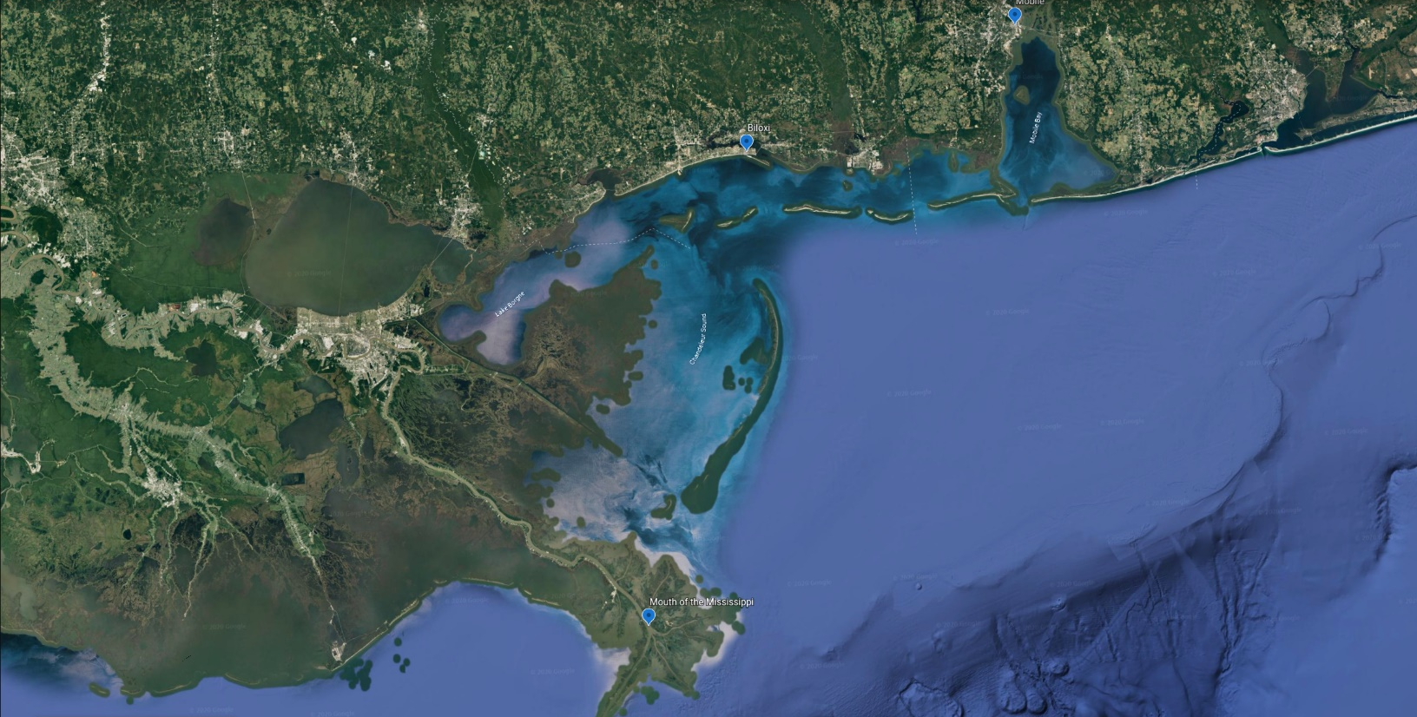
This map shows the locations of the French settlements at Biloxi and Mobile, along with the “mouth” of the Mississippi River, where the river meets the Gulf of Mexico.

Guiding Questions
What role did Iberville play in establishing the first permanent French settlement in Louisiana?

_____________________________________________________________________________________

_____________________________________________________________________________________

_____________________________________________________________________________________

Source K: Document Bank: La Balise

Source K is a collection of documents related to La Balise. La Balise was a French fort and settlement near the mouth of the Mississippi River, in what later became Plaquemines Parish. The village's name meant "seamark." La Balise was used as a stop off point for ships that had crossed the Atlantic or were coming from the Caribbean to resupply. It was also where many ships unloaded cargo in order to lighten their loads (and therefore allow the ship to not sit so deep in the water) before they could pass the sandbars at the mouth of the river. The cargo would then be shuttled upriver on smaller vessels. There were semi-permanent residents at the Balise, including a priest, soldiers, and enslaved Africans who worked as sailors and also as dockworkers, loading and unloading vessels. It was rebuilt several times because of hurricane damage.

Document 1 – Timeline of La Balise

1541 | Spanish conquistador Hernando De Soto explores the Mississippi River.
1682 | Robert Cavelier de La Salle claims the Mississippi watershed area for the French Crown and names the area “La Louisiane” for King Louis XIV.
1699 | La Balise is established as the first French fort and settlement inside the current boundaries of the state of Louisiana.
1721 | The first lighthouse-type structure, rising 62 feet out of the marsh, is constructed at La Balise.

Document 2 – Map of La Balise (1759)
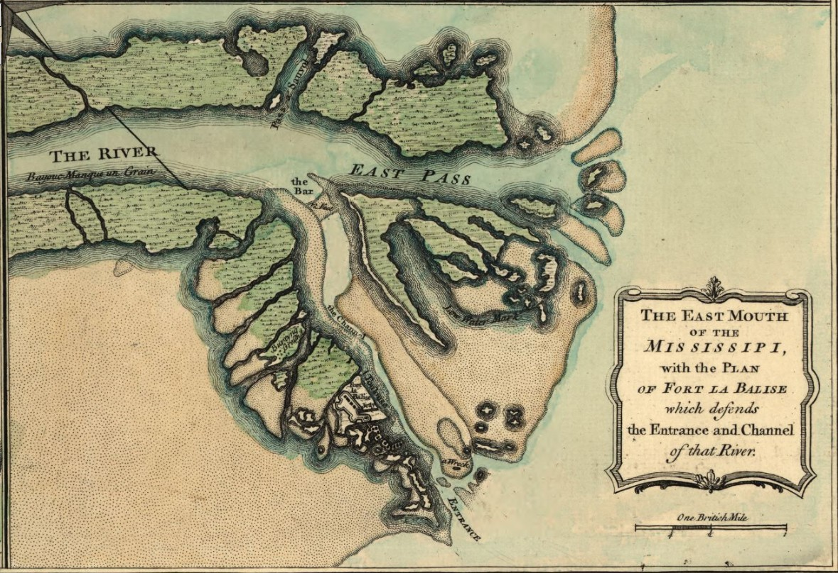

La Balise

Guiding Questions
Describe the location of La Balise. Why would French explorers want to create a settlement there?

_____________________________________________________________________________________

_____________________________________________________________________________________

Source L: Adapted from “Jean-Baptiste Le Moyne, Sieur de Bienville” by Michael T Pasquier
Text | Vocabulary
In 1702, Bienville (Iberville’s younger brother) was appointed governor of the colony. During his first term as governor of Louisiana from 1702 to 1713, Bienville struggled to manage military and commercial alliances with Indigenous groups. Several of the Indigenous groups were in contact with English traders from the Carolinas. Chickasaw and Choctaw Indians, the two largest and most powerful nations in the region, proved especially important to Bienville’s plans for the colony. It was during this time that Bienville organized annual gift-giving ceremonies with local chiefs in Mobile, present-day Alabama.  One of Bienville’s first duties was to establish a town about one hundred miles up the Mississippi River and name it after the Duc d’Orléans. In 1718, Bienville chose a site on the east bank of the river where there was a “fine crescent,” though it was not until 1722 that New Orleans became the capital of the colony. He received two plots of land in the vicinity of New Orleans, which were cleared and worked by some of the first enslaved Africans in Louisiana. | commercial: having to do with business  vicinity: the area nearby

Guiding Questions
What role did Bienville play in establishing the first permanent French settlement in Louisiana?

_____________________________________________________________________________________

_____________________________________________________________________________________

_____________________________________________________________________________________

Source M: “Plan de la Nouvelle Orleans Capitale de la Louisiana 1728”

After considering several other places, Bienville selected the site for New Orleans for several reasons. The site was on relatively high ground, along a sharp bend of the Mississippi River. Though the river posed a flood risk, the site’s natural levees offered some protection. The site also had access to the Gulf of Mexico and was a safe distance from Spanish and English colonial settlements.

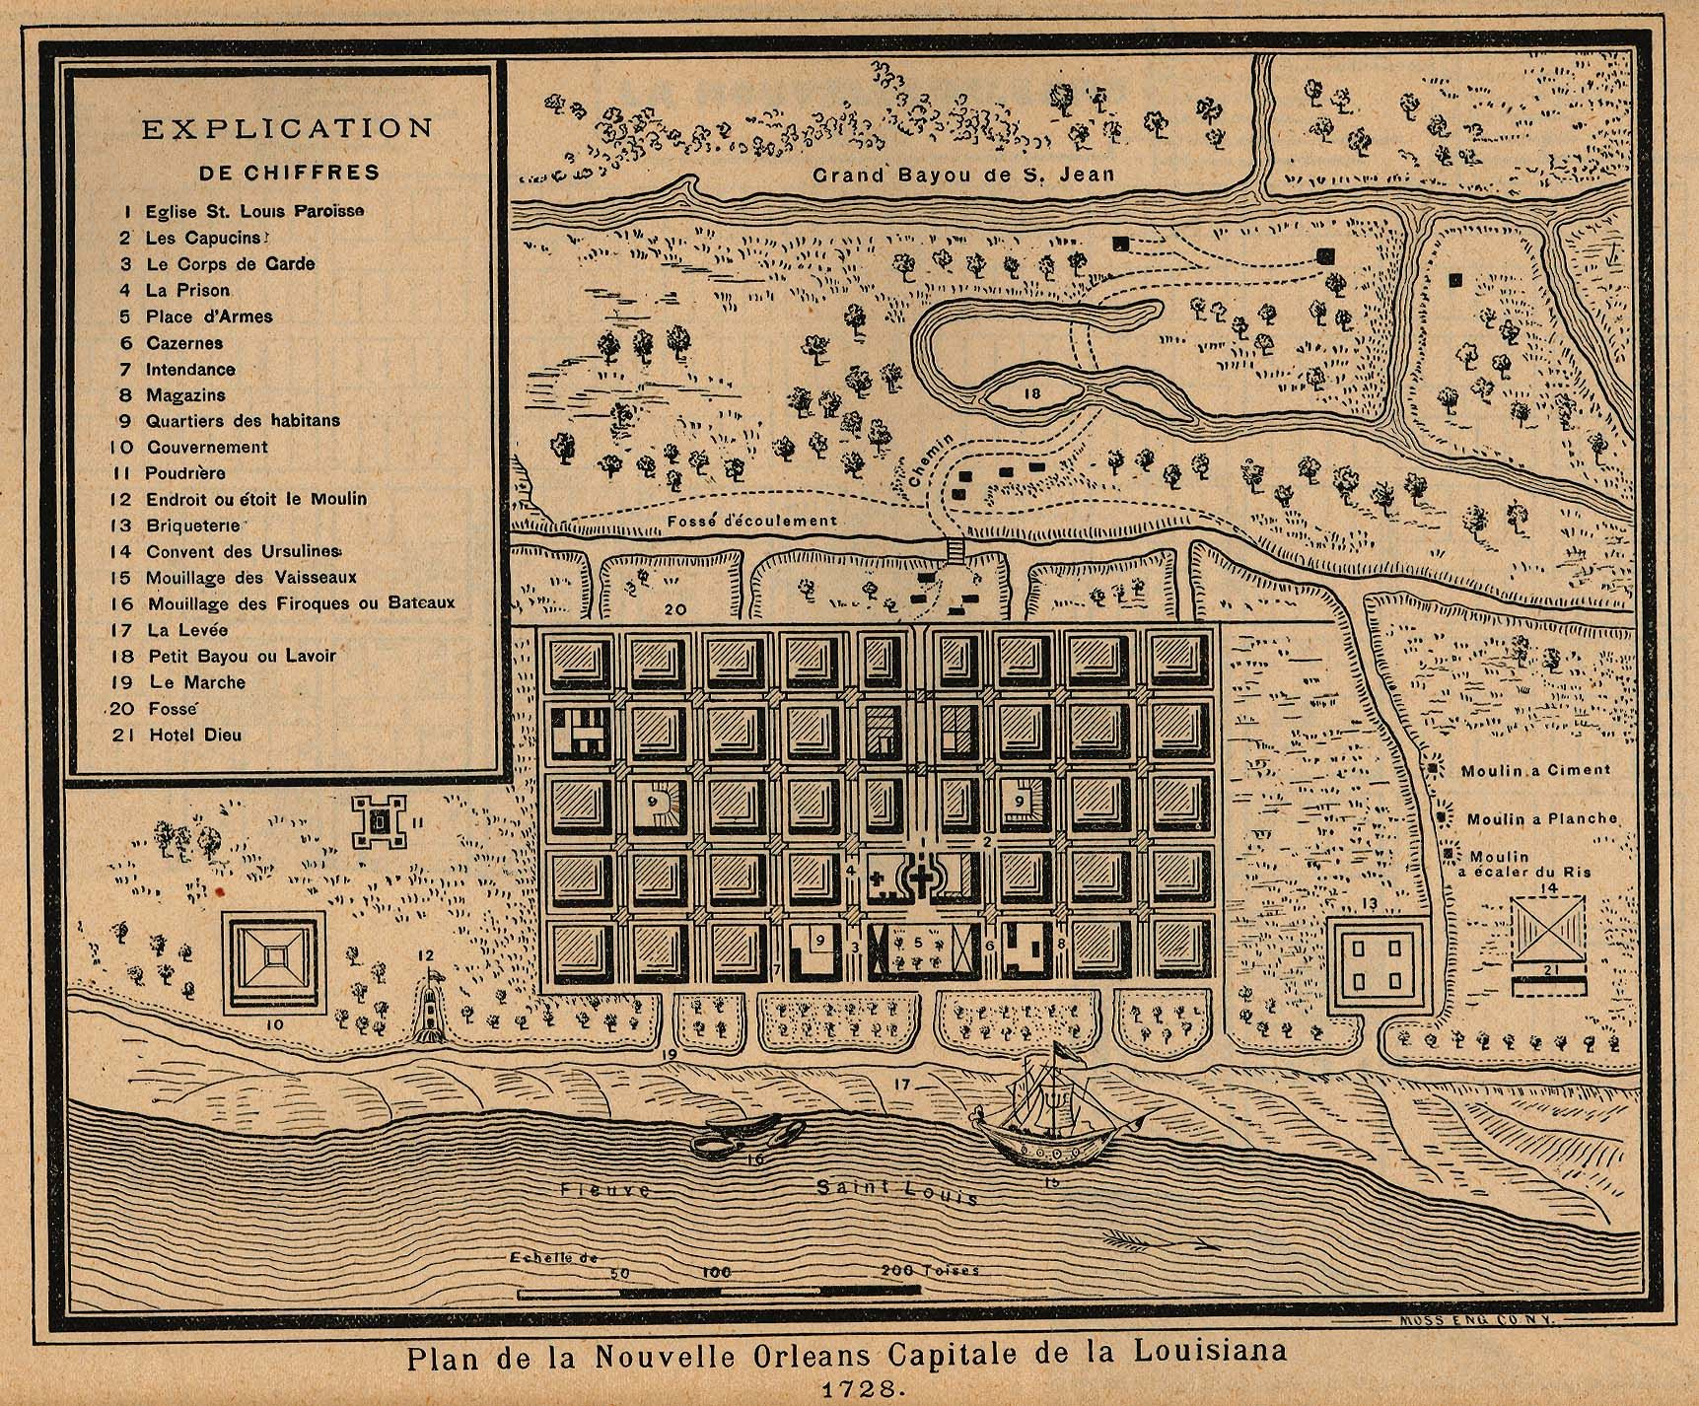

Guiding Questions
Using Sources M and N, describe the location and layout of New Orleans.

_____________________________________________________________________________________

_____________________________________________________________________________________

Lesson 5 – How did French and Spanish colonization change Louisiana?
Student Directions | Read and study Sources N, O, P and Q and complete the guiding questions.
Featured Sources | Source N: Adapted from “French Colonial Louisiana” by Michael T. Pasquier (excerpts)  Source O: "Veüe et Perspective de la Nouvelle Orleans" (View and Perspective of New Orleans) by Jean-Pierre Lassus.  Source P: Adapted from “Natchez Revolt of 1729” by Kelby Ouchley (excerpts)  Source Q: “Panorama of the Monumental Grandeur of the Mississippi Valley”

Source N: Adapted from “French Colonial Louisiana” by Michael T. Pasquier (excerpts)
Text | Vocabulary
The forced migration of approximately 6,000 enslaved Africans was the most significant change to French colonial Louisiana during the 1720s. Enslaved Africans brought with them knowledge of rice, corn, tobacco, cotton, and indigo farming, as well as technologies and skills related to craftsmanship. All of these were considered useful for the development of a new colony in the Americas.  By 1732 enslaved Africans accounted for approximately 65 percent of the total population of Louisiana. The large majority of African slaves lived and worked on private plantations along the Mississippi River away from New Orleans. Near the capital, however, many enslaved Africans worked on plantations owned by the governor, the Catholic Church, the Company of the Indies, and later the French king. These enslaved men, women, and children made up 12 percent of New Orleans’s population in 1726. | migration: the action of coming to live permanently in a foreign country

Guiding Questions
How did the population of Louisiana change as a result of French colonization?

_____________________________________________________________________________________

_____________________________________________________________________________________

_____________________________________________________________________________________

Source O: "Veüe et Perspective de la Nouvelle Orleans" (View and Perspective of New Orleans) by Jean-Pierre Lassus. (1726)

This painting shows the young city of New Orleans from across the Mississippi River at Algiers Point. The city was not built upon unclaimed land but upon a long-established Indigenous settlement called “Bulbancha.” The founding of New Orleans was made possible using enslaved labor. The figure in the foreground, battling an alligator, is an enslaved laborer. So, too, are the men chopping wood and carrying timber.

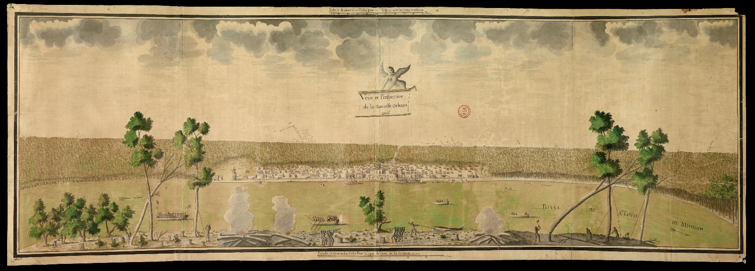

Guiding Questions
How did geography and Indigenous settlement influence the location of New Orleans?

_____________________________________________________________________________________

_____________________________________________________________________________________

_____________________________________________________________________________________

Sources P describes how French colonization of the Mississippi River valley affected Indigenous peoples.

Source P: Adapted from “Natchez Revolt of 1729” by Kelby Ouchley (excerpts)
Text | Vocabulary
The Natchez revolt of 1729 was the result of failed French diplomacy with the Natchez Indian tribe that lived in several villages near present-day Natchez, Mississippi. At the beginning of the eighteenth century, French leaders of the Louisiana colony found the Natchez to be friendly and open to sharing land for trade purposes. However, the French, in efforts to develop agriculture, pressured the Natchez to give up their lands and threatened to drive them off. The Natchez responded with an attack that led to the deaths of more than two hundred settlers and soldiers.  The events of 1729 began as a series of smaller disputes in 1715, 1722, and 1723. In these skirmishes, both the Frenchmen and Natchez were murdered, which only provoked revenge by the opposing side. Relations between the groups were troubled, and the tension increased as the settlers changed from trading with the Natchez for food to farming. | diplomacy: the activity, or skill of managing international relations, typically by a country's representatives abroad.  agriculture: farming  skirmishes: smaller-scale battles

Guiding Questions
Explain what caused the decrease of friendly relationships between the French and Natchez people?

_____________________________________________________________________________________

_____________________________________________________________________________________

_____________________________________________________________________________________

_____________________________________________________________________________________

Source: Q: Panorama of the Monumental Grandeur of the Mississippi Valley by John J. Egan

In 1729, a new French commander, Chepart, arrived in Louisiana. He demanded that the Natchez move from the site of their Great Village so that a large tobacco farm, worked by enslaved Africans, might be built there. The demand was unthinkable to the Natchez, whose high temple, which held the bones of their ancestors, occupied the village. The Natchez tribe saw no option but to rid its lands of the attackers.

In response to the Natchez revolt, the French governor ordered attacks on the nearby, peaceful Chaouchas tribe as a warning to other Indigenous groups. A force consisting mostly of Choctaws loyal to the French was sent against the Natchez in February 1730. The Natchez were able to survive the attack and lived in present-day Catahoula Parish for a year until they were attacked once again. Most members then went to the Natchitoches area, where many of them were captured in the fall of 1731 and sold into slavery in the Caribbean. A few survivors joined the Chickasaw and Cherokee tribes.
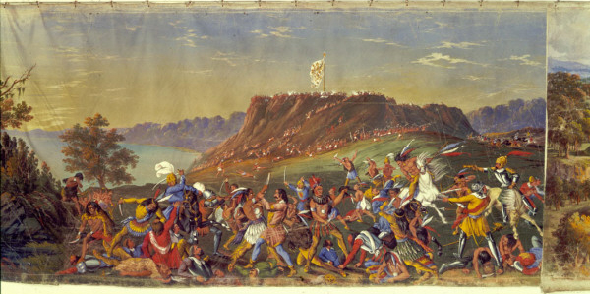

Guiding Questions
What was the outcome of the Natchez revolt of 1729?

_____________________________________________________________________________________

_____________________________________________________________________________________

_____________________________________________________________________________________

Lesson 6 – How did French and Spanish colonization change Louisiana?
Student Directions | Read and study Sources R and S while answering the guiding questions. Next, complete performance task #2 at the end of this lesson.
Featured Sources | Source R: Adapted from “Spanish Colonial Louisiana” by Charles Chamberlain and Lo Faber(excerpts)  Source S: Adapted from “The Cajuns” by Shane Bernard (excerpts)

In Source R, you will learn about Spanish colonial Louisiana. France gave control of the colony of Louisiana to Spain in 1762 as part of a peace agreement at the end of a war.

Source R: Adapted from “Spanish Colonial Louisiana” by Charles Chamberlain and Lo Faber (excerpts)
Text | Vocabulary
Spain governed the colony of Louisiana for nearly four decades, from 1763 through 1802. Spain took control of Louisiana during a time of uncertainty and a major rebellion – by Louisiana colonists who refused to recognize Spanish control, but it ended with a degree of prosperity. By giving out large yearly payments to support agriculture and employing skilled administrators who were culturally sensitive to the colony’s French-speaking population, the Spanish managed to do what the French had never done—make Louisiana a somewhat stable, growing colony.  When Spain took over Louisiana, the colony claimed lots of land, but had very few colonists. It stretched north to remote French fur-trading settlements on the upper Mississippi River and west into the Texas borderlands. Relations with Native American tribes required fancy and expensive gifts. The colony’s new settlers numbered about 7,500, and the majority lived along the lower Mississippi River. About a third of them were enslaved Africans.  Under Spanish rule, Louisiana’s population began to grow, especially through new immigration. Acadian immigrants (whose descendants are known as Cajuns) were by far the most numerous, having been evicted from their Canadian homeland by the British during the French and Indian War. As many as five thousand Acadians arrived between 1762 and 1770; most settled in the bayous and prairie country south and west of New Orleans.  Encouraged by Spain to occupy undeveloped areas, groups of Canary Islanders, or Isleños, also began to arrive in the 1770s. Some settled in Galveztown in Ascension Parish, others traveled downriver from New Orleans to what is now St. Bernard Parish. Settlers from Malaga, Spain, founded the town of New Iberia. Many Anglo-Americans also came to Spanish Louisiana, some as merchants, others as pioneer settlers lured by free land in the regions farther upriver. After the St. Domingue Revolution many people from that French colony also found their way to Louisiana.  As some Creoles began to prosper under Spanish rule, they sought labor for the plantations that now dotted the banks of the Mississippi River. At the same time, British slave traders sharply increased slave exports to Spanish America. Both of these factors led to a dramatic expansion of African slavery in Louisiana. The surge in slave importation in the 1770s and 1780s transformed both Louisiana’s economy and culture. | prosperity: wealth  Acadian: French-speaking people who immigrated from Acadia after the British claimed the territory from France  evicted: to remove someone from a property, especially with the support of the law  Isleños: people who left the Canary Islands and moved to Louisiana  lured: tempted to do something or to go somewhere  Anglo-Americans: English-speaking Americans with English ancestry  Creoles: While this term has many meanings and its usage has evolved over time, in this context, it refers to a white person descended from early French or Spanish settlers and preserving their speech and culture.  slave traders: people who buy and sell enslaved people  surge: a sudden powerful forward or upward movement

Guiding Questions
Identify two groups that immigrated to Spanish Louisiana.

_____________________________________________________________________________________

_____________________________________________________________________________________

Describe one way that Spanish colonial Louisiana was different from French colonial Louisiana.

_____________________________________________________________________________________

_____________________________________________________________________________________

Source S: Adapted from “The Cajuns” by Shane K. Bernard
Text | Vocabulary
Acadian exiles from New France (today’s Canadian provinces of Nova Scotia, New Brunswick, and Prince Edward Island) migrated to southern Louisiana during the Spanish colonial period. Today, most Cajuns live in a twenty-two-parish region of southern Louisiana known as Acadiana. large numbers of Cajuns also live in border parishes, such as Allen and Jefferson, as well as in southeastern Texas, particularly around Beaumont, Port Arthur, and Orange. Although best known outside Louisiana for their spicy food and music, Cajuns have made many important contributions to Louisiana’s history and culture.  The Acadians came to the New World for several reasons: religious persecution, disease, poverty, famine, and drought, as well as heavy taxation. The Acadians left France to escape these hardships, but also to gain their own land, which they considered essential to personal liberty and happiness. Although fur trapping remained an important part of the economy of New France, many Acadians became farmers, growing what they and their families needed to survive and producing only a small surplus for trade. The Acadians thrived in their new homeland. Between 1654 and 1755, the estimated population of the colony rose from about 325 to about 15,000 settlers.  The Acadians occupied lands considered important by both France and its major rival, Great Britain. As a result, in the century after its founding, the Acadian colony passed back and forth between these countries ten times. In 1710 the British captured Acadia permanently.  The British pressured the Acadians to swear an oath of allegiance to the British Crown. Some refused but for decades the British continued to press the Acadians to swear the oath of allegiance. Finally, the colony’s lieutenant governor, Colonel Charles Lawrence decided to expel every Acadian man, woman, and child. Lawrence wanted to deport the Acadians because he feared they would rise up against him if a war with France ever started. He also wanted the Acadians’ valuable farmlands, which he planned to give to loyal British colonists.  British soldiers under Lawrence’s command captured Acadians throughout the colony, marching them at gunpoint to the coast, dividing them according to age and gender, and loading them aboard crowded transport ships. Lawrence sent these ships to distant lands, scattering the Acadians throughout the British colonies of North America and beyond. Some historians estimate that as many as half of the approximately fifteen thousand Acadians died from exposure to harsh weather, disease, starvation, and violence related to their deportation. | exiles: people forced to leave their native country, usually for political reasons  migrated: moved from one area to another  religious persecution: being mistreated based on religious beliefs  surplus: the amount of something left over when what is needed has been used  thrived: did well  oath of allegiance: a legal promise where a person acknowledges a duty or loyalty  expel: to force someone to leave a place, especially a country  deportation: to expel someone from a country, typically on the grounds of having committed a crime
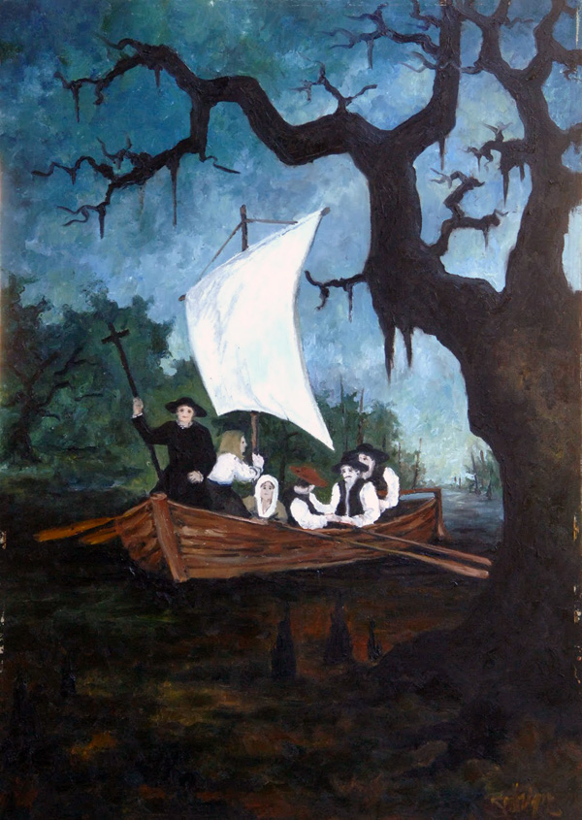
This painting by George Rodrigue illustrates what the first Acadians entering Louisiana may have looked like.

COURTESY OF GEORGE RODRIGUE
The First Cajuns. Rodrigue, George (Artist)

Guiding Questions
Explain why the Acadians immigrated to Louisiana.

_____________________________________________________________________________________

_____________________________________________________________________________________

_____________________________________________________________________________________

_____________________________________________________________________________________

Where do the majority of people with Cajun ancestry live in Louisiana today?

_____________________________________________________________________________________

_____________________________________________________________________________________

Formative Performance Task 2 – Constructed Response
Student Directions | Based on the sources, write a paragraph that describes two ways Louisiana changed during the French and Spanish colonial period.

Lesson 7 – How did different groups influence the culture of Louisiana?
Student Directions | Read and study Sources T and U and complete the guiding questions.
Featured Sources | Source T: “Discovering Culture”  Source U: Image Bank: Louisiana Cuisine

Source T: “Discovering Culture”

Text
Culture refers to a group’s way of life or how they do things. The culture of a community is the way of life for a group that has been passed from one generation to the next.

Every community in the world has a culture. Culture is reflected in how a community—a group of people—has lived in the past and how they live now. It is a collection of many things like the members of the community, languages spoken, customs and traditions, food and celebration, and religious beliefs and practices. These are preserved in the present and given to future generations. From ancient civilizations to the present, there are ways to discover what a group of people believe in, what they value as important, and how they live their lives.

A custom is an accepted way of doing something or an accepted way of behaving that is special to a certain group, a certain place, or a certain time. It is something done regularly. Customs are one way to learn about a community’s culture. For example, In the United States, if we nod our head up and down, we mean yes, and if we shake it back and forth, we mean no. In Bulgaria, however, nodding means no, while shaking our head back and forth means yes!

A tradition is a behavior or action that has been handed down from a previous generation. There are many different types of traditions. Examples include family traditions, social traditions and religious traditions. Traditions can often relate to the way a holiday is celebrated.

Customs and traditions are some ways to find evidence of a community’s culture. Each of these captures part of “the story” that allows us to appreciate what a group of people believes in, what they value as important, and how they live their lives.

Guiding Questions
What are some things that can make-up a community’s culture?

_____________________________________________________________________________________

_____________________________________________________________________________________

_____________________________________________________________________________________

_____________________________________________________________________________________

What are some examples of traditions or customs from one of the communities that you’re a part of?

_____________________________________________________________________________________

_____________________________________________________________________________________

_____________________________________________________________________________________

Source U includes images and text that explore the lasting influences of African, American Indian, Cajun, French and Spanish cultures on Louisiana cuisine.

Source U: Image Bank: Louisiana Cuisine

Image 1: A Bowl of Gumbo

Gumbo is a thick soup that could be considered a defining dish of South Louisiana, and yet there is no standard recipe, as the dish overlaps both Creole and Cajun cuisines. Historian Gwendolyn Midlo Hall suggests that the term gombo, from a West African language, translates as okra—a common ingredient in gumbo. Indeed, okra arrived in Louisiana as a consequence of the forced migration of enslaved Africans. Plantation owners specifically targeted those very same slaves in an effort to transplant the traditional rice cultivation techniques in West Africa to Louisiana as a method of feeding the slave population at large.

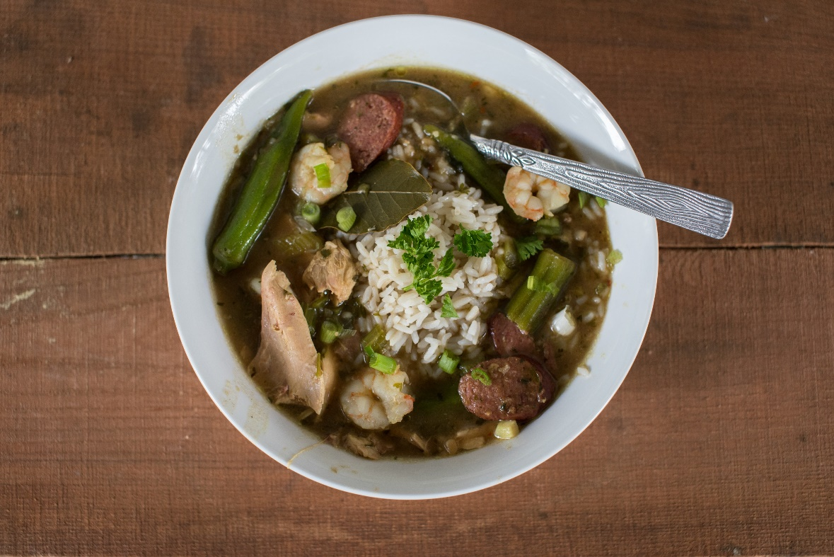
CHRISTIE MATHERNE HALL
A bowl of gumbo.

Guiding Questions
How is gumbo influenced by West African culture?

_____________________________________________________________________________________

_____________________________________________________________________________________
Image 2: Homemade Jambalaya

Jambalaya is a popular dish of West African, French and Spanish influence, consisting mainly of meat and vegetables mixed with rice. Traditionally, the meat always includes sausage of some sort, often a smoked meat such as andouille, along with pork or chicken and seafood, such as crawfish or shrimp. The vegetables are usually of onion, celery, and green bell pepper, though other vegetables such as okra, carrots, tomatoes, chilies and garlic are also used. Jambalaya is a dish of Spanish origin in Louisiana from the time when Spaniards were attempting to make their beloved dish "paella" in the New World. The dish has continued to change over time as different cultures influenced it.

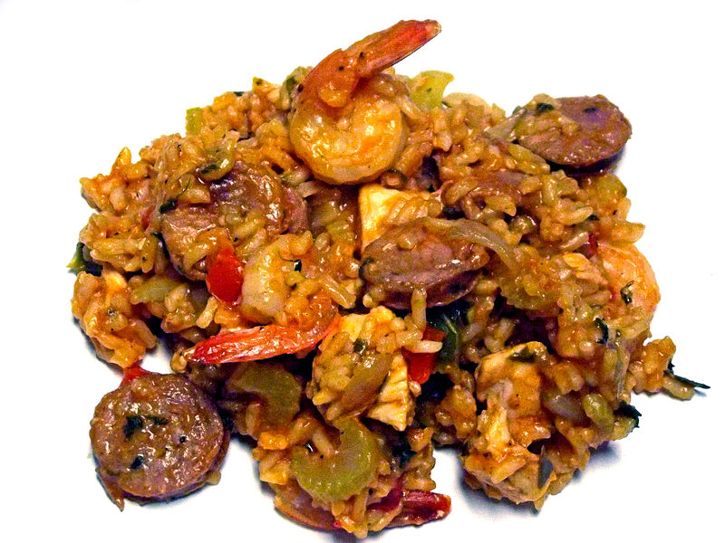

Guiding Questions
What are the origins of jambalaya?

_____________________________________________________________________________________

_____________________________________________________________________________________

Image 3: Red Beans and Rice

Red beans and rice is one of the most common dishes found in New Orleans, cooked in homes and restaurants throughout the New Orleans area. Red beans arrived with French Creoles from Haiti who escaped Haiti during the St. Domingue Revolution, settling in New Orleans. The wonderful stew of red beans has a strong Caribbean influence.

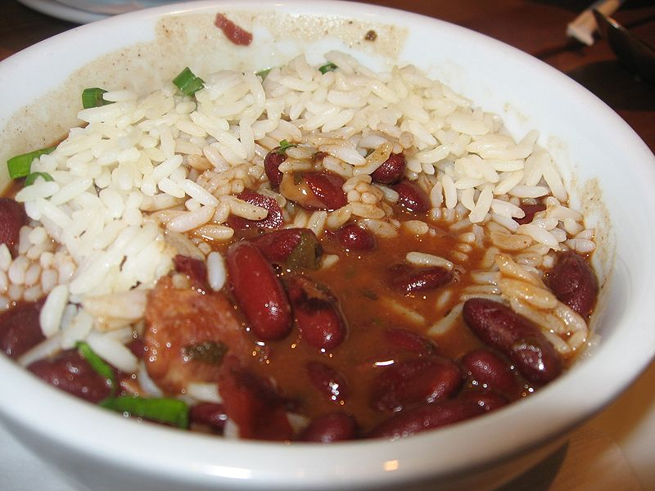

Guiding Questions
What are the origins of red beans and rice?

_____________________________________________________________________________________

_____________________________________________________________________________________

Lesson 8 – How did different groups influence the culture of Louisiana?
Student Directions | Read and study Source V and W and complete the guiding questions.
Featured Sources | Source V: Image Bank: Louisiana’s Musical Traditions  Source W: Image Bank: Louisiana’s Festivals

Source V: Image Bank: Louisiana’s Musical Traditions

Image 1: Jazzman

Many different cultures have influenced language, food, and music in our state. The Cajun culture has a style of music known as zydeco. Jazz music began in Louisiana. It is a mixture of African and European styles of music that is now known all over the world.
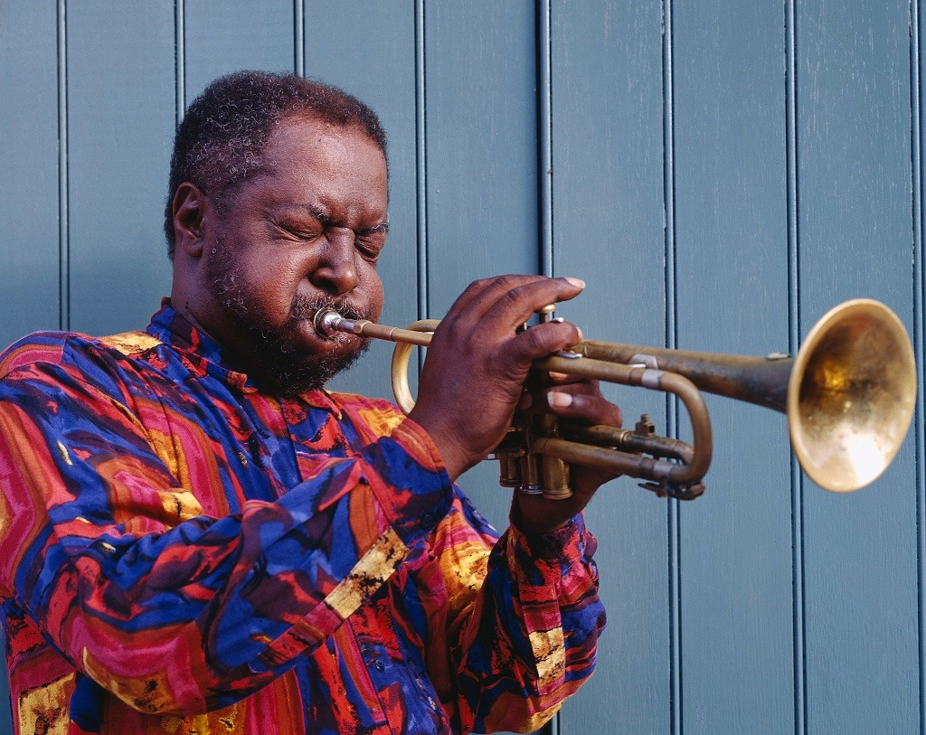
Guiding Questions
What cultures influenced the creation of jazz music?

______________________________

______________________________

______________________________

______________________________

______________________________

______________________________

______________________________

______________________________

Image 2: Zydeco

Zydeco is a type of music that evolved (changed over time) in southwest Louisiana by French speakers which blends blues, rhythm and blues, and music indigenous to the Louisiana Creoles and the Native people of Louisiana. Zydeco usually has a quick tempo and is dominated by the button or piano accordion and a form of a washboard known as a "rub-board," "scrub-board," "wash-board," or frottoir, zydeco music was originally created at house dances, where families and friends gathered for socializing. The photograph below shows an unidentified accordion player in 1850.
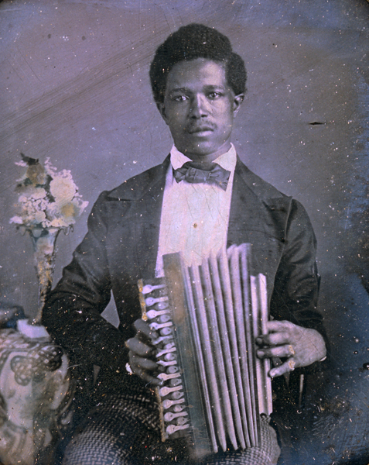
Guiding Questions
What cultures influenced the creation of zydeco music?

______________________________

______________________________

______________________________

______________________________

______________________________

______________________________

______________________________

______________________________

______________________________

______________________________

______________________________

______________________________
LOUISIANA STATE MUSEUM.
Reproduction of a daguerreotype of an unidentified accordion player, 1850.

Image 3: Cajun Music

Cajun music is an accordion and fiddle-based folk music, influenced by the French, originating in southwestern Louisiana. Most people identify Cajun music with Louisiana’s Acadian settlers and their descendants, the Cajuns, but this music in fact reflects a mixture with complex roots in Irish, African, German, Appalachian as well as Acadian traditions. While zydeco blends elements of rhythm and blues, blues, and more recently hip hop and rap, Cajun music has historically been influenced by Western swing, rock ‘n’ roll, and country music. Although the historical and cultural center of Cajun music continues to be southwestern Louisiana, interest in the music has recently spread. Today, musicians and fans of Cajun music can be found throughout the world.
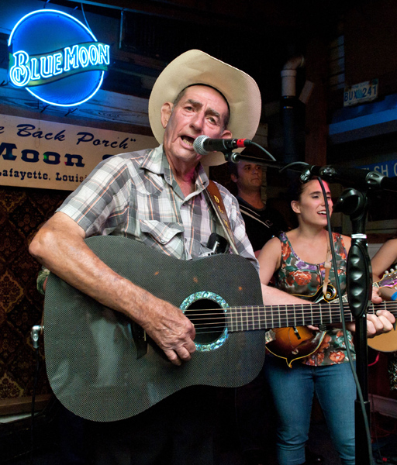
Guiding Questions
What cultures influenced the creation of Cajun music?

______________________________

______________________________

______________________________

______________________________

______________________________

______________________________

______________________________

______________________________

______________________________

______________________________

______________________________

______________________________
COURTESY OF CAJUN AND ZYDECO PHOTOS,
DAVID SIMPSON D.L. Menard. Simpson, David (Photographer)

Source W: Image Bank: Louisiana’s Festivals

Image 1: Breaux Bridge Crawfish Festival

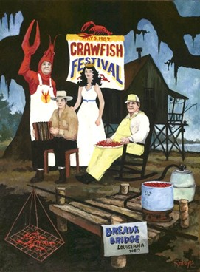
Throughout the state, there are festivals that celebrate elements of Louisiana culture. Different festivals celebrate cultural traditions such as holidays, music and food. This 1984 painting by Cajun artist George Rodrigue was done for the Breaux Bridge Crawfish Festival. The festival, beginning in 1960, helped to build local interest in shellfish. Today, the festival brings in thousands of people over three days. People come to listen to over thirty bands that play Cajun, zydeco, and even swamp pop. Other activities include a dance contest, a crawfish eating content, crawfish races, and cook offs.
Guiding Questions
What cultural elements are present at the Breaux Bridge Crawfish Festival?

____________________________________

____________________________________

____________________________________

____________________________________

____________________________________

____________________________________

____________________________________

____________________________________

____________________________________

____________________________________

____________________________________

____________________________________

COURTESY OF GEORGE RODRIGUE Breaux Bridge Crawfish Festival. Rodrigue, George (Artist)

Image 2: Mardi Gras in New Orleans

When European colonialists came to the New World, they brought the celebration of Mardi Gras with them. In French Louisiana, the first recorded celebration of the holiday took place on March 3, 1699. Men accompanying explorer Pierre Le Moyne d’Iberville participated in festivities south of present-day New Orleans along the banks of the Mississippi River at a location they named Point du Mardi Gras.

After the founding of New Orleans in 1718, colonists continued to celebrate the holiday there in the eighteenth century, although little is known about how it was celebrated. By the nineteenth century, some Louisianians considered aspects of the celebrations to be unruly, and there were calls to cancel Mardi Gras. Instead, steps were taken to guide the celebration into more controllable forms – like highly organized parades that influenced the modern version of Mardi Gras.
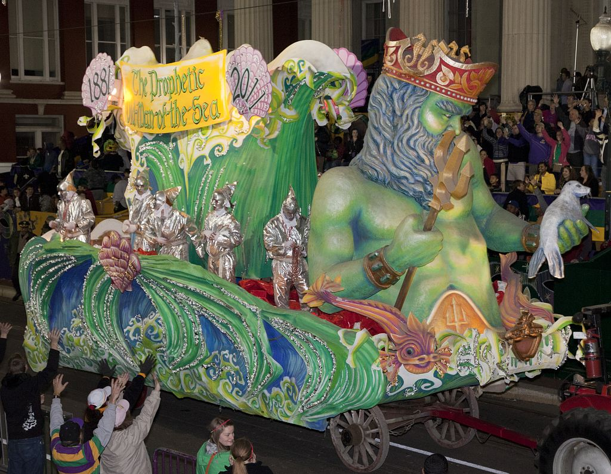
Guiding Questions
Where did the tradition of celebrating Mardi Gras come from?

______________________________

______________________________

______________________________

______________________________

______________________________

______________________________

______________________________

______________________________

______________________________

______________________________
COURTESY OF LIBRARY OF CONGRESS PRINTS AND PHOTOGRAPHS DIVISION.
2011 Krewe of Proteus Parade

Lesson 9 – How did different groups influence the culture of Louisiana?
Student Directions | Read and study the documents in Source X and complete the guiding questions. Next, complete performance task #3 at the end of this lesson.
Featured Sources | SourceX: Document Bank: Louisiana’s Linguistic Heritage

Source X: Louisiana’s Linguistic Heritage Bank

Document 1: French Language Influence in Louisiana Chart

In modern Louisiana, there are many examples of French influence. In some parts of the state, people still speak French. Some of the places in Louisiana are named after French people. Louisiana is named after King Louis XIV of France. La Salle, Iberville, and Bienville are examples of French explorers in Louisiana who have parishes named after them. There are other place names that come from the French language.

Place | French Meaning
Terrebonne | “good land”
Rapides | “rapids”
LaFourche | “the fork”
Pointe Coupee | “the place of the cut off”

Document 2: American Indian Language Influence in Louisiana Chart

Many place names in Louisiana have their origins in American Indian languages, some of which continue to be spoken by people living in Louisiana.

Place | American Indian Meaning
Catahoula | “big clear lake”
Plaquemine | “persimmon” (a type of fruit)
Tangipahoa | “ear of corn”
Mississippi | “big water”
Calcasieu | “crying eagle”
Document 3: Spanish Language Influence in Louisiana Chart

Many place names in Louisiana, including some parishes, are Spanish, or Islenos in origin. Islenos is a dialect of Spanish spoken by descendants of Canary Islanders who settled in St. Bernard Parish.

Place | French Meaning
Saint Bernard Parish | named after patron saint of Spanish colonial governor Bernardo de Galvez
New Iberia | Named after the Iberian Peninsula in Spain

Document 4 - Calle de San Luis – French Quarter New Orleans Street Name Tiles

Streets in present-day New Orleans have plaques describing the former Spanish street names. Calle is the Spanish word for street.

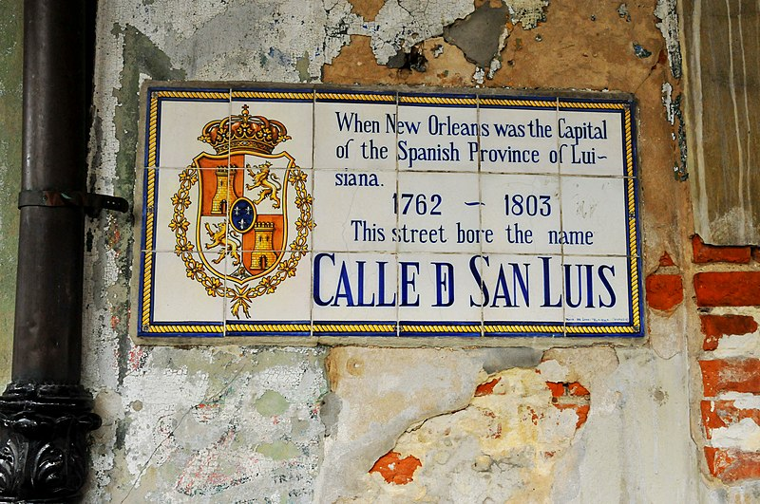

Guiding Questions
Describe how French, American Indian, and Spanish influences have influenced place names in Louisiana.

_____________________________________________________________________________________

_____________________________________________________________________________________

_____________________________________________________________________________________

_____________________________________________________________________________________

Formative Performance Task #3 – Item Set
Student Directions | Based on the sources, complete the item set below.

_____ 1. Louisiana is often described as culturally diverse. Which of the following statements best explains why it is described this way?

- Louisiana is made up of people with many different backgrounds.
- Louisiana offers a variety of foods for visitors to taste.
- Louisiana has many state parks and historic sites.
- Louisiana has many swamps for visitors to see.

_____ 2. Which statement best describes why locals would start a festival based on crawfish?

- Crawfish were scarce at one time, but now the population is growing.
- They want to educate tourists about the importance of crawfish in Louisiana.
- Crawfish must be imported and aren’t available year-round.
- Crawfish is plentiful in this area and has been a food source for thousands of years.

_____ 3. According to Source W, the Breaux Bridge Crawfish Festival celebrates some of Louisiana's unique cultural elements. Select two cultural elements that the festival celebrates.

- food
- architecture
- music
- religion
- technology

Formative Performance Task 3 – Constructed Response
Student Directions | Based on the sources, write a paragraph that describes two ways different groups have influenced culture in Louisiana.

Lesson 10 - Summative Performance Task
Student Directions | Based on the sources from this packet and your knowledge of social studies, write an essay answering the framing question: How did European exploration and colonization change Louisiana?

Name________________________________________________Date_________________

How Does Government Affect the
Lives of People in Louisiana?

Introduction
Student Directions | Over the next two weeks, you will explore the sources in this packet to learn about how people in Louisiana can influence their government, along with the functions and responsibilities of the state and local government. At the end of the packet, you will express your understanding by writing an extended response answering the following question: How does government affect the lives of people in Louisiana? This packet includes three supporting questions which will help you develop your claim on government’s impact. After you read each text or analyze each image, you will be asked to answer questions about it. Some words are defined to help you better understand each source and answer the questions. Some sources have digital extensions, which are optional sources you can explore if you have internet access.

Lesson 1 – Setting the Context
Student Directions | Read and study Sources A and B and complete the guiding questions. Next, answer the after you read questions at the end of this lesson.
Featured Sources | Source A: Adapted from “Westward Expansion: The Louisiana Purchase”  Source B: Louisiana Purchase Map

Source A describes how the United States purchased Louisiana from France.

Source A: Adapted from “Westward Expansion: The Louisiana Purchase”
Text | Vocabulary
In 1800, France took over Louisiana from Spain. With Louisiana now led by Napoleon Bonaparte, he threatened to stop Americans from using the important port of New Orleans on the Mississippi River. New American settlements west of the Appalachians Mountains needed the river transport to get their goods to market. The overland trade to the east was expensive and difficult.  Blocking access to New Orleans was a serious threat to America. So, President Thomas Jefferson considered an alliance with the British. At the same time James Monroe was sent to France to try to work out a deal. Napoleon offered all of the Louisiana Territory to the United States for fifteen million dollars. The territory stretched from the Mississippi River to the Rocky Mountains and more than doubled the size of the United States. | Napoleon Bonaparte: the ruler of France  alliance: a partnership

Guiding Questions
Why was the Mississippi River so important to the United States?

How did Jefferson end up solving the problem of French control of the Mississippi River?

Source B: Louisiana Purchase Map

The Louisiana Purchase did not say where the exact boundaries of the new territory were. So, the United States first had to explore and settle it. However, many American Indians already lived in the Louisiana Territory. President Jefferson hired Meriwether Lewis and William Clark to lead an expedition to explore the land. In May 1804, Lewis and Clark left from the St. Louis area with about forty soldiers. Their journey up the Missouri River and into unexplored lands took over a year. They returned to St. Louis in September 1806. They found a route to the Pacific Ocean. The map below shows the route they took to reach the Pacific Ocean.
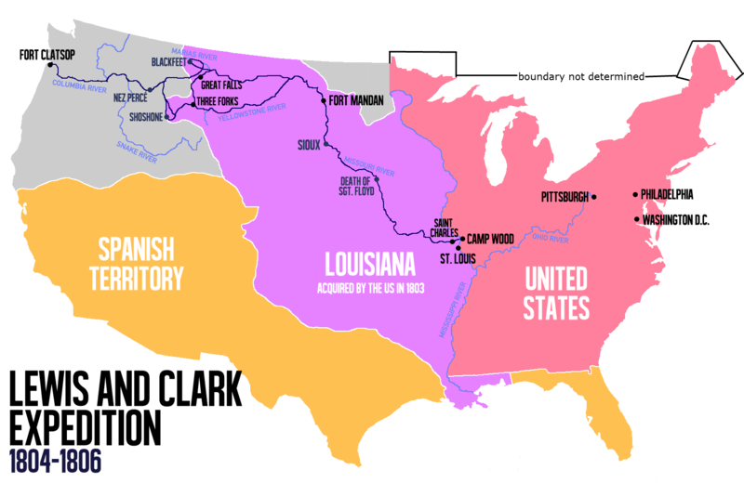

Guiding Questions
Why did Jefferson send the Lewis and Clark Expedition into the Louisiana Territory?

______________________________________________________________________________________

After you read:

What geographic features did the Lewis and Clark expedition have to cross in order to reach the Pacific Ocean?

How did the Louisiana Purchase change the size of the United States? Why would this benefit settlers looking for land?

Lesson 2 – Setting the Context
Student Directions | Read Sources C, D, and E while completing the guiding questions.
Featured Sources | Source C: Adapted from “Louisiana Purchase and Territorial Period” by Peter J. Kastor  Source D: States and Territories of the United States July 4, 1805 – March 1, 1809  Source E: 1812 Constitution of Louisiana

Source C describes how the government of the United States handled the Louisiana Purchase by dividing up the purchase into areas called territories that would eventually become states.

Source C: Adapted from “Louisiana Purchase and Territorial Period” by Peter J. Kastor
Text | Vocabulary
News of the Louisiana Purchase came as a surprise to most people in the United States. President Thomas Jefferson had wanted only New Orleans and access to the Gulf Coast. He now had the challenge of governing more territory and a more diverse population.  In 1804, Congress created the Territory of Orleans. This included much of the area that is now the present-day state of Louisiana. Making Louisiana a territory of the United States was done to provide a temporary system of government for the region. It would also prepare Louisiana for statehood. Instead of electing leaders, they would be chosen by the United States Congress and the president. Local residents were allowed to elect a territorial legislature. This system was a big change from being ruled by the kings of France and Spain.  Louisiana’s statehood brought up problems between the cultural groups of people within Louisiana. At the time of the Purchase, the territory’s white population was primarily made up of Creolesand migrants from Canada, the French Caribbean, and France. Most of these people spoke French and considered themselves French in culture. At the same time, however, people had experienced more than thirty years of Spanish rule, where they had been joined by a sizeable population of Hispanic residents and English-speaking Americans. The different cultural groups often disagreed on languages, rules, customs, and political goals.  After the Louisiana Purchase, whites in Louisiana (regardless of ethnic background) came together to impose new restrictions on enslaved people and free people of color. Enslaved people repeatedly tried to run away. In 1811, more than eighty people led an unsuccessful revolt along the German Coast (an area in South Louisiana). This was the largest single slave uprising in the United States. Free people of color were more successful. Located primarily in New Orleans, they became the largest, most prosperous community of free Black people anywhere in North America. | diverse: including people from a range of different social and ethnic backgrounds  legislature: law-making body  Creole: at this time, a white person descended from early French or Spanish settlers  Hispanic: relating to Spain or to Spanish-speaking countries, especially those of Latin America. Also included people that came from the Canary Islands.  prosperous: gaining wealth or success

Guiding Questions
Why did Congress create the territory of New Orleans instead of immediately making Louisiana a state with the ability to elect its own leaders?

______________________________________________________________________________________

How did the French-speaking Louisianans feel about the new English-speaking immigrants from the United States?

How did statehood affect enslaved people and free people of color?

Source D: States and Territories of the United States July 4, 1805 – March 1, 1809

After purchasing Louisiana, the United States and Spain argued about the territory’s western border. The United States argued that Louisiana's border stretched at least to the Sabine River and perhaps beyond. In 1819, an agreement signed by both countries put the boundary between Texas and the United States along the Sabine River, where it remains today.
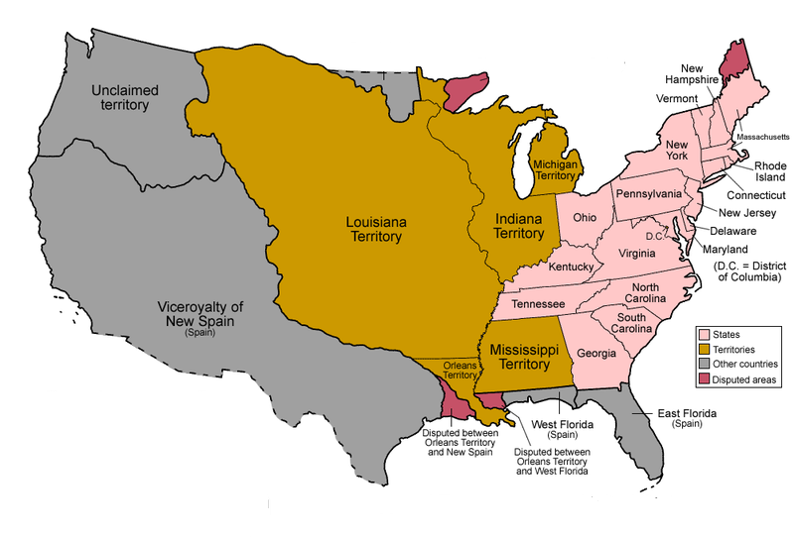

Unclaimed by Europeans

Guiding Questions
What disagreement did Spain and the United States have about Louisiana’s borders?

Source E: 1812 Constitution of Louisiana

In order to become a state, Louisiana had to have a large enough population and write a constitution to set up their state government. A constitution is a written document that explains the basic values and laws of a state. Every state in the United States has its own constitution, but they are all modeled after the national Constitution. A constitution sets up a system of government in which the people choose representatives to speak for them in a congress. This system is called a republic, or a representative democracy.
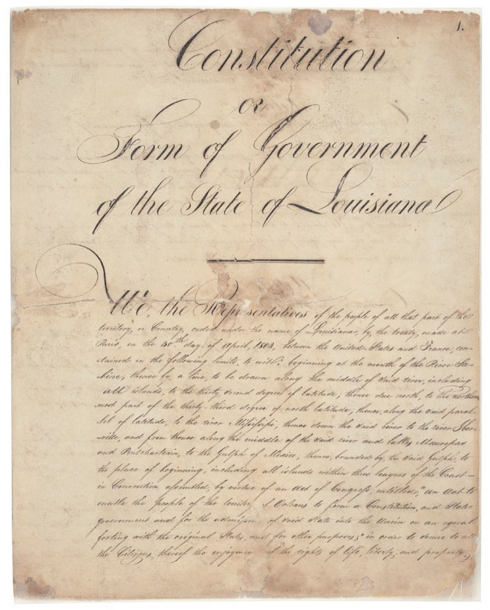
In 1811 the United States Congress allowed Louisiana to write a constitution for the state. At that time, more than 76,000 people lived in the Territory of Orleans. This territory included the present state of Louisiana except the parishes east of the Mississippi River. On April 30, 1812, Congress added Louisiana as the eighteenth state in the nation.

This photograph shows a part of the original 1812 Constitution of Louisiana.

Guiding Questions
What two things did Louisiana need to do in order to become a state?

What type of government would Louisiana have?

______________________________________________________________________

Lesson 3 – How does the state government affect residents of Louisiana?
Student Directions | Read Sources F, G, H, I and J while completing the guiding questions. Next, complete the after you read questions at the end of this lesson.
Featured Sources | Source F: Adapted from “Antebellum Louisiana” by John M. Sacher  Source G: Branch of Louisiana’s State Government Infographic  Source H: Louisiana State Capitol, Baton Rouge, The House of Representatives in Session  Source I: Governors of Louisiana Chart 2004–2020  Source J: Louisiana’s Judicial System

Source F explains some of the important details of Louisiana’s first constitution, which did not allow most common people to vote or run for office to represent their community. In the first statewide elections, held in 1810, Louisiana had a population over 76,000, but only 3,874 votes were cast in the election for the state’s first governor in 1812. Louisiana has rewritten its constitution several times and many of the unfair restrictions that prevented people (especially women and people of color) from participating in government have been removed.

Source F: Adapted from “Antebellum Louisiana” by John M. Sacher
Text | Vocabulary
The Constitution of 1812 required that, in order to vote, a citizen needed to own property. This generally meant owning land. State representatives needed to hold at least $500 worth of land property, senators needed $1000, and in order to become governor, a person needed at least $5,000!  Additionally, many of the important positions were not directly chosen by voters. Legislators chose the governor from the top two candidates, and then the governor chose most other officers, including the attorney general, state treasurer, and state judges. | property: a thing or things belonging to someone. In 1812 enslaved people in Louisiana were also considered property  legislators: people who make laws

Guiding Questions
How did the Constitution of 1812 limit the number of people who could vote or hold public office?

Source G: Branches of Louisiana’s State Government Infographic

This source shows the three branches of Louisiana’s state government, along with the purpose and the most important jobs in each branch. The legislative branch is responsible for making laws. The executive branch, led the governor, enforces the laws made by the legislative branch on behalf of the people of Louisiana. The Judicial branch makes up the courts of Louisiana. The Supreme Court of Louisiana is located in New Orleans and is made up of seven judges who decide if laws are being read correctly and follow the state’s Constitution.
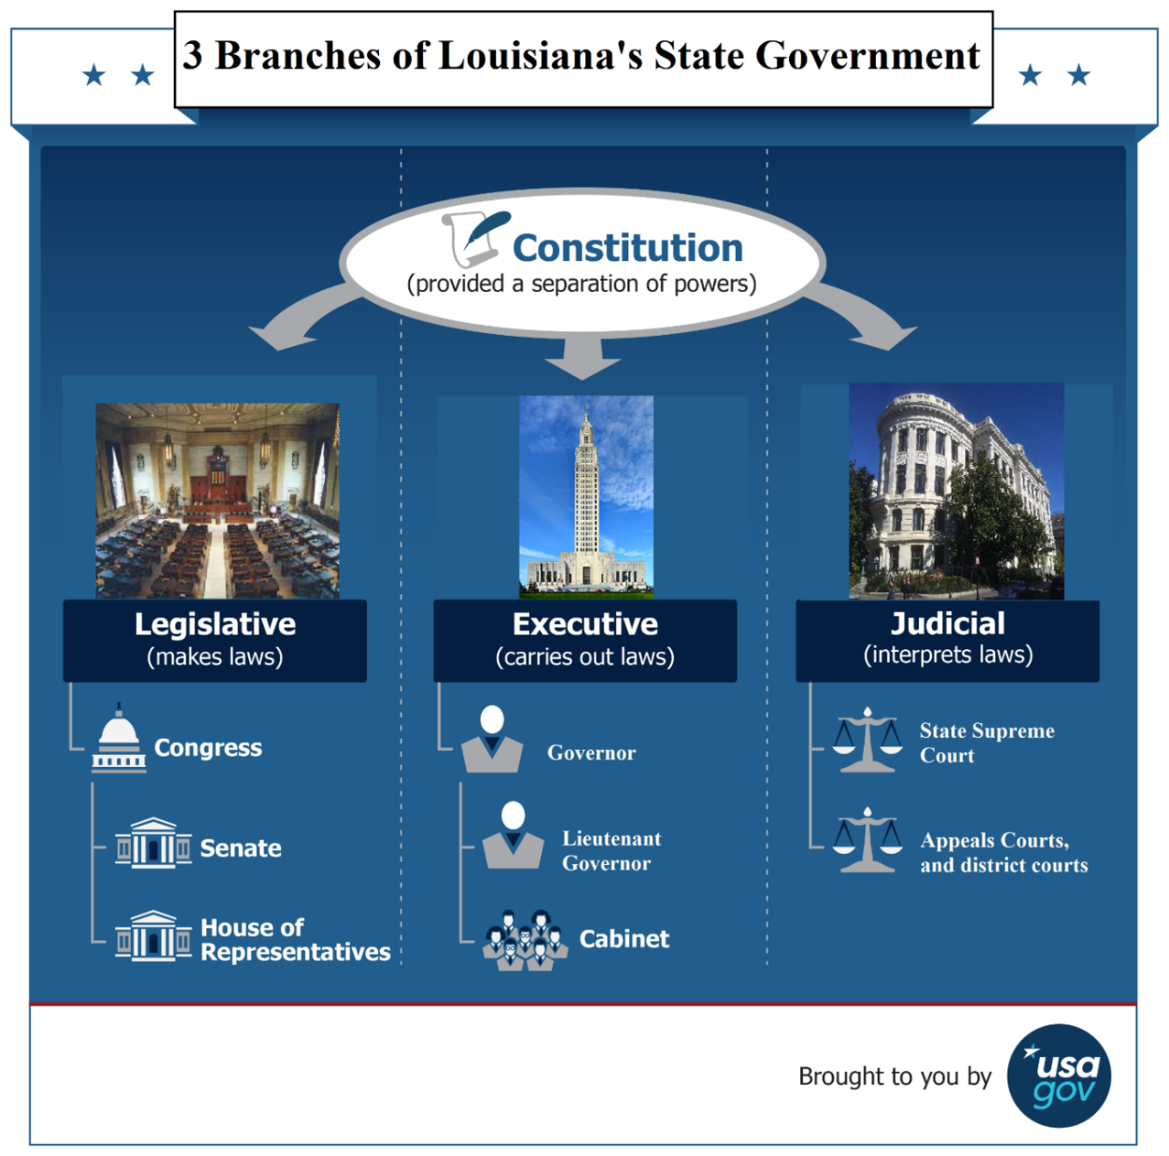
Guiding Questions

What are the three branches of government?

_____________________

_____________________

_____________________

What is function of the legislative branch?

_____________________

_____________________

What is function of the
executive branch?

_____________________

_____________________

What is function of the judicial branch?

_____________________

_____________________

Source H: Louisiana State Capitol, Baton Rouge, The House of Representatives in Session, View from Gallery

The legislative branch, or law-making branch, is made up of two houses, one called the Senate, and the other called the House of Representatives. The individual members of each house are called Representatives and Senators. Making laws is a very important function of the state government. Though rules and laws have some similarities, there are important differences. Unlike rules, laws are voted on by an elected group of representatives and are enforced by the government. Rules can be made by a variety of groups (families, schools, churches, mosques, synagogues) but are not enforced by the government. In order for an idea to become a law, it must get a majority (more than half) of votes in in the House of Representatives and Senate.
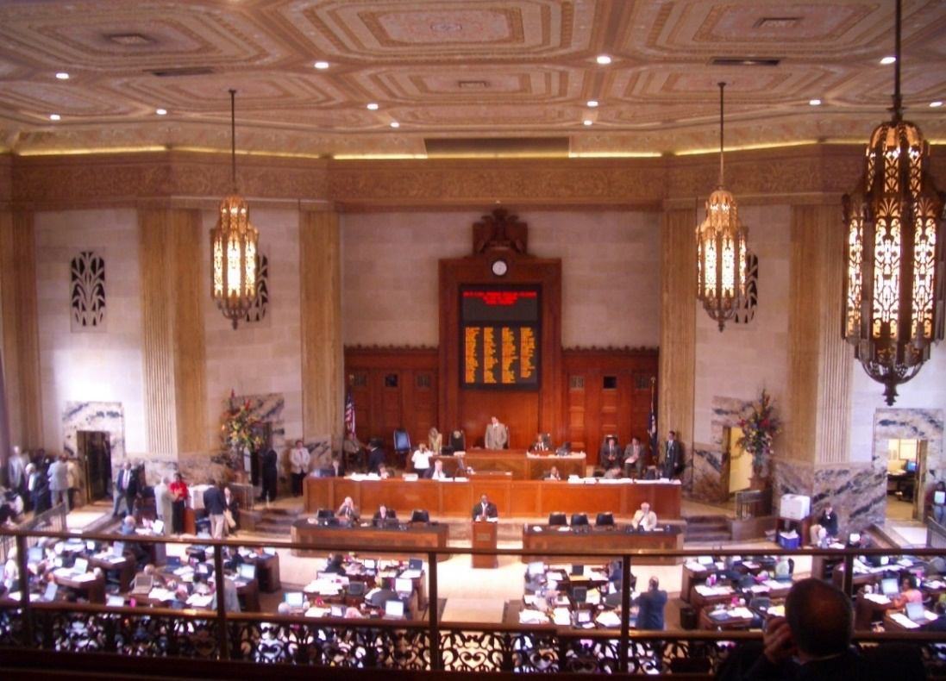

Guiding Questions
What are the two houses in the legislative branch of Louisiana’s state government?

In your own words, explain the difference between rules and laws.

______________________________________________________________________________________

______________________________________________________________________________________

Source I: Governors of Louisiana

The governor of Louisiana is the leader of the state executive branch and is elected by the people of Louisiana every four years. The chart below shows Louisiana’s governors from 2004 until 2020. If the governor is unable to perform their duties, the lieutenant governor can act in their place. The governor works with the legislative branch and must sign bills before they become laws. If a governor doesn’t like a bill that has passed the legislature, he can veto, or reject it. The governor’s main responsibility to make sure the laws of Louisiana are followed by its citizens.
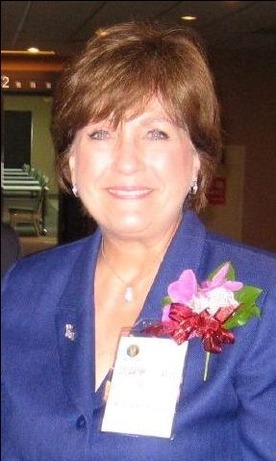
Name | Term | Background
Kathleen Blanco | January 12, 2004 –January 14, 2008 | Kathleen Blanco was born in New Iberia, Louisiana, and was the first woman to be elected governor of Louisiana. Prior to becoming governor, Blanco served twenty years in public office.
Bobby Jindal | January 14, 2008 – January 11, 2016 | Piyush Jindal was born in Baton Rouge, Louisiana and served as Louisiana’s Secretary of the Department of Health and Hospitals before becoming governor.
John Bel Edwards | January 11, 2016 – Present Day | Governor Edwards grew up in Amite, Louisiana as one of eight children. With four Tangipahoa Parish sheriffs in his lineage, he learned the importance of public service at an early age.

Guiding Questions
What is the main responsibility of the governor of Louisiana?

________________________________________________________________________________________

Source J: Louisiana’s Judicial System

The state government’s judicial branch is made up of a system of courts. Courts are places where issues related to law are decided. The highest court in Louisiana is the Supreme Court. Courts are used to determine if a person is guilty or innocent of a crime, but they also issue marriage licenses, and some become polling places where people vote during an election. The photograph below is of Algiers Courthouse in Algiers Point, a neighborhood in New Orleans.

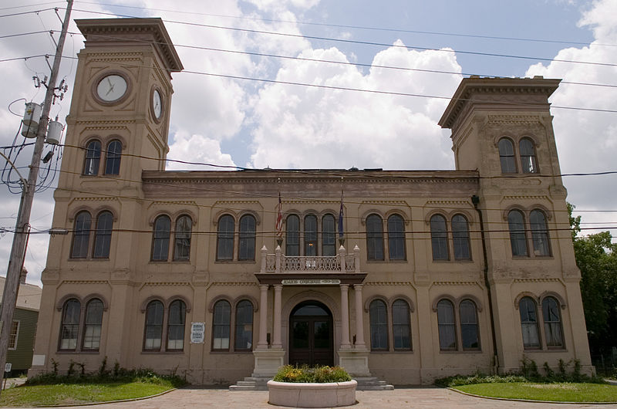

Guiding Questions
How does the judicial system of Louisiana serve its citizens?

After you read

Using Sources G, H, I and J, describe the different parts of Louisiana’s state government.

Which branch of Louisiana’s government do you think is the most important? Why?

Lesson 4 – How does the state government affect residents of Louisiana?
Student Directions | Read and study the images and text in Source K and complete the guiding questions. Next, complete performance task #1 at the end of this lesson.
Featured Sources | Source K: Image Bank: Functions of Louisiana State Government

Louisiana state government has many functions (jobs) and responsibilities to its citizens. Source K is a collection of images that illustrate some of those functions and responsibilities.

Source K: Image Bank: Functions of Louisiana State Government

Image 1 – Tax Revenue
Louisiana, like all states, needs revenue (money) to work. Revenue, the state’s income, is made in a few different ways including taxes. Some taxes are added to the cost of goods and services, and others taxes are taken from workers’ income or the profits of businesses. In Louisiana, one of the main ways revenue is collected is through sales taxes. This image of a receipt shows the original price of a good along with added tax and total cost.

Guiding Questions
Why is it important for states to collect taxes?

Image 2 – Transportation and Infrastructure

Within the Louisiana state government, there are different groups called departments that work to serve public needs. One of those departments is called the Department of Transportation and Development. This department is responsible for creating safe and efficient methods of transportation services in the state. The Department of Transportation and Development also is responsible for most of the upkeep of the state’s buildings, roads, and power supplies. The department is responsible to the governor, but also works with state and local legislators to accomplish its goals. Below is a chart of some of things that are managed and run by the state government of Louisiana.

Roadways | Airports | Public Transit
- 16,675 miles of state highways  - 893 miles of interstate highway | - 7 commercial service airports  - 64 general aviation airports | - 11 urban transit systems

Ports | Bridges | Railroads
- 6 deep-water ports  - 20 shallow-water ports | - 7, 694 state-owned bridges | - 15 major railroads

Public Works | Operations
- 24 levee districts  - 470 dams | - 3.6 million acres mowed  - 16 rest areas  - 8 ferry service locations  - 3000+ highway-rail crossings  - 3000+ traffic signals

Guiding Questions
How does the Department of Transportation and Development provide services to the people of Louisiana?

Image 3 – Louisiana Coastal Wetlands Conservation and Restoration Act

One of the more recent laws passed by the state is the Louisiana Coastal Wetlands Conservation and Restoration Act. This law was created to reduce harmful environmental effects on Louisiana wetlands and to restore the wetlands. Wetlands are the home to many species of wildlife. Louisiana’s coastal habitat is also the state’s first line of defense during storms, reducing the harmful effects of wind, waves, and flooding. However, in the lifetime of a child born in 2019, approximately 800,000 acres (a football field is 1.32 acres) of Louisiana wetlands will be lost, moving the coastline inland by 33 miles in some areas. This means Louisiana is losing important fisheries and wildlife habitat. Solving important problems of Louisiana is an essential function of the state government.

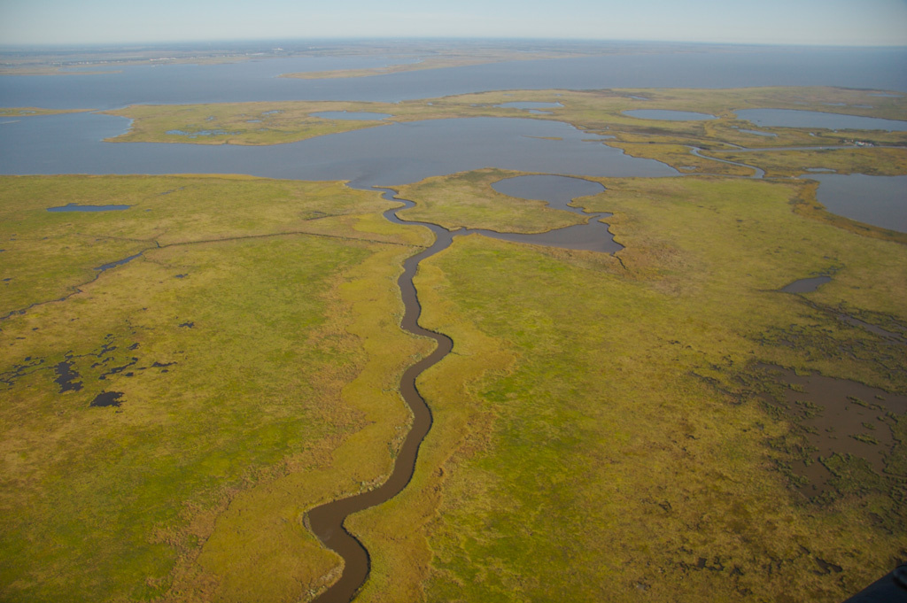

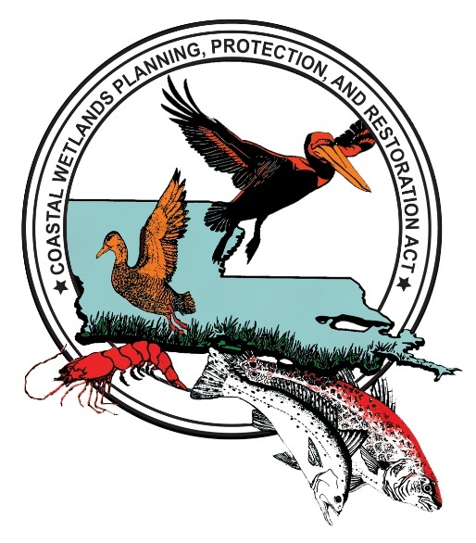

Guiding Questions
How is the Louisiana Coastal Wetlands Conservation and Restoration Act an example of the state government’s responsibilities?

Formative Performance Task #1 – Constructed Response
Student Directions | Based on the sources, write a paragraph that explains two ways the state government can affect people living in Louisiana.

Lesson 5 – How do local governments in Louisiana affect their citizens?
Student Directions | Read and study Sources L, M and N while completing the guiding questions. Next, complete the after you read questions at the end of this lesson.
Featured Sources | Source L: Louisiana Parishes Map  Source M: “Police Juries”  Source N: Local Government Officials Chart

Source L: Louisiana Parishes Map

Louisiana is divided into 64 parishes. Each parish is then divided into cities and towns, each with their own local governments. Local governments are set up in a few different ways. Police juries are the most popular form of parish government, but many other parishes use a council-president system. Others, like Orleans Parish, have a single city-parish local government.
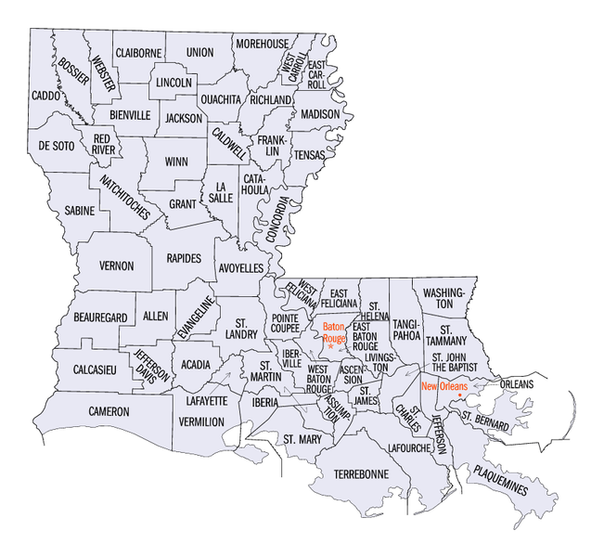
Guiding Questions

How many parishes is Louisiana divided into?

What type of local government do most parishes in Louisiana have?

Source M explains how the most popular type of local government in Louisiana, police juries, is structured.

Source M: “Police Juries”
Text | Vocabulary
The police jury form of government may have no fewer than 3 members nor more than 15 members.  Police Juries have the power to create ordinances and polices within the parish. They also oversee the parish budget and respond to citizens’ concerns at neighborhood meetings.  To become a Police Juror, a person must be at least 18 years old, a resident of the state for the past two years, and have a residence for a period of one year in the same parish they would like to represent. Once these qualifications are met, a majority vote is needed to secure the elected office. The term of a Police Juror is four years. | ordinances: laws enacted by a local authority

Guiding Questions
Describe a Police Jury.

Why would someone want to be elected to a Police Jury?

Source N: Local Government Officials Chart

Source N is a chart of some positions, or jobs, in the local governments of Louisiana. Serving in government is one way citizens of Louisiana can help their state be better.

Local Government Position | Responsibilities | What branch are they part of? | Term (how long the position lasts before re-election)
Mayor | Oversees city laws and ordinances, represents the city | Executive Branch | Elected for 4 years
Judges | Insure that the law is followed, and oversees over criminal and civil trials | Judicial Branch | Elected for 6 years
District Attorney | Prosecutes criminal cases | Judicial Branch | Elected for 6 years
Sherriff | Enforces the laws | Judicial Branch | Elected 4 years
City Council / Policy Jury | A local law-making body (see Source L) | Legislative Branch | 4 years

After you read:

Describe two positions (jobs) in the judicial branch of Louisiana’s state and local governments.

Describe two positions (jobs) in the legislative branch of Louisiana’s state and local governments.

Lesson 6 – How do local governments in Louisiana affect their citizens?
Student Directions | Read Sources O, P, Q and R while completing the guiding questions. Next, complete performance task #2 at the end of this lesson.
Featured Sources | Source O: Louisiana’s School Boards  Source P: Lafreniere Park Louisiana, November 2019  Source Q: New Orleans Fire Department E74  Source R: Calcasieu Parish Public Library

Source O: Louisiana’s School Boards

Louisiana’s parish governments are responsible for developing and maintaining their public-school systems. These local school systems are governed by elected school boards and superintendents. Local school boards are in charge of making lots of decisions that will affect students, parents and teachers. They decide things such as the number and location of schools, which teachers to hire, bus routes, and the curriculum that is taught.

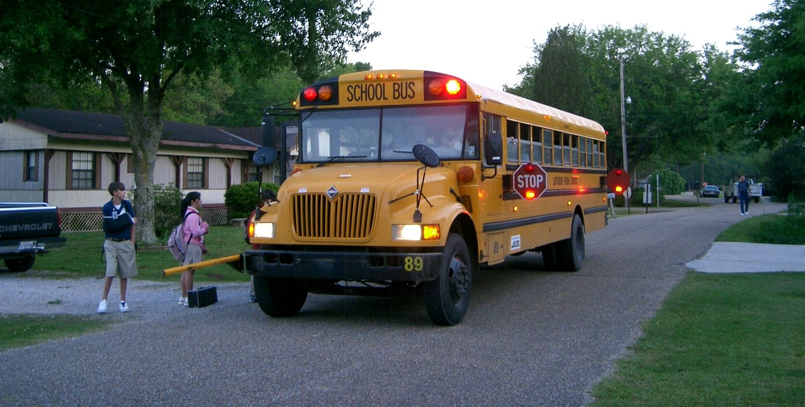

Guiding Questions
How do local school boards affect the people of Louisiana?

Source P: Lafreniere Park Louisiana, November 2019

Local governments in Louisiana are responsible for developing and maintaining public parks. One reason local governments do this is to create and enhance beautiful spaces for all of the people of Louisiana to enjoy. The image below is of Lafreniere Park. It is the largest park in Metairie, Louisiana. The park is funded by taxing local residents. Public parks are places for residents of Louisiana to meet, exercise and enjoy the natural beauty of Louisiana.

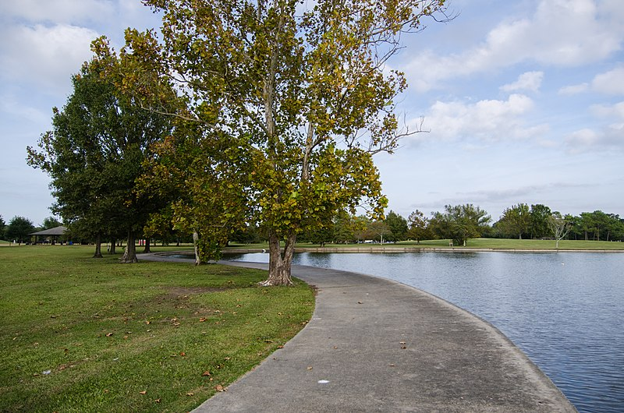

Guiding Questions
How are public parks paid for, and how do they benefit local communities?

Source Q: New Orleans Fire Department E74

Local governments are responsible for developing and running police and firefighting services. The image below is of a fire truck in the New Orleans Fire Department. The New Orleans Fire Department provides fire protection and ambulance services to the city of New Orleans, Louisiana. The department serves 378,715 people living in the Greater New Orleans area. Fire and police departments are responsible for keeping the people of Louisiana safe.

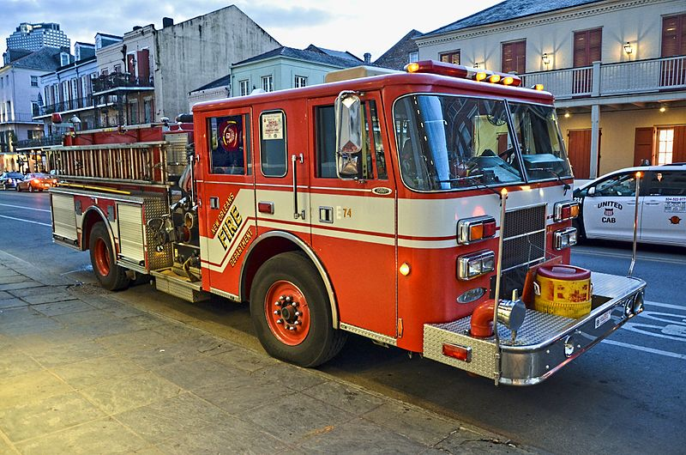

Guiding Questions
What are ways in which fire and police departments help to keep local citizens safe?

Source R: Calcasieu Parish Public Library

Public libraries are developed and managed by local governments. Libraries give the public access to books, film, music and other multimedia and is paid for by tax revenue. Many public libraries also provide free internet access to citizens and a variety of reference and educational materials for students.

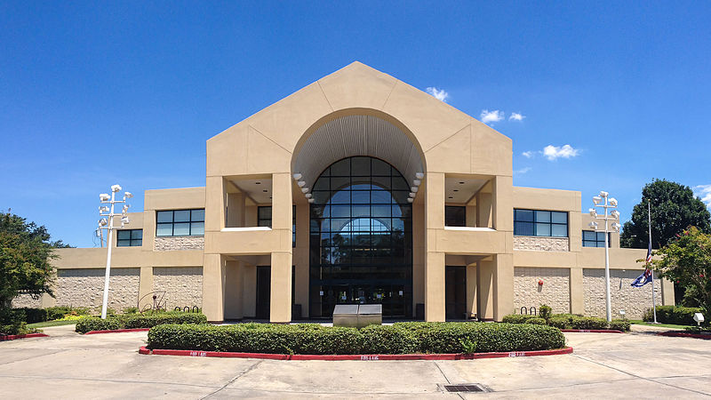

Guiding Questions
Identify a basic need provided by public libraries, and explain why this is important.

Formative Performance Task #2 – Constructed Response
Student Directions | Based on the sources, write a paragraph that explains how state and local government in Louisiana provide similar and different services.

Lesson 7 – How can Louisianans influence their government?
Student Directions | Read and study Sources S, T and U while completing the guiding questions.
Featured Sources | Source S: Registering to Vote  Source T: Environmental Volunteer Work  Source U: Serving in Local or State Government

Source S: Registering to Vote

Voting in local, state and national elections is one of the most important ways citizens can take action their government. In order to vote in Louisiana, you must be a U.S. citizen and at least 18 years old. The photo below shows a voter registration drive. Voter registration drives are events that encourage people who meet the requirements to register to vote.
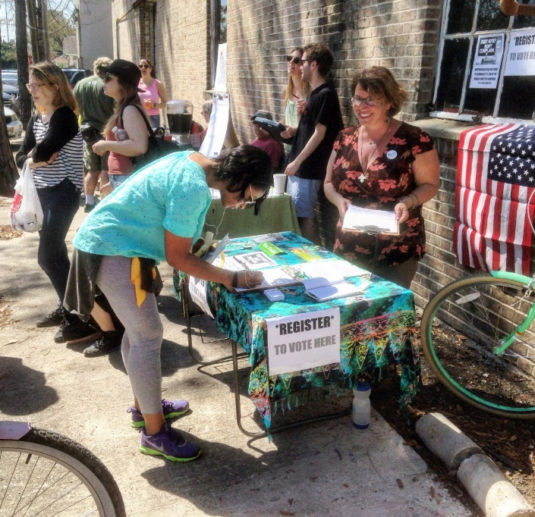

Guiding Questions
How does voting in elections let citizens take action their government?

Source T: Volunteering

Residents of Louisiana can assist their communities and local governments by volunteering in a variety of ways. Volunteering means to freely offer your time to help. Local governments, like the state government, rely on tax revenue to accomplish their goals. This usually limits what the government is able to afford. Volunteers can help complete projects without adding to the state’s costs. The image below shows volunteers pushing wheelchairs to arriving trains in New Orleans as residents returned from evacuation during Hurricane Gustav. Individual volunteers and volunteer organizations are extremely important during disasters.

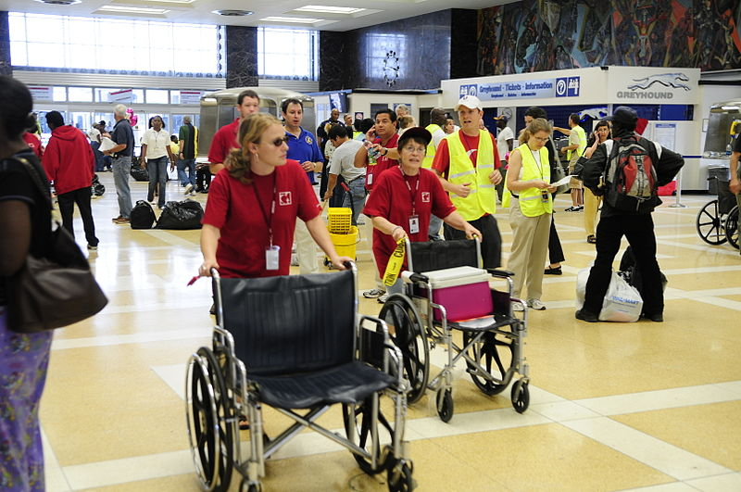

Guiding Questions
What is another way residents of Louisiana can volunteer to help their community and local government?

Source U: Individuals Serving in Local or State Government

Residents of Louisiana can be involved in their government by running for office to serve in their state or local government. Elected officials make important decisions that affect all the people of Louisiana depending on their role. They can use their influence to make positive changes. Examples of this might include passing laws that improve the state’s roads and bridges or improve the state’s public schools. Public officials also are leaders on long-term issues facing Louisiana, like coastal restoration. Source U highlights a few individuals who currently serve Louisiana.
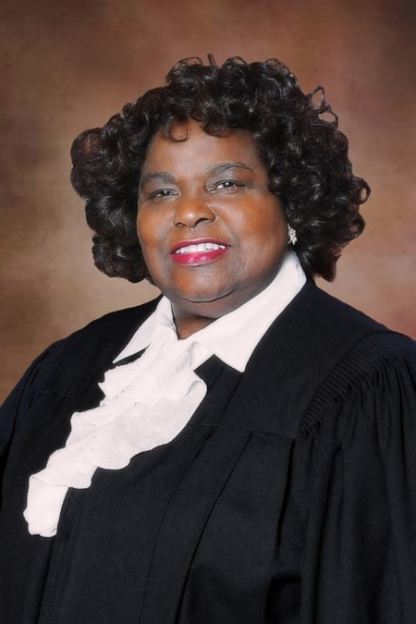
Portrait 1 – Chief Justice Bernette Joshua Johnson

Bernette Joshua Johnson (born June 17, 1943) is a lawyer from New Orleans, Louisiana, who has served as the chief justice of the Louisiana Supreme Court since 2013. Bernette Johnson is the first African-American Chief Justice of the Louisiana Supreme Court. During her long career, Johnson has emphasized civil rights and legal assistance to the poor.

Portrait 2 – State Senator Katrina R. Jackson

Katrina Renee Jackson (born July 1977) is a lawyer from Monroe, Louisiana, who is a member of the Louisiana State Senate for the 34th district, serving since 2020. From 2012 until 2020, Jackson served in the Louisiana House of Representatives for the 16th district, which includes Morehouse and Ouachita parishes.

Portrait 3 - Jefferson Parish President Cynthia Lee Sheng

President Cynthia Lee Sheng was sworn into office on January 8, 2020, as the first woman to be elected as the Jefferson Parish president. Cynthia’s father was Sheriff Harry Lee who served Jefferson Parish for over 28 years.

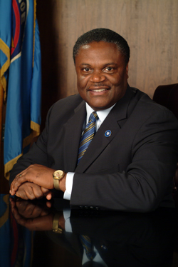
Portrait 4 – Mayor James Mayo

James Earl Mayo (born March 30, 1957) is the former mayor of Monroe, the seat of Ouachita Parish in northeastern Louisiana. First appointed as interim mayor, he won a special election to become mayor in 2001, and was then re-elected to four full terms, becoming the longest-serving mayor of Monroe.

Portrait 5 – Clay Schexnayder

Clay John Schexnayder (born February 1969) is an American businessman and politician from Ascension Parish, Louisiana, currently serving as Speaker of the Louisiana House of Representatives.

Guiding Questions
What are important qualities an elected official would need to have? Why?

Lesson 8 – How can Louisianans influence their government?
Student Directions | Read Sources V, W, and X while completing the guiding questions. Next, answer the after you read questions. Finally, complete performance task #3 at the end of this lesson.
Featured Sources | Source V: Engaging in local and state politics  Source W: Petitioning the government  Source X: Serving on a Jury

Source V: Engaging in local and state politics

Another way people of Louisiana can influence their government is to educate themselves on the issues within their communities. Since many candidates often run for election, it is important to understand each candidate’s beliefs on important issues. Reading and researching the issues and each candidate is one way to educate yourself before voting. Another way to educate yourself is watch debates between the competing candidates. The image below is a sticker given to citizens after they cast their votes in Louisiana.

Guiding Questions
Why is it important for residents of Louisiana to educate themselves about important issues facing their community and state?

______________________________________________________________________________________

Source W: Petitioning the government

Residents of Louisiana have the right to petition their government and gather peacefully to draw attention to issues that concern them. Petitioning the government means the right to make a complaint to, or seek the assistance of the government, without fear of punishment. The photo below shows Louisiana college students from around the state gathered on the steps of the Capitol to protest cuts in funding to college and university programs.

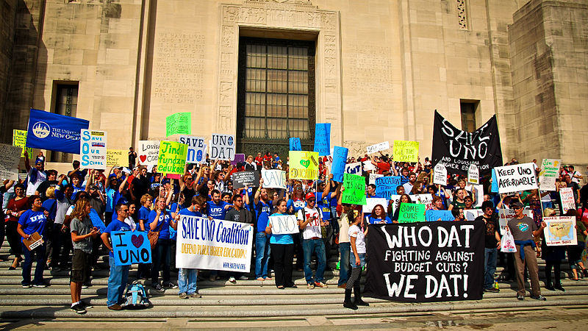

Guiding Questions
How can petitioning the government, or peacefully protesting, help your local community?

______________________________________________________________________________________

______________________________________________________________________________________

Source X: Serving on a Jury

Not all court trials have a jury. But when they do, a suspect’s guilt or innocence is determined by a group of citizens called a jury. It is one of the responsibilities of citizenship to serve on a jury when called. Most juries have twelve members. All 12 jurors must find the person guilty to convict. This is known as a unanimous jury decision, which means everyone agrees. Juries are an important part of the judicial system. They rely on citizens’ participation to work.

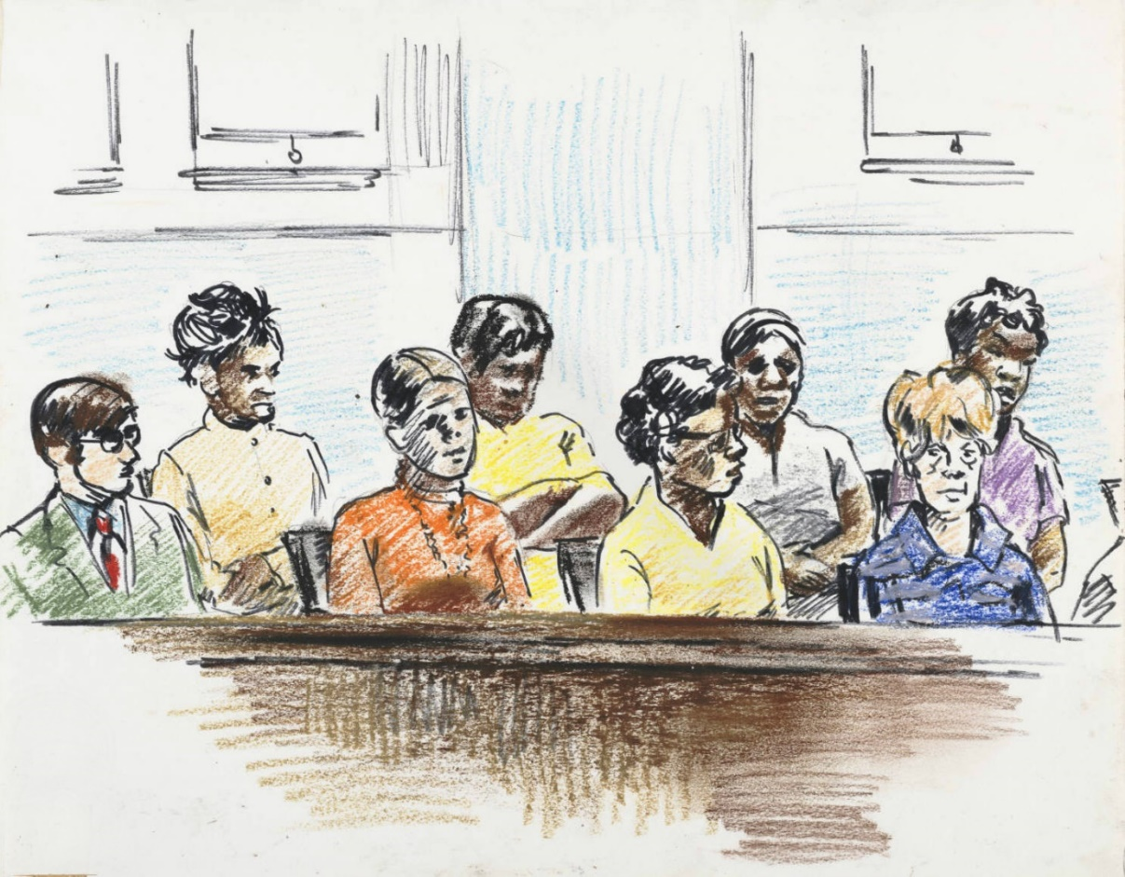

Guiding Questions
Why would the responsibility of serving on a jury help make the community a better place to live?

Formative Performance Task #3 – Constructed Response
Student Directions | Based on the sources, write a paragraph that explains two ways Louisianans can influence their government.

Lesson 9 - Summative Performance Task
Student Directions | Based on the sources from this packet and your knowledge of social studies, write an essay answering the framing question: How does government affect the lives of people in Louisiana?

Images are from Google Maps. Attribution can be found on the image. The original image can be found at https://goo.gl/maps/PKDk3X88AmDLq7VPA.
This source was commissioned by LDOE for the EAGLE item bank.
This image from Wikimedia Commons is licensed under the Creative Commons (CC BY) license and can be found at https://commons.wikimedia.org/wiki/File:Compass_rose_en_08p.svg.
This image is in the public domain and is available online at https://commons.wikimedia.org/wiki/File: Louisiana_parishes_map.png.
This source was commissioned by LDOE for the EAGLE item bank.
This source was commissioned by LDOE for the EAGLE item bank.
This image is in the public domain and is available online at https://commons.wikimedia.org/wiki/File:Viewing_ man-made_canals_in_the_marsh_in_Louisiana,_Barataria_Basin.jpg.
This image by Kiddle encyclopedia is licensed under the Creative Commons (CC BY) license. Available online at https://kids.kiddle.co/Image:Clouds_over_hills.jpg.
This image by Kiddle encyclopedia is licensed under the Creative Commons (CC BY) license. Available online at https://kids.kiddle.co/Image:Rising-sun-indiana-ohio-river--from-above.jpg.
This text by Kiddle encyclopedia is licensed under the Creative Commons (CC BY) license and has been modified. Available online at https://kids.kiddle.co/Natural_resource.
This source was commissioned by LDOE for the EAGLE item bank.
This source was commissioned by LDOE for the EAGLE item bank.
This source was commissioned by LDOE for the EAGLE item bank.
This image by Wikipedia Commons is licensed under the Creative Commons (CC BY) license. Available online at https://commons.wikimedia.org/wiki/File:Natural_Gas_Drilling_Haynesville_Shale_Louisiana_Jan_2013.jpg.
This image by Wikipedia Commons is licensed under the Creative Commons (CC BY) license. Available online at https://commons.wikimedia.org/wiki/File:Crawfish_boil.jpeg.
This image by Queensland’s Archives is licensed under the Creative Commons (CC BY) license. Available online at http://www.archivessearch.qld.gov.au/Image/DigitalImageDetails.aspx?ImageId=26386.
This image by Wikipedia Commons is licensed under the Creative Commons (CC BY) license. Available online at https://commons.wikimedia.org/wiki/File:Pumpjack_in_Jennings_LA.jpg.
This image by Kiddle encyclopedia is licensed under the Creative Commons (CC BY) license. Available online at https://kids.kiddle.co/Image:Timber_DonnellyMills2005_SeanMcClean.jpg.
This image is in the public domain and is available online at https://louisianadigitallibrary.org/islandora/object/lsu-sea-p15140coll21%3A1866.
This text is in the public domain and is available online at https://www.wlf.louisiana.gov/subhome/commercial-fishing and has been modified.
“Prehistoric Archaeology in Louisiana” by Rebecca Saunders is from 64parishes.org, a website produced by the Louisiana Endowment for the Humanities. Used and adapted with permission. Downloaded July 20, 2020.
This image is the from State Library of Louisiana collection in the Louisiana Digital Library and can be found at https://louisianadigitallibrary.org/islandora/object/state-lwp%3A1121. Used with permission.
This photograph by Jeff Girard is in the public domain and is available online at https://www.crt.state.la.us/Assets/OCD/archaeology/discoverarchaeology/teaching-materials/Archaeology_PowerPoint_2016.pptx.
This photograph by George Avery is in the public domain and is available online at https://www.crt.state.la.us/Assets/OCD/archaeology/discoverarchaeology/teaching-materials/Archaeology_PowerPoint_2016.pptx.
This image from the Louisiana Office of Tourism and Coastal environments is in the public domain and is available online at https://www.crt.state.la.us/Assets/OCD/archaeology/discoverarchaeology/teaching-materials/Archaeology_PowerPoint_2016.pptx.
This image is in the public domain and is available online at: https://www.crt.state.la.us/Assets/ocd/archaeology/discoverarchaeology/teachingmaterials/Prehistoric_Louisiana_PowerPoint%202016.pptx.
This image is licensed under the Creative Commons Attribution-ShareAlike 4.0 License and is available online at https://en.wikipedia.org/wiki/File:Hunting_Woolly_Mammoth.jpg.
This image by Phyllis Lear is in the public domain and is available online at https://www.crt.state.la.us/Assets/OCD/archaeology/discoverarchaeology/teaching-materials/Prehistoric_Louisiana_PowerPoint%202016.pptx.
This painting by Steven Patricia is in the public domain and is available online at https://www.crt.state.la.us/Assets/OCD/archaeology/discoverarchaeology/teaching-materials/Prehistoric_Louisiana_PowerPoint%202016.pptx.
These images by Paula McIver, David Griffing and Phyllis Lear are in the public domain and are available online at https://www.crt.state.la.us/Assets/OCD/archaeology/discoverarchaeology/teaching-materials/Prehistoric_Louisiana_PowerPoint%202016.pptx.
This painting by Martin Pate is in the public domain and is available online at https://www.crt.state.la.us/Assets/OCD/archaeology/discoverarchaeology/teaching-materials/Prehistoric_Louisiana_PowerPoint%202016.pptx.
These images by Margaret Humphris and Kevin Duffy are in the public domain and are available online at https://www.crt.state.la.us/Assets/OCD/archaeology/discoverarchaeology/teaching-materials/Prehistoric_Louisiana_PowerPoint%202016.pptx.
This image was commissioned by LDOE for the EAGLE item bank.
“Poverty Point” by Rebecca Saunders is from 64parishes.org, a website produced by the Louisiana Endowment for the Humanities. Used and adapted with permission. Downloaded July 20, 2020.
This image of LiDAR data courtesy of FEMA and the state of Louisiana, distributed by “Atlas: The Louisiana Statewide GIS,” LSU CADGIS Research Laboratory, Baton Rouge, Louisiana and is available online at https://www.crt.state.la.us/Assets/OCD/archaeology/discoverarchaeology/teaching-materials/Poverty_Point_PowerPoint_2016.pptx
This image is licensed under the attribution-sharealike 4.0 international license and is available online at https://commons.wikimedia.org/wiki/Category:Poverty_Point#/media/File:Mound_A_at_the_Monumental_Earthworks_Poverty_Point_World_Heritage_Site.jpg
These paintings by Martin Pate and in the public domain and are available online at https://www.crt.state.la.us/Assets/OCD/archaeology/discoverarchaeology/teaching-materials/Poverty_Point_PowerPoint_2016.pptx.
These paintings by Martin Pate and in the public domain and are available online at https://www.crt.state.la.us/Assets/OCD/archaeology/discoverarchaeology/teaching-materials/Poverty_Point_PowerPoint_2016.pptx.
This image was commission by LDOE for the EAGLE item bank.
“Tchefuncte Culture” by Rebecca Saunders and Richard Weinstein is from 64 parishes.org a website produced by the Louisiana Endowment for the Humanities. Used and adapted with permission. Downloaded July 28, 2020.
This image was commissioned by LDOE for the EAGLE item bank.
“Marksville Culture” by Rebecca Saunders is from 64parishes.org, a website produced by the Louisiana Endowment for the Humanities. Used and adapted with permission. Downloaded July 21, 2020.
This image is from is from 64parishes.org, a website produced by the Louisiana Endowment for the Humanities. Used and adapted with permission. Downloaded July 21, 2020.
This image was commissioned by LDOE for the EAGLE item bank.
This file is licensed under the Creative Commons Attribution-Share Alike 3.0 Unported license and is available online at https://commons.wikimedia.org/wiki/File:Mississippian_cultures_HRoe_2010.jpg.
Adapted from “Plaquemine culture” by Mark A Rees and Rebecca Saunders is from 64parishes.org, a website produced by the Louisiana Endowment for the Humanities. Adapted and used with permission. Downloaded July 26, 2020.
This file is licensed under the Creative Commons Attribution-Share Alike 4.0 International license. https://commons.wikimedia.org/wiki/File:Age_of_Discovery_explorations_in_English.png.
This map was commissioned by DOE for the EAGLE item bank.
“Caddo Culture” By Rebecca Saunders and Jeffrey Girard is from 64parishes.org, a website produced by the Louisiana Endowment for the Humanities. Adapted and used with permission. Downloaded on July 22, 2020.
This file is licensed under the Creative Commons Attribution-Share Alike 4.0 International license and is available online at https://commons.wikimedia.org/wiki/File:Nanih_Waiya.jpg.
Adapted from “History” from http://jenachoctaw.org/content/history and used with permission.
“Coushatta Tribe of Louisiana” by Sheri Shuck Hall is from 64parishes.org. Used with permission. Downloaded July 29th, 2020.
This text was adapted from a piece by John D. Barbary provided by the Tunica-Biloxi Tribe. Used with permission.
This text was adapted from “Jena Band of the Choctaw Indians” by Johnna Fisher and was provided by the Jena Band of the Choctaw Indians. Used with permission.
This image was provided by the Jena band of the Choctaw Indians. Used with permission.
This text was adapted from “The Tunica-Biloxi People – A Brief History” by John Barbry provided by the Tunica-Biloxi tribe. Used with permission.
This file is licensed under the Creative Commons Attribution-Share Alike 3.0 Unported license and is available online at https://commons.wikimedia.org/wiki/File:Flag_of_the_Tunica-Biloxi_Tribe_of_Louisiana.PNG.
“American Indians in the Twentieth-Century America” by Jay Precht is from 64parishes.org, a website produced by the Louisiana Endowment for the Humanities. Adapted and used with permission. Downloaded on July 20, 2020.
This text “Jena Band of the Choctaw Indians” was written by Johnna Fisher and provided by the Jena Band of the Choctaw Indians. Used with permission.
This image was provided by the Jena Band of the Choctaw.
This image was provided by the Jena Band of the Choctaw.
“Coushatta Baskets” by Teresa Parker Farris is from 64parishes.org. Used with permission. Downloaded July 25, 2020.
This photo is in the public domain and is available online at https://commons.wikimedia.org/wiki/File:FEMA_-_11951_-_Photograph_by_Bob_McMillan_taken_on_10-07-2002_in_Louisiana.jpg.
This photograph was taken from a video clip from http://www.koasatiheritage.org/blog/2014/jul/25/koasati-immersion-class/.
Adapted from “Native Americans in Twentieth-century Louisiana” by Jay Precht from 64parishes.org, a website produced by the Louisiana Endowment for the Humanities. Used and adapted with permission. Downloaded July 25, 2020.
Image and text from The Tunica-Biloxi Tribe: Its Culture and People, 2nd Edition by John Barbry. Used with permission. Downloaded on August 5, 2020.
This photograph was downloaded from https://www.pactribe.com/federal-recognition , on July 30, 2020. Used with Permission.
This image is in the public domain and is available online at https://commons.wikimedia.org/wiki/Maps_of_the_world#/media/File:Eckert4.jpg.
This text has been adapted from the task “What was the Age of Exploration” from NewVisions and is available online at https://curriculum.newvisions.org/social-studies/course/9th-grade-global-history/interactions-and-disruptions/ Used with permission.
This image is in the public domain and is available online at http://commons.wikimedia.org/wiki/File:Caravela_de_armada_of_Joao_Serrao.jpg.
This image is licensed under the Attribution-ShareAlike 3.0 unported license and is available online at https://commons.wikimedia.org/wiki/Astrolabe#/media/File:Jean_Fusoris_planispheric_astrolabe_in_Putnam_Gallery,_2009-11-24.jpg.
This image is licensed under the Creative Commons Attribution-ShareAlike 3.0 Unported and is available online at https://en.wikipedia.org/wiki/Azimuth_compass#/media/File:Br%C3%BAjula_azimutal_espa%C3%B1ola_s.XVIII_(M.A.N._Madrid)_01.jpg.
This image is in the public domain and is available online at https://commons.wikimedia.org/wiki/File:1519_Portolan_chart_of_the_Mediterranean_Sea_by_Lopo_Homem_from_Atlas_Miller.jpg.
This image is in the public domain and is available online at https://commons.wikimedia.org/wiki/File:Landing_of_Columbus_(2).jpg.
This image is in the public domain and is available online at https://upload.wikimedia.org/wikipedia/commons/a/aa/Discovery_of_the_Mississippi.jpg.
Adapted from “Early Exploration” by Michael T. Pasquier from 64parishes.org and is available online at https://64parishes.org/entry/early-exploration. Downloaded on 9.6.20. Used with permission.
This image was adapted from “Queen Anne’s War Before,” is licensed under the Creative Commons Attribution-Share Alike 3.0 Unported license, and is available online at https://commons.wikimedia.org/wiki/File:QueenAnnesWarBefore.jpg.
“Early Exploration” by Michael T. Pasquier is from 64Parishes.org and is available online at https://64parishes.org/entry/early-exploration. Used with permission.
This image is in the public domain and is available online at https://commons.wikimedia.org/wiki/File:Lasalle_au_Mississippi.jpg.
This image is from 64parishes.org and is available online at https://64parishes.org/entry-image/carte-de-la-nouvelle-france-et-de-la-louisiane-nouvellement-decouverte-2. Downloaded on 9.12.20. Used with permission.
Adapted from “Pierre Le Moyne D’Iberville” by Michael T. Pasquier from 64parishes.org and is available online at https://64parishes.org/entry/pierre-le-moyne-diberville-2. Downloaded on 9/12/20. Used with permission.
This image was created using Google Earth. Credit: Google Data SIO, NOAA, U.S. Navy, NGA, GEBCO Landsat / Copernicus TerraMetrics NOAA Data LDEO-Columbia, NSF, NOAA Data USGS.
This item was commissioned by the LDOE for the EAGLE item bank.
This image is in the public domain and is available online at https://www.loc.gov/resource/g4014n.ar167702/.
“Jean-Baptiste Le Moyne” by Michael T. Pasquier is from 64parishes.org and is available online at https://64parishes.org/entry/jean-baptiste-le-moyne-sieur-de-bienville-2. Used with permission.
This image is in the public domain and is available online at https://commons.wikimedia.org/wiki/File:New_orleans_plan_1728.jpg.
Adapted from “French Colonial Louisiana” by Michael T. Pasquier from 64parishes.org and is available online at https://64parishes.org/entry/french-colonial-louisiana. Downloaded on 9.5.20. Used with permission.
This image is in the public domain and is available online at https://commons.wikimedia.org/wiki/Category:Ve%C3%BCe_et_Perspective_de_la_Nouvelle_Orleans_1726#/media/File:NouvelleOrleans1726LassuslC.jpg.
Adapted from “The Natchez Revolt of 1729” by Kelby Ouchley and is from 64parishes.org and is available online at https://64parishes.org/entry/natchez-revolt-of-1729. Downloaded on 9.5.20. Used with permission.
This image is in the public domain and is available online at https://commons.wikimedia.org/wiki/File:Panorama_of_the_Monumental_Grandeur_of_the_Mississippi_Valley_-_section_14.jpg.
Adapted from “The Natchez Revolt of 1729” by Kelby Ouchley and is from 64parishes.org and is available online at https://64parishes.org/entry/natchez-revolt-of-1729. Downloaded on 9.16.20. Used with permission.
Adapted from “Spanish Colonial Louisiana” by Charles Chamberlain and Lo Faber from 64parishes.org and is available online at https://64parishes.org/entry/spanish-colonial-louisiana. Used with permission.
For more information, read “Creole” at 64Parishes.org.
Adapted from “Cajuns” by Shane K. Bernard from 64parishes.org and is available online at https://64parishes.org/entry/cajuns. Downloaded on 9.17.20. Used with permission.
This image is from 64parishes.org and is available online at https://64parishes.org/entry-image/the-first-cajuns. Downloaded on 5/15/20. Used with permission.
This source is from the How Does Our Culture Make Us Similar and Different? inquiry developed for the New York State Social Studies Resource Toolkit. The task is licensed under a Creative Commons Attribution-Noncommercial-ShareAlike 4.0 International License.
Adapted from “Gumbo” by Ryan Brasseaux from 64parishes.org and is available online at https://64parishes.org/entry/gumbo. Downloaded on 9.5.20. Used with permission.
This image is in the public domain and is available online at https://commons.wikimedia.org/wiki/File:Homemade_Jambalaya.JPG.
This image is in the public domain and is available online at https://commons.wikimedia.org/wiki/File:Red_Beans_and_Rice.jpg.
This photograph was commissioned by LDOE for the EAGLE item bank.
This photograph is from 64parishes.org and is available online at https://64parishes.org/entry/zydeco-music. Downloaded on 9.17.20. Used with permission.
Adapted from “Cajun” by Joshua C. Caffery from 64parishes.org and is available online at https://64parishes.org/entry/cajun-music. Downloaded on 9.12.20. Used with permission.
This image is from 64parishes.org and is available online at https://64parishes.org/entry-image/breaux-bridge-crawfish-festival. Downloaded on 9.12.20. Used with permission.
Adapted from “Mardi Gras in New Orleans” by Frank De Caro from 64 parishes.org available online at This image is from https://64parishes.org/entry/mardi-gras-in-new-orleans.Downloaded on 9.12. 20. Used with permission.
SCOPE AND SEQUENCE
This image is licensed under the Creative Commons Attribution 2.0 generic license and is available online at https://commons.wikimedia.org/wiki/File:Calle_de_San_Luis_-_French_Quarter_New_Orleans_Street_Name_Tiles.jpg.
This text was adapted from “Westward Expansion: The Louisiana Purchase” licensed under the Creative Commons 4.0 available online at https://www.ushistory.org/us/20c.asp.
This image is in the public domain and is available online at https://commons.wikimedia.org/wiki/File:Carte_Lewis_and_Clark_Expedition.png.
Adapted from “Louisiana Purchase and Territorial Period” by Peter J Kastor available online at https://64parishes.org/entry/louisiana-purchase-and-territorial-period Downloaded on 10.18.20. Used with permission.
See 64parishs.org for a longer discussion of this word https://64parishes.org/entry/creoles.
There is no strict consensus about the number of people ultimately involved in the uprising because eyewitness accounts range from 150 to 500. See https://64parishes.org/entry/slave-insurrection-of-1811 for more information.
This image is licensed under the Creative Commons Attribution-Share Alike 3.0 Unported license and is available online at https://commons.wikimedia.org/wiki/File:United_States_1805-07-1809.png.
This image is in the public domain and is available online at https://www.archives.gov/legislative/features/louisiana-statehood/louisiana-constitution.html.
Adapted from “Antebellum Louisiana by John M. Sacher from 64parishes.org available online at https://64parishes.org/entry/antebellum-louisiana Downloaded on 10.19.20. Used with permission.
Adapted from “Infographic: 3 Branches of the U.S. Government” which is in the public domain and available online at https://www.usa.gov/branches-of-government?source=kids.
This image is licensed under the Creative Commons Attribution 2.0 Generic license available online at https://commons.wikimedia.org/wiki/File:Louisiana_House_of_Representatives.jpg.
Created by the LDOE using information and images collected from https://www.sos.la.gov/HistoricalResources/AboutLouisiana/LouisianaGovernors1877-Present/Pages/default.aspx.
This image is licensed under the Attribution 2.0 Generic (CC BY 2.0) available online at https://commons.wikimedia.org/wiki/File:New_Orleans_June_07_-_-191_Algiers_Courthouse.jpg.
Created by the LDOE.
Created by the LDOE using data from https://house.louisiana.gov/slg/PDF/Chapter%202%20Part%20E%20-%20Transportation%20and%20Infrastructure.pdf.
Text and image are in the public domain and available online at https://commons.wikimedia.org/wiki/File:Louisiana_Office_of_Coastal_Protection_and_Restoration,_ConocoPhillips_and_the_LSU_AgCenter.jpg.
This image is in the public domain and is available online at https://commons.wikimedia.org/wiki/File:Louisiana_parishes_map.png .
Written using information from https://house.louisiana.gov/slg/PDF/2012-16_SLG.pdf (see section 2C- 4).
Created by LDOE.
This image is licensed under the Creative Commons Attribution-Share Alike 3.0 Unported license available online at https://commons.wikimedia.org/wiki/File:Children_about_to_board_the_school_bus_(Thibodaux,_Louisiana).jpg.
This image is licensed under the Creative Commons Attribution 2.0 Generic license. Available online https://commons.wikimedia.org/wiki/File:Lafreniere_Park_Louisiana_November_2019_04.jpg.
This image is licensed under the Creative Commons Attribution-Share Alike 2.0 Generic license. Available online https://commons.wikimedia.org/wiki/File:New_Orleans_Fire_Department_E74_(8915798349).jpg.
This image is licensed under the Creative Commons Attribution-Share Alike 4.0 International license and is available online at https://commons.wikimedia.org/wiki/File:Calcasieu_Parish_Public_Library.jpg.
This file is licensed under the Creative Commons Attribution 2.0 Generic license. Available online at https://commons.wikimedia.org/wiki/File:Voter_Registration_(25199374359).jpg.
This image is in the public domain and is available online at https://commons.wikimedia.org/wiki/File:Volunteers_go_to_arriving_trains_to_help_returning_evacuees_in_Louisiana.jpg.
This photo is in the public domain and is available online at https://www.lasc.org/About/Biography?t=Chief_Justice
This image is in the public domain and is available online at http://senate.la.gov/senators/senpage.asp?SenID=34
This image is in the public domain and is available online at https://jeffparish.net/government/parish-president.
This image is licensed under the Attribution-ShareAlike 4.0 International (CC BY-SA 4.0) license and available online at https://en.wikipedia.org/wiki/Jamie_Mayo#/media/File:Jamie_Mayo_01.jpg.
This image is in the public domain and is available online at https://house.louisiana.gov/H_Reps/members?ID=81.
This image is in the public domain and is available online at https://www.sos.la.gov/ElectionsAndVoting/GetElectionInformation/Pages/IVotedSticker.aspx.
This file is licensed under the Creative Commons Attribution 2.0 Generic license and is available online at https://commons.wikimedia.org/wiki/File:Rally_to_Save_Higher_Education_in_Baton_Rouge_10.jpg.
This file is licensed under the Creative Commons Attribution-Share Alike 2.0 Generic license available online at https://commons.wikimedia.org/wiki/File:Oil_Pastels_and_ink_drawing_of_jurors_consisting_of_six_African_American_women,_one_white_woman_and_one_white_man._20.jpg.

