Unit 1
Unit 2
Unit 3
Unit 4

Name________________________________________________Date__________________

How Does Geography Influence the Way People Live in the United States?
Introduction
Student Directions | Over the next two weeks, you will explore the sources in this packet to learn about the geography of the United States and the connection between geography, economy, and culture in each region. At the end of the packet, you will express your understanding by writing an extended response answering the following question: How does geography influence the way people live in the United States? This packet includes three supporting questions which will help you develop your claim on the influence of geography on American life. After you read each text or analyze each image, you will be asked to answer questions about it. Some words are defined to help you better understand each source and answer the questions. Some sources have digital extensions, which are optional sources you can explore if you have internet access.

Lesson 1 – Setting the Context
Student Directions | Read Source A, then complete the guiding questions in the right-hand column. Next, study Sources B, C and D. Then complete the after you read questions at the end of this lesson.
Featured Sources | Source A: “Definition of Geography”  Source B: Five Regions of the United States  Source C: Physical Map of the United States  Source D: Map of the U.S. with State Names
Optional Digital Extensions | Studies Weekly - 5 Regions of the United States

Source A: “Definition of Geography”
Text | Vocabulary | Guiding Questions
Geography is the study of earth and its features and how these features affect human beings. Features are things like continents, seas, rivers, mountains, plains, swamps or deserts. Geography also includes the study of climate and weather, including natural disasters like earthquakes, tornados, and hurricanes.  Geography is divided into two main parts called physical geography and human geography. Physical geography is the study of the natural environment and the physical features of the world. Human geography includes things like population and the economy and culture of people living in a certain area. | continents: a very large landmass  physical: a natural feature of the surface, like water, mountains, and deserts | How is the study of physical geography different from human geography?  _____________________________  _____________________________  _____________________________  _____________________________  _____________________________  _____________________________  _____________________________

Source B: Regions of the United States

Note: the map below illustrates five regions of the United States. Not all the states in each region have the same features, but they tend to be more alike than different.

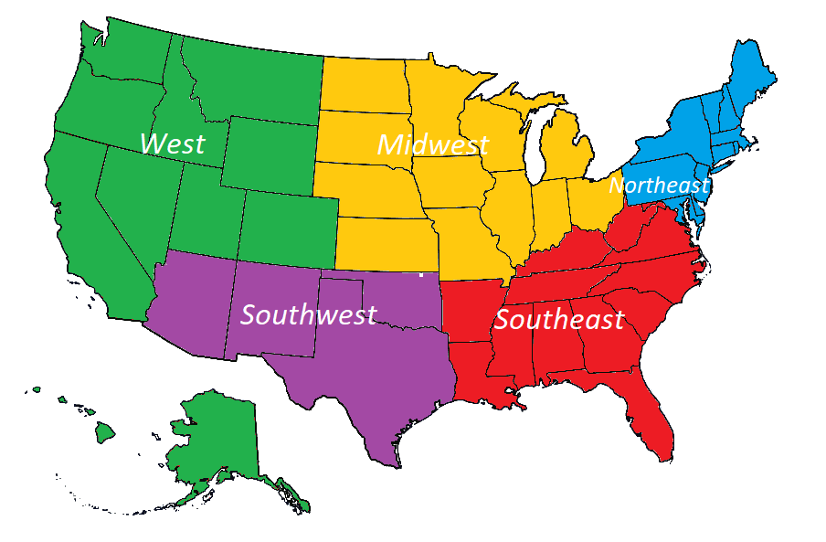

Source C: Physical Map of the United States

The map below shows some of the major physical features of the United States. The darker areas indicate a higher elevation. The Great Lakes (labeled on the map) are the largest store of fresh water on earth.

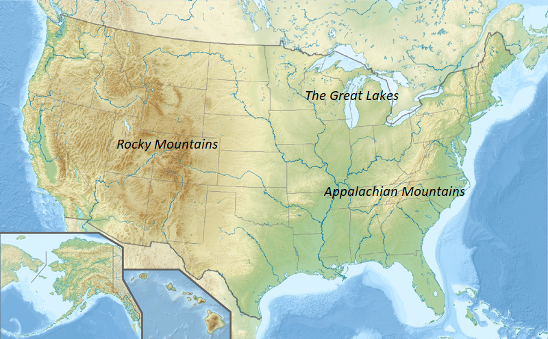

Guiding Questions
What regions are the Rocky Mountains located in?
What two regions have access to the Great Lakes?
What regions are the Appalachian Mountains located in?

Source D: Map of the U.S. with State Names

The political map below shows the fifty states and the borders of the United States. To the north of the United States is Canada, which borders states like Montana and Maine, while the United States shares its southern border with Mexico. The western coastline of the United States is the Pacific Ocean, while the southern and eastern states have access to the Gulf of Mexico and the Atlantic Ocean.

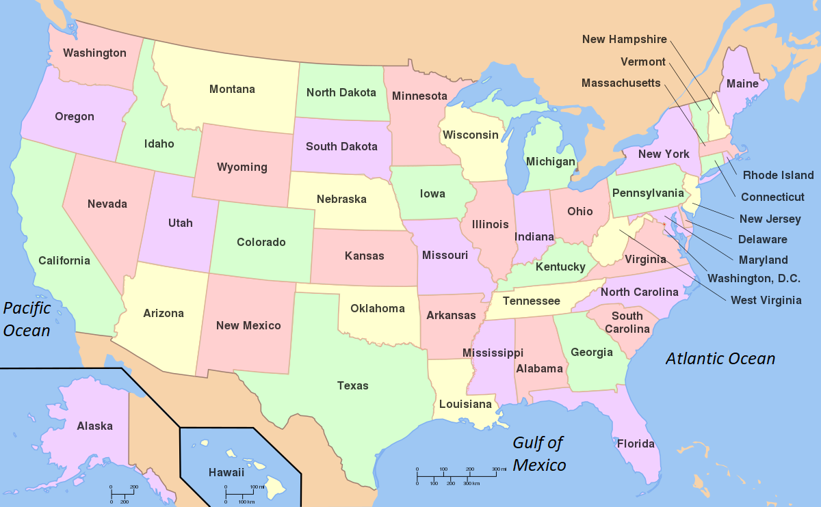

Use both Sources B and D to complete the questions below.
Guiding Questions
What states are found in the West?
What states are found in the Southwest?
What states are found in the Midwest?
What states are found in the Northeast?
What states are found in the Southeast?

After you read:

1. What are the five regions of the United States? Make a few predictions about how different regions might be similar or different from each other.

Lesson 2 – Setting the Context
Student Directions | First, study Sources E, F and G, then answer the guiding questions for each (look back at Source B from the previous lesson if needed). Next, complete the after you read questions at the end of this lesson.
Featured Sources | Source E: United States Regions and Population  Source F: United States Climate Map  Source G: Land Use in the United States

Source E: United States Regions and Population

The map below shows the population—or how many people live in each area—of the U.S. Each red dot represents a city with over 100,000 people.

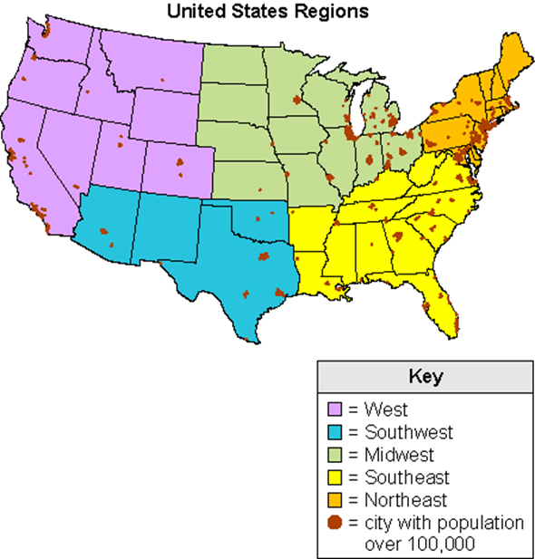

Guiding Questions
What regions have many large cities located on their coasts?
What region has the most densely packed cities?

Source F: United States Climate Map

The map below shows the climate in each of the regions of the United States. The word ‘mild’ means the climate is usually not too hot or too cold. The word “arid” means very dry. Use Source B from the previous lesson to help you answer the guiding questions
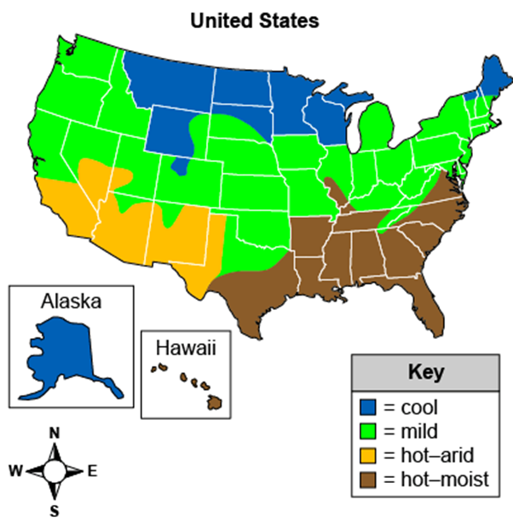
Guiding Questions
What regions of the United States have both a hot and arid climate?
What regions of the United States have hot and moist climates?
What regions of the United States have a cool climate?

Source G: Map of Land Use in the United States

The map below shows how land is used in each of the regions of the United States. Grazing means land used for animals like cows, sheep, and other livestock. Raising livestock humanely requires large amounts of open land.
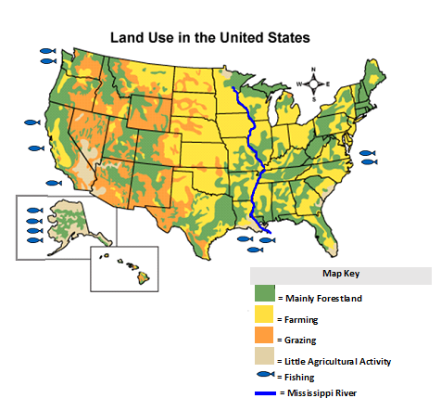
Guiding Questions
In what regions of the U.S. is fishing present?
In what regions in the U.S. is grazing most present?
What regions does the Mississippi River pass through?

After you read:

1. Using Sources E, F, and G, explain why fishing is an important part of the economy of the Southeast and Northeast, but not the Midwest.

2. Why is grazing more common in the West and in the Northeast?

3. Using Source G, describe how the land is used in the area surrounding the Mississippi River.

Lesson 3 – How does the geography of the Northeast influence how people live there?
Student Directions | Read Source H and complete the guiding questions in the right-hand column. Next, study Source I and complete performance task #1 at the end of this lesson.
Featured Sources | Source H: “Northeastern United States”  Source I: Northeast Image Collection
Optional Digital Extension | Northeast Region of the United States

Source H: “Northeastern United States”
Text | Vocabulary | Guiding Questions
The Northeastern United States, also referred to as the American Northeast or simply the Northeast, is a geographical region of the United States bordered to the north by Canada, to the east by the Atlantic Ocean, to the south by the southern United States, and to the west by the midwestern United States. The Northeastern region is the nation's most economically developed, densely populated, and culturally diverse region.  The Northeast has the second-largest percentage of residents living in an urban setting, 85 percent, and is home to the nation's largest metropolitan area.  As of 2007, forests covered approximately 60% of the Northeastern states. About 12% was cropland and another 4% grassland pasture or range. There is also more urbanized land in the Northeast than any other region in the U.S  The climate of the Northeastern United States varies from northernmost Maine to southernmost Maryland. Summers range from normally warm in northern areas to hot in southern parts of the Northeast. Winter often brings both rain and snow. The climate of the Northeast can be divided into a colder and snowier interior (Pennsylvania, New York state, and the New England area) and a milder coastal area (Rhode Island and southward, including New Haven, CT, New York City, and Philadelphia). | densely: tightly packed together  diverse: lots of variety  urban: areas with large towns or cities  range: a large area of open land for grazing or hunting. | What country does the Northeast region border?  ______________________________  ______________________________  What percent of people in the Northeast live in cities?  ______________________________  ______________________________  What is the climate like in the Northeast?  ______________________________  ______________________________  ______________________________  ______________________________  ______________________________  ______________________________  ______________________________  ______________________________

Source I: Northeast Image Collection

Hudson River and New York City

This image shows the Hudson River and a portion of New York City. The Northeast has many such waterways and deep-water ports. These allowed the easy shipping of people and goods before steam power and electricity revolutionized transportation. Many large cities (including New York City) have grown along these deep-water ports and waterways, making the Northeast the most densely populated of all the regions in the U.S.

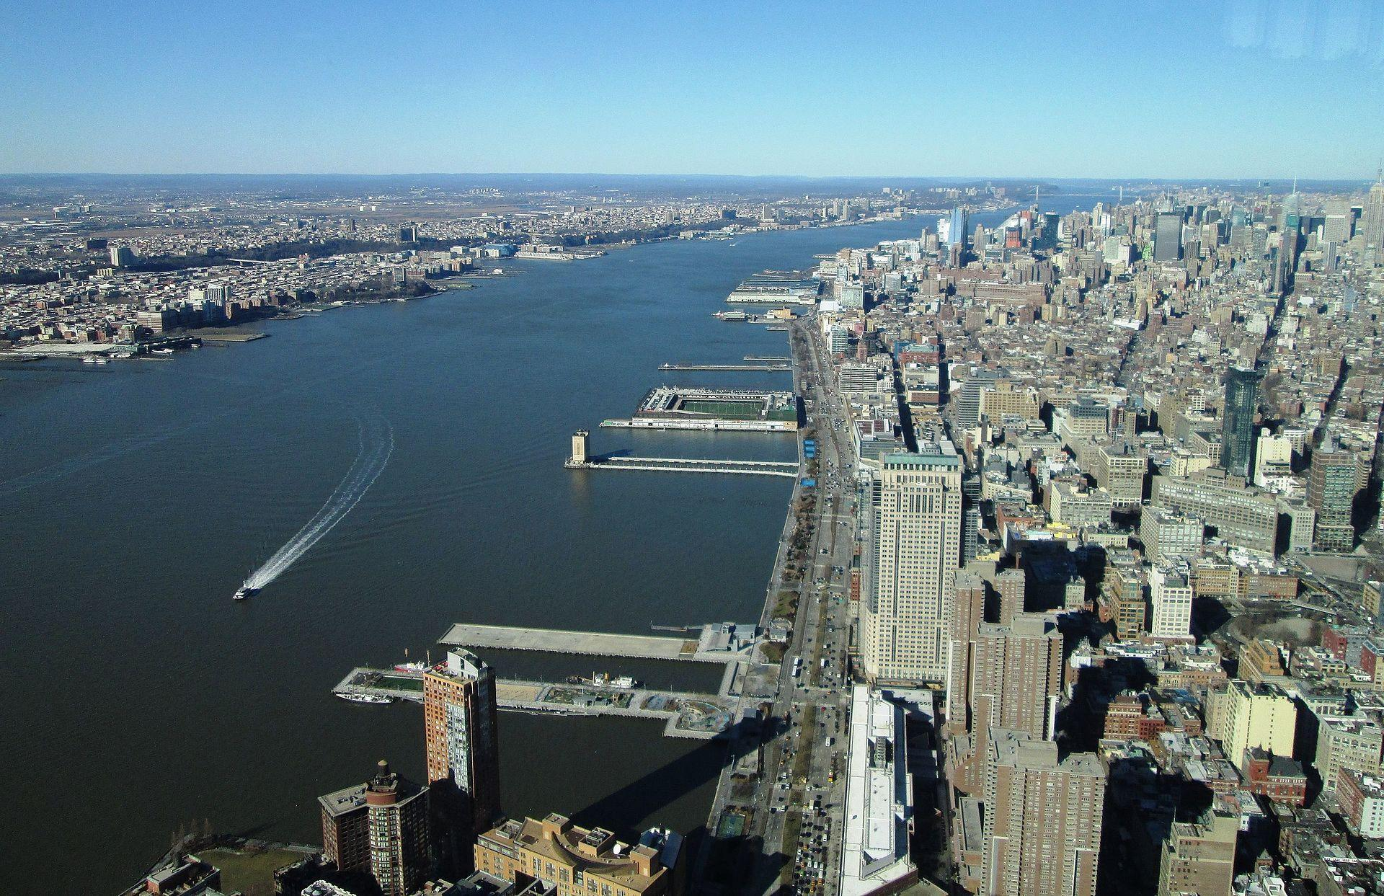

Lobster Traps and Commercial Fishing Boats in New England

Note: The Northeast is known for its seafood industry. The image below shows a commercial fishing boat and cages used to catch and hold lobster. Because of its closeness to the Atlantic Ocean, many people who live in the Northeast work in the fishing and shipping industries.

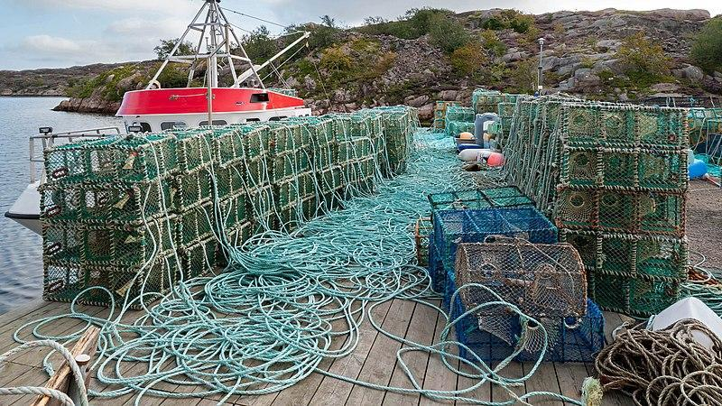

Guiding Questions
How do the waterways in the Northeast help people trade?
How does the location of the Atlantic Ocean influence people who live in the Northeast?

“Tapping the Sugar Maples” by Vermont Stereoscopic Company

Note: The Northeast region has lots of forests, and logging is an important industry there. Trees are cut down
to make houses, paper, furniture, and fuel. Vermont is known throughout the world for its delicious maple syrup produced from the sap of the sugar maple tree. This photograph below shows a man tapping a maple tree to drain its sap in order to make syrup. The photograph was taken between 1870–1890.

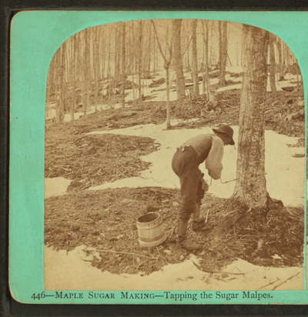

Lower Mills, Massachusetts

The Northeast region has many rivers and waterfalls. This was especially important in the growth of the
region because the power produced by the running water made it possible for people to build mills, or factories. By using water-driven power, people could run machines and make things much faster than
people could at home by hand. Today, factories use other sources of power instead, but the Northeast region continues to be an important manufacturing center in the United States. Iron, glass, steel, and many chemicals such as shampoos, paints, and medicines are manufactured in the Northeast.

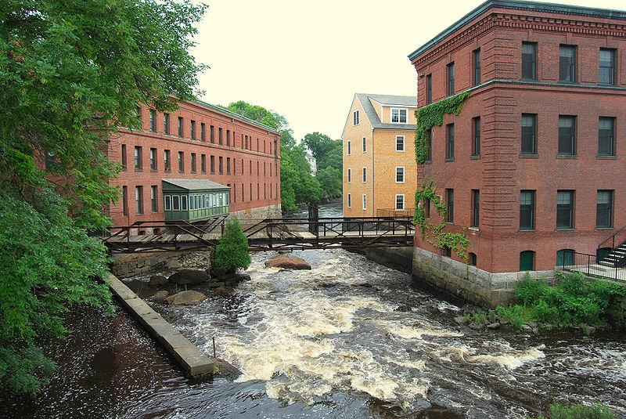

Guiding Questions
How have the forests in the Northeast influenced how people live?
How have the rivers in the Northeast influenced how people live?

Acadia National Park, Maine

This photograph shows two people driving snowmobiles through Acadia National Park in northern Maine. Parts of the Northeast can experience heavy snowfall and very low temperatures in the winter. The Northeast is subject to the occasional blizzard, a severe snowstorm with high winds and low visibility.

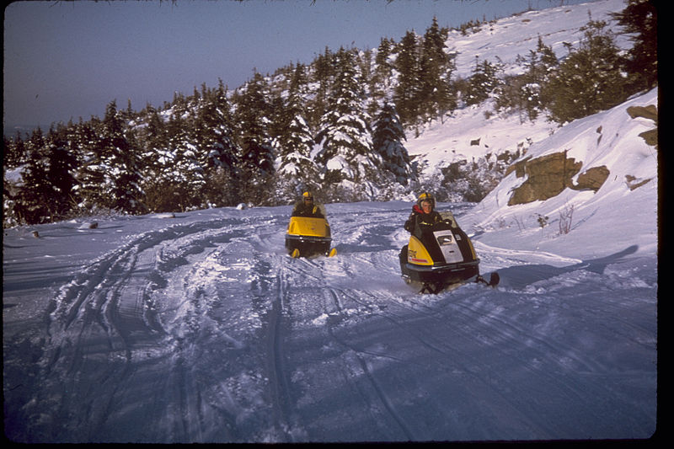

Formative Performance Task #1 – Constructed Response
Student Directions | Based on the sources, write a paragraph that explains two ways the geography of the Northeast influences how people live there.

Lesson 4 – How does the geography of the Midwest influence how people live there?
Student Directions | Read Source J and answer the guiding questions in the right-hand column. Next, study Source K and complete performance task #2 at the end of this lesson.
Featured Sources | Source J: “Midwestern United States”  Source K: Midwest Image Collection
Optional Digital Extensions | Studies Weekly – The Midwest

Source J: “Midwestern United States”
Text | Vocabulary | Guiding Questions
The Midwest is a landscape of low, flat to rolling plains. Most of its eastern two-thirds form the Interior Lowlands, sometimes known as the Great Plains.  While most of the Midwest is relatively flat, made up of plains or rolling, small hills, there is a measure of geographical difference. In particular, the eastern Midwest near the foothills of the Appalachian Mountains; the Great Lakes Basin; the Ozark Mountains of southern Missouri; the rugged landscape of southern Indiana and far southern Illinois; and the Driftless Area of northwest Illinois, southwest Wisconsin, southeast Minnesota, and northeast Iowa all exhibit a high degree of variety.  Although hardwood forests in the northern Midwest were nearly all cut down in the late 19th century, they were replaced by new growth. Ohio and Michigan's forests are still growing. Most of the Midwest can now be labeled as either urbanized areas or pastoral agricultural areas.  Agriculture is one of the biggest drivers of local economies in the Midwest, accounting for billions of dollars’ worth of exports and thousands of jobs. The area consists of some of the richest farming land in the world. The region's fertile soil, combined with the steel plow, has made it possible for farmers to produce abundant harvests of grain and cereal crops, including corn, wheat, soybeans, oats, and barley, to become known today as the nation's "breadbasket." | plains: a large area of flat land with few trees  pastoral: countryside  fertile: good for agriculture  plow: a tool used to break up soil to plant crops | Describe the landscape of the Midwest.  ________________________________  ________________________________  ________________________________  ________________________________  ________________________________  ________________________________  What role does agriculture play in the Midwest’s economy?  ________________________________  ________________________________  ________________________________  ________________________________  ________________________________  ________________________________  What are some of the most important crops grown in the Midwest?  ________________________________  ________________________________  ________________________________  ________________________________

Source K: Midwest Image Collection

View of the Great Plains near Lincoln, Nebraska, U.S.

The photograph gives a view of the Great Plains near Lincoln Nebraska. The Wheat Belt in the Great Plains produces most of the wheat in the U.S. Wheat is ground into flour. The flour is then turned into products like pasta, bread, and cereal.

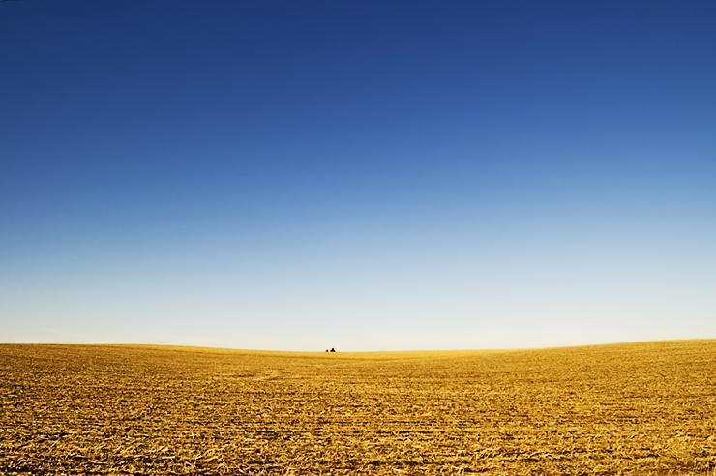

Soybean field at Applethorpe Farm, Ohio

This is a picture of a soybean field at Applethorpe Farm in Ohio. Soybeans are grown throughout the United States, but the ideal planting locations are in the Midwest. Soybeans are used for many things, such as food for humans and industrial products, but they are most commonly used to feed livestock. In fact, 98 percent of U.S. soy meal goes to feed pigs, chickens, and cows.

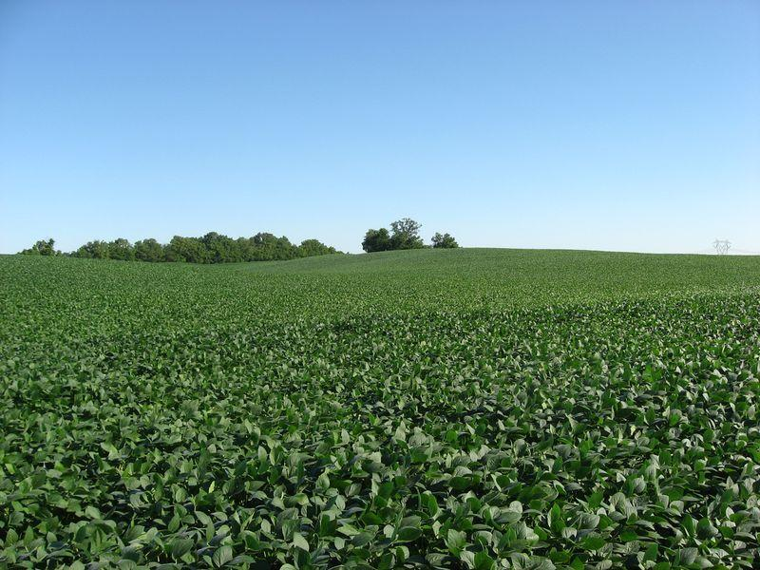

Guiding Questions
What are some of the most important crops grown in the Midwest? | _________________________________________________________________  _________________________________________________________________
Why is farming important in the Midwest? | _________________________________________________________________  _________________________________________________________________

Aerial View of Mississippi River

The photograph gives a view of the Mississippi River from a helicopter flying overhead. The flat area below the river is farmland. Farmers in the Midwest have used the Mississippi and other rivers to help water and transport their crops.

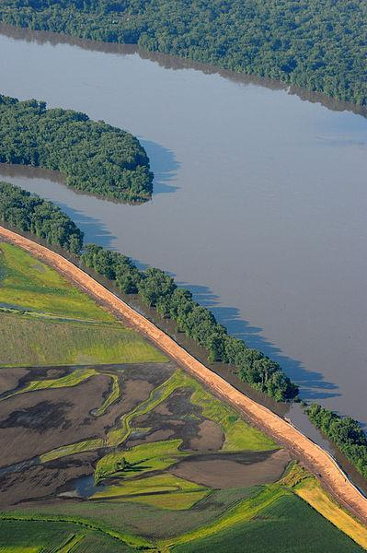

Tornado on the ground. Near Scottsbluff, Nebraska

Tornados are more common in the United States than in any other country. The Midwest region is especially prone to tornados and has earned the nickname “Tornado Alley.” The strongest tornados can generate winds over 200 miles per hour—strong enough to uproot trees and destroy houses.

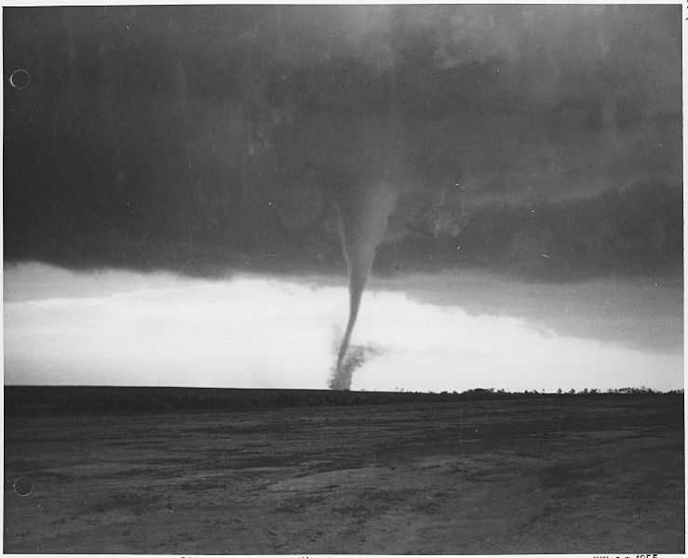

Chicago River from Michigan Avenue

This photograph shows the Chicago River running through the city near the Magnificent Mile. Chicago is by far the largest city in the Midwest. Its central location in the United States and its proximity to the Great Lakes and the Mississippi River make it a natural hub for trade and transportation.

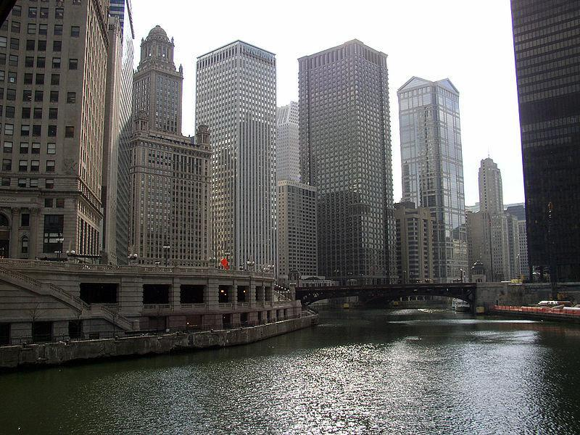

Guiding Questions
How have the rivers in the Midwest influenced agriculture? | _________________________________________________________________  _________________________________________________________________
How have the rivers in the Midwest influenced urban areas like Chicago? | _________________________________________________________________  _________________________________________________________________

Formative Performance Task #2 – Constructed Response
Student Directions | Using the sources, write a paragraph that explains two ways the geography of the Midwest influences how people live there.

Lesson 5 – What similarities and differences are there between the
Southeast and Southwest regions?
Student Directions | Read Source L and answer the guiding questions in the right-hand column. Next, study the images in Source M and complete the after you read questions at the end of this lesson.
Featured Sources | Source L: “Southwestern United States Facts”  Source M: Southwest Image Collection
Optional Digital Extensions | The America Southwest – A Time Lapse Journey

Source L: “Southwestern United States Facts”
Text | Vocabulary | Guiding Questions
The Southwestern United States, also known as the American Southwest, Desert Southwest, or simply the Southwest, is the informal name for one region of the western United States.  The geography of the region is mainly made up by four features—the Mojave, Sonoran, and Chihuahuan Deserts, and the Colorado Plateau—although there are other physical features as well, such as a portion of the Great Basin Desert. The two major rivers of the region are the Colorado River, running in the northern and western areas, and the Rio Grande, running in the east, north to south.  The Chihuahuan Desert includes more species of cacti than any other desert in the world and has an incredible diversity of plants and animals. The most common plants in this region are agave, yucca and creosote bushes, in addition to the abundant presence of various cacti species.  The Colorado Plateau varies from the large forests in the west, including the largest stand of ponderosa pine trees in the world. Although not called a desert, the Colorado Plateau is mostly made up of high desert.  The Plateau is characterized by a series of plateaus and mesas interspersed with canyons. The most dramatic example is the Grand Canyon. But that is one of many dramatic vistas included within the Plateau, which includes spectacular lava formations, deserts, sand dunes, and badlands. One of the most distinctive features of the Plateau is its longevity, having come into existence at least 500 million years ago.  The cities of Phoenix, El Paso, and Las Vegas are the largest urban areas in the Southwest. The southwestern United States has a semi-arid to arid climate, depending on the location. In some mountainous locations in the Southwest, snowfall is common. | plateau: an area of relatively level high ground.  mesa: a medium sized flat-topped hill or mountain | What are four important features of the Southwest region?  _________________________________  _________________________________  _________________________________  _________________________________  _________________________________  _________________________________  _________________________________  What is unique about the Chihuahuan Desert?  _________________________________  _________________________________  _________________________________  _________________________________  _________________________________  What landforms are found in the Colorado Plateau?  _________________________________  _________________________________  _________________________________  _________________________________  What type of climate does the Southwest have?  _________________________________  _________________________________  _________________________________  _________________________________  _________________________________  _________________________________  _________________________________

Source M: Southwest Image Collection

Monument Valley, Arizona

This photograph is an aerial view of a mesa in Monument Valley, on the Colorado Plateau.
Monument Valley is a region of the Colorado Plateau characterized by a cluster of vast and recognizable sandstone mesas, the largest reaching 1,000 ft above the valley floor. It is located on the southern border of Utah with northern Arizona.

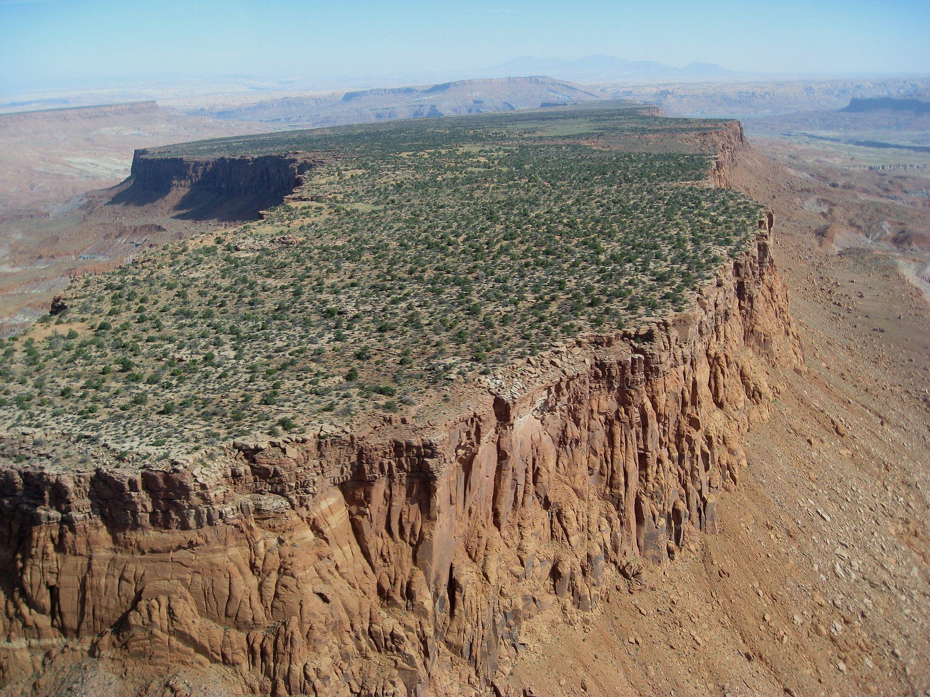

The Hoover Dam

The image is of the Hoover Dam. Completed in 1936, the dam harnesses the power of the Colorado River to generate electricity for nearby metropolitan areas. Water is a critical resource in the Southwest; without the water redirected from the Colorado River, large cities like Phoenix, Arizona, would not be able to produce enough drinking water for its residents.

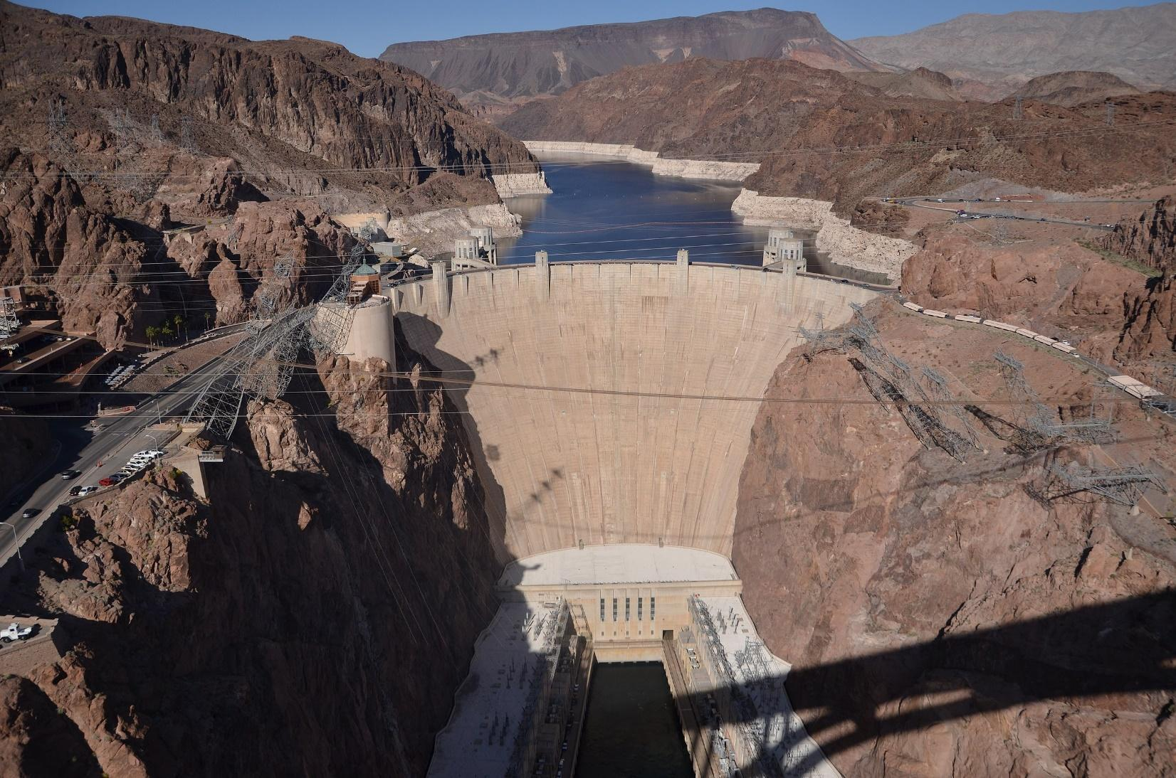

Colorado River at Pima Point, Arizona

This photograph shows a view of the Colorado River running through the Grand Canyon from Pima Point, Arizona. Because much of the Southwest is an arid desert, many of the major cities in the Southwest depend on rivers and underground deposits of water called aquifers for fresh water.
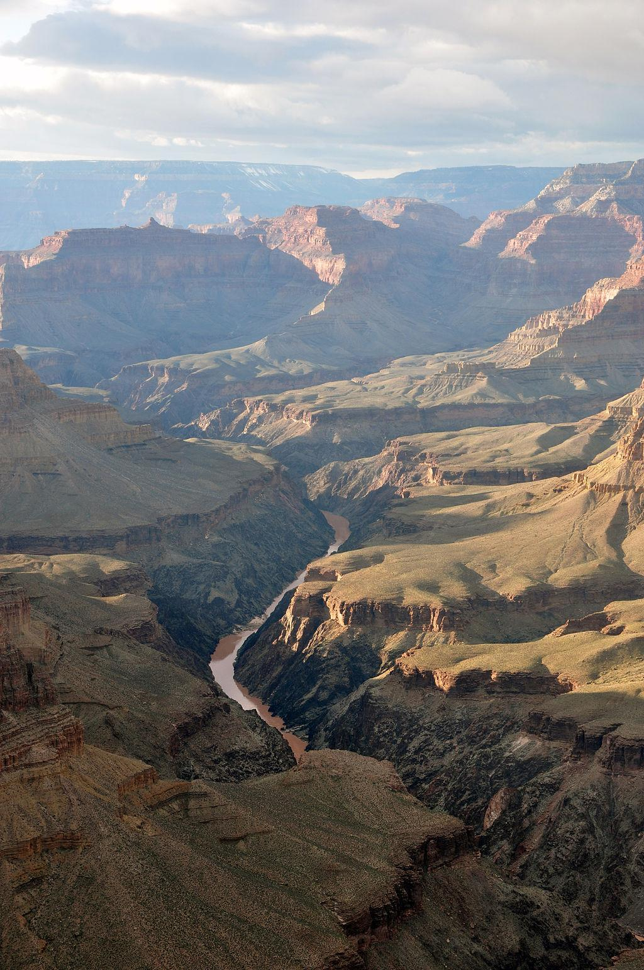
Guiding Questions
What are two ways the Colorado River is important to people living in the Southwest?

________________________________

________________________________

________________________________

________________________________

________________________________

________________________________

________________________________

________________________________

________________________________

________________________________

________________________________

________________________________

Oil Well in Andrews Texas

This photograph is of an oil well in Andrews, Texas. The Southwest is rich in many natural resources including oil, natural gas, coal, and copper. Many people in the Southwest work in industries related to these natural resources. Oil can be refined into gasoline that powers cars and airplanes, and the copper mined in the Southwest is used in electrical wire and equipment. Because of its abundant sunlight, solar power is becoming increasingly popular in the Southwest.

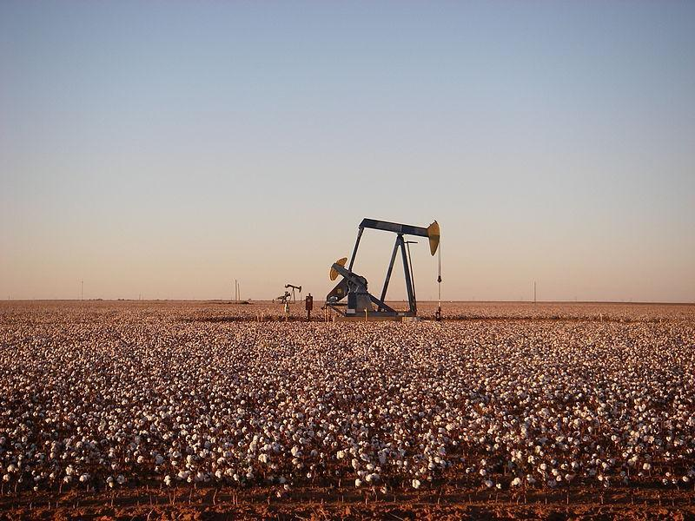

Guiding Questions
What natural resources are found in the Southwest? | __________________________________________________________________________  __________________________________________________________________________  __________________________________________________________________________

Cattle Grazing in Oklahoma

This photograph is of a herd of cattle grazing in Oklahoma. Many cleared forests in the Southwest are now pastures used for grazing. Herds of cattle require lots of space; it takes nearly 2 acres to feed a single cow. Milk, meat, leather, sheep’s wool and mohair are all well-known products from grazing animals.

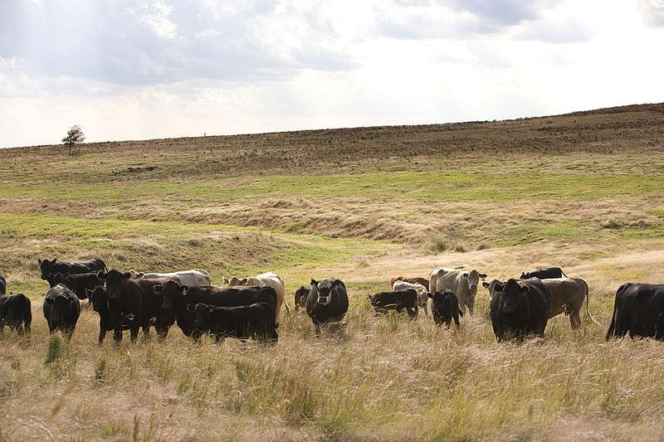

Guiding Questions
What products are produced by grazing animals? | __________________________________________________________________________  __________________________________________________________________________  __________________________________________________________________________
After you read:

1. Using Sources L and M, describe the climate and geography of the Southwest.

2. What industries are found in the Southwest, and how are they related to the natural resources found there?

3. Why would water be an important resource to people living in the Southwest? How have people adapted the environment to gain more access to water resources?

Lesson 6 – What similarities and differences are there between
the Southeast and Southwest regions?
Student Directions | Read Source N and answer the guiding questions in the right-hand column. Next, study the images in Source O and complete performance task #3 at the end of this lesson.
Featured Sources | Source N: “Southern United States Facts”  Source O: Southeast Image Collection

Source N: Southern United States Facts
Text | Vocabulary | Guiding Questions
Usually the South is defined as including the southeastern and south-central United States. The region is known for its culture and history, having developed its own customs, musical styles, and cuisines which have distinguished it in some ways from the rest of the United States.  The Southern ethnic heritage is diverse and includes strong European (mostly English, Italian, Scottish, Scotch-Irish, Irish, German, French, Portuguese and Spanish American), African and Native American elements.  The South is a diverse region with numerous climatic zones, including temperate, sub-tropical, tropical, and arid—though the South generally has a reputation as hot and humid, with long summers and short, mild winters.  Most of the south—except for the higher elevations and areas near the western, southern and some northern fringes—fall in the humid subtropical climate zone. Crops grow easily in the South; its climate regularly provides growing seasons of at least six months before the first frost.  Historically, the South relied heavily on agriculture and was highly rural until after 1945. It has since become more industrialized and urban and has attracted national and international migrants. The American South is now among the fastest-growing areas in the United States. | heritage: traditions and culture  sub-tropical:  a climate where the temperature rarely drops below freezing  fringes: edges  Industrialized: to develop factories and industry on a large scale | What groups have contributed to the unique culture of the South?  ________________________________  ________________________________  ________________________________  ________________________________  ________________________________  ________________________________  ________________________________  What are some of the different climate zones in the South?  ________________________________  ________________________________  ________________________________  ________________________________  ________________________________  ________________________________  ________________________________  ________________________________  ________________________________

Source O: Southeast Image Collection

Commercial shrimp boats docked at Georgia coastline

Commercial fishing is a major part of the economy of many states in the Southeast, especially in the Gulf of Mexico where commercial fisherman catch 1.7 billion pounds of finfish and shellfish every year.

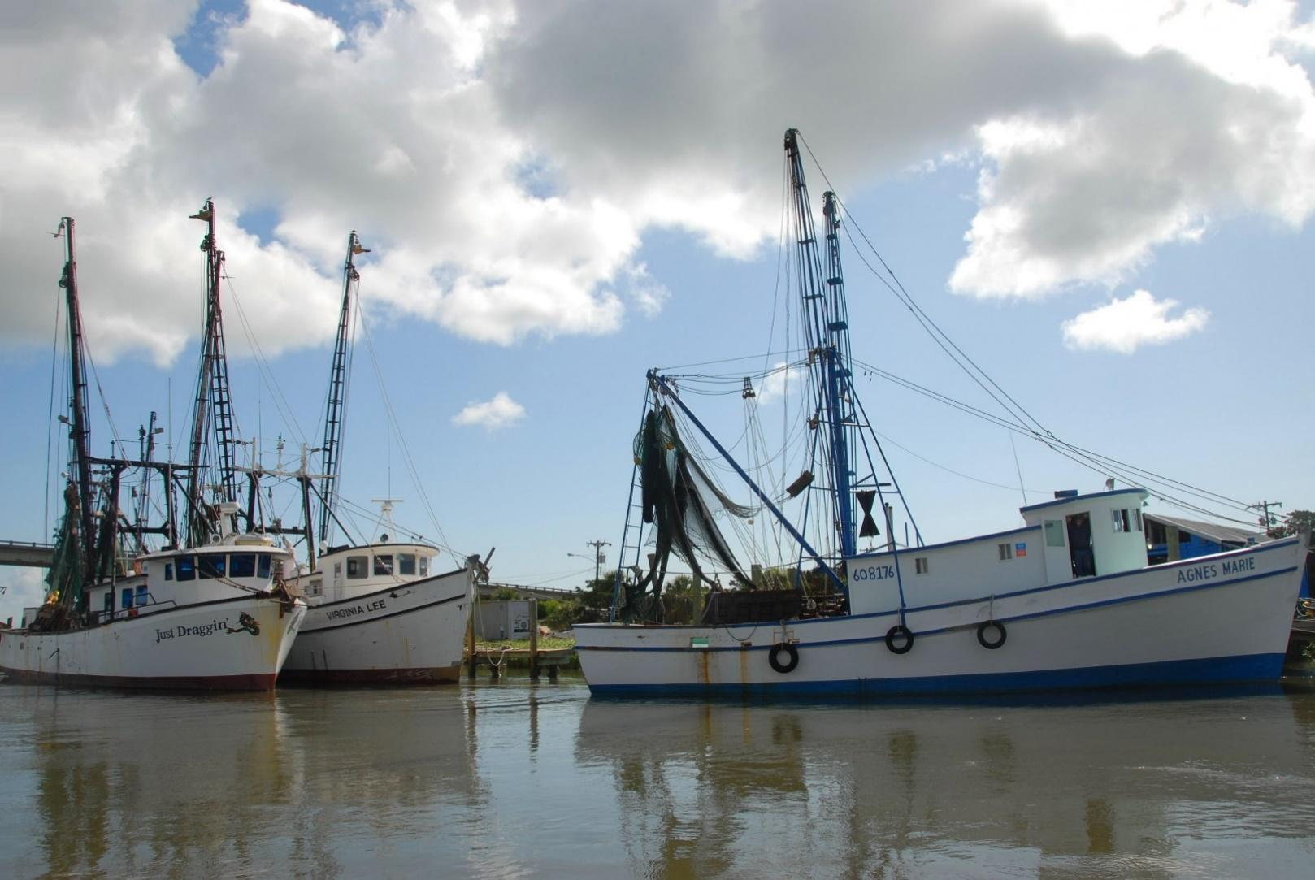

Center pivot irrigation, Georgia

The photograph shows a field of crops being watered by a large-scale irrigation system. Irrigation means channeling the supply of water to land or crops to help growth. In this case, a large metal arm with sprinklers slowly rolls across the field. Many areas in the south have very fertile soil and agriculture is still a major part of the economy of the Southeast.

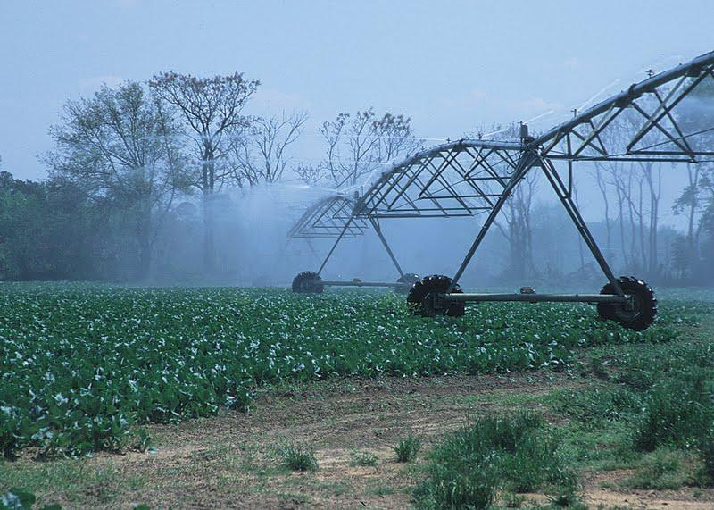

Guiding Questions
How does irrigation help farmers in the South? | __________________________________________________________________________  __________________________________________________________________________  __________________________________________________________________________
Pearl River Backwater in Mississippi

This photograph was taken near the Pearl River in Mississippi. Swamps, marshes and bogs (which are all low-lying, flooded areas) are found all along the Gulf Coast.

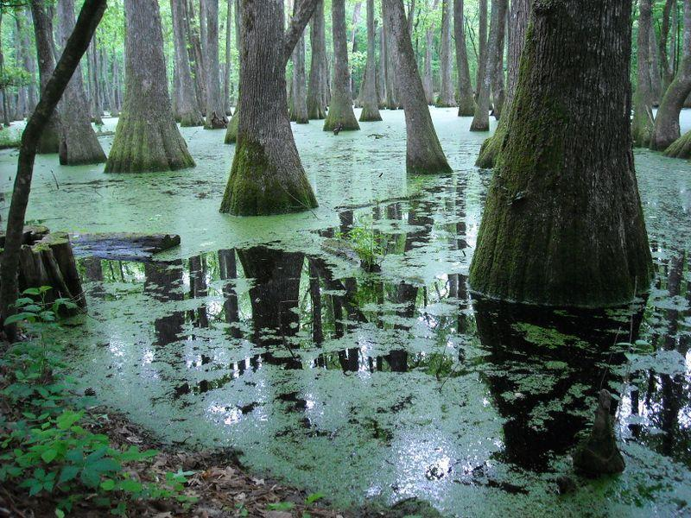

Guiding Questions
How is the environment shown in the picture above different than the environment in the Southwest? | ____________________________________________________________  ____________________________________________________________  ____________________________________________________________

Dogback Mountain, North Carolina

This photograph is of Dogback Mountain at sunrise, as seen from Wiseman's View on the Linville Gorge in North Carolina. Both the Appalachian and Ozark mountain ranges can be found in the Southeast. Though not nearly as tall as the Rocky Mountains in the west, they are far older.

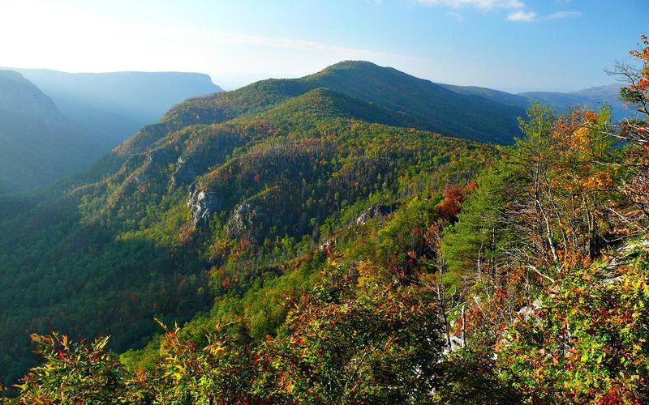

Guiding Questions
How are the mountain ranges in the Southeast different from those in the West and Southwest? | ____________________________________________________________  ____________________________________________________________  ____________________________________________________________

Aerial view of the Port of New Orleans

This photograph is an aerial view of the Port of New Orleans, one of the largest ports in the United States. Due to its location near the Mississippi River, the port is responsible for nearly 60% of all grain being exported from the United States. Many people in the Southeast work in industries related to shipping and distributing goods.

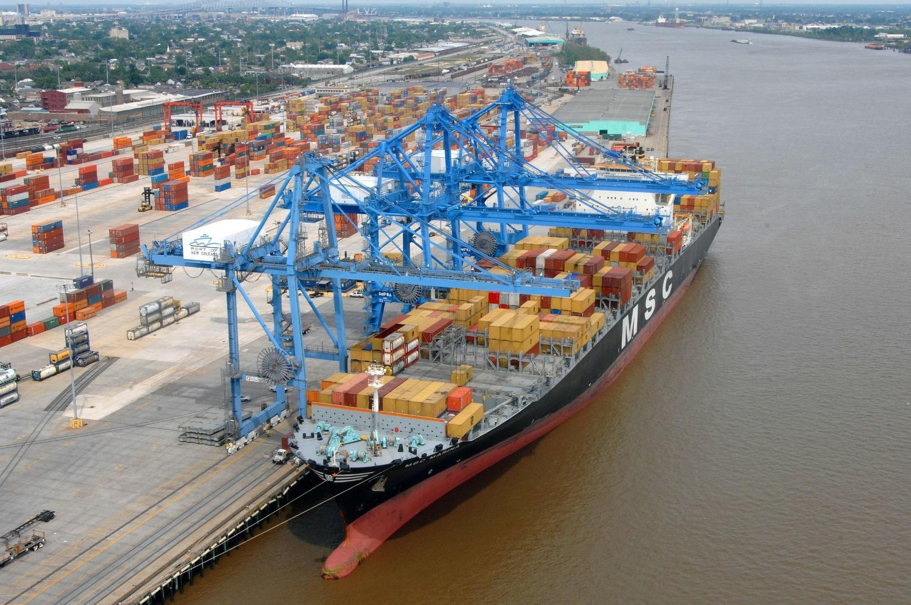

Guiding Questions
How does the Mississippi River and the Gulf of Mexico affect the economy of the Southeast? | ____________________________________________________________  ____________________________________________________________  ____________________________________________________________

Drilling Company offshore mobile oil drilling platform, Grand Isle, Louisiana

This photograph shows an offshore drilling platform in federal waters in the Gulf of Mexico, near Grand Isle, Louisiana. Offshore oil drilling, and the refining of oil into other products is a major part of the economy of many Southeastern states.

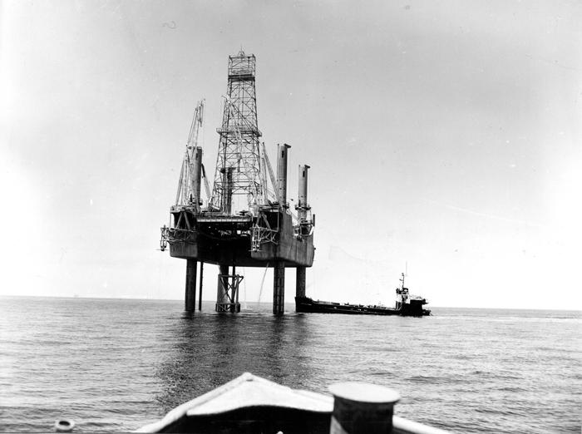

Guiding Questions
In what ways is the oil rig pictured above similar to and different from those found in the Southwest? | ____________________________________________________________  ____________________________________________________________  ____________________________________________________________

Search and Rescue Operation in Ascension Parish

This photograph is of a search and rescue operation boat in Ascension Parish after flooding. Hurricanes that form in the Gulf or Atlantic Ocean cause large amounts of rainfall and heavy winds. In low-lying communities along the Gulf, this often leads to flooding. In some communities, houses are raised up on stilts to reduce the damage from flooding.

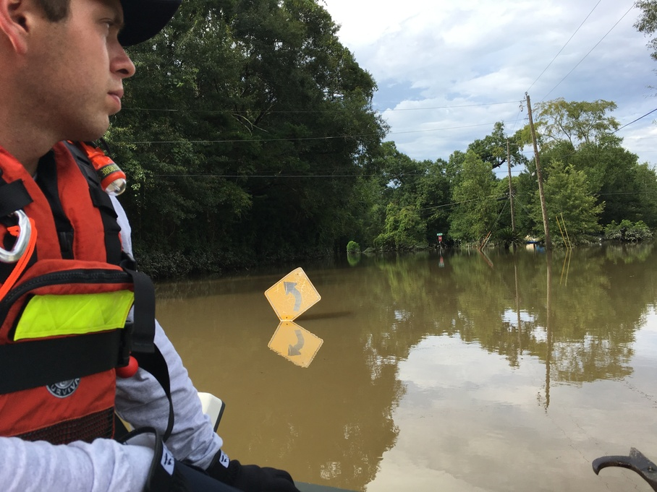

Guiding Questions
What natural disasters often cause the flooding pictured above? How have people who live in the Southeast adapted? | ____________________________________________________________  ____________________________________________________________  ____________________________________________________________

Formative Performance Task #3 – Constructed Response
Student Directions | Using the sources, write a paragraph that describes one similarity and one difference between the Southwest and Southeast region.

Lesson 7 – How does the geography of the West influence how people live there?
Student Directions | Read Source P and complete the guiding questions in the right-hand column. Next, study Source Q and complete performance task #4 at the end of this lesson.
Featured Sources | Source P: “Western United States Facts”  Source Q: West Image Collection
Optional Digital Extensions | Studies Weekly – Economy of the West  The West Region

Source P: Western United States Facts
Text | Vocabulary | Guiding Questions
The Western United States, commonly referred to as the American West, the Far West, or simply the West, traditionally refers to the region made up of the westernmost states of the United States.  The West contains several different environments. It is known for: arid to semi-arid plateaus and plains, particularly in the American Southwest; forested mountains, including the major ranges of the American Sierra Nevada and Rocky Mountains; the massive coastal shoreline of the American Pacific Coast; and the rainforests of the Pacific Northwest.  The entire Western region has also been strongly influenced by European, Hispanic or Latino, Asian and Native Americans; it contains the largest number of minorities in the U.S.  Along the Pacific Ocean coast lie the coastal mountain ranges, the Sierra Nevada in the south and the Cascade Range in the north. Mount Whitney, at 14,505 feet the tallest peak in the contiguous 48 states, is in the Sierra Nevada. The Cascades are also volcanic. Mount Rainier, a volcano in Washington, is also over 14,000 feet. Mount Denali in Alaska is the highest mountain peak in all of North America. Mount St. Helens, a volcano in the Cascades, erupted explosively in 1980. A major volcanic eruption at Mount Mazama around 4860 BC formed Crater Lake. These mountain ranges see heavy precipitation, capturing most of the moisture that remains after the Coast Ranges, and creating a rain shadow to the east forming vast stretches of arid land. These dry areas take up much of Nevada, Utah, and Arizona. The Mojave Desert and Sonoran Desert, along with other deserts, are found here.  Beyond the deserts lie the Rocky Mountains. In the north, they run almost immediately east of the Cascade Range, so that the desert region is only a few miles wide by the time one reaches the Canada–US border. The Rockies are hundreds of miles wide, and run uninterrupted from New Mexico to Alaska. The Rocky Mountain region is the highest overall area of the United States, with an average elevation of above 4,000 feet. | rainforests: an area of tall trees that receives a high amount of rainfall  contiguous; connected together, sharing common borders (not separated by water or other countries) | What type of environments can you find in the West?  ________________________________  ________________________________  ________________________________  ________________________________  ________________________________  ________________________________  ________________________________  ________________________________  ________________________________  ________________________________  ________________________________  ________________________________  ________________________________  ________________________________  What mountain ranges are found in the West?  ________________________________  ________________________________  ________________________________  ________________________________  ________________________________  ________________________________  ________________________________  ________________________________  ________________________________  ________________________________  ________________________________  ________________________________

Source Q: The West Image Collection

Tongass National Forest in Juneau, Alaska

Tongass National Forest in Southeast Alaska is the largest national forest in the United States at 16.7 million acres. The forest offers unique chances to view eagles, bears, spawning salmon, and the breath-taking vistas of “wild” Alaska.

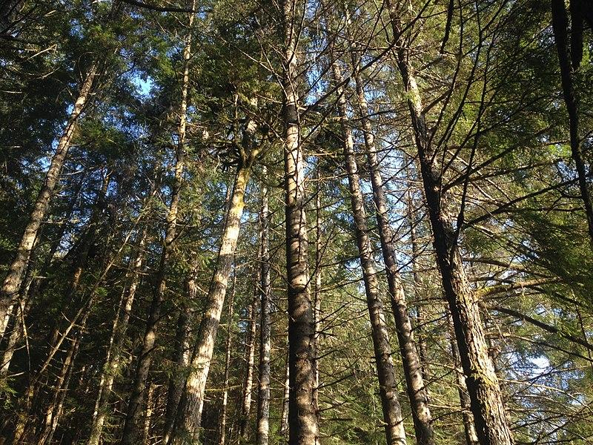

Breckenridge Ski Resort, Colorado

This photograph is of Breckenridge, Colorado, ski resort. Breckenridge is in the background and Keystone Ski Resort is seen in the foreground. Many people travel to Colorado every year for its outdoor spaces and recreational activities like skiing, snowboarding, and hiking.

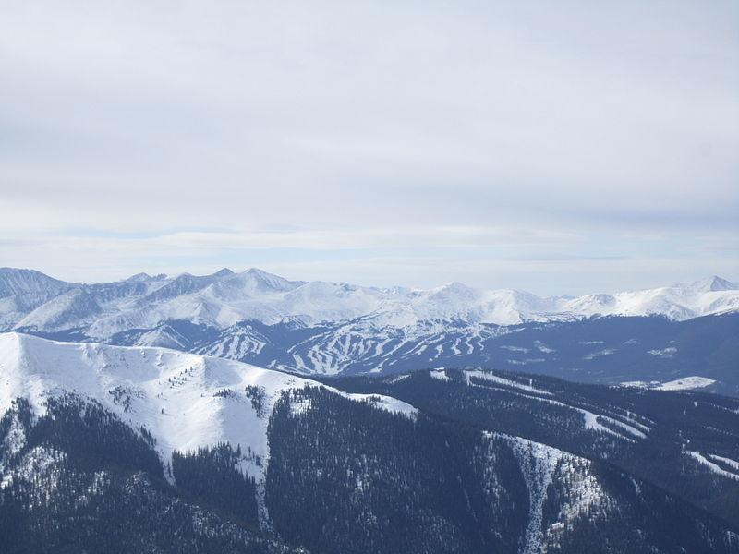

San Francisco Pier 39, California

Every year California draws millions of tourists from other states, and around the world. Tourists come to visit the beautiful sandy beaches, majestic redwood forests, and vibrant diverse cities. The photograph below shows a crowd gathered at a storefront along a pier in San Francisco, a major city located on California’s coast.

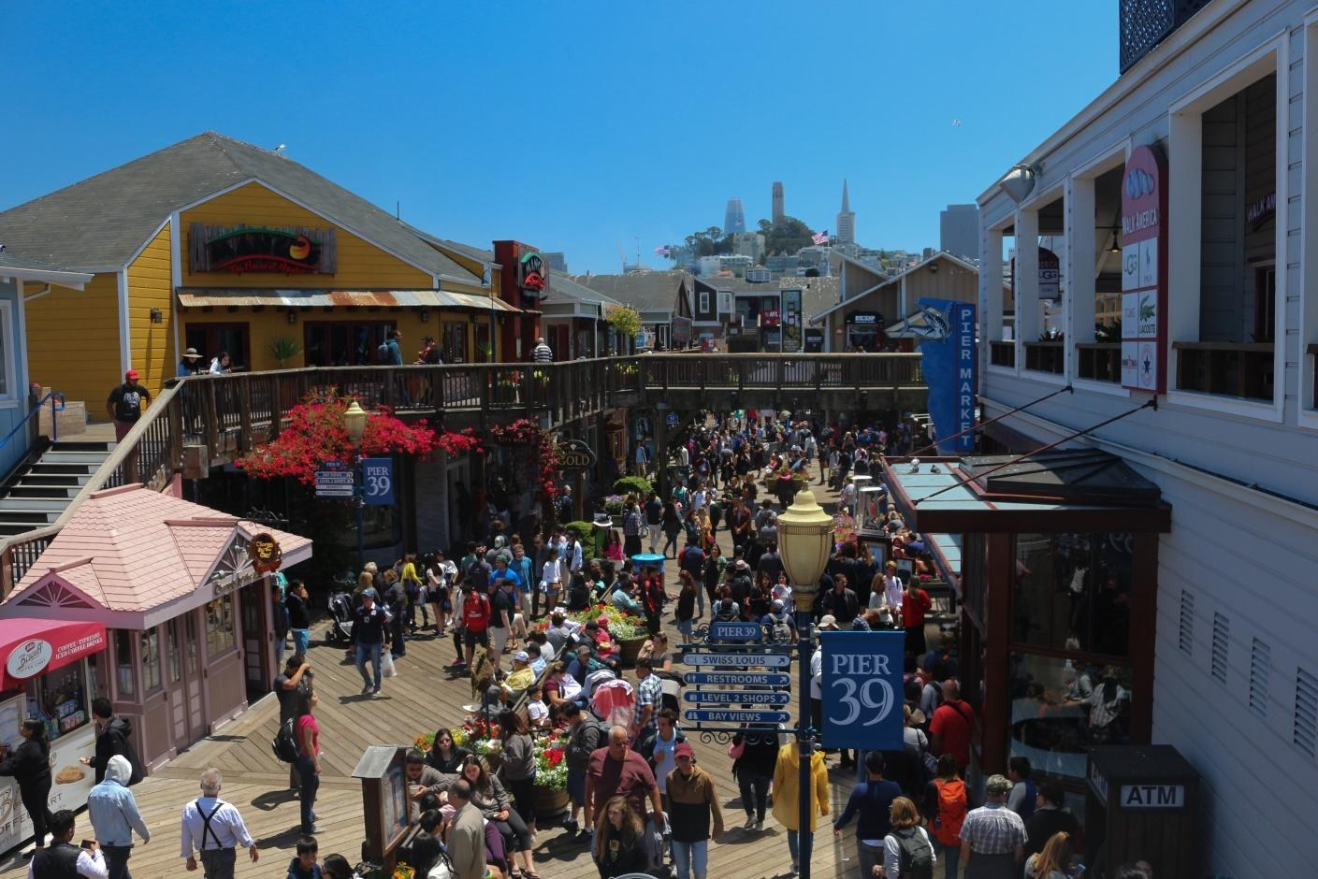

Guiding Questions
Why do many tourists travel to California and the West? | ____________________________________________________________  ____________________________________________________________  ____________________________________________________________  ____________________________________________________________  ____________________________________________________________

Wildfire in California

Parts of the West, including California, are vulnerable to forest fires during prolonged periods of drought. Some communities have decided to adopt building codes that require new buildings to be created out of fire-resistant materials.

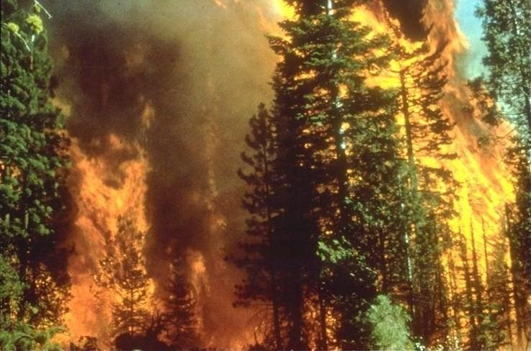

“Result of Earthquake in Street,” San Francisco, California

This image is a postcard illustration of the results of an Earthquake in San Francisco sometime before 1925. Earthquakes can cause major damage to buildings and other infrastructure and are extremely dangerous for people. Today, buildings can be built to be resistant to quakes and are less likely to collapse during one.

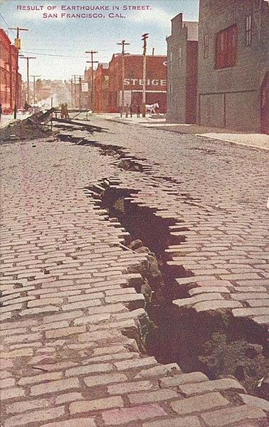

Guiding Questions
How have people adapted to some of the natural disasters that occurr in the West? | ____________________________________________________________________  ____________________________________________________________________  ____________________________________________________________________

Northern Coastal Range, Logging Road, Oregon

This photograph is of a Northern Coast Range logging road in Oregon. The vast forests of the Pacific Northwest are a valuable natural resource. Timber harvested from the Northwest is used in the construction of homes, furniture, and many other consumer goods.

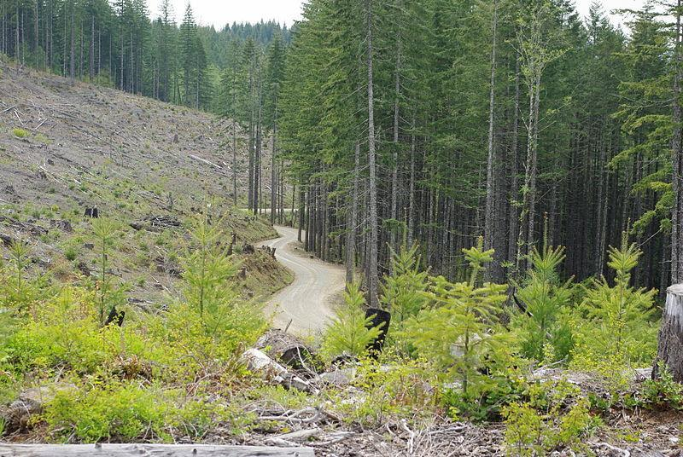

Grape Orchard at Hanzell Farms

California has incredible agricultural diversity with more than 400 products being grown. Over a third of the country's vegetables and two-thirds of the country's fruits and nuts are grown in California. The top produced products for 2018 include: milk, grapes, almonds, cattle, pistachios, strawberries, lettuce, tomatoes, and oranges. The image below is of a grape orchard in Sonoma, California.

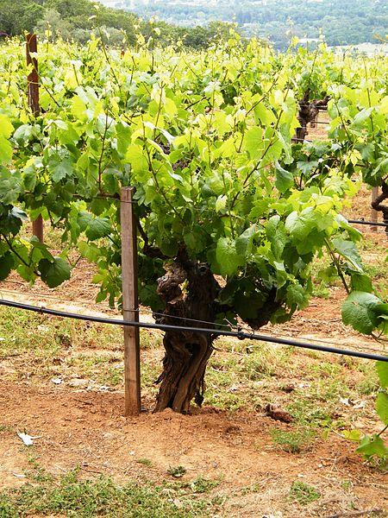

Guiding Questions
How does agriculture and logging impact the West’s economy? | ____________________________________________________________________  ____________________________________________________________________  ____________________________________________________________________

Formative Performance Task #4 –Constructed Response
Student Directions | Using the sources, write a paragraph that describes two ways geography influences how people live in the West.

Lesson 8 - Summative Performance Task
Student Directions | Based on the sources from this packet and your knowledge of social studies, write an essay answering the framing question: How does geography influence the way people live in the United States?

Name________________________________________________Date__________________
What Influenced the Development of Early English Colonies?
Introduction
Student Directions | Over the next two weeks, you will explore the sources in this packet to learn about Plymouth and Jamestown, the early English colonies in North America. At the end of the packet, you will express your understanding by writing an extended response answering the following question: What influenced the development of early English colonies?  This packet includes three supporting questions which will help you develop your claim of influential factors in the settlement of Jamestown and Plymouth. After you read each text or analyze each image, you will be asked to answer questions about it. Some words are defined to help you better understand each source and answer the questions. Some sources have digital extensions, which are optional sources you can explore if you have internet access.

Lesson 1 – Setting the Context
Student Directions | Read Source A and complete the guiding questions in the right-hand column. Next study Sources B, C and D and complete the guiding questions. Then complete the after you read questions at the end of this lesson.
Featured Sources | Source A: “Age of Exploration”  Source B: Age of Discovery Explorations Map  Source C: First Landing on the shores of the New World by D. Puebla 1892  Source D: Indigenous Population of Central Mexico Graph
Optional Digital Extensions | PBS World Explorers - Christopher Columbus  PBS World Explorers - John Cabot  PBS World Explorers - Vasco da Gama  PBS World Explorers - Amerigo Vespucci  PBS World Explorers - Ferdinand Magellan  PBS World Explorers - Francis Drake

Source A: “Age of Exploration”
Text | Vocabulary | Guiding Questions
The Age of Exploration was a period of global history that started in the 15th century and continued into the 18th century. During this time, Europeans sailed on exploration voyages around the world, discovering new routes to Asia, and coming into contact with North and South America which were unknown to people in the Eastern Hemisphere.  The Age of Exploration led to the first truly global turning point, the encounter between the “Old World” (Africa, Asia, and Europe) and the “New World” (North and South America).  For several years, Christopher Columbus asked the Spanish monarchy to fund an expedition that would find a new route to Asia. Columbus was finally funded and in 1492, he landed in the Caribbean. Believing he’d arrived in India, he called the indigenous people he encountered Indians. [They were not.]  His exploration spurred repeated waves of Spanish exploration and colonization led by conquistadors who arrived in the Americas with plans to reap the economic benefits of exploration by conquering the indigenous people in the Americas. | expedition: trip or voyage for exploration  indigenous: original inhabitants  spurred: began, started, encouraged  reap: gain or harvest  conquering: overcoming and taking control of a place or people by use of military force | What continents are considered part of the “Old World”?  ________________________________  ________________________________  ________________________________  ________________________________  ________________________________  ________________________________  Why is Columbus’ voyage considered the “first truly global turning point”?  ________________________________  ________________________________  ________________________________  ________________________________  ________________________________  ________________________________  ________________________________  ________________________________  ________________________________  ________________________________

Source B: Age of Discovery Explorations Map

The lines on the map illustrate various routes taken by European explorers and colonizers during the Age of Exploration. Two European countries, Spain and Portugal, were the first to claim large pieces of territory as colonies. A colony is country or area under the full or partial control of another country, typically a distant one, and occupied by settlers from that country. Colonizing an area usually involved enslaving its indigenous population or forcing them off their land.
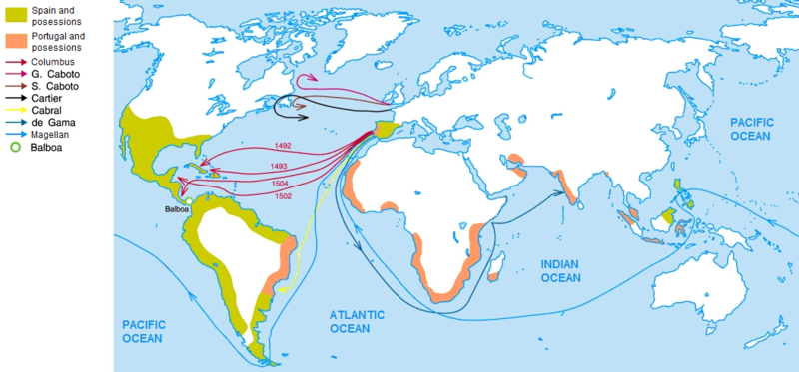

Guiding Question
What is a colony? | _________________________________________________________  _________________________________________________________
What did colonizing an area usually mean for the indigenous people there? | _________________________________________________________  _________________________________________________________

Source C: First Landing on the Shores of the New World by D. Puebla 1892

This painting shows Christopher Columbus and a landing party arriving in the New World. It illustrates some of the different motivations for European exploration and colonization. On the left side of the painting, a priest holds up a cross, a religious symbol used by Christians. Columbus is kneeling, planting a flag in the ground to claim the island for Spain.

The island Columbus landed on was called Guanahani by its native people, the Taino. Columbus renamed it San Salvador. Before European arrival, the Taino were farmers and fisherman who the Spanish described as a peaceful people. Their population rapidly declined due to European disease, enslavement by the Spanish, and warfare with the neighboring Carib tribe. After Columbus’ voyage, Spain began conquering and colonizing much of the New World. The discovery of gold and silver in South America made Spain enormously rich.

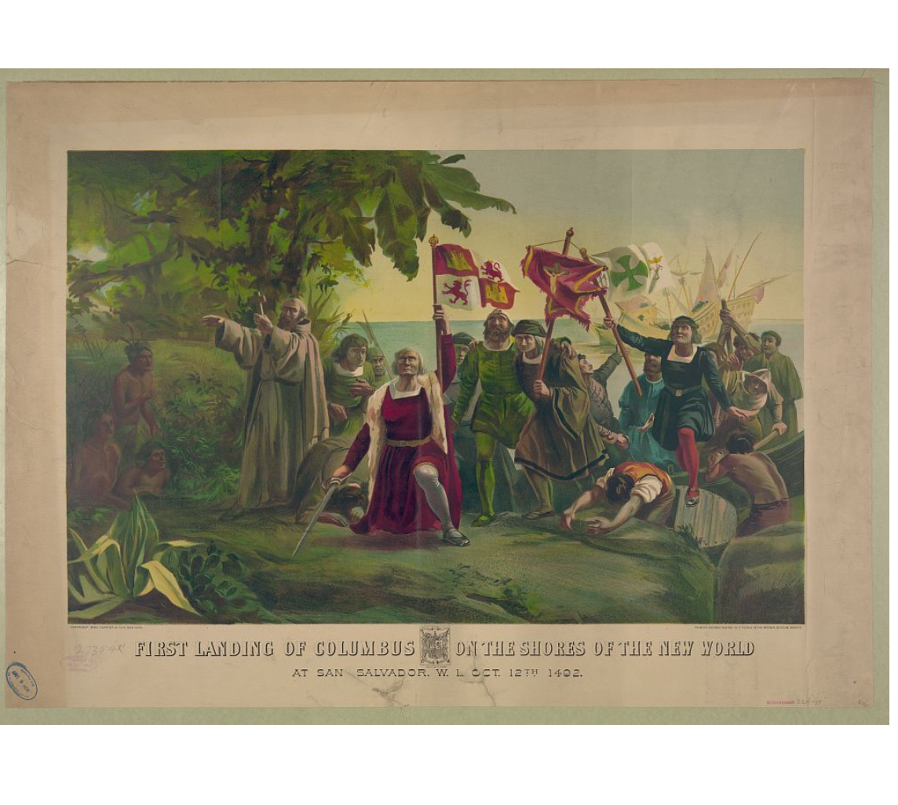

Guiding Question
What does the priest holding a cross and Columbus planting a flag say about what motivated them to explore and claim land? | _________________________________________________________  _________________________________________________________  _________________________________________________________

Source D: Indigenous Population of Central Mexico Graph

Europeans brought a variety of diseases with them to the New World—diseases to which American Indians had little or no resistance. The Spanish arrived in what today would be central Mexico in 1519. In just one-hundred years, over 90% of the indigenous population of central Mexico died from disease. This tragedy was repeated across South and North America as Europeans made contact with American Indians.

The graph below illustrates the population of indigenous peoples of central Mexico before and after contact with Europeans. Hernan Cortez, a Spanish invader, entered central Mexico in the 1530s.

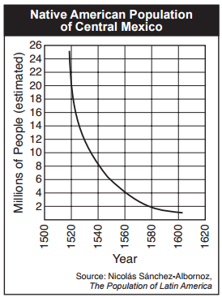

Guiding Question
What happened to the indigenous population of central Mexico from 1520 until 1620? | _________________________________________________________  _________________________________________________________  _________________________________________________________

After you read:

1. What motivated Columbus and other explorers to claim and colonize areas in the New World?

2. How did Spain benefit from colonizing the New World? How did American Indians suffer as a result?

Lesson 2 – Setting the Context
Student Directions | Study and read Sources E and F and complete the guiding questions in the right-hand column. Next, complete the after you read questions at the end of this lesson.
Featured Sources | Source E: Colonies in 1600 Map  Source F: “Joint-Stock Companies”

Source E: Colonies in 1600 Map

By the year 1600, Spain had invaded and claimed large parts of South and Central America. Portugal had claims along the eastern coast of South America and in Africa and Asia. England had not yet established any colonies.

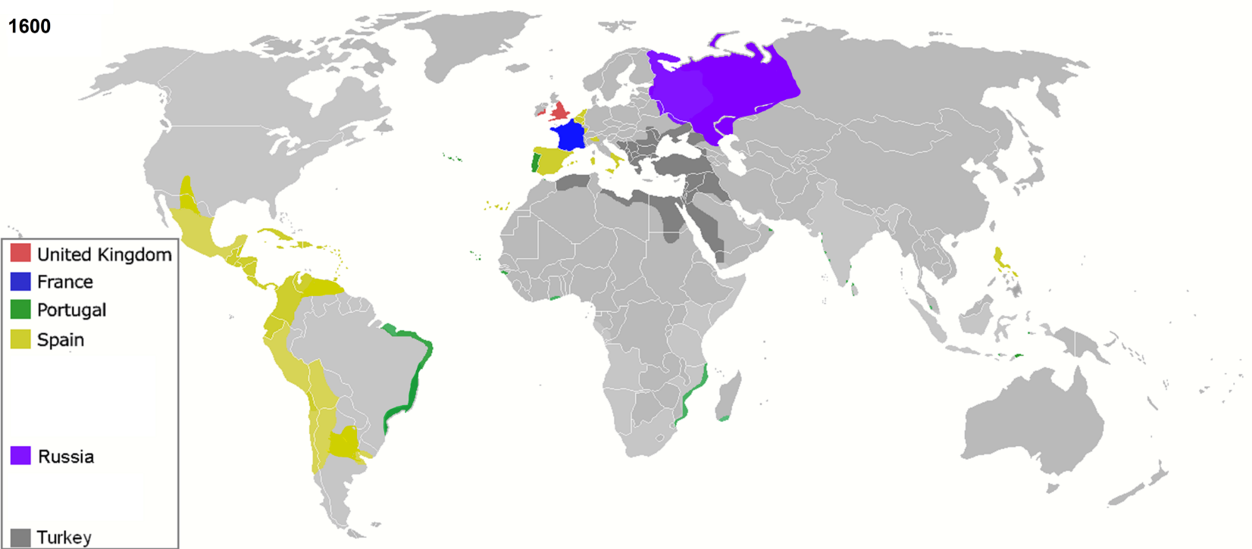

Guiding Question
By 1600, what European countries had colonies in North and South America? | _________________________________________________________  _________________________________________________________  _________________________________________________________  _________________________________________________________

Source F: “Joint-Stock Companies”
Text | Vocabulary | Guiding Questions
Compared with other European nations in 1600, England was relatively poor. As new farming methods made fewer farmers necessary, fewer people were able to find work, and they became homeless.  Richard Hakluyt, a 16th-century geographer interested in explorers and travel narratives, suggested to Queen Elizabeth (of England) that New World colonies could serve two purposes. First, they could challenge Spanish domination of the New World. Second, the ever-growing poorer classes could be transported there, easing England's population pressures.  But Elizabeth was not persuaded to invest in a project that was likely to fail. She was not opposed to private investors taking such a chance, however. Sir Walter Raleigh had tried and failed. When it became clear that the wealth of an individual was not enough, the joint-stock company arose.  In a joint-stock company, stock was sold to wealthy investors who provided money. By pooling their money together these investors limited their individual risk. These companies had proven profitable in the past. The risk was small, and the payoff could be fairly quick.  But investing in a colony was an altogether different venture. The risk was larger as the colony might fail. The startup costs were enormous, and the returns might take years. Investors in such endeavors needed more than a small sense of adventure.  Who were the explorers that led these English colonial expeditions? Often, these leaders were second sons from noble families. Under English law, only the first-born male could inherit property. Many early explorers were all second sons with a thirst to find their own riches.  Merchants who disagreed with the Church of England were also willing investors in New World colonies. There were plenty of Puritans who had the necessary money, and with a Catholic-leaning king assuming the throne, the Puritans' motive to move became stronger.  With a landless population to serve as workers, and motivated, adventurous, or devout investors, the joint-stock company became the vehicle by which England finally settled in the Western Hemisphere. | domination: control, rule  opposed: against  Sir Walter Raleigh: an early English explorer  stock:  a piece or fraction of a company that can be bought and sold; when the company profits, stockholders are paid a percentage of those profits  startup costs: money required to begin a business  Puritans: a group of Christians persecuted in England  Catholic: a type of Christianity that was in conflict with Puritans  landless population: people who do not own property  devout: religious | In what ways did Richard Hakluyt argue that New World colonies could help England?  ________________________________  ________________________________  ________________________________  ________________________________  ________________________________  Why did Queen Elizabeth not want to invest in New World colonies?  ________________________________  ________________________________  ________________________________  ________________________________  ________________________________  ________________________________  What is a joint-stock company?  ________________________________  ________________________________  ________________________________  ________________________________  ________________________________  What made investing in a colony so risky?  ________________________________  ________________________________  ________________________________  ________________________________  ________________________________  ________________________________  Why were Puritans interested in leaving England?  ________________________________  ________________________________  ________________________________  ________________________________  ________________________________  ________________________________  ________________________________  ________________________________  ________________________________

After you read:

1. Why was England interested in starting colonies in North America?

2. How did England’s plan to pay for colonies differ from earlier efforts by Spain and France?

Lesson 3 – How and why were Plymouth and Jamestown founded?
Student Directions | Read Source G and answer the guiding questions in the right-hand column. Next study Source H and complete the guiding questions. Then complete the after you read questions at the end of this lesson.
Featured Sources | Source G: “Jamestown Settlements and the Starving Time”  Source H: Location of Jamestown

Source G: “Jamestown Settlements and the Starving Time” (excerpts)
Text | Vocabulary | Guiding Questions
The first joint-stock company to launch a lasting mission to the New World was the Virginia Company of London. The investors had one goal in mind: gold. They hoped to repeat the success of Spanish who found gold in South America.  In 1607, 144 English men and boys established the Jamestown colony, named after King James I.  The colonists were told that if they did not generate any wealth, financial support for their efforts would end. Many of the men spent their days vainly searching for gold.  As a consequence, the colonists spent little time farming. Food supplies dwindled. Malaria and the harsh winter affected the colonists as well. After the first year, only 38 of the original 144 had survived. The colony may well have been lost had it not been for the leadership of John Smith. He imposed strict discipline on the colonists. "Work or starve" was his motto, and each colonist was required to spend four hours per day farming.  The winter of 1609–10, known as the starving time, may have been the worst of all. Disease and hunger ravaged Jamestown. Two desperate colonists were tied to posts and left to starve as punishment for raiding the colony's food storage. The fate of the venture was uncertain and without the aid of American Indians native to the area, they would have starved.  Yet still more colonists arrived, and their numbers included women. Despite the introduction of growing tobacco, the colony was a failure as a financial venture. The king declared the Virginia Company bankrupt in 1624. About 200,000 pounds were lost among the investors. The charter was thereby revoked, and Virginia became a royal colony, the first in America to be ruled by the Crown.  Investments in permanent settlements were risky indeed. The merchants and nobles paid with their pocketbooks. Many colonists paid with their lives. For every six colonists who ventured across the Atlantic, only one survived. | vainly: hopelessly  malaria: a deadly virus, usually spread by mosquitos  John Smith: English soldier, explorer, and colonial governor  pounds: British money  revoked: taken back | Why did investors support the Virginia company?  _____________________________  _____________________________  _____________________________  When was Jamestown started, and who were the first colonists?  _____________________________  _____________________________  _____________________________  _____________________________  _____________________________  _____________________________  _____________________________  _____________________________  _____________________________  Why is the winter of 1609–10 in Jamestown known as the “starving time”?  _____________________________  _____________________________  _____________________________  _____________________________  _____________________________

Source H: Location of Jamestown

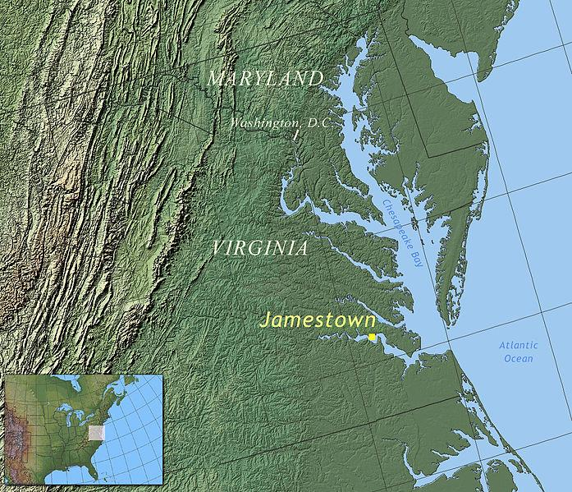
This map shows the location of Jamestown in what would become the colony of Virginia. Jamestown was built along the James River which flows into Chesapeake Bay and the Atlantic Ocean.

Guiding Questions
What ocean did English explorers cross to get to North America?

__________________________
__________________________

Why might Jamestown have been founded on a river?

__________________________

__________________________

__________________________

__________________________

After you read:

1. What motivated investors and settlers to support the colony of Jamestown?

2. What challenges did the early settlers of Jamestown face? How were these challenges largely of their own making?

Lesson 4 – How and why were Plymouth and Jamestown founded?
Student Directions | Read Sources I and K and complete the guiding questions in the right-hand column. Study Source J and complete the guiding question. Next, complete performance task #1 at the end of this lesson.
Featured Sources | Source I: “The New England Colonies”  Source J: Embarkation of the Pilgrims by Robert Weir  Source K: “A Relation or Journal of the Proceedings of the Plantation settled at Plymouth in New England” (excerpts)

Not long after Jamestown colony was founded, another group of English settlers would begin a colony to the north near a place they called Plymouth Rock. Over time this region began to be referred to as New England.

Source I: “The New England Colonies”
Text | Vocabulary | Guiding Questions
The founders of the New England colonies had an entirely different mission from the Jamestown settlers. Although economic prosperity was still a goal of the New England settlers, their true goal was spiritual.  Fed up with the ceremonial Church of England, Pilgrims and Puritans wanted to recreate society in the manner they believed God truly intended it to be designed.  The Pilgrims, sometimes called separatists in England because of their desire to separate from the Church of England, were mistreated by the throne.  The Puritans, so named for their desire to purify the Church of England [rather than leave it], experienced the same degree of harassment.  By the second and third decades of the 1600s, each group decided that England was no place to put their controversial beliefs into practice.  Where else but in the New World could such a golden opportunity be found? They believed the land was unspoiled and that in the Americas their children could be raised without the corruption of old English religious ideas. The chance to create a perfect community was there for the taking.  The English kings saw America as a way to get rid of troublemakers. Everything was falling into place. By 1620, a new community at Plymouth Rock was growing, quite different from Jamestown. This community would eventually form the basis of New England society. | Pilgrims: a religious group who wanted to separate from England  Puritans: a religious group who wanted to purify the Church of England  throne: refers to a government under a king or queen  unspoiled: untouched, natural (this was a false idea as the land was already inhabited) | How were the motives of the Pilgrims and Puritans different from the Jamestown settlers?  _____________________________  _____________________________  _____________________________  _____________________________  _____________________________  _____________________________  _____________________________  _____________________________  _____________________________  _____________________________  _____________________________  Why was immigrating to the New World appealing to the Pilgrims and Puritans?  _____________________________  _____________________________  _____________________________  _____________________________  _____________________________  _____________________________  _____________________________  _____________________________  _____________________________

Source J: Embarkation of the Pilgrims by Robert Weir

In September 1620, over a hundred travelers sailed on the Mayflower, the ship that carried the first Plymouth colonists. 36 of the 102 passengers were English separatists. The rest were immigrants, adventurers, and investors. This painting shows the Pilgrims before their voyage to the New World. The figure in the center is leading the group in prayer. The rainbow on the left side symbolizes hope and divine protection.

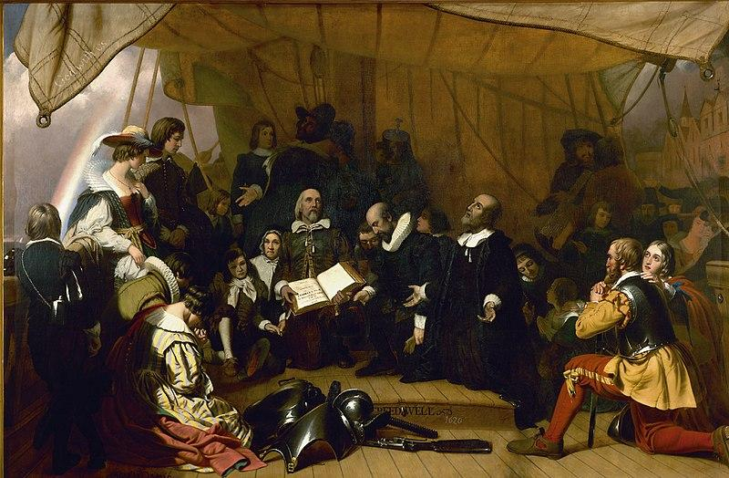

Guiding Question
Which motivation for the founding of the Plymouth colony does the painting show? What percentage of the colonists on the Mayflower were so motivated? | _________________________________________________________  _________________________________________________________  _________________________________________________________
The Pilgrims were originally bound for Virginia to live north of Jamestown under the same charter granted to citizens of Jamestown. Lost at sea, they happened upon a piece of land that would become known as Cape Cod. After surveying the land, they set up camp not too far from Plymouth Rock. Source K was primarily written by Edward Winslow, a leader among the Pilgrims on the Mayflower.

Source K: “A Relation or Journal of the Proceedings of the Plantation settled at Plymouth in New England” (excerpts)
Text | Vocabulary | Guiding Questions
Having thus discovered this place [Plymouth], it was controversial amongst us, what to do, some thought it best for many reasons to abide there.  First, there was a convenient harbor for the ships. . . .  Secondly, good corn ground ready to our hands, as we saw by experience the goodly corn it yielded. . . .  Thirdly, Cape Cod was like to be a place of good fishing and saw daily great whales of the best kind for oil and bone. . . .  Fourthly, the place was likely to be healthful, secure and defensible.  But the last reason was, that now the heart of winter and unseasonable weather was come upon us, so that we could not go upon coasting and discovery, without danger of losing men and boat. . . . Also cold and wet lodging had so tainted our people, for scare any of us were free from vehement coughs. | abide: stay or remain  convenient: suitable, accessible  vehement: intense, violent | Why would the Pilgrims want to settle in a place with a natural harbor?  _____________________________  _____________________________  _____________________________  _____________________________  What natural resources does Winslow mention the area having?  _____________________________  _____________________________  _____________________________  _____________________________  _____________________________

Guiding Question
Why did the Pilgrims and Puritans decide to settle further north than they originally intended? | ________________________________________________________  ________________________________________________________

Formative Performance Task #1 – Constructed Response
Student Directions | Based on the sources, explain one motivation for the establishment of the English colony at Jamestown and one motivation for the establishment of the English colony at Plymouth.

Lesson 5 – How did geography influence life and economic activities in the colonies?
Student Directions | Study Source L and complete the guiding questions. Next, read and study Sources M and N and complete the guiding questions. Finally, complete the after you read questions at the end of this lesson.
Featured Sources | Source L: Climate Map of the Early Colonies  Source M: “Growth of Tobacco Trade”  Source N: Landing at Jamestown, 1619 Illustration from Harper’s Monthly Magazine (c. 1901)

Source L: Climate Map of the Early Colonies

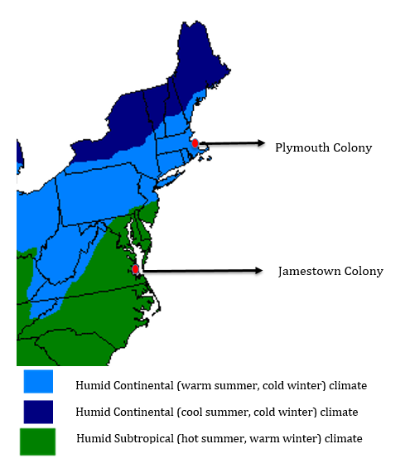
The map below shows the location of Plymouth and Jamestown in North America, along with the climate of each region.

Guiding Questions
What type of climate did Plymouth have?

_____________________________

_____________________________

_____________________________

_____________________________

What type of climate did Jamestown have?

_____________________________

_____________________________

_____________________________

_____________________________

Source M: “Growth of the Tobacco Trade”
Text | Vocabulary | Guiding Questions
Virginia's [and Jamestown’s] economic future was not with gold. There was too little gold to be found there. Looking for new ways to make money from the colony, the Virginia Company of London began encouraging multiple projects by 1618.  Jamestown settlers experimented with glassblowing, vineyard cultivation, and even silkworm farming. Despite efforts to find many ways to make money from the Virginia colony, by the end of the 1620s only one Virginia crop was drawing a fair market price in England: tobacco.  Tobacco was introduced to Europe by the Spanish, who had learned to smoke it from American Indians. Despite some early criticism of "drinking smoke," tobacco became popular among the middle classes in England. Much of the tobacco smoked in England was grown in the West Indies.  John Rolfe thought that Virginia might be an outstanding site for tobacco growth. Rolfe reacted to consumer demand by importing seed from the West Indies and cultivating the plant in the Jamestown colony. Those tobacco seeds became the seeds of a huge economic empire.  By 1630, over a million and a half pounds of tobacco were being exported from Jamestown every year. The tobacco economy rapidly began to shape the society and development of the colony.  Growing tobacco can harm the soil over time. Because tobacco drained the soil of its nutrients, only about three successful growing seasons could occur on a plot of land. Then the land had to lay fallow for three years before the soil could be used again. This created a huge drive for new farmland.  Settlers grew tobacco in the streets of Jamestown. The yellow-leafed crop even covered cemeteries. Because tobacco cultivation is labor intensive, more [laborers] were needed.  Indentured servants became the first means to meet this need for labor. In return for free passage to Virginia, a laborer worked for four to five years in the fields before being granted freedom. The Crown rewarded planters with 50 acres of land for every inhabitant they brought to the New World.  Naturally, the colony began to expand. That expansion was soon challenged by the Native American alliance called the Powhatan. | West Indies: islands in the Caribbean  John Rolfe: an English settler in Jamestown  demand: wanting something  nutrients: parts of soil needed for plant growth  fallow: land with nothing planted in it  indentured servants: mostly poorer white English men and women (but some Irish, Africans, and American Indians too) who signed contracts (or were tricked into signing) to be laborers for a set amount of time in exchange for land or passage to the New World  Powhatan: an alliance of indigenous Algonquian speaking people; the leader of this alliance was also called Powhatan | Why did the Virginia Company begin encouraging new ways to make the colony profitable?  _____________________________  _____________________________  _____________________________  _____________________________  _____________________________  _____________________________  _____________________________  _____________________________  _____________________________  How was John Rolfe involved in expanding the tobacco trade?  _____________________________  _____________________________  _____________________________  _____________________________  _____________________________  _____________________________  _____________________________  How did tobacco farming influence the demand for land and more workers?  _____________________________  _____________________________  _____________________________  _____________________________  _____________________________  _____________________________  _____________________________  _____________________________  _____________________________  How did colonial leaders find people to work in the tobacco fields?  _____________________________  _____________________________  _____________________________  _____________________________  _____________________________  _____________________________  _____________________________  _____________________________

Source N: Landing at Jamestown, 1619 Illustration from Harper’s Monthly Magazine (c. 1901)

This drawing shows Dutch sailors, who have captured enslaved people from a Spanish ship, negotiating a trade with the Jamestown settlers for food. The first enslaved people were brought to Jamestown in 1619. Slavery made the cultivation of tobacco and other cash crops profitable and made the Virginia colony and its investors very wealthy. Africans were forcibly brought to the New World on ships across the Atlantic Ocean, enduring brutal conditions and high rates of death.

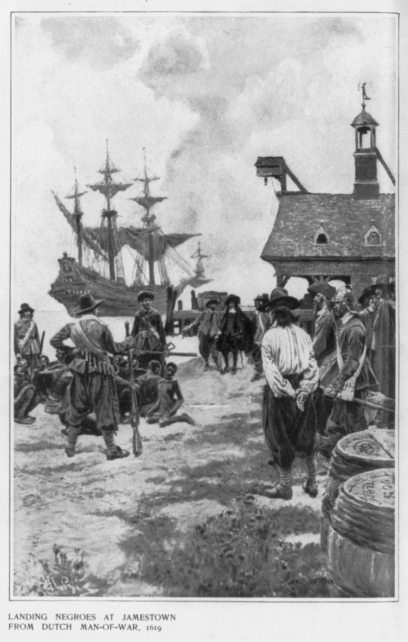

Guiding Questions
When were the first slaves brought to Jamestown? | _________________________________________________________  _________________________________________________________  _________________________________________________________  _________________________________________________________
Why did the colonists bring enslaved people to Jamestown?

After you read:

1. How did the humid subtropical climate of Jamestown affect what the colonists (and the people they forced to work for them) produced there?

2. How did growing tobacco influence the growth of slavery and indentured servitude in the colonies?

Lesson 6 – How did geography influence life and economic activities in the colonies?
Student Directions | Read and study Sources O, P, and Q then complete the guiding questions. Next, complete performance task #2 at the end of this lesson.
Featured Sources | Source O: Letter of Edward Winslow, 11 December 1621  Source P: Colonial Shipping, Salem  Source Q: Exports from the New England Colonies
Optional Digital Extensions | Guardians of Jamestown: 1619 – The First English Thanksgiving  The Pilgrims: The Beaver Trade and Colonial New England

When the Pilgrims and Puritans arrived in the New World in November, it was too late to plant crops. Many settlers died of malnutrition during the first winter. Of the 102 original Mayflower passengers, only 44 survived. Like in Jamestown, the cooperation and support from the local American Indians saved them from a frosty death.

By early 1621, the Pilgrims had built plain huts and a common house on the shores of Plymouth Bay. Soon neighboring Indians began to build relations with the Pilgrims Source O is written by Edward Winslow, a senior leader among the separatists who traveled on the Mayflower. In this letter to a friend, he describes their early interactions with the Wampanoag people, who he refers to as “Indians.”

Source O: Letter of Edward Winslow, 11 December 1621
Text | Vocabulary | Guiding Questions
We set the last spring some twenty acres of Indian corn, and sowed some six acres of barley and peas, and according to the manner of the Indians, we [enriched] our ground with herrings, which we have in great abundance. . . .  For three days we entertained and feasted with King Massasoit, with some ninety of his men, whom, and they went out and killed five deer, which they [gave to] our governor. . . .  We have found the Indians very faithful in their covenant of peace with us; very loving and ready to [delight] us: we often go to them, and they come to us; some of us have been fifty miles by land in the country with them. . . . | sowed: planted  manner: method  herrings: a type of fish common in waters around New England  King Massasoit: a leader of the Wampanoag people  covenant: agreement | How did the Wampanoag help the Pilgrims farm?  ______________________________  ______________________________  ______________________________  ______________________________  How does Winslow describe the Wampanoag?  ______________________________  ______________________________  ______________________________

Source P: Colonial Shipping, Salem

The economy of New England was based on fishing, whaling, the fur trade, and agriculture. New England traded these goods with the other colonies and exported them to Europe. The painting below shows a harbor in New England and boats being stocked with goods for export.

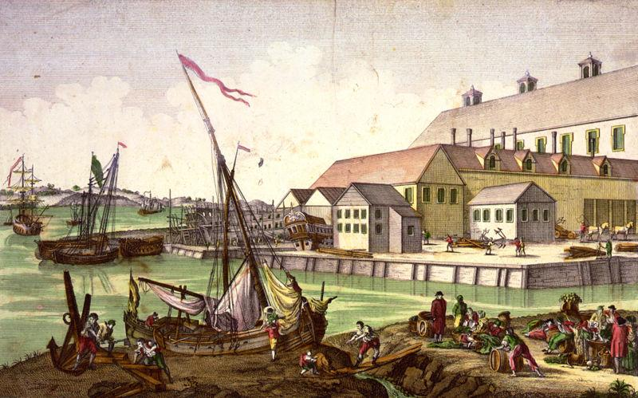

Guiding Question
Why did the Plymouth colonists suffer less hardship than the Jamestown colonists? | _________________________________________________________  _________________________________________________________
How was the Plymouth economy different from the Jamestown economy? | _________________________________________________________  _________________________________________________________

Source Q: Exports from the New England Colonies

This pie chart below shows the major exports of the New England Colonies that developed after the settlement of Plymouth. Their cold winters and continental climate made agriculture more difficult, but raising livestock, the fur trade, and fishing and shipping became important parts of the economy of New England.

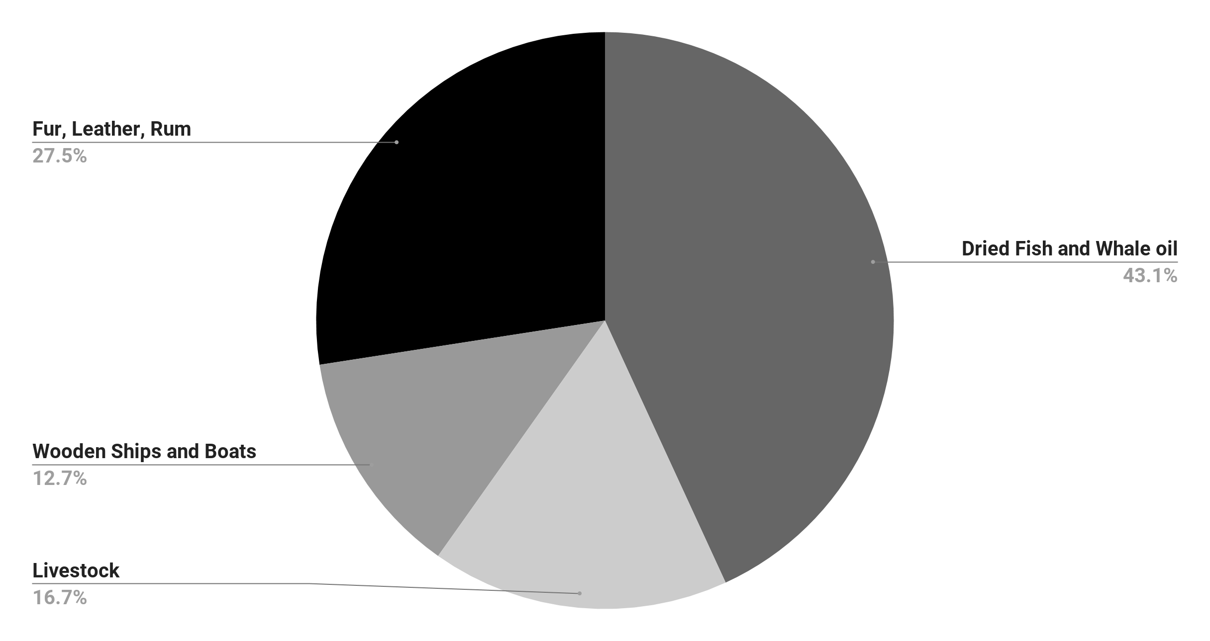

Guiding Question
How did the economy of the Plymouth colony reflect adaptation to the environment? | _________________________________________________________  _________________________________________________________  _________________________________________________________  _________________________________________________________  _________________________________________________________  _________________________________________________________

Formative Performance Task #2 – Constructed Response
Student Directions | Using the sources, write a paragraph describing how geography and climate affected economic development in BOTH Jamestown and Plymouth.

Lesson 7 – What were some of the negative effects of the colonization of North America by England?
Student Directions | Read Sources R, S, and T and complete the guiding questions in the right-hand columns. Next, study Source U and complete the after you read questions at the end of this lesson.
Featured Sources | Source R: “Colliding Cultures”  Source S: The Burning of Jamestown, Harper's Encyclopedia of United States History  Source T: Metacom 1676 (excerpts)  Source U: Population of peoples in North America – 1610 and 1700
Optional Digital Extension | NBC News Learn – King Philips War

Source R describes the relations between the Powhatan, a group of American Indian tribes who spoke a similar language, and the English colonies. The leader of the Powhatan, Wahunsenacawh, had assisted the first colonists at Jamestown in the earliest days of the colony when they were starving and in dire need of supplies.

Source R: “Colliding Cultures” (excerpted and adapted)
Text | Vocabulary | Guiding Questions
The Powhatan had kept the English alive that first winter in Jamestown. The Powhatan had welcomed the English and valued their metal ax-heads, kettles, tools, and guns, and eagerly traded furs and other abundant goods for them.  With ten thousand united natives and with food in abundance, the Indians had little to fear and much to gain from the isolated outpost of sick and dying Englishmen.  But soon the tobacco-growing colonists expanded beyond the bounds of Jamestown. When it became clear that the English were not merely content on maintaining a small trading post but sought a permanent ever-expanding colony, conflict with the Powhatan became almost inevitable.  Wahunsenacawh, leader of the Powhatan alliance, died in 1622 and was followed by his brother, Opechancanough, who promised to drive the land-hungry colonists back into the sea. He launched a surprise attack and in a single day (March 22, 1622) killed over 350 colonists, or one third of all the colonists in Virginia.  The colonists responded by attacking settlements and driving American Indians off their land. War and disease destroyed the Powhatan and tilted the balance of power decisively toward the English colonizers.  Despite their earlier starvation, and assistance from the Powhatan, English colonists nevertheless judged themselves physically, spiritually, and technologically superior to Indigenous peoples in North America. Christianity, metallurgy, intensive agriculture, and transatlantic navigation all magnified the English sense of superiority.  This sense of superiority, when coupled with outbreaks of violence, left the English feeling entitled to indigenous lands and resources. | abundant: plentiful, available in large amounts  content: the feeling  of happiness or satisfaction  inevitable: unavoidable, sure to happen  metallurgy: the art of shaping and creating items from metal | What did the English have that interested the Powhatan?  ______________________________  ______________________________  ______________________________  ______________________________  ______________________________  ______________________________  ______________________________  ______________________________  ______________________________  Why does the author think conflict between the colonists and Powhatan was inevitable?  ______________________________  ______________________________  ______________________________  ______________________________  How did the English colonists view themselves as compared to the American Indians they met in the New World?  ______________________________  ______________________________  ______________________________  ______________________________  ______________________________  ______________________________  ______________________________  ______________________________  ______________________________  ______________________________  ______________________________  ______________________________  ______________________________  _____________________________
Source S: The Burning of Jamestown, Harper's Encyclopedia of United States History

Early in Jamestown’s settlement, land went mostly to wealthy people who settled in villages and towns nearer to the eastern coastline. As the population of Jamestown grew, poorer people, many who had come to America as indentured servants, were forced to settle further inland on the western edges on the Virginia frontier, closer to American Indian settlements.

Guiding Questions
What did Bacon and other colonists want Jamestown’s government to do?

__________________________________

__________________________________

__________________________________

__________________________________

How did Bacon’s Rebellion affect American Indians?

__________________________________

__________________________________

__________________________________

__________________________________

__________________________________

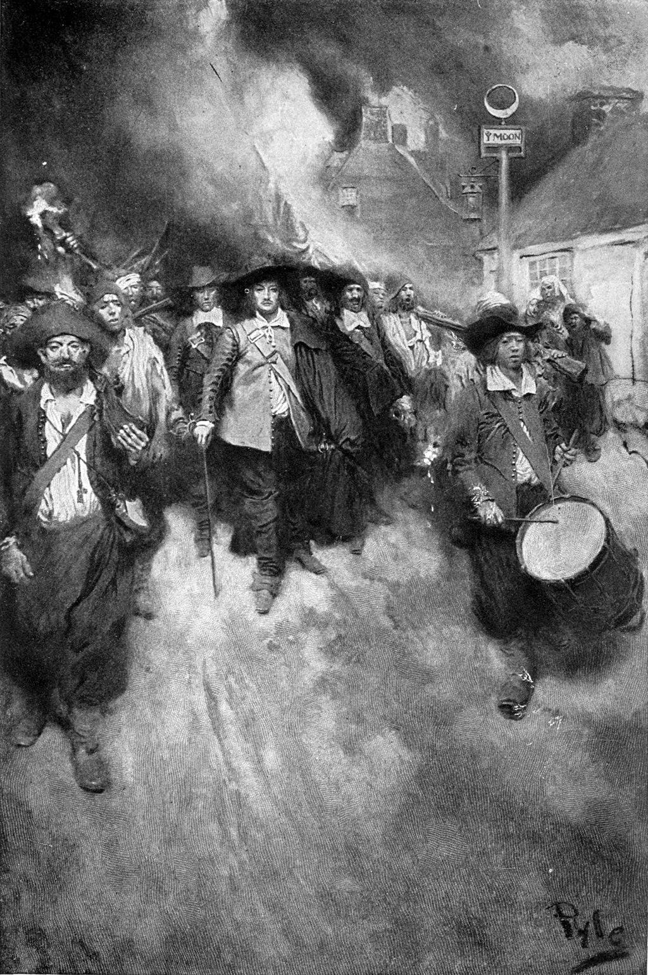
Nathaniel Bacon, a wealthy landowner began suggesting that more had to be done to rid the American Indians on the western frontier, and that the Jamestown government was not doing enough. He insisted on organizing armed militias to fight the Indians, outside official control. In response, the governor of Jamestown proclaimed him, and his militia army, rebels. In 1676, Bacon organized a large group of men to begin attacking and raiding American Indian settlements. The British government sent a navy fleet of 1,000 British soldiers to put down and control the rebellion. The image below shows a group of rebels, marching through a burning Jamestown.

Source T is an excerpt of a speech given by Metacom, a chief of the Wampanoag People.

Source T: Metacom (Wampanoag tribe) 1676 (excerpts)
Text | Vocabulary | Guiding Questions
The English who came first to this country were but a handful of people, forlorn, poor and distressed. My father did all in his power to serve them. Others came. Their numbers increased. My father’s counselors were alarmed.  They urged him to destroy the English before they became strong enough to give law to the Indians and take away their country. . . . He remained their friend.  Experience shows that his counselors were right. The English disarmed my people. They tried them by their own laws, determined amounts of fines for damages my people could not pay. Sometimes the cattle of the English would come into the cornfields of my people, for they did not make fences like the English. . . . My father's counselors advised him properly, he should have destroyed them when he had the chance. . . . | forlorn: lonely  give law: attempt to control  disarmed: having weapons removed | According to Metacom’s speech, what had happened to the population of English colonists?  ______________________________  ______________________________  ______________________________  ______________________________  ______________________________  ______________________________  How did the English colonists’ laws affect the Wampanoag tribe?  ______________________________  ______________________________  ______________________________  ______________________________  ______________________________  ______________________________

Source U: Population of peoples in North America —1610 and 1700

This table shows the population of English and Powhatan people living in Virginia in 1610 and 1700.

Estimated European Populations | 1610 | 1700
English in Virginia | 100 | 72,000
Estimated Indigenous Populations | 1610 | 1700
Powhatans | 15,000 | 1,000

After you read:

1. What do you notice about the changes in the population of Europeans and American Indians in North America between 1610 and 1700?

2. How did more English colonists affect the balance of power in the colonies?

Lesson 8 – What were some of the negative effects of the colonization of North America by England?
Student Directions | Read Source V and answer the guiding questions in the right-hand column. Next, study Sources W and X and complete the guiding questions below. Then complete the after you read questions at the end of this lesson.
Featured Sources | Source V: “The Growth of Slavery”  Source W: Number of Enslaved People Arriving in the Colonies  Source X: Timeline of Slavery in Colonial America

Source V: “The Growth of Slavery”
Text | Vocabulary | Guiding Questions
Africans were the immigrants to the British New World that had no choice in their destinations or destinies. The first Africans that arrived in Jamestown in 1619 on a Dutch trading ship were listed as indentured servants.  Despite the complete lack of a slave tradition in England, slavery gradually replaced indentured servitude as the chief means for plantation labor.  Virginia would become the first British colony to legally establish slavery in 1661, but slavery had existed in the colonies since 1619. Maryland and the Carolinas were soon to follow. Laws soon passed in these areas that condemned all children of African slaves to lifetimes in chains.  No northern or middle colony was without its slaves. From Puritan Massachusetts to Pennsylvania, Africans lived in bondage. The economics and geography of the North did not promote the need for slave importation like the South did. Therefore, the slave population remained small compared to their southern neighbors. While laws throughout the region recognized the existence of slavery, it was far less systematized. Slaves were more frequently granted their freedom, and opposition to the institution was more common, especially in Pennsylvania.  As British colonists became convinced that Africans best served their demand for labor, importation increased. By the turn of the eighteenth-century, enslaved Africans numbered in the tens of thousands in the British colonies. Before the first shots were fired at Lexington and Concord, they totaled in the hundreds of thousands. The cries for liberty by the colonial leaders that were to follow turned out to be merely white cries. | bondage: slavery  systematized: organized  Lexington and Concord: the first battle in the American Revolution | When did slavery start in the colonies?  ______________________________  ______________________________  ______________________________  ______________________________  ______________________________  ______________________________  ______________________________  Why was slavery more widespread in the South than in the North?  ______________________________  ______________________________  ______________________________  ______________________________  ______________________________  What does the author mean when they say, “the cries for liberty by the colonial leaders that were to follow turned out to be merely white cries?”  ______________________________  ______________________________  ______________________________  ______________________________  ______________________________  ______________________________  ______________________________  ______________________________  ______________________________  ______________________________

Source W: Enslaved People Arriving in the Colonies

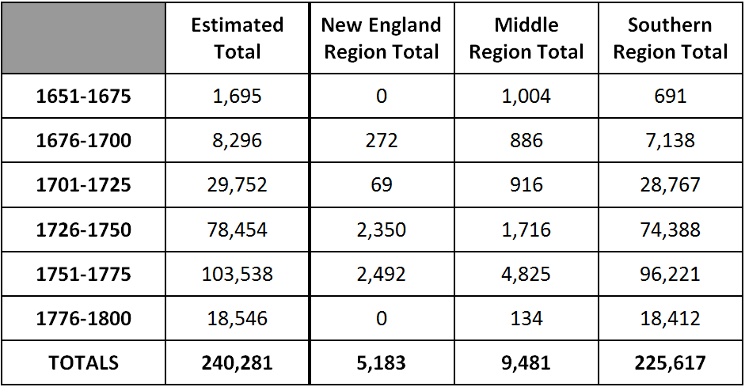

Guiding Questions
How did the population of enslaved people change from 1651–1750? | ___________________________________________________________  ___________________________________________________________
Why were Southern colonies more likely to use enslaved labor as shown in Source V? | ___________________________________________________________  ___________________________________________________________  ___________________________________________________________  ___________________________________________________________

Source X: Timeline of Slavery in Colonial America 1600 - 1705

Timeline of Slavery in Colonial America 1600 - 1705
1612 | The first commercial tobacco crop is raised in Jamestown, Virginia.
1619 | In Jamestown, Virginia, 20 captive Africans are sold into slavery.  They are classified as indentured servants.
1636 | First colonial slave trading ship is built in Massachusetts.
1640 | When three runaway indentured servants were captured, the General Court of Colonial Virginia gave the white servants additional years to serve while John Punch, a Black man, was sentenced to servitude for life. Some historians believe Punch may have been the first African in Virginia to be enslaved for life; other historians believe this occurred sooner, but there is not enough evidence from the time period to be certain.
1639 / 1640 | The General Assembly of Virginia specifically excludes  Black people from possessing firearms.
1641 | Massachusetts is the first state to legalize slavery.
1652 | Rhode Island passed laws restricting slavery and forbidding  enslavement for more than 10 years.
1662 | The General Assembly of Virginia decides that any child born to an  enslaved woman will also be enslaved.
1664 | The State of Maryland mandates lifelong servitude for all enslaved Black people. New York, New Jersey, the Carolinas, and Virginia all pass similar laws.
1705 | Virginia Slave codes decree that all slaves are considered property. Many other states follow and pass similar laws over the next 50 years.

Guiding Question
When does John Punch become the first person on record to be enslaved for life? | ___________________________________________________________  ___________________________________________________________

After you read:

What patterns do you notice on the restriction of freedoms of enslaved Black people between 1640 and 1705?

2. Based on Sources V, W, and X what claims can you make about slavery in the English colonies?

Formative Performance Task #3 – Constructed Response
Student Directions | Using the sources, write a paragraph that explains two negative consequences of the English colonization of North America.

Lesson 9 - Summative Performance Task
Student Directions | Based on the sources from this packet and your knowledge of social studies, write an essay answering the framing question: What influenced the development of the early English colonies?

__________________________________________________________________________________________

__________________________________________________________________________________________

__________________________________________________________________________________________

__________________________________________________________________________________________

__________________________________________________________________________________________

__________________________________________________________________________________________

__________________________________________________________________________________________

__________________________________________________________________________________________

__________________________________________________________________________________________

__________________________________________________________________________________________

__________________________________________________________________________________________

__________________________________________________________________________________________

__________________________________________________________________________________________

__________________________________________________________________________________________

__________________________________________________________________________________________

__________________________________________________________________________________________

__________________________________________________________________________________________

__________________________________________________________________________________________

__________________________________________________________________________________________

__________________________________________________________________________________________

__________________________________________________________________________________________

__________________________________________________________________________________________

__________________________________________________________________________________________

Name________________________________________________Date_______________
How did Ideas Influence the Founding
of the United States?
Introduction
Student Directions | Over the next two weeks, you will explore the sources in this packet to learn about the causes of the American Revolution, the ideas and ideals of the framers of the Constitution, and the structure and function of the U.S. government as outlined by the Constitution and the Bill of Rights. At the end of the packet, you will express your understanding by writing an extended response answering the following question: How did ideas influence the founding of the United States? This packet includes three supporting questions which will help you develop your claim on the ideas that influenced the American Revolution and the U.S. Constitution. After you read each text or analyze each image, you will be asked to answer questions about it. Some words are defined to help you better understand each source and answer the questions. Some sources have digital extensions, which are optional sources you can explore if you have internet access.

Lesson 1 – Setting the Context
Student Directions | Read Sources A and B and complete the guiding questions.
Featured Sources | Source A: North America, 1775  Source B: “Cantonment of the forces in North America” 1765

Source A: North America, 1775

In 1763, Great Britain and France signed a peace treaty, ending their seven-year war, much of which was fought in North America. As a result, France gave most of its territory in North America to Great Britain, including Quebec and the Ohio River Valley. The war was extremely costly for Great Britain, who had to send soldiers across the Atlantic Ocean to fight the French and their Indigenous allies (partners). The newly won territory was appealing to colonists, but the British feared conflict with scattered French settlers and Indigenous people would ignite another costly conflict. In 1763, the English king, George III, issued a royal proclamation (statement) that colonial settlements would only be allowed east of the Appalachian Mountains (shown as a dotted line below).

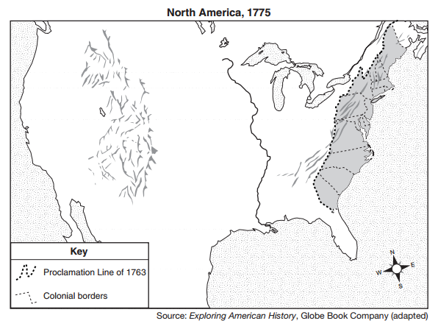
Quebec

Ohio River Valley

Guiding Questions
What did King George III’s proclamation of 1763 hope to accomplish?

Source B: Cantonment of the forces in North America (1765)

Despite the tough language of the King George III’s proclamation of 1763, the British couldn’t, or wouldn’t, enforce the rule. Settlers continued to move into the region, returning to old towns and building new ones. Many wealthy colonists, like George Washington, believed that King George would never succeed in keeping settlers out of that region; many others felt annoyed or threatened by Britain's heavy-handed intervention in colonial affairs. In many ways, then, the Proclamation Line can be considered the first of Britain's laws, or policies, that would put the colonies on the path to independence. The map below shows the colonies, and the land “reserved” for American Indians, along with the number of soldiers stationed, represented by rectangular boxes.
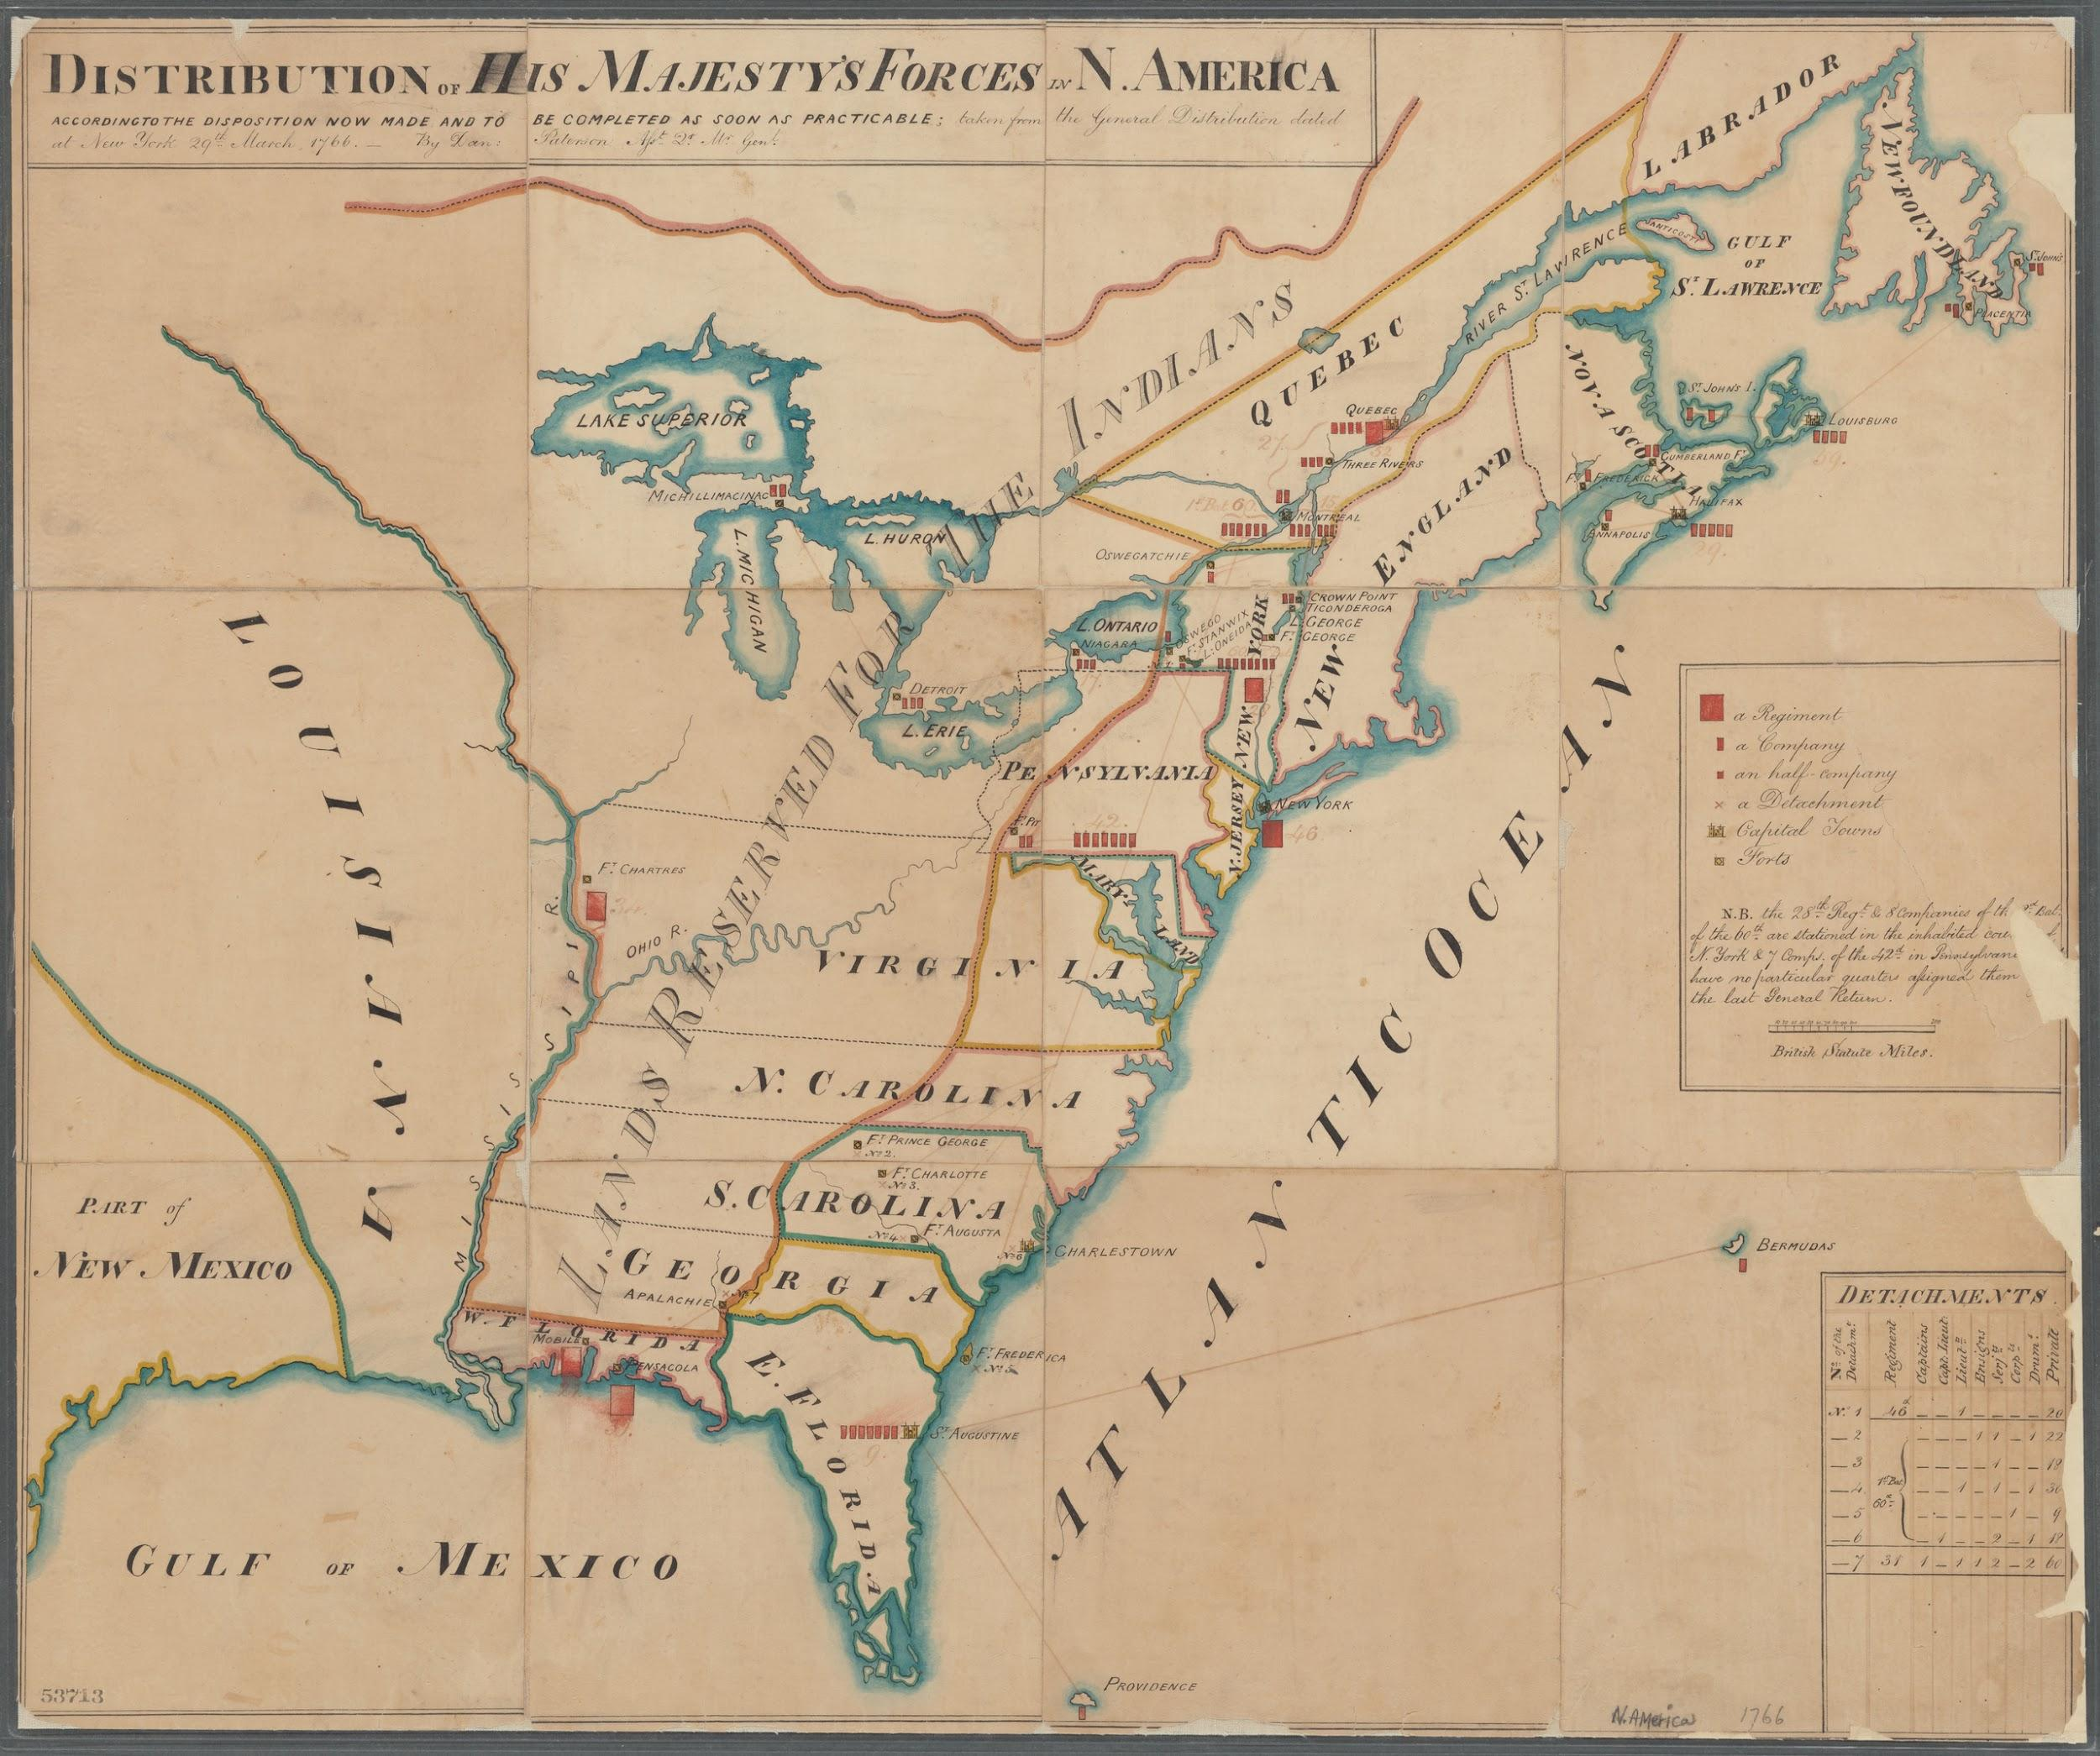

Proclamation Line of 1763
Ohio River
Ohio River Valley

Guiding Questions
How did colonists react to King George’s Proclamation of 1763?

Lesson 2 – Setting the Context
Student Directions | Read documents 1–5 in Source C and complete the guiding questions.
Featured Sources | Source C: Document Bank: British Colonial Policies
Optional Digital Resources | NBC News Learn – The Stamp Act

Source C: Document Bank: British Colonial Policies

Source C is a collection of images and texts about British policies, or laws, that affected people living in the Thirteen Colonies. These laws were passed by the British Parliament, a legislative, or law-making group, that governed Great Britain and its colonies along with King George III.

Document 1 – Stamp Act
Text | Vocabulary
The Stamp Act was passed by the British Parliament on March 22, 1765. The new tax was imposed on all American colonists and required them to pay a tax on every piece of printed paper they used. Ship's papers, legal documents, licenses, newspapers, and playing cards were taxed. The money collected by the Stamp Act was to be used to help pay the costs of defending and protecting the American frontier near the Appalachian Mountains (10,000 troops were to be stationed on the American frontier for this purpose).  The actual cost of the Stamp Act was fairly small. What made the law so insulting to the colonists was not so much its cost but the standard it seemed to set. In the past, taxes on colonial trade had always been viewed as measures to control trade, not to raise money. The Stamp Act, however, was viewed as a direct attempt by England to raise money in the colonies without the approval of the colonists. | Imposed: force something unwelcome to be accepted or put in place

Guiding Questions
Why did British Parliament pass laws like the Stamp Act?

How did colonists react to the Stamp Act?

Document 2 - The Navigation Act

The cartoon below details some of the specific restrictions Great Britain put on the 13 colonies through the Navigation Acts. These restrictions were generally designed to increase British profits, at the expense and liberty of colonial merchants (people who buy and sell goods). The restrictions included forcing the colonists to only sell exported goods to Great Britain and forbid the production of goods that would compete with manufacturers in Great Britain. The person speaking represents the British point of view.

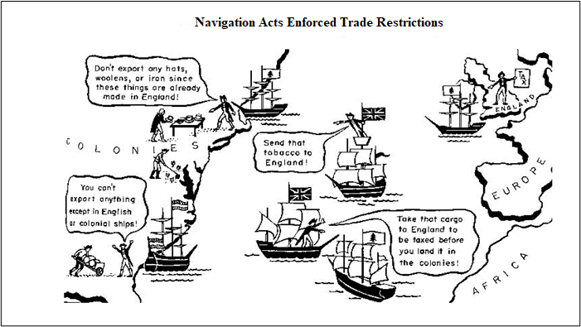

Guiding Questions
What type of restrictions did the Navigation Act place on English colonies in North America, and why?

Document 3 – The Quartering Act
Text | Vocabulary
During the French and Indian War, British military commanders in North America often found it difficult to convince some colonies to pay for the costs of housing and supplying food for the soldiers sent over to fight the French. Once the war had ended, the king’s advisors decided that some British troops should remain in North America, to defend colonists from further attacks. The Quartering Act of 1765 required colonial governments to provide and pay for feeding and sheltering any troops in their colony. If enough barracks were not made available, then soldiers could be housed in inns, stables, or private homes that sold goods. American colonists disliked and opposed the Quartering Act of 1765 because they were also being taxed by the colonial governments to pay for food and barracks for the army.  Many American colonists saw the Quartering Act as another way Parliament was taxing them without their consent. Many suspected that the real purpose of keeping a small army in America—stationed in cities, not on the frontier—was not for defense, but to make sure the new British policies and taxes were obeyed. They felt threatened by the British army always being in the colonies, fearing that the army might randomly attack or harass them. | barracks: a building or group of buildings used to house soldiers  consent: permission for something to happen or agreement to do something

Guiding Questions
What was Britain’s reason for having soldiers in North America?

How did colonists react to the Quartering Act?

Document 4 – Landing of the Troops by Paul Revere and Christian Remick

Paul Revere engraved this view of the 1768 landing of the British troops in Boston. The troops were sent to subdue the protests and turmoil following the passage of the Townshend Acts, which were another set of taxes on the colonists that replaced the Stamp Act. Colonists were angry that the British were trying to raise revenue through taxes. The British King and Parliament felt it was necessary to pay for their expenses in the colonies, such as keeping soldiers there to secure lands and trading posts.
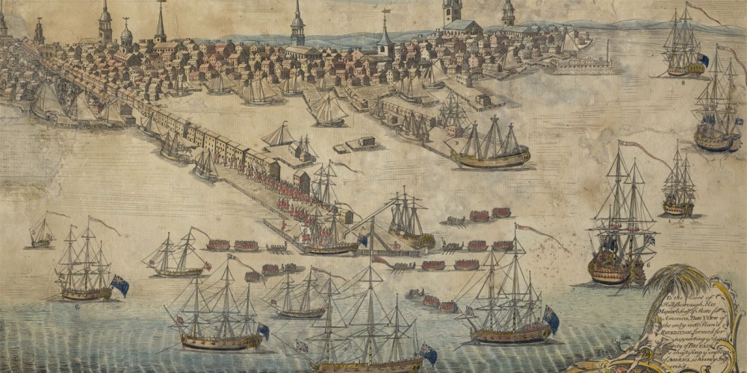

After you read
Why did Great Britain increase the number of soldiers stationed in the colonies?

Lesson 3 – Setting the Context
Student Directions | Read and study documents 1–5 in Source D and complete the guiding questions. Next, complete the after you read questions at the end of this lesson.
Featured Sources | Source D: Document Bank: Colonial Responses
Optional Digital Resources | TedEd – The Story of the Boston Tea Party

Source D: Document Bank: Colonial Responses

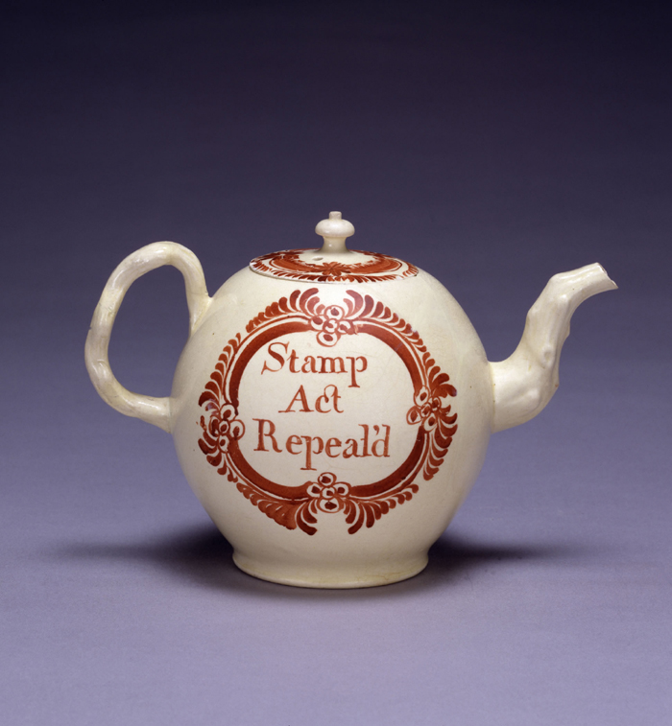
Source D is a collection of images and texts that illustrate the variety of colonial responses to British policies. Patriots, as the anti-British rebels were known, engaged in a wide variety of protests against Great Britain. A patriot is someone who supports their country and is prepared to defend it. During the years right before the American Revolution, a patriot was a colonist who supported the colonies breaking away from Britain to start a new country.
Document 1 – Colonial Teapot
Text | Vocabulary
The colonists took many actions to protest British tax policies, including boycotting specific taxed goods, forming committees, or groups to organize themselves. Colonists made their opinions known by buying and displaying items that clearly showed their position for or against Parliaments actions. This teapot celebrates the end of the Stamp Act which parliament repealed in 1786. | boycotting: the act of refusing to buy goods as a form of protest  repealed: cancelled, removed
Guiding Questions
How does the teapot shown in the image support colonial protests against British taxes?

Document 2 - The Boston Massacre
Text | Vocabulary | Guiding Questions
The tension between the colonists and British had been rising for years and reached a peak following the French and Indian War. The Proclamation of 1763 prevented colonists from moving west into the Ohio River valley, an area of the new world ripe with natural resources that colonists wanted to take advantage of. Further angering the colonists, the British Parliament raised taxes to pay for the costs of the war and future protection of the colonies. After the passage of the Sugar Act (1764), the Quartering Act (1764), the Stamp Act (1765), and the Townshend Acts (1767), colonists became fed up.  The taxes on everyday goods and services were very high and making ends meet was becoming very difficult for colonists. The colonists were paying taxes to a British monarchy and parliament in which they had no representation or voice. The phrase, “No taxation without representation!” spread like wildfire. The taxes caused riots in Boston and other major American cities. These riots led to customs officials to demand additional protection from the British government. Four additional British regiments of soldiers arrived in the colonies in 1768, making the colonists feel threatened and the British feel like they had greater control over the colonists.  In Boston, where the most unrest was taking place, colonists felt there were too many British troops there to monitor them and keep order: there were 4,000 troops to control a population of only 20,000 colonists. People in Boston called the British troops “lobster backs” because they wore red coats. Crowds constantly booed and harassed the troops. On March 5, 1770, the colonists and British troops clashed in what is now called the Boston Massacre. | riots: a violent disturbance of the peace by a crowd  customs officials: a person whose job is to make certain travelers are not taking goods into a country without paying taxes | Why did the phrase “no taxation without representation” become popular in the colonies?  What caused Great Britain to send additional troops to the colonies in 1768?

Document 3 – Crispus Attucks

Cripus Attucks was a Black longshoreman (dock worker at a port) in Boston and is widely believed to be the first person killed in the Boston Massacre, and therefore, the first American killed in the American Revolution. Attucks, like others who worked on the docks, competed with the British troops for work. British soldiers stationed in Boston often took part-time jobs during their off-duty hours and worked for lower wages. Attucks was a fugitive from slavery, escaping to Boston many years before the massacre. Attucks’s reputation has changed over time, from a troublemaking villain to hero and patriot who died in the name of the new nation of America.
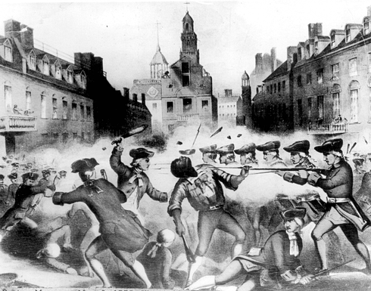

Guiding Questions
What caused conflict between dockworkers and British soldiers stationed in Boston?

Document 4 – “The Bloody Massacre Perpetrated in King Street, March 5th, 1770”, Paul Revere (1770)

The image below was created by Bostonian Paul Revere. Paul Revere was a famous American colonist and a leader in the movement for American independence. Revere was an original founding member of a rebellious group of American colonists fighting for freedom from Great Britain called the Sons of Liberty. Originally produced as a woodblock engraving, it was copied and spread throughout the colonies in 1770. It appeared in many colonial newspapers, brochures, and pamphlets to illustrate the cruelty of the British government and to gain support for the revolutionary movement.

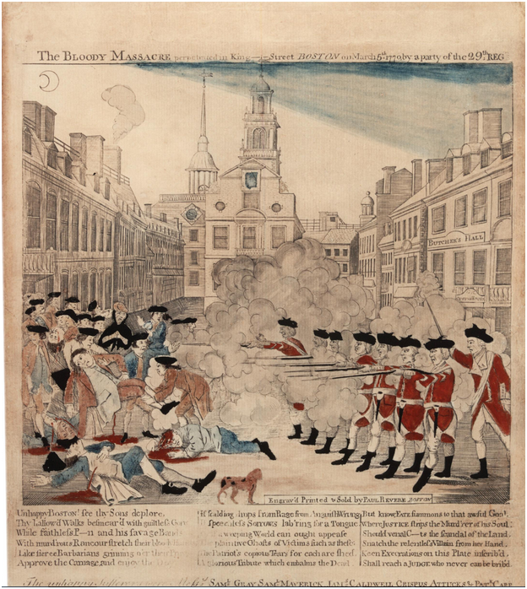
Document 5 - The Boston Tea Party
Guiding Questions
Who made this print? How could his background and beliefs impact how he represented the incident?

How do you think colonists in 1770 would have reacted to this image of the Boston Massacre?

The Boston Tea Party was a political protest by the Sons of Liberty in Boston, Massachusetts, on December 16, 1773. Some colonists strongly opposed the taxes in the Townshend Act as a violation of their rights. Demonstrators, some disguised as American Indians, destroyed an entire shipment of British tea. They boarded the ships and threw the chests of tea into the Boston Harbor. The British government responded harshly by passing the Coercive Acts which closed Boston Harbor, further raising tensions in the colonies.

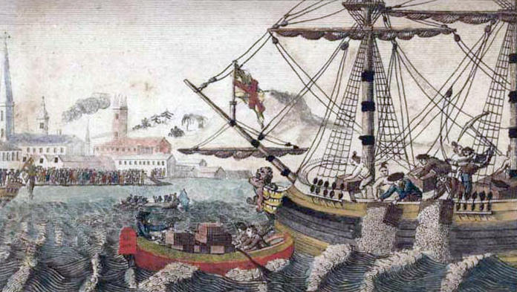

Guiding Questions
What was the Boston Tea Party? How did British leaders respond?

Document 6 -The Battle of Lexington by John H Daniels and son

On April 19, 1775, British soldiers set out to seize colonial weapons in Lexington and Concord. A group of armed townspeople, called a militia, met them at a field in Lexington. The British ordered them to leave when someone fired, setting off the clash. The battle continued all the way to the next town, Concord. News of the events at Lexington spread rapidly throughout the countryside. Militia members, known as minutemen, responded quickly and inflicted significant injuries on the British as they chased them back to Boston. Approximately twenty thousand colonial militiamen surrounded Boston, effectively trapping the British.

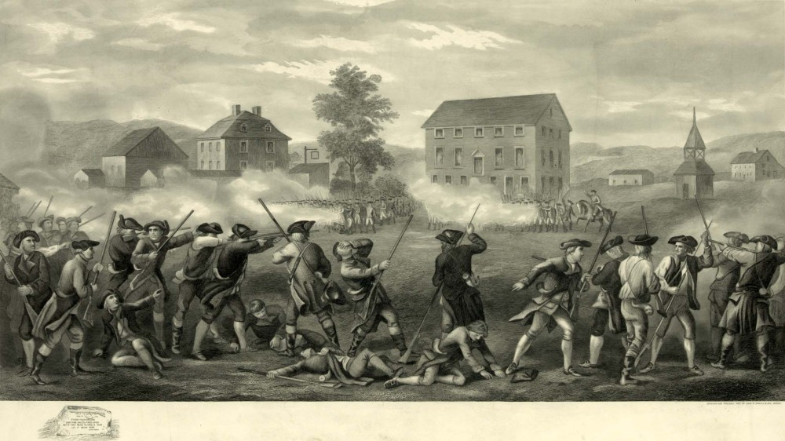

Guiding Questions
Why did the colonists and Great Britain start fighting at Lexington and Concord?

Lesson 4 – What did the Declaration of Independence actually declare?
Student Directions | Read Sources E, F and G while completing the guiding questions.
Featured Sources | Source E: Second Continental Congress  Source F: Background on the Declaration of Independence  Source G: The Declaration of Independence: Preamble

Source E describes how colonial leaders responded to fighting with the British at Lexington and Concord, and the rising tensions between the colonies and Great Britain.

Source E: “Second Continental Congress”
Text | Vocabulary | Guiding Questions
Times had taken a sharp turn for the worse. Lexington and Concord had changed everything. When the Redcoats fired into the Boston crowd in 1775 during the Boston Massacre, many colonists did not see it as a reason to go to war. Now the professional British army was attempting to arrest patriot leaders, and militiamen had been killed in their defense. In May 1775, with Redcoats once again storming Boston, the Second Continental Congress met in Philadelphia. The questions were different this time. First and foremost, how would the colonist meet the military threat of the British. It was agreed that a Continental army would be created. The Congress decided George Washington of Virginia should be the supreme commander (army leader).  On June 7, 1776, Richard Henry Lee introduced a resolution to the Congress that declared the thirteen colonies "free and independent states." A vote was set for early July. In the meantime, it seemed that some sort of explanation was in order for such a bold act. A group of five people, including Benjamin Franklin, John Adams, and Thomas Jefferson, were selected to choose the careful wording, and write the Declaration of Independence. Such a document must be convincing to a great many parties. The five agreed that Jefferson was the most talented writer, and would take the lead. | Redcoats: a nickname given to British soldiers by colonists  Second Continental Congress: the second meeting of delegates, or representatives from the colonies.  Continental army: title of the army raised by the 13 colonies to fight Britain  independent: free from outside control | Why did colonial leaders meet again, in the Second Continental Congress?  Who would lead the newly created continental army?  Who worked on drafting the Declaration of Independence?  ______________________

Source F: Background on the Declaration of Independence
Text | Vocabulary
The Declaration of Independence was adopted by the Second Continental Congress in Philadelphia on July 4, 1776. The document announced that the thirteen American colonies were at war with the Kingdom of Great Britain, and that they regarded themselves as a newly independent nation. The document has four main parts—an introduction or preamble that outlines a general idea of government, an indictment or list of particular charges or grievances against the King of England, and finally a denunciation that made the case for independence. | preamble: an introduction or opening  indictment: an accusation, a claim of wrongdoing  grievances: a list of complaints  denunciation: a public disapproval of someone or something

Guiding Questions
What did the Declaration of Independence announce?

According to Source F, what are the four parts of the Declaration of Independence?

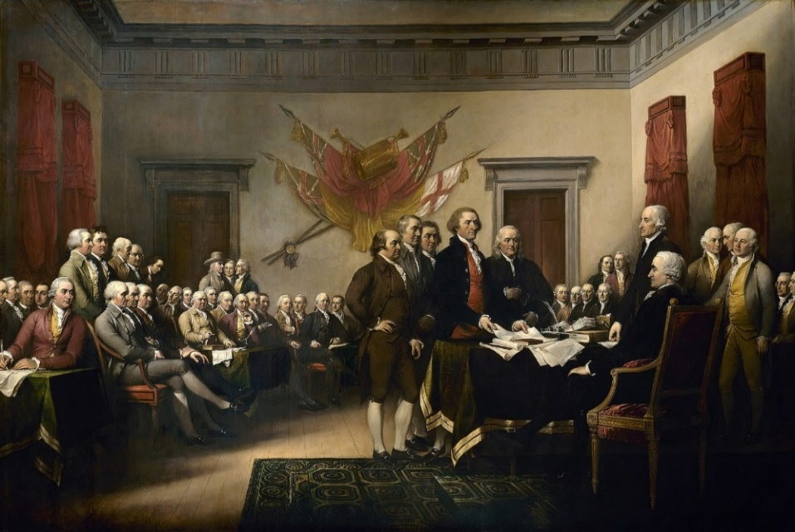
This painting by John Trumbull depicts the signing of the Declaration of Independence.

Source G is the introduction, or preamble of the Declaration of the Independence. The preamble contains many important claims about the nature of man, and a just government. A claim is a statement of belief or opinion that is supported with evidence.

Source G: Declaration of Independence: Preamble
Text | Vocabulary
We hold these truths to be self-evident, that all men are created equal, that they are endowed by their Creator with certain unalienable Rights, that among these are Life, Liberty and the pursuit of Happiness.--That to secure these rights, governments are instituted among men, deriving their just powers from the consent of the governed, --That whenever any form of government becomes destructive of these ends, it is the Right of the People to alter or to abolish it, and to institute new Government, laying its foundation on such principles and organizing its powers in such form, as to them shall seem most likely to effect their Safety and Happiness... | self-evident: obvious  unalienable: that which can’t be taken away or denied  institute/instituted: start/started  deriving: receiving  consent: to give approval  abolish: to end or overthrow

Guiding Questions
What claim does the Declaration of Independence make about equality?

What are the three unalienable rights listed in the preamble of the Declaration of Independence?

Who does the Declaration of Independence claim that governments get their powers from?

According to the preamble, when do people have the right to abolish (get rid of) their government?

Lesson 5 – What did the Declaration of Independence actually declare?
Student Directions | Read Sources H and I and complete the guiding questions.
Featured Sources | Source H: Declaration of Independence: Grievances  Source I: Declaration of Independence: Denunciation

Source H is a section of the Declaration of Independence that lists the grievances, or specific complaints the colonists have with King George III and Parliament.

Source H: Declaration of Independence: Grievances
Text | Vocabulary
Wisdom, indeed, will dictate that governments long established should not be changed for light and simple causes; But when a long train of abuses...reduce the people to live under absolute despotism, it is their right, it is their duty, to throw off such government, and to provide new protection for their future security. — Such has been the patient suffering of these colonies... The history of the present King of Great Britain is a history of repeated injuries and he has as a direct resulted established an absolute tyranny over these states.  To prove this, let facts be submitted to the world.  - He has kept among us, in times of peace, standing armies without the consent of our legislature;  - He has allowed the military to act independent of any laws, doing as they please to reign terror over our us;  - He has cut off our trade with all parts of the world;  - He imposes taxes on us without our consent;  - He deprives us, in many cases, of the benefits of trial by jury...and instead throws us in jail or sentences colonists to death. | grievances: reasons for protest  dictate: to command  abuses: mistreatments  despotism: the exercise of power in a cruel and oppressive way  tyranny: cruel and oppressive government rule

Guiding Questions
According to the Declaration of Independence, what are some of the reasons that the colonists have chosen to declare independence?

Source I is a section of the Declaration of Independence that both explains the colonists’ disapproval of King George III and announces the colonies independence from Great Britain.

Source I: Declaration of Independence: Denunciation
Text | Vocabulary
In every stage of these oppressions We have petitioned for help….Our repeated petitions have been answered only by repeated injury and abuse. A Prince, whose character is thus marked by every act which may define a tyrant, is unfit to be the ruler of a free people...We have reminded them of the circumstances and reasons of our settlement here...They too have been deaf to the voice of justice... We must, therefore...which announce our Separation from Great Britain.  We, therefore, the representatives of the United States of America... do…. declare, that these united colonies are, and of right ought to be free and independent states; that they are separated from all allegiance to the British Crown, and that all political connection between them and the state of Great Britain, is and ought to be totally dissolved; and that as free and independent states, they have full power to levy war, conclude peace, contract alliances, establish commerce, and to do all other acts and things which independent states may of right do. | oppressions: cruel treatment over a long period of time  petition: to write a list of requests & explain the reasons for these requests in a document; usually it is presented to a government  tyrant: a cruel or unjust ruler  allegiance: loyalty  dissolved: removed, closed down

Guiding Questions
What have colonists done before this Declaration of Independence to address their concerns?

Explain the most likely reason the colonists named the document the “Declaration of Independence.”

Lesson 6 – What did the Declaration of Independence actually declare?
Student Directions | Read Sources J and K and complete the guiding questions. Next, complete performance task #1 at the end of this lesson.
Featured Sources | Source J: Abigail Adams to John Adams – March 31st 1776  Source K: Consequences of the Revolution

After declaring independence, the colonies fought a seven-year war against Great Britain called the Revolutionary War. Men and women together struggled through years of war and hardship. For patriots, the end of the war brought new political, social, and economic opportunities. Despite these important changes, the American Revolution had its limits. The Revolution did not result in political equality for women. Source J is an excerpt of a letter written by Abagail Adams, wife to John Adams. In this letter, she reminds her husband to “remember the ladies” when working on the set of laws that would set up a new government for colonies.

Source J: Abigail Adams to John Adams – March 31st 1776
Text | Vocabulary
I long to hear that you have declared independence from England -- and by the way in the new Code of Laws which I suppose it will be necessary for you to make I desire you would remember the Ladies, and be more generous and favorable to them than your ancestors. Do not put such unlimited power into the hands of the Husbands. Remember all Men would be tyrants if they could. If particular care and attention is not paid to the Ladies we are determined to foment a Rebellion, and will not hold ourselves bound by any Laws in which we have no voice, or Representation. | Code of Laws: Abigail is referring to the new set of set of laws that will create a new government for the colonies  foment: start

Guiding Questions
What does Abigail Adams say women will do if “unlimited power is pushed into the hands of the husbands?”

Source K: Consequences of the Revolution
Text | Vocabulary
In 1783, thousands of formerly enslaved Loyalists fled with the British army. They hoped that the British government would uphold the promise of freedom and help them establish new homes elsewhere in the Empire. The Treaty of Paris, which ended the war, demanded that British troops leave formerly enslaved people behind, but the British military commanders kept earlier promises and evacuated thousands formerly enslaved people, transporting them to Canada, the Caribbean, or Great Britain.  The fight for liberty led some Americans to free their enslaved laborers, and most of the new northern states soon passed laws that would gradually end slavery. Some enslaved people were freed in the Upper South, but in the Lower South, some enslavers forced freed people back into slavery. In the long term, the Revolution failed to settle the tension between slavery with the new idea of equality that the Declaration of independence claimed is “self-evident.” | Loyalists: colonists who wanted to remain a British colony during the Revolutionary War. Some enslaved people had fought for England under the promise they would win their freedom.  self-evident: obvious

Guiding Questions
How did the Thirteen Colonies’ freedom from the British affect enslaved people?

In this formative performance task, you will be asked to identify two claims made in the Declaration of Independence. A claim is a statement of belief or opinion that is supported with evidence.

Formative Performance Task #1 – Constructed Response
Student Directions | Based on the sources, write a paragraph that explains two claims made in the Declaration of Independence.

Lesson 7 – What ideas influenced the authors of the United States founding documents?
Student Directions | Read Sources L and M and complete the guiding questions. Next, complete the after you read questions at the end of this lesson.
Featured Sources | Source L: “Constitutional Convention”  Source M: Portrait Bank: The Framers

Source L: Constitutional Convention

After winning independence in 1783, the colonies now had to create and carry out a new system of government. In 1787, a group of colonial leaders met in Philadelphia to draft that system under a new set of rules called the Constitution. This meeting was called the Constitutional Convention. These individuals, called the framers, and sometimes the Founding Fathers, were generally wealthy, white, land-owning men, many of whom also owned enslaved people. The framers had in enormous influence on the founding documents of the United States, including the Declaration of independence, the Constitution, and the Bill of Rights.
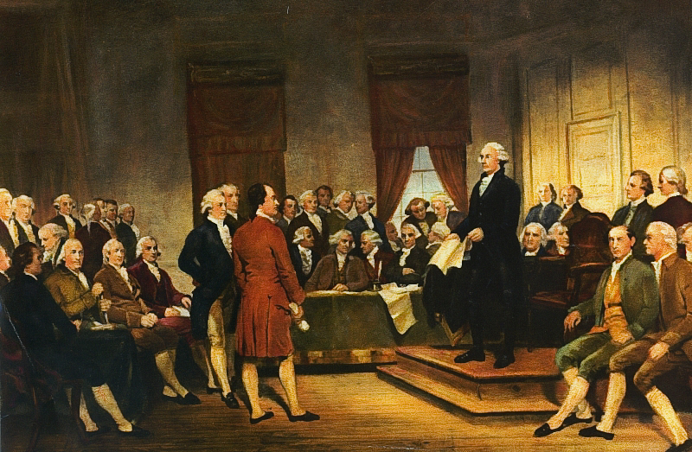

Guiding Questions
Who does the term “framers” apply to?

Source M: Portrait Bank: The Framers

The Framers are defined as those 55 individuals who were appointed to be delegates (members) to the 1787 Constitutional Convention and took part in drafting the proposed Constitution of the United States. Of the 55 Framers, only 39 were signers of the Constitution. Source M gives some information on six of the individuals who made major contributions to the documents that founded the United States.

Portrait 1 – James Madison

James Madison was born in 1751 in the Colony of Virginia to a wealthy family who owned large farms worked by enslaved people. He was a lawyer and also served as a member of the Virginia House of Delegates and the Continental Congress. He is known as the “Father of the Constitution” because he played a critical role in drafting the U.S. Constitution and the Bill of Rights.
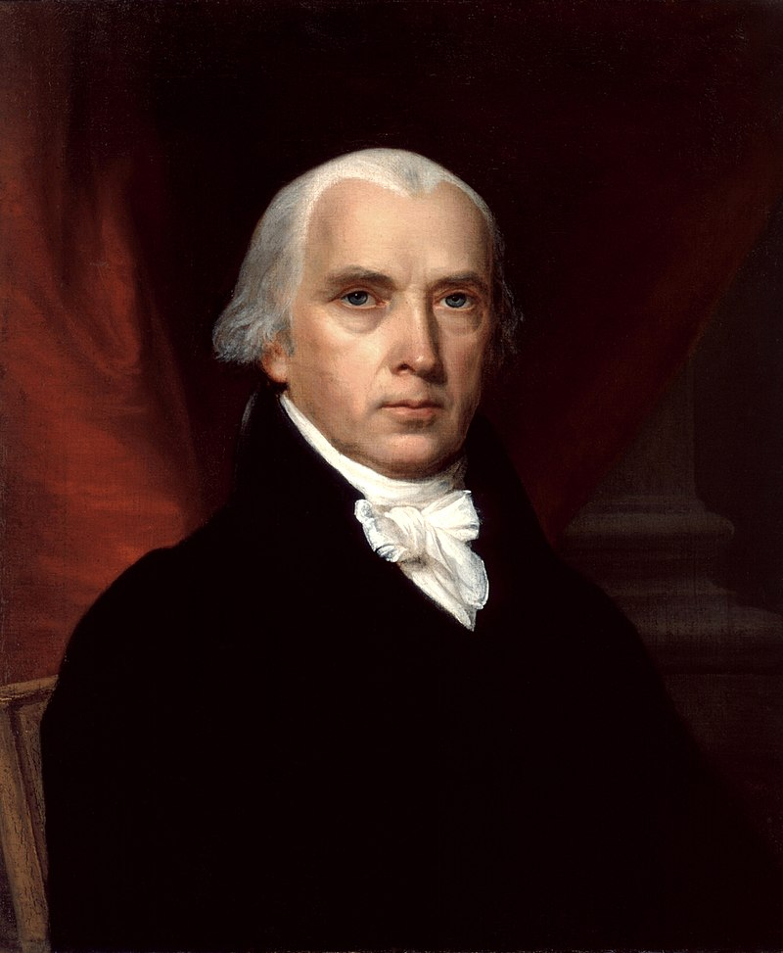

Portrait 2 – Alexander Hamilton

Alexander Hamilton was born on January 22, 1755 or 1757—historians don’t know the exact year—in Nevis, which is a small island in the Caribbean Sea. He became an orphan as a child and was taken in by a rich merchant family who recognized his intelligence and talent and sponsored him to attend college at King’s College (now Columbia University). After graduating, he stayed in the Thirteen Colonies to make a life for himself. He was an influential promoter of the U.S. Constitution. He favored a strong central government and a strong executive branch.

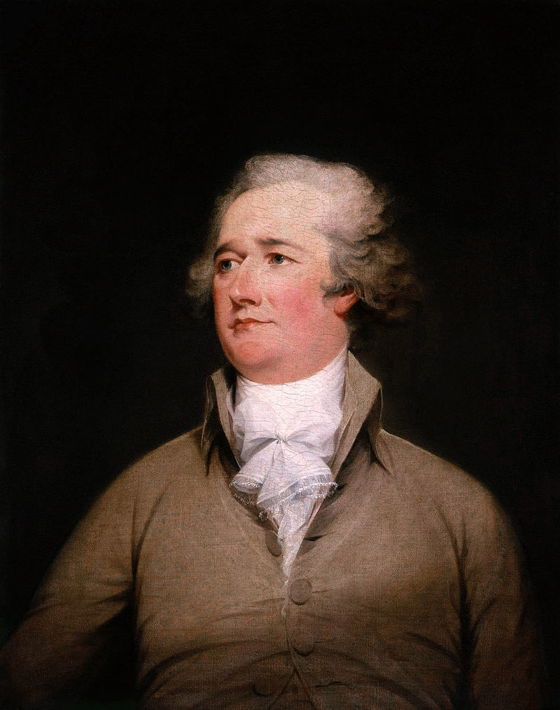

Portrait 3 – Thomas Jefferson

Thomas Jefferson was born on April 13, 1743, in the Colony of Virginia to a wealthy family who owned farms worked by enslaved people. He studied law at the College of William and Mary and was the Virginia representative at the Continental Congress that adopted the Declaration of Independence. He served as Governor of Virginia during the American Revolution and drafted laws on religious freedom.

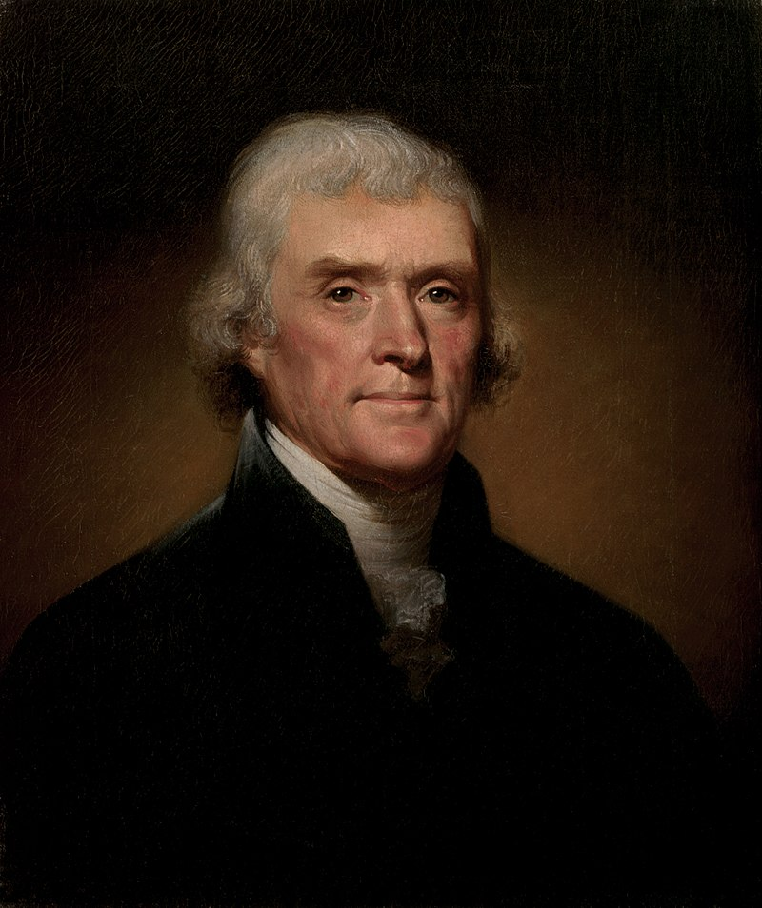

Portrait 4 – James Monroe

James Monroe was born in 1758 in the Colony of Virginia to a wealthy family who owned farms worked by enslaved people. He fought in the American Revolution and was injured. He studied law under Thomas Jefferson and served as a delegate in the Continental Congress. Monroe opposed confirmation of the Constitution because he believed it gave too much power to the central government.

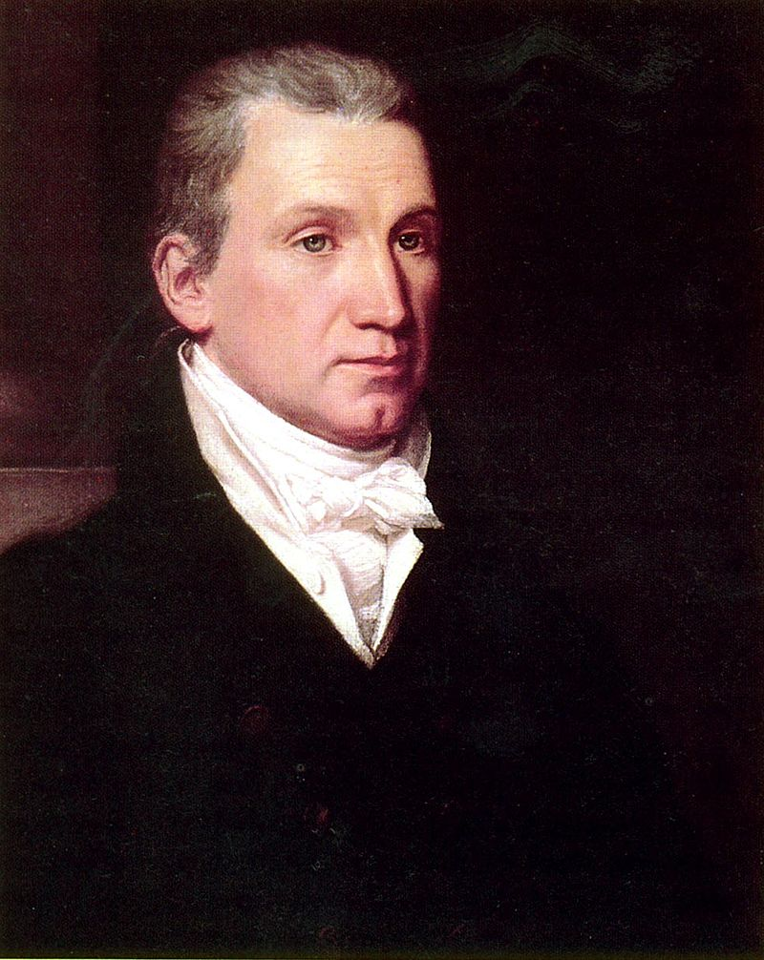

Portrait 5 – George Washington

George Washington was born on February 22, 1732, in the colony of Virginia to a wealthy family who owned tobacco plantations and enslaved laborers, which he inherited. He was a senior officer in the colonial militia during the French and Indian War.He was the commander-in-chief of the Continental Army during the American Revolution, winning the war against the British. After the American Revolution, he was elected the first president of the United States. As president, George Washington promoted bipartisanship (political parties working together), a well-financed and debt-free national government, and not entering foreign wars.
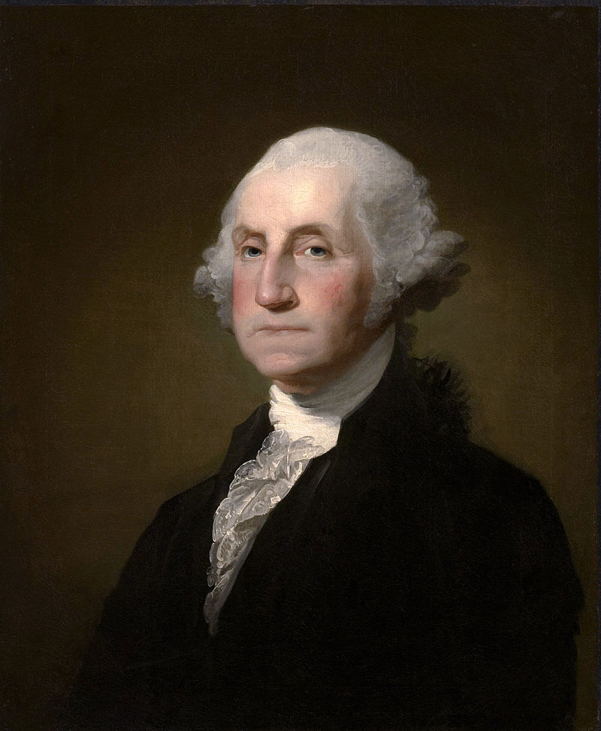

After you read:

What does it mean to be a framer of the constitution?

What skills might these framers have that helped them lead a new nation? What about their pasts might have hindered them?

What are some similarities between these framers?

Lesson 8 – What ideas influenced the authors of the United States founding documents?
Student Directions | Read Sources N, O, and P and complete the guiding questions. Next, complete the after you read questions and performance task #2 at the end of this lesson.
Featured Sources | Source N: “The Ideas at the Heart of the United States Government”  Source O: “Principles of American Government”  Source P: 3 Branches of Government Graphic Organizer

Source N: The Ideas at the Heart of the United States Government
Text | Vocabulary
After the colonies separated from the British monarchy and formed the United States of America, they had to answer some important questions:  - If not a monarchy, what type of government was the United States going to have?  - What kind of government was going to protect the people without violating their individual liberties?  The Framers decided to create a limited government based on ideas of natural rights and popular sovereignty. We can see some of these ideas in the foundational documents of the United States, including the Declaration of Independence and the Constitution.  What is a limited government?  Limited government is a political system in which there are certain restrictions placed on the government to protect individual rights and liberties. This decision to create a limited government was a deliberate departure from the British monarchy, which the Framers felt violated their rights. They intentionally created a limited government that would have to abide by a set of rules designed by the people of the country.  What are natural rights?  The main argument in the Declaration of Independence was that the British monarchy violated the natural rights of the American people. Natural rights, sometimes called unalienable rights, are rights the Framers believed all people are born with and can never give up. Some examples of natural rights that the framers believed all citizens should have are the right to liberty and the right to own property. The framers argued that the government’s central purpose should be to protect and uphold these rights for all people who are granted citizenship. At the time when the constitution was written, only land-owning white men were granted citizenship.  What is popular sovereignty?  The framers believed that the United States should be founded on the principle of popular sovereignty. Popular sovereignty is the idea that the government’s power comes from the will of the people or the “consent of the governed.” If the government started to violate the will of the people, Americans would have the right to change that. | monarchy: form of government led by a king or queen  deliberate: something that is done on purpose  liberty: to live within a society without unfair restrictions

Guiding Questions
What some examples of natural rights?

Why did many of the framers’ experience with Great Britain influence their thinking about limited government?

Source O: Principles of the American government
Text | Vocabulary
At the Constitutional Convention, the Framers debated the issue of how best to prevent the new government from becoming despotic. Their ultimate solution was to separate the powers of government among three branches—legislative, executive, and judicial—so that each branch had to cooperate with the others in order to accomplish policymaking goals. For example, although the executive branch commands the military, only the legislative branch can declare war and make funds available to pay the army. Therefore, both the legislative branch (Congress) and the executive branch (the president) must approve the United States to go to war.  In addition to separating powers among the branches, the Framers gave each branch the power to check, or stop, the actions of the other two branches in meaningful ways. For example, the president has the power to veto, or reject, laws made by Congress. But Congress can balance out that power in its turn by overriding the president’s veto with a two-thirds vote. This system of checks and balances keeps each branch of government from overstepping its bounds, and consequently, the government itself from becoming too powerful. | despotic: undemocratic; tyrannical  legislative: having the power to make laws  executive: having the power to enforce laws  judicial: having the power to judge laws  veto: the power to reject a decision or proposal by a law-making body

Guiding Questions
What three branches is the United States government divided into?

What ideas did the framers adopt to prevent the government from becoming tyrannical or despotic?

Source P: 3 Branches of Government Graphic Organizer

This graphic shows the three branches of the United States government. It also shows the main function and key positions of each branch. The framers hoped that by dividing up power, the government would be less likely to become cruel and oppressive.
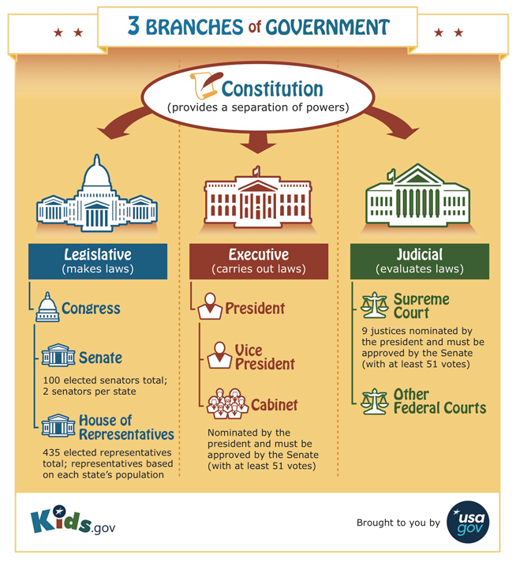

Guiding Questions
What are some the key positions in the executive branch?

After you read:

Why did the framers believe in separating the powers of government into different parts or branches?

Using Sources G, H, I and P, describe how the ideas of popular sovereignty and natural rights are presented in the Declaration of Independence.

Formative Performance Task #2 – Constructed Response
Student Directions | Based on the sources, write a paragraph that explains two ideas that influenced the creation of the United States’ founding documents?

Lesson 9 – How does the structure of the United States government reflect
the framer’s intentions?
Student Directions | Read sources Q, R and S complete the guiding questions. Next, complete the after you read questions at the end of this lesson.
Featured Sources | Source Q: Outline of the U.S. Constitution  Source R: Preamble of the U.S. Constitution  Source S: Checks and Balances Graphic

The arrangement and relationship between the parts of the structure of the United States government reflects many of the ideas embraced by the framers, including popular sovereignty, natural rights, limited government, and the separation of powers. Lessons 9 and 10 examine how the United States government is structured and in what ways that structure supports the framer’s intention (goal) to avoid tyranny.

Source Q: Outline of the US Constitution

Source Q is a graphic that outlines the structure, or the composition, of the U.S. Constitution. The Preamble explains the purpose of the Constitution. Amendments are changes to the Constitution. The first ten amendments are called the Bill of Rights, which is also an important founding document. The Bill of Rights was added to the Constitution about four years after it was approved by the states.

Outline of the U.S. Constitution

Preamble: Introduction to the U.S. Constitution

Articles 1–7: Articles 1–7 describe the form and function of the US Government

Bill of Rights: Amendments 1–10 of the U.S. Constitution; outline basic rights of all citizens

Amendments 11–27: Additional changes to the U.S. Constitution, such as abolishing slavery and expanding the right to vote

Source R is the preamble, or introduction, to the constitution. The preamble states the purpose of the government.

Source R: Preamble to the U.S. Constitution
Text | Vocabulary
We the People of the United States, in Order to form a more perfect Union, establish Justice, insure domestic Tranquility, provide for the common defense, promote the general welfare, and secure the Blessings of Liberty to ourselves and our Posterity, do ordain and establish this Constitution for the United States of America. | Union: government  Justice: just behavior or treatment, a concern for fairness, peace, and genuine respect for people  domestic: occurring inside a particular country; not foreign or international  Tranquility: the quality or state of being at peace  General welfare: health and safety  Posterity: future generations of people

Guiding Questions
According to the Preamble, what are some of the objectives, or goals, that the Constitution sets for the government?

Source S: Checks and Balances Graphic

The first three articles in the Constitution describe the function and structure of the three branches of government. Source S illustrates the responsibility (or function) of each branch, along with a short description of how each branch can check others’ power. Each of the “checks” are represented by arrows drawn between the branches. For example, the president can veto, or reject bills (laws) that pass through Congress, but Congress can override the president’s veto with a 2/3rds vote (instead of a simple majority).
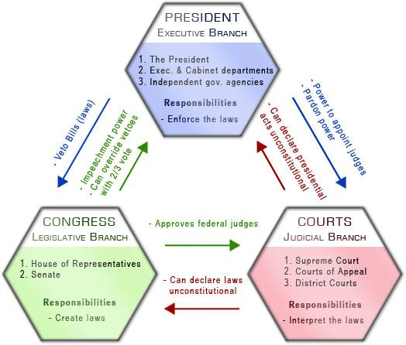

Guiding Questions
Explain how the legislative branch (Congress) can “check” the power of the executive branch (the president).

After you read:

According to the Preamble, “We the People…do ordain and establish this Constitution.” What gives the people this right to establish government?

According to the Preamble, who is the new government being established for?

The Constitution mandates that the United States have a republican form of government. In a republic, people vote for delegates to represent their interests in the government. How is the republican structure of the U.S. government related to the idea of Popular Sovereignty?

Lesson 10– How does the structure of the United States government reflect
the framer’s intentions?
Student Directions | Read Sources T and U and answer the guiding questions. Next, complete the after you read questions at the end of the lesson.
Featured Sources | Source T: “The Bill of Rights”  Source U: Table of First 10 Amendments

Source T describes the fears some of the framers had with the Constitution and how their concerns resulted in the Bill of Rights, an important founding document.
Source T: The Bill of Rights
Text | Vocabulary
Not everyone believed the new Constitution was a good idea. A number of individuals who had played important roles in the Revolution worried that a powerful government would eventually become tyrannical and that the new Constitution would be replacing British tyranny with a homegrown variety.  In order for the Constitution to take effect, it would have to be ratified by at least nine states, but several states threatened to refuse to ratify the document unless it included strong guarantees of individual rights and liberties. Delegates, led by James Madison, set to work on writing a list of checks on the government’s power that would guarantee individual liberty. That list would become known as the Bill of Rights.  The Bill of Rights has proven to be one of the most influential documents in modern history. It represents the theory of natural rights, which states that humans are granted certain freedoms and liberties by God and that the state should not have the power to take those rights. This was a major change from previous theories of individual rights, which were granted to citizens by the state or monarch. The Bill of Rights has influenced many political leaders around the globe. | tyrannical:  having a cruel and oppressive quality  ratified: confirmed or approved

Guiding Questions
Why was a Bill of Rights demanded by many colonial leaders?

How was the Bill of Rights related to the idea of Natural Rights?

Source U: Table of First 10 Amendments

This table shows a simplified version of the first ten amendments to the Constitution, commonly referred to as the Bill of Rights. The first five clearly state things the government cannot do to citizens, while amendments six through eight focus on the rights of people accused of a crime. Amendments nine and ten deal with dividing the power between the national and state governments.

Amendment 1 | Amendment 2 | Amendment 3 | Amendment 4 | Amendment 5 | Amendment 6 | Amendment 7 | Amendment 8 | Amendment 9 | Amendment 10
No law can prohibit the freedom of religion, speech, press, assembly and petition | Right to bear arms | Government may not quarter soldiers in the house of citizens during peacetime without permission | Government may not search or seize a person’s property without a warrant | A person can’t be tried for the same crime twice, and does not have to testify against him or herself | A person charged with a crime has the right to a quick trial, a fair jury and a lawyer | A person in a civil case is guaranteed to a trial by jury | No cruel or unusual punishment or excessive fees | The people have rights other than those mentioned in the Constitution | Any power not given to the Federal government by the Constitution is a power of the State or the people

How do the first 10 amendments to the Constitution reflect the desire of the framers to protect natural rights?

Formative Performance Task #3 – Constructed Response
Student Directions | Based on the sources, write a paragraph that explains two ways the structure of the U.S. Constitution reflects the framers’ desire to avoid tyranny.

Lesson 10 - Summative Performance Task
Student Directions | Based on the sources from this packet and your knowledge of social studies, write an essay answering the framing question: How did ideas influence the founding of the United States?

Name________________________________________________Date__________________

What Were the Causes and Effects of Westward Expansion in the 19th century?

Introduction
Student Directions | Over the next two weeks, you will explore the sources in this packet to learn about how and why the United States expanded in the 19th century. At the end of the packet, you will express your understanding by writing an extended response answering the following question: What were the causes and effects of westward expansion in the 19th century? This packet includes three supporting questions which will help you develop your claim on westward expansion. After you read each text or analyze each image, you will be asked to answer questions about it. Some words are defined to help you better understand each source and answer the questions. Some sources have digital extensions, which are optional sources you can explore if you have internet access.

Lesson 1 – Setting the Context
Student Directions | Read and study Sources A and B and complete the guiding questions. Next complete the after you read questions at the end of this lesson.
Featured Sources | Source A: “Definition of Westward Expansion”  Source B: United States Expansion Map

Source A: Definition of Westward Expansion
Text | Vocabulary
National Geographic defines the term westward expansion as:  - widespread migration of white people westward from the Atlantic coast.  - the growth of the borders of the United States.  While Europeans in North America had been migrating since the land was colonized, the era of westward expansion is most commonly believed to have started in the early 19th century. | migration: movement from one part of something to another

Guiding Questions
Describe what westward expansion means in your own words.

______________________________________________________________________________________

Source B: United States Expansion Map

Guiding Questions
Using Source B, when did the United States begin expanding west?

_________________________

_________________________

What are some of the territories that the United States eventually added??

_________________________

_________________________

_________________________

This historical map illustrates when new territories were added to the United States from 1783 until 1917.
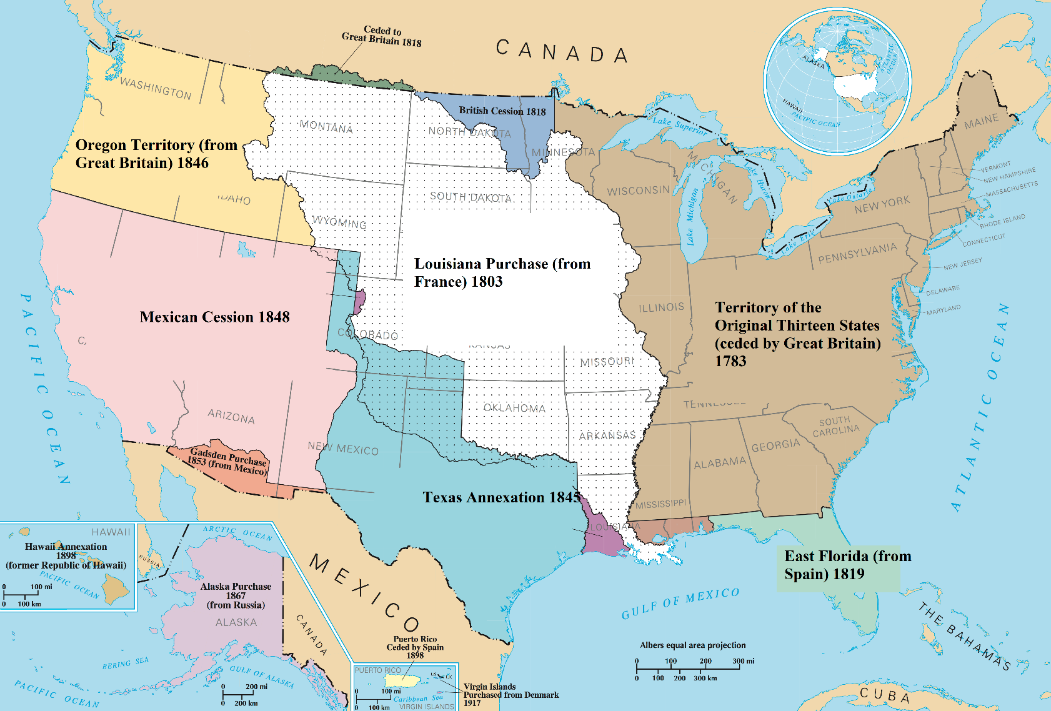

Lesson 2 – What is Westward Expansion, and why did Americans want to move west?
Student Directions | Read and study Source C, D, E and F while completing the guiding questions. Next, answer the after you read questions at the end of this lesson.
Featured Sources | Source C: “Westward Expansion: The Louisiana Purchase”  Source D: Lewis and Clark Expedition Map 1804–1806  Source E: “Exploration: Lewis and Clark”  Source F: Image Bank: Lewis and Clark
Digital Extensions | National Park service – Lewis and Clark Story Map

Source C: Adapted from “Westward Expansion: The Louisiana Purchase”
Text | Vocabulary
In 1800, under the leadership of Napoleon Bonaparte, France took over governing the Louisiana Territory from Spain. With Louisiana now led by Napoleon, France threatened to block Americans from using the port of New Orleans on the Mississippi River. New American settlements west of the Appalachians Mountains depended upon the Mississippi River to transport their goods since overland trade to the east coast was expensive and difficult.  Blocking access to New Orleans was such a threat to America that President Thomas Jefferson considered an alliance with the British. This would have given the United States more power against France. At the same time, Jefferson sent diplomats to France. They were sent to bargain for continued access along the Mississippi. James Monroe, the top American negotiator was allowed to offer up to 10 million dollars for New Orleans. Surprisingly, however, Napoleon offered all of the Louisiana Territory to the United States for 15 million dollars. The huge territory stretched from the Mississippi River to the Rocky Mountains. It more than doubled the size of the United States. | Napoleon Bonaparte: the ruler of France  alliance: a partnership  diplomats: an official representing a country abroad  negotiator: a person who helps others reach agreements

Guiding Questions
How much did the United States pay to purchase the Louisiana Territory?

Why did Thomas Jefferson believe the United States needed to purchase New Orleans from France?

______________________________________________________________________________________

Source D: Lewis and Clark Expedition Map 1804–1806

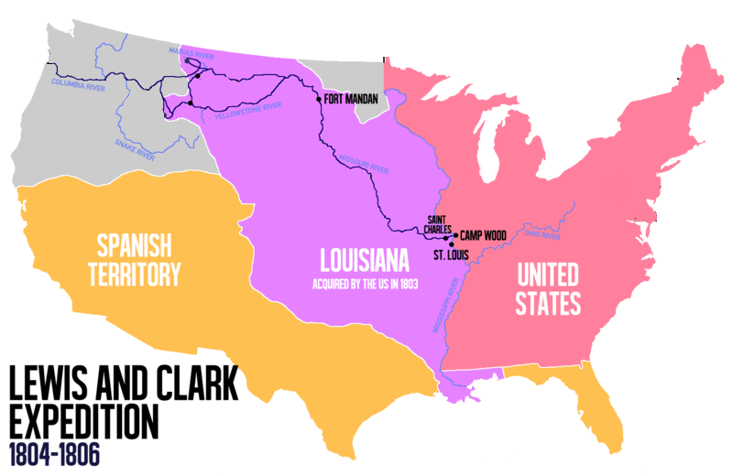
The Louisiana Purchase did not describe where the exact boundaries of the new territory were. To claim its new territory, the United States first had to explore and then settle it. Many American Indians lived in the Louisiana Territory at the time of the purchase. President Jefferson hired Meriwether Lewis and William Clark to lead an expedition called the Corps of Discovery to explore the territory. In May 1804, they departed from the St. Louis area with about forty soldiers. Their journey up the Missouri River and into new lands took over a year. They returned to St. Louis in September 1806, having found a route to the Pacific Ocean. The map below shows the route they took to reach the Pacific Ocean.
Mississippi River
Missouri River
Appalachian Mountains
Rocky Mountains

Guiding Questions
Why did Thomas Jefferson send the Corps of Discovery into the Louisiana Territory?

______________________________________________________________________________________

Source E: “Exploration: Lewis and Clark”
Text | Vocabulary | Guiding Questions
In May 1804, a group of 50 Americans led by Meriwether Lewis, Jefferson's personal assistant, and William Clark, an army officer, headed northwest along the Missouri River from St. Louis. While trying to find a route across the continent, they were also expected to make detailed observations of the natural resources and geography of the west. Also, they were to establish good relations with native groups.  By mid-October 1804, the expedition called the Corps of Discovery reached the Mandan villages in present-day North Dakota. Here they found several large, successful settlements with an overall population of about 5,000 people. The Mandan villages were an important trade center. The villages brought together many different native groups as well as a handful of multilingual Frenchmen. They decided to camp with the Madan for the winter.  During the winter they established good relations with the Mandan and received a great deal of information about the best route for heading west to the Pacific Ocean. The expedition also hired several of the Frenchmen who lived among the Mandan to serve as guides and translators. Along with them came a fifteen-year-old Shoshone named Sacajawea who had been kidnapped and sold into marriage to one of the Frenchmen. Her knowledge of the west and language skills played an extremely important role in the success of the expedition. Additionally, the presence of Sacajawea and her baby helped assure other Indian groups further west that the expedition didn’t have hostile intentions.  From the Mandan villages the expedition headed west to cross the Rockies, the highest mountain range in North America. By the winter of 1805 they had reached the Pacific Ocean using the Columbia River. When the long overdue expedition finally returned to St. Louis in September 1806, they were celebrated as heroes who had accomplished an extraordinary feat.  An underlying motivation of the expedition was a widely shared belief that the future prosperity of the United States required the expansion of agriculture in the West.  This expansion had many negative consequences. The United States built Fort Clark at the Mandan villages. At first it provided the Mandan with another trading partner, not just with the British. The American fort provided defense from their traditional enemies the Sioux. However, Americans at the fort brought new diseases to the area that destroyed the local native population. While the Mandan had a thriving trading center when Lewis and Clark arrived in 1804, by the late 1830s, their total population had been reduced to less than 150. The nation's growth combined tragedy and triumph at every turn. | Mandan: American Indian tribe of the Great Plains who have lived for centuries primarily in what is now North Dakota.  multilingual: speaking multiple languages  Shoshone: American Indian tribe who lived in present-day Idaho and Wyoming.  hostile: aggressive, violent  prosperity: wealth, success  Sioux: a tribe of American Indians also known as the Očhéthi Šakówiŋ ("Seven Council Fires")  thriving: growing or developing well | Identify at least three things Jefferson expected Lewis and Clark to accomplish.  ______________________  ______________________  ______________________  ______________________  ______________________  ______________________  What did the Corps of Discovery gain from their time with the Mandan?  ______________________  ______________________  ______________________  ______________________  ______________________  ______________________  ______________________  ______________________  How did Sacajawea help the expedition reach the Pacific Ocean?  ______________________  ______________________  ______________________  ______________________  ______________________  ______________________  What negative consequences did the expedition have?  ______________________  ______________________  ______________________  ______________________  ______________________  ______________________

Source F: Image Bank: Lewis and Clark

Image 1 - List of Manufactured Goods ,1803

The picture below is a list of goods that the Corps of Discovery brought on the expedition. The list includes four dozen butcher knives, twelve dozen pocket looking-glasses, seventy-two pairs of striped ribbons, and eight brass kettles.

Image 2 – Map of Route to Pacific Ocean

Cartographers (people who make maps) used information gathered by the Corps of Discovery to make detailed maps of the west, which were used by future explorers and settlers. The image below is an historical map made by a cartographer in 1814 that shows the area explored by Lewis and Clark.

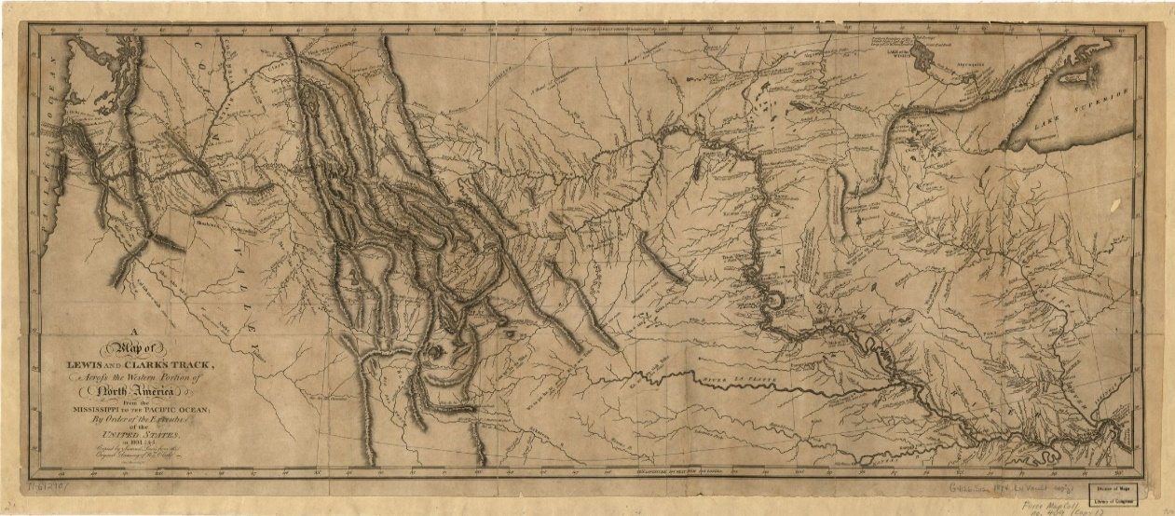

Image 3 – Scientific Specimen

The Corps of Discovery cataloged and described many species of plants and animals that were new to them. Their notes and drawings enchanted the American public and contributed to the general interest in the West.

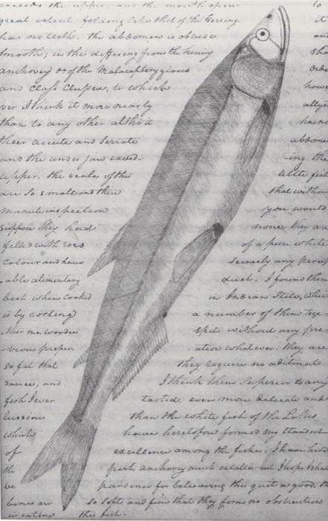
Image 4 – Mandan Hut

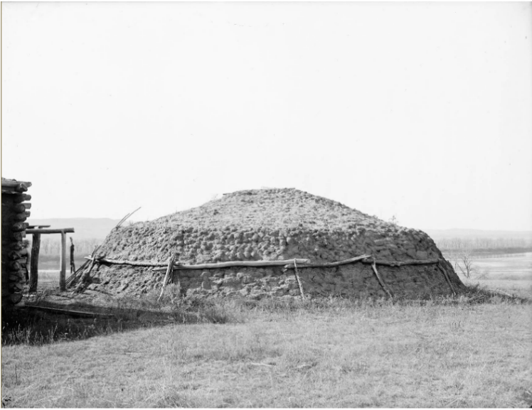
Image 4 is a photo of a Mandan lodge made of sod (grass) similar to ones encountered by the Corps of Discovery. One of the goals of the Corps of Discovery was to establish trading relationships with American Indians. When talking to American Indians about trading with the Americans, Meriwether Lewis told them that they were the “children” of a new “great father” (Thomas Jefferson) who would provide them with trade and protection in place of their unreliable trade with the French and the Spanish.

Image 5 - A picture of a Shoshone women and children, circa 1888-1892

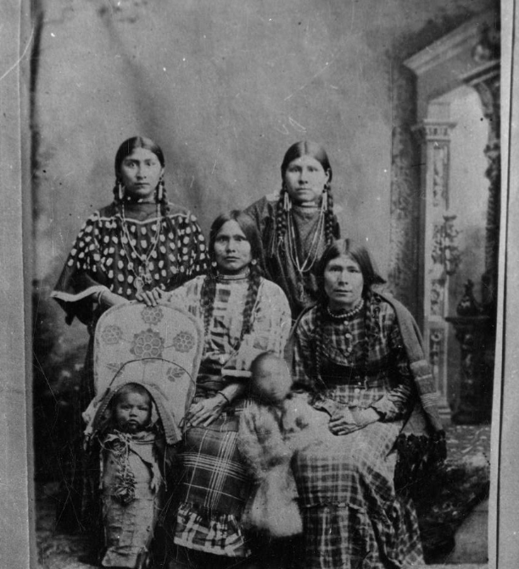
Image 5 shows a group of Shoshone women, dressed in traditional clothing. Sacagawea, a Shoshone woman, traveled thousands of miles with the Corps of Discovery, from North Dakota to the Pacific Ocean, and helped to establish cultural contacts between the expedition and American Indians.

After you read:

How did the Corps of Discovery work to establish trading relationships with American Indians?

______________________________________________________________________________________

How did the Corps of Discovery contribute to the United States’ knowledge of western lands?

______________________________________________________________________________________

Why would the Corps of Discovery bring many manufactured goods with them during their expedition?

______________________________________________________________________________________

Lesson 3 - What is Westward Expansion, and why did Americans want to move west?
Student Directions | Read and study Sources G, H and I while completing the guiding questions. Next answer the after you read questions at the end of this lesson.
Featured Sources | Source G: Population Density of the United States 1820–1860  Source H: “Manifest Destiny”  Source I: American Progress by John Gast

Source G: Population Density of the United States 1820 –1860

These two maps show the population density of the United States in 1820 and 1860. Population density refers to the number of people living in a given area. German and Irish immigration from Europe helped increase the population of the United States in the early 19th century. A higher population in the East meant increased competition for land and jobs.

Image 1 - Population Density 1820

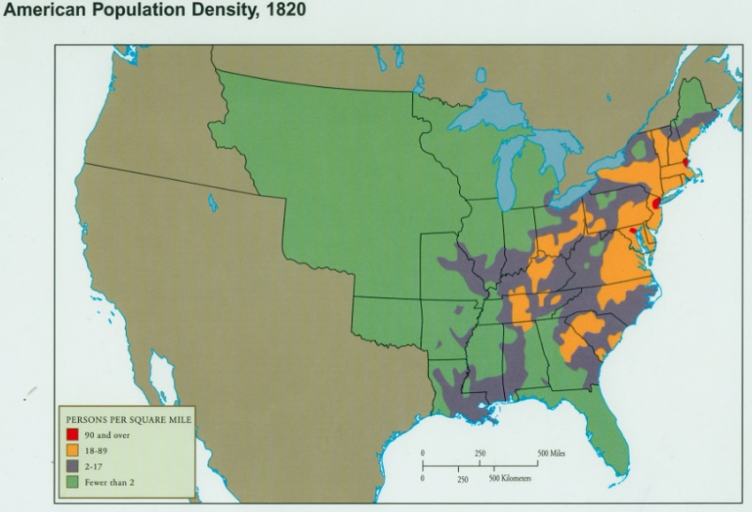

Persons Per Square Mile

90 and over
18 – 89
2 – 17
Fewer than 2

Image 2 – Population Density, 1860
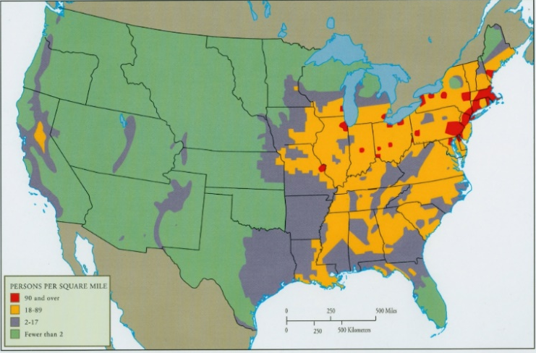

90 and over
18 – 89
2 – 17
Fewer than 2

Persons Per Square Mile
Upper Mississippi
Great Lakes Region

Guiding Questions
What areas have a lower population density in both 1820 and 1860?

Why did the population density change in the western parts of the United States between 1820 and 1860?

______________________________________________________________________________________

Source H: “Manifest Destiny”
Text | Vocabulary | Guiding Questions
Beginning in the early 19th century, Americans began settling the Great Lakes region. By the 1830s and 1840s, increasing numbers of European immigrants joined Americans from the eastern coast in settling the upper Mississippi area (see maps in Source G.)  Some Americans argued that the United States should benevolently conquer the West as the main way of spreading American values and democratic government. However, the West was not empty. Native Americans controlled much of the land east of the Mississippi River and almost all of the West. Expansion depended on Indian removal. The harassment and removal of American Indians—whether by the actions of the U.S. government or individual Americans—depended on the belief in manifest destiny. The process of expansion rested on the belief that white American settlers would use the new lands and opportunities better.  Manifest destiny was a belief that went back to the founding of the nation. First, many Americans believed that American values provided a good reason for expanding American borders into lands controlled by American Indians. Second, the lands west of the Mississippi River needed political and agricultural improvement. Third, God and the Constitution supported America’s destiny to make the world democratic. These beliefs and the resulting actions were often disastrous to anyone in the way of American expansion. | benevolently:  well-meaning and kindly.  manifest destiny: the belief that the United States should spread its values and system of government across North America | Why did settlers initially avoid migrating to areas west of the Rocky Mountains?  __________________  __________________  __________________  __________________  __________________  __________________  What reasons did white Americans use to support westward expansion?  __________________  __________________  __________________  __________________  __________________  __________________  __________________

Source I: American Progress by John Gast

Source I is an 1872 painting by John Gast, a European-born painter who lived in Brooklyn, New York. The painting is widely believed to be a representation of Manifest Destiny. The figure in the center is called “Progress” and she moves from the light-skied east to the darkened west, brining with her wagons, stream trains, and telegraph wires. As she moves west, American Indians and buffalo are seen fleeing.

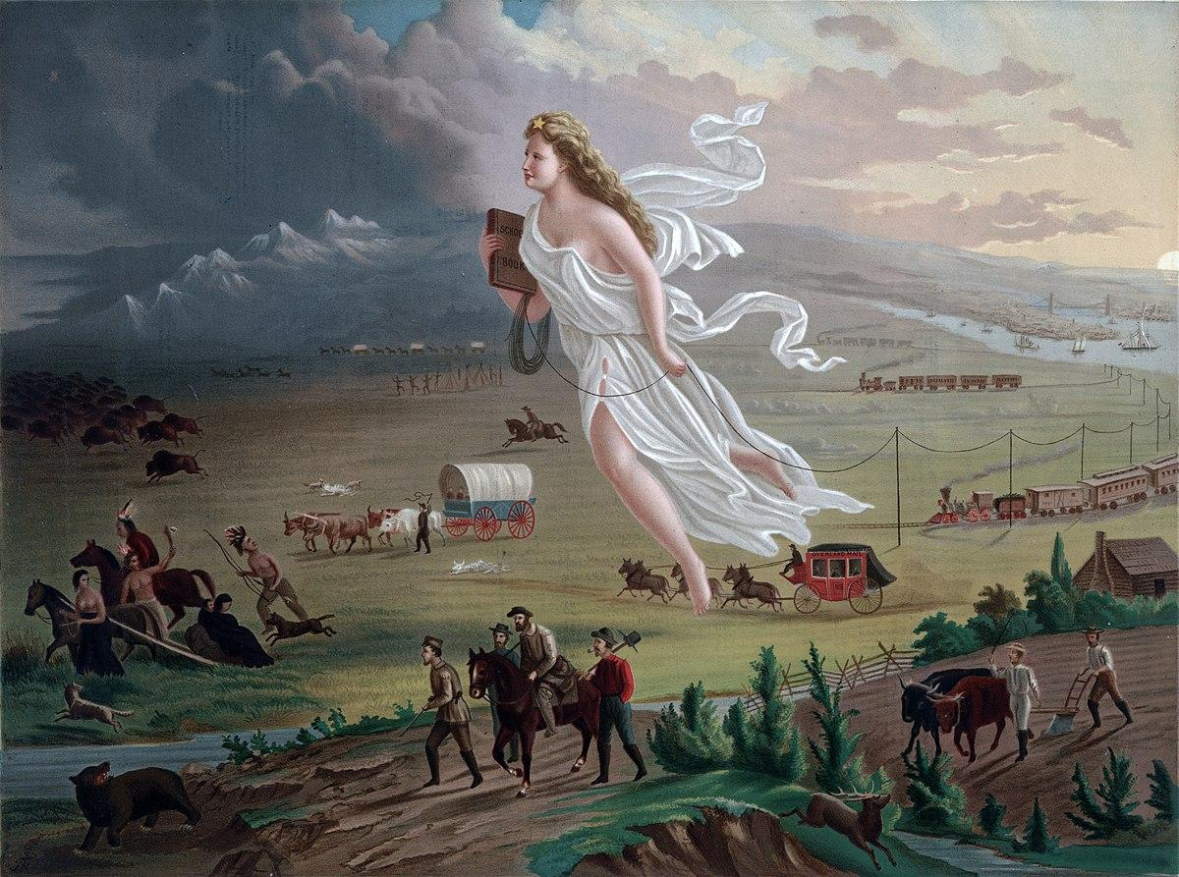

Guiding Questions
Why might the painter have painted the landscape darker in the areas where “Progress” hasn’t passed?

______________________________________________________________________________________

How does this painting reflect the main way Americans viewed Indigenous people at this time?

______________________________________________________________________________________

______________________________________________________________________________________

After you read:

How did the belief in Manifest Destiny affect Westward Expansion?

_____________________________________________________________________________________

_____________________________________________________________________________________

What were some negative effects of Manifest Destiny?

_____________________________________________________________________________________

_____________________________________________________________________________________

_____________________________________________________________________________________

Formative Performance Task #1 – Constructed Response
Student Directions | Based on the sources, write a paragraph that explain two factors that motivated Americans to move west.

Lesson 4 - What actions did the United States government take that supported westward expansion?
Student Directions | Read and study Sources J, K, L and M while completing the guiding questions.
Featured Sources | Source J: “Antebellum Western Migration and Indian Removal”  Source K: “The Dawes Act” by Dr. Michelle Getchell  Source L: Indian Reservation System  Source M: “Before and After Education”

Source J describes how the United States government dealt with large American Indian communities living east of the Mississippi River.

Source J: Adapted from “Antebellum Western Migration and Indian Removal”
Text | Vocabulary | Guiding Questions
Wishes to remove American Indians from valuable farmland motivated state and federal governments to plan for forced removal. Congress passed the Indian Removal Act in 1830, giving the president the power to begin treaty negotiations that would give American Indians land in the West in exchange for their lands east of the Mississippi. Many supporters of removal, including President Andrew Jackson, claimed that it would protect Native American communities.  The experience of the Cherokee was particularly horrible, despite many tribal members adopting some Euro-American ways. State and federal governments pressured the Choctaw, Chickasaw, Creek, and Cherokee Nations to sign treaties and give up their land. Many of these tribal nations used the law in hopes of protecting their lands.  The Cherokee had signed earlier treaties with the United States that guaranteed the Cherokee Nation control of their land and independence from the United States. The Cherokee used these treaties to argue that the United States Supreme Court should prevent their removal from their land in Georgia. The Supreme Court ruled that Georgia laws did not apply within Cherokee territory. Therefore, the Cherokee did not have follow orders for removal. The state government of Georgia ignored the Supreme Court and did little to prevent conflict between settlers and the Cherokee.  In 1835, a part of the Cherokee Nation led by John Ridge, hoping to prevent more violence, signed a treaty which gave up land in Georgia for five million dollars. However, most of the tribe viewed the treaty as illegal. President Martin van Buren used the treaty to order the army to forcibly remove those Cherokee. Harsh weather, poor planning, and difficult travel added the tragedy of what became known as the Trail of Tears. Sixteen thousand Cherokee embarked on the journey but only ten thousand completed it.  Not every instance of removal was as disastrous as the Cherokee. On the other hand, some tribes violently resisted removal. In the end, over sixty thousand American Indians were forced west. | embarked: to begin to go somewhere | Why did settlers and the United States government want to remove American Indians from their land east of the Mississippi?  ______________________  ______________________  ______________________  ______________________  How did the Cherokee defend themselves?  ______________________  ______________________  ______________________  ______________________  ______________________  ______________________  ______________________  ______________________  How did President Van Buren force the Cherokee off their land?  ______________________  ______________________  ______________________  ______________________  ______________________

This map shows three routes taken by American Indians on the forced journey west.

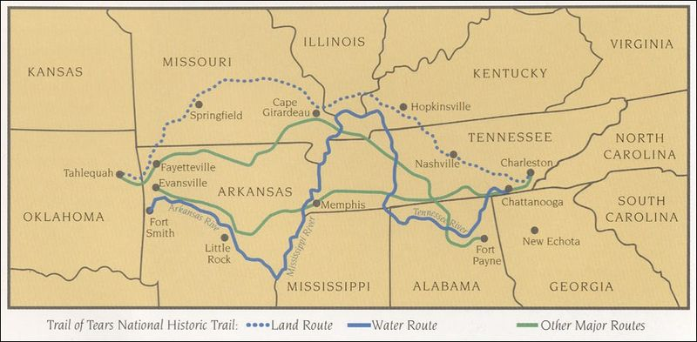

Source K: “The Dawes Act” by Dr. Michelle Getchell
Text | Vocabulary | Guiding Questions
Violent conflict between white settlers and American Indians had begun during the colonization of North America. Violence increased in the mid-nineteenth century as American settlers moved ever further west across the continent. Most white Americans believed they could not live in peace with American Indians, whom they regarded as less advanced. As a result of this belief, the U.S. government created the reservation system in 1851. This would keep American Indians off of lands that white Americans wished to settle. Many American Indians resisted the reservation system. This resulted in a series of conflicts known as the Indian Wars.  Ultimately, the U.S. Army overpowered the American Indians militarily and forced them onto reservations. The American Indians were allowed to govern themselves and maintain some of their traditions and culture. A main factor in removing American Indians from their land was so settlers could gain access to the best farmland. Often times lands that Reservations were created on was not good for farming, so American Indians were removed from land that was good for farming, to land that couldn’t support farming as well. |  | Why did many white Americans believe they could not successfully live with American Indians?  ______________________  ______________________  ______________________  How did the U.S. government help white settlers in gaining farmland?  ______________________  ______________________  ______________________  ______________________

Source L: Indian Reservation System

The map below shows reservations in the year 1900 for American Indians in light beige.

Guiding Questions
What areas of North America have American Indian reservations?

______________________________________________________________________________________

What factors influenced the U.S. government’s decision to designate certain areas reservations?

______________________________________________________________________________________

Source M: “Before and After Education”

In the mid and late 19th century, the United States passed laws based on the false idea that it was better for American Indians give up their own values and traditions and to learn the values and customs associated with the United States. After the end of the Indian Wars, in the late 19th and early 20th centuries, the U.S. government outlawed the practice of traditional Indian religious ceremonies. It also helped establish schools which American Indian children were required to attend. In these schools they were forced to speak English, study standard subjects, attend church, and give up their traditions. The photograph on the left below shows three Sioux boys when they arrived at such a school. The photograph on the right shows the same three Sioux boys taken three years after arriving at boarding school in the 1890s.

Guiding Questions
Why did the United States government create schools specifically for American Indian children?

_____________________________________________________________________________________

How do the images reflect changes to the American Indian culture?

______________________________________________________________________________________

Lesson 5 - What actions did the United States government take that supported westward expansion?
Student Directions | Read and study Sources N, O, P and Q while completing the guiding questions. Next, complete performance task #2 at the end of this lesson.
Featured Sources | Source N: “The Oregon Trail”  Source O: Image Bank: Oregon Trail  Source P: Photograph of Daniel Freeman  Source Q: Public Lands of the United States 1830–1870

Source N describes the origins of the Oregon Trail, a path used by early settlers to journey westward.

Source N: “The Oregon Trail”
Text | Vocabulary | Guiding Questions
There were many reasons for the westward movement to Oregon and California. Economic problems upset farmers and businessmen. Free land in Oregon and the possibility of finding gold in California lured them westward. At the same time, eastern churches wanted to teach American Indians of the Oregon Country their European ideas of "civilization." Many simply hoped for a chance to start a new life. It was not until 1841 that the first group with serious plans to emigrate to the Oregon area left and headed west. In 1843 nearly 1,000 people completed the trip with many more to follow.  Pioneer families carried all of their possessions in wagons that were only about ten feet long and four feet wide. They were called "prairie schooners" because the canvas cover looked like a ship’s sail. Most wagons were pulled by oxen. They were dependable and inexpensive, costing about $50 each.  A typical wagon in the 1840s could carry a load weighing from 1,600 to 2,000 pounds, depending on the number and type of animals that pulled the wagon. Many of the wagons were overloaded with food and belongings. As a result, the trails became | schooners: a sailing ship with two or more masts | What encouraged people to settle in Oregon and California in the 19th century?  __________________________  __________________________  __________________________  __________________________  Why did pioneer families usually travel by wagon?  __________________________  __________________________  __________________________  __________________________  __________________________
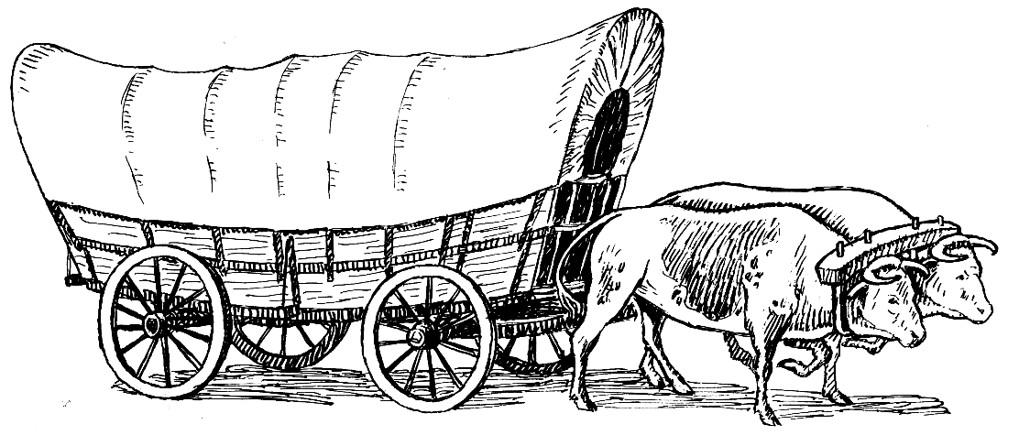
*This drawing shows what a typical “prairie schooner” looked like.
winding junkyards. The litter included everything from cook stoves to furniture. Wild game became scarce due to the thousands of pioneers who traveled the trails. So, food for the trip had to be carried in the wagons. A typical meal might be coffee, bacon and beans. A bread substitute, called fried cakes, was usually served. It was made of water and flour fried in bacon fat. Sometimes there was a dessert of dried fruit.  The pioneers traveled in groups called trains, but often individual families would strike out on their own. They could travel about 16 miles per day. There were rare attacks by American Indians. Up until 1849, fewer than fifty emigrant deaths were blamed on American Indian attacks. But as the numbers of travelers increased, so did the attacks. By 1860 emigrant deaths probably totaled close to 400. However, the emigrants killed even more Indians.  Illness and accidents were more serious threats than American Indian attacks. About 20,000 people died on the California Trail between 1841 and 1859—an average of ten graves for every mile. Disease was the number one killer. A cholera epidemic swept through the trains in 1850. Other diseases included scurvy, smallpox, and tick-borne fever. There were also many accidents, including gunshot wounds, burns, and broken bones. A few people were even run over by wagons since nearly everyone walked beside the prairie schooners. | wild game: mammals or birds hunted for sport or food  scarce: rare  cholera: a disease typically from infected water supplies | How might a family decide what to throw out on the journey if they needed to lighten their load?  __________________________  __________________________  __________________________  __________________________  __________________________  __________________________  What challenges did they face on the journey west?  __________________________  __________________________  __________________________  __________________________  __________________________  __________________________

Source O: Image Bank: Oregon Trail

Image 1 – Oregon Trail Map

The Oregon Trail was a 2,200-mile historic east-west trail and large wheeled wagon route across the Northwestern United States. It connected the Missouri River to valleys in Oregon and the Oregon Territory. The eastern half of the trail crossed the future states of Kansas, Nebraska, and Wyoming. The western half crossed the future states of Idaho and Oregon.

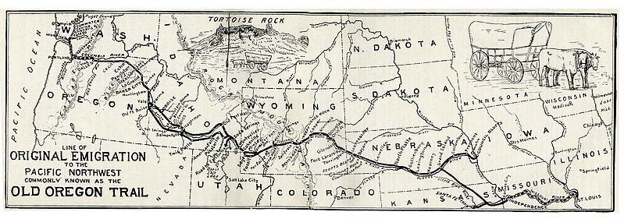

Guiding Questions
What geographic feature and landscapes did the settlers cross on their journey on the Oregon Trail?

______________________________________________________________________________________

Image 2 – Covered Wagon Train

Before railroads were a reliable method of transportation, the main mode of westward travel was by a covered wagon. Traveling in large groups provided some measure of safety, but the journey was still dangerous and often very difficult.

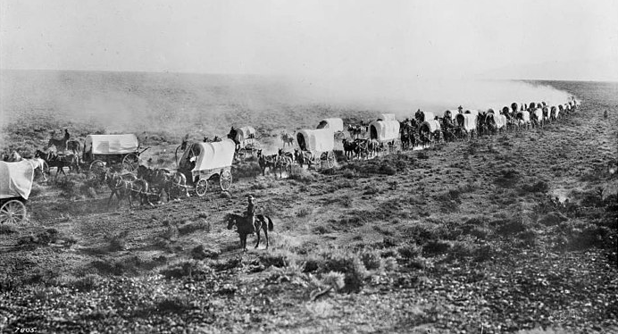

Guiding Questions
Describe how traveling in large groups would provide some safety for the settlers.

______________________________________________________________________________________

Image 3 – Oregon Trail Sign – U.S. Department of the Interior

Today, access to much of the 2,170 miles of the original Oregon Trail depends upon the permission of the land owner. Some segments are open to the public for hiking and other means of recreation, while others are not. There are a number of ways to enjoy the Oregon Trail including auto-touring, visiting historical sites, hiking, biking or horseback riding trail segments and visiting museums.

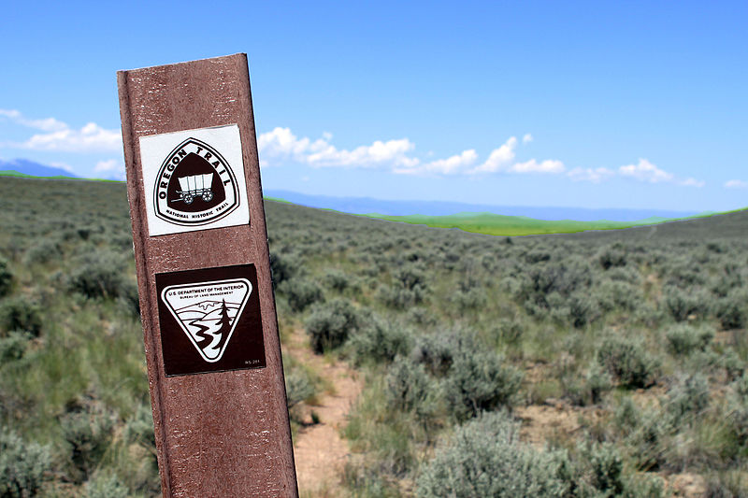

Guiding Questions
How is the Oregon Trail used today?

Source P: Photograph of Daniel Freeman

The Homestead Act was a federal law that encouraged western migration by providing settlers 160 acres of public land. In exchange, homesteaders paid a small fee and were required live on the land for five years before receiving ownership. The Homestead Act led to the distribution of 80 million acres of public land by 1900. The photograph below shows Daniel Freeman, one of the first people to file a claim under the Homestead Act in 1863.

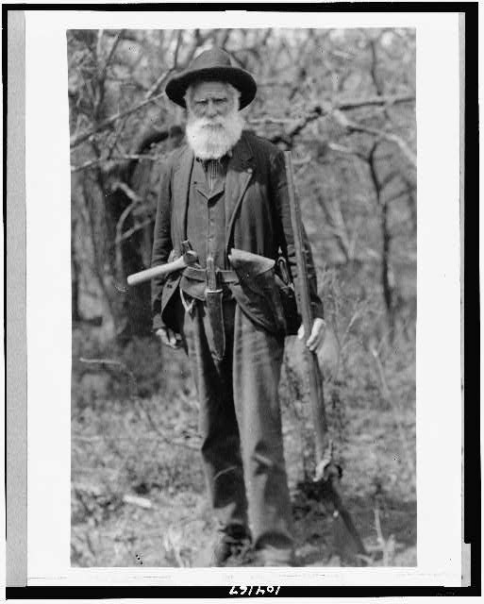

Source Q: Public Lands of the United States 1830–1870

Source Q is a map of land held by the federal government in 1830 and 1870. The territory in yellow is land owned by the U.S. Government, and the territory in green is land the government sold to private citizens or businesses, including through the Homestead Act.

Guiding Questions
How did the Homestead Act help support westward expansion?

_________________________

_________________________

_________________________

_________________________

_________________________

_________________________

_________________________

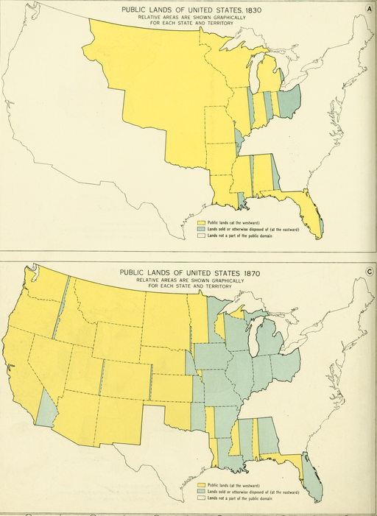

Formative Performance Task #2 – Constructed Response
Student Directions | Based on the sources, write a paragraph that explains two actions taken by the United States government that supported westward expansion and migration.

Lesson 6 – How did new technologies support and drive westward expansion?
Student Directions | Read and study Sources R, S, T and U while completing the guiding questions.
Featured Sources | Source R: “Roads and Canals”  Source S: Image Bank: Erie Canal  Source T: Travel During the Erie Canal Era  Source U: “Low Bridge” by Thomas S. Allen (1905)

Source R: “Roads and Canals”
Text | Vocabulary | Guiding Questions
Improvements in travel and trade helped both economic growth and westward expansion in the 1820s and 1830s. Canal improvements were seen in the East, while road building was seen in the West. The U.S. government helped pay for the National Road, begun in 1811, which pushed farther west every year. Building the National Road increased employment opportunities and encouraged non-farmers to move to the West.  The use of steamboats grew quickly throughout the 1810s and into the 1820s. Because after trade and travel grew in popularity local, state, and federally funded projects were created. Hundreds of miles of new canals cut through the eastern United States. The most famous of these early projects was the Erie Canal. That project, completed in 1825, linked the Great Lakes to New York City.  Early railroads like the Baltimore and Ohio lines hoped to link eastern cities with western trade routes. Not only did rail lines move goods faster, but the building of railroads encouraged the growth of new towns farther away from traditional waterway locations. | canal: a man-made river used for transportation  steamboats: boats powered with a steam engine | How did the U.S. government support efforts to build roads and canals?  _________________________  _________________________  _________________________  _________________________  _________________________  _________________________  How did railroads encourage migration and settlement?  _________________________  _________________________  _________________________  _________________________

Source S: Photograph of the Erie Canal crossing the Mohawk River in Rexford, New York.

The Erie Canal is a 363-mile waterway that greatly lowered the cost of shipping between the Midwest and the Northeast. The canal helped to ship food to Eastern cities and transport ship machinery and manufactured goods to the Midwest. The canal also made a large contribution to the wealth and importance of New York City, Buffalo and New York State. The canal also helped to increase trade throughout the nation by opening eastern and overseas markets to Midwestern farm products.

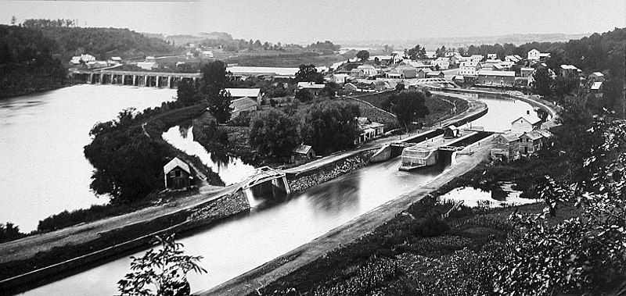

Guiding Questions
How did the Erie Canal affect New York State and the cities along the canal?

Source T: Travel During the Erie Canal Era

The Erie Canal provided businesses and consumers with time and cost savings when shipping goods. The chart below compares shipping costs by dirt road to shipping by canal in the 19th Century.

 | Dirt Road  (freight) | Canal  (freight)
Method | Wagon  8 Horses | Line Boat  2 Mules
Amount of Time | 15–45 Days | 9 Days
Cost | $100/Ton | $6/Ton

Guiding Questions
How did the cost and travel times compare between shipping goods on roads versus using canals?

How did the cost of shipping (dollars per ton) differ between using roads and canals?

Source U: “Low Bridge” by Thomas S. Allen (1905)
Text | Vocabulary
I've got a mule and her name is Sal  Fifteen years on the Erie Canal  She's a good old worker and a good old pal  Fifteen years on the Erie Canal  We've hauled some barges in our day  Filled with lumber, coal, and hay  And every inch of the way I know  From Albany to Buffalo  Low bridge, everybody down  Low bridge cause we're coming to a town  And you'll always know your neighbor  And you'll always know your pal  If you've ever navigated on the Erie Canal  Get up there Sal, we've passed that lock,  Fifteen years on the Erie Canal  And we'll make Rome before six o'clock  Fifteen years on the Erie Canal | mule: the offspring of a donkey and a horse, used as a beast of burden (to do difficult work)  barges: a flat-bottomed boat for carrying freight, typically on canals and rivers, either under its own power or towed by animals
Guiding Questions
What types of goods does he describe being traded on the canal?

Why might the author use the term “mule” while he describes his boat? What does this show about the development of new technologies being used in transportation?

Lesson 8 – How did new technologies support and drive westward expansion?
Student Directions | Read and study Sources V, W and X while completing the guiding questions. Next, complete performance task #3 at the end of this lesson.
Featured Sources | Source V: The ceremony for the driving of the golden spike at Promontory Summit, Utah on May 10, 1869  Source W: Transcontinental Railroad Map  Source X: Image Bank: Technological Change

Source V: The ceremony for the driving of the golden spike at Promontory Summit, Utah on May 10, 1869

The first transcontinental (across the entire continent) railroad crossed western plains and mountains and linked the West Coast with the rail networks of the eastern United States. Constructed from the west by the Central Pacific and from the east by the Union Pacific, the two roads were linked in Utah in 1869. The photograph below shows the ceremony for the driving of the golden spike that completed the railroad.

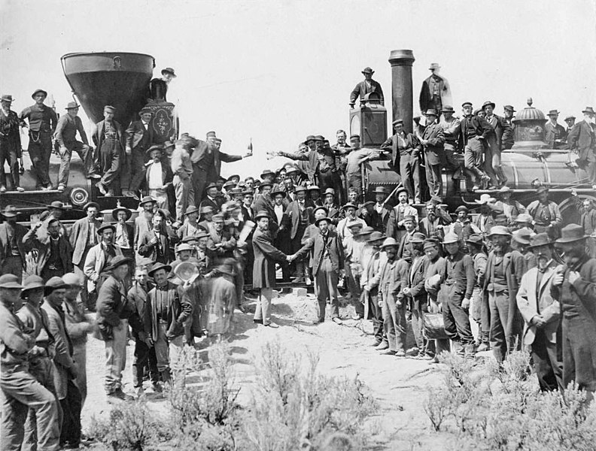

Source W: Transcontinental Railroad Map

By the mid-19th century, the railroad business in the United States was booming. In 1850, there were 9,000 miles of railroads in the United States. In 1900 there were 190,000. To manage these large networks of freight and passenger lines, companies used central locations where many rail lines met, called hub cities. Railroads made transporting people and shipping goods around the country much cheaper and faster.
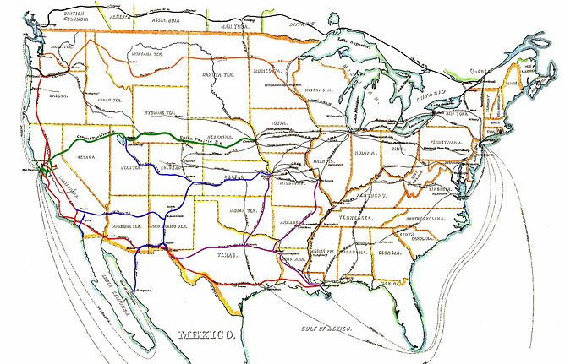
Guiding Questions
How did railroads affect the settlement of the West?

__________________________________________________________________________________________

__________________________________________________________________________________________

__________________________________________________________________________________________

Source X: Image Bank: Technological Change

Image 1 - Rear and Side View of George Stephenson’s Steam Locomotive and Railroad Cars of the Stockton and Darlington Railway, 1826.

A steam engine is a heat engine that performs mechanical work using steam. The steam engine uses the force produced by steam pressure to push a piston back and forth inside a cylinder. This pushing force is transformed, by a connecting rod and flywheel, into rotational force for work. The image below shows a diagram of an early steam engine locomotive railroad car. The steam engine allowed for faster transportation of goods across distances that would have never been possible using covered wagons pulled by horses or oxen.

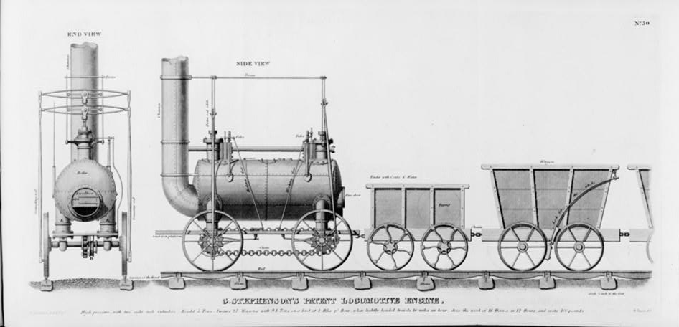

Guiding Questions
How did the development of the steam engine impact trade and the economy?

______________________________________________________________________________________

Image 2- Photograph of a steamship, Robert Fulton’s Clermont, the First Steamboat, on the Hudson, c1909.

Powered by steam engine, steamboats were far more efficient and faster and had the advantage of also being able to travel up a river, against the current. The steamboats had a steam engine that turned a paddle wheel in back of the boats. Early steamboats could travel at a speed of up to 5 miles per hour and quickly revolutionized river travel and trade. Steamboats began dominating the waterways of rivers such as the Mississippi, Alabama, Apalachicola, and Chattahoochee. Steamboats also enabled travel from the Northeast to California by traveling around South America.

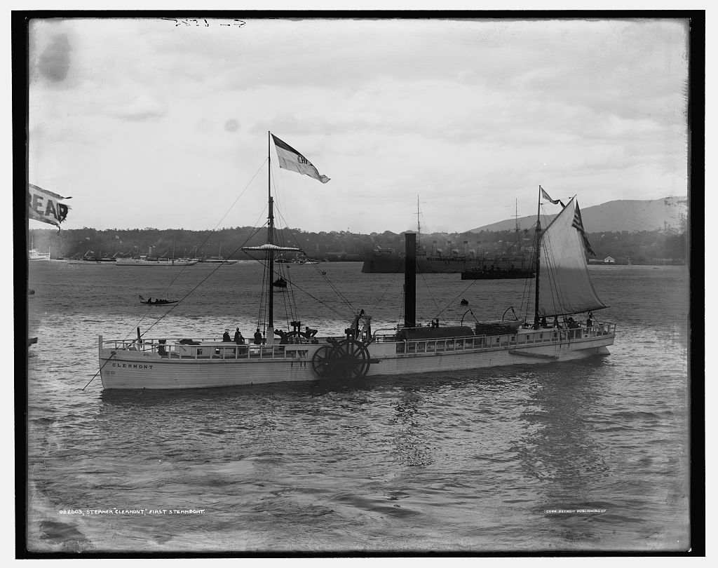

Guiding Questions
How did the steamboat affect travel on rivers, especially when traveling upstream?

______________________________________________________________________________________

Image 3 – The Cotton Gin

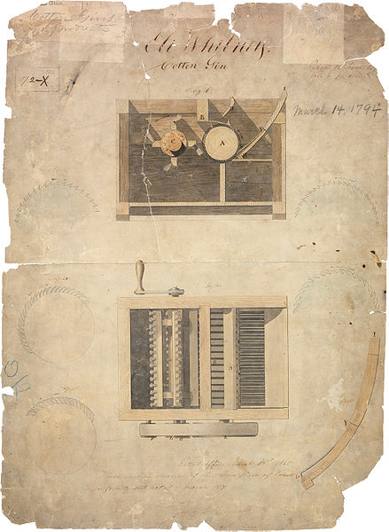
Before the introduction of the cotton engine (gin for short), cotton had required lots of work to clean and separate the fibers from the seeds. The invention of the cotton gin caused massive increase in the production of cotton in the United States, mostly in the South. As a result, the region became even more dependent on plantations that used enslaved labor. While it took a single enslaved person about ten hours to separate a single pound of fiber from the seeds, a team of two or three enslaved people using a cotton gin could produce around fifty pounds of cotton in just one day. The demand for slave labor increased with the increase in cotton production. The invention of the cotton gin by Eli Whitney revived the South’s cash crop economy and encouraged plantation owners to expand their land and move west (cotton farms eventually expanded as far west as East Texas.) The image below shows Whitney’s 1794 patent for his cotton engine.

Guiding Questions
How did the cotton gin increase the growth and creation of plantations and cotton farms in the South?

______________________________________________________________________________________

______________________________________________________________________________________

How did the cotton gin affect the use of enslaved labor?

______________________________________________________________________________________

Image 4 - Steel Plough

The soil in the west can be tough and wooden plows would often break tilling the soil. In 1837 John Deere patented the steel plow that could stand up to tough soil. By 1847 John Deere’s company was manufacturing 1000 plows a year. Steel plows made farming in the Midwest and West less difficult, and therefore made moving to these areas more desirable to farmers.

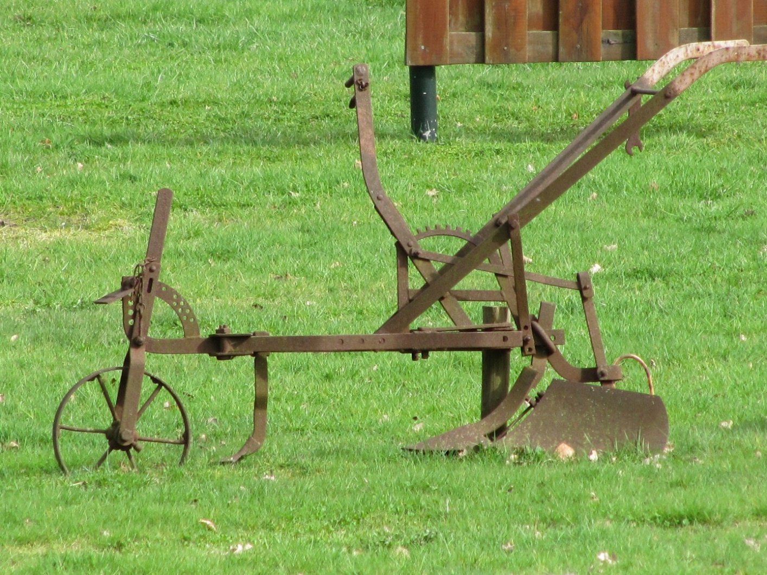

Guiding Questions
How did the steel plough support agriculture in the Midwest and West?

______________________________________________________________________________________

Formative Performance Task #3 – Constructed Response
Student Directions | Based on the sources, write a paragraph that explains two technological developments that affected westward expansion.

Lesson 10 - Summative Performance Task
Student Directions | Based on the sources from this packet and your knowledge of social studies, write an essay answering the framing question: What were the causes and effects of westward expansion in the 19th century?

This text is licensed under Attribution-ShareAlike and is available online at Geography Facts for Kids. Kiddle Encyclopedia. This page was last modified on 22 May 2020, at 08:21.
Modified by the LDOE. Original image is the in the public domain and is available at https://commons.wikimedia.org/wiki/Category:Blank_maps_of_the_United_States#/media/File:Blank_map_of_states.png.
This file is licensed under the Creative Commons Attribution-Share Alike 3.0 Unported license and is available online at https://commons.wikimedia.org/wiki/File:Usa_edcp_(%2BHI_%2BAK)_relief_location_map.png.
this document under the terms of the GNU Free Documentation License, and is available online at https://commons.wikimedia.org/wiki/File:Map_of_USA_with_state_names.svg
This source was commissioned by LDOE for the EAGLE item bank.
This source was commissioned by LDOE for the EAGLE item bank.
This source was commissioned by LDOE for the EAGLE item bank.
Text is available under the Creative Commons Attribution-ShareAlike License and is available online at https://en.wikipedia.org/wiki/Northeastern_United_States
This image is in the public domain and is available online at https://en.wikipedia.org/wiki/Hudson_River#/media/File:2016_One_World_Observatory_view_along_Hudson_River.jpg.
This image is in the public domain and is available online at https://commons.wikimedia.org/wiki/File:Stacks_of_lobster_traps_in_Norra_Grundsund_2.jpg.
This image is in the public domain and is available online at https://commons.wikimedia.org/wiki/File:Maple_sugar_making._Tapping_the_sugar_malpes_(maples),_by_Vermont_Stereoscopic_Company.png.
This image is in the public domain and are available online at https://commons.wikimedia.org/wiki/File:Lower_Mills_MA.jpg.
This photograph is in the public domain and is available online at https://commons.wikimedia.org/wiki/File:Acadia_National_Park_ACAD0308.jpg.
This text is under Attribution ShareAlike license and is available online at Midwestern United States Facts for Kids. Kiddle Encyclopedia. This page was last modified on 22 May 2020, at 08:21.
This file is licensed under the Creative Commons Attribution 2.0 Generic license and is available online at https://upload.wikimedia.org/wikipedia/commons/5/57/Great_Plains%2C_Nebraska%2C_U.S._1.jpg.
This image is in the public domain and is available at https://kids.kiddle.co/Image:Soybean_fields_at_Applethorpe_Farm.jpg.
This image is in the public domain and is available online at https://commons.wikimedia.org/wiki/File:FEMA_-_36508_-_Aerial_of_Mississippi_River_in_Missouri.jpg
This image is in the public domain and is available online at https://commons.wikimedia.org/wiki/File:Tornado_on_the_ground._Near_Scottsbluff,_Nebraska_-_NARA_-_283872.jpg.
This image is in the public domain and is available online at https://commons.wikimedia.org/wiki/File:Chicago_River_from_Michigan_Avenue.jpg.
Southwestern United States Facts for Kids. Kiddle Encyclopedia. This page was last modified on 22 May 2020, at 08:21.
This file is licensed under the Creative Commons attribution -share alike 4.,0 international license https://en.wikipedia.org/wiki/Mesa#/media/File:Over_Monument_Valley,_Navajo_Nation.jpg.
This file is licensed under the Creative Commons Attribution-Share Alike 3.0 Unported license. And is available online at https://commons.wikimedia.org/wiki/Category:Hoover_Dam#/media/File:Barrage_de_hoover.JPG.
This image is the public domain and is available online at https://commons.wikimedia.org/wiki/File:GrandCanyon_view_from_Pima_Point_2010.jpg.
This file is licensed under the Creative Commons attribution -share alike 4.,0 international license https://commons.wikimedia.org/wiki/File:Oil_andrewsTX.JPG.
This image is in the public domain and is available online at https://commons.wikimedia.org/wiki/File:NRCSOK07018_-_Oklahoma_(716988)(NRCS_Photo_Gallery).jpg.
This text is in the public domain and is available online at https://www.nrcs.usda.gov/Internet/FSE_DOCUMENTS/stelprdb1167344.pdf.
Southern United States Facts for Kids. Kiddle Encyclopedia. This page was last modified on 26 May 2020, at 10:09.
This image is in the public domain and is available online at https://www.publicdomainpictures.net/en/view-image.php?image=89939&picture=shrimp-boats.
This text is in the public domain and is available online at https://www.fisheries.noaa.gov/region/southeast.
This image is in the public domain and is available online at https://commons.wikimedia.org/wiki/File:NRCSGA02056_-_Georgia_(2015)(NRCS_Photo_Gallery).jpg
This file is licensed under the Creative Commons Attribution-Share Alike 2.0 Generic license and is available online at https://commons.wikimedia.org/wiki/File:Pearl_River_backwater_in_Mississippi.jpg.
This image is in the public domain and is available online at https://commons.wikimedia.org/wiki/File:Linville_Gorge-27527-3.jpg.
This file is licensed under the Creative Commons Attribution 3.0 Unported license and is available online at https://commons.wikimedia.org/wiki/File:MSC_Marina_docked_at_Port_of_New_Orleans.jpg.
This image is in the public domain and is available online at https://commons.wikimedia.org/wiki/File:GrandIsleBlock48OilDrillingPlatform.jpg.
This image is created by FEMA. It is available online at https://www.fema.gov/media-library/assets/images/122743.
Western United States Facts for Kids. Kiddle Encyclopedia. This page was last modified on 22 May 2020, at 08:21.
This file is licensed under the Creative Commons Attribution-Share Alike 2.0 Generic license and is available online at https://commons.wikimedia.org/wiki/File:Sunny_rainforest_(16917016973).jpg.
This image is in the public domain and is available online at https://commons.wikimedia.org/wiki/Rocky_Mountains#/media/File:Grand_Teton_in_Winter-NPS.jpg.
This file is licensed under the Creative Commons Attribution-Share Alike 4.0 International license and is available online at https://commons.wikimedia.org/wiki/File:USA,_California,_San_Francisco,_Pier_39.jpg.
This image is in the public domain and is available online at https://commons.wikimedia.org/wiki/File:Wildfire_in_California.jpg
This image is in the public domain and is available online at https://commons.wikimedia.org/wiki/File:San_Francisco_CA_-_Result_of_Earthquake_in_Street_(NBY_431765).jpg
This file is licensed under the Creative Commons Attribution-Share Alike 3.0 Unported, 2.5 Generic, 2.0 Generic and 1.0 Generic license and is available online at https://commons.wikimedia.org/wiki/File:Northern_Oregon_Coast_Range_logging_road_-_Washington_and_Yamhill_counties,_Oregon.jpg.
This image is licensed under the Creative Commons Attribution 4.0 International license and is available online at https://commons.wikimedia.org/wiki/File:Chardonnay_Grapes_at_Hanzell_Winery_-_Stierch.jpg.
This text was adapted from Interactions and disruptions, developed by New Visions for Public Schools and is available online at https://curriculum.newvisions.org/social-studies/course/9th-grade-global-history/interactions-and-disruptions/.
This file is licensed under the Creative Commons Attribution-Share Alike 4.0 International license. https://commons.wikimedia.org/wiki/File:Age_of_Discovery_explorations_in_English.png.
This file is in the public domain and is available online at https://commons.wikimedia.org/wiki/File:Christopher_Columbus3.jpg.
This image was adapted from “Interactions and disruptions” developed by New Visions for Public Schools and is available online at https://docs.google.com/document/d/1VnG1sk6t-u_cHVqqwk1RwbzVVzxE8uskWY9C4R-D88I/edit.
This image is in the public domain and is available online at https://commons.wikimedia.org/wiki/File:Colonisation_1660.png
This text is licensed under a Creative Commons 4.0 international license and is available online at https://www.ushistory.org/us/2b.asp.
This text is licensed under a Creative Commons 4.0 international license and is available at https://www.ushistory.org/us/2c.asp.
This image is licensed under the Creative Commons Attribution-Share Alike 3.0 Unported license and is available online at https://commons.wikimedia.org/wiki/File:Location_of_jamestown_virginia.jpg.
This text is licensed under a Creative Commons 4.0 international license and can be found online at https://www.ushistory.org/us/3.asp.
This image is in the public domain and is available online at https://commons.wikimedia.org/wiki/File:Robert_Walter_Weir_-_Embarkation_of_the_Pilgrims_-_Google_Art_Project.jpg.
This text is in the public domain and is available online at https://static1.squarespace.com/static/50a02efce4b046b42952af27/t/50a8701fe4b08d1f2ced2ff4/1353216031950/MourtsRelation.pdf.
This source was commissioned by LDOE for the EAGLE item bank.
This text is licensed under a Creative Commons 4.0 international license and can be found online at https://www.ushistory.org/us/2d.asp.
This source was commissioned by LDOE for the EAGLE item bank.
This text is in the public domain and is available online at http://mayflowerhistory.com/letter-winslow-1621.
This image is in the public domain and is available online at https://commons.wikimedia.org/wiki/File:Salem_shipping_colonial_color.jpg.
This image was adapted from “Economies of Colonies America,” developed by New Visions for Public Schools and is available online at https://docs.google.com/document/d/1BgQHDCXagEcwRhFWivvjmtnUpfO6KMAM1BNtRWb1MZc/edit.
This text is licensed under the Attribution-ShareAlike 4.0 International license and is available online at http://www.americanyawp.com/text/02-colliding-cultures/.
This image is in the public domain and is available online at https://upload.wikimedia.org/wikipedia/commons/b/b7/Howard_Pyle_-_The_Burning_of_Jamestown.jpg.
This text adapted from “Colonial Foundations” developed by New Visions for Public Schools and is available online at https://docs.google.com/document/d/13n-3b8Fd9Qv6h95q0BtRHy5kRLCKES1qEZVwKAowr70/edit.
This text adapted from “Colonial Foundations” developed by New Visions for Public Schools and is available online at https://docs.google.com/document/d/1Ly2rIAmWpXrbbgeSDPNt89YgCJkQzA6yGz1LKEuFKUs/edit.
This text adapted from “Colonial Foundations” developed by New Visions for Public Schools and is available online at https://docs.google.com/document/d/1Ly2rIAmWpXrbbgeSDPNt89YgCJkQzA6yGz1LKEuFKUs/edit.
This text is licensed under a Creative Commons 4.0 international license and is available online at https://www.ushistory.org/us/6c.asp.
This item was commissioned by LDOE for the EAGLE item bank.
This text adapted from “Colonial Foundations” developed by New Visions for Public Schools and is available online at https://docs.google.com/document/d/1Ly2rIAmWpXrbbgeSDPNt89YgCJkQzA6yGz1LKEuFKUs/edit.
This map was adapted from the task “Proclamation Line of 1763” from NewVisions for Public Schools and is available online at https://docs.google.com/document/d/1JSDfHI_fmv1OqtR_Mm3YhJ91bWGiyLMNhJr5MurzUZE/edit?usp=sharing. Used with permission.
This image is in the public domain and is available online at https://www.loc.gov/resource/g3301r.ar011400/?r=0.307,0.13,0.141,0.121,0.
This text is in the public domain and is available online at https://avalon.law.yale.edu/18th_century/stamp_act_1765.asp.
This image was adapted from the task “Excise Taxes” from NewVisions for Public Schools and is available online at https://docs.google.com/document/d/16ouMBHdRbbFdboizMP1ozZ5ClXjRU-AjmRJBLfUABZo/edit?usp=sharing. Used with permission.
This image was adapted from the task “Excise Taxes” from NewVisions for Public Schools and is available online at https://docs.google.com/document/d/16ouMBHdRbbFdboizMP1ozZ5ClXjRU-AjmRJBLfUABZo/edit?usp=sharing. Used with permission.
This image is in the public domain and is available online at https://commons.wikimedia.org/wiki/File:Boston_1768.jpg.
This image is licensed under the Creative Commons Attribution-Share Alike 3.0 Unported license and is available online at https://commons.wikimedia.org/wiki/Category:Stamp_Act_teapots#/media/File:Stamp_Act_Repeal'd.jpg.
This text was adapted from the task “The Bloody Massacre” from NewVisions for Public Schools and is available online at https://docs.google.com/document/d/11LUFAoPxUgKJcxxv_O617gfb1Ja6PmPkoHGB6u2XWNA/edit?usp=sharing. Used with permission.
This image is in the public domain and is available online at https://commons.wikimedia.org/wiki/Category:Crispus_Attucks#/media/File:Boston_massacre2.gif.
This image is in the public domain and is available online at https://commons.wikimedia.org/wiki/File:Boston_Massacre.jpg.
This image is in the public domain and is available online at https://commons.wikimedia.org/wiki/File:Boston_Tea_Party_w.jpg.
This image is in the public domain and is available online at https://www.loc.gov/pictures/resource/pga.00995/.
Adapted from “The American Revolution” licensed under the Attribution-ShareAlike 4.0 International (CC BY-SA 4.0) and available online at http://www.americanyawp.com/text/05-the-american-revolution/.
Adapted from “Second Continental Congress” licensed under the Attribution-ShareAlike 4.0 International (CC BY-SA 4.0) and available online athttps://www.ushistory.org/us/10e.asp.
This text is in the public domain and is available online at https://avalon.law.yale.edu/18th_century/declare.asp.
This image is in the public domain is available online at https://commons.wikimedia.org/wiki/File:Declaration.independence.1776.jpg.
This text is in the public domain and is available online at https://avalon.law.yale.edu/18th_century/declare.asp.
This text is in the public domain and is available online at https://avalon.law.yale.edu/18th_century/declare.asp.
This text is in the public domain and is available online at https://avalon.law.yale.edu/18th_century/declare.asp.
This text is in the public domain and is available online at https://founders.archives.gov/documents/Adams/04-01-02-0241.
Adapted from “The American Revolution” licensed under the Attribution-ShareAlike 4.0 International (CC BY-SA 4.0) and available online at http://www.americanyawp.com/text/05-the-american-revolution/.
This image is in the public domain and is available online at https://commons.wikimedia.org/wiki/File:Washington_Constitutional_Convention_1787.jpg.
This image is in the public domain and is available online at https://commons.wikimedia.org/w/index.php?curid=1761716.
This text is in the public domain and is available online at https://www.archives.gov/founding-docs/founding-fathers.
This image is in the public domain and Is available online at https://commons.wikimedia.org/w/index.php?curid=20179126.
This image is in the public domain and Is available online at https://commons.wikimedia.org/w/index.php?curid=20179140.
This image is in the public domain and Is available online at https://commons.wikimedia.org/w/index.php?curid=1761716.
This image is in the public domain and is available online at https://commons.wikimedia.org/wiki/Category:Portraits_of_George_Washington#/media/File:Gilbert_Stuart_Williamstown_Portrait_of_George_Washington.jpg.
Adapted from “The Ideas at the Heart of the US Government” licensed under Attribution-ShareAlike 4.0 International (CC BY-SA 4.0) available online at https://www.khanacademy.org/humanities/us-government-and-civics/us-gov-foundations/us-gov-ideals-of-democracy/a/democratic-ideals-in-the-declaration-of-independence-and-the-constitution.
Adapted from “Principles of American Government” licensed under Attribution-ShareAlike 4.0 International (CC BY-SA 4.0) available online at https://www.khanacademy.org/humanities/us-government-and-civics/us-gov-foundations/us-gov-principles-of-american-government/a/principles-of-american-government-article.
This image is in the public domain and is available online at https://kids.usa.gov/three-branches-of-government/index.shtml.
Created by LDOE.
This text is in the public domain is available online at https://avalon.law.yale.edu/18th_century/usconst.asp.
This file is licensed under the Creative Commons Attribution-Share Alike 3.0 unported license and is available online at https://commons.wikimedia.org/wiki/File:Separation_of_Powers.jpg.
Adapted from “The Bill of Rights” licensed under the Attribution-NonCommercial-ShareAlike 4.0 International (CC BY-NC-SA 4.0) and is available online at https://www.khanacademy.org/humanities/us-history/road-to-revolution/creating-a-nation/a/the-bill-of-rights.
This map was adapted from the task “Foundational Documents of America” from NewVisions for Public Schools and is available online at https://docs.google.com/document/d/18R24ex0RlhLyjOUeSdSLKg18Uvv4mmDEl-tEVySH6i8/edit?usp=sharing. Used with permission.
The National Geographic Education Blog: https://blog.education.nationalgeographic.org/2018/09/16/what-is-westward-expansion/.
This image is in the public domain and is available online at https://commons.wikimedia.org/wiki/File:UnitedStatesExpansion.png.
This text was adapted from “Westward Expansion: The Louisiana Purchase” licensed under the Creative Commons 4.0 available online at https://www.ushistory.org/us/20c.asp.
This image is in the public domain and is available online at https://commons.wikimedia.org/wiki/File:Carte_Lewis_and_Clark_Expedition.png.
Adapted from “Exploration: Lewis and Clark” licensed under the Creative Commons license and available online at https://www.ushistory.org/us/21b.asp.
“List of Indian Presents Purchased by Meriwether Lewis in Preparation for the Expedition to the West,” Digital Public Library of America, http://dp.la/item/2638c6ebd7901dd8aab8f24c408918b0.
This image is in the public domain and is available online at https://www.loc.gov/resource/g4126s.ct000028/.
This image is provided by the Missouri History Society and is available online at https://lewisandclarkjournals.unl.edu/item/lc.img.1806-02-25.01 Used with permission.
Huffman, L. A., “Mandan Earth Lodges, Mandan Reservation, Dakota,” Digital Public Library of America, http://dp.la/item/7d8e02120b152cd0232c708e747c5b14.
Adapted from from “discovering Diplomacy” available online at https://www.loc.gov/exhibits/lewisandclark/lewis-landc.html.
Baker & Johnstone, “Shoshone women and children,” Digital Public Library of America, https://dp.la/item/f02392e31ed936d0fafca74e2de2f1c7.
This task is adapted from “Westward Expansion” developed for the New York State Social Studies Resource Toolkit. The task is licensed under a Creative Commons Attribution-Noncommercial-ShareAlike 4.0 International License, which allows for it to be shared and adapted as long as the user agrees to the terms of the license.
Adapted from “Manifest Destiny” is available under the Attribution-ShareAlike 4.0 International (CC BY-SA 4.0) license and is available online at http://www.americanyawp.com/text/12-manifest-destiny/.
This image is in the public domain and is available online at https://commons.wikimedia.org/wiki/File:American_Progress_(John_Gast_painting).jpg
Adapted from “Manifest Destiny” licensed under the Attribution-ShareAlike 4.0 International license available online http://www.americanyawp.com/text/12-manifest-destiny/.
Adapted from “The Dawes Act” by Dr. Michelle Getchell. This article is licensed under a CC-BY-NC-SA 4.0 license available online at https://www.khanacademy.org/humanities/us-history/the-gilded-age/american-west/a/the-dawes-act.
This image is in the public domain and is available online at https://quod.lib.umich.edu/g/genpub/abl7462.0001.001/241?rgn=full+text;view=image;q1=reservations.
“Sioux boys as they arrived at Carlisle,” Digital Public Library of America, http://dp.la/item/d7ca78d98ae563bfefd20c2620613c8b and “Sioux boys 3 years after arriving at Carlisle,” Digital Public Library of America, http://dp.la/item/f7b6ae7adfd4a9c9ecbceaf3af5fa8b5.
“The Oregon Trail” is from Nebraskasstudies.org and PBS Learning Media who allow this text to be reproduced and shared without adaptations. https://lpb.pbslearningmedia.org/resource/lesson-3-routes-west/lesson-3-routes-west/
This image is in the public domain and is available online at https://commons.wikimedia.org/wiki/File:Oregontrail_1907.jpg.
This file is licensed under the Creative Commons Attribution 3.0 Unported license available online at https://commons.wikimedia.org/wiki/File:Train_of_covered_wagons_on_the_Santa_Fe_Trail.jpg.
This image is in the public domain and is available online at https://commons.wikimedia.org/wiki/File:Oregon_Trail_(16965608719).jpg.
This image is in the public domain and is available online at https://www.loc.gov/pictures/item/91783897/resource/cph.3c04167/?sid=bf1428127e396c88529521f0ad598e64.
This image is in the public domain and is available online at https://quod.lib.umich.edu/g/genpub/abl7462.0001.001/274?page=root;rgn=full+text;size=100;view=image.
Adapted from “Manifest Destiny” is available under the Attribution-ShareAlike 4.0 International (CC BY-SA 4.0) license and is available online at http://www.americanyawp.com/text/12-manifest-destiny/.
This image is in the public domain and is available online at https://commons.wikimedia.org/wiki/File:NYmohawk-ErieCanalRexford.JPG.
This task is adapted from the “Westward Expansion” developed for the New York State Social Studies Resource Toolkit. The task is licensed under a Creative Commons Attribution-Noncommercial-ShareAlike 4.0 International License, which allows for it to be shared and adapted as long as the user agrees to the terms of the license.
This text is in the public domain and is available online at https://en.wikipedia.org/wiki/Low_Bridge_(song).
This image is in the public domain and is available online at https://commons.wikimedia.org/wiki/File:1869-Golden_Spike.jpg
This image is in the public domain and is available online at https://commons.wikimedia.org/wiki/File:US_Transcontinental_Railroads_1887.jpg.
Adapted from “Western Economic Expansion: Railroads and Cattle” is available under the Attribution-ShareAlike 4.0 International (CC BY-SA 4.0) license and is available online at https://www.americanyawp.com/text/17-conquering-the-west/#V_Western_Economic_Expansion_Railroads_and_Cattle.
This task is adapted from the “Westward Expansion” developed for the New York State Social Studies Resource Toolkit. The task is licensed under a Creative Commons Attribution-Noncommercial-ShareAlike 4.0 International License, which allows for it to be shared and adapted as long as the user agrees to the terms of the license.
Courtesy of the I. N. Phelps Stokes Collection, Miriam and Ira D. Wallach Division of Art, Prints and Photographs, The New York Public Library, Astor, Lenox and Tilden Foundations. Public domain. Library of Congress Prints and Photographs Division, LC-DIG-det-4a16095. http://www.loc.gov/pictures/item/det1994012454/PP/.
This image is in the public domain and is available online at https://en.wikipedia.org/wiki/File:Patent_for_Cotton_Gin_(1794)_-_hi_res.jpg.
This image is in the public domain and is available online at https://commons.wikimedia.org/wiki/File:Plow.jpg.

