Unit 1
Unit 2
Unit 3
Unit 4

Name________________________________________________ Date ________________
How Did Louisiana Change Over the Course of the French Colonial Period?
Introduction
Student Directions | Over the next two weeks, you will explore the sources in this packet to learn about how Louisiana developed and changed while it was a colony of France. At the end of the packet, you will express your understanding by writing an extended response. This packet includes four supporting questions which will help you develop your claim about how Louisiana changed during the French colonial period. After you read each text or analyze each image, you will be asked to answer questions about it. Some words are defined to help you better understand each source and answer the questions. Some sources have digital extensions, which are optional sources you can explore if you have internet access.

Lesson 1 – Setting the Context
Student Directions | First, read Source A and answer the guiding questions in the right-hand column. Next, analyze Sources B and C and complete the after you read questions at the end of this lesson.
Featured Sources | Source A: “A Brief History of Louisiana to 1812: Early Spanish Interests”  Source B: “Map del Golfo y costa de la Nueva Espana” by Alonso de Santa Cruz  Source C: “Peruuiae Vvriferæ Regionis Typus” by Abraham Ortelius
Optional Digital Extensions | Biography.com – Hernando De Soto Video  64 Parishes – “Early Exploration”  Louisiana: A History: Episode 1 (watch until 9:40)

Source A: Excerpt from “A Brief History of Louisiana to 1812: Early Spanish Interests”
Text | Vocabulary | Guiding Questions
Louisiana’s coast and the mouth of the Mississippi River were observed by the Spanish as early as 1519. Just over 20 years later the Spanish explorer Francisco Vásquez de Coronado and his party became the first Europeans to venture into the part of the region that would become modern day Louisiana. Coronado and his men journeyed north out of Mexico as far as present-day Nebraska, which they probably reached in 1541.  Two years earlier another team of Spanish explorers, headed by Hernando de Soto, began to penetrate the southeastern interior of what is now the United States, and in 1541 became the first Europeans to officially sight the Mississippi River inland. Following Soto’s death in June 1542 and his subsequent burial in the Mississippi, his followers wandered through Texas and Louisiana, finally returning to the river and descending to the Gulf of Mexico by way of the river’s mouth. Soto’s expedition laid the groundwork for later Spanish claims to the entire Southeast.  In search of rumored material wealth but encountering mainly privations, the surviving members of the Soto expedition who returned to Spain carried with them valuable firsthand information. This information was included in Gacilaso de la Vega’s La Florida del Inca, a 1605 publication recounting the Soto expedition through Florida and southeastern North America.  The observations of the region’s terrain and inhabitants also appeared on what is the only surviving contemporary, and possibly the first, cartographic representation of the lower Mississippi Valley and the interior of the present-day United States as seen by a party of European explorers (as seen in Source B).  Besides illustrating the same region and relying on similar outlines of the coasts, both the manuscript map and its printed offspring (as seen in Source C) contain many equivalent names. There are 22 Native American villages on La Florida, some reportedly visited by the Soto party.  All the villages are represented pictorially and identified by name, a few of them still recognizable, such as "Tascalisa" (Tuscaloosa) and "Chiacha" (Choctaw).  The appearance of the Mississippi River on La Florida (“Rio del Spirito Santo,” or River of the Holy Spirit) is the earliest reference to the Mississippi River on a printed map.  The unnatural manner in which the other rivers branch and link reflect a European misinterpretation of geographic information, particularly distances and travel networks, as understood and provided by Native American informants. | Hernando de Soto: a Spanish explorer and conquistador; played an important role in the conquest of the Inca Empire in Peru, but is best known for leading the first Spanish expedition deep into the territory of the modern-day United States  privations: the loss or absence of essential things like food or warmth  contemporary: living or occurring at the same time  cartographic: relating to the science or practice of drawing maps | Who were the first Europeans to observe the Mississippi River? When did this occur?  ________________________________  ________________________________  ________________________________  ________________________________  ________________________________  ________________________________  ________________________________  ________________________________  ________________________________  ________________________________  What were Spanish explorers searching for in North America?  ________________________________  ________________________________  ________________________________  ________________________________  ________________________________  ________________________________  ________________________________  What groups already inhabited the areas explored by de Soto? How did he record his findings?  ________________________________  ________________________________  ________________________________  ________________________________  ________________________________
Source B: “Map del Golfo y costa de la Nueva Espana” by Alonso de Santa Cruz, 1572

Note: This map shows the coast from the vicinity of the Cape Fear River in present-day North Carolina—with locations of Indian settlements and lakes and rivers in the region—to the Pánuco River in Mexico; the interior is as far north as the latitude of the Tennessee River. It is the earliest known attempt to map this region.

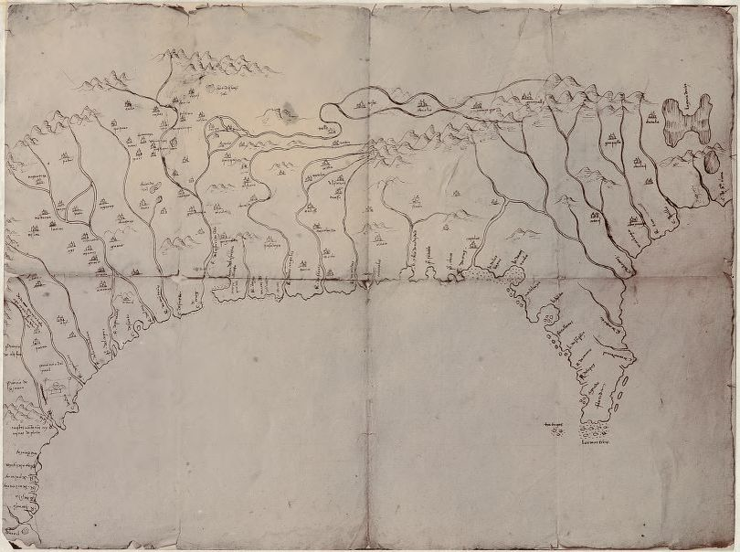

Source C: Peruuiae Avriferæ Regionis Typus by Abraham Ortelius, 1584

Note: This map was included by the Flemish cartographer and publisher, Abraham Ortelius, in the 1584 edition of his monumental atlas, Theatrum Orbis Terrarum. American Indian villages and waterways are clearly marked.

After you read:

1. How are the two maps shown in Sources B and C similar or different? What important physical features are present in both maps? Why might those features be of interest to European explorers?

2. How would future exploration (including by the French) benefit from de Soto’s expedition?

Lesson 2 – Who inhabited the Mississippi River Valley before European colonists?
Student Directions | First, study Source D. Next, read Source E and complete the guiding questions in the right-hand column. Finally, complete the after you read questions at the end of this lesson.
Featured Sources | Source D: Map of Mississippian and Related Cultures in North America.  Source E: Plaquemine Culture by Mark A. Rees and Rebecca Saunders

Source D: Map of Mississippian and Related Cultures in North America.

Note: The map below shows the location of American Indian settlements in North America prior to European colonization. Several of these groups lived in what would become modern-day Louisiana.

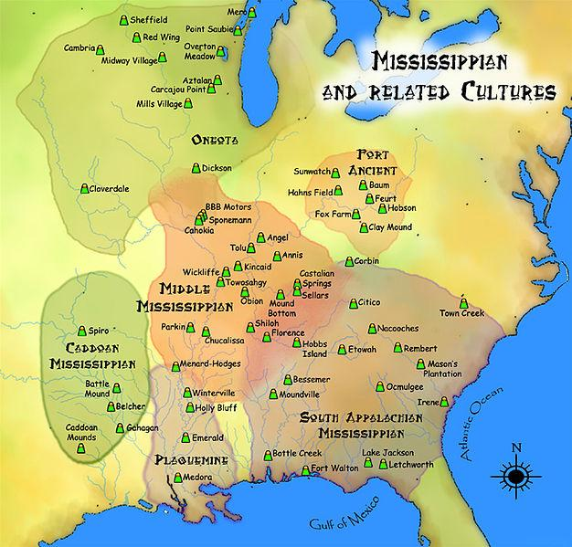

Source E: “Plaquemine Culture” by Mark A. Rees and Rebecca Saunders
Text | Vocabulary | Guiding Questions
In the Mississippi period, which spanned 1200–1700 CE, three distinct cultures were visible in Louisiana. Two of these were native to Louisiana: the Caddo culture occupied northwest Louisiana and the Plaquemine culture ranged along the Lower Mississippi River Valley and adjacent coast.  Indigenous people associated with these cultures interacted, to a greater or lesser degree, with people distinguished by Mississippian culture, which first arose around 1050 CE in the fertile bottomlands near [modern-day] St. Louis.  Mississippian culture had a major influence on many southeastern societies, including those in Louisiana—especially on peoples living in the northeast and extreme southeastern portions of the state. Influences can be seen in the presence of shell-tempered pottery, larger and more elaborate ceremonial centers, maize (corn) agriculture, artifacts associated with social status, and artifacts bearing symbols developed by the Mississippian culture at Cahokia.  The term Plaquemine is applied to late precolonial sites that evolved out of the preceding Coles Creek culture but also may have adopted elements of the pervasive Mississippian culture to the north and east of Louisiana. Plaquemine culture occurred in the Lower Mississippi River Valley from the Gulf Coast to just south of the mouth of the Arkansas River. From west to east, sites are present in the lower Ouachita and Red River Valleys.  The culture is named after the town of Plaquemine in West Baton Rouge Parish, which is near the Medora mound site, where the culture was defined in the 1940s. The site is on the floodplain of Manchac Point, where the Mississippi River takes a hair-pin turn. As at earlier Coles Creek culture sites, stone tools are not common on Plaquemine culture sites. For example, only one projectile point of the Plaquemine culture was found at Medora. However, a few stone artifacts from Medora are typical of Mississippian culture sites. These include two groundstone celts (stone axe heads) and a groundstone spoon-shaped object, all made of greenstone, and a chunkey stone made of polished sandstone. Chunkey was a game played by almost all historic tribes in the Southeast, either in the central plaza of a ceremonial center or in other specially prepared fields. The Medora plaza/field was about two acres; at Cahokia, the grand plaza covered forty-seven acres.  Plaquemine people presumably made other tools from shell, bone, and wood, but few have survived Louisiana’s humid climate and acidic soils. The Discovery site in Lafourche Parish is an exception. Archaeologists recovered sixteen bone projectile points from that site.  Information on the daily lives of Plaquemine people was scarce until 1997, when archaeologists excavated the Discovery site. The site dates between 1450 and 1600 CE, just about one hundred years before the arrival of the French explorer Pierre Le Moyne d’Iberville to south Louisiana. The site contained a long, 131-foot oval shell lens surrounded by an earth midden (organic material and other trash). Evidence for housing—wall trenches, postholes, hearths, and storage facilities (pits)—as well as a cemetery, indicated a sedentary village site. The cemetery area was an important find, because despite the amount of mound excavation that has been done on Plaquemine sites, few Plaquemine burials have been found in Louisiana.  The Discovery site cemetery contained twenty-two graves, holding thirty-seven individuals. The style of burial was highly variable. Some persons were interred soon after death, and the bodies were laid out either supine or, in a few cases, prone. Some individuals were cremated. Some bodies were allowed to decompose until the time came for permanent burial, when the bones were collected and arranged into bundles.  Archaeologists could not associate the type of burial with any particular social status, primarily because no mortuary items were identified. It appears that, at least at the village level in south Louisiana, everyone was equal in death. Burials in Plaquemine mounds in south Louisiana sometimes contained a few pottery vessels, but grave goods were rare. In central and north Louisiana, pottery vessels were more common in mound sites, and a very few mound sites contained other artifacts like ear ornaments, pipes, and projectile points.  Despite the popularity of Mississippian ideas elsewhere, the majority of Plaquemine peoples in Louisiana do not appear to have had much interest in Mississippian things. Most did not trade with groups to the north and east, and most rejected the extreme status hierarchies—as signified by opulent grave goods—of Mississippian culture or societies. The majority of Plaquemine folk maintained the lifestyle of their ancestors, in place more than five hundred years earlier. | Cahokia: a large Mississippian settlement located near modern-day St. Louis  Coles Creek culture: an indigenous group that preceded the Plaquemine  hierarchies: a system or organization in which people or groups are ranked one above the other according to status or authority  opulent: lavish, wealthy | What two cultures were native to Louisiana during the Mississippian period?  ________________________________  ________________________________  ________________________________  ________________________________  ________________________________  How did Mississippian culture influence American Indians in Louisiana?  ________________________________  ________________________________  ________________________________  ________________________________  ________________________________  ________________________________  ________________________________  ________________________________  ________________________________  ________________________________  ________________________________  Where does the term Plaquemine come from?  ________________________________  ________________________________  ________________________________  ________________________________  What artifacts were found in the Medora mound site?  ________________________________  ________________________________  ________________________________  ________________________________  ________________________________  ________________________________  ________________________________  ________________________________  What artifacts were recovered at the Lafourche Parish Discovery site?  ________________________________  ________________________________  ________________________________  ________________________________  ________________________________  ________________________________  ________________________________  ________________________________  ________________________________  How were Plaquemine graves different from ones from Mississippian cultures?  ________________________________  ________________________________  ________________________________  ________________________________  ________________________________  ________________________________  ________________________________  ________________________________
After you read:

1. Using Sources D and E, what American Indian cultures inhabited modern-day Louisiana, Texas, and Mississippi?

2. How did Mississippian culture influence the Plaquemine? In what ways did the Plaquemine culture remain distinct?

Lesson 3 – Who inhabited the Mississippi River Valley before European colonists?
Student Directions | First, read Source F and complete the guiding questions in the right-hand column. Second, study Source G. Third, read Source H and complete the guiding questions in the right-hand column. Fourth, study Source I. Finally, complete performance task #1 at the end of this lesson.
Featured Sources | Source F: “The Caddo Nation” by Dayna Bowker Lee  Source G: Image Bank: Caddo Artifacts  Source H: “Native American Basketry” by Dayna Bowker Lee  Source I: Image Bank: Native American Baskets

Note: The source below describes the Caddo people, a group of American Indians who lived in Northwestern Louisiana prior to the arrival of Europeans.

Source F: “The Caddo Nation” by Dayna Bowker Lee
Text | Vocabulary | Guiding Questions
Caddo people began to inhabit the Red River Valley approximately 2,500 years ago. Around that time, the ancestors of the southern Caddo began to settle in permanent villages, build the first mounds, cultivate plants, and develop the use of ceramics. The backbone of the Caddo world was the Red River, but their extensive traditional territory, known as the Caddoan area, included southwestern Arkansas, northwestern Louisiana, northeastern Texas, and southeastern Oklahoma. The southern Caddo are related linguistically to the Wichita, Pawnee, and the Arikara through the Caddoan language group.  Caddo Organization  The early Caddo settled in hamlets and dispersed villages and occupied ceremonial centers with mounds for elite burials and ritual activities. They produced elaborate cane basketry, shell work, and ceramics and were renowned for their bois d’arc (bows), which they traded, along with salt and other goods, across the American Southeast and southern plains.  The Caddo were sedentary and practiced agriculture, growing maize, beans, squash, and pumpkins. They also gathered seasonal foods such as nuts and berries and hunted extensively. The Caddo maintained a central religious and civil authority in their villages and ceremonial centers, each of which was structured around a hereditary chiefly lineage. . . .  By the Late Caddoan Period, c. 1300–1680, the Caddo were organized in a widespread system of rural communities along rivers and streams. Late Caddo mound sites ranged from one to four small mounds, with larger towns placed along major waterways, primarily the Red and Ouachita rivers. At the time of European contact in the late seventeenth century, the era of Caddo mound building was drawing to a close, although Caddo people continued to utilize some mounds for ceremonial activities. The Caddo also participated in a vast social as well as trading network.  There were at least sixteen separate Caddo groups at the end of the seventeenth century. Variously referred to as villages, bands, or tribes, the nature of these divisions and their relationship to one another is poorly understood.  Recognized as separate entities by colonial and US territorial administrators, by the mid-seventeenth century the Red River bands were collectively identified as “Caddo,” derived from Kadohadacho, the primary Caddo division in the Red River Valley. Although early geographic groupings have been identified as confederacies, the arrangement of Caddo villages reflects a typical Southeastern pattern of east and west divisions of people connected by both kinship and tradition.  Population data for the Caddo at the beginning of the Historic Period (c. 1680–1700) is sketchy at best. Estimates range from 6,000 to as many as 250,000 precontact Caddo. What is certain is that by the time France established an outpost at Natchitoches in 1714, the Caddo had already suffered drastic population loss resulting from the introduction of European pathogens such as influenza and smallpox, to which they had no immunities.  Caddo population continued to decline throughout the remainder of the colonial period and beyond, reaching a population nadir of about five hundred people in the 1890s.  The Arrival of European Settlers  The Caddo welcomed French colonials, who exchanged prestigious European goods like weapons, cloth, mirrors, and glass beads for deer hides, bear oil, livestock, and Indian slaves. French traders often took Caddo wives, and the nations formed a strong alliance through French Canadian adventurer Louis Juchereau de St. Denis and his descendants. Interactions between the St. Denis family and the Caddo came to dominate the regional economy in the Red River Valley throughout the eighteenth century. Colonial governors and administrators maintained diplomatic and commercial relations with the Caddo through a series of long-tenured chiefs called kaadii. | lineage: ancestry, family line  confederacy: a loose political alliance  nadir: lowest point | When did the Caddo people settle in the Red River Valley area?  ________________________________  ________________________________  ________________________________  ________________________________  ________________________________  What goods did the Caddo produce and trade in the American Southeast?  ________________________________  ________________________________  ________________________________  ________________________________  ________________________________  ________________________________  ________________________________  ________________________________  ________________________________  ________________________________  ________________________________  ________________________________  What was the relationship between separate Caddo groups? Where does the term “Caddo” come from?  ________________________________  ________________________________  ________________________________  ________________________________  ________________________________  ________________________________  ________________________________  ________________________________  ________________________________  ________________________________  ________________________________  ________________________________  What caused the drastic population loss suffered by the Caddo?  ________________________________  ________________________________  ________________________________  ________________________________  ________________________________  ________________________________  How did the Caddo initially welcome European settlers?  ________________________________  ________________________________  ________________________________  ________________________________  ________________________________  ________________________________  _______________________________
Source G: Image Bank Caddo Artifacts
Image 1
Note: Hodges-engraved carinated bowl from the Belcher Site, Caddo Parish
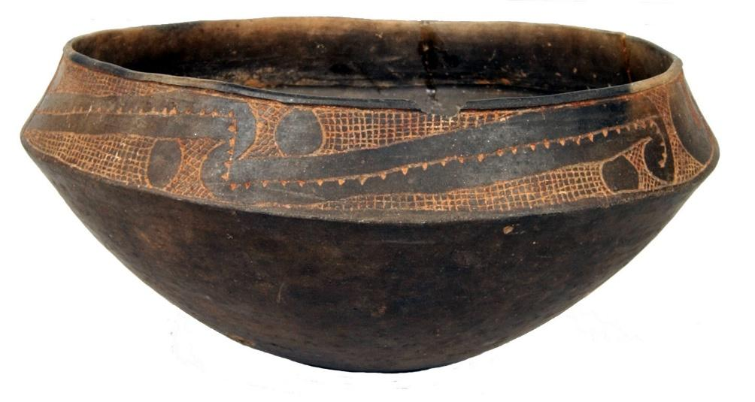

Image 2
Note: Gahagan knives recovered from the Mounds Plantation site in Caddo Parish
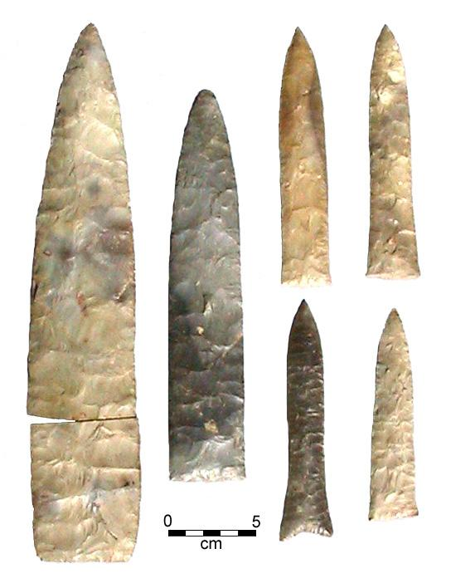
Image 3
Note: Copper-covered stone earspool jewelry recovered from the Mounds Plantation Site

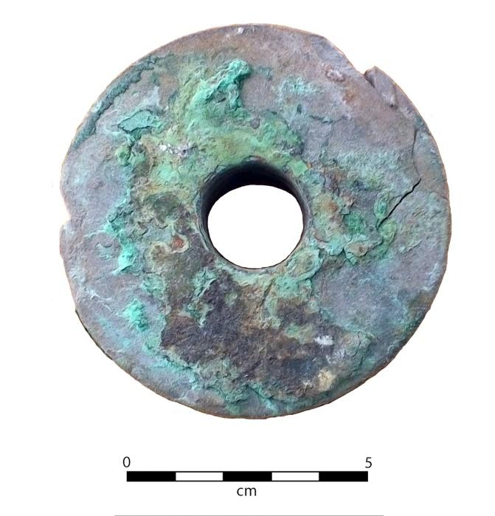
Image 4
Note: Belcher-engraved long-necked bottle from the Belcher Site, Caddo Parish
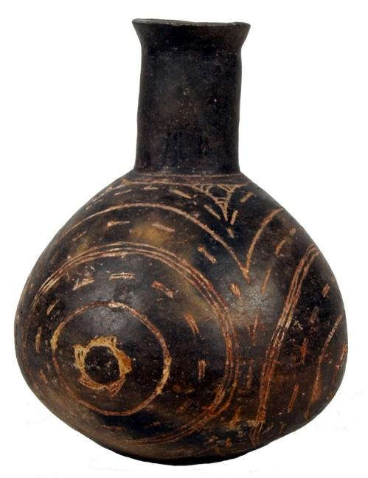
Note: The text below discusses a shared cultural element common to many American Indian groups native to Louisiana, basket weaving.

Source H: “Native American Basketry” by Dayna Bowker Lee (excerpts)
Text | Vocabulary | Guiding Questions
Across the pre-Columbian American Southeast, indigenous women wove cultural identity and social experience into baskets and matting of native cane. A hallmark of southeastern Indian societies, cane basketry traditions persist in fewer than ten contemporary tribal communities in the southeastern United States, including three in Louisiana. Largely created for community use, cane basketry was commodified when southeastern Indians entered into an exchange-based colonial economy with their European neighbors.  Cane basketry is one of the oldest sustained artistic traditions practiced by American Indians. In Louisiana, native Chitimacha, Caddo, Opelousas, and Atakapas weavers crafted utilitarian and ritual items from bamboo-like river cane that was gathered, divided into splints of diverse widths, dried, often dyed, and twilled or woven into baskets and matting.  Baskets could be single or double-walled and were created in a variety of forms and sizes. Some baskets were undecorated or minimally decorated and were used for daily activities like gathering and storing plant foods, winnowing grains, and for storing clothing and other personal items. Matting could be utilized to demark space within houses or used as bedding.  Other baskets and mats were highly embellished with zoomorphic or geometrical designs and motifs created by interweaving splints dyed with tints derived from plant and animal sources and were used for ritual activities like burials.  Colonial Europeans were quick to recognize the usefulness of native technology, particularly crafts like basketry that combined utility with beauty and exotic appeal. Highly skilled native weavers developed local markets among colonial settlers in Louisiana, where paniers sauvages (Indian baskets) were common in household inventories, especially the almost watertight double woven trunks that were crucial for storage in the days when houses had no closets. A few rare examples of colonial-era native basketry survive today as treasured family heirlooms.  The only Louisiana Indians to continuously inhabit a portion of their ancient homelands, the Chitimacha once claimed a vast area stretching from east of the Mississippi River through the Atchafalaya Basin. From the early eighteenth century, Chitimacha basketry was highly prized for its quality and complex designs and Chitimacha basketry can be found in museums throughout the world.  The intricate design motifs on Chitimacha basketry reflect iconography associated with the Southeastern Ceremonial Complex (Southern Cult) of the Mississippian Tradition (ca. A.D. 1200—1600). Unusual among southeastern basketry traditions, Chitimacha designs bear specific names. Designs like nish-tu wa-ki (alligator entrails), tcik ka-ni (blackbird’s eyes), and tcish mish (worm track) reflect the natural world of early weavers “who first captured these impressions in cane.” Chitimacha basketry is so conservative that a basket produced at the turn of the century is indistinguishable from a similar example made today. This remarkable consistency may be attributed in part to the careful curation of heirloom pattern baskets passed down within the families of weavers. | commodified: turned into something to be bought and sold  winnowing: sorting  zoomorphic: in the shape of an animal  motifs: themes, designs | What American Indian groups in Louisiana practiced cane basket making?  ________________________________  ________________________________  ________________________________  ________________________________  ________________________________  ________________________________  ________________________________  ________________________________  ________________________________  ________________________________  What were cane baskets used for?  ________________________________  ________________________________  ________________________________  ________________________________  ________________________________  ________________________________  ________________________________  ________________________________  ________________________________  ________________________________  ________________________________  ________________________________  ________________________________  ________________________________  ________________________________  How do the Chitimacha design their baskets?  ________________________________  ________________________________  ________________________________  ________________________________  ________________________________  ________________________________  ________________________________  ________________________________  ________________________________  ________________________________  ________________________________

Source I: Image Bank: Native American Baskets
Image 1
Note: Rose Langley, Ronald Langley, and Edna Lorena Langley of the Coushatta Indian Tribe, made these contemporary pieces, respectively: "Mask," of pine needles and raffia; "Fanner Basket," of split needle cane and commercial dye; and "Large Turtle Basket with Lid," with pine needles and pine cones.

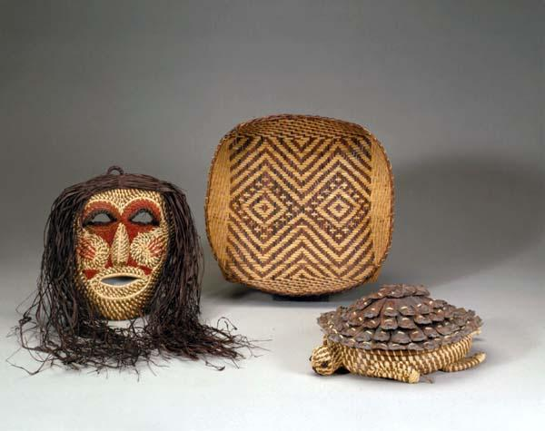

Image 2
Note: Deeply rooted in the history, spirituality, and daily activities of the Chitimacha people, basketry remains a visible expression of the Chitimacha Indian tribe’s culture and tradition.

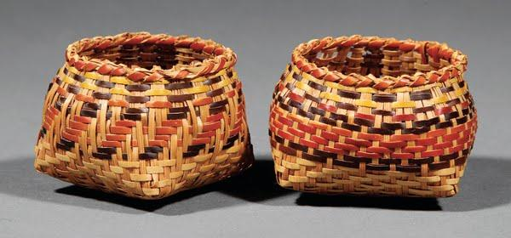

Formative Performance Task #1 – Constructed Response
Student Directions | Based on the sources from this packet and your knowledge of social studies, describe two elements, or practices, of an American Indian culture native to Louisiana.

Lesson 4 – How was Louisiana claimed and settled by France?
Student Directions | First, read Source J and answer the guiding questions in the right-hand column. Next, study Source K, a painting of La Salle claiming Louisiana. Finally, read Source L and complete the guiding and after you read questions at the end of this lesson.
Featured Sources | Source J: “A Brief History of Louisiana to 1812: French Canada Explores the Mississippi River”  Source K: “Rene-Robert Cavelier, Sieur de La Salle, taking possession of Louisiana and the Mississippi River” by Jean-Adolphe Bocquin  Source L: Diary of Jacques de la Metairie, notary on LaSalle’s voyage (1682)
Optional Digital Extensions | Mélchisédech Thévenot's Map of the Gulf  64 Parishes – Rene-Robert Cavelier Sieur de la Salle Article  Louisiana: A History: Episode 1 (from 9:40 – 11:00)

Source J: “A Brief History of Louisiana to 1812: French Canada Explores Mississippi River Valley”
Text | Vocabulary | Guiding Questions
Although French coureurs de bois are believed to have reached the northern Mississippi River by 1659, official exploration of the Mississippi commenced in 1665 with the appointment of Jean-Baptiste Talon as intendant of New France. Talon resolved to expand French governmental control over the Great Lakes Region. He engaged an expedition to locate and survey the fabled Great River, or Father of Waters, rumored to flow through the American interior either into the Gulf of California or the Pacific Ocean to the west, or into the Gulf of Mexico in the south.  Firsthand knowledge of the fabled river and charts of its course gave New France a definite advantage in its contest with Great Britain and Spain for rule over North America. A chain of forts and trading posts extending from the lower reaches of the river to the St. Lawrence stemmed the advance of the English, already established at Hudson’s Bay and along the Atlantic seaboard.  Once France had officially declared sovereignty over virtually all of North America in 1671, Talon was ready to dispatch his expedition for exploring and mapping the Mississippi Valley. As its leader he chose the French Canadian surveyor, cartographer, and explorer Louis Jolliet, who was accompanied by Jacques Marquette, a Jesuit missionary and scholar of Indian languages. They embarked in May 1673, and following the course of the Wisconsin River, reached the Great River on June 17, exactly one month later.  In addition to having deduced the Mississippi’s course to the south, Marquette and Jolliet first reported on the Missouri River, which they called by its Native American name, Pekitanoui, or Muddy River. Marquette, in his memoir, erroneously proposed the Missouri River as a route to the Pacific Ocean. The first published depiction of the discoveries of Marquette and Jolliet appeared in a map drawn by the French traveler and writer, Mélchisédech Thévenot, to accompany a printed version of Marquette’s narrative included in Thévenot’s Recueil de Voyages in 1681. (See the digital extensions to view his map.)  One year after Thévenot’s map provided the Western world with its initial view of the Mississippi River, René-Robert Cavelier, Sieur de La Salle took formal possession of the Mississippi Valley for France and moved towards his goal of building a French commercial and military empire stretching from the St. Lawrence Seaway to the Gulf of Mexico. At a time when French energies and finances were devoted to wars in Europe rather than colonies in America, La Salle’s confidence gained the support of Governor Frontenac and the endorsement of the French Crown for erecting forts in western New France and profiting from a monopoly in hides.  Despite setbacks that would have discouraged a less audacious man, La Salle pursued his quixotic agenda by bold means. An enemy of Canadian fur traders and Jesuits, he was befriended by the indomitable soldier and explorer Henri de Tonti. With Tonti, the priests Zenobius Membré and Louis Hennepin, and a group of French and Canadian woodsmen, laborers, and Native Americans, La Salle entered the Mississippi in early February 1682 and reached its mouth three months later.  In order to sustain what tenuous hold La Salle and France had on the lower Mississippi Valley, a fort and colony needed to be established at the river’s mouth to guard against English or Spanish intrusions. La Salle repaired to France to seek the crown’s support. Realizing that royal patronage would be withheld if his colony could not be proven economically viable, he was forced to compromise the integrity of his project, falsifying the geography of the river’s course. La Salle described its mouth as being far west of its true location by about 8 degrees of longitude, or roughly 500 miles, where it would serve as an ideal location for staging incursions into Spanish settlements and attacks on the silver mines of northern Mexico.  Having gained French support for his project, La Salle attempted to return to the Mississippi by way of the Gulf Coast in 1684–85, but his ships missed the mouth of the river and the expedition landed at Matagorda Bay, Texas. Two years of starvation and disease followed and subsequently a mutiny took his life. La Salle failed to establish a permanent colony in the lower Mississippi Valley, but he did plant French claims over the vast region that eventually became the Louisiana Purchase. | coureurs de bois: a woodsman or trader of French origin  sovereignty: the authority of a state to govern itself or another state  Jesuit: a Catholic missionary  deduced: discovered  erroneously: mistakenly  René-Robert Cavelier, Sieur de La Salle: a fur trader and French explorer  hides: animal skin and furs  quixotic: overly idealistic, unrealistic  indomitable:  stubborn, persevering  tenuous: very weak  repaired: returned  incursion: a sudden or brief attack  mutiny: an open rebellion | What gave France an early advantage in its competition for North America with Great Britain and Spain?  ________________________________  ________________________________  ________________________________  ________________________________  ________________________________  ________________________________  ________________________________  ________________________________  ________________________________  ________________________________  Why were Jolliet and Marquette chosen to explore and map the Mississippi Valley?  ________________________________  ________________________________  ________________________________  ________________________________  ________________________________  ________________________________  ________________________________  What did La Salle hope to build in the New World?  ________________________________  ________________________________  ________________________________  ________________________________  What did La Salle and company reach in February 1682?  ________________________________  ________________________________  ________________________________  ________________________________  What did France need to build in order to defend against Spanish and English attacks?  ________________________________  ________________________________  ________________________________  What ultimately happened to La Salle?  ________________________________  ________________________________

Source K: “Rene-Robert Cavelier, Sieur de La Salle, taking possession of Louisiana
and the Mississippi River” by Jean-Adolphe Bocquin
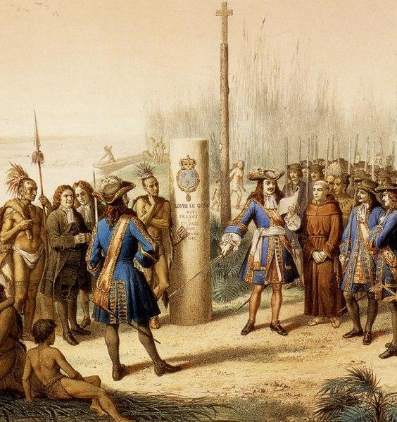

Image Analysis

1. How does Jean Adolphe Bocquin portray La Salle taking possession of Louisiana? How does the artist, a French subject, portray the other people in attendance?

Note: The source below is an excerpt from the diary of a French notary who traveled with LaSalle. Though LaSalle claimed all the land surrounding the Mississippi River, the territory continued to be controlled by indigenous peoples for years.

Source L: Diary of Jacques de la Metairie, notary on LaSalle’s voyage (1682)
Text | Vocabulary | Guiding Questions
When we discovered three channels by which the River Colbert discharges itself into the sea, we landed on the bank of the western channel about three leagues from its mouth. . . Here we prepared a column and a cross, and to the said column were affixed the arms of France with this inscription:  Louis the Great, King of France and Navarre, Reign; The Ninth April 1682. . . after a salute of fire-arms and cries of Vive le Roi the column was erected by De La Salle, who standing near it, said with a loud voice: “In the name of the most high, by the grace of God, King of France . . . this ninth day of April, one thousand six hundred and eighty-two, I, in virtue of the commission of his Majesty (Louis XIV) which I hold in my hand, and which may be seen by all whom it may concern, have taken and do now take in the name of his Majesty and of his successors to the crown, possession of this country of Louisiana . . . the River Colbert and rivers which discharge themselves therein. . . from the source of the great river . . . as far as the mouth at the . . . Gulf of Mexico. . . Upon the assurance which we have received from all these nations that we are the first Europeans who have descended or ascended the River Colbert, hereby protesting against all those who may in future undertake to invade any or all these countries, people, or lands.” | River Colbert: original French name of Mississippi River  Vive le Roi: French for “long live the king”  discharge themselves therein: rivers which flow into the Mississippi | According to Metairie, what did they discover?  ________________________________  ________________________________  ________________________________  ________________________________  ________________________________  ________________________________  According to La Salle, what gives him the power to claim the land for France?  ________________________________  ________________________________  ________________________________  ________________________________  ________________________________  ________________________________

After you read:
1. What about La Salle’s claim to Louisiana is misleading or does not acknowledge the reality of the situation in the area surrounding the Mississippi River?

2. Using Sources J, K and L, why is La Salle an important figure in French colonial history?

Lesson 5 – How was Louisiana claimed and settled by France?
Student Directions | First, read Source M and complete the guiding questions in the right-hand column. Next, examine Sources N and O and complete the after you read questions at the end of this lesson.
Featured Sources | Source M: “A Brief History of Louisiana to 1812: Difficult Early Years of the Colony”  Source N: “Le Commerce que les Indiens du Mexique Font avec Les Francois au Port de Missisipi,” François-Gérard Jollain, publisher  Source O: “The Street of Speculators during the Mississippi Bubble,” Office of War
Optional Digital Extensions | Louisiana: A History: Episode 1 (11:00–28:25)  64 Parishes - John Law

Source M: “A Brief History of Louisiana to 1812: Difficult Early Years of the Colony”
Text | Vocabulary | Guiding Questions
From its inception Louisiana faced an inauspicious existence. Its fate was bound to the French economy during the last years of the reign of Louis XIV. Already a vast empire, the French government and its highly centralized bureaucracy disliked policies that would have nurtured the economic independence of its colonies. Further, the French treasury, depleted by wars in Europe, was unable to finance adequately the Department of the Marine, which oversaw colonial operations.  Although all French colonies were subject to the same desperate circumstances, the Mississippi colony, as the newest in the French imperial system, fared the worst. During the colony’s infant stages Louisiana’s settlers were neglected by the government and left entirely to their own resources. Lured by promises of mines and gold, most of the early settlers made little effort to hunt or plant crops. Few farms developed along the banks of the Mississippi or along the sandy coast.  Since the earliest settlers were never furnished with adequate food supplies, they frequently resorted to scavenging for crabs, crayfish, and seeds of wild grasses. Whenever possible they traded blankets and utensils for corn and game with the surrounding Native American tribes. Disease, particularly yellow fever, diminished the community. Floods, storms, humidity, mosquitoes, and poisonous snakes added to the misery.  Having maintained direct control over its Mississippi colony for 13 unprofitable years, the French court held less than sanguine prospects for its future development. In an effort to instill vitality into Louisiana, King Louis XIV granted a proprietary charter on September 14, 1712, to the merchant and nobleman, Antoine Crozat. The royal charter afforded Crozat exclusive control over all trading and commercial privileges within the colony for a 15-year period. Crozat gained a monopoly over all foreign and domestic trade, the right to appoint all local officials, permission to work all mines, title to all unoccupied lands, control over agricultural production and manufacture, and sole authority over the African slave trade. In return he was obligated to send two ships of supplies and settlers annually and to govern the colony in accordance with French laws and customs.  The colony could neither be governed adequately nor profited from. Estimates placed Crozat’s losses in Louisiana at just under 1 million French livres (about $1 billion). Unable to sustain the colony any longer, in August 1717 he petitioned the king and his ministers for release from his charter.  Crozat’s failure to turn Louisiana to his financial advantage once more made the colony a ward of the crown. In September 1717, the Regent of France, Philippe, Duke of Orléans, fearing that the province would again drain his country’s already bankrupt treasury, placed its fortunes into the hands of John Law, a Scottish investment banker. Law cultivated a childhood talent for equations and games of chance into a career as a financier. His Company of the West, more commonly known as the Mississippi Company, was granted a 25-year proprietorship with a commercial monopoly over the colony, along lines similar to given to Crozat.  Seeing an opportunity to simultaneously pay off the public debt and develop Louisiana by using the bank’s deposits, Law also offered his company’s shares to the public. The Company of the West later merged with the French East India Company and several trading concessions to form the Company of the East, which became responsible for managing the collection of revenues and taxes.  The company’s stock soared in value, the bank continued to print money, shareholders indulged in their newfound paper wealth, and Law became the toast of France. Law himself fueled the frenzy by having ingots of gold, advertised as being from the mines of Louisiana, displayed in the shop windows of Paris.  Promotional literature, much of it including maps of Louisiana, added to Law’s inflated reputation and roused interest in his plans for developing and settling New France. The wild speculative frenzy that had inflated the company’s stock to outrageous levels burst in 1720, when Law’s organization was forced into bankruptcy by reports of mismanagement and dire hardships in the colony.  The failure of the company took down its chief creditor, the Bank of France, and financial ruin descended upon thousands of investors on the continent, including John Law, who was run out of Paris by a mob. After several reorganizations and years of financial reverses incurred in managing affairs in Louisiana, the directors of the Company of the East returned the colony to Louis XIV in 1731. | inception: beginning  inauspicious:  unpromising  bureaucracy: unelected state officials  furnished: given  sanguine: optimistic or positive  livres: a unit of currency  cultivated: worked to grow  monopoly: the exclusive control of the supply or trade of a good or service  ingots: block of gold, silver, or other metal | What attracted settlers to the colony in the early years?  ________________________________  ________________________________  ________________________________  ________________________________  ________________________________  ________________________________  ________________________________  ________________________________  ________________________________  ________________________________  ________________________________  ________________________________  What challenges did the early settlers face in Louisiana?  ________________________________  ________________________________  ________________________________  ________________________________  ________________________________  ________________________________  ________________________________  ________________________________  ________________________________  ________________________________  ________________________________  ________________________________  How did Antoine Crozat come to control the colony? How did it fare under his leadership?  ________________________________  ________________________________  ________________________________  ________________________________  How did John Law’s Company of the West come to control the colony?  ________________________________  ________________________________  ________________________________  ________________________________  ________________________________  ________________________________  ________________________________  ________________________________  Why did Law’s company end up in bankruptcy? Who regained control of the colony?  ________________________________  ________________________________  ________________________________  ________________________________

Source N: Le Commerce que les Indiens du Mexique Font avec Les Francois au Port de Missisipi
Note: Scene of trade between French colonists and American Indians at the mouth of the Mississippi River; this engraving was distributed by agents of John Law to promote investment in the Company of the West and emigration to the Louisiana colony.

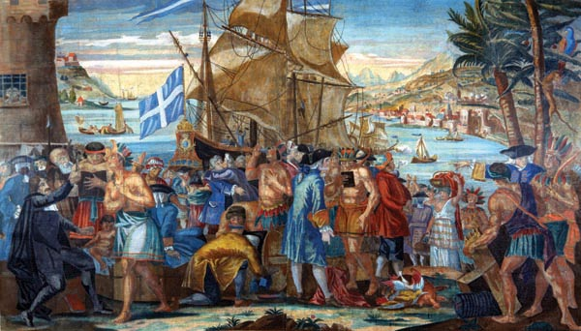

Source O: The Street of Speculators during the Mississippi Bubble
Note: This image depicts the frenzy of speculation during the Mississippi Bubble, when many French investors bought stock in John Law’s company, which would ultimately go bankrupt. Investors are
so eager to sign up, one can be seen using another’s back as a desk.

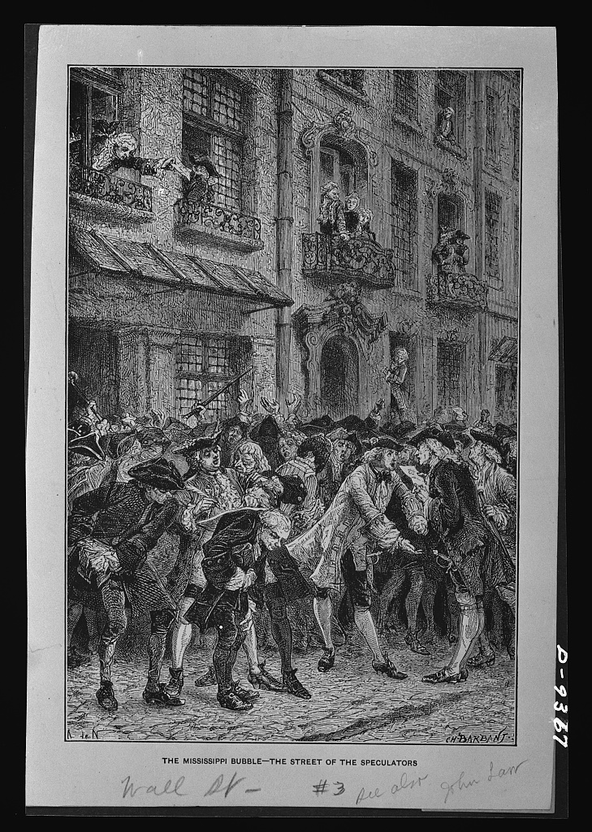

After you read:

1. How is the image of the colony presented in Source N misleading? Why would John Law and others invested in the Company of West promote such images to potential colonists?

2. Why were both Crozat and Law unable to make the colony economically successful? How did this affect future French efforts in Louisiana?

Lesson 6 – How was Louisiana claimed and settled by France?
Student Directions | First, read Source P and complete guiding questions in the right-hand column. Next, study both Sources Q and R and complete performance task #2 at the end of this lesson.
Featured Sources | Source P: “A Brief History of Louisiana to 1812: Bienville and the Founding of New Orleans”  Source Q: “Early Map of New Orleans” by George E. Waring (1728)  Source R: Timeline of European Exploration of Louisiana
Optional Digital Extensions | Louisiana: A History: Episode 1 (28:00–41:00)  64 Parishes – Jean Baptiste Le Moyne Sieur de Bienville

Source P: “A Brief History of Louisiana to 1812: Bienville and the Founding of New Orleans”
Text | Vocabulary | Guiding Questions
Despite the unwillingness of French citizens to leave France for Louisiana, Law’s company was obliged to populate the colony with new citizens. Arrangements were made with the government to force inmates of prisons, asylums, and houses of corrections to emigrate. In an effort to improve the quality–and quantity–of its colonists, the company resorted to furnishing large land grants to wealthier Europeans who promised to settle the grants with their families.  Later, the Company of the East agreed to pay emigration expenses and furnish each family with livestock, supplies, and food. Between 1717 and 1722 several thousand families and individuals from the German Rhineland, Switzerland, and the Low Countries (the Netherlands, Belgium, and Luxembourg)–the countries on low-lying land around the delta of the Rhine and Meuse rivers–took up residence in settlements along the Mississippi just above New Orleans in an area that soon became known as La Côte des Allemands, or the German Coast. These settlers were industrious farmers and their efforts laid the basis for agriculture in Louisiana.  Law’s scheme ultimately advanced the crown’s desire to populate Louisiana by transporting émigrés from France and elsewhere to settlements along the Gulf Coast and Mobile, as well as to other locales in the lower Mississippi Valley. If the population were to expand, however, so would the need for providing them with an adequate and well-founded seat of local government, preferably at a location that controlled transportation and communications along the Mississippi River.  Possibly the most ardent proponent of establishing a permanent capital for Louisiana was Jean Baptiste Le Moyne, Sieur de Bienville. For many years Bienville had in mind a proper site for a capital. This site lay on a slightly elevated tract of land at a bend of the Mississippi closest to Lake Pontchartrain. This location also commanded a handsome view of approaching ships from the east bank of the river. When Bienville was reinstated as governor of the colony, he was authorized in 1717 to establish his capital and trading post on the banks of the river. Wanting to name the seed of his city in honor of the company’s friend and patron, the Duke of Orleans, he called it La Nouvelle-Orléans, or New Orleans.  A year after its founding, New Orleans consisted of a few dwellings and storehouses by the riverbank, vulnerable to perennial flooding despite feeble protection afforded by a levee, drainage ditches, and a moat. After its destruction by a hurricane in 1719, the city’s site was reassessed by engineer Le Blond de La Tour. Despite his adverse appraisal, work continued under the assistant engineer, Adrien de Pauger, who properly surveyed the land and oversaw the construction of the first four blocks in 1720. Probably within a year de Pauger prepared plans for a more permanent city. His plan of New Orleans may have been a collaborative design between the two engineers, who had already established the settlement at New Biloxi.  Census figures for New Orleans in 1721 reveal that within three years of its founding the town’s population stood at 372 persons, including 147 men, 65 women, 38 children, 28 servants, 73 African slaves, and 21 Native Americans.  To this day, New Orleans remains a community defined by its heterogeneous mixture of races and bound by longstanding cultural affinities. With the relocation of the capital to New Orleans, the colony of Louisiana acquired the beginnings of permanence. New France, until then consisting entirely of Canada, acquired a southern component worthy of its equal at the opposite end of the Mississippi Valley. Imperial France, by attempting to establish a firm presence at the mouth of the Mississippi, had in effect taken the first steps towards uniting defenses and communications from Quebec to New Orleans and was in a position to command access to the Great Plains and beyond. | furnishing: giving  industrious: hardworking  émigrés: a person who has left their own country to settle in another  ardent: enthusiastic  Bienville: brother of Iberville, a French explorer who helped set up the French colonies in the Gulf near at Mobile and Biloxi  perennial: enduring or continually recurring  feeble: weak  hetero-  geneous: diverse  permanence: a state or quality of lasting | How did John Law’s company work to send more colonists to Louisiana? What problems did they face? What successes did they have?  __________________________________  __________________________________  __________________________________  __________________________________  __________________________________  __________________________________  __________________________________  __________________________________  __________________________________  __________________________________  __________________________________  What did Bienville advocate for building in Louisiana?  __________________________________  __________________________________  __________________________________  __________________________________  __________________________________  __________________________________  __________________________________  __________________________________  __________________________________  __________________________________  Why was New Orleans chosen as the site for a permanent capital in Louisiana?  __________________________________  __________________________________  __________________________________  __________________________________  __________________________________  __________________________________  __________________________________  __________________________________  __________________________________  __________________________________  Why would settling New Orleans give the colony a sense of permanence?  __________________________________  __________________________________  __________________________________  __________________________________  __________________________________  __________________________________  __________________________________

Source Q: Early Map of New Orleans (1728)

Jean Baptiste Le Moyne Sieur de Bienville and architects from France planned and built New Orleans over 100 miles from the mouth of the Mississippi River in 1718. The site for New Orleans was chosen because it was on high ground and on a bend on the river which created a natural levee.

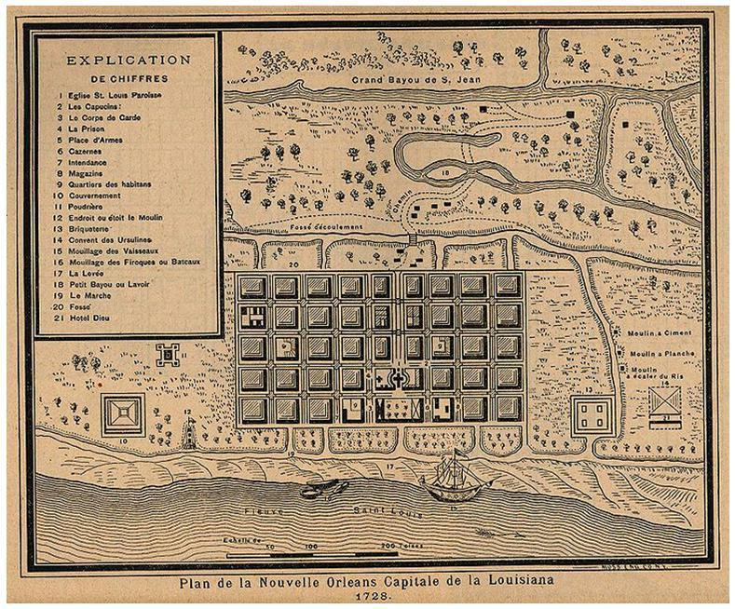

Source R: Timeline of European Exploration of Louisiana

1630s–1640s
The French establish themselves as fur traders in French Canada.

1538–1542
Hernando De Soto travels throughout the southeastern part of North America looking for precious metals. His expedition reaches the Mississippi River.

1699
French officials pick Pierre Le Moyne d’Iberville to lead an expedition to set up a colony in Louisiana. He settles near present day Biloxi Mississippi.

1702
Iberville moves the colony to present day Mobile Bay Alabama. Iberville leaves the colony and gives power of the colony to his brother Jean-Baptiste Le Moyne Sieur de Bienville.

1673
The French start expanding their trading network further south. Marquette and Joliet go on a voyage to explore the Mississippi River and reach southern Arkansas.

1718
Bienville sets up a city thirty leagues up the Mississippi River and calls it New Orleans. The city is located on the east bank of the river on a natural high spot.

April 9, 1682
La Salle reaches the mouth of the Mississippi River and claims it and its tributaries to be officially a part of France.

1687
La Salle returns to set up a fort at the mouth of the Mississippi River. He cannot locate the mouth of the river. His crew eventually mutinies against him and he is killed in modern-day Texas.

Early 1700s
France is at war in Europe. The colony in Louisiana is neglected.

Formative Performance Task #2 – Write a Summary
Student Directions | Based on the sources from this packet and your knowledge of social studies, summarize the events that led to France claiming Louisiana and settling the city of New Orleans.

Lesson 7 – What challenges did colonists face in French colonial Louisiana?
Student Directions | First, read Sources S, T and U and answer the guiding questions in the right-hand column. Next, complete performance task #3 at the end of this lesson.
Featured Sources | Source S: “French Colonial Louisiana” by Michael T. Pasquier (excerpts)  Source T: Excerpts from A History of the Foundation of New Orleans by Baron Marc de Villiers  Source U: “A Brief History of Louisiana to 1812: Hostilities on the Frontier”
Optional Digital Extensions | 64 Parishes - Natchez Revolt of 1729  Louisiana: A History: Episode 1 (41:20–45:30)

Source S: “French Colonial Louisiana” by Michael T. Pasquier (excerpt)
Text | Vocabulary | Guiding Questions
French Crown officials paid little attention to the needs of Lower Louisiana during the early 1700s because of their involvement in the War of Spanish Succession (1701–1714). Lacking official support, Iberville and his elite associates were unable to implement the conventional French mercantilist practice of exploiting natural resources (furs, minerals, cash crops) from colonial territories. To compensate for supply shortages, French colonists relied heavily on the slave labor and agricultural acumen of neighboring Native American groups.  To protect against the slave raids and military advances of British-allied tribes such as the Creek, Native American villages in the vicinity of Mobile developed close working relationships with the French. The Choctaw and Chickasaw were especially influential in how the French developed strategies to defend against British encroachment throughout frontier areas east of the Mississippi River. The close interconnectedness of Native Americans and Europeans during this early colonization phase convinced historian Daniel Usner to describe French colonial Louisiana as a “frontier exchange economy” influenced by local and regional networks as well as transatlantic and global movements.  A 1708 census recorded 339 individuals in the French colony: 60 Canadian coureurs des bois (woods runners or backwoodsmen); 122 soldiers, seamen, and craftsmen employed by the Crown; and 157 Indian slaves and European men, women, and children. A handful of Catholic missionary priests traveled through or settled in the colony, though with limited success at evangelizing Native Americans and gaining support from the French laity. With no clear leader, the political organization of Louisiana bore modest resemblance to Canada, its neighbor to the north. | encroachment: invasion  evangelizing: to convert or seek to convert someone to Christianity | Why did the French government pay little attention to Louisiana in the early 1700s?  ________________________________  ________________________________  ________________________________  ________________________________  ________________________________  ________________________________  Why did the French fear British-allied American Indian tribes?  ________________________________  ________________________________  ________________________________  ________________________________  ________________________________  Based on the census, how successful was the colony in 1708?  ________________________________  ________________________________  ________________________________

Source T: A History of the Foundation of New Orleans by Baron Marc de Villiers, 1920 (excerpts)
Text | Vocabulary | Guiding Questions
In the month of March 1718, the New Orleans establishment was begun. It is situated at 29° 50’, in flat and swampy ground fit only for growing rice; river water filters through under the soil, and crayfish abound, so that tobacco and vegetables are hard to raise. There are frequent fogs, and the land being thickly wooded and covered with canebrakes, the air is fever laden and an infinity of mosquitoes cause further inconvenience in the summer. . .  The climate of New Orleans encouraged epidemics which on several occasions decimated the population. If we are to believe D’artaguette, eight or nine people per day, or one-sixtieth of its inhabitants were dying in the capital, when he came down from Illinois in September 1723. Two years before, one thousand had died at Biloxi. A new epidemic raged in the summer of 1725; Father Raphael wrote: “There are not two people who have not been ill.” | canebrake: a piece of ground covered with dense growth  epidemic: a widespread occurrence of an infectious disease | What does Source T say about the potential for agriculture in the New Orleans area?  ________________________________  ________________________________  ________________________________  ________________________________  What problems did disease cause in New Orleans and Louisiana?  ________________________________

Source U: “A Brief History of Louisiana to 1812: Hostilities on the Frontier”
Text | Vocabulary | Guiding Questions
By the 1720s the Native Americans of the lower Mississippi Valley were beginning to resent openly the growing European presence in their tribal homelands. During the early period of French settlement of what is present-day Louisiana, the area was inhabited by six Native American linguistic groups—the Caddoan, Tunican, Atakapan, Chitimachan, Muskogean, and Natchezan.  Each group was composed of a number of different tribes and each resided within a separate region of the colony. Although the many tribes differed in traditions, languages, religion, and customs, they also shared many similarities. Most tribes lived along the banks of lakes and rivers, upon which they could travel for trade in foodstuffs and finished products, as well as communicate in the regional dialect of Mobilian. They supported themselves by hunting, fishing, gathering, agriculture, and trade.  At first, the French were able to cultivate relatively friendly relations with the various Louisiana tribes. However, as more French settlers began to encroach on lands occupied by Native Americans, colonial administrators were faced with the dilemma of maintaining good relations with the tribes while satisfying growing demands of their colonists for arable lands.  In general, the Native American policy of Bienville’s successor, Étienne Boucher de la Périer de Salvert, disfavored tribal ownership of property. As the nine Natchez villages occupied some of the most desirable lands in the colony, the situation was ripe for conflict. The French engaged in three wars with the Natchez Indians.  In 1729 full-scale conflict erupted between the French and the Natchez when Périer unwisely supported a punitive order given by the commandant of Fort Rosalie to force the Natchez from their village of White Apple and abandon all adjoining lands under cultivation. The fort, erected by the French in 1716 on the bluffs of the Mississippi, overlooked the Great Village and its surrounding fields.  The Natchez responded out of desperation with a surprise attack on November 26, 1729, killing about 250 settlers of the region, including the commandant of the post, and enslaving 300 others. Additional tribes from other parts of the colony joined the uprising. A combined force of mostly French and Choctaws mobilized for a counterattack on the Natchez.  After being routed, the Natchez withdrew to defenses and managed to fend off their opponents until early 1731, when they were driven out and either killed or captured and sold into slavery. The few who escaped ultimately became assimilated with other tribes, such as the Chickasaw. As a result of the war, the Natchez nation was driven to extinction.  In early 1731 Louisiana found itself once again a dependent of the French Crown. King Louis XV (reigned 1715 – 74 ) and his ministers immediately turned to Bienville, making him the royal governor of the province.  Upon his return in 1733 Bienville faced a growing threat from the Chickasaw Indians, who occupied the western parts of the present-day states of Kentucky and Tennessee. Chickasaw resistance to French rule dated to 1720, when the French set their Choctaw allies against the Chickasaw for having established trade ties with the English in the Mississippi Valley.  To Bienville’s dismay, the Chickasaw provided refuge to members of the Natchez tribe who had survived the punitive expeditions under Governor Périer, and, to the further detriment of the French, had rejected renewed demands for ceasing their trade with the British. When the Chickasaw refused an order to surrender the remaining Natchez rebels, Bienville went to war.  For years the French waged an unsuccessful war of vengeance against the fierce and well-defended Chickasaw. Major military campaigns undertaken in 1736, 1739, and 1752 resulted in either defeat for the French or inconclusive results. By the end of French rule over Louisiana, the Chickasaw remained unvanquished.  The Indian wars of Périer and Bienville resulted in economic and military difficulties in the colony. Trade and currency reforms instituted in the early 1730s failed to revive Louisiana’s sluggish economy. By the end of the decade, natural disasters, combined with a shortage of currency, led to a decline in agricultural production and export trade. As a result, the quality of life further diminished for a population whose ranks were already thinned by yellow fever epidemics and decreasing immigration. | resent: to feel bitterness at a situation or person  arable: land usable or suitable for farming  routed: defeated  dismay: distress caused by something unexpected  punitive: inflicting punishment  detriment:  causing harm | How did relations between various Louisiana tribes and French settlers change by the 1730s?  ________________________________  ________________________________  ________________________________  ________________________________  ________________________________  ________________________________  ________________________________  ________________________________  ________________________________  ________________________________  ________________________________  ________________________________  What led to conflict with the Natchez, and what was the outcome?  ________________________________  ________________________________  ________________________________  ________________________________  ________________________________  ________________________________  ________________________________  ________________________________  ________________________________  ________________________________  ________________________________  ________________________________  ________________________________  ________________________________  ________________________________  ________________________________  ________________________________  ________________________________  ________________________________  ________________________________  ________________________________  How did Bienville’s war against the Chickasaw affect the colony?  ________________________________  ________________________________  ________________________________  ________________________________  ________________________________  ________________________________  ________________________________

Formative Performance Task #3 – Constructed Response
Student Directions | Based on the sources from this packet and your knowledge of social studies, describe two challenges faced by colonists in French Louisiana.

Lesson 8 – How did Louisiana continue to develop before the French and Indian War?
Student Directions | First, read Source V and W and answer the guiding questions in the right-hand column. Next, answer the after you read questions at the end of this lesson.
Featured Sources | Source V: “French Colonial Louisiana” by Michael T. Pasquier (excerpts)  Source W: “Slavery in French Colonial Louisiana” by John C. Rodrigue (excerpts)

Source V: “French Colonial Louisiana” by Michael T. Pasquier (excerpts)
Text | Vocabulary | Guiding Questions
Military expeditions against the Natchez and Chickasaw produced mixed results. French forces failed to achieve any clear victories over the Chickasaw, while their ties with the Choctaw became ever more tenuous. At the same time, French officials attempted to revitalize the economy of Louisiana by encouraging the production of tobacco and trade with French ports such as La Rochelle and Bordeaux, again with only moderate success.  Inflation of the currency and poor weather, including a devastating hurricane, did not make their jobs easier. Much of the blame for the colony’s decline fell upon Bienville, who was finally replaced as governor in 1742 by the Marquis Pierre de Rigaud de Vaudreuil de Cavagnial. With the governorship of Vaudreuil came a previously unattained level of prosperity in Lower Louisiana. From 1744 to 1755, colonial leaders realized increases both in trade and population, this despite French involvement in the War of Jenkins’ Ear (1739–1742) and the War of Austrian Succession (1740–1748).  Some large plantation owners along the Mississippi River replaced tobacco with the more profitable indigo, though small-scale farming of other cash crops and lumbering continued. Louisiana merchants enhanced trade with Spanish ports in Cuba, Mexico, and Florida. Trade between Dauphin Island (near Mobile) and Pensacola, in particular, remained strong through much of the 1750s.  Some historians estimate a 50 percent increase in population during this period, due primarily to the arrival of fils de cassette (coffer girls), Alsatians, and French soldiers. Most Europeans lived in the vicinities of New Orleans, Mobile, or Natchez. The increase in plantation productivity also marked an increase in the importation of slaves, most of whom came from the French West Indies. | tenuous: weak, slight  revitalize: to put life back into, re-energize  fils de cassette: French for casket girl, a term for a woman brought to Louisiana to marry  Alsatians: people from a region of France which borders Germany; their native language, Alsatian, is a dialect of German | What were the results of the war with the Natchez and Chickasaw?  ________________________________  ________________________________  ________________________________  ________________________________  ________________________________  ________________________________  ________________________________  ________________________________  What did some large plantations begin farming in Louisiana?  ________________________________  ________________________________  ________________________________  ________________________________  ________________________________  ________________________________  What increased the population in the colony?

Source W: “Slavery in French Colonial Louisiana” by John C. Rodrigue (excerpts)
Text | Vocabulary | Guiding Questions
In as early as 1699, when Pierre Le Moyne d’Iberville first began to develop the French colony of Louisiana, he petitioned the king to allow a slaving expedition to the west coast of Africa to procure captive laborers. Although the first cargo of enslaved Africans did not arrive in Louisiana until 1719, a census of the colony in 1708 counted eighty Indian men and women held as slaves among the total population of 278.  Between 1719 and 1731, when the Company of the Indies was in charge of economic development in Louisiana, the company’s ships landed more than six thousand Africans who were sold into slavery. The French instituted the Code Noir, a set of laws that was supposed to ensure the well-being of the enslaved workers while keeping them under control, but the laws were frequently ignored by owners and slaves.  Slavery in Louisiana under French rule has to be viewed against general conditions in the colony. For much of the period, Louisiana struggled for survival, and it never developed into the profitable, self-sustaining colony its founders had intended. French colonial Louisiana was more a “society with slaves” than a full-fledged “slave society,” a distinction commonly used by scholars who study the history of slavery in the United States. There were few enslaved people in Louisiana before 1720. As in other New World colonies, efforts to enslave the Indian population in Louisiana proved futile and contributed to the colonial authorities’ decision to import enslaved Africans.  The large majority of the approximately six thousand slaves imported into Louisiana during the entire French period arrived during the 1720s, when the Company of the Indies controlled the colony’s economic development. Following the bursting of the Mississippi Bubble in 1720 the unprofitable Louisiana colony was heavily subsidized by profits from the company’s holdings in the West Indies and elsewhere. The 1729 Natchez Indian revolt ended such support by the early 1730s.  Daily Life  Slaves devoted most of their waking hours to labor. The primary cash crops during this period were tobacco and indigo, with cotton and sugar emerging only later. Many slaves worked on plantations, but the plantation system as a whole had not yet come to dominate Louisiana society; many slaves lived and worked on farms and smaller holdings, while others labored at a host of nonagricultural tasks.  Moreover, because of the overall importance of New Orleans to the colony, slavery there was more urban-centered than in other colonies. Historian Lawrence N. Powell has asserted that “Africans were the only segment of the surging population capable of pulling New Orleans and the Lower Mississippi Valley out of the mud.” Powell notes that they dug the drainage canals, laid out the streets, and moved massive amounts of earth to raise the levees that protected the town. Many of the enslaved West Africans in New Orleans had been artisans or boatmen in their homelands. Because French tradesmen were in short supply, newly arrived West Africans were trained as coopers (barrel makers) and blacksmiths. As a result, they enjoyed a greater measure of economic autonomy than did slaves in the countryside. Their owners hired them out, and the enslaved workers sometimes were allowed to keep a portion of their wages. Even outside the city, however, some slaves were similarly hired out and allowed a degree of autonomy.  Despite the many difficulties the colony faced, by mid-century Louisiana was well on its way toward becoming a plantation society based on racial slavery. Slave status and conceptions of race were hardening, and a distinct slaveholding class was emerging. Although the development of New World slavery in Louisiana was not necessarily inevitable by the end of French rule, the foundations of an identifiable “slave society” had already been established. Even as the slave regime was solidifying, however, the enslaved managed to stake out spheres of autonomy within society.  Maroons  For most people living in bondage, however, the only way to control their own lives was to run away from their masters. Enslaved Indians and Africans found opportunities to slip away from their owners, temporarily or permanently, into the cypress swamps. These escapees were referred to as “maroons,” a term used throughout the Caribbean basin that was derived from the Spanish word cimarron, which could describe either wilderness country or livestock that had run away and gone wild. Runaway slaves could remain in marronage (communal living in the back country) almost indefinitely, subsisting on fish, shellfish, game, and the occasional poached livestock from neighboring farms. Sometimes they would slip under the cover of night into plantation slaves’ quarters for a meal. Some maroons obtained money by selling crafts to settlers in the hinterlands or cutting cypress logs and bringing them to sawmills.  In 1726 the attorney general of the colony warned of escaped Indian slaves banding together just outside of New Orleans. Because the runaways had taken their masters’ weapons and ammunition when they fled, the colonists feared the fugitives would soon attack. Indians who ran away from their French owners often brought enslaved Africans with them to Indian settlements.  By 1728 the problem had reached the level that Governor Etienne de Périer had to declare a tax on owners whose slaves escaped, which was then offered as a bounty to anyone who could capture and return the escapees. Périer sent word to Indian settlements between New Orleans and Natchez that they would be rewarded if they returned runaway slaves—whether African or Indian—and villages that harbored refugees would be treated as enemies. The French believed that through this policy, they could divide the Indians and Africans, keeping both groups in check. If any enslaved Africans escaped from their masters, Indians would likely capture them, and the Africans would stop trying to escape when they knew that Indians would no longer assist them.  In fact, marronage continued to plague the Louisiana colony throughout the French period because slave owners frequently mistreated their African and Indian laborers. As Hall found in her study of colonial court records, “Recaptured runaways consistently explained that they left because they were overworked, underfed, threatened, assaulted, and maimed by their masters. Some of them demonstrated sophisticated knowledge of their rights under the Code Noir” and knew that their owners were blatantly disregarding the law. If a runaway slave was recaptured, though, the owner often ignored the punishment specified in the Code Noir: escapees were supposed to be branded on the chest with a fleur de lis symbol, and their ears would be cropped. Slave masters had little incentive to see that the punishment was carried out because it would permanently mark the person as a flight risk and lower his or her value as a slave. Court officials often dealt with repeat runaways or slaves who were dangerously violent by selling them to unsuspecting buyers outside of Louisiana.  Hall also notes that most of the violent acts reported in court documents were perpetrated by whites against blacks, although the reported crimes do not represent the full scope of the violence. Only masters who punished their slaves with extreme brutality were prosecuted in court; typically, injuring an enslaved person was only considered a criminal act if the party who inflicted the wound was damaging someone else’s “property.”  Throughout the period of French rule in Louisiana, the colony never produced the riches the crown had hoped it would. The mortality rate among European colonists, especially during the first decades, was so high that without the additional numbers of captive Indians and Africans who were pressed into labor, the Louisiana colony might not have developed beyond a few outposts along the Gulf of Mexico. | futile: useless, pointless  autonomy: being able to be independent  refugee: a person forced to leave to home in order to escape war, persecution or a natural disaster | When did the first enslaved Africans arrive in Louisiana?  ________________________________  ________________________________  ________________________________  ________________________________  ________________________________  What set of laws was supposed to govern the treatment of slaves in the French colonies?  ________________________________  ________________________________  ________________________________  ________________________________  ________________________________  When did the majority of enslaved people arrive in Louisiana during the French period?  _______________________________  ________________________________  ________________________________  ________________________________  ________________________________  Besides working on plantations, what other types of labor did enslaved people do in Louisiana?  _______________________________  ________________________________  ________________________________  ________________________________  ________________________________  _______________________________  ________________________________  ________________________________  ________________________________  ________________________________  _______________________________  ________________________________  ________________________________  ________________________________  What type of skills were in short supply in French Louisiana? How did this affect enslaved Africans?  _______________________________  ________________________________  ________________________________  ________________________________  ________________________________  _______________________________  ________________________________  ________________________________  ________________________________  ________________________________  What does the term “maroon” refer to?  _______________________________  ________________________________  ________________________________  ________________________________  ________________________________  _______________________________  ________________________________  ________________________________  ________________________________  Why was marronage a continuous problem for French slaveholders in Louisiana? What did French leaders attempt to do about it?  _______________________________  ________________________________  ________________________________  ________________________________  ________________________________  _______________________________  ________________________________  ________________________________  ________________________________  ________________________________  What were some of the punishments for runaway slaves according to the Code Noir? Why were these laws sometimes ignored?  ________________________________  ________________________________  ________________________________  ________________________________  ________________________________  ________________________________  ________________________________  ________________________________  ________________________________  ________________________________  ________________________________

After you read:
1. In Source W, why does the author make the claim that “without the additional numbers of captive Indians and Africans who were pressed into labor, the Louisiana colony might not have developed beyond a few outposts along the Gulf of Mexico”?

Lesson 9 – How did Louisiana continue to develop before the French and Indian War?
Student Directions | First, read Source X and complete the guiding questions in the right-hand column. Next, study Source Y and complete performance task #4 at the end of this lesson.
Featured Sources | Source X: “Women in Colonial Louisiana” by Lee Smith  Source Y: “Filles à la Cassette”

Source X: “Women in Colonial Louisiana” by Lee Smith
Text | Vocabulary | Guiding Questions
Women constituted a valuable, yet scarce, asset in colonial Louisiana (1699–1803, and until 1810 for West Florida, or the Florida Parishes). Throughout the colonial period the population—which consisted of Native American, African, European, and British inhabitants—reflected a marked degree of imbalance that did not equalize until the last decades of the nineteenth century. The shortage of female settlers deeply concerned those in charge of colonization, but initial attempts to provide Louisiana men with marriageable women frequently failed.  Regardless of their status or ethnic background, colonial Louisiana women endured difficult lives as they negotiated the dangers of the frontier: scarce supplies, hostile environment, and the hard physical labor that came with transforming the wilderness into a home. Even the most elite women succumbed to the diseases that flourished in Louisiana’s climate. However, the women who eventually came to Louisiana influenced the colony not only in terms of their impact on population growth, but in their contributions to the nascent society and their ability to assimilate and transfer cultural patterns that are still evident today.  Importance of Women in the Louisiana Colony  In 1699, France established Louisiana primarily as a military outpost, and later efforts by Spanish and British regimes also focused on Louisiana’s value as a strategic asset. Therefore, soldiers, administrators, and support personnel, not families, formed the largest percentage of Louisiana colonists. Subsequent efforts by French, Spanish, and British governments to bring in family groups sometimes succeeded, but not in sufficient numbers to create a growing, productive colony based on natural reproduction to mirror the success of the Atlantic seaboard colonies. To support the military presence, Louisiana needed to increase its population and produce goods for market. These objectives required the presence of families.  The 1726 French census of settlements within the current state of Louisiana reveals a ratio of 2.5 adult men for every adult woman. Colonial officials were well aware of the success enjoyed by the colonizers of the eastern seaboard colonies, whose settlers consisted primarily of family groups. Indeed, some of the most successful immigrants to colonial Louisiana were the Germans, who came as families and whose “German Village” (German Coast) settlement consisted of an equal number of women and men by 1726. Officials also understood the civilizing influence women could exert on unruly, male-dominated settlements. At the most basic level, the men who populated colonial Louisiana desired companions capable of softening the rough edges of frontier life. Louisiana needed women.  American Indian Women  From the beginning of colonization efforts, Europeans encountered Native American women who participated in the support of their own villages, as well as in trade, political, and personal relationships with colonizers. In many of these societies, some of which adhered to matrilineal inheritance practices, women owned the land and took primary responsibility for planting and harvesting crops. During the French colonial period (1682–1762), French trappers and traders sometimes formed relationships with Native American women, often in order to solidify trade relationships with their villages. Native American women sold provisions, baskets, and other goods to neighboring European settlements, and frequently served as translators between chiefs and colonial officials. Attempts to enslave Native Americans resulted in marginal success. While the number of enslaved Native Americans never approached the number of enslaved Africans in Louisiana, some women did endure lives that mirrored the experiences of African slaves, and women constituted the majority of enslaved Native Americans.  European and British American Women  During the French colonial period, the Company of the Indies began to assemble and transport groups of young women to Louisiana. The first group arrived aboard the ship Le Pélican in July 1704, and by September most had found husbands. The company made numerous attempts to populate Louisiana by periodically transporting groups of women, some of whom were criminals and prostitutes. In general, this experiment failed in its effort to provide a sufficient number of marriageable young women to colonial men. In contrast, the casket girls, or “filles à la Cassette,” groups of modest young French women so called because of the small chests in which their belongings were shipped, proved to be the most notable success. Upon their arrival in Louisiana in 1728, the Ursuline nuns in New Orleans housed and cared for these young women until they found husbands. Today many Louisianans proudly trace their ancestry to these women.  The Ursulines  In 1726 Father Nicolas de Beaubois, a Jesuit priest, recommended that the presence of a contingent of Ursuline sisters would be a beneficial addition to the colonial environment of New Orleans. Company of the Indies officials agreed and entered into a contract with the Ursulines to operate the Royal Hospital, a departure from their traditional mission as educators.  To serve the needs of inhabitants who would otherwise be forced to send their daughters back to France for education, the contract also allowed the Ursulines to operate a school for the education of young women and girls. This school served not only the daughters of white European settlers but students of African and Native American descent as well. Along with reading, writing, and mathematics, the school taught sewing, knitting, and additional housekeeping skills. The sisters also housed and schooled orphan girls, most notably the victims of the 1729 Fort Rosalie massacre in Natchez. The Ursuline Academy, which is still in operation today, is the longest continuously operating school for women in the United States.  Enslaved Women and Free Women of Color  Enslaved women, both African and Native American, formed a large percentage of the female population of colonial Louisiana. French colonizers began importing Africans into Louisiana in 1719, and the enslaved population continued to grow throughout the colonial period. Bondswomen performed an almost unlimited variety of tasks within the colony, engaging in domestic work as well as chores in fields, forests, and on docks. Many enslaved Louisiana women participated in the colonial economy and were the primary purveyors of goods and services in the marketplace, a cultural continuity from Africa, where women dominated the markets.  Historian Gwendolyn Midlo Hall has observed that African women influenced culture in Louisiana more than in any other North American colony. Hall identifies the early importation of Wolof women from the Senegal region of West Africa as the primary factor in this synthesis. Wolof women represented the majority of African females in the first years of the Louisiana slave trade, and they were most likely to continue and disseminate cultural practices brought from Africa.  As the women who raised their own children as well as those of their owners, Wolof—or Senegal as they were more commonly known in Louisiana—women possessed the ability to pass on these cultural continuities to an expanding number of both black and white children and adults. Perhaps the best-known Wolof legacy is the Bouki-Lapin folktales, the original source of Brier Rabbit stories.  Not all women of color in Louisiana were enslaved, however. By exercising opportunities as vendors or by hiring themselves out in other capacities, many enslaved women gained their freedom by self-purchase. Owners manumitted their slaves for various reasons, and some men who formed interracial relationships freed the children who resulted from these relationships as well as their mothers. Perhaps the best-known of these Louisiana free women of color was Marie Thèrése, better known as Coincoin, matriarch of the Cane River settlement of Creoles of color. | assimilate: to resemble, liken  manumitted: freed from slavery | What challenges did women face in the Louisiana colony?  ________________________________  ________________________________  ________________________________  ________________________________  ________________________________  ________________________________  ________________________________  ________________________________  ________________________________  ________________________________  ________________________________  ________________________________  ________________________________  ________________________________  ________________________________  ________________________________  Why were French colonial leaders interested in bringing more women to the colony?  ________________________________  ________________________________  ________________________________  ________________________________  ________________________________  ________________________________  ________________________________  ________________________________  ________________________________  ________________________________  ________________________________  ________________________________  ________________________________  ________________________________  ________________________________  What role did American Indian women play in French colonial Louisiana?  ________________________________  ________________________________  ________________________________  ________________________________  ________________________________  ________________________________  ________________________________  ________________________________  ________________________________  ________________________________  ________________________________  ________________________________  Who were the filles à la Cassette?  ________________________________  ________________________________  ________________________________  ________________________________  ________________________________  ________________________________  ________________________________  ________________________________  ________________________________  ________________________________  ________________________________  ________________________________  ________________________________  ________________________________  Who were the Ursulines? How did they help develop the colony?  ________________________________  ________________________________  ________________________________  ________________________________  How did enslaved and free women of color participate in the economy?  ________________________________  ________________________________  ________________________________  ________________________________  ________________________________  What region of Africa were many enslaved women taken from? How did this influence Louisiana?  ________________________________  ________________________________  ________________________________  ________________________________  How did some enslaved women gain freedom?  ________________________________

Source Y: Filles à la Cassette
Note: The filles à la cassette (translated in English as “casket girls”) is the name given to French girls who migrated to Louisiana in 1728 to marry colonists already living in Louisiana. The Ursuline Convent was the destination point for these girls. The filles à la cassette were sheltered, educated, and kept in this house until married. The education for the girls ranged from languages to cooking and all other homemaking skills. Men with good incomes and who also had commendable reputations were invited to visit and meet the girls at the convent during the day. The convent was built in 1727 for the Sisters of Ursula who arrived in New Orleans just one year before these “casket girls.” It is located on 1100 Chartres Street in New Orleans’ French Quarter

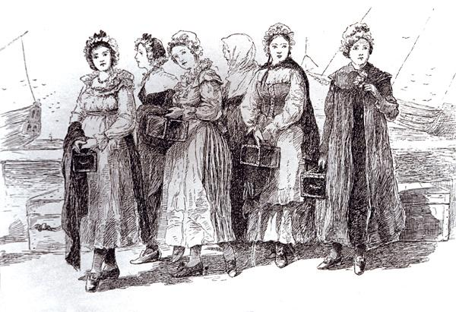

After you read:
1. How were groups of women in colonial Louisiana treated differently?

2. What are some examples of how women participated in and improved French colonial Louisiana?

Formative Performance Task #4 – Constructed Response
Student Directions | Based on the sources from this packet and your knowledge of social studies, describe two ways colonial Louisiana changed from 1720 to 1754.

Lesson 10 - Summative Performance Task
Student Directions | Based on the sources from this packet and your knowledge of social studies, write an essay answering the framing question: How did Louisiana change during the French colonial period?

Name________________________________________________Date__________________

How did an expanding United States affect Louisiana?
Introduction
Student Directions | Over the next two weeks, you will explore the sources in this packet to learn about the Louisiana Purchase and the territorial period. At the end of the packet, you will express your understanding by writing an extended response answering the following question: How did an expanding United States affect Louisiana? This packet includes three supporting questions which will help you develop your claim on how the expansion of the United States affected Louisiana. After you read each text or analyze each image, you will be asked to answer questions about it. Some words are defined to help you better understand each source and answer the questions. Some sources have digital extensions, which are optional sources you can explore if you have internet access.

Lesson 1 – Setting the Context
Student Directions | Read Source A and complete the guiding questions in the right-hand column. Next, study Source B and complete the after you read questions at the end of this lesson.
Featured Sources | Source A: “Spanish Louisiana” by Charles Chamberlin Lo Faber  Source B: “States and Territories of the United States of America 1789–1790”

Source A: “Spanish Louisiana” by Charles Chamberlin and Lo Faber
Text | Vocabulary | Guiding Questions
Spain governed the colony of Louisiana for nearly four decades, from 1763 through 1802, returning it to France for a few months until the Louisiana Purchase conveyed it to the United States in 1803. Under kings Carlos III and Carlos IV, the administration of Spain’s Atlantic empire was strengthened and improved through a number of policies called the Bourbon Reforms. In Louisiana the period began amid uncertainty and a major rebellion, but it ended with an unprecedented degree of prosperity.  By disbursing large annual subsidies and employing competent administrators who were culturally sensitive to the colony’s French-speaking Creole population, the Spanish managed to accomplish what their French predecessors had never done—make Louisiana a relatively stable, growing outpost, even as the turbulent age of Atlantic revolutions unfolded.  The period was also marked by the dramatic expansion of slavery in the young colony. The unprecedented arrival of thousands of enslaved Africans, combined with Spain’s liberal manumission policies, contributed to the growth of a caste of free people of color. Many of them lived in New Orleans, which developed significantly during the Spanish period and was largely rebuilt in the wake of catastrophic fires in 1788 and 1794.  In 1795 two events transformed the economic future of Louisiana. In Madrid, American envoy Thomas Pinckney negotiated a treaty that ceded to the United States all Spanish territory east of the Mississippi River and north of the latitude 31° north, including the vital Natchez region. The treaty also granted Americans the right to freely navigate the Mississippi and allowed U.S. merchants a place in New Orleans to deposit their goods for duty-free re-export.  Meanwhile, the development of the cotton gin transformed the agricultural landscape of upcountry Louisiana, as it did throughout the American South. By 1802 there were twenty-five cotton gins along the Red River, and cheap, profitable cotton soon replaced tobacco as the crop of choice on Red River plantations, on the upper Mississippi, and in the western prairies. By 1796 Julien Poydras, the wealthiest landholder of Pointe Coupée, switched his plantations to cotton—as did hundreds of smaller-scale planters who could afford neither the massive slave force nor the prime lowland real estate required to produce sugar.  Cotton culture also predominated in what would later become the Florida Parishes, especially along the Mississippi River near Baton Rouge, where a predominantly Anglo-American planter population had sworn allegiance to Spain in exchange for generous land grants. In New Orleans, commerce soon centered on cotton trading, fueled by the ever-growing demand from British merchants in Liverpool and textile mills in Manchester, England.  Along with the new cash crops, trade with the United States fueled the colony’s sudden growth after 1795. Increasing numbers of flatboats descended the Mississippi, laden with pork, hemp, and flour from as far away as Pittsburgh, Pennsylvania. At the same time, coasting vessels from the Atlantic ports came upriver to sell British trade goods and pick up sugar and cotton cargoes. New Orleans was now both a strategic point of transshipment and a major market in its own right. The long-obscure colonial outpost had finally become a city with ambitious plans for urban development and municipal improvements.  But even as Spanish Louisiana began to thrive, Spain itself was deeply troubled. Now ruled by the meek, indecisive Carlos IV, the country was reluctantly dragged into a ruinous war against Great Britain. Increasingly subject to the influence of France’s new first consul, Napoleon Bonaparte, the Spanish agreed in October 1800 to cede Louisiana back to France in the secret Treaty of San Ildefonso. | conveyed: gave, delivered  subsidies: money provided by government to stimulate economic activity  competent:  intelligent,  experienced, skilled  manumission: to free from a state of slavery  ceded: gave, surrendered  duty-free: tax free  pre-dominated: became greater in number or amount  Anglo-American: English-speaking American  obscure: relatively unknown  meek: gentle, overly cautious  Napoleon Bonaparte: French leader who came to power after the chaos of the French Revolution and the Reign of Terror | How did Spain’s Bourbon Reforms change Louisiana?  _____________________________  _____________________________  _____________________________  _____________________________  _____________________________  _____________________________  _____________________________  _____________________________  How did Spain’s policies towards enslaved people change Louisiana?  _____________________________  _____________________________  _____________________________  _____________________________  _____________________________  _____________________________  _____________________________  What were two outcomes of the treaty negotiated by Thomas Pinckney with Spain?  _____________________________  _____________________________  _____________________________  _____________________________  _____________________________  _____________________________  _____________________________  Why did Louisiana’s farmers largely abandon crops like indigo and tobacco for cotton?  _____________________________  _____________________________  _____________________________  _____________________________  _____________________________  _____________________________  _____________________________  _____________________________  _____________________________  _____________________________  _____________________________  When did Louisiana return to French control?  _____________________________  _____________________________  _____________________________  _____________________________
Source B: States and Territories of the United States of America 1789–1790

This map shows territory held by Spain prior to the Treaty of San Ildefonso, which secretly transferred Louisiana to French control. Also marked is the area in West Florida that both the United States and Spain claimed following the Louisiana Purchase.

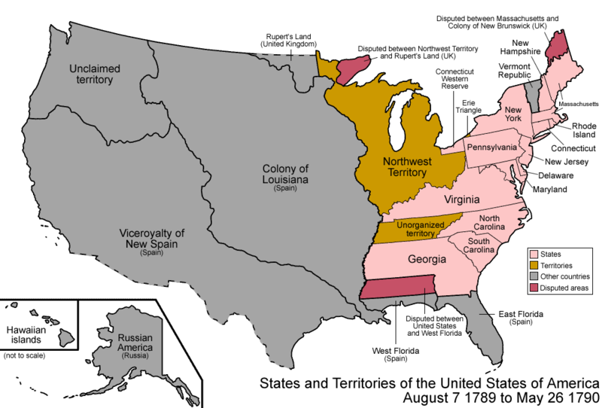

After you read:
1. Why did New Orleans develop as a center of trade during the period of Spanish control of Louisiana?

2. How was France able to acquire Louisiana from Spain? What implications would that have for the treaty the United States negotiated with Spain in 1795?

Lesson 2 – How did the Haitian Revolution affect Louisiana?
Student Directions | Study Sources C and D. Next, read Source E and complete the guiding questions in the right-hand column. Then complete the after you read questions at the end of this lesson.
Featured Sources | Source C: “Caribbean map”  Source D: Général Toussaint L’Ouverture  Source E: “The Saint-Domingue Revolution” by Jim Bradshaw
Optional Digital Extensions | CrashCourse World History – Haitian Revolution
Source C: Caribbean Map
The map below shows the location of Haiti (Saint-Domingue) in the Caribbean. Saint-Domingue was a French colony that used enslaved labor to produce cash crops. In 1791, a slave uprising began that eventually removed the French from power and resulted in the founding of Haiti, an independent state led by the formerly enslaved inhabitants of the island. Louisiana became a common destination for refugees after the revolution because of its proximity to Haiti and its large French-speaking population.

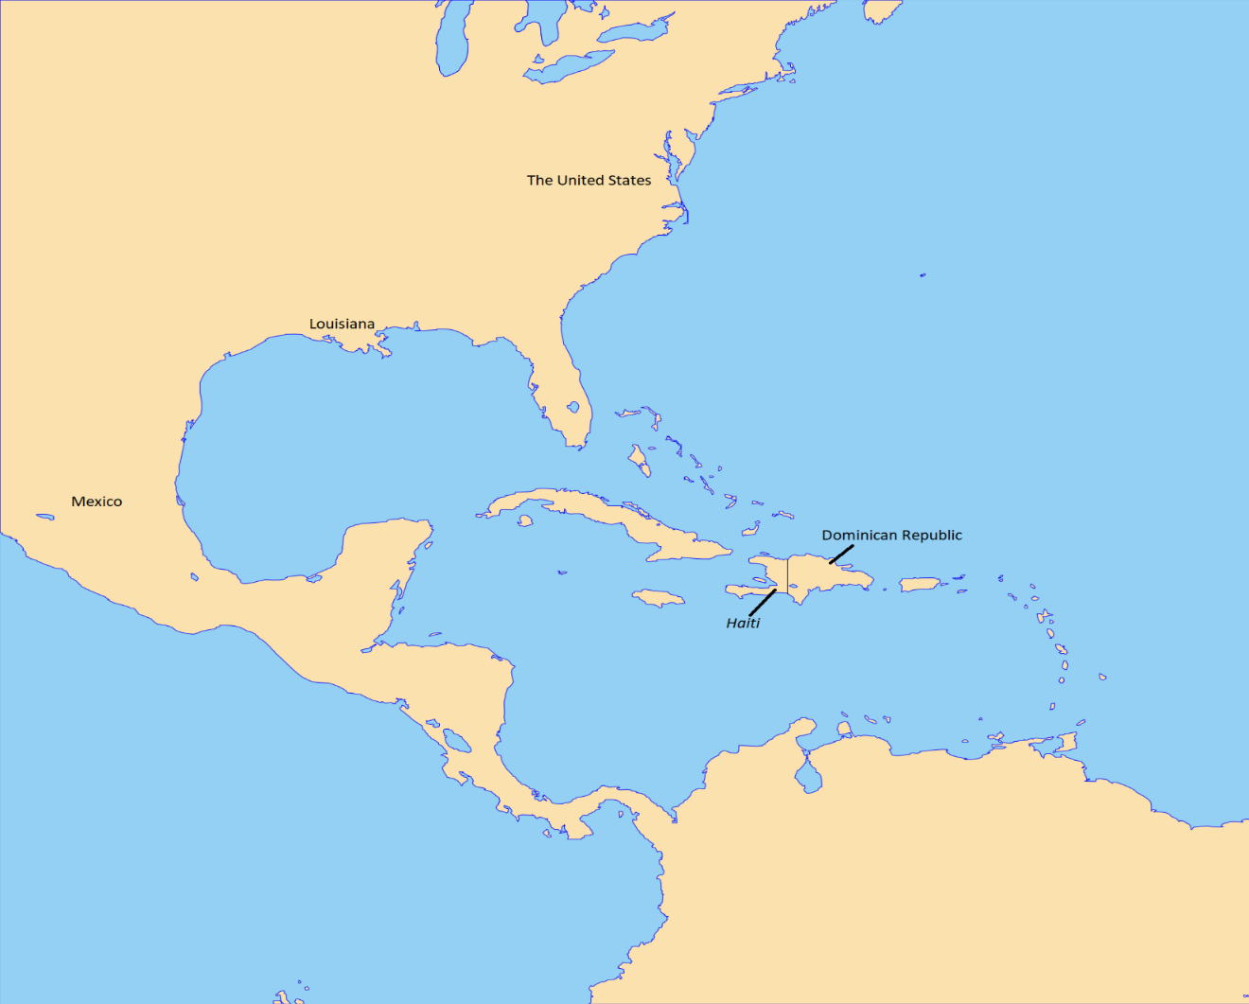

Source D: Général Toussaint L’Ouverture

Toussaint L’Ouverture was a general and the best-known leader of the Haitian Revolution. His military and political skills helped to transform a rebellion into a revolutionary movement. In 1802, he was arrested under false allegations. He was then sent to France and jailed, dying of pneumonia in 1803. Though L’Ouverture died before Haiti achieved independence, his accomplishments laid the groundwork for victory. The revolution continued under L’Ouverture's lieutenant, Jean-Jacques Dessalines, who declared independence on January 1, 1804, thereby establishing the state of Haiti.

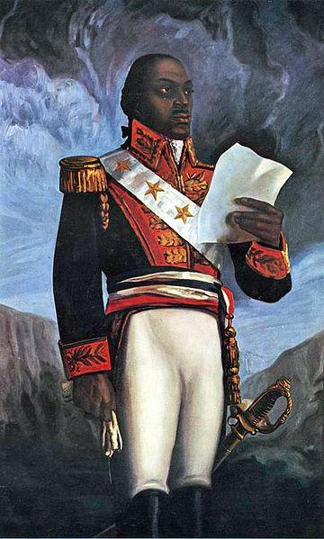
Source E: “The Saint-Domingue Revolution” by Jim Bradshaw (excerpts)
Text | Vocabulary | Guiding Questions
Between 1791 and 1804 the Saint-Domingue revolution in the West Indies led to the abolition of slavery in the former French colony and the establishment of Haiti, the second independent republic in the Western Hemisphere and the first Western nation governed by persons of African descent. The insurrection forced thousands of refugees, including many free people of color and white planters, to immigrate to Louisiana in the 1790s and early 1800s. Among the immigrants were planters and workers experienced in growing and refining sugar, an industry just emerging as a significant crop in Louisiana, as well as artisans skilled in a wide range of trades and crafts.  The Colonization of Saint-Domingue  Saint-Domingue occupied approximately one-third of the western portion of Hispaniola, the island Christopher Columbus claimed for Spain in 1492. Spanish exploitation quickly reduced the native Arawakan population to such a degree that colonists [began importing] slaves from Africa. The first Africans were brought to the island in 1502, beginning a slave trade that would profoundly shape the political and economic future of the Caribbean and the Americas.  Small groups of French colonists began to appear in the West Indies shortly after the Spanish discovery, but it was not until 1664 that the newly established French West Indies Company wrested firm control of western Hispaniola from Spain. . . .  Many of the early planters established hugely successful coffee, indigo, and sugar plantations. From the mid-eighteenth century until the French Revolution (1789–1799), Saint-Domingue prospered, becoming the richest colonial possession in the world and the basis for French colonial wealth in the West. Its success, however, was built on enslaved African labor, and by the late 1750s the slave population of around five hundred thousand far outnumbered the white population of around thirty-two thousand. Fearing a revolution, the French created a rigid caste system dominated by grand blancs, white planters born in the colony (known as Creoles) and French-born bureaucrats and landowners. Poor whites, or petit blancs, formed an underclass, while people of mixed ancestry and free men, known as affranchise, came next in the social hierarchy. At the bottom were enslaved Africans.  White masters, who were outnumbered by enslaved workers, often used physical violence to maintain control and quell any chance of rebellion. Slaves who left the plantations or disobeyed their owners were brutally whipped and sometimes subjected to more extreme forms of torture. Although France established the Code Noir in 1685 in an attempt to regulate the treatment of slaves in the colony, the code was rarely enforced. Further, local legislators reversed parts of the code during the eighteenth century. Attempting to escape the brutality, large numbers of runaway slaves, called maroons, lived on the margins of large plantations and often stole supplies from their former masters. Other slaves fled to towns, blending in with the urban and freed slaves (free persons of color) living there. When they were caught, these runaway slaves were severely and violently punished. The hard labor on sugar plantations also led to an extremely high death rate among the slaves who worked them. But with sugar profits so high, planters found it more cost effective to work enslaved people to death and replace them with new imported slaves. As a result, it is estimated that Saint-Dominque alone imported as much as 40,000 enslaved Africans annually and accounted for approximately one-third of the Atlantic slave trade.  Effects of the French Revolution  Despite the attempts of grand blancs to maintain control, violent conflicts between slaves and white landowners became more and more frequent. The French Revolution in 1789 exacerbated this turmoil. When, in March 1790, the newly formed French National Assembly approved the Declaration of the Rights of Man, giving Saint-Domingue’s free people of color full rights as citizens, white planters refused to recognize the decision; instead, they saw it as an opportunity to gain political independence from France.  These tensions led to increasing conflicts, between factions of whites at first and then between whites and free people of color. On August 22, 1791, the slaves of Saint-Domingue plunged the colony into a civil war and quickly took control of the important northern province of the country. The three principal black leaders of the rebellion were Toussaint L’Ouverture, Jean-Jacques Dessalines, and Henri Christophe, each of whom had served whites in various capacities, ranging from slave to French army officer.  The last battle of the Saint-Domingue revolution was fought on November 18, 1803, between rebels led by Dessalines and the decimated French forces. . . . It was no contest. The victorious Dessalines named himself “Emperor Jacques I” of the new republic and renamed it Haiti, which meant “land of mountains” in the indigenous Arawakan language.  Effects on Louisiana  The Saint-Domingue revolution had a great impact on Louisiana from the 1790s through the 1810s; first and foremost was France’s loss in its attempted re-conquest of the island during 1802 and 1803. Napoleon had hoped to retake Saint-Dominque in order to revive the sugar trade and reestablish the island as a source of wealth for France. In 1800 he negotiated with Spain in the Treaty of San Iledefonso for the French possession of Louisiana, which would serve as a breadbasket for Saint-Dominque. When French forces were defeated by Haitian rebels, Napoleon no longer needed the colony of Louisiana and decided to sell the entire colony to the United States in April 1803.  Thomas Jefferson had sent emissaries Robert Livingston and James Monroe to negotiate with France for the sale of the Isle of Orleans (the City of New Orleans). Napoleon, who realized he could use the sale to finance his planned campaign against Great Britain, then offered to sell the entire colony for $15 million. Livingston and Monroe agreed to the sale, and on December 20, 1803, Louisiana was officially transferred from French to US control.  The revolution also had a great impact on Louisiana’s slave and immigration policies. In the 1790s Louisiana’s Spanish colonial Governor Francisco Luis Hector de Carondolet feared that immigrants from Saint-Domingue would import dangerous, revolutionary ideas, so he attempted to keep slaves and free people of color from the island from entering Louisiana. The discovery of a planned slave rebellion on Julien Poydras’s plantation in Point Coupee in 1795 seemed to confirm this suspicion. Aware of the revolution in Saint-Domingue, Poydras’s slaves plotted to burn several buildings and then use the ensuing confusion as a way to seize weapons and kill their masters. Though the rebellion was aborted, white anxieties about slave insurrections remained.  Louisiana Territorial Governor William C. C. Claiborne was reluctant to allow Saint-Domingue refugees into Louisiana. In 1809 and 1810 Claiborne believed that their presence would be a hindrance to the growth of American democratic principles. At the same time, U.S. slave laws passed in 1807 prohibited the importation of slaves from outside the nation. On the one hand, Claiborne allowed enslaved persons—referred to as “servants” on ship manifests—into the Louisiana Territory to appease planters’ need for labor. On the other hand, Claiborne prohibited the immigration of free men of color but allowed free women of color passage.  Between the beginning of May and the end of July 1809 thirty-four vessels brought nearly 5,800 Saint-Domingue émigrés to Louisiana from Cuba; immigrants from Guadalupe and other Caribbean islands soon followed. In all, some ten thousand Saint-Domingue refugees arrived in Louisiana between 1809 and 1810. About one-third of them were white elite, another third were free people of color, and the remaining third were slaves, who belonged to either the whites or the free blacks.  The revolution also left a huge void in the global market for sugar—a void that Louisiana subsequently filled. The large influx of Saint-Domingue immigrants helped to further develop Louisiana’s nascent sugar industry. In the late 1790s sugar planters, such as Etienne Bore, used Haitian refining techniques to successfully granulate sugar. This development made the crop more profitable. Whereas tobacco and indigo were the principal plantation crops in the Spanish colonial period, by the American era sugar and cotton had emerged as the two most important export crops and fueled a great labor demand—and therefore a boom in the market for enslaved persons.  The influx of Saint-Domingue refugees undeniably shaped Louisiana culture, particularly that of New Orleans. The number of free people of color in New Orleans doubled, as did the number of French speakers in the city. As a result, Louisiana Creoles generally encouraged such immigration, seeing the refugees as potential cultural allies in the struggle against Americanization. Some immigrants became citizens of great standing in the community. Gilbert Joseph Pilie, for example, was a prominent Creole architect, surveyor, and civil engineer who made a lasting impact on New Orleans and Louisiana.  He served as city surveyor, beginning in 1818, and mapped out the plan for the Esplanade Prolongment (Esplanade Avenue), which serves as the lower border of the French Quarter and connects the Mississippi riverfront to City Park. As an architect, he designed the main house at Oak Alley Plantation, perhaps one of the most iconic plantation homes in the country, for his son-in-law Jacques Telesphore Roman. He is also credited with designing the main iron gate of the Cabildo entrance and the iron fence around Jackson Square.  New Orleans’s signature dish, red beans and rice, is also credited to the Saint-Dominguans. Immigrants from the island brought to New Orleans a preference for mixing large red kidney beans with rice and pork flavoring; in the city, it became a dish associated with Mondays, which were traditional wash days when a pot of beans could be easily cooked without much supervision, leaving time for tending to the day’s wash. . . .  The Saint-Domingue refugees also left a considerable cultural mark on New Orleans. Voodoo is often associated with both Haiti and New Orleans. The religion is essentially a syncretic blend of West African spiritual beliefs and Catholicism. In Louisiana, the Code Noir required all enslaved Africans to be baptized in the Catholic Church, and those who became Christian often blended their traditional spiritual beliefs with Catholic rituals. The influx of voodoo practitioners from Saint-Domingue in the early 1800s added another layer of voodoo culture, which became more prominent in the mid-1800s under priestess Marie Laveau and her daughter. | abolition: ending, elimination  Code Noir: a set of laws that regulated race relations in French colonies, including the treatment of enslaved people, and restrictions on free people of color  French National Assembly: a revolutionary legislative body created in the aftermath of the French Revolution  Declaration of the Rights of Man: a statement from the French National Assembly stating, “All men are born free and equal in rights.” The declaration did not outlaw slavery in French colonies but inspired slave rebellions for freedom.  decimated: destroyed  emissaries: ambassadors, diplomats  Governor William C. C. Claiborne: the first territorial governor of Louisiana  nascent: growing  Etienne Bore: a Louisiana planter who popularized a method of granulating sugar  surveyor: a person who analyzes land to plan construction projects  syncretic: merging of two different or opposing ideas or systems | How did the insurrection in Saint-Domingue affect immigration to Louisiana?  _____________________________  ________________________________  _____________________________  ________________________________  _____________________________  ________________________________  _____________________________  ________________________________  _____________________________  ________________________________  When did France gain control of Saint-Domingue (the western part of Hispaniola)?  _____________________________  ________________________________  _____________________________  ________________________________  _____________________________  _____________________________  What was the basis of Saint-Domingue’s economic success?  ________________________________  _____________________________  _____________________________  ________________________________  _____________________________  How was the system of slavery in Saint-Domingue maintained?  ________________________________  _____________________________  _____________________________  ________________________________  _____________________________  ________________________________  _____________________________  _____________________________  How did enslaved peoples resist?  _____________________________  ________________________________  _____________________________  _____________________________  _____________________________  How did the French Revolution and the Declaration of the Rights of Man increase tensions in Saint-Domingue?  ________________________________  _____________________________  _____________________________  ________________________________  _____________________________  ________________________________  _____________________________  ________________________________  _____________________________  _____________________________  ________________________________  _____________________________  ________________________________  _____________________________  Who led the enslaved people in rebellion?  _____________________________  ________________________________  _____________________________  _____________________________  ________________________________  How did Napoleon plan to use Louisiana and Saint-Domingue?  ________________________________  _____________________________  _____________________________  ________________________________  _____________________________  _____________________________  ________________________________  _____________________________  _____________________________  ________________________________  _____________________________  _____________________________  ________________________________  ________________________________  Why did Spanish governor Carondolet and territorial governor Claiborne work to limit immigration from Haiti?  _____________________________  ________________________________  _____________________________  ________________________________  _____________________________  ________________________________  Despite the ban on the importation slaves affecting the slave trade being changed in 1807, why did Governor Claiborne and other leaders allow the importation of enslaved people among the refugees?  _____________________________  ________________________________  _____________________________  ________________________________  _____________________________  Describe the refugees that immigrated to Louisiana between 1809 and 1810.  _____________________________  ________________________________  _____________________________  How did the Haitian Revolution affect the market for sugar in Louisiana?  _____________________________  ________________________________  _____________________________  ________________________________  _____________________________  ________________________________  How did immigration from Haiti influence the culture of New Orleans and Louisiana?  _____________________________  ________________________________  _____________________________  ________________________________  _____________________________

After you read:
1. How did Napoleon’s failure to conquer and re-enslave the people of Saint-Domingue influence his decision to sell Louisiana?

2. How did the Haitian Revolution affect the population, demographics, and culture of Louisiana?

Lesson 3 – How did the Haitian Revolution affect Louisiana?
Student Directions | First, read Sources F and G and answer the guiding questions in the right-hand column. Next, study Source H and complete performance task #1 at the end of this lesson.
Featured Sources | Source F: Letter from Thomas Jefferson to Robert Livingston, April 18, 1802  Source G: Representative Roger Griswold, speech to Congress in 1803  Source H: Louisiana Purchase (1803)

Source F is a letter from President Jefferson to diplomat Robert Livingston who was headed to France to negotiate with the French leader, Napoleon Bonaparte.

Source F: Letter from Thomas Jefferson to Robert Livingston, April 18, 1802
Text | Vocabulary | Guiding Questions
The cession of Louisiana & the Floridas by Spain to France works most sorely on the U.S. On this subject the Secretary of state has written to you fully. . .  There is on the globe one single spot, the possessor of which is our natural & habitual enemy. It is New Orleans, through which the produce of three eighths of our territory must pass to market, and from its fertility it will long yield more than half of our whole produce and contain more than half our inhabitants. France placing herself in that door assumes to us the attitude of defiance. Spain might have retained it quietly for years. . . . Her feeble state, would induce her to increase our facilities there, so that her possession of the place would be hardly felt by us, and it would not perhaps be very long before some circumstance might arise which might make the cession of it to us the price of something of more worth to her.  Not so can it ever be in the hands of France. . . It [is] impossible that France and the US can continue [to be] friends when they meet in so irritable a position. . . The day that France takes possession of New Orleans . . . we must marry ourselves to the British fleet & nation. We must turn all our attentions to a maritime force, for which our resources place us on very high ground: and having formed and cemented together a power which may render reinforcement of her settlements here impossible to France. . . This is not a state of things we seek or desire. . .  If France considers Louisiana however as indispensable for her views, she might perhaps be willing to look about for arrangements which might reconcile it to our interests. If anything could do this it would be the ceding to us the island of New Orleans and the Floridas. This would certainly in a great degree remove the causes of jarring & irritation between us, and perhaps for such a length of time as might produce other means of making the measure permanently conciliatory to our interests & friendships.. . . . Perhaps nothing since the revolutionary war has produced more uneasy sensations through the body of the nation [than France taking over Louisiana]. Notwithstanding temporary bickerings have taken place with France, she [France] has still a strong hold on the affections of our citizens generally.—I have thought it not amiss, by way of supplement to the letters of the Secretary of state, to write you this private one to impress you with the importance we affix to this transaction. . . | cession: giving up territory  sorely: to a very high degree especially of an unwelcome or unpleasant state or emotion  habitual: persistent  induce: cause or prompt  maritime: having to do with seafaring or naval operations  reconcile: to resolve  conciliatory: peace-making  affix: attach to | Why does Jefferson believe French control of New Orleans will negatively affect the United States?  ________________________________  ________________________________  ________________________________  ________________________________  ________________________________  According to Jefferson, if France acquires Louisiana, who will the United States be forced to ally with?  ________________________________  ________________________________  ________________________________  ________________________________  What does Jefferson hope France will be willing to cede to the United States?  ________________________________  ________________________________  ________________________________  ________________________________  According to Jefferson, how do Americans generally feel about France?  ________________________________  ________________________________  ________________________________
Source G is a speech given by Roger Griswold, who opposed the Louisiana Purchase.
Source G: Representative Roger Griswold, speech to Congress in 1803
Text | Vocabulary | Guiding Questions
It is, in my opinion, scarcely possible for any gentleman on this floor to advance an opinion that the President and Senate may add to the members of the union by treaty whenever they please, or, in the words of this treaty, may incorporate in the union of the United States a foreign nation who, from interest or ambition, may wish to become a member of our government. Such a power would be directly repugnant to the original compact between the states, and a violation of the principles on which that compact was formed.  The incorporation of a foreign nation into the Union, so far from tending to preserve the Union, is a direct inroad upon it. It destroys the perfect union contemplated between the original parties, by interposing an alien and a stranger to share the powers of government with them . . .  This subject was much considered during the last session of Congress, but it will not be found . . . that any individual entertained the least wish to obtain the province of Louisiana. Our views were then confined to New Orleans and the Floridas, and, in my judgment, if would have been happy for the country if they were still confirmed within those limits. The vast and unmanageable extent which the accession of Louisiana will give to the United States; the consequent dispersion of our population; and the destruction of that balance which it is so important to maintain between the Eastern and Western states, threatens, at no very distant day, the subversion of our Union. | repugnant: in conflict with  compact: agreement (Griswold is referring to the U.S. Constitution)  direct inroad: hostile invasion  interposing: putting in between  accession: in this context, the act of obtaining Louisiana  dispersion: scattering  subversion: the act of being overthrown or corrupted | What action, taken by the President and Congress does Griswold believe is an attack on the Constitution?  ________________________________  ________________________________  ________________________________  ________________________________  ________________________________  What people is Griswold describing as ‘alien”?  ________________________________  ________________________________  ________________________________  What concern does Griswold have about the “balance” between the states being changed by Louisiana’s addition?  ________________________________  ________________________________  ________________________________  ________________________________  ________________________________

Source H: Louisiana Purchase (1803)
In addition to giving the United States control over the Mississippi River and New Orleans, the Louisiana Purchase doubled the size of the United States. This map also illustrates the present day states the Louisiana Territory would be divided into.
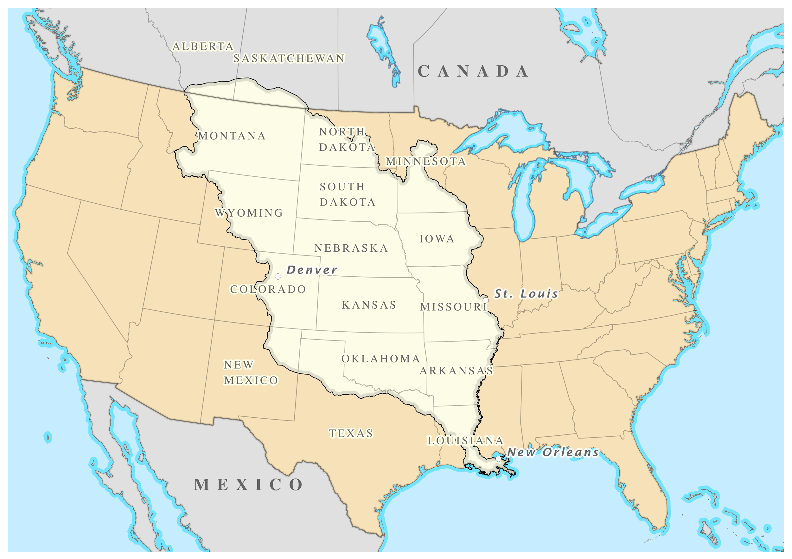
Map by William Morris. Licensed under the Creative Commons Attribution-Share Alike 3.0 Unported license. Available online at https://upload.wikimedia.org/wikipedia/commons/5/57/Louisiana_Purchase.png

Formative Performance Task #1 – Constructed Response
Student Directions | Based on the sources, write a paragraph that describes two ways the Haitian Revolution affected Louisiana.

Lesson 4 – How did Louisiana change during the territorial period?
Student Directions | Read Sources I and K and complete the guiding questions in the right-hand column. Study Source J. Then complete the after you read questions at the end of this lesson.
Featured Sources | Source I: “Louisiana Purchase and Territorial Period” by Pete J. Kastor  Source J: States and Territories of the United States of America May 12th to June 4th, 1812  Source K: “Slave Insurrection of 1811” by Robert L. Paquette

Source I: “Louisiana Purchase and Territorial Period” by Pete J. Kastor (excerpts)
Text | Vocabulary | Guiding Questions
The period from 1803 to 1812 was a landmark in Louisiana history. In these years, the land that became Louisiana went from a European colony to a federal territory and finally to the eighteenth state in the union. In the midst of these political changes, Louisianians experienced social unrest, racial revolt, and international conflict.  Meanwhile, determining what would become of Louisiana and its residents forced people in the United States and in Europe to consider what it meant to be American. Although Louisiana became a state in 1812, that hardly settled the questions unleashed by the Louisiana Purchase.  Acquiring and Defining Louisiana  Nothing reflected the tumult and uncertainly of early Louisiana more clearly than the battle over its borders. In April 1803, France ceded a vast but vaguely defined geographic space to the United State with the Louisiana Purchase. News of the acquisition came as an enormous surprise to the United States. President Thomas Jefferson had sought only New Orleans and access to the Gulf Coast. He now faced the challenge of governing far more territory and, even more daunting, a much larger and more diverse population. Further, the Louisiana Purchase treaty failed to specify clear borders, and it would be almost two decades before the United States had clear title to all of the land that now constitutes the state of Louisiana.  The boundaries of Louisiana took shape as a result of the political conflicts that gripped Europe and stretched across the Atlantic Ocean. These conflicts played out differently in the New World, as the United States exploited Napoleon’s invasion of Spain in 1807 and the subsequent crisis within the Spanish empire to seize West Florida in 1810. The Mexican struggle for independence also made Spain willing to make major territorial concessions in the West, even as the United States abandoned some of its own ambitions in Texas. It was not until 1819 that the Transcontinental Treaty finally established the eastern and western boundaries of Louisiana.  In the midst of these international conflicts, the federal government was also subdividing the land acquired through Louisiana Purchase into manageable political subdivisions.  In 1804, Congress created the Territory of Orleans, which included much of the territory that now constitutes the state of Louisiana. Territorial rule was intended to provide a temporary system of government for the region and to prepare Louisiana for eventual statehood and jurisdictional equality alongside the other states of the union. The federal leadership appointed most major offices, while local residents were allowed to elect a territorial legislature. This system of territorial administration constituted a dramatic change from European imperial rule.  Many Louisianans complained about what they considered the slow progress toward statehood. Local residents demanded an increase in the number of elected offices and were particularly keen to see members of the old francophone community elected to those offices instead of the newly arrived Anglo-Americans. Despite these grievances, few sought a return to European rule, in large part because they believed the federal system offered far more benefits to its frontier settlements.  In the years immediately following the Louisiana Purchase, the federal leadership, officials in the Territory of Orleans, and local residents struggled to create the institutions that would make self-government within the federal system secure. In 1812, Congress approved Louisiana statehood, and President James Madison eagerly signed it into law. Statehood actually preceded the final determination of Louisiana’s borders, which underwent minor revisions until the Transcontinental Treaty finally established the boundaries once and for all.  Ethnic Relations  The Louisiana Purchase created confusing political circumstances within the Territory of Orleans. The treaty granted immediate citizenship to white Louisianans, who were eager to enjoy what they considered the rights of U.S. citizenship. However, many people outside the territory claimed that the Louisianans did not know how to act as good Americans.  The political battle over Louisiana statehood often reflected the tense ethnic relations among whites within Louisiana. At the time of the Purchase, the territory’s white population consisted primarily of Creoles born in Louisiana, as well as migrants from Canada, the French Caribbean, and France itself. The vast majority of these people spoke French and considered themselves products of a French culture. At the same time, however, people had known more than thirty years of Spanish rule in Louisiana, and they had been joined by a sizeable population of Hispanic residents and Anglo-Americans. Equally important, many of them were deeply suspicious of the Napoleonic regime in France.  In these circumstances, Louisiana experienced complex and at times bewildering ethnic relations. The francophone (French-speaking) and anglophone (English-speaking) populations were often at odds. Meanwhile, the francophone majority created and preserved cultural institutions that made Louisiana unlike any other state in the union. French remained a common language in daily conversation and in official documents, and Louisiana’s legal system combined the Anglo-American common law with French, Spanish, and Roman principles of civil law.  At the same time, these differences were never so obvious as they now appear. First of all, there was no uniform francophone “community.” Creoles argued with French migrants, the residents of cosmopolitan New Orleans shared little with the residents of rural Louisiana, and French- and English-speaking residents often found common cause in their political and commercial pursuits. The notion of a Creole-American split eventually became the stuff of legend in Louisiana, but most observers were more struck by the absence of conflict or revolt.  The general amity among white residents depended in no small part on their commitment to racial supremacy. Whatever cultural or political disputes might divide white residents of Louisiana, they shared a belief in white superiority and a fear of non-white revolt. In the wake of the Louisiana Purchase, whites in Louisiana (regardless of ethnic background) came together to impose new restrictions on slaves and free people of color.  Non-whites responded accordingly. Slaves repeatedly sought to run away and in 1811, more than eighty slaves owned by Manuel Andry in St. Charles and St. John the Baptist parishes launched an unsuccessful revolt along the German Coast that was the largest single slave uprising in the United States.  Free people of color proved more successful. Located primarily in New Orleans, they sustained themselves as the largest, most prosperous community of free blacks anywhere in North America. Meanwhile, whites supported the efforts of the federal government to undermine Native American sovereignty and, eventually, to force most Native Americans out of Louisiana. Native Americans developed numerous strategies of resistance but in the end proved unable to restrain the federal onslaught. | tumult: turmoil, turbulence  daunting: very difficult  exploited: took advantage of  jurisdictional: legal  legislature: group elected to create laws  francophone: French-speaking  institutions: organizations  Trans-  continental Treaty: also known as the Adams-Onis treaty, this agreement settled the boundaries of the United States and New Spain in 1819  Creole: While this term has many meanings and its usage has evolved over time, in this context, it refers to a white person descended from early French or Spanish settlers and preserving their speech and culture.  bewildering: confusing  amity: harmony, peace, goodwill  onslaught: attack, offense | In what years was Louisiana a federal territory, and what does it mean to be a federal territory?  _____________________________  _____________________________  _____________________________  _____________________________  _____________________________  _____________________________  _____________________________  What challenges did the Louisiana Purchase present to Jefferson and Congress?  _____________________________  _____________________________  _____________________________  _____________________________  _____________________________  _____________________________  How and when were the final borders of the Louisiana Purchase decided?  _____________________________  _____________________________  _____________________________  _____________________________  _____________________________  _____________________________  _____________________________  _____________________________  _____________________________  _____________________________  _____________________________  _____________________________  What was the point of territorial rule as opposed to immediate statehood?  _____________________________  _____________________________  _____________________________  _____________________________  _____________________________  _____________________________  What tensions existed between the francophone population and the newly arrived Anglo-Americans in Louisiana?  _____________________________  _____________________________  _____________________________  _____________________________  _____________________________  _____________________________  _____________________________  _____________________________  _____________________________  _____________________________  _____________________________  _____________________________  _____________________________  _____________________________  _____________________________  Despite cultural and political divides, what united white residents in Louisiana?  _____________________________  _____________________________  _____________________________  _____________________________  _____________________________  _____________________________  What was life like for black people (both free and enslaved) during the territorial period?  _____________________________  _____________________________  _____________________________  _____________________________  _____________________________  _____________________________  _____________________________  _____________________________  _____________________________  _____________________________  _____________________________

Source J: States and Territories of the United States of America May 12th to June 4th 1812

This map shows the Louisiana Purchase and its division into the Orleans Territory and the District of Louisiana. The areas of contention with Spain are also shown to the east of and west of the Orleans Territory. While this map shows territories claimed by the United States and European countries, it should be noted that Native American tribes still held sovereignty over much of these territories.
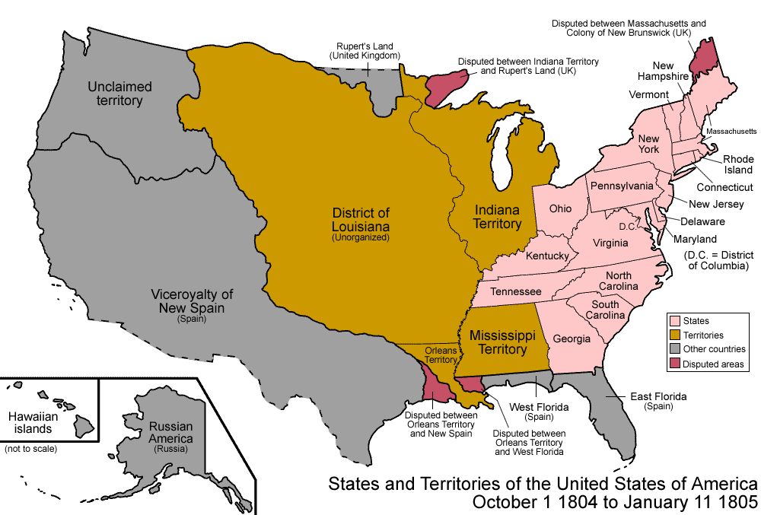

Source K: “Slave Insurrection of 1811” by Robert L. Paquette (excerpts)
Text | Vocabulary | Guiding Questions
The first major sugar-producing zone in the United States was the site of the largest slave insurrection in US history, one year before Louisiana’s statehood. During a ferocious downpour on a cold, windy late Tuesday evening, January 8, 1811, in the Territory of Orleans, slaves on a sugar plantation owned by Manuel Andry rose in rebellion. Andry owned more than eighty slaves, more than any other slaveholder in St. John the Baptist Parish. The slaves attacked the big house and assaulted Andry. Although severely wounded, he managed to escape his assailants and in desperate search of succor, crossed to the west bank of the Mississippi River. Gilbert Thomassin Andry, Manuel’s youngest son, fell to the rebels, “ferociously murdered” in the words of his father.  After looting Andry’s estate, the insurgents moved southward rapidly along the east bank levee, following the serpentine contours of the Mississippi River. . . .  The rebels soon crossed into St. Charles Parish and headed for New Orleans, little more than thirty miles away. The slaves marched noisily, according to eyewitnesses, in military-style formation. They beat drums, waved flags, and carried a variety of weapons, including firearms. Slaves from other plantations joined the rebels, who recruited on the fly, using force and intimidation in some cases to swell their ranks. The number of rebels fluctuated during the course of the insurrection; eyewitness estimates range from 150 to 500. In plundering several other estates, the slaves tarried long enough in St. Charles Parish to dispatch Jean François Trépagnier, who had attempted to defend the family manor house, standing on the veranda with a shotgun.  Panicked whites, warned of the movement, scrambled for safety down the river road into New Orleans. William C. C. Claiborne, the territorial governor, called out the militia, ordered a lockdown of shops and cabarets, and imposed a curfew. General Wade Hampton, commander of regular troops stationed in the area to guard the territorial frontier, had arrived in New Orleans two days before the revolt. He took command of a hastily mustered force of regular troops, militia, and volunteers who headed northward on January 9 to confront the rebels. Hampton’s mobilization represents the first time in U.S. history that federal troops were mobilized to suppress a slave insurrection. Hoping to crush the rebels in a vise, Hampton dispatched orders for Major Homer Virgil Milton in Baton Rouge to descend the river with another body of regulars. Unknown to Milton and Hampton, Manuel Andry, despite his wounds, had managed to rally a sizeable militia force on the west bank of the river.  The revolt climaxed on the morning of the second day, January 10, as these three forces converged. A unit of Hampton’s forces under the command of Major John Darrington made first contact shortly after the rebels had crossed into Orleans Parish. The main body of rebels had ensconced themselves at night on a sugar plantation owned by Jacques Fortier, about eighteen miles from the city. Hampton planned to envelope the rebels after dawn with a coordinated, multipronged attack. Once on the offensive, however, Hampton discovered to his astonishment that the reportedly drunk and disorderly rebels had abandoned Fortier’s estate in the dead of night with a disciplined retreat northward. Repositioned on Bernard Bernoudi’s sugar plantation in St. Charles Parish, the rebels were caught off guard by Andry’s militia after it had quietly crossed over from the Mississippi’s west bank. Lines of charging mounted militiamen, including free persons of color, broke the rebels’ ranks; the battle quickly turned into a rout. The wounded Andry, an eyewitness, reported to Governor Claiborne that it was “un grand carnage” (“a great slaughter”).  Slaveholding judges assembled in St. John the Baptist Parish, St. Charles Parish, and New Orleans to try captured slaves. Sketchy records from two of the courts (St. Charles Parish and New Orleans) survive. The busiest tribunal, comprising five elite slaveholders, convened on the Destrehan Plantation in St. Charles Parish. Outraged whites removed from captivity Charles Deslondes, the alleged ringleader, and proceeded to shoot, burn, and mutilate him. The presence in and around New Orleans of thousands of recently arrived white refugees from the Haitian Revolution intensified emotions and framed perceptions of the insurrection. To deter future slave rebelliousness, whites gathered the heads from multiple black corpses and placed them atop poles at regular intervals along the east-bank levee for more than thirty miles from Andry’s plantation to the gates of New Orleans.  Although historians have largely overlooked the event, no slave insurrection in US history left more black bodies on the battlefield. Close to one hundred slaves died either in combat or by execution soon afterwards. Unlike the 1739 Stono rebellion in colonial South Carolina or the 1791 Pointe Coupée conspiracy in Spanish Louisiana, in which a single African ethnic group predominated, the 1811 insurrection combined African and Creole slaves, men and women, field hands and more privileged slaves, and mulattos and blacks. Misinformation about the origin and status of Charles Deslondes abounds. Neither a free person of color nor of Haitian origin, Charles Deslondes was a mulatto slave driver, most likely born in Spanish Louisiana, who had been working for Manuel Andry, although he was owned by Andry’s neighbor, the widow Marguerite Deslondes.  Surviving evidence permits no firm conclusion as to what caused the insurrection or the goals of the rebels. An intensifying, coercive labor regimen associated with sugar culture undoubtedly preconditioned the movement. Interrogatories of captured slaves indicate the predominance of young, skilled male slaves in the insurrection, whose planning was facilitated by the mobility of the slave drivers like Charles Deslondes. Shifting troop movements related to the US annexation of West Florida in December 1810 may have helped kindle the revolt. Wade Hampton accused Spanish agents of stirring up the slaves. No evidence has yet surfaced to support his claim. To be sure, some slaves had particular grievances regarding treatment by their masters. One Congo slave, when asked why he was headed to New Orleans, replied succinctly, “to kill whites.” The rapid movement of a disciplined force of slaves who covered dozens of miles in little more than twenty-four hours suggests not only a conscious assault on New Orleans, but also a mass slave breakout from the territory, possibly to Haiti.  In the aftermath of the revolt’s suppression, citizens of the territory effected police and militia reforms and demanded an increased presence of federal troops. | insurrection: rebellion  succor: assistance and support in time of distress  insurgents: rebels or revolution-aries  serpentine: winding and snake-like  veranda: porch  ensconced: established  rout:  disorderly retreat  mutilate: inflict a violent and disfiguring injury  interrogatories: formal questionings | How did the insurrection of 1811 begin?  _____________________________  _____________________________  _____________________________  _____________________________  _____________________________  _____________________________  _____________________________  _____________________________  _____________________________  _____________________________  _____________________________  _____________________________  _____________________________  _____________________________  _____________________________  _____________________________  _____________________________  How did Governor Claiborne respond to the insurrection?  _____________________________  _____________________________  _____________________________  _____________________________  _____________________________  _____________________________  _____________________________  _____________________________  _____________________________  _____________________________  _____________________________  _____________________________  _____________________________  _____________________________  _____________________________  _____________________________  _____________________________  _____________________________  _____________________________  _____________________________  How did the insurrection conclude?  _____________________________  _____________________________  _____________________________  _____________________________  _____________________________  _____________________________  _____________________________  _____________________________  What actions did pro-slavery whites take to deter future slave rebellions?  _____________________________  _____________________________  _____________________________  _____________________________  What is unique about the German Coast Uprising of 1811 compared to other slave insurrections in the United States?  _____________________________  _____________________________  _____________________________  _____________________________  _____________________________  _____________________________  _____________________________  _____________________________  _____________________________  _____________________________  _____________________________
After you read:
1. What were some effects of changing demographics in Louisiana during the territorial period?

2. What were the effects of the 1811 German Coast Uprising on Louisiana?

3. What does the German Coast Uprising say about how enslaved persons felt about and reacted to the institution of slavery?

Lesson 5 – How did Louisiana change during the territorial period?
Student Directions | Study Source L. Then read Sources M and N and complete the guiding questions in the right-hand columns. Next complete the after you read questions and performance task #2 at the end of this lesson.
Featured Sources | Source L: “Louisiana Map 1814”  Source M: Constitution of United States (excerpts)  Source N: Constitution of Louisiana 1812 (excepts)

Source L: Louisiana Map 1814
For Louisiana to become a state, it had to call a convention, draft a constitution, and petition to be allowed into the union (as per the 1787 Northwest Ordinance). Though still in flux when Louisiana first became a state, the map below shows Louisiana’s boundaries in 1814.

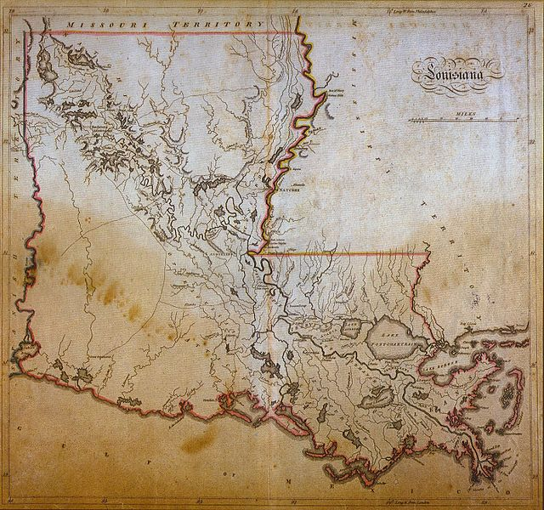

This excerpt from the Constitution of the United States, ratified in 1789, describes the purpose of the federal government and the process for electing representatives.

Source M: Constitution of the United States (excerpt)
Text | Vocabulary | Guiding Questions
Preamble  We the People of the United States, in Order to form a more perfect Union, establish Justice, insure domestic Tranquility, provide for the common defense, promote the general Welfare, and secure the Blessings of Liberty to ourselves and our Posterity, do ordain and establish this Constitution for the United States of America.  Article. I. Section. 4.  The Times, Places and Manner of holding Elections for Senators and Representatives, shall be prescribed in each State by the Legislature thereof; but the Congress may at any time by Law make or alter such Regulations, except as to the Places of choosing Senators.  The Congress shall assemble at least once in every Year, and such Meeting shall be on the first Monday in December, unless they shall by Law appoint a different Day. | domestic: existing inside a country, not foreign  Welfare: the health and happiness of a group | What purposes does the U.S. Constitution set for the government?  _____________________________  _____________________________  _____________________________  _____________________________  _____________________________  What power will the states have regarding how, when and where their elections are held?  _____________________________  _____________________________
The first Louisiana Constitution was modeled after the Constitution of Kentucky with three major differences: a Bill of Rights was not included, the system of law was (and still is) based on Napoleonic law instead of English Common law, and parishes were used as jurisdictions instead of counties. The Louisiana Constitution of 1812 only allowed wealthy white men who paid taxes to vote and did not provide voting rights to poorer white men, Black people, or women. Candidates for governor could be voted upon by all white voters, but the constitution provided that the legislature chose from the two who received the most votes.

Source N: Constitution of the State of Louisiana 1812 (Excerpt)
Text | Vocabulary | Guiding Questions
We, the Representatives of the People of all that part of the Territory or country ceded under the name of Louisiana, by the treaty made at Paris, on the 30th day of April 1803, between the United States and France, contained in the following limits, to wit; beginning at the mouth of the river Sabine, ‘thence by a line to be drawn along the middle of said river, including all its islands, to the thirty second degree of latitude—thence due north to the Northernmost part of the thirty third degree of north latitude—thence along the said parallel of latitude to the river Mississippi— thence down the said river to the river Iberville, and from thence along the middle of the said river and lakes Maurepas and Pontchartrain to the Gulf of Mexico—thence bounded by the said Gulf to the place of beginning, including all Islands within three leagues of the coast—in Convention Assembled by virtue of an act of Congress, entitled “an act to enable the people of the Territory of Orleans to form a constitution and State government and for the admission of said State into the Union on an equal footing with the original States, and for other purpose:” In order to secure to all the citizens thereof the enjoyment of the right of Life, Liberty and property, do ordain and establish the following constitution or form of government, and do mutually agree with each other to form ourselves into a free and independent State, by the name of the State of Louisiana.  Article I  Sect. 8th. In all elections for Representatives every free white male citizen of the United States, who at the time being, having attained to the age of twenty-one years and resided in the county in which he offers to vote one year not preceding the election, and who in the last six months prior to the said election, shall have paid a state tax, shall enjoy the right of an elector: provided however that every free white male citizen of the United States who shall have purchased land from the United States, shall have the right of voting whenever he shall have the other qualifications of age and residence above prescribed—Electors shall in all cases, except treason, felony, breach of surety of peace, be privileged from arrest during their attendance at, going to or returning from elections. . . . | bounded: bordered by | In what ways in the opening of the Louisiana Constitution different from the U.S. Constitution?  _____________________________  _____________________________  _____________________________  _____________________________  _____________________________  _____________________________  _____________________________  What purposes does the Louisiana Constitution outline for its government?  _____________________________  _____________________________  _____________________________  _____________________________  According to Article I, what were the requirements to register to vote?  _____________________________  _____________________________  _____________________________  _____________________________  _____________________________  _____________________________
After you read:
1. What similarities are there between the Constitution of the United States and the Louisiana State Constitution of 1812?

2. How did boundary disputes play a role in Louisiana’s development?

3. In what ways was the Constitution of 1812 undemocratic?

Formative Performance Task #2 – Constructed Response
Student Directions | Based on the sources, write a paragraph that explains two ways Louisiana changed during the territorial period.

Lesson 6 – How did the Battle of New Orleans affect Louisiana?
Student Directions | Read Source O and complete the guiding questions in the right-hand column. Next, study Sources P and Q and complete the after you read questions at the end of this lesson.
Featured Sources | Source O: “The Battle of New Orleans” by Jim Bradshaw  Source P: Events Related to the Battle of New Orleans  Source Q: Battle of New Orleans by Jean-Hyacinthe Laclotte

Just as Louisiana gained statehood, the United States and Great Britain went to war again. The War of 1812 was fought in many places, but its final battles occurred in New Orleans.
Source O: “The Battle of New Orleans” by Jim Bradshaw
Text | Vocabulary | Guiding Questions
The Battle of New Orleans, fought on January 8, 1815, was the culmination of a month-long series of skirmishes between U.S. and British forces in southern Louisiana; it was the final major engagement of the War of 1812. Despite its name, the battle was actually fought in Chalmette, five miles south of the city. British forces, led by Major General Edward Pakenham, sought to block the mouth of the Mississippi River, thereby controlling America’s inland waterways. General Andrew Jackson led the Americans in their attempts to defend the port. Ironically, the battle took place after British and American officials had signed a peace treaty, ending the war. Though the Treaty of Ghent had been signed on December 24, 1814, the news did not reach New Orleans until March.  Background and Context  The War of 1812 began, at least in part, because Americans resented Britain’s domination of the seas, especially its interference with US shipping and the impressment of sailors from American vessels. Some Americans also hoped the war would enable them to grab land in Canada and Florida then held by Britain or its ally, Spain. At the war’s outbreak, Great Britain was preoccupied with its war against Napoleon’s France. Victory in Europe in 1814 meant Britain could concentrate on its war with America. The British crown sent twenty thousand troops to invade the United States by way of the Niagara Peninsula, Lake Champlain, the Chesapeake Bay, and New Orleans.  At first, American commanders discounted the threat to New Orleans, then a city of about eighteen thousand people. Andrew Jackson, who commanded the Seventh Military District (which included Louisiana, the Mississippi Territory, and Tennessee), expected the attack to be made at Mobile, Alabama. Jackson’s prediction proved somewhat accurate. In mid-September, British forces—under naval captain William Percy and Major Edward Nicholls of the Royal Marines—did attack Mobile. US troops, however, forced them to withdraw to Pensacola, Florida, then belonging to Spain.  Granted a temporary reprieve, Jackson and his staff relocated to New Orleans to plan their defense strategy. They knew that the British were likely to use one of two water routes in their attack on New Orleans. They could reach the city by sailing up the Mississippi River or by entering Lake Pontchartrain via Lake Borgne. Turns and shallow spots in the Mississippi made the former a less likely route of attack, as did the presence of Forts St. Philip and Bourbon on opposite sides of the river.  As Jackson prepared for the attack, his primary concern was the lack of manpower. He had one thousand regulars and fewer than two thousand militia to face twice as many British soldiers. The available American naval force, under Master Commandant Daniel Patterson, consisted of six small, unnamed gunboats; the Louisiana, a more formidable craft without a crew to man it; and the Carolina, a schooner that happened to be in New Orleans.  Ultimately Jackson put together a polyglot fighting force that included two divisions of the Louisiana militia, Native Americans, African Americans, and Baratarians (or pirates) who worked for Jean Laffite. Many Americans questioned the loyalty of French-speaking Louisianans and the wisdom of arming African Americans and pirates with guns.  The Attack on New Orleans Begins  By December 12, a British fleet carrying more than ten thousand soldiers was anchored in the Gulf of Mexico, not far from Lake Borgne. Unable to take their big ships into the shallow lake, British troops had to load into smaller vessels and then battle the US troops guarding the lake’s entrance. When the two forces met on December 14, the winds, tides, and numbers all worked against the Americans. Within two hours, thousands of British soldiers took command of the lake, came ashore, and began building a garrison on Pea Island, thirty miles east of New Orleans. News of the battle brought panic to New Orleans and rapidly spread through the state. Jackson declared martial law in the city and sent out a call for more men and materials.  Spanish fishermen guided two British officers to an unguarded path leading to the plantation of Jacque Villeré, major general in the Louisiana militia. Located on the east bank of the Mississippi River, Villeré’s estate put the British within nine miles of New Orleans. Following the same route, British general John Keane and eighteen hundred soldiers surprised the Louisiana militia, commanded by Major Gabriel Villeré, the planter’s son, and seized the plantation house on December 22.  Though Keane did not know it, he could have continued up the river road, which was undefended, to within cannon shot of New Orleans. Instead, he waited for reinforcements. That gave Jackson enough time to plan a surprise night attack, using the guns of the Carolina and the hastily manned Louisiana (war ships) for support from the river. He also had his men build defensive earthworks along the Rodriguez Canal, about four miles south of New Orleans. According to historian Wilburt Brown, among others, this decision was “the most decisive single factor in the campaign.” The British suffered an unexpected setback and numerous injuries, while the Americans boosted their morale.  Realizing the Americans would not surrender easily, Pakenham, the high British commander, arrived at the Villeré plantation on Christmas Day. The next day he ordered an artillery attack on the American ships, both stationed opposite the British camp in order to lob artillery fire into it. The Carolina, becalmed and unable to move, was set afire and sunk by the British. The Americans were able to tow the Louisiana upriver and out of range of British guns.  At dawn on December 28, Pakenham continued the assault, sending two strong columns toward the American line on the Rodriguez Canal. The Americans drove the British back, however, with unexpectedly heavy artillery fire. The British spent the next three days and nights landing heavy naval cannons and bringing up ammunition in preparation for a large-scale attack. British troops came within five hundred yards of the Americans, ready to pounce if the big guns battered a hole in the US fortifications. British guns opened fire at 10:00 a.m. on New Year’s Day 1815, but the American artillery response drove the British gunners from their weapons after three hours of fighting.  The Battle of New Orleans  On January 8, Pakenham launched an all-out assault on US troops. A small British diversionary force attacked on the west bank of the Mississippi, routing an American force that had been hastily assembled there. But that was of little consequence. The main British attack was on the earthworks protecting New Orleans on the east bank of the river. Knowing that Jackson’s greatest artillery strength was on the American right, toward the river, the British concentrated on the center and to the left of Jackson’s line.  The attack began in darkness and heavy fog, but the fog lifted as the British neared the American line, exposing the soldiers to withering fire from U.S. artillery. The British forces, massed in the confined space in front of the earthworks, stood no chance against the musket fire and grapeshot from Jackson’s cannons. When the smoke cleared, the Americans surveyed what appeared to be a field of blood; it was, in fact, covered with red-coated British bodies. Most of the senior British officers were killed or wounded. Pakenham had been fatally wounded by grapeshot, leaving General John Lambert to oversee a withdrawal from the battlefield.  Leaving New Orleans presented a challenge to the British army. There were not enough boats to carry more than half the men at once. Leaving half an army behind was, the British thought, too much of an invitation to attack. Instead, the British spent nine days building a rough road to Lake Borgne. On the night of January 18, the British army silently moved out, leaving campfires burning to mislead the Americans.  The fighting caused more than 2,000 British casualties, including 278 dead, 1,186 wounded, and 484 captured or missing. The Americans reported 13 men killed, 39 wounded, and 19 missing. After the battle was over, Jackson said, “The unerring hand of providence shielded my men.” The battle enhanced Jackson’s national reputation almost immediately and eventually helped propel him to the White House. In the bigger picture, historians generally agree that the victory was a catalyst for American nationalism. Louisianans, who had become US citizens only a few years earlier, proved their loyalty to the nation.  In Louisiana, however, it was a different story; Jackson’s popularity fell when he did not revoke martial law until March 13, when official word of the peace treaty finally arrived. He was particularly hard on the French Creoles, whom he still distrusted. Feelings became so embittered that the Louisiana legislature refused to include Jackson’s name on a resolution thanking the American troops for their defense of the city. Federal judge Dominick Hall even fined Jackson $1,000 for refusing to end his strict control of the city.  New Orleans eventually forgave Jackson and, in 1851, renamed the Place d’Armes as Jackson Square. A dramatic sculpture of Jackson, created by Clark Mills, was installed in the center of the square in 1856. A federal park, now part of the Jean Lafitte National Historical Park and Preserve, was established in 1907 to preserve the Chalmette Battlefield. | impressment: forcing sailors to join opposing country’s navy  reprieve: temporary peace, rest; delay of trouble  schooner: a type of boat  polyglot: a mixture of those knowing or using several languages  martial law: suspension of ordinary laws in favor of military control of justice  earthworks: fortifications  artillery: cannons and gunfire  hastily: quickly  grapeshot: ammunition consisting of a number of small iron balls fired together from a cannon  providence: divine will  nationalism: identification with one’s own nation and support for its interests, especially over the interest of other nations  embittered: resentful | The Battle of New Orleans was part of what larger conflict?  _____________________________  _____________________________  _____________________________  _____________________________  _____________________________  _____________________________  Why did the Battle of New Orleans occur after a peace treaty was signed?  _____________________________  _____________________________  _____________________________  _____________________________  _____________________________  What concerned Jackson about facing the British forces in New Orleans?  _____________________________  _____________________________  _____________________________  _____________________________  _____________________________  _____________________________  _____________________________  _____________________________  _____________________________  What strategy did Jackson believe the British would use to capture New Orleans?  _____________________________  _____________________________  _____________________________  _____________________________  _____________________________  _____________________________  _____________________________  _____________________________  _____________________________  What groups made up the fighting force that defended New Orleans?  _____________________________  _____________________________  _____________________________  _____________________________  _____________________________  _____________________________  _____________________________  _____________________________  _____________________________  Why did Andrew Jackson declare martial law before the battle?  _____________________________  _____________________________  _____________________________  _____________________________  _____________________________  _____________________________  _____________________________  _____________________________  _____________________________  _____________________________  How did Jackson and Louisianians prepare for the battle?  _____________________________  _____________________________  _____________________________  _____________________________  _____________________________  _____________________________  _____________________________  _____________________________  _____________________________  _____________________________  _____________________________  _____________________________  _____________________________  _____________________________  _____________________________  _____________________________  _____________________________  _____________________________  _____________________________  _____________________________  Describe how the battle of New Orleans began and concluded.  _____________________________  _____________________________  _____________________________  _____________________________  _____________________________  How did the residents of New Orleans react to Jackson? How did their reaction change over time?  _____________________________  _____________________________  _____________________________  _____________________________  _____________________________  _____________________________  _____________________________

Source P: Events Related to the Battle of New Orleans

June 1812: The War of 1812 begins.

May 1814: Andrew Jackson is assigned to command Tennessee, Louisiana, and the Mississippi Territory for the U.S. Military.

December 1814: Andrew Jackson arrives in New Orleans where he

- directs local defenses to be improved and orders all water routes into the city to be obstructed;

- declares martial law in New Orleans; and

- recruits a diverse group of fighters including enslaved people, freedmen, Native Americans, and Jean Lafitte’s Baratarians (pirates).

British forces led by General Packenham advance toward the Mississippi River near Chalmette, Louisiana.

Jackson’s forces attack the British, stopping their advance. American forces fall back and begin constructing a defensive line behind the Rodriguez Canal.

The United States and British agree to end the War of 1812 by signing the Treaty of Ghent.

Jackson’s forces open the Chalmette levee and flood the ground between the two armies.

January 1815: The British attack Jackson’s forces, but must retreat after running out of artillery.

January 8, 1815: The British launch another attack, but suffer many deaths and are defeated, resulting in a decisive victory for the United States under Andrew Jackson.

A ceremony celebrating victory in the Battle of New Orleans occurs near St. Louis Cathedral in New Orleans, an area later named Jackson Square.

February 1815: News of the American victory reaches Washington, D.C.

Source Q: “Battle of New Orleans” by Jean-Hyacinthe Laclotte
During the Battle of New Orleans, First Louisiana Militia engineer Jean-Hyacinthe Laclotte sketched the action on the battlefield at Chalmette plantation. From these drawings, he developed a composition titled "View of the Battle of New Orleans" (1815), believed to be the most accurate depiction of the clash between British Redcoats and American troops under the command of Gen. Andrew Jackson.

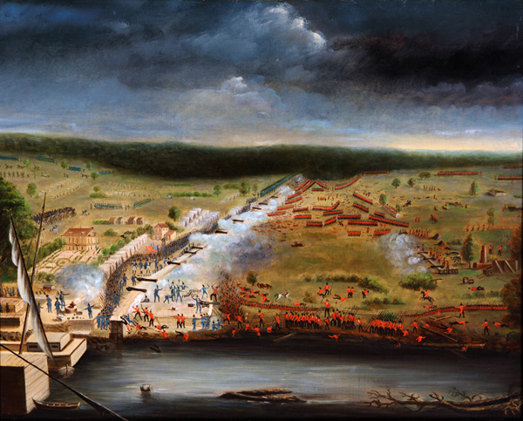

After you read:
1. What immediate (short-term) effects did the Battle of New Orleans have on the city and Louisianans?

2. How did the victory play into a growing feeling of nationalism in Louisiana and the country?

Lesson 7 – How did the Battle of New Orleans affect Louisiana?
Student Directions | Read Source R and complete the guiding questions in the right-hand column. Next, study Source S and T and complete performance task #3 at the end of this lesson.
Featured Sources | Source R: Proclamation by Andrew Jackson December 1814 (excerpt)  Source S: Celebration in New Orleans after Victory  Source T: Jackson Sculpture in French Quarter, New Orleans, Louisiana
Optional Digital Extension | CrashCourse – War of 1812

Source R: Proclamation by Andrew Jackson December 1814 (Excerpt)
Text | Vocabulary | Guiding Questions
Louisianians!  [The deceitful] Britons have attempted to invade your country . . . [T]hey were not long indulged in their error . . .  The proud Briton . . . has called upon you, by proclamation, to aid him in his tyranny, and to [give up] the holy temple of our liberty. Can Louisianians, can Frenchmen, can Americans, ever stoop to be the slaves or allies of Britain?  [British] colonel Nicholls, when he addressed you . . . had forgotten that you were [devoted to] freedom, or he would never have [tried to] . . . lure you from your fidelity to the government of your choice. “I ask you, Louisianians, can we place any confidence in the honour of men who have courted an alliance with pirates and robbers? . . . Have they not made offers to the pirates of Barataria to join them, and their holy cause? And have they not dared to insult you by calling on you to associate, as brethren with them[?]” | fidelity: loyalty  brethren: brothers, part of a family | What is Jackson calling on the people of Louisiana to reject? Who is he hoping they will give their loyalty to?  _____________________________  _____________________________  _____________________________  _____________________________  _____________________________  _____________________________

Source S: Celebration in New Orleans after Victory
The image below shows the general mood of triumph and celebration following the U.S. victory over the British at the Battle of New Orleans.

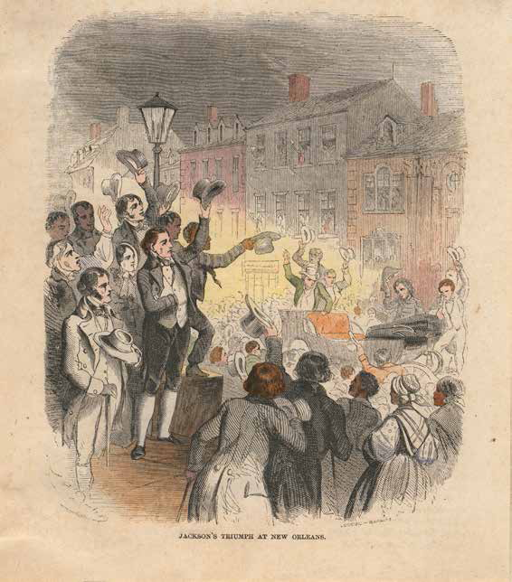

Source T: Jackson Sculpture in French Quarter, New Orleans, Louisiana
This sculpture was crafted by Clark Mills in 1856. The statue sits in the Place d’Armes, renamed to Jackson Square. Though residents of New Orleans protested Andrew Jackson’s heavy-handed treatment and declaration of martial law, attitudes toward him changed over time as Louisiana increasingly saw itself as part of the United States.

Today, some Americans are increasingly questioning how statues are used in society to glorify leaders from the past. Jackson is one such leader. While he is being celebrated here for military leadership in the Battle of New Orleans, he was also a slaveholder and responsible during his presidency for the removal of Native Americans from their land, including the Trail of Tears forced relocation, which resulted in thousands of deaths.

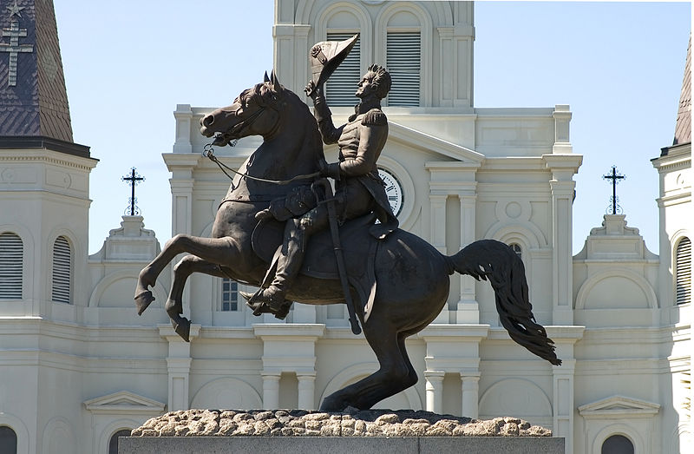
Formative Performance Task #3 – Constructed Response
Student Directions | Based on the sources, write a paragraph that explains two ways the Battle of New Orleans affected Louisiana.

Lesson 8 - Summative Performance Task
Student Directions | Based on the sources from this packet and your knowledge of social studies, write an essay answering the framing question: How did an expanding United States affect Louisiana?

Name________________________________________________ Date ________________
To What Extent Did Reconstruction Change the Lives of Black People in Louisiana?
Introduction
Student Directions | Over the next two weeks, you will explore the sources in this packet to learn about the economic, political, and social changes experienced by Black Louisianans in the Reconstruction period following the Civil War. At the end of the packet, you will express your understanding by writing a response to the following question: To what extent did Reconstruction change the lives of Black people in Louisiana? This packet includes three supporting questions which will help you develop your claim. After you read each text or analyze each image, you will be asked to answer questions about it. Some words are defined to help you better understand each source and answer the questions. Some sources have digital extensions, which are optional sources you can explore if you have internet access. *Note: During this time period (the late 19th century), the Democratic political party was a pro-slavery party for the most part, while the Republican political party had more members in favor of abolition.

Lesson 1 – Setting the Context
Student Directions | First, read Source A and answer the guiding questions in the right-hand column. Then, read and study Source B and answer the question below the source. Then, read Source C and answer the guiding questions in the right-hand column. Finally, complete the after you read questions at the end of this lesson.
Featured Sources | Source A: “Antebellum Louisiana”  Source B: Slave Populations of the United States, 1861  Source C: Excerpts from Twelve Years a Slave by Solomon Northup

Source A: “Antebellum Louisiana”
Text | Vocabulary | Guiding Questions
The antebellum period of American history covers the first part of the nineteenth century, leading up to the Civil War. The antebellum period in Louisiana begins on April 30, 1812, when it entered the Union as the eighteenth state, and ends on March 21, 1861, when it joined the Confederacy. During its first years of statehood, political and cultural conflict continued to revolve around tension between Louisianans of Anglo-American descent and those of French or Spanish descent, frequently called Creoles. The state also was home to a significant population of Acadian refugees known as Cajuns. The imprint of Creoles and Cajuns affected the state’s legal system (a combination of French civil law and English common law), its religion (the greatest percentage of Catholics in the South), and its culture, whether through its Mardi Gras celebration, foods such as gumbo, boudin, jambalaya, and étouffée, or unique musical traditions that would ultimately become elements of jazz and zydeco.  . . .  Plantation System and Slavery  With much of its wealth resting on the production and marketing of staple crops, the state relied on slave labor to support the plantation system. In each census during the antebellum period, slaves made up at least 45 percent of Louisiana’s total population, and more than 60 percent of the population outside of New Orleans. Slave concentrations were highest along the Mississippi River, with slaves comprising more than 90 percent of the population in Concordia and Tensas parishes. While not home to a large slave population, New Orleans did contain the South’s largest interstate slave market, where slaves from the upper South were sold to the cotton fields of the Deep South. This slave labor allowed some plantation owners to accumulate vast sums of wealth best viewed today in elegant plantation homes such as Nottoway, Oak Alley, and Shadows on the Teche. Plantation owners also dominated the state legislature, the governor’s office, and the state’s secession convention.  Most Louisianans could only dream of such affluence, as the average white man farmed his own small plot of land with the help of his family. These farmers aimed to feed their families first, but might grow a bale or two of cotton as well. Despite the importance of cotton and sugar, Louisianans actually planted more acreage in corn than in any other crop. Corn, along with pork, served as the key foods in the typical Louisiana diet, though in south Louisiana, seafood and rice-based dishes appeared as well. Most farmers lived an isolated life owing to the state’s primitive transportation network. Louisianans relied on water transportation, with plantation homes facing rivers and steamboats traveling up and down its waterways. The Red River, however, was only occasionally navigable upriver from Alexandria, and the Atchafalaya Basin held a much lower volume of water than it does today. Starting in the 1830s, railroads began to improve transportation, but a lack of both planning and capital, especially after the nationwide Panic of 1837, made their growth sporadic. In 1835, one of the first railroad ventures connected New Orleans and the resort of Carrollton. The New Orleans and Carrollton Railroad would become the famous St. Charles Avenue Streetcar line, still in existence today.  Social Life in antebellum Louisiana  Louisianans’ social life depended upon their wealth and where they lived. Unsurprisingly, New Orleans residents had the most options. The city offered nationally renowned operas and theaters, opulent hotels, fancy balls, and excellent restaurants. At the other end of the spectrum were gambling dens and houses of prostitution. Outside New Orleans, social activities centered on political gatherings, court days, and religious services. Although the southern portion of the state had a Catholic majority, Protestants predominated in northern Louisiana and eventually in the state as a whole. By 1860, the state had 199 Methodist and 161 Baptist churches, compared with 99 Catholic churches. Nevertheless, Catholic churches possessed more wealth than all of their Protestant counterparts combined.  Religion impacted all Louisianans, whether free or slave. African Americans synthesized their traditions with Christianity to form Voudou. Additionally, slaves used the Christian religion as a way to cope with bondage, identifying with the enslaved Israelites and seeking their own Moses. Regardless of what their owners thought, slaves did not accept their status. While the antebellum period never saw a slave revolt rivaling the 1811 slave rebellion, fears among white Louisianans of rebellion never disappeared. Just about every edition of every newspaper included numerous advertisements seeking the return of escaped slaves. Although Louisiana slaves did not leave many extensive records, some narratives, most famously that of Solomon Northup, detail their efforts to endure slavery. Northup, a freeman kidnapped into slavery, describes slaves’ lives, and his account demonstrates the extensive array of tasks slaves performed in antebellum Louisiana.  Not all of Louisiana’s African Americans were enslaved. A significant number of free people of color lived in the state. French and Spanish slave society had a greater toleration of interracial liaisons than Americans and a greater likelihood of freeing the children of these relationships. Also, following the Haitian Revolution, more free Blacks came to Louisiana. Most of them lived in New Orleans, but a significant colony lived in the Cane River region. The number of free people of color in Louisiana peaked at 25,500 in 1840. Because of mounting obstacles placed in the way of emancipation and an increasingly hostile attitude toward their presence, by 1860 their total had decreased to 18,647. In contrast, by 1860, Louisiana’s overall population had grown to 708,002, of whom 331,726 were slaves. | Anglo-American: white Americans whose ancestors lived in western Europe  plantation: an estate where cash crops are farmed by people who live on the grounds; in the South, labor for plantations were largely provided by enslaved people  affluence: wealth  opulent: fancy or wealthy  synthesized: to make something by combining different things  Voudou: combination of West African and Roman Catholic religious traditions  bondage: enslavement  1811 slave rebellion: slaves rebelled along the German Coast of Louisiana  emancipation: freedom | Which two major events mark the beginning and end of the antebellum period in Louisiana?  ________________________________  ________________________________  ________________________________  ________________________________  ________________________________  How did Cajun and Creole people impact the culture of Louisiana?  ________________________________  ________________________________  ________________________________  ________________________________  ________________________________  How did plantation owners gain wealth during the antebellum period?  ________________________________  ________________________________  ________________________________  ________________________________  ________________________________  ________________________________  ________________________________  ________________________________  ________________________________  ________________________________  ________________________________  ________________________________  ________________________________  ________________________________  ________________________________  How did Louisianans travel during the antebellum period?  ________________________________  ________________________________  ________________________________  ________________________________  ________________________________  ________________________________  ________________________________  ________________________________  Where did most Catholics in Louisiana live?  ________________________________  ________________________________  ________________________________  ________________________________  ________________________________  ________________________________  ________________________________  ________________________________  ________________________________  ________________________________  ________________________________  How did enslaved people resist enslavement?  ________________________________  ________________________________  ________________________________  ________________________________  ________________________________  ________________________________  ________________________________  ________________________________  ________________________________  How did the size of Louisiana’s free people of color population change over time before the Civil War in 1861?  ________________________________  ________________________________  ________________________________  ________________________________  ________________________________  ________________________________  ________________________________

Source B: Slave Populations of the United States, 1861
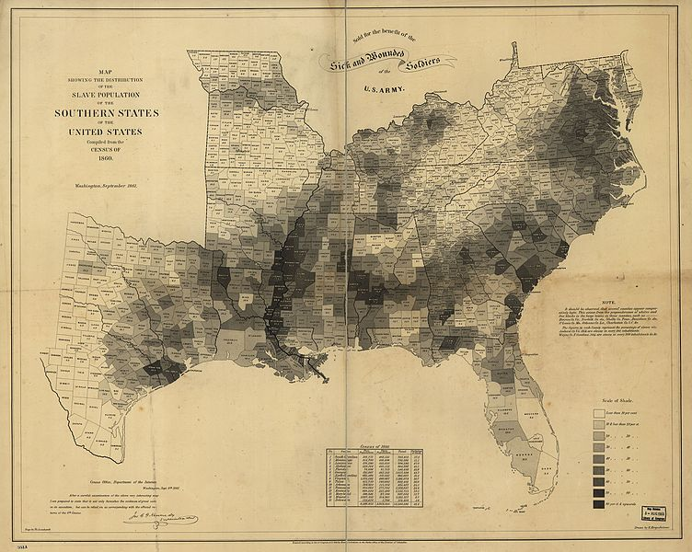
This map, published by the US Coast Guard, shows the percentage of enslaved people in the population in each county of the slave-holding states in 1860. The areas with the darkest shading represent the areas with the largest enslaved population. The highest percentages lie along the Mississippi River, in the “Black Belt” of Alabama, and coastal South Carolina, all of which were centers of agricultural production (cotton and rice) in the United States.
What determined where the largest concentrations of enslaved people lived in Louisiana?

_________________________________________________________________________________________________

*Note: Solomon Northup was a free man of color who was born and lived in New York City. Northup was offered a job in Washington, D.C., where slavery was legal, and then kidnapped by enslavers and sold into slavery in Louisiana. He spent twelve years enslaved in Louisiana. He was freed in 1853 and became an abolitionist, telling his story publicly and calling for an end to slavery. Northup’s account of his experience, Twelve Years a Slave, was published in 1853. The excerpt below describes Northup’s experience in a slave pen waiting to be sold after he was kidnapped and beaten.

Source C: Excerpts from Twelve Years a Slave by Solomon Northup
Text | Vocabulary | Guiding Questions
I remained in Williams' slave pen about two weeks. The night previous to my departure a woman was brought in, weeping bitterly, and leading by the hand a little child. They were Randall's mother and half-sister. On meeting them he was overjoyed, clinging to her dress, kissing the child, and exhibiting every demonstration of delight. The mother also clasped him in her arms, embraced him tenderly, and gazed at him fondly through her tears, calling him by many an endearing name.  Emily, the child, was seven or eight years old, of light complexion, and with a face of admirable beauty. Her hair fell in curls around her neck, while the style and richness of her dress, and the neatness of her whole appearance indicated she had been brought up in the midst of wealth. She was a sweet child indeed. The woman also was arrayed in silk, with rings upon her fingers, and golden ornaments suspended from her ears. Her air and manners, the correctness and propriety of her language—all showed, evidently, that she had sometime stood above the common level of a slave. She seemed to be amazed at finding herself in such a place as that. It was plainly a sudden and unexpected turn of fortune that had brought her there. Filling the air with her complainings, she was hustled, with the children and myself, into the cell. Language can convey but an inadequate impression of the lamentations to which she gave incessant utterance. Throwing herself upon the floor, and encircling the children in her arms, she poured forth such touching words as only maternal love and kindness can suggest. They nestled closely to her, as if there only was there any safety or protection. At last they slept, their heads resting upon her lap. While they slumbered, she smoothed the hair back from their little foreheads, and talked to them all night long. She called them her darlings—her sweet babes—poor innocent things, that knew not the misery they were destined to endure. Soon they would have no mother to comfort them—they would be taken from her. What would become of them? Oh! she could not live away from her little Emmy and her dear boy. They had always been good children, and had such loving ways. It would break her heart, God knew, she said, if they were taken from her; and yet she knew they meant to sell them, and, may be, they would be separated, and could never see each other anymore. It was enough to melt a heart of stone to listen to the pitiful expressions of that desolate and distracted mother. Her name was Eliza. | inadequate: not complete  lamentations: expressions of grief or sorrow  maternal: motherly | Why was Eliza so upset when she met Solomon Northup?  ________________________________  ________________________________  ________________________________  ________________________________  ________________________________  ________________________________  ________________________________  ________________________________  ________________________________  ________________________________  ________________________________  ________________________________  ________________________________  ________________________________  ________________________________  ________________________________  ________________________________  ________________________________  ________________________________  ________________________________  ________________________________  ________________________________  ________________________________  ________________________________  ________________________________  ________________________________

After you read:
1. Describe how the enslaved labor of Black people drove the economy of the antebellum South.

2. Describe the political and social power of Black people in the antebellum South. How did the lives of enslaved people differ from the lives of free people of color?

Lesson 2 – Setting the Context
Student Directions | First, read Sources D and E and answer the guiding questions in the right-hand column. Then, read and study Source F. Then, read Sources G, H, I, and J and answer the guiding questions in the right-hand column. Finally, complete the after you read questions at the end of this lesson.
Featured Sources | Source D: “Introduction to the Civil War”  Source E: “The Election of 1860 and Secession”  Source F: “Civil War Divisions”  Source G: Excerpts from an Address to the Texas Secession Convention Given by Commissioner George Williamson of Louisiana on February 11, 1861  Source H: “Civil War Louisiana”  Source I: Excerpts from the Emancipation Proclamation  Source J: “The War Ends”

Source D: “Introduction to the Civil War”
Text | Vocabulary | Guiding Questions
The 1860 election of Abraham Lincoln was a turning point for the United States. Throughout the tumultuous 1850s, the Fire-Eaters of the Southern states had been threatening to leave the Union. With Lincoln’s election, they prepared to make good on their threats. Indeed, the Republican president-elect appeared to be their worst nightmare. The Republican Party had committed itself to keeping slavery out of the territories as the country expanded westward, a position that shocked Southern sensibilities. Meanwhile, Southern leaders suspected that Republican abolitionists would employ the violent tactics of John Brown to deprive Southerners of their slave property. The threat posed by the Republican victory in the election of 1860 spurred eleven Southern states to leave the Union to form the Confederate States of America, a new republic dedicated to maintaining and expanding slavery. The Union, led by President Lincoln, was unwilling to accept the departure of these states and committed itself to restoring the country. Beginning in 1861 and continuing until 1865, the United States engaged in a brutal Civil War that claimed the lives of over 600,000 soldiers. By 1863, the conflict had become not only a war to save the Union, but also a war to end slavery in the United States. Only after four years of fighting did the North prevail. The Union was preserved, and the institution of chattel slavery had been legally ended. | tumultuous: hectic  Fire-Eaters:  pro-slavery Democrats in the antebellum South  Union: the states that remained in the United States during the Civil War; also known as the North  abolitionists: people who called for an end to slavery  John Brown: abolitionist who tried to lead a violent slave uprising  chattel slavery: a form of slavery where the enslaved person is the personal property of the enslaver | Why did the election of Abraham Lincoln, and therefore the Republican Party, anger Southerners?  ________________________________  ________________________________  ________________________________  ________________________________  ________________________________  ________________________________  ________________________________  ________________________________  ________________________________  What were the results of the Civil War?  ________________________________  ________________________________  ________________________________  ________________________________  ________________________________  ________________________________  ________________________________  ________________________________

*Note: The next source discusses the relationship of the presidential election of 1860 and the start of the Civil War. During this time period, the Democratic political party was a pro-slavery party for the most part, while the Republican political party had more members in favor of abolition. This source also uses the term “negro” which is an outdated term.

Source E: “The Election of 1860 and Secession”
Text | Vocabulary | Guiding Questions
The 1860 presidential election was chaotic. In April, the Democratic Party convened in Charleston, South Carolina, the bastion of secessionist thought in the South. The goal was to nominate a candidate for the party ticket, but the party was deeply divided over differences in policy toward slavery.  Abraham Lincoln’s nomination proved a great windfall for the Republican Party. Lincoln carried all free states with the exception of New Jersey (which he split with Stephen Douglas, a Republican candidate). Of the voting electorate, 81.2 percent came out to vote—at that point the highest ever for a presidential election. Lincoln received less than 40 percent of the popular vote, but with the field so split, that percentage yielded 180 electoral votes. Since the Republican platform prohibited the expansion of slavery in future western states, all future Confederate states, with the exception of Virginia, excluded Lincoln’s name from their ballots.  The election of Lincoln and the perceived threat to the institution of slavery proved too much for the deep Southern states. South Carolina acted almost immediately, calling a convention to declare secession. On December 20, 1860, the South Carolina convention voted unanimously 169–0 to dissolve their union with the United States. The other states across the Deep South quickly followed suit.  Confederates quickly shed their allegiance to the United States and adopted a new Confederate nationalism. Confederate nationalism was based on several ideals, foremost among these being slavery. As Confederate vice president Alexander Stephens stated, the Confederacy’s “foundations are laid, its cornerstone rests, upon the great truth that the negro is not equal to the white man; that slavery . . . is his natural and normal condition.” The election of Lincoln in 1860 demonstrated that the South was politically overwhelmed. Slavery was omnipresent in the prewar South, and it served as the most common frame of reference for unequal power. To a Southern man, there was no fate more terrifying than the thought of being reduced to the level of a slave. Religion likewise shaped Confederate nationalism, as Southerners believed that the Confederacy was fulfilling God’s will. The Confederacy even veered from the American Constitution by explicitly invoking Christianity in their founding document. Yet in every case, all rationale for secession could be thoroughly tied to slavery. “Our position is thoroughly identified with the institution of slavery—the greatest material interest of the world,” proclaimed the Mississippi statement of secession. Thus for the original seven Confederate states (and the four that would subsequently join), slavery’s existence was the essential core of the fledging Confederacy. | bastion: a place strongly defending or upholding particular principles, attitudes, or activities  secessionist thought: the belief that Southern states should and could leave the United States  windfall: an unexpected success  secession: when a smaller group removes itself from a larger group  nationalism: belief that the success of one’s own nation is more important than any individual, group, or other nation  Confederacy: another term for the Confederate States of America  omnipresent: present everywhere | Why did the Democrats have difficulty nominating someone for president in the 1860 election?  ________________________________  ________________________________  ________________________________  ________________________________  ________________________________  ________________________________  ________________________________  ________________________________  ________________________________  ________________________________  ________________________________  ________________________________  ________________________________  ________________________________  ________________________________  ________________________________  ________________________________  Why did the platform of the Republican party anger the Southern States?  ________________________________  ________________________________  ________________________________  ________________________________  ________________________________  ________________________________  ________________________________  ________________________________  ________________________________  Which state was the first to secede from the United States? In which year did Louisiana secede?  ________________________________  ________________________________  ________________________________  According to Alexander Stephens, why was the formation of the Confederate States of America necessary?  ________________________________  ________________________________  ________________________________  ________________________________  ________________________________

Source F: “Civil War Divisions”

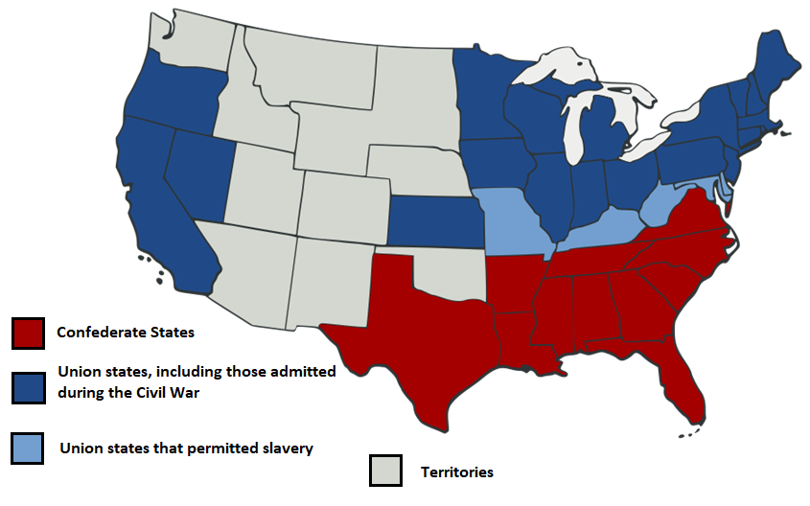

The eleven states that seceded from the Union and formed the Confederate States of America were South Carolina, Mississippi, Florida, Alabama, Georgia, Louisiana, Texas, Virginia, Arkansas, North Carolina, and Tennessee.

*Note: Prior to the Civil War, secession in Louisiana was not universally supported. However, by the time Louisiana voted to secede from the Union on January 26, 1861, five other Southern states had already seceded. Delegates to Louisiana’s secession convention meeting in Baton Rouge voted 113 to 17 to secede from the Union. Louisiana remained independent until March 21, 1861, when it joined the Confederate States of America. Of the eleven states that joined the Confederate States of America, only six states wrote detailed explanations justifying their secession. Louisiana’s delegates wrote a simple declaration that “the union now subsisting between Louisiana and other States under the name of ‘The United States of America’ is hereby dissolved.” The source below details some causes for Louisiana’s secession from the Union.

Source G: Excerpts from an Address to the Texas Secession Convention Given by Commissioner George Williamson of Louisiana on February 11, 1861
Text | Vocabulary | Guiding Questions
The people of Louisiana were unwilling to endanger their liberties and property by submission to the despotism of a single tyrant. . . . Insulted by the denial of her constitutional equality by the non-slave-holding States, outraged by their contemptuous rejection of proffered compromises, and convinced that she was illustrating the capacity of her people for self-government by withdrawing from a union that had failed, without fault of hers, to accomplish its purposes, she declared herself a free and independent State. . . . History affords no example of a people who changed their government for more just or substantial reasons. Louisiana looks to the formation of a Southern confederacy to preserve the blessings of African slavery, and of the free institutions of the founders of the Federal Union, bequeathed to their posterity. As her neighbor and sister State, she desires the hearty co-operation of Texas in the formation of a Southern Confederacy. . . .  Both States have large areas of fertile, uncultivated lands, peculiarly adapted to slave labor; and they are both so deeply interested in African slavery that it may be said to be absolutely necessary to their existence, and is the keystone to the arch of their prosperity. Each of the States has an extended Gulf coast, and must look with equal solicitude to its protection now. . . .  The people of Louisiana would consider it a most fatal blow to African slavery, if Texas either did not secede or having seceded should not join her destinies to theirs in a Southern Confederacy. If she remains in the union the abolitionists would continue their work of incendiarism and murder. . . . The people of the slaveholding States are bound together by the same necessity and determination to preserve African slavery. The isolation of any one of them from the others would make her the theatre for abolition emissaries from the North and from Europe. Her existence would be one of constant peril to herself and of imminent danger to other neighboring slave-holding communities. . . . [Louisiana’s] interests are identical to Texas and the seceding States. . . . Taking [the constitution of the late United States] as the basis of our new government we hope to form a slave-holding confederacy that will secure to us and our remotest posterity the great blessings its authors designed in the Federal Union. With the social balance wheel of slavery to regulate its  machinery, we may fondly indulge the hope that our Southern government will be perpetual. | despotism: form of government in which the ruler governs with absolute power  proffered: offered  bequeathed: given  posterity: future generations  incendiarism: promotion of violence | According to Commissioner George Williamson, why did Louisiana secede from the Union and what did he hope to gain from joining the Confederacy?  ________________________________  ________________________________  ________________________________  ________________________________  ________________________________  ________________________________  ________________________________  ________________________________  ________________________________  ________________________________  ________________________________  ________________________________  ________________________________  ________________________________  ________________________________  ________________________________  How does Commissioner George Williamson appeal to people in Texas to join the Confederacy?  ________________________________  ________________________________  ________________________________  ________________________________  ________________________________  ________________________________  ________________________________  ________________________________  ________________________________  ________________________________  ________________________________  ________________________________  ________________________________

Source H: “Civil War Louisiana”
Text | Vocabulary | Guiding Questions
The years between 1861 and 1865 were the most tumultuous five-year span in Louisiana history. During this period, Louisiana seceded from the United States, sent thousands of Confederate soldiers out of state, witnessed Union invasion and occupation, and saw the emancipation of more than 300,000 slaves. . .  Port Hudson and African American Troops  Throughout the war, a key component of overall Union strategy—often labeled the Anaconda Plan—called for the capture of the Mississippi River in order to divide the Confederacy in two parts. Simultaneous with its 1862 invasion up the Mississippi River, the Union army had also driven down the river as well. By the beginning of 1863, the Union controlled the entire Mississippi River except for the 150-mile portion between Vicksburg, Mississippi, and Port Hudson, Louisiana (approximately twenty miles north of Baton Rouge). On the northern end, the Union’s advance against Vicksburg led to numerous incursions into the Louisiana parishes on the opposite bank from that Mississippi town. On the southern end, General Nathanial Banks, who had replaced Benjamin Butler in New Orleans in December 1862, ordered ill-fated assaults on Port Hudson in both May and June 1863. Despite being greatly outnumbered, the besieged garrison did not surrender until July 9, five days after Vicksburg’s surrender. And, with its capitulation, the Union Army controlled the full length of the Mississippi River, thereby severing the Confederacy in two.  The Port Hudson campaign marked one of the first uses of African American troops in the Union army, with the 1st and 3rd Louisiana Native Guard facing combat three months before the more famous Massachusetts 54th challenged the Confederates at Battery Wagner. Ironically, the Louisiana Native Guard was initially a Confederate unit. In 1861, approximately 800 free African Americans, hoping to maintain their status as a caste separate from slaves, had enlisted in the unit. The Confederacy, however, had no intention of using these men as part of its army. After the Union captured New Orleans, some of these Native Guards offered their services to General Benjamin Butler, and on September 27, 1862, the 1st Louisiana Native Guard became the Union army’s first officially sanctioned African American unit. The regiment continued to include free men, including P.B.S. Pinchback, who would later serve as the South’s only African American governor during Reconstruction. Former slaves, however, now comprised a majority of the troops. As it did in other states, the Union army primarily employed these men in fatigue duties, but in May 1863 they mounted a hopeless charge at Port Hudson. Although they failed in their military goal, their actions contributed to a changing attitude toward the use of African American troops. Eventually, more than 24,000 African American Louisianans would fight for the US during the Civil War. | emancipation: setting free  capitulation: surrender  caste: social class  General Benjamin Butler: a Union general  fatigue duties: work in the military that does not require the use of weapons | Why were Vicksburg and Port Hudson important to the Union?  ________________________________  ________________________________  ________________________________  ________________________________  ________________________________  ________________________________  ________________________________  ________________________________  ________________________________  ________________________________  ________________________________  ________________________________  ________________________________  ________________________________  ________________________________  ________________________________  ________________________________  ________________________________  Why did free African Americans join Union forces?  ________________________________  ________________________________  ________________________________  ________________________________  ________________________________  ________________________________  ________________________________  ________________________________  ________________________________  How were Black troops allowed to participate in the Union military?  ________________________________  ________________________________  ________________________________  ________________________________  ________________________________  ________________________________

*In the Emancipation Proclamation, President Lincoln defined areas in rebellion against the United States as regions that had seceded but had not been re-taken by Union forces. Parishes in Louisiana exempted from the proclamation were those occupied by Union forces, and therefore no longer part of the Confederacy.

Source I: Excerpts from the Emancipation Proclamation
Text | Vocabulary | Guiding Questions
Now, therefore I, Abraham Lincoln, President of the United States. . . in time of actual armed rebellion against the authority and government of the United States, and as a fit and necessary war measure for suppressing said rebellion, do. . . order and designate as the States and parts of States wherein the people thereof respectively, are this day in rebellion against the United States, the following, to wit:  Arkansas, Texas, Louisiana, (except the Parishes of St. Bernard, Plaquemines, Jefferson, St. John, St. Charles, St. James, Ascension, Assumption, Terrebonne, Lafourche, St. Mary, St. Martin, and Orleans, including the City of New Orleans) Mississippi, Alabama, Florida, Georgia, South Carolina, North Carolina, and Virginia, (except the forty-eight counties designated as West Virginia, and also the counties of Berkley, Accomac, Northampton, Elizabeth City, York, Princess Ann, and Norfolk, including the cities of Norfolk and Portsmouth), and which excepted parts, are for the present, left precisely as if this proclamation were not issued.  . . . I do order and declare that all persons held as slaves within said designated States, and parts of States, are, and henceforward shall be free; and that the Executive government of the United States, including the military and naval authorities thereof, will recognize and maintain the freedom of said persons.  And I hereby enjoin upon the people so declared to be free to abstain from all violence, unless in necessary self-defence; and I recommend to them that, in all cases when allowed, they labor faithfully for reasonable wages.  And I further declare and make known, that such persons of suitable condition, will be received into the armed service of the United States to garrison forts, positions, stations, and other places, and to man vessels of all sorts in said service.  And upon this act, sincerely believed to be an act of justice, warranted by the Constitution, upon military necessity, I invoke the considerate judgment of mankind, and the gracious favor of Almighty God. | designate: identify  except: not including | How did the Emancipation Proclamation affect enslaved people in the regions identified as “in rebellion against the United States”?  ________________________________  ________________________________  ________________________________  ________________________________  ________________________________  ________________________________  ________________________________  ________________________________  ________________________________  How did the Emancipation Proclamation affect enslaved people in the regions not identified as “in rebellion against the United States”?  ________________________________  ________________________________  ________________________________  ________________________________  ________________________________  Lincoln states that the proclamation is a “military necessity.” Describe one way the Emancipation Proclamation helped the Union’s military during the Civil War.  ________________________________  ________________________________  ________________________________  ________________________________  ________________________________  ________________________________

Source J: “The War Ends”
Text | Vocabulary | Guiding Questions
By the spring of 1865, it had become clear to both sides that the Confederacy could not last much longer. Most of its major cities, ports, and industrial centers—Atlanta, Savannah, Charleston, Columbia, Mobile, New Orleans, and Memphis—had been captured by U.S. Army forces. On April 9, 1865, the Confederate general, Robert E. Lee, surrendered to United States general Ulysses S. Grant at Appomattox Court House in Virginia. By that time, he had fewer than 35,000 soldiers, while Grant had some 100,000. The war had cost the lives of more than 600,000 soldiers. Many more had been wounded. Thousands of women were left widowed. Children were left without fathers, and many parents were deprived of a source of support in their old age. In some areas, where local volunteer units had marched off to battle, never to return, an entire generation of young women was left without marriage partners. Millions of dollars’ worth of property had been destroyed, and towns and cities were laid to waste. With the conflict finally over, the very difficult work of reconciling North and South and reestablishing the United States lay ahead. |  | What were the results of the Civil War?  ________________________________  ________________________________  ________________________________  ________________________________  ________________________________  ________________________________  ________________________________  ________________________________  ________________________________  ________________________________  ________________________________

After you read:

1. What factors led to Louisiana seceding from the Union and joining the Confederate States of America?

2. How did the events of the Civil War, including the Emancipation Proclamation, affect the lives of Black people in Louisiana?

Lesson 3
Supporting Question 1: What was Reconstruction?
Student Directions | First, read Sources K and L and answer the guiding questions in the right-hand column. Then, read and study Source M. Then, complete performance task #1 at the end of this lesson.
Featured Sources | Source K: “Reconstruction”  Source L: Excerpts from Reconstruction Amendments  Source M: “The ‘Rail Splitter’ at Work Repairing the Union,” 1865

Source K: “Reconstruction”
Text | Vocabulary | Guiding Questions
Reconstruction—the effort to restore Southern states to the Union and to redefine African Americans’ place in American society—began before the Civil War ended. President Abraham Lincoln began planning for the reunification of the United States in the fall of 1863. With a sense that Union victory was imminent and that he could turn the tide of the war by stoking Unionist support in the Confederate states, Lincoln issued a proclamation allowing Southerners to take an oath of allegiance. When just 10 percent of a state’s voting population had taken such an oath, loyal Unionists could then establish governments. These so-called Lincoln governments sprang up in pockets where Union support existed like Louisiana, Tennessee, and Arkansas. Unsurprisingly, these were also the places that were exempted from the liberating effects of the Emancipation Proclamation.  Initially proposed as a war aim, Lincoln’s Emancipation Proclamation committed the United States to the abolition of slavery. However, the proclamation freed only enslaved people in areas of rebellion and left more than seven hundred thousand in bondage in Delaware, Kentucky, Maryland, and Missouri as well as in Union-occupied areas of Louisiana, Tennessee, and Virginia.  To cement the abolition of slavery, Congress passed the Thirteenth Amendment on January 31, 1865. The amendment legally abolished slavery “except as a punishment for crime whereof the party shall have been duly convicted.” Section Two of the amendment granted Congress the “power to enforce this article by appropriate legislation.” State ratification followed, and by the end of the year the requisite three fourths of the states had approved the amendment, and four million people were forever free from the slavery that had existed in North America for 250 years.  Lincoln’s policy was lenient, conservative, and short-lived. Reconstruction changed when John Wilkes Booth shot Lincoln on April 14, 1865, during a performance of Our American Cousin at Ford’s Theater. Treated rapidly and with all possible care, Lincoln nevertheless succumbed to his wounds the following morning, leaving a somber pall over the North and especially among African Americans.  The assassination of Abraham Lincoln propelled Vice President Andrew Johnson into the executive office in April 1865. Johnson, a states’ rights, strict-constructionist, and unapologetic racist from Tennessee, offered Southern states a quick restoration into the Union. His Reconstruction plan required provisional Southern governments to void their ordinances of secession, repudiate their Confederate debts, and ratify the Thirteenth Amendment. On all other matters, the conventions could do what they wanted with no federal interference. He pardoned all Southerners engaged in the rebellion with the exception of wealthy planters who possessed more than $20,000 in property. The Southern aristocracy would have to appeal to Johnson for individual pardons. In the meantime, Johnson hoped that a new class of Southerners would replace the extremely wealthy in leadership positions.  Restrictive laws passed by state governments and outrageous mob violence against Black Southerners led Republicans to call for a more dramatic Reconstruction. So when Johnson announced that the Southern states had been restored, congressional Republicans refused to seat delegates from the newly reconstructed states.  Republicans in Congress responded with a spate of legislation aimed at protecting freedmen and restructuring political relations in the South. Many Republicans were keen to grant voting rights for freedmen in order to build a new powerful voting bloc. Some Republicans, like U.S. congressman Thaddeus Stevens, believed in racial equality, but the majority were motivated primarily by the interest of their political party. The only way to protect Republican interests in the South was to give the vote to the hundreds of thousands of Black men. Republicans in Congress responded to the codes with the Civil Rights Act of 1866, the first federal attempt to constitutionally define all American-born residents (except Native peoples) as citizens. The law also prohibited any curtailment of citizens’ “fundamental rights.”  The Fourteenth Amendment developed concurrently with the Civil Rights Act to ensure its constitutionality. The House of Representatives approved the Fourteenth Amendment on June 13, 1866. Section One granted citizenship and repealed the Taney Court’s infamous Dred Scott (1857) decision. Moreover, it ensured that state laws could not deny due process or discriminate against particular groups of people. The Fourteenth Amendment signaled the federal government’s willingness to enforce the Bill of Rights over the authority of the states.  Because he did not believe African Americans deserved equal rights, President Johnson opposed the passage of the Fourteenth Amendment and vetoed the Civil Rights Act. But after winning a two-thirds majority in the 1866 midterm elections, Republicans overrode the veto, and in 1867, they passed the first Reconstruction Act, dissolving state governments and dividing the South into five military districts. Under these new terms, states would have to ratify the Fourteenth Amendment, write new constitutions enfranchising African Americans, and abolish repressive “Black Codes” before rejoining the union. In the face of President Johnson’s repeated obstructionism, the House of Representatives issued articles of impeachment against the president. Although Johnson narrowly escaped conviction in the Senate, Congress won the power to direct a new phase of Reconstruction. Six weeks later, on July 9, 1868, the states ratified the Fourteenth Amendment, guaranteeing birthright citizenship and equal protection of the laws. | strict-construction-ist: a person who believes the Constitution should be interpreted strictly by its original meaning  repudiate: to refuse to pay  pardoned: forgave  constitution-ality: following the constitution  Dred Scott (1857) decision: ruled that enslaved people could not be citizens and therefore did not have rights  enfranchising: giving the right to vote  obstruction-ism: trying to prevent  impeachment: the first step in the process of removing a president from office | What did President Lincoln believe Confederate states must do to rejoin the United States?  ________________________________  ________________________________  ________________________________  ________________________________  ________________________________  ________________________________  ________________________________  ________________________________  ________________________________  ________________________________  ________________________________  ________________________________  ________________________________  ________________________________  ________________________________  What did the Thirteenth Amendment to the constitution do? What exception was made in the law?  ________________________________  ________________________________  ________________________________  ________________________________  ________________________________  ________________________________  ________________________________  ________________________________  ________________________________  ________________________________  What did President Andrew Johnson believe Confederate states needed to do to rejoin the United States?  ________________________________  ________________________________  ________________________________  ________________________________  ________________________________  ________________________________  ________________________________  ________________________________  ________________________________  Describe one way that Republicans tried to stop the effects of Johnson’s Reconstruction plan.  ________________________________  ________________________________  ________________________________  ________________________________  ________________________________  ________________________________  ________________________________  ________________________________  What was one reason Republicans wanted to make sure Black people were able to vote during Reconstruction?  ________________________________  ________________________________  ________________________________  ________________________________  ________________________________  ________________________________  ________________________________  ________________________________  ________________________________  ________________________________  What did the Fourteenth Amendment do?  ________________________________  ________________________________  ________________________________  ________________________________  ________________________________  ________________________________  ________________________________  ________________________________  ________________________________  How did Republicans in Congress get states to pass the Fourteenth Amendment?  ________________________________  ________________________________  ________________________________  ________________________________  ________________________________  ________________________________

Source L: Excerpts from Reconstruction Amendments
Text | Vocabulary | Guiding Questions
Amendment XIII  Passed by Congress January 31, 1865. Ratified December 6, 1865. The 13th Amendment changed a portion of Article IV, Section 2.  SECTION. 1. Neither slavery nor involuntary servitude, except as a punishment for crime whereof the party shall have been duly convicted, shall exist within the United States, or any place subject to their jurisdiction.  Amendment XIV  Passed by Congress June 13, 1866. Ratified July 9, 1868. The 14th Amendment changed a portion of Article I, Section 2. A portion of the 14th Amendment was changed by the 26th Amendment.  SECTION. 1. All persons born or naturalized in the United States, and subject to the jurisdiction thereof, are citizens of the United States and of the State wherein they reside. No State shall make or enforce any law which shall abridge the privileges or immunities of citizens of the United States; nor shall any State deprive any person of life, liberty, or property, without due process of law; nor deny to any person within its jurisdiction the equal protection of the laws.  SECTION. 3. No person shall be a Senator or Representative in Congress, or elector of President and Vice-President, or hold any office, civil or military, under the United States, or under any State, who, having previously taken an oath, as a member of Congress, or as an officer of the United States, or as a member of any State legislature, or as an executive or judicial officer of any State, to support the Constitution of the United States, shall have engaged in insurrection or rebellion against the same, or given aid or comfort to the enemies thereof. But Congress may by a vote of two-thirds of each House, remove such disability.  SECTION. 4. The validity of the public debt of the United States, authorized by law, including debts incurred for payment of pensions and bounties for services in suppressing insurrection or rebellion, shall not be questioned. But neither the United States nor any State shall assume or pay any debt or obligation incurred in aid of insurrection or rebellion against the United States, or any claim for the loss or emancipation of any slave; but all such debts, obligations and claims shall be held illegal and void.  Amendment XV  Passed by Congress February 26, 1869. Ratified February 3, 1870.  SECTION. 1. The right of citizens of the United States to vote shall not be denied or abridged by the United States or by any State on account of race, color, or previous condition of servitude.  SECTION. 2. The Congress shall have the power to enforce this article by appropriate legislation. | naturalized: to become a citizen  immunities: protections | What legal protections did the Thirteenth Amendment give to Black people?  ________________________________  ________________________________  ________________________________  ________________________________  Which group of people did the Thirteenth Amendment not protect?  ________________________________  ________________________________  Who was given rights and protections that could not be taken away by states in the Fourteenth Amendment? What were these rights and protections?  ________________________________  ________________________________  ________________________________  ________________________________  ________________________________  ________________________________  ________________________________  ________________________________  Who was excluded from holding office in Section 3 of the Fourteenth Amendment?  ________________________________  ________________________________  ________________________________  ________________________________  ________________________________  What legal protections did the Fifteenth Amendment give Black people?  ________________________________  ________________________________  ________________________________  ________________________________  ________________________________  ________________________________  ________________________________  ________________________________  ________________________________  ________________________________
Source M: “The ‘Rail Splitter’ at Work Repairing the Union,” 1865

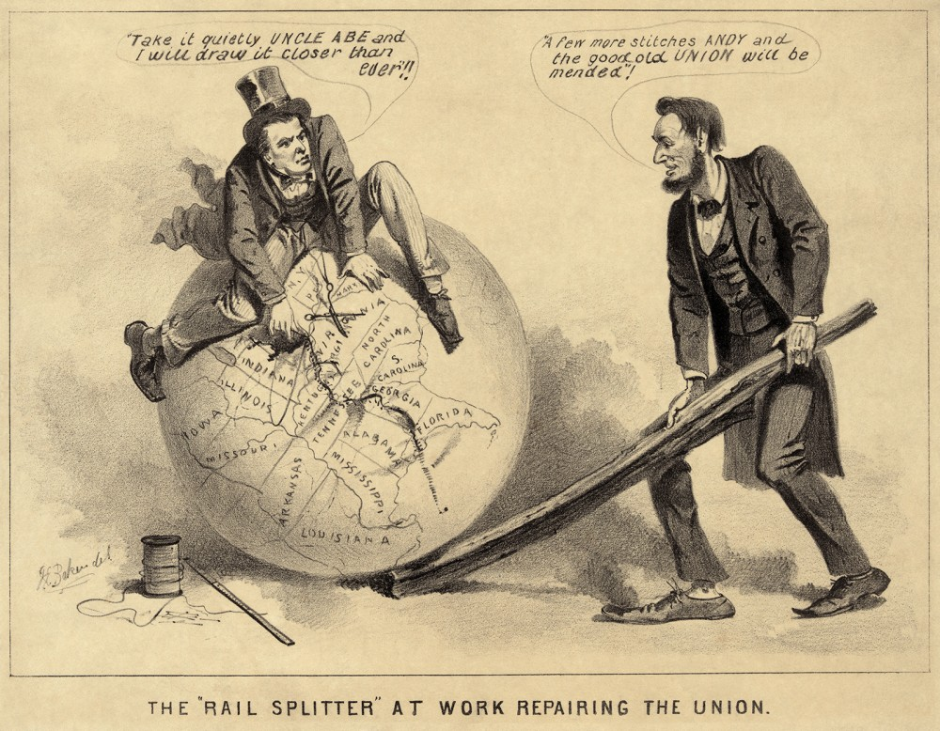

Lincoln’s Presidential Reconstruction plans were seen by many, including Radical Republicans in Congress, to be too tolerant towards those they considered to be traitors. This political cartoon reflects this viewpoint, showing Lincoln and Johnson happily stitching the Union back together with little anger towards the South. Radical Republicans, on the other hand, wanted immediate abolition of slavery, full citizenship and voting rights for Black people, and for the Southern states to pay financially and socially for the war. They also pushed the nation to finally realize the Declaration of Independence’s promises that “all men are created equal” and have “certain unalienable rights.” White Democrats granted African Americans legal freedom but little more. When Black Americans and their radical allies succeeded in securing citizenship for freed people with the Fourteenth Amendment, a new fight commenced to limit the implications of American citizenship for Black Americans.
Formative Performance Task #1 – Constructed Response
Student Directions | Describe plans for reconstruction in the left column. In the right column, describe the details of the Reconstruction amendments and what legal protections they granted.

Reconstruction Plans | Reconstruction Amendments
President Abraham Lincoln: | 13th Amendment:
President Andrew Johnson: | 14th Amendment:
Radical Republicans: | 15th Amendment:

Lesson 4
Supporting Question 2: How did the lives of Black people in Louisiana
change economically due to Reconstruction?
Student Directions | First, read Source N and answer the guiding questions in the right-hand column. Read and study Sources O and P. Then, read Sources Q and R and answer the guiding questions in the right-hand column. Next, read and study Source S. Finally, complete the after you read questions and performance task #2 at the end of this lesson.
Featured Sources | Source N: “The Freedman’s Bureau”  Source O: “Frank Leslie’s Illustrated Newspaper”  Source P: African American Workers on Cape Fear River Rice Plantation, N.C. Weeding  Source Q: “Sharecropping”  Source R: “Convict Leasing”  Source S: “Angola Landing, State Penitentiary Farm, Mississippi River, LA”

Source N: “The Freedman’s Bureau”
Text | Vocabulary | Guiding Questions
Freed people everywhere celebrated the end of slavery and immediately began to take steps to improve their own condition by seeking what had long been denied to them: land, financial security, education, and the ability to participate in the political process. They wanted to be reunited with family members, grasp the opportunity to make their own independent living, and exercise their right to have a say in their own government.  However, they faced the wrath of defeated but un-reconciled Southerners who were determined to keep Blacks an impoverished and despised underclass. Recognizing the widespread devastation in the South and the dire situation of freed people, Congress created the Bureau of Refugees, Freedmen, and Abandoned Lands in March 1865, popularly known as the Freedmen’s Bureau. Lincoln had approved of the bureau, giving it a charter for one year.  The Freedmen’s Bureau engaged in many initiatives to ease the transition from slavery to freedom. It delivered food to Blacks and whites alike in the South. It helped freed people gain labor contracts, a significant step in the creation of wage labor in place of slavery. It helped reunite families of freedmen, and it also devoted much energy to education, establishing scores of public schools where freed people and poor whites could receive both elementary and higher education. Respected institutions such as Fisk University, Hampton University, and Dillard University are part of the legacy of the Freedmen’s Bureau.  In this endeavor, the Freedmen’s Bureau received support from Christian organizations that had long advocated for abolition, such as the American Missionary Association (AMA). The AMA used the knowledge and skill it had acquired while working in missions in Africa and with American Indian groups to establish and run schools for freed slaves in the postwar South. While men and women, white and Black, taught in these schools, the opportunity was crucially important for participating women. At the time, many opportunities, including admission to most institutes of higher learning, remained closed to women. Participating in these schools afforded these women the opportunities they otherwise may have been denied.  The schools that the Freedmen’s Bureau and the AMA established inspired great dismay and resentment among the white populations in the South and were sometimes targets of violence. Indeed, the Freedmen’s Bureau’s programs and its very existence were sources of controversy. Racists and others who resisted this type of federal government activism denounced it as both a waste of federal money and a foolish effort that encouraged laziness among Blacks. Congress renewed the bureau’s charter in 1866, but President Johnson, who steadfastly believed that the work of restoring the Union had been completed, vetoed the re-chartering. Radical Republicans continued to support the bureau, igniting a contest between Congress and the president that intensified during the next several years. Part of this dispute involved conflicting visions of the proper role of the federal government. Radical Republicans believed in the constructive power of the federal government to ensure a better day for freed people. Others, including Johnson, denied that the government had any such role to play. | wrath: extreme anger  wage labor: paid labor | What did former enslaved people want after the end of the Civil War?  ________________________________  ________________________________  ________________________________  ________________________________  ________________________________  ________________________________  ________________________________  ________________________________  ________________________________  ________________________________  How did the Freedman’s Bureau aim to help freed Black people?  ________________________________  ________________________________  ________________________________  ________________________________  ________________________________  ________________________________  How did the Freedman’s Bureau and Christian organizations support the education of Black children?  ________________________________  ________________________________  ________________________________  ________________________________  ________________________________  ________________________________  ________________________________  Why did the Freedman’s Bureau experience resistance?  ________________________________  ________________________________  ________________________________  ________________________________  ________________________________  ________________________________

Source O: “Frank Leslie’s Illustrated Newspaper”
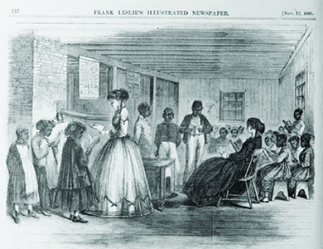
The Freedmen’s Bureau, as shown in this 1866 illustration from Frank Leslie’s Illustrated Newspaper, created many schools for Black elementary school students. Many of the teachers who provided instruction in these Southern schools, though by no means all, came from northern states.

Source P: African American Workers on Cape Fear River Rice Plantation, N.C. Weeding
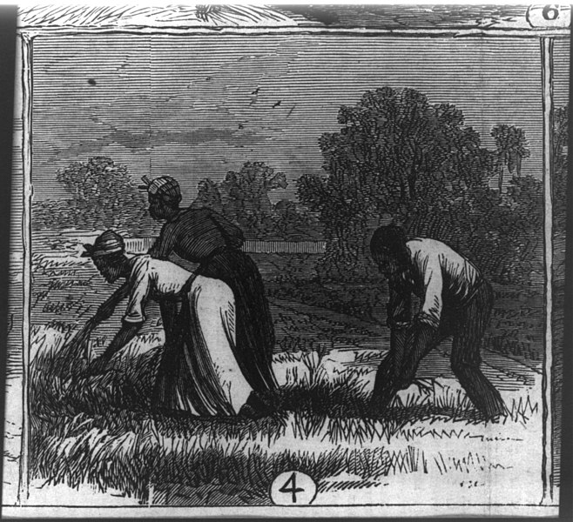
In this 1866 illustration from Frank Leslie’s Illustrated Newspaper, Black workers are shown working on a rice farm. Planters broke up large farms into smaller plots tended by single families in exchange for a portion of the crop, a system called sharecropping. Lacking the means to buy their own farms, Black farmers often turned to sharecropping. Sharecropping often led to cycles of debt that kept families bound to the land.

Source Q: “Sharecropping”
Text | Vocabulary | Guiding Questions
Of all the images of economic backwardness, racial oppression, and social stagnation associated with Louisiana and the South in the post-Civil War decades, that of sharecropping has persisted most vividly as a defining symbol of a region held captive by the chains of poverty and tradition. Much of the relevant scholarly literature, and certainly public opinion, has stereotyped sharecropping as little more than a recast form of slavery, with even fewer protections than found under the “peculiar institution” and just as many opportunities for exploitation. There is a core of truth to this characterization, of course. As a labor system and way of life, though, sharecropping was much more complex than such a narrow description allows. . . .  The emergence of sharecropping, or more precisely “farm tenancy,” as the dominant form of agricultural organization in postwar Louisiana reflected the state’s deep economic crisis as well as its indelible bond to the cotton economy. Originating in the old plantation districts along the Mississippi and Red rivers, the sharecropping system represented a compromise between newly freed but landless African American workers and impoverished white planters who lacked capital and credit. The former slaves provided the manpower needed for the struggling plantations, and in return they received housing, food, and a share of the cotton crop, along with considerable latitude in their daily lives. The planters maintained their dominant social position and, most important, the title to their lands, even while being forced to accept a new, decentralized labor structure.  While outsiders often perceived sharecropping as the collapse of the plantation system, it actually signified less a breakup of the old order than a dispersal of its functions. Planters gave up direct control over production in return for the convenience of a semi-autonomous but fairly stable labor force. . . Yet as planters regained political and economic power in the 1880s and 1890s, sharecropping lost much of its elasticity and became a more impersonal institution. Landlords exercised considerable control over the lives of their tenants through the legal instrument of the “crop-lien” and the application of other means of leverage, including physical violence.  On the lowest rung of the agricultural ladder, day or wage laborers proved among the easiest to exploit. Essentially operating as hired hands, they worked at the direction of the plantation manager, who could use them for any number of tasks associated with cotton production or plantation upkeep. As part of their “contract,” they usually received a cabin or shack for living quarters and collected cash wages. Occasionally these wages were paid in real currency, but more often were paid with paper “scrip” or cheap metal tokens known as “bronzeen,” redeemable only at the plantation store. As one might imagine, few bargains awaited the customer at such places.  One step up from the day laborer, sharecroppers farmed specific plots of plantation ground. These farmsteads ranged anywhere from ten to thirty acres in size, depending on the cropper’s expertise and the number of “hands” (wives or children) who could be deployed in planting, tending, and picking cotton. Planters usually supplied the necessary work stock, seed, fertilizer, cotton bagging, and equipment, along with a cabin and an account with either the plantation commissary or a local “furnish” merchant to meet day-to-day needs. The croppers primarily supplied their labor. Although nominally more independent than day laborers, these tenants nonetheless met with close supervision from plantation managers, who determined when to plant and harvest, and deducted any additional services, such as plowing, dusting, or ginning, from the croppers’ accounts. At the end of the season, croppers, as true share-tenants, received anywhere from a quarter to half the value of the harvested cotton and cottonseed (hence, the phrases “working on quarters” or “working on halves”). The landlord, however, retained control of the crop’s marketing as well as the settlement of accounts. This final reckoning of the plantation books rarely favored the cropper, who often cleared only $50 to $150 in a good season, and dipped further into debt during a bad one.  Tenants who owned a mule, had their own equipment, or were otherwise in a better financial position might arrange for a straight-cash rental or some mix of cash payments and crop-shares. These farmers maintained more control over their individual routines than either day laborers or croppers. Indeed, they often planted vegetable gardens and orchards, kept milk cows, and raised chickens or pigs. Because they led fairly self-sufficient lives, they reaped larger shares of the profits. Working on the Montrose and Trinidad plantations in Madison Parish during the 1920s, tenants who had their own mules and equipment cleared upwards of $400 or $500 a season, for example. But any sort of economic reversal—such as the death of a mule or a bad harvest—often sent these “renters” spiraling back down the ladder into cropper or laborer status.  Whatever the situation, sharecropping was a perilous existence. . . . In 1880 only a third of Louisiana’s farmers could be classified as tenants, but by 1910 this number had surged to 55 percent. By 1930, a staggering 67 percent of Louisiana farmers were classified as tenants, with the vast majority listed as share-tenants or croppers, rather than renters. White farmers, formerly the sturdy yeomanry of antebellum times, comprised a solid third of this tenant population. Driven by ruinous economic conditions and an expanding market, these landless whites, like their Black counterparts, became enmeshed in the cyclically depressive cotton economy of the late nineteenth and early twentieth centuries.  Although trapped within this repressive system, sharecroppers were not bound to the land like feudal serfs, as is popularly imagined. Mobility, in fact, defined the lives of most tenants as they shifted about from plantation to plantation and region to region in search of better opportunities. In her memoir of life in Caldwell and Richland parishes during the 1930s, Lillian Laird Duff recounts moving on an almost yearly basis, making a different agreement with each landlord. These agreements might include a more liberal “furnish” from the plantation store or associated country merchant, better living quarters, expanded acreage, less supervision from management, or any number of other factors. Often, proximity to family or friends proved to be a major selling point.  Such mobility, though, had its costs. Children of tenant farmers, both white and Black, had very little access to educational or medical facilities and suffered as a consequence. Likewise, Louisiana’s stringent voting requirements worked against this vulnerable class of workers, who usually were not in one place long enough to establish residency and rarely could afford to pay the poll tax. In addition, Black tenants were unable to exercise the franchise. Without a political voice, sharecroppers had little chance to improve their conditions. Most simply drifted along with the ebb and flow of events far beyond their control. | stagnation: no growth  peculiar institution: term used for slavery in the American South  exploitation: unfairly using people or resources for personal gain  indelible: not easily removed  decentralized: spread out  dispersal: distributing things over a wide area  semi-autonomous: some, but not all, self-government  crop-lien: sharecroppers received supplies from local merchants or land owners and would pay once the crops came in; this system tied sharecroppers to the land they were farming  yeomanry: the people who cultivate their own land (usually rented land, sometimes owned)  ruinous: disastrous, destructive  mobility: the ability to move freely  poll tax: money that had to be paid in order to vote | Why did white planters and newly freed Black workers develop the “farm tenancy” system?  ________________________________  ________________________________  ________________________________  ________________________________  ________________________________  ________________________________  ________________________________  ________________________________  ________________________________  ________________________________  ________________________________  ________________________________  ________________________________  ________________________________  ________________________________  ________________________________  ________________________________  How were day or wage laborers exploited by the plantation owners?  ________________________________  ________________________________  ________________________________  ________________________________  ________________________________  ________________________________  ________________________________  ________________________________  ________________________________  ________________________________  ________________________________  ________________________________  How did plantation owners exploit sharecroppers?  ________________________________  ________________________________  ________________________________  ________________________________  ________________________________  ________________________________  ________________________________  ________________________________  ________________________________  ________________________________  How were some sharecroppers able to be more prosperous?  ________________________________  ________________________________  ________________________________  ________________________________  ________________________________  ________________________________  ________________________________  ________________________________  ________________________________  ________________________________  ________________________________  ________________________________  How did sharecroppers and tenant farmers have more freedom than enslaved people?  ________________________________  ________________________________  ________________________________  ________________________________  ________________________________  ________________________________  ________________________________  ________________________________  ________________________________  ________________________________  ________________________________  ________________________________  ________________________________  ________________________________  How did mobility harm the long term economic prospects of sharecroppers and tenant farmers?  ________________________________  ________________________________  ________________________________  ________________________________  ________________________________  ________________________________  ________________________________  ________________________________  ________________________________  ________________________________  ________________________________  ________________________________

Source R: “Convict Leasing”
Text | Vocabulary | Guiding Questions
Convict leasing refers to a method of controlling and distributing convict labor that was characteristic of Southern states, including Louisiana, for the half-century after the Civil War. Though the system varied from place to place, states essentially turned over the responsibility for managing prisons to labor-hungry businesses, planters, and corporations, usually for a payment that was established by statute. . . With few exceptions, Southern states lacked prison structures in this period, and, in the aftermath of the war, landowners and businesses feared an impending labor shortage. By 1867, convict leasing was the established practice in every Southern state except Virginia. Louisiana’s convict leasing system was both similar to and different from those in other states  One distinctive aspect of convict leasing in Louisiana was the almost complete lack of record keeping; officials did not present even a pretense of accountability during most of the system’s history. . . Another distinctive feature of the convict leasing system in Louisiana was that it went into effect before, rather than after, the Civil War (1861–1865). In fact, convict leasing took place almost continuously between 1844 and 1901. Early contracts pertained to prisoners in the penitentiary in Baton Rouge. The first five-year lease of the penitentiary went to James McHatton and William Pratt, who paid almost nothing for the privilege. McHatton and Pratt advanced $15,000 to the state as surety for the state’s purchase and installation of textile machinery in the prison, so that prisoners could manufacture rope, pack cloth, and cotton and woolen fabric. They also paid $2,200 annually for the services of a clerk, chaplain, and prison doctor. As this example suggests, antebellum contracts generally called for lessees to administer an existing penitentiary that was equipped with industrial machinery; white prisoners were trained to operate it. In 1857, the state leased convicts to J. M. Hart and W. S. Pike, this time in exchange for half the prison factory’s profits. This arrangement was halted, however, by the devastation incurred during the Civil War.  Convict Leasing in the Postbellum Era  As it was in other spheres, the Civil War marked a turning point in penal history. The textile factory in use during Hart and Pike’s lease was completely destroyed; only the walls and roof of the carpenter’s shop and the pressroom remained standing. In this chaos, forty-five convicts were sent to the Baton Rouge, Grosse Tete and Opelousas Railroad, which was partly state-owned, to repair the tracks at fifty cents per convict per day. This was only a makeshift arrangement, however. The convicts returned to Baton Rouge and its dilapidated prison in January 1867. Though records are scarce, the existing documentation suggests that the prison included 222 prisoners, 214 of whom were African American, by the end of that year. An astonishing forty-five—one-fifth of the population—escaped, while sixteen died.  Though some workers were leased to employers in and around Baton Rouge, the penitentiary was adrift until the state legislature turned the mess over to new partners: John Hugher and Charles Jones. Hugher and Jones successfully sued the prison’s board of control in an effort to gain complete authority over the convicts. The legislature quickly passed a law giving Hugher and Jones the control they requested. Flush with their victory, Hugher and Jones immediately sold out to Samuel Lawrence “S.L.” James, for whom they had probably been working all along. James, a former Confederate major, thus began a quarter-century of dominance as a Louisiana labor-lord. . .  . . . Though convicts sometimes worked on levees, especially after 1882 Mississippi flood, and on railroad construction, most of their labor went toward the cultivation of cotton. By 1901, most of the 1,142 prisoners lived and worked at the Louisiana State Penitentiary, commonly referred to as Angola, a former plantation transformed into a prison farm. The vast majority of these convicts were Black, and 240 were serving life sentences.  The Demise of Convict Leasing  . . . Convict leasing had always generated moral and political opposition. As early as 1883, the state’s Democratic Party convention called for its abolition, albeit in a slow process. In 1892, however, Governor Murphy J. Foster threw his support behind the enemies of the lease system. Foster also championed the disfranchisement of African American voters and the destruction of the Louisiana lottery, a notorious source of corruption. The Louisiana Constitution of 1898, passed on his watch, accomplished all these goals, specifically prohibiting the leasing of convicts and turning the prison over to state control.  When the last lease contract expired in 1901, the state of Louisiana took over Angola. Prisoners, however, probably did not notice much of a change. The previous warden was kept in place, the plantation manager was S.L. James’s son, and the chairman of the penitentiary board was the executor of James’s estate. | convict: person found guilty of a crime  statute: law  accountability: being held responsible  penitentiary: prison  advanced: loaned money with the expectation that it will be paid back quickly  lessees: a person who holds the lease of a property; lessees were the people who managed convict labor for profit  administer: manage  Postbellum: occurring after the Civil War  penal: having to do with the punishment of people convicted in the legal system  dilapidated: run down, destroyed  disfranchise-ment: taking away the right to vote  executor: someone in charge of carrying out a task | In your own words, what is convict leasing?  ________________________________  ________________________________  ________________________________  ________________________________  ________________________________  ________________________________  ________________________________  ________________________________  ________________________________  ________________________________  How was Louisiana’s convict leasing system unique from most other Southern states systems?  ________________________________  ________________________________  ________________________________  ________________________________  ________________________________  ________________________________  ________________________________  How was convict labor used during the antebellum period?  ________________________________  ________________________________  ________________________________  ________________________________  ________________________________  ________________________________  ________________________________  ________________________________  ________________________________  Describe the population of the prison in Baton Rouge in 1867.  ________________________________  ________________________________  ________________________________  ________________________________  ________________________________  ________________________________  How was convict labor used after the Civil War?  ________________________________  ________________________________  ________________________________  ________________________________  ________________________________  ________________________________  ________________________________  ________________________________  How did convict labor change after 1898? How did it remain the same?  ________________________________  ________________________________  ________________________________  ________________________________  ________________________________  ________________________________  ________________________________

Source S: “Angola Landing, State Penitentiary Farm, Mississippi River, LA”
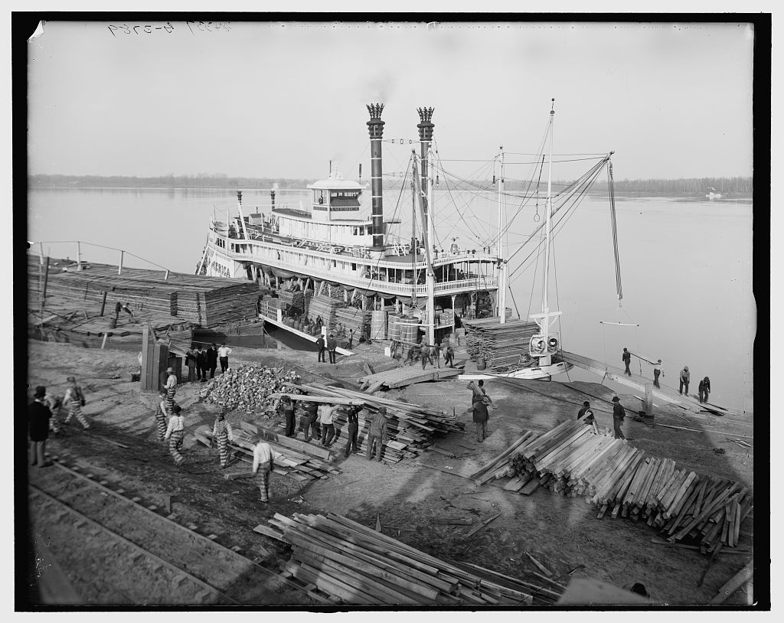

The state of Louisiana continued using convict labor on Angola after the last lease contract of 1901. Prisoners continued working on the former plantation at Angola for no pay. These conditions were allowed by the Thirteenth Amendment of the United States Constitution which said that slavery was not allowed “except as a punishment for crime whereof the party shall have been duly convicted.”

After you read:

1. How successful was the Freedman’s Bureau at helping formerly enslaved Black people and poor people during Reconstruction?

2. How was sharecropping similar to antebellum slavery? How was it different?

3. How was the convict labor similar to antebellum slavery? How was it different?

Formative Performance Task #2
Student Directions | Complete the T-chart below. Explain ways that the economic experiences of Black people in Louisiana changed and remained the same during Reconstruction.

How did the economic experiences of Black people in Louisiana remain the same during Reconstruction? | How did the economic experiences of Black people in Louisiana change during Reconstruction?

Lesson 5
Supporting Question 3: How did the lives of Black people in Louisiana change
politically and socially during Reconstruction?
Student Directions | First, read Sources T and U and answer the guiding questions in the right-hand column. Then, read and study Source V. Finally, complete the after you read questions at the end of this lesson.
Featured Sources | Source T: “Politics of Reconstruction”  Source U: “Reconstruction in Louisiana”  Source V: “Portraits of the Distinguished Members of the Convention & Assembly, 1868”

Source T: “Politics of Reconstruction”
Text | Vocabulary | Guiding Questions
Reconstruction brought the first moment of mass democratic participation for African Americans. In 1860, only five states in the North allowed African Americans to vote on equal terms with whites. Yet after 1867, when Congress ordered Southern states to eliminate racial discrimination in voting, African Americans began to win elections across the South. In a short time, the South was transformed from an all-white, pro-slavery, Democratic stronghold to a collection of Republican-led states with African Americans in positions of power for the first time in American history.  Through the provisions of the congressional Reconstruction Acts, Black men voted in large numbers and also served as delegates to the state constitutional conventions in 1868. Black delegates actively participated in revising state constitutions. One of the most significant accomplishments of these conventions was the establishment of a public school system. While public schools were virtually nonexistent in the antebellum period, by the end of Reconstruction, every Southern state had established a public school system. Republican officials opened state institutions like mental asylums, hospitals, orphanages, and prisons to white and Black residents, though often on a segregated basis. They actively sought industrial development, northern investment, and internal improvements.  African Americans served at every level of government during Reconstruction. At the federal level, Hiram Revels and Blanche K. Bruce were chosen as U.S. senators from Mississippi. Fourteen men served in the House of Representatives. At least 270 other African American men served in patronage positions as postmasters, customs officials, assessors, and ambassadors. At the state level, more than 1,000 African American men held offices in the South. P. B. S. Pinchback served as Louisiana’s governor for thirty-four days after the previous governor was suspended during impeachment proceedings and was the only African American state governor until Virginia elected L. Douglas Wilder in 1989. Almost 800 African American men served as state legislators around the South, with African Americans at one time making up a majority in the South Carolina House of Representatives.  African American officeholders came from diverse backgrounds. Many had been born free or had gained their freedom before the Civil War. Many free African Americans, particularly those in South Carolina, Virginia, and Louisiana, were wealthy and well educated, two facts that distinguished them from much of the white population both before and after the Civil War. Some, like Antoine Dubuclet of Louisiana and William Breedlove from Virginia, owned enslaved laborers before the Civil War. Others had helped enslaved people escape or taught them to read, like Georgia’s James D. Porter.  Most African American officeholders, however, gained their freedom during the war. Among them were skilled craftsmen like Emanuel Fortune, a shoemaker from Florida; ministers such as James D. Lynch from Mississippi; and teachers like William V. Turner from Alabama. Moving into political office was a natural continuation of the leadership roles they had held in their former communities.  By the end of Reconstruction in 1877, more than two thousand African American men had served in offices ranging from local levee commissioner to U.S. senator. When the end of Reconstruction returned white Democrats to power in the South, all but a few African American officeholders lost their positions. After Reconstruction, African Americans did not enter the political arena again in large numbers until well into the twentieth century. | mental asylums: hospitals for the mentally ill  segregated: races are separated | Why were Black people able to be elected to office after 1867?  ________________________________  ________________________________  ________________________________  ________________________________  ________________________________  ________________________________  How did increasing political power of Black people affect state governments and institutions?  ________________________________  ________________________________  ________________________________  ________________________________  ________________________________  ________________________________  ________________________________  ________________________________  Who was the first Black state governor elected in the United States (and only until 1989)? In which state was he elected?  ________________________________  ________________________________  ________________________________  ________________________________  ________________________________  ________________________________  ________________________________  ________________________________  Describe the various backgrounds of Black people who held elected offices during Reconstruction.  ________________________________  ________________________________  ________________________________  ________________________________  ________________________________  ________________________________  ________________________________  What happened to Black office holders when Reconstruction ended? Why?  ________________________________  ________________________________  ________________________________  ________________________________  ________________________________  ________________________________  ________________________________  ________________________________

P.B.S. Pinchback
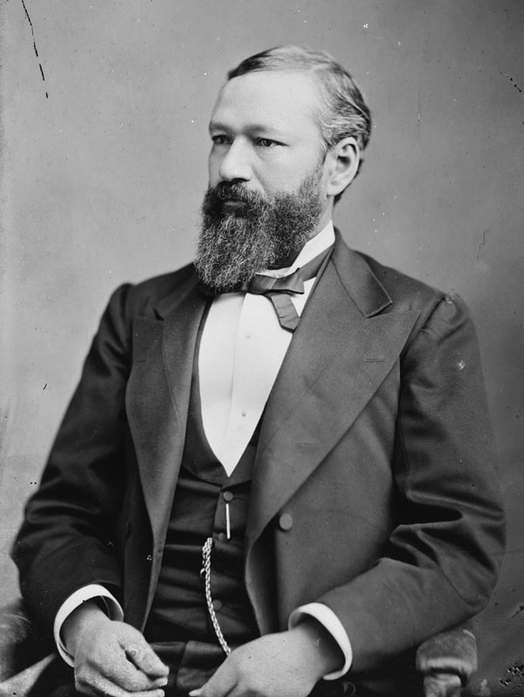

Source U: “Reconstruction in Louisiana”
Text | Vocabulary | Guiding Questions
. . .  Despite its many flaws and critics, Lincoln’s plan served as the basis for all wartime electioneering in Louisiana. This included gubernatorial and state legislative elections held at the behest of General Nathaniel Banks, which resulted in the inauguration of Michael Hahn as governor in March 1864, and the reestablishment of the state legislature in the new wartime capitol of New Orleans. Later that year, delegates from occupied Louisiana drafted a new state constitution, which led to the first meaningful debate over many of the key issues that would later dominate the Reconstruction era, including Black suffrage and public education. The underlying conservatism of the resulting document, however, bred discontent among the state’s radical leadership. More tragically, a clause that allowed the convention to reconvene in order to make amendments set in motion a series of events that would lead to postwar bloodshed.  The war years also led to an awakened Black political awareness in Louisiana. Not only did the state boast a large, educated, and prosperous free Black population, it was already organized around fraternal orders and trades. The first Black-run daily newspaper, the bilingual Tribune founded by the Afro-Creole physician Dr. Louis Charles Roudanez, appeared in New Orleans in 1864. Louisiana also supplied the largest number of soldiers to the US Colored Troops, a key element in forging Black political consciousness during Reconstruction.  Presidential Reconstruction, 1865–1867  The elevation of former planter James Madison Wells to the office of governor in March 1865, combined with the end of the war and Lincoln’s assassination, dramatically altered the path of Reconstruction in Louisiana. . . Wells saw in President Andrew Johnson’s proclamation of pardon and amnesty an opportunity to build a new political coalition out of returning Confederates and conservative Southern unionists such as himself. Wells proved unable to control what he had created, however. The new statewide elections that the governor ordered held in November 1865 resulted in the election of an almost entirely Democratic legislature that was devoted to enacting a most reactionary program. Abetted by President Johnson’s leniency, the newly reconstituted state government set about passing laws such as the Black Codes and other laws designed to compel the speedy return of freed Blacks to agricultural labor. By the early months of 1866, Radical Republicans and other advocates of universal suffrage faced grave danger from conservative violence, which culminated in the New Orleans Riot of 1866.  The riot came about when those who had crafted the state constitution of 1864 invoked the clause that allowed them to reconvene and make changes to the state’s governing document. Louisiana Radicals believed that the federal government, seeing its victory in the war slipping away, would uphold their legal authority to assemble and back their bid to introduce universal suffrage as an issue at this convention. What they did not realize was that the police and volunteer firemen of New Orleans would descend upon the meeting and murder more than thirty of their number. Along with a violent outbreak in Memphis earlier in the year, the melee in New Orleans proved influential in rallying northern support behind Radical political candidates, and as such, played a crucial role in empowering the Radical ascendancy in the fall 1866 congressional elections.  The Radical Ascendancy in Louisiana  In March 1867, over President Johnson’s veto, the new U.S. Congress passed the first of four federal Reconstruction Acts and paved the way for the liquidation of the governments in Louisiana and nine other Southern states then being controlled by former Confederates. In addition to effectively disfranchising all those who had been in support of the rebellion, these acts placed Louisiana into a military district with Texas and established guidelines for the creation of a new state government that included ratification of the recently passed Fourteenth Amendment. By eliminating the reactionary government that had formed under Andrew Johnson’s “Presidential Reconstruction,” the Radical ascendancy created an enormous political vacuum in Louisiana and ushered in a prolonged era when men with competing visions of the future battled for control of the state.  At the direction of General Philip Henry Sheridan, the military commander of the district, Louisianans set about crafting a new state constitution in the winter of 1867–1868. The document that emerged was quite revolutionary and provided for equal citizenship, the Black franchise, equal public accommodations, and public education. Balloting for new state officeholders and the constitution’s ratification by the people took place in April, resulting in the election of Republicans Henry Clay Warmoth, an Army veteran and early advocate of universal suffrage, as governor, and Oscar J. Dunn, an African American, as lieutenant governor. | gubernatorial: having to do with the governor of a state  suffrage: right to vote  consciousness: awareness  amnesty: pardon  coalition: group of people who join together to reach a shared goal  Black Codes: restrictive laws designed to limit the freedom of African Americans  Radical Republicans: fought for suffrage for Black people during Reconstruction  melee: battle  ascendancy: rise to power  franchise: right to vote | How did political activity of Black people increase during the Civil War?  ________________________________  ________________________________  ________________________________  ________________________________  ________________________________  ________________________________  ________________________________  ________________________________  ________________________________  ________________________________  ________________________________  ________________________________  ________________________________  ________________________________  ________________________________  What were the goals of the Democrats elected to Louisiana’s legislature in 1865?  ________________________________  ________________________________  ________________________________  ________________________________  ________________________________  ________________________________  ________________________________  ________________________________  ________________________________  ________________________________  ________________________________  ________________________________  Describe the events that led to Republican ascendancy in the Louisiana legislature, and therefore the Constitution of 1868.  ________________________________  ________________________________  ________________________________  ________________________________  ________________________________  ________________________________  ________________________________  ________________________________  ________________________________  ________________________________  ________________________________  ________________________________  How did the Louisiana Constitution of 1868 change the lives of Black people in Louisiana?  ________________________________  ________________________________  ________________________________  ________________________________  ________________________________  ________________________________  ________________________________  ________________________________  ________________________________

Source V: “Portraits of the Distinguished Members of the Convention & Assembly, 1868”
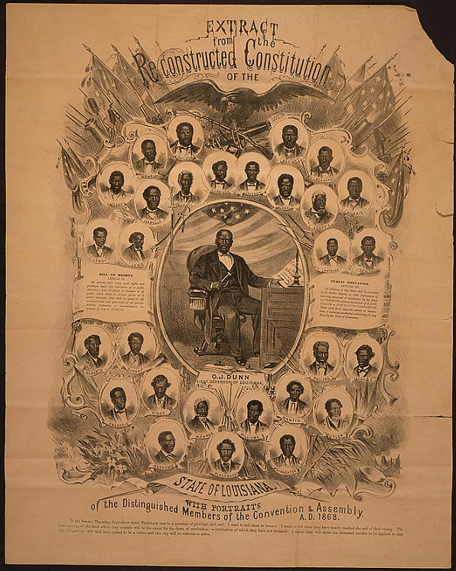

Full-length portrait of Oscar J. Dunn, Lieut. Governor of Louisiana, seated at desk, and twenty-nine head-and-shoulders portraits of African American delegates to the Louisiana Constitutional Convention.

After you read:
1. What factors led to more political power for Black people during Reconstruction?

2. What were the effects of increased political power for Black people in Louisiana?

Lesson 6
Supporting Question 3: How did the lives of Black people in Louisiana change
politically and socially due to Reconstruction?
Student Directions | First, read Source W and answer the guiding questions in the right-hand column. Then, read and study Source X. Then, read Sources Y and Z and answer the guiding questions in the right-hand column. Next, read and study Sources AA, AB, and AC. Finally, complete the after you read questions at the end of this lesson.
Featured Sources | Source W: “Colfax Massacre”  Source X: “Worse than Slavery” by Thomas Nast, 1874  Source Y: “Louisiana White League Platform”  Source Z: “Coushatta Massacre”  Source AA: Harper's Weekly, October, 1874  Source AB: Battle of Liberty Place Monument  Source AC: New Orleans Republican, October 12, 1868
Digital Extension | White League - 64Parishes.org article written by Justin A. Nystrom

*Note: Some people who believed that white people were superior to others based on their race formed groups to promote white supremacy and pass laws that would make inequality between white and Black people legal. The Ku Klux Klan was founded in 1865, and kept its members and actions secret. The White League was a public group founded in 1874. These groups and others used violence to intimidate Black and Republican voters.

Source W: “Colfax Massacre”
Text | Vocabulary | Guiding Questions
The Colfax Massacre of 1873, also known as the Colfax Riot, was the deadliest incident of racial and political violence during the Reconstruction era, claiming the lives of at least seventy and perhaps as many as 150 men. Nearly all of the victims were African American. The confrontation elevated the standing of white supremacist organizations in Louisiana and the South. The Colfax Massacre is remembered as a signal event in the establishment of the Jim Crow system, for it led to United States v. Cruikshank (1875), a Supreme Court decision that disallowed the federal prosecution of racially motivated crimes.  The Disputed Election of 1872  In an era characterized by extreme and repeated restructuring of election laws and practices, the elections of November 1872 produced disputed results and a divided government in Louisiana. The contest pitted Radical Republicans allied with President Ulysses Grant and the U.S. Congress against a “Fusion Ticket” of conservative Democrats and liberal Republicans sympathetic to the cause of home rule in the South. Because neither party recognized the legitimacy of the other side’s claim to victory, two sets of officials laid claim to every office in the state. In Grant Parish, the establishment of dual governments led to a contest for control of the courthouse in Colfax, a rural outpost and Radical stronghold on the Red River.  The Radicals claimed the offices of sheriff and judge for party stalwarts Dan Shaw and R. C. Register. Fusionists insisted that voters had favored Christopher Columbus Nash for sheriff and Alfonse Cazabat for judge. Led by members of a disbanded Black militia unit, the Radical faction gained control of the courthouse building and began to form a sheriff’s posse in defense of its position. White men of Grant and nearby parishes organized their own ranks, mustering volunteers from as far as one hundred miles away.  The Battle of the Colfax Courthouse  After weeks of mounting tension and incidents of violence, the confrontation at Colfax erupted on Easter Sunday, April 13, 1873. Hundreds of Black people, including women and children as well as dozens of men with guns, had gathered in the vicinity of the courthouse. A white force of 150 or more announced its intention to attack and made time for the safe passage of noncombatants from the site. Armed with a small cannon, mounted whites forced most of the defenders inside the courthouse and set fire to the building. As some of the men inside the courthouse tried to arrange for surrender, other participants fired their weapons. Two white men died, including James West Hadnot, thought to be the leader of the local white supremacist organization, the Knights of the White Camellia.  Enraged by the killings, white participants began firing at the crowd of Black militants near the courthouse door. A general slaughter ensued, as the African Americans scattered and the white men rode off in pursuit. A large number of men emerged from the burning courthouse to be detained as prisoners on a site nearby.  The Massacre  Late in the evening, white participants began to dispute the wisdom of releasing their Black prisoners, as members of families drew close to the courthouse site. Led by the sons of James Hadnot, a group of militants proceeded to execute their captives. Members of the prisoners’ families served as eyewitnesses to the killings, most of which were shots to the head. A white participant estimated the total number of victims to be forty-eight, but a few survived to testify against the perpetrators in court proceedings.  United States v. Cruikshank  State officials investigated the scene of the violence and assisted in the burial of fifty-nine bodies. The U.S. attorney in New Orleans, James Beckwith, prepared an indictment and commissioned federal marshals to arrest suspected organizers on the white side. His authority derived from the Enforcement Acts of 1870 and 1871, which created a special code of federal criminal offenses to fight Klan violence. Hundreds of African American and white witnesses testified in the case United States v. Columbus Nash, later renamed United States v. Cruikshank, because the lead defendant remained at large.  The jury convicted three of the men on charges of conspiracy, but federal Circuit Court and Supreme Court rulings threw out the convictions and all charges and invalidated key sections of the Enforcement Acts. After 1875, the full responsibility for prosecuting racial and political crimes would rest with the states. Southern courts and elected officials increasingly favored white supremacy and turned a blind eye to Klan-style violence and repression. | Jim Crow system: racial segregation  home rule: in the context of Reconstruc-tion, this term referred to rule by Southern Democrats | What were the outcomes and effects of the Colfax Massacre?  ________________________________  ________________________________  ________________________________  ________________________________  ________________________________  ________________________________  ________________________________  ________________________________  ________________________________  ________________________________  Describe the political conflict that led to the Colfax Massacre.  ________________________________  ________________________________  ________________________________  ________________________________  ________________________________  ________________________________  ________________________________  Describe the groups that participated at the Battle of the Colfax Courthouse.  ________________________________  ________________________________  ________________________________  ________________________________  ________________________________  ________________________________  ________________________________  ________________________________  ________________________________  ________________________________  ________________________________  ________________________________  How might the massacre at Colfax have affected the lives of Black people in Louisiana?  ________________________________  ________________________________  ________________________________  ________________________________  ________________________________  ________________________________  ________________________________  ________________________________  ________________________________  ________________________________  What happened to the organizers of the Colfax Massacre?  ________________________________  ________________________________  ________________________________  ________________________________  ________________________________  Why was justice for events like the Colfax Massacre even more difficult to accomplish after 1875?  ________________________________  ________________________________  ________________________________  ________________________________  ________________________________  ________________________________

Source X: “Worse than Slavery” by Thomas Nast, 1874
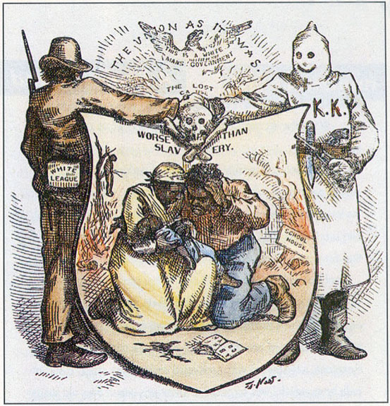
The White League was first founded in Grant Parish in Louisiana and was made up of many former Confederate soldiers who had participated in the Colfax Massacre. In this political cartoon by Thomas Nast, which appeared in Harper’s Weekly in October 1874, the “White League” shakes hands with the Ku Klux Klan over a shield that shows a couple weeping over a baby. In the background, a schoolhouse burns, and a lynched freedman is shown hanging from a tree. Arsons, or fires, and lynchings, racially motivated murders for an alleged offence without a legal trial, were commonly used to stoke fear and assert control over Black people and their allies. Above the shield, which is labeled “Worse than Slavery,” the text reads, “The Union as It Was: This Is a White Man’s Government.”

Note: This source uses the term “negro,” which is an outdated term.

Source Y: “Louisiana White League Platform,” 1874
Text | Vocabulary | Guiding Questions
Disregarding all minor questions of principle or policy, and having solely in view the maintenance of our hereditary civilization and Christianity menaced by a stupid Africanization, we appeal to men of our race, of whatever language or nationality, to unite with us against that supreme danger. A league of whites is the inevitable result of that formidable, oath-bound, and blindly obedient league of the Blacks, which, under the command of the most cunning and unscrupulous negroes in the State, may at any moment plunge us into a war of races . . . It is with some hope that a timely and proclaimed union of the whites as a race, and their efficient preparation for any emergency, may arrest the threatened horrors of social war, and teach the Blacks to beware of further insolence and aggression, that we call upon the men of our race to leave in abeyance all lesser considerations; to forget all differences of opinions and all race prejudices of the past, and with no object in view but the common good of both races, to unite with us in an earnest effort to re-establish a white man’s government in the city and the State. |  | What was the stated purpose of the White League? Why did the members of the White League believe this was necessary?  ________________________________  ________________________________  ________________________________  ________________________________  ________________________________  ________________________________  ________________________________  ________________________________  ________________________________  ________________________________  ________________________________

Note: This source uses the term “negro,” which is an outdated term.

Source Z: “Coushatta Massacre”
Text | Vocabulary | Guiding Questions
The Coushatta Massacre was an important event in the overthrow of Radical Reconstruction in Louisiana. On the upper Red River, during the last week of August 1874, the White League murdered ten Republicans: four Blacks and six whites. Nine of the murdered men were from Red River Parish; one was a De Soto Parish official. The killings all had the same end: the destruction of Republican government in northwestern Louisiana.  . . .  In fall 1865, Captain Marshall H. Twitchell, formerly a white officer in the U.S. Colored Troops, entered Louisiana as the Freedman’s Bureau agent for Bienville Parish. He left the Bureau in mid-1866 and married Adele Coleman, the daughter of Isaac Coleman, a prominent Bienville Parish planter. Twitchell bought a plantation on the eastern shore of Lake Bistineau and became the business manager of the combined Coleman-Twitchell estates. He served as Bienville Parish’s delegate to the state’s radical constitutional convention of 1867–1868.  A Democratic “white line” strategy emerged in the Deep South dedicated to restoring white supremacy. In Louisiana the strategy took the form of the White League, which first appeared in the lower Red River Valley and spread rapidly across the state. Though the name was new, the White League was less a new party than it was the Democratic Party, reinvigorated. The membership of the White League and the Democratic Party were virtually identical. In the summer of 1874, Red River Parish merchants and planters organized the White League in Coushatta under the leadership of Thomas Abney. . .  Before moving on Coushatta, White Leaguers struck the town of Natchitoches, twenty-seven miles downriver from Coushatta. In late July the Natchitoches White League. . . and other Coushatta men, seized the Natchitoches Parish government. . . . Their intentions are clear: “It is simply extermination of the Carpetbag and Scalawag Element. Nothing more nor less.”  . . . Around midnight on August 25, whites murdered Thomas Floyd, a Black Republican in the Brownsville community, south of Coushatta. Floyd’s murder set in motion the violent events that followed. Two days later, the Red River White League arrested six prominent white Republicans: Homer Twitchell (tax collector and brother of Marshall), Sheriff Edgerton, William Howell (parish attorney), Clark Holland and Monroe C. Willis (minor officials and brothers-in-law of Marshall Twitchell), and Robert Dewees (De Soto Parish tax collector). At the same time, League leaders rounded up twenty Black Republicans.  News of a Negro uprising raced through the upper Red River Valley and within forty-eight hours hundreds of heavily armed whites from neighboring parishes and the Texas border country descended on Coushatta. The angry outsiders thronged the streets, swearing, drinking, and demanding blood. The Republican prisoners, confined in the basement of Thomas Abney’s store, were terrified, and one of them asked, “Where in the name of God did all these people come from?”  On Saturday, August 29, a panel of Coushatta’s leading citizens conducted a star-chamber trial of the white prisoners. Late in the day, after hours of merciless grilling, Homer Twitchell, Sheriff Edgerton, and the other white prisoners, in return for a promise of safe passage to Shreveport, resigned their offices and promised in writing to leave the state and never return. At the same time, the White League issued a proclamation over the signatures of Abney, Pierson, Julius Lisso, and other town leaders, alleging that the prisoners were evil men who had indoctrinated “vicious ideas into the minds of the colored people of Red River, and arrayed them against the true interest of the country.”  Abney chose a guard of about twenty-five men, and mid-morning on Sunday prisoners and guards, mounted in column, headed up the river toward Shreveport. Near 4:00 PM, the column, now strung out with the prisoners in front, crossed the line into Caddo Parish, twenty miles below Shreveport. Minutes later, guards at the rear of the group spied forty or fifty heavily armed riders in hot pursuit. The pursuers were led by a mysterious “Captain Jack”—his real name Dick Coleman—about whom almost nothing is known except that he liked to kill Republicans. Captain Jack’s gang overtook the train, crying out to the guards, “Clear the track,” or die with the prisoners. Dewees, Homer Twitchell, and Sheriff Edgerton died in the first hail of bullets. The lynch mob took Howell, Willis, and Holland prisoner, then executed them in cold blood. At no point did the guards make any effort to protect the prisoners.  In the meantime, south of Coushatta, whites seized a Black leader named Levin Allen, broke his arms and legs, and burned him alive. Then, on Monday, the Coushatta White League conducted a mock trial of two of the Black prisoners confined in Abney’s store, Louis Johnson and Paul Williams, allegedly for shooting a white man. Captain Jack’s mob, returned from their bloody work upriver, seized Johnson and Williams and hanged them.  Although four Black men died in the Coushatta Massacre, it was the murder of white officeholders that grabbed newspaper headlines across the nation. Coushatta marked a dramatic escalation of Reconstruction violence. The officialdom of an entire parish—and white men at that—had been killed in a single murderous act. The Coushatta Massacre stunned Republicans in every corner of Louisiana. If the White League could take the officials of an entire parish and simply gun them down with impunity (none of the lynch mob would ever be brought to justice), then Republican governance was a hollow shell. The massacre occurred just two weeks before the White League routed Republican forces in the Battle of Liberty Place in New Orleans. Republican governance in the state never recovered from these savage blows. | Carpetbag: a person from the North who came to the South to make a profit during Reconstruc-tion, often seen by Southern Democrats as someone who was exploitative  Scalawag: white Southerners who supported Republicans  arrayed: organized | What were the outcomes and effects of the Coushatta Massacre?  ________________________________  ________________________________  ________________________________  ________________________________  ________________________________  ________________________________  ________________________________  ________________________________  ________________________________  ________________________________  Who was Captain Marshall H. Twitchell? Why would Southern Democrats oppose him?  ________________________________  ________________________________  ________________________________  ________________________________  ________________________________  ________________________________  ________________________________  Why did the White Leaguers attack Natchitoches and Coushatta?  ________________________________  ________________________________  ________________________________  ________________________________  ________________________________  ________________________________  Describe what happened to the six white Republicans that were arrested by the White League.  ________________________________  ________________________________  ________________________________  ________________________________  ________________________________  ________________________________  ________________________________  ________________________________  ________________________________  ________________________________  ________________________________  ________________________________  ________________________________  ________________________________  ________________________________  ________________________________  ________________________________  ________________________________  Why did the murders in Coushatta receive national attention? What does this say about the social position of Black people in the United States at the time?  ________________________________  ________________________________  ________________________________  ________________________________  ________________________________  ________________________________  ________________________________  ________________________________  ________________________________  ________________________________  ________________________________  ________________________________  How did the Coushatta Massacre help return Southern Democrat rule in Louisiana?  ________________________________  ________________________________  ________________________________  ________________________________  ________________________________  ________________________________  ________________________________  ________________________________

Source AA: Harper's Weekly, October, 1874
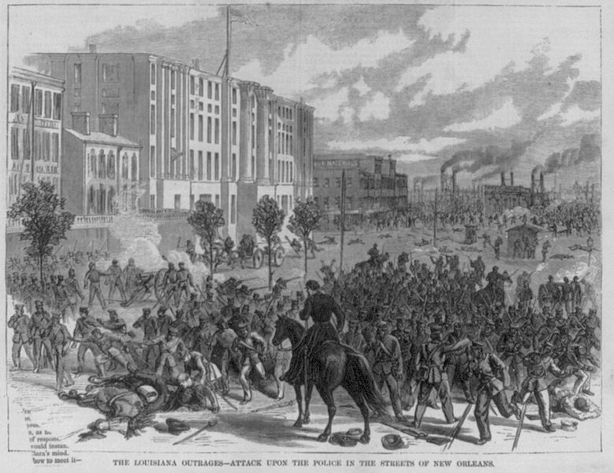
This image depicting the Battle at Liberty Place (September 14, 1874) is from an October 1874 edition of the magazine Harper’s Weekly. The text at the bottom reads “The Louisiana Outrages – Attack Upon the Police in the Streets of New Orleans.” The battle was the result of tensions between conservative Democrat politicians, backed by the White League, an organization that sought to maintain white supremacy, and Republican politicians, backed by the Metropolitan Police. Both parties claimed victory in the 1872 gubernatorial election. After widespread election fraud, William Pitt Kelllog, the Republican candidate backed primarily by Black voters, was declared the winner by a Federal court. This angered white Louisianans who felt that the Federal government was trying to force a Republican government in Louisiana. The White League planned to overthrow the Republican government by force, and organized over 8,000 troops on Canal Street in New Orleans on September 14, 1874. The Metropolitan police were outnumbered and soon the White League controlled most of the city. Governor Kellogg asked for federal help, and when federal troops arrived, the White League’s forces surrendered. As a result of the battle, eleven men on the Metropolitan’s side and twenty-one members of the White League and their supporters died. Many more were wounded. The Battle of Liberty Place is one of many examples of political violence during Reconstruction in Louisiana.

Source AB: Battle of Liberty Place Monument
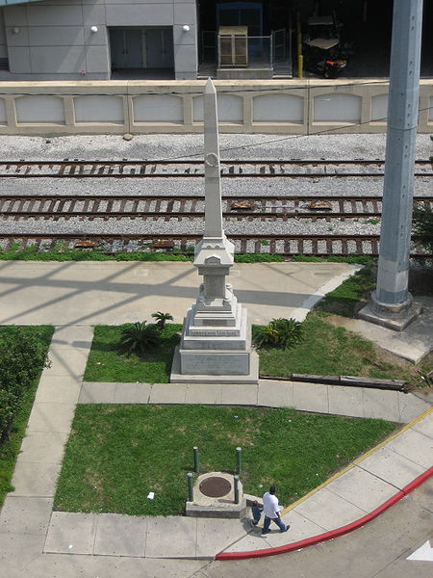

In 1891, a memorial was placed on Canal Street in New Orleans to pay honor to the members of the White League who died, and memorial services were held every year until World War I at the site. In the 1930s, language was added to the memorial that promoted white supremacy. In the 1970s, Black politicians and activists, as well as the NAACP Youth Council, called for its removal. In response to the controversy, Mayor of New Orleans Moon Landrieu placed a plaque near the monument that denounced the white supremacist language on the monument. The monument became a place for rallying for the Ku Klux Klan, who wanted the monument to remain untouched and in view of the public. It was removed from its visible position on Canal Street in 1989. In 1993, David Duke, a prominent member of the Ku Klux Klan, led a movement to restore the monument. It was placed in a less visible area on Iberville Street, with the language supporting white supremacy removed and a new plaque honoring Metropolitan Police casualties, several of whom were Black. The image above shows the monument on Iberville Street. The monument was permanently removed in 2017 after the New Orleans City Council voted 6–1 for removal.

Source AC: New Orleans Republican, October 12, 1868
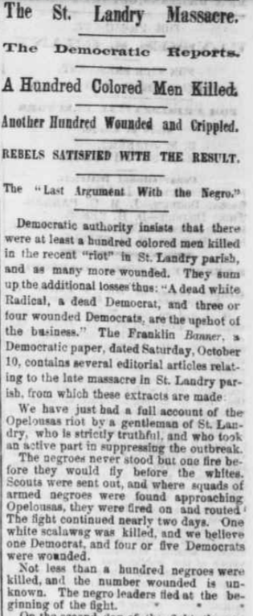
Note: The following newspaper text from 1868 uses the term “Negro,” which is an outdated term.
The Opelousas Massacre of September 1868, also called the St. Landry Massacre, was well documented in local newspapers. The conflict began after a white Republican school teacher, Emerson Bentley, wrote a newspaper article that encouraged Black people to register to vote and support the Republican party. This angered white Democrats, and three men threatened and beat Bentley at his school. Bentley went into hiding, and conflict and violence escalated between The Knights of the White Camellia, a white supremacist group similar to the White League, and local Black residents and their white Republican allies. Estimates of death tolls vary, but it is possible that hundreds of Black people were killed over three days of violence. Deaths of white Democrats are estimated to be between one and four people. Newspapers at the time noted that Black voter participation decreased in the region after the attacks. The newspaper excerpt pictured above is from a pro-Republican perspective, and reads: “Democratic authority insists that there were at least a hundred colored men killed in the recent “riot” in St. Landry parish, and as many more wounded. They sum up the additional losses thus: “a dead white radical, a dead Democrat, and three or four wounded Democrats, are the upshot of the business.” The Franklin Banner, a Democratic paper, dated Saturday, October 10, contains several editorial articles relating to the late massacre in St. Landry parish, from which these extracts are made. “We have just had a full account of the Opelousas riot by a gentleman of St. Landry, who is strictly truthful, and who took an active part in suppressing the outbreak. The Negroes never stood but on fire before they would fly before the whites. Scouts were sent out, and where squads of armed Negros were found approaching Opelousas, they were fired on and routed. The fight continued nearly two days. One white scalawag was killed, and we believe one Democrat, and four or five Democrats were wounded. Not less than a hundred Negros were killed and the number wounded is unknown. The negro leaders fled at the beginning of the fight.”

After you read:
1. Describe the methods used to limit Republican and Black political power in the South by groups like the White League.

Lesson 7
Supporting Question 3: How did the lives of Black people in Louisiana change
politically and socially due to Reconstruction?
Student Directions | First, read Sources AD, AE, and AF and answer the guiding questions in the right-hand column. Then, complete the after you read questions and performance task #3 at the end of this lesson.
Featured Sources | Source AD: “Black Codes”  Source AE: Louisiana Black Codes, 1865  Source AF: “The End of Reconstruction”

Source AD: “Black Codes”
Text | Vocabulary | Guiding Questions
Many Southern governments enacted legislation that reestablished antebellum power relationships. South Carolina and Mississippi passed laws known as Black Codes to regulate Black behavior and impose social and economic control. These laws granted some rights to African Americans, like the right to own property, to marry, or to make contracts. But they also denied fundamental rights. White lawmakers forbade Black men from serving on juries or in state militias, refused to recognize Black testimony against white people, apprenticed orphaned children to their former enslaver, and established severe vagrancy laws. Mississippi’s vagrant law required all freedmen to carry papers proving they had means of employment. If they had no proof, they could be arrested and fined. If they could not pay the fine, the sheriff had the right to hire out his prisoner to anyone who was willing to pay the tax. Similar ambiguous vagrancy laws throughout the South reasserted control over Black labor in what one scholar has called “slavery by another name.” Black Codes effectively criminalized Black people’s leisure, limited their mobility, and locked many into exploitative farming contracts. Attempts to restore the antebellum economic order largely succeeded. | apprenticed: employed as an apprentice  vagrancy laws: laws that criminalize homelessness and publicly begging for money  leisure: free time | How did measures like Black Codes and vagrancy laws help keep Black people in a state similar to slavery?  ________________________________  ________________________________  ________________________________  ________________________________  ________________________________  ________________________________  ________________________________  ________________________________  ________________________________  ________________________________  ________________________________  ________________________________  ________________________________

*Note: Black Codes were laws passed in Southern states after the Civil War that restricted the rights of Black people. These laws differed among states. The source below lists some of these laws that were passed in Louisiana in 1865. This source uses the term “negro,” which is an outdated term.

Source AE: Louisiana Black Codes, 1865
Text | Vocabulary | Guiding Questions
. . . Sec. 1. Be it ordained by the police jury of the parish of St. Landry, That no negro shall be allowed to pass within the limits of said parish without special permit in writing from his employer. Whoever shall violate this provision shall pay a fine of two dollars and fifty cents, or in default thereof shall be forced to work four days on the public road, or suffer corporeal punishment as provided hereinafter. . . .  Sec. 3. . . . No negro shall be permitted to rent or keep a house within said parish. Any negro violating this provision shall be immediately ejected and compelled to find an employer; and any person who shall rent, or give the use of any house to any negro, in violation of this section, shall pay a fine of five dollars for each offence.  Sec. 4. . . . Every negro is required to be in the regular service of some white person, or former owner, who shall be held responsible for the conduct of said negro. But said employer or former owner may permit said negro to hire his own time by special permission in writing, which permission shall not extend over seven days at any one time. . . .  Sec. 5. . . . No public meetings or congregations of negroes shall be allowed within said parish after sunset; but such public meetings and congregations may be held between the hours of sunrise and sunset, by the special permission in writing of the captain of patrol, within whose beat such meetings shall take place. . . .  Sec. 6. . . . No negro shall be permitted to preach, exhort, or otherwise declaim to congregations of colored people, without a special permission in writing from the president of the police jury. . . .  Sec. 7. . . . No negro who is not in the military service shall be allowed to carry fire-arms, or any kind of weapons, within the parish, without the special written permission of his employers, approved and indorsed by the nearest and most convenient chief of patrol. . . .  Sec. 8. . . . No negro shall sell, barter, or exchange any articles of merchandise or traffic within said parish without the special written permission of his employer, specifying the article of sale, barter or traffic. . . .  Sec. 9. . . . Any negro found drunk, within the said parish shall pay a fine of five dollars, or in default thereof work five days on the public road, or suffer corporeal punishment as hereinafter provided.  Sec. 11. . . . It shall be the duty of every citizen to act as a police officer for the detection of offences and the apprehension of offenders, who shall be immediately handed over to the proper captain or chief of patrol. . . . | corporeal punishment: physical punishment, beating | How was the movement and living arrangements of Black people restricted by Louisiana’s Black Codes?  ________________________________  ________________________________  ________________________________  ________________________________  ________________________________  ________________________________  ________________________________  How was the social standing of Black people similar to the social standing of enslaved people?  ________________________________  ________________________________  ________________________________  ________________________________  ________________________________  ________________________________  ________________________________  ________________________________  ________________________________  ________________________________  Which activities of Black people were restricted in Sections 5, 6, 7, and 8? Why do you think these activities were restricted?  ________________________________  ________________________________  ________________________________  ________________________________  ________________________________  ________________________________  ________________________________  ________________________________  ________________________________  How did Louisiana’s Black Codes give white people authority over Black people?  ________________________________  ________________________________  ________________________________  ________________________________  ________________________________  ________________________________

Source AF: “The End of Reconstruction”
Text | Vocabulary | Guiding Questions
Reconstruction ended when Northerners abandoned the cause of formerly enslaved people and Democrats recaptured Southern politics. Between 1868 and 1877, and especially after the Depression of 1873, economic issues supplanted Reconstruction as the foremost issue on the national agenda.  So-called Redeemer Democrats—who focused on business, economics, political corruption, and trade—gained strength by distancing themselves from pro-slavery Democrats. White Southerners initially opposed the Redeemers and instead clung tightly to white supremacy and the Confederacy, but between 1869 and 1871, the Redeemers won support from white Southerners by promising local rule by white Democrats, rather than Black or white Republicans. By 1871, Redeemers won political control and ended Reconstruction in three important states: Tennessee, Virginia, and Georgia.  In September 1873, Jay Cooke and Company declared bankruptcy, resulting in a bank run that spiraled into a six-year depression. The Depression of 1873 crushed the nation’s already suffering laboring class and destroyed whatever remaining idealism Northerners had about Reconstruction. In the South, where many farms were capitalized entirely through loans, sources of credit vanished, many landowners defaulted, and farmers entered an already oversaturated labor market. Wages plummeted and a growing system of debt peonage trapped workers in endless cycles of poverty. The economic turmoil enabled the Democrats to take control of the House of Representatives after the 1874 elections, blunting the legislature’s capacity to any longer direct Reconstruction.  On the eve of the 1876 presidential election, the nation still reeled from depression. By 1875, Democrats in Mississippi hatched the Mississippi Plan, a wave of violence designed to intimidate Black activists and suppress Black voters. The state’s Republican governor pleaded for federal intervention, but national Republicans ignored the plea.  Republicans chose Rutherford B. Hayes as their nominee; Democrats chose Samuel J. Tilden, who ran on honest politics and home rule in the South. Florida, Louisiana, and South Carolina would determine the president. Despite the enduring presence of Reconstruction in those states, white conservatives organized violence and fraud with impunity. With the election results contested, a federal special electoral commission voted along party lines—eight Republicans for, seven Democrats against—in favor of Hayes.  Democrats threatened to boycott Hayes’s inauguration. Rival governments arose claiming to recognize Tilden as the rightfully elected president. Republicans, fearing another sectional crisis, reached out to Democrats. In what became known as the Compromise of 1877, Democrats conceded the presidency to Hayes on the condition that all remaining troops would be removed from the South and the South would receive special economic favors. Hayes was inaugurated in March 1877. In April, the remaining troops were ordered out of the South. The compromise allowed Southern Democrats, no longer fearing reprisal from federal troops or northern politicians for their flagrant violence and intimidation of Black voters, to return to power.  After 1877, Republicans no longer had the political capital—or political will—to intervene in the South in cases of violence and electoral fraud. In certain locations with large populations of African Americans, such as South Carolina, freed people continued to hold some local offices for several years. Yet, with its most revolutionary aims thwarted by 1868, and economic depression and political turmoil taking even its most modest promises off the table by the early 1870s, most of the promises of Reconstruction were unmet. | supplanted: replaced  Jay Cooke and Company: U.S. bank that was instrumental in funding the Union during the Civil War  debt peonage: when a person Is made to work to pay off a debt  impunity: without punishment  thwarted: prevented | How did Redeemer Democrats win support from white Southerners?  ________________________________  ________________________________  ________________________________  ________________________________  ________________________________  ________________________________  ________________________________  ________________________________  ________________________________  ________________________________  ________________________________  ________________________________  ________________________________  ________________________________  ________________________________  ________________________________  ________________________________  ________________________________  ________________________________  ________________________________  ________________________________  ________________________________  How did some white Southerners try to influence elections?  ________________________________  ________________________________  ________________________________  ________________________________  ________________________________  ________________________________  ________________________________  How did the Compromise of 1877 help bring about the end of Reconstruction?  ________________________________  ________________________________  ________________________________  ________________________________  ________________________________  ________________________________  How did the weakening of the Republican party lead to the end of Reconstruction?  ________________________________  ________________________________  ________________________________  ________________________________  ________________________________  ________________________________

After you read:
1. How did Black Codes affect the treatment of Black people in the South?

2. What social, economic, and political factors contributed to the end of Reconstruction?

Formative Performance Task #3 – Constructed Response
Student Directions | Complete the T-chart below. Explain ways that the social and political experiences of Black people in Louisiana changed and remained the same during Reconstruction.

How did the social and political experiences of Black people in Louisiana remain the same during Reconstruction? | How did the social and political experiences of Black people in Louisiana change during Reconstruction?

Lesson 8 – Summative Performance Task
Student Directions | Based on the sources from this packet and your knowledge of social studies, write a response to the following question: To what extent did Reconstruction change the lives of Black people in Louisiana?

Name________________________________________________ Date ________________
Why Was Longism Influential in Louisiana?
Introduction
Student Directions | Over the next two weeks, you will explore the sources in this packet to learn about factors that led to the rise of politician Huey P. Long, including the rise of Populism, economic problems, and the Great Flood of 1927. At the end of the packet, you will express your understanding by writing a response to the following question: Why was Longism influential in Louisiana? This packet includes three supporting questions which will help you develop your claim. After you read each text or analyze each image, you will be asked to answer questions about it. Some words are defined to help you better understand each source and answer the questions. Some sources have digital extensions, which are optional sources you can explore if you have internet access.

Lesson 1 – Setting the Context
Student Directions | First, read Source A and answer the guiding questions in the right-hand column. Next, read and study Source B. Then, read Source C and answer the guiding questions in the right-hand column. Then, read and study Sources D and E. Finally, complete the after you read questions at the end of this lesson.
Featured Sources | Source A: “The Compromise of 1877”  Source B: “’Colored’ Water Cooler in a Streetcar Terminal, Oklahoma City, Oklahoma”  Source C: “Jim Crow & Segregation”  Source D: “’White’ and ‘Jim Crow’ Railcars”  Source E: “Sharecropper's Family Standing in a Cotton Field in North Louisiana in 1920s”

Huey P. Long was a Louisiana politician who served as governor of Louisiana from 1928 until 1932 and U. S. Senator from 1932. He was an extremely popular, but also controversial, political leader. He was a populist, someone whose support comes from ordinary people, and appealed to the poor and farming classes of Louisiana. His opponents criticized him for exerting too much control over the government of Louisiana and he was formally accused of abuse of power while governor. “Longism" refers to Huey P. Long’s period of political power from 1928 until his death in 1935, as well as the actions and policies that characterized his political career.

The era after the Civil War was known as Reconstruction. Source A discusses the presidential election of 1876, which was an event that led to the end of the Reconstruction era. During this time period (the late 19th century), the Democratic political party was a pro-slavery party for the most part, while the Republican political party had more members in favor of abolition.

Source A: “The Compromise of 1877”
Text | Vocabulary | Guiding Questions
The Compromise of 1877 resolved the tumult that had arisen following the 1876 presidential election. In that election, Democratic candidate Samuel J. Tilden of New York won 247,448 more popular votes than Republican Rutherford B. Hayes of Ohio. But the electoral votes in the three southern states of Florida, Louisiana, and South Carolina were disputed. For almost four months, from November into late February, tensions remained high as the question of who was to become the nation’s next president remained unresolved.  In January 1877, Congress established a 15-member Electoral Commission to resolve the issue of which candidate had won the contested states. The commission voted 8-7 along party lines to award the votes of all three states to Hayes.  During Reconstruction, the period after the Civil War when the South reorganized its political, social, and economic systems to account for the end of slavery, federal troops occupied the South. These troops served to guarantee African American men's right to vote, and the Republican-controlled federal government would only end the military occupation when states rewrote their Constitutions to recognize the citizenship and voting rights of African American men. White Southerners generally despised these troops, and wanted an end to the intervention of the federal government in the South.  The Compromise of 1877 gave white Southerners their chance to stop the military occupation of the South. In the compromise, Southern Democrats agreed not to block the vote by which Congress awarded the contested electoral votes to Rutherford B. Hayes, and Hayes therefore became president. In return, Republicans agreed to withdraw federal troops from actively intervening in the politics of Louisiana and South Carolina (the last two states occupied by federal troops). Accordingly, within two months of becoming president, Hayes ordered federal troops in Louisiana and South Carolina to return to their bases.  The removal of the federal soldiers from the streets and from statehouse offices signaled the end of the Republican Party’s commitment to protecting the civil and political rights of African Americans, and marked a major political turning point in American history—it ended Reconstruction.  Another important part of the Compromise of 1877 was that Republicans agreed to home-rule in the South. Home-rule meant that the Republican Party would refrain from interfering in the South’s local affairs, and that white Democrats, many of them racist, would rule. Southern Democrats, for their part, pledged that they would “recognize the civil and political equality of Blacks.” They did not subsequently carry through on this promise but instead disfranchised Black men from voting and imposed Jim Crow segregation across the South.  The end of Reconstruction  In all, with the Compromise of 1877, the Republican Party abandoned the last remnant of its support for equal rights for African Americans in the South. With the withdrawal of federal troops went any hope of reconstructing the South as a racially-egalitarian society after the end of slavery. As Henry Adams, a Black Louisianan, lamented, “The whole South—every state in the South—had got into the hands of the very men that held us as slaves.”  In the aftermath of the Compromise of 1877, a few African Americans in some areas of the South continued to vote and serve in government offices into the 1890s, but the Compromise of 1877 marked the effective end of the Republican Party’s active support of civil rights for Black Americans. Southern states rapidly passed laws disenfranchising African Americans and implementing racial segregation. | tumult: confusion, disorder  electoral votes: votes from the Electoral College, which elects the president  along party lines: doing the same as one’s political party does  Jim Crow: Jim Crow was the name of a series of state and local laws that legalized mistreatment of Black people and segregation based on race; a synonym for racial segregation  segregation: separation of racial groups | Who received more votes from people in the 1876 presidential election? Why didn’t that person win the presidency?  ________________________________  ________________________________  ________________________________  ________________________________  ________________________________  How were the results of the election of 1876 decided? Who won the presidency?  ________________________________  ________________________________  ________________________________  ________________________________  ________________________________  ________________________________  ________________________________  ________________________________  ________________________________  ________________________________  ________________________________  ________________________________  What did Southerners gain in the Compromise of 1877?  ________________________________  ________________________________  ________________________________  ________________________________  ________________________________  ________________________________  ________________________________  How did “home-rule” change the politics of southern states after Reconstruction?  ________________________________  ________________________________  ________________________________  ________________________________  ________________________________  ________________________________  ________________________________  ________________________________  ________________________________  ________________________________  ________________________________  ________________________________  ________________________________  ________________________________  ________________________________  ________________________________  ________________________________

Source B: “’Colored’ Water Cooler in a Streetcar Terminal, Oklahoma City, Oklahoma”

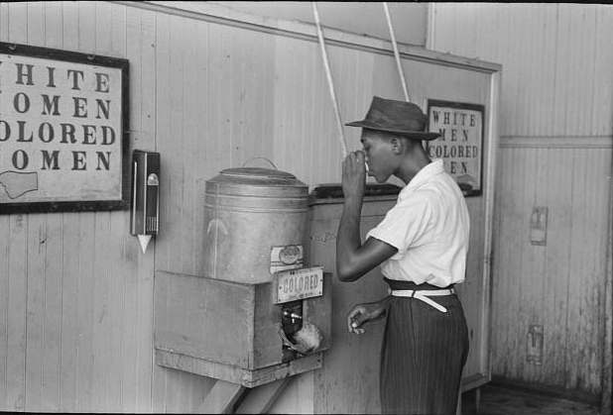
The Jim Crow laws were a series of segregation laws enacted as early as the 1890s, primarily in the southern and border states. Jim Crow laws were designed to create a "separate but equal" status for Black Americans and other non-white racial groups. The enactment of Jim Crow began shortly after Reconstruction, but the most stringent restrictions were established following the Supreme Court case Plessy v. Ferguson, which created the "separate but equal" doctrine.

More than 400 state laws, constitutional amendments, and city ordinances legalizing segregation and discrimination were passed in the United States between 1865 and 1967, covering every aspect of daily life. Twenty-nine laws were passed that specifically dealt with segregation in voting.

There was also a subtler, social dimension to Jim Crow, which required that African Americans demonstrate subservience (being in a lower position) and inferiority to whites at all times. A Black man who succeeded in business might find his shop burned to the ground by jealous whites. A Black woman who failed to step off of the sidewalk to make way for a white man might be fired by her employer the following day. A Black man who had a relationship with a white woman might be hanged in the middle of town. Most Southern whites interpreted any claim to pride or equality by African Americans as an affront (an action that offends).

Source C: “Jim Crow & Segregation”
Text | Vocabulary | Guiding Questions
The Origins of Jim Crow, 1865 to 1890  In the five years after the Civil War, the Republican-controlled Louisiana Congress enacted powerful civil rights legislation aimed at securing African Americans their political rights. The Thirteenth, Fourteenth, and Fifteenth Amendments, respectively, abolished slavery, recognized African Americans as citizens, and guaranteed African American men the right to vote. The Fourteenth Amendment was particularly significant because it guaranteed African Americans the same rights of citizenship that white Americans had, including equal protection under the law. By 1875 African Americans across the South, supported by the federal government, had established nearly four thousand schools for Black students. In addition, more than fifteen hundred had run for office as state and national representatives.  . . . At the beginning of Reconstruction, Louisiana sent several Black politicians to the U. S. House of Representatives, and one African American, P. B. S. Pinchback, served as governor from late 1872 to January 1873. By the time federal troops were officially removed from Louisiana in 1877, however, all of these politicians had been defeated; all hopes for improved racial relations, or federal intervention on behalf of Blacks, seemed to have evaporated.  Institutionalizing Jim Crow  By 1890, the Democratic Party hatched a scheme to completely remove the Republican Party from the South by disenfranchising southern Blacks, the most ardent supporters of the Republican Party. Whites implemented poll taxes, literacy tests, residency requirements, and “understanding” clauses to prevent Blacks from registering to vote. Despite the rights guaranteed them by the Fourteenth and Fifteenth Amendments, African Americans were systematically excluded from the political process. Social segregation soon followed.  In 1891, the Louisiana legislature had officially segregated the railroads within the state. In 1892, Homer Plessy, an active member of a New Orleans civil rights organization, the Comité de Citoyens, bought a first-class ticket on a train and attempted to sit among whites. After he was arrested for breaking the law, Plessy sued the railroad company, his lawyers arguing that segregation denied him equal protection under the law as guaranteed by the Fourteenth Amendment. In 1896, however, the U.S. Supreme Court upheld Louisiana law in its decision on Plessy vs. Ferguson. Speaking for the majority, Justice Henry Brown stated that segregation did not deprive Plessy of his rights, nor did it make him an inferior person. The justices argued that states could establish “separate but equal” facilities; if Blacks and whites were treated equally, segregation would be allowed to stand. Yet, in almost all public facilities—schools, hospitals, trains, restaurants, hotels, parks, cemeteries, the armed forces, and jury duty—whites received priority over African Americans. Following the decision, some institutions excluded African Americans altogether.  Two years after the Plessy decision, Louisiana passed one of the first laws officially stripping Blacks of the right to register to vote. In essence, everything that could be segregated in Louisiana was. Public facilities for adults, including restaurants, hotels, night clubs, and cemeteries, were strictly segregated, as were public facilities for children such as amusement parks, playgrounds, and schools. By 1900, the line separating whites and Blacks had become deeply entrenched in Louisiana’s culture. After 1902, New Orleans streetcars were segregated. A 1908 state law prohibited cohabitation (in marriage or domestic situations) between whites and Blacks. Racial segregation in jails was required in 1920. Even in New Orleans, tolerant (if not friendly) interactions between whites and African Americans all but disappeared. The Catholic Church established a segregated parish in downtown New Orleans, the Congregation of Corpus Christi.  Not coincidentally, lynchings increased dramatically after 1900, primarily in the northern parishes of Caddo, Ouachita, and Morehouse. Between 1900 and 1931, more than half the lynchings in the state occurred north of Alexandria. The numbers of African Americans lynched are in the thousands, though detailed statistics are skewed because police officers in the northern parishes rarely considered lynchings as homicides. Still, lynchings and the threat of lynching contributed to the maintenance of Jim Crow.  . . .  The impact of segregation on Louisiana’s culture and history continues to linger. One lasting consequence of Jim Crow is the persistence of extreme poverty among African Americans, particularly in the northern parishes bordering the Mississippi River. The decline of cotton and sugar production, the source of Louisiana’s wealth prior to the Civil War, has left behind impoverished communities unable to find suitable alternatives. As the twenty-first century began, “stealth racism,” or subtle long-term racism, remains in Louisiana, particularly as racial attitudes harden in the midst of economic instability. | disenfranchis-ing: take away the right to vote  poll taxes: fees that had to be paid before a person could register to vote  literacy tests: test given to potential voters to test reading ability; in practice restricted the voting rights of Black Americans and immigrants  lynchings: killings (often racially motivated) for an alleged offence without a legal trial as a means of social control; usually enacted by mobs | How did social and political conditions for Black people in Louisiana improve during Reconstruction?  ________________________________  ________________________________  ________________________________  ________________________________  ________________________________  ________________________________  ________________________________  ________________________________  ________________________________  ________________________________  ________________________________  ________________________________  ________________________________  ________________________________  What methods were used to disenfranchise Black people?  ________________________________  ________________________________  ________________________________  ________________________________  ________________________________  ________________________________  ________________________________  ________________________________  ________________________________  ________________________________  In your own words, what does “separate but equal” mean? What were the results of the Plessy v. Ferguson Supreme Court decision?  ________________________________  ________________________________  ________________________________  ________________________________  ________________________________  ________________________________  ________________________________  ________________________________  Describe two ways interactions between white and Black people were restricted in New Orleans after the Plessy decision.  ________________________________  ________________________________  ________________________________  ________________________________  ________________________________  ________________________________  ________________________________  ________________________________  ________________________________  How did lynchings of Black people in Louisiana contribute to maintaining the Jim Crow system?  ________________________________  ________________________________  ________________________________  ________________________________  ________________________________  ________________________________  ________________________________  ________________________________  ________________________________  ________________________________  ________________________________  ________________________________

Source D: “’White’ and ‘Jim Crow’ Railcars”
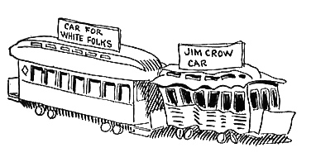

John T. McCutcheon drew this satirical cartoon in 1904, illustrating the unequal treatment of Black people during the Jim Crow era. The Plessy v. Ferguson Supreme Court decision said that racial segregation was legal as long as services provided to white and Black people were equal. However, in reality, segregation did not produce equal services. In the political cartoon above, the train car for “white folks” is superior to the one designated for Black people. Legal segregation in schools remained in place until the Supreme Court found it to be unconstitutional with its ruling in Brown v. Board of Education in 1955.

Source E: “Sharecropper's Family Standing in a Cotton Field in North Louisiana in 1920s”
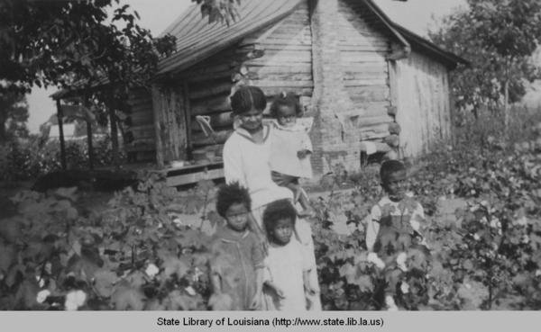

As Reconstruction ended, most African Americans in Louisiana rented small plots of land, hoping to become self-sufficient farmers. Former slaves tended to stay geographically close to their former enslavers, usually living no more than fifty miles away. In place of slavery, whites developed an agricultural system called sharecropping. Whites gave African American farmers access to land with the understanding that these farmers would give the landowner part of the crop as “rent.” Sharecropping quickly evolved into an exploitative relationship between farmers and landlords. While there were attempts to unify white and Black farmers in the immediate postbellum period, sharecropping allowed class and racial distinctions to persist.

After you read:

1. In your own words, describe Jim Crow segregation.

2. How did Jim Crow laws and sharecropping systematically disadvantage Black people?

Lesson 2
Supporting Question 1: What were the characteristics of politics in Louisiana during the late 19th century and early 20th century?
Student Directions | First, read and study Source F and answer the guiding questions below the source. Then, read Source G and answer the guiding questions in the right-hand column. Finally, complete the after you read questions at the end of this lesson.
Featured Sources | Source F: Louisiana’s Constitutions  Source G: “Bourbon Louisiana”

Note: the chart below shows some, but not all, changes adopted to the Louisiana Constitution between 1812–1921.
Source F: Louisiana’s Constitutions
1812 Constitution | - first Louisiana constitution  - allowed only free white men who owned land and paid property taxes to vote
1845 Constitution | - removed the property requirement for voting and holding office  - established public schools
1861 Constitution | - Louisiana seceded from the Union  - adopted the constitution of the Confederate States of America
1868 Constitution | - included a bill of rights  - gave Black men full citizenship and voting rights  - ordered the establishment of a racially integrated (not segregated) school system  - called for equal treatment in public transportation and accommodations  - abolished the 1865 Black Codes  - disenfranchised former Confederates
1879 Constitution | - establishment of separate public school systems  - established limitations on voting rights for formerly enslaved men
1898 Constitution | - added voting requirements and restrictions such as property ownership, literacy tests, poll taxes, and a grandfather clause that disenfranchised Black men  - the grandfather clause stated you could only vote if your grandfather voted, which meant that Black people were not allowed to vote because their ancestors could not vote
1913 Constitution | - election rather than appointment of state Supreme Court justices  - establishment of juvenile courts  - increased funding for education  - changes to state debt funding  - restrictions on state government borrowing money
1921 Constitution | - increased power to regulate business such as transportation and communication  - environmental protections  - authority to regulate working conditions, hours, and wages for women  - established term limits for state judges
Guiding Questions:
How did voting rights in the Louisiana Constitution change from 1812 to 1868?

__________________________________________________________________________________________________

__________________________________________________________________________________________________

__________________________________________________________________________________________________

__________________________________________________________________________________________________

How did the Louisiana Constitutions change who was allowed to vote from 1868 to 1898?

__________________________________________________________________________________________________

__________________________________________________________________________________________________

__________________________________________________________________________________________________

__________________________________________________________________________________________________

Source G: “Bourbon Louisiana”
Text | Vocabulary | Guiding Questions
The terms “Bourbon Democrat” and “Bourbonism” refer to the reactionary members and policies of the Democratic Party in power in Louisiana following the collapse of Reconstruction in 1877 through the enactment of the Constitution of 1898. Republicans in Louisiana applied the term “Bourbon” to all opponents of Reconstruction policy in order to paint them as obstructionists who failed to accept the Southern defeat in the Civil War. Bourbon Democrats sought not only the overthrow of Reconstruction, but also stood in opposition to the compromises made by other Conservative-Democratic elements in Louisiana. Louisiana’s Bourbons strongly opposed both political and social equality for non-whites and wanted to return to the sort of control of the labor force that existed under slavery. While “Bourbon Democrat” was originally conceived of as an insult, many of those who were the target embraced the term.  The Bourbon-Ring Alliance  From the standpoint of political control, Bourbonism in Louisiana operated primarily as an alliance between the planters of the state’s cotton growing regions and The Ring in New Orleans, a group dominated by the city’s ward bosses. Several factors drew these sides together. Perhaps none was more important or more clear-cut than the Louisiana Lottery.  Chief Objectives  The maintenance of the constitutional charter that allowed the Louisiana Lottery to operate was arguably the single most important political objective of the Bourbons. Not to be confused with modern state-run lotteries, the Louisiana Lottery was an international operation in which the state received a mere $40,000 annual payment in return for allowing the Lottery Company to make millions each year. The state of Louisiana was one of the lottery’s smaller beneficiaries. Much more substantial sums went to key people and various popular charitable organizations, which in turn gave the Lottery Company enormous political leverage. Lottery money often kept those who might otherwise be opposed to the Bourbon program from taking action against injustices. It also made Bourbonism stronger in Louisiana than it was in other Southern states.  Across the South, the Bourbons were legendary for reducing the tax burden on property owners. As they did elsewhere, Louisiana’s Bourbons balanced the budget by dramatically reducing investment in infrastructure such as levees, roads, and railroads and social services such as education. Indeed, whatever gains Reconstruction achieved in establishing a public school system in Louisiana, twenty years of Bourbon rule had all but demolished. Bourbon planters feared that education for the masses might disrupt the steady supply of cheap agricultural labor, particularly in rural parishes. The Bourbons also greatly expanded the convict-lease system which increased revenue for the state. The mortality rates for convicts laboring in the lease system was much worse than under slavery, ranging between 10 and 20 percent per year. The convict-lease system was much like any other program under the Bourbons—ripe for abuse and a vehicle engineered to enrich the politically connected at the expense of the people of Louisiana.  Perhaps the most ironic goal of the Bourbon-Ring faction was that of opposing disfranchisement legislation, though the two groups had very different reasons for doing so. By the mid-1880s, opponents to Bourbon rule began pushing for tough restrictions for voter registration—namely literacy and competency tests. These proposed laws targeted the immigrant masses of New Orleans, who voted for the Ring, and plantation laborers, whose votes were routinely stolen by Bourbon planters. Planters certainly did not want their mostly black laborers to vote freely, but if their names did not appear on the registration rolls, then their votes were not available to be stolen at election time. Proponents of disfranchisement legislation surely pursued a racist desire to disfranchise, but were also trying to address real and rampant political corruption in Louisiana’s countryside by which big planters undemocratically ran the state.  The Transformation of Bourbon Rule  Bourbonism was transformed during the turbulent 1890s. In 1892, the United States Supreme Court ruled that it was illegal for the lottery to mail materials using the U.S. Postal Service.  The Bourbons felt threatened by the Louisiana Farmer’s Union, a labor union that had the potential to unite both white and Black farm workers and undermine the Bourbon’s power. With the lottery money now gone, they also had little hope but to go along with the Reformer Democrats’ program of disfranchisement in order to keep their power. Disfranchisers overreached in 1896, however, with a law that would have prevented most of Louisiana’s poorer whites from voting. The widespread rejection and unrest cause by such proposals led directly to modifications such as the infamous “grandfather cause” of the 1898 State Constitution, an amendment that provided political rights for poor, illiterate whites but not their Black counterparts. With its ratification, a new era dawned in Louisiana politics.  Legacy of Bourbonism  Although the Bourbons often reminisced that Reconstruction was a period of tragedy, one could make a far greater case that the period that followed immediately afterward set a much more lasting and dangerous precedent for the state of Louisiana. While one might point to corruption among politicians of all persuasions during Reconstruction, their misdeeds pale in comparison with those perpetrated by their successors, the Bourbons. Bourbon rule ingrained an atmosphere of plunder that continues to cast a long shadow on the Pelican State. So, too, did the Bourbon stance on everything from education to economic development. Moreover, those who might have mitigated the damage done by the Bourbons, the Reform Democrats, only ended up meeting the Bourbons half way in a compromise forged in corruption and undemocratic principle. While this collaboration led to the expulsion of the Louisiana Lottery, it also brought about segregation and disfranchisement, cures for corruption that were nearly as bad as the illness itself. Yet perhaps the greatest long-term legacy of the Bourbons would not be the Progressive or Jim Crow eras that followed, but the sort of suffering among the common people who empowered a personality like Huey Long to amass an equally corrupt and even more untrammeled power over the state. | reactionary: wanting to return society to how it once was before a change occurred; conservative  obstruction-ists: people who delay progress on purpose  ward bosses: political bosses who control a part of a political party  political leverage: power to influence a person or group for one’s own political benefit  convict-lease system: use of forced labor from incarcerated people  revenue: income  mortality: death  disfranchise-ment: preventing people from voting  labor union: an organized group of workers formed to protect and further their rights  Reformer Democrats: Democrats in the South who were willing to compromise on some reconstruction measures  disfranchisers: Bourbons and Reformers who wanted to suppress the votes of poor people and laborers  grandfather clause: those who had the right to vote prior to the Civil War and their descendants were exempted from restrictions on voting like literacy tests and poll taxes  mitigated: lessened the effects of  untrammeled: not restricted | When were the Bourbons in power and what were the social and political changes the Bourbons were reacting to?  ________________________________  ________________________________  ________________________________  ________________________________  ________________________________  ________________________________  ________________________________  ________________________________  ________________________________  ________________________________  ________________________________  ________________________________  ________________________________  ________________________________  How did the Louisiana Lottery reinforce Bourbon power?  ________________________________  ________________________________  ________________________________  ________________________________  ________________________________  ________________________________  ________________________________  ________________________________  ________________________________  ________________________________  How did Bourbons cut costs in the government of Louisiana during their time in power?  ________________________________  ________________________________  ________________________________  ________________________________  ________________________________  ________________________________  ________________________________  ________________________________  ________________________________  ________________________________  Why did the Bourbons oppose public education and support the convict leasing system?  ________________________________  ________________________________  ________________________________  ________________________________  ________________________________  ________________________________  ________________________________  Why did the Bourbon-Ring faction oppose disenfranchising voters based on literacy and competency tests?  ________________________________  ________________________________  ________________________________  ________________________________  ________________________________  ________________________________  ________________________________  ________________________________  ________________________________  ________________________________  ________________________________  ________________________________  ________________________________  ________________________________  ________________________________  How did Bourbon and Reformer Democrats disenfranchise Black voters without disenfranchising poor white voter who would support them?  ________________________________  ________________________________  ________________________________  ________________________________  ________________________________  ________________________________  ________________________________  ________________________________  ________________________________  ________________________________  ________________________________

After you read:

1. Why did the Louisiana Constitution change over time?

2. How did the Bourbons gain and maintain power in Louisiana?

Lesson 3
Supporting Question 1: What were the characteristics of politics in Louisiana during the late 19th century and early 20th century?
Student Directions | First, read and study Source H. Then, read Sources I, J, and K and answer the guiding questions in the right-hand columns. Finally, complete the after you read questions at the end of this lesson.
Featured Sources | Source H: Mary Elizabeth Lease  Source I: “Wall Street Owns the Country” by Mary Elizabeth Lease, 1890  Source J: Excerpts from the Populist Party Platform, 1896  Source K: “Populism”

In addition to the Bourbons, another political movement was on the rise in Louisiana in the late 19th and early 20th century: The Populist movement. Sources H, I, and J discuss Populism in the United States. Source K discusses Populism in Louisiana.

Source H: Mary Elizabeth Lease
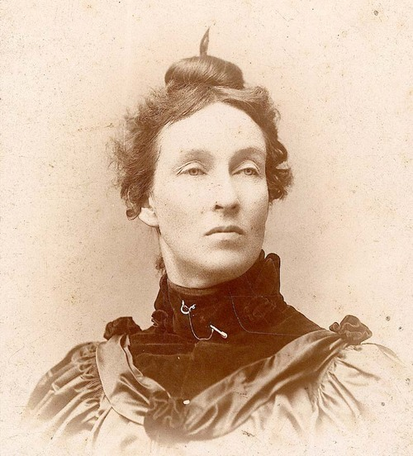

In the late 1800s, the United States was becoming more urbanized, but was still made up mostly of farmers in rural areas. Farmers were often in debt and forced to pay unfair fees to the railroad industry in order to transport their crops to be sold. In 1867, farmers formed a national organization, the Grange, to address the problems of the farmers. Grangers lobbied state legislatures for regulation of the railroad industry. By 1874, several states passed the Granger Laws, establishing maximum shipping rates.

Beginning in 1889, Northern and Southern Farmer’s Alliances championed the same issues as the Grangers, but also entered the political arena. Members of these alliances won seats in state legislatures across the Great Plains to strengthen the agrarian voice in politics. Farmers concerns were captured by the Populist Party, also known as the People’s Party, in 1891.

Mary Elizabeth Lease was a well-known speaker who advocated for women’s suffrage, prohibition, worker’s rights, and most famously, the Populist Party. In Source I, she appeals to farmers by addressing their troubles.

Source I: “Wall Street Owns the Country” by Mary Elizabeth Lease, 1890
Text | Vocabulary | Guiding Questions
. . . Wall Street owns the country. It is no longer  a government of the people, by the people, and  for the people, but a government of Wall Street,  by Wall Street, and for Wall Street. The great  common people of this country are slaves, and  monopoly is the master. The West and South are  bound and prostrate before the manufacturing  East. . . The [political] parties lie to us and the  political speakers mislead us. We were told two  years ago to go to work and raise a big crop, that  was all we needed. We went to work and plowed  and planted; the rains fell, the sun shone, nature  smiled, and we raised the big crop that they  told us to; and what came of it? Eight-cent corn,  ten-cent oats, two-cent beef and no price at all  for butter and eggs—that’s what came of it. The  politicians said we suffered from overproduction.  Overproduction, when 10,000 little children, so  statistics tell us, starve to death every year in  the United States. . . | Wall Street: the rich and powerful people and companies that heavily influence the U.S. economy  monopoly: a company that completely controls a commodity  prostrate: lying stretched out on the ground, face downward  overproduc-tion: producing too much of a commodity which leads to the decrease in the price of that commodity | How did Lease describe Wall Street?  ________________________________  ________________________________  ________________________________  ________________________________  ________________________________  ________________________________  Why did Lease distrust politicians?  ________________________________  ________________________________  ________________________________  ________________________________  ________________________________

The Populists advocated for economic solutions which they believed would help the financial security of farmers and stop corruption between big business and the government. They outlined their beliefs in the Populist Party Platform in 1896. In the platform, they demanded that the government have direct control of currency, without the intervention of banks, money backed by silver rather than gold, and more money in circulation. Populists believed that these financial measures would increase the amount of currency available to farmers and alleviate some of their financial issues.

Source J: Excerpts from the Populist Party Platform, 1896
Text | Vocabulary | Guiding Questions
The Finances  7. We demand a graduated income tax, to the end that aggregated wealth shall bear its just proportion of taxation. . .  Railroads and Telegraphs  1. Transportation being a means of exchange and a public necessity, the Government should own and operate the railroads in the interest of the people and on a non-partisan basis, . . . that the tyranny and political power now exercised by the great railroad corporations, which result in the impairment, if not the destruction of the political rights and personal liberties of the citizens, may be destroyed. . .  2. The interest of the United States in the public highways built with public moneys, and the proceeds of grants of land to the Pacific railroads, should never be alienated, mortgaged, or sold, but guarded and protected for the general welfare. . .  4. The telegraph, like the Post Office system, being a necessity for the transmission of news, should be owned and operated by the Government in the interest of the people.  The Public Lands  1. . . . All lands now held by railroads and other corporations in excess of their actual needs should by lawful means be reclaimed by the Government and held for actual settlers only, and private land monopoly, as well as alien ownership, should be prohibited.  The Referendum  We favor a system of direct legislation through the initiative and referendum, under proper Constitutional safeguards.  Direct Election of President and Senators by the People  We demand the election of President, Vice-President, and United States Senators by a direct vote of the people...  A Fair Ballot  Believing that the elective franchise and an untrammeled ballot are essential to a government of, for, and by the people, the People's party condemns the wholesale system of disfranchisement adopted in some States as un-republican and undemocratic, and we declare it to be the duty of the several State legislatures to take such actions as will secure a full, free and fair ballot and an honest count.  The Financial Question "The Pressing Issue"  . . . we recognize that the great and pressing issue of the pending campaign, upon which the present election will turn, is the financial question, and upon this great and specific issue between the parties we cordially invite the aid and co-operation of all organizations and citizens agreeing with us upon this vital question. | graduated income tax: higher taxes are collected from people who earn higher incomes  aggregated: collected, gathered  telegraph: a system for transmitting messages over long distances before the invention of the telephone  referendum: a direct vote on an issue  untrammeled: unrestricted | How would a graduated income tax further the goals of the Populists?  ________________________________  ________________________________  ________________________________  ________________________________  ________________________________  ________________________________  ________________________________  ________________________________  ________________________________  ________________________________  What role did the Populists want the government to take in transportation and the postal service?  ________________________________  ________________________________  ________________________________  ________________________________  ________________________________  ________________________________  ________________________________  How did Populists want the electoral system to change?  ________________________________  ________________________________  ________________________________  ________________________________  ________________________________  ________________________________  ________________________________  ________________________________  ________________________________  ________________________________  ________________________________  ________________________________

Source K: “Populism”
Text | Vocabulary | Guiding Questions
In the late nineteenth century, Americans witnessed a period of rapid industrialization and a corresponding political realignment. Expanding transportation and communication networks transformed America from a rural agrarian-based society to a modern urban industrial society championed by the captains of big business. Increasing numbers of Americans came to enjoy modern conveniences ranging from electricity to paved roads, yet not all were pleased with the changing conditions. Before the turn of the century, a political reaction known as the Populist revolt would occur, pitting those who felt victimized by the new order against those who enjoyed its rewards.  Post-Civil War Poverty  In the aftermath of the Civil War and Reconstruction, appalling poverty descended upon the South. Whole regions of the southern countryside had been devastated by war, and the federal government proved hostile to any legislation offering relief to the defeated rebels. The bankrupt southern states were forced to attempt to rebuild their shattered economies on the backs of people who had lost virtually everything. Making matters worse, southern farmers were forced to pay taxes for all the years they had been out of the Union. As a result, scores of formerly proud and independent yeomen farmers were forced off their land. At the same time, emancipation not only wiped out a multibillion-dollar investment in the slave system, it also injected huge numbers of freedmen into the labor pool, greatly exacerbating the economic chaos.  While the former slaves enjoyed their freedom, they had not been provided with the means necessary to sustain themselves—namely, land. The freedmen were often forced to steal livestock and crops to survive, a practice that pitted them at dangerous odds against desperate small farmers. Economic malaise and despair enveloped the South; in the eyes of many northerners, this was a just punishment for the defeated region.  In an effort to get people back to work and maintain the social and racial hierarchy of the Old South, many planters resorted to sharecropping. The sharecropping system allowed landless farmers, Black or white, to rent a parcel of land from a landowner in exchange for a share of the crop. Furnishing merchants, often unscrupulous opportunists from the North, likewise provided the sharecroppers with goods in exchange for a share of their crop. Since the sharecropper began with no resources, the merchant placed a lien on the crop, in exchange for food and other goods, which guaranteed the merchant’s share of the crop at harvest time. When sharecroppers went to settle up at the end of a planting season, they typically found that the cotton or tobacco they produced did not cover the year’s debts, and they were forced to sign on for another season, a process that ensured a never-ending cycle of debt and poverty.  Efforts to provide relief to suffering southern farmers were typically derailed by northern congressmen who “waved the bloody shirt,” reminding their colleagues that the same southern farmers now desperate for relief had previously cast their lot with the Confederacy. Making matters worse, Southern state governments, as in Louisiana, were controlled by Bourbon Democrats, whose conservative fiscal policies demonstrated far more concern for their own financial well-being than the plight of farmers. Few in Washington or in any southern state government showed much realistic concern for the plight of the freedmen, who characteristically were assigned the bottom rung in the cycle of misery.  The Rise of the Populist Party  Aware that they would have to initiate any opportunities for relief themselves, farmers in eastern Texas and other scattered regions began to organize. Led by talented and energetic Charles Macune, the emerging Farmers’ Alliance, as it came to be known, focused on educating farmers who had lost the ability to control their own destiny in a world seemingly dominated by corporate greed. The Alliance taught farmers methods of improving productivity and encouraged crop diversification. Significantly, the Farmers’ Alliance also advocated a system of crop warehouses in which farmers could store their crops until prices rose. Members of the Alliance soon realized that education would not be enough to overcome the conditions that victimized them; a political movement would also be necessary to affect change.  Since Bourbon Democrats and the nationally dominant Republican Party often appeared as allies in exploitation, Alliance members concluded that it would take a new party to promote their interests. In states such as Louisiana, the very notion of supporting any party other than the Democrats—who were perceived as rescuing the South from the grips of carpetbaggers and scalawags—proved a very bitter pill to swallow. Despite such powerful concerns, by the late 1880s and early 1890s, utter desperation forced scores of Louisiana farmers, Black and white, to enlist in the new Populist Party.  Though some Farmers’ Alliance members such as Macune could not bring themselves to abandon the Democrats, tens of thousands did. The southern farmers found an ally among Midwestern farmers, who also suffered from the institutional neglect of the federal government. In 1892 the Populist Party fielded its first presidential candidate, James B. Weaver. Though he failed to win, Weaver performed respectably. Increasing numbers of farmers flocked to the Populist banner as the farming crisis deepened in the early 1890s.  Central to the emerging Populist ideology was the subtreasury plan. Conceived by Macune, the subtreasury plan would empower the federal government to set up warehouse storage facilities and provide low-interest loans to farmers. The plan would free farmers from crop lien mortgages by allowing them to store crops until prices rose. It would also put more money into circulation. When Louisiana’s Democratic congressional delegation unanimously voted against the subtreasury plan, amid growing evidence of corruption courtesy of the Louisiana Lottery, the Populist Party officially came to life in Louisiana. Farmers in northern Louisiana proved particularly receptive to the nascent political movement. Homegrown leaders such as the Reverend Benjamin Brian, his son Hardy, and B. W. Bailey encouraged farmers to take a stand against injustice.  The Rise and Fall of the Populist Party  Aware that strength lay in numbers, Populist supporters reached out to the equally outraged Negro Farmers’ Alliance to advance their percentage at the polls. Across the state, Populist Party advocates hosted picnics and barbeques where orators railed against the prevailing system and urged cooperation among oppressed peoples to secure reform. . .  In 1893 the nation descended into an economic depression, and the demands for an expanded money supply dramatically increased. In the 1894 congressional elections, Louisiana Populists made a determined effort to capture the Fourth and Fifth District congressional seats. Despite spirited campaigning and amid rampant allegations of fraud, the Populists were defeated, but not discouraged, in each race. Most observers concluded that if a fair election could occur, growing Populist strength in upstate Louisiana and the Florida Parishes would guarantee victory. Only in Acadiana, where the Democrats successfully painted the Populists as anti-Catholic Protestants, did the movement remain weak.  Over the next few years, worsening economic conditions and increasing disillusionment with the Democratic Party’s response produced growing numbers of Populists. As the election of 1896 approached, Louisiana Populists made overtures to southern Louisiana sugar planters, who frequently supported the Republicans and were also feeling the pinch of depression. Both groups relished the thought of unseating Democratic governor Murphy J. Foster—a shared purpose that would allow for a Populist-Republican fusion in the approaching gubernatorial campaign. To cement the alliance, the Fusion ticket endorsed St. Mary Parish sugar planter John N. Pharr, one of Louisiana’s wealthiest men.  If the fusion of Black and white farmers along with wealthy sugar planters could be maintained, the Populists seemed poised for victory. The Democrats, predictably, reacted with hysteria, alleging that the Populists represented racial equality and social upheaval. One Shreveport Democratic paper went so far as to declare, “It is the religious duty of Democrats to rob Populists and Republicans of their votes. Rob them! You bet! What are we here for?” Massive violence characterized election day 1896 across the state. When the Democratic-controlled state election commission completed the tally, it reported a narrow Foster victory. In many predominantly Black parishes the Populists received not a single vote, suggesting that the results had been tampered with or that Blacks had been bulldozed into voting for the Democrats. Despite armed protests against the results, especially in north central Louisiana, Foster retained his position.  The election of 1896 broke the power of the Louisiana Populist movement. It also ushered in significant social change. In the next legislative session, the Democratic-controlled assembly passed sweeping electoral law changes that markedly contracted the electorate and concentrated power in the hands of the elite. Likewise, many former Populists who supported racial unity to achieve reform now believed that Blacks were unreliable allies who should be removed from the rolls lest their votes be manipulated. It is perhaps not surprising that not long after the election a Louisiana court handed down a landmark decision in the case of Plessy v. Ferguson (1896), which coined the term “separate but equal” and ushered in the era of legally enforced segregation—a dark legacy for a movement dedicated to improving the quality of life for Louisiana’s poor. | industrializa-tion: the process by which an economy is transformed from primarily agricultural to one based on manufacturing of goods  agrarian: having to do with agriculture  yeomen: farmers who owned their own small piece of land  exacerbating: making worse  furnishing merchants: people who sold goods and supplies to sharecroppers on credit  unscrupulous: not honest or fair  crop diversification: planting different crops to protect against crop fail  carpetbaggers: a person from the North who came to the South to make a profit during Reconstruc-tion, often seen by Southern Democrats as someone who was exploitative  scalawags: white Southerners who supported Republicans  nascent: new  expanded money supply : more readily accessible cash for farmers  gubernatorial: having to do with the governor  contracted: decreased | How did the economy of the United States change in the years after Reconstruction?  ________________________________  ________________________________  ________________________________  ________________________________  ________________________________  ________________________________  ________________________________  ________________________________  ________________________________  ________________________________  Describe two causes of economic trouble for southern farmers and/or farm laborers.  ________________________________  ________________________________  ________________________________  ________________________________  ________________________________  ________________________________  ________________________________  ________________________________  Describe the economic condition of formerly enslaved people.  ________________________________  ________________________________  ________________________________  ________________________________  ________________________________  ________________________________  ________________________________  ________________________________  ________________________________  ________________________________  ________________________________  Describe two factors that prevented economic relief from reaching southern farmers and laborers in the South.  ________________________________  ________________________________  ________________________________  ________________________________  ________________________________  ________________________________  ________________________________  ________________________________  ________________________________  How did the Farmers’ Alliance help farmers?  ________________________________  ________________________________  ________________________________  ________________________________  ________________________________  ________________________________  ________________________________  ________________________________  ________________________________  ________________________________  Describe three factors that drove Populist Party support in Louisiana.  ________________________________  ________________________________  ________________________________  ________________________________  ________________________________  ________________________________  ________________________________  ________________________________  ________________________________  ________________________________  ________________________________  ________________________________  ________________________________  ________________________________  ________________________________  ________________________________  ________________________________  ________________________________  ________________________________  ________________________________  ________________________________  ________________________________  ________________________________  Why did the Populist movement remain weak in Acadiana?  ________________________________  ________________________________  ________________________________  ________________________________  ________________________________  ________________________________  How did the state economy of the 1890s impact the popularity of the Populists in Louisiana?  ________________________________  ________________________________  ________________________________  ________________________________  ________________________________  ________________________________  ________________________________  ________________________________  How did Democrats try to weaken the Populist-Republican candidate in the 1896 gubernatorial election?  ________________________________  ________________________________  ________________________________  ________________________________  ________________________________  ________________________________  ________________________________  ________________________________  ________________________________  ________________________________  ________________________________  Describe two effects of the Populist Movement in Louisiana.  ________________________________  ________________________________  ________________________________  ________________________________  ________________________________  ________________________________  ________________________________  ________________________________  ________________________________

After you read:

1. Describe the goals of the Populist Party.

2. How did the Populist Party gain support?

Lesson 4
Supporting Question 1: What were the characteristics of politics in Louisiana during the late 19th century and early 20th century?
Student Directions | First, read Sources L and M and answer the guiding questions in the right-hand column. Then, read and study Source N. Next, complete the after you read questions at the end of this lesson. Finally, complete performance task #1 at the end of this lesson.
Featured Sources | Source L: “The Progressive Era: Introduction”  Source M: “Progressive Era in Louisiana”  Source N: “Cutting Sugar Cane in Louisiana”

The rise of the populist movement was followed by an era of reform in Louisiana and all of America called the Progressive Era. Some Populist era reforms were adopted by the Progressives. The following sources explain what the Progressive era was and how it affected Louisiana politics.

Source L: “The Progressive Era: Introduction”
Text | Vocabulary | Guiding Questions
The many problems associated with the Gilded Age—the rise of unprecedented fortunes and unprecedented poverty, controversies over imperialism, urban squalor, a near-war between capital and labor, loosening social mores, unsanitary food production, the onrush of foreign immigration, environmental destruction, and the outbreak of political radicalism—confronted Americans. Terrible forces seemed out of control and the nation seemed imperiled. Farmers and workers had been waging political war against capitalists and political conservatives for decades, but then, slowly, toward the end of the nineteenth century a new generation of middle-class Americans interjected themselves into public life and advocated new reforms to tame the runaway world of the Gilded Age. | Gilded Age: period in U.S. history from 1870s to 1900 characterized as being a time of great inequality in wealth between the rich and the poor  squalor: poor and unsanitary living conditions  mores: customs embodying the moral views of a group | In your own words, describe what life was like in the United States during the Gilded Age. Describe some of the problems Americans faced.  _____________________________  _____________________________  _____________________________  _____________________________  _____________________________  _____________________________

Source M: “Progressive Era in Louisiana”
Text | Vocabulary | Guiding Questions
At its heart, Progressivism was a revolution by the middle class to reshape the rest of the nation in an idealized image of itself. While what constituted a Progressive issue varied from region to region, nobody could doubt the political success of the movement. By the time America had entered a new political paradigm in the 1920s, the Progressives had appended four amendments to the U.S. Constitution, including the imposition of a national income tax, direct election of U.S. Senators, prohibition, and women’s suffrage. Moreover, both the Presidencies of Theodore Roosevelt and Woodrow Wilson endeavored to shape both national and diplomatic policy based in Progressive principles.  Just as it had in the rest of the nation, Progressivism in Louisiana had built upon the foundations of earlier efforts to address social and political ills. Most, but not all of these movements had originated in New Orleans, where a reform element had hoped to impose white middle class values upon the electoral system by imposing literacy and other qualifications designed to purge illiterate, and in the reformers’ minds, unqualified voters from the rolls. This “good government impulse” for “electoral reform” culminated in the state constitution of 1898. Often known as Louisiana’s “disfranchisement” constitution, its newly imposed restrictions prevented most of the state’s Black electorate from registering to vote. Yet in the mind of those who sought more sweeping reform, the document did not go far enough as it made provisions for the state’s poor whites through the so-called “grandfather clause” and had a special provision that exempted naturalized citizens so that the urban machine in New Orleans would not lose its power base of immigrant voters. Both the grandfather and naturalization clauses flew in direct opposition to true southern Progressive conceptions of “good government.” Indeed, the changes only served to entrench old corrupt interests. One issue in which Progressives could take heart, however, was that the document adopted the secret “Australian” style ballot, eliminating the pre-printing of straight-ticket ballots by the parties. This measure required, by definition, that the voter know how to read in order to make “his mark” by any given candidate. Such measures had a limited impact upon reducing fraud.  Probably the most prominent Progressive in Louisiana was New Orleanian John M. Parker. He was active in organizations such as the Crescent City’s Good Government League, which fought with only limited success against machine rule in the city. Parker’s difficulties in enacting Progressive reform in Louisiana were emblematic of the movement’s liabilities in the state in general. To go against the all-powerful Democratic Party. . . was to invite charges of political apostasy. This was the essential conundrum of Progressivism in the one-party South: to accomplish anything politically in Louisiana required the support of either the rural Democratic machine or Mayor Martin Behrman’s urban Choctaw Club that ran New Orleans, and sometimes both. By definition, true Progressivism eschewed the idea of machine rule. Thus, any hope that the Progressives might destroy machine rule was inherently in vain because the only hope that they had of putting other Progressive programs in place was to pursue them through the structure of the Democratic Party. Thus, the Progressive Parker, despite his considerable portfolio as a reformer, was only able to attain Louisiana’s gubernatorial chair in 1920 by running as a Democrat.  As issues adopted by Louisiana’s Democratic Party, many Progressive programs became law. Prohibition, one of the major Progressive movements to not originate in New Orleans, made steady inroads in the state legislature during the first decade of the twentieth century when promoted by upstate legislators. By the time the Louisiana Legislature met in a contentious session to ratify the Volstead Act in 1918, over eighty-five percent of the Pelican State’s parishes had gone “dry.” Prohibition is just one of many issues, however, that show the paradoxical nation of Progressivism in the nation, region, and in Louisiana. Running unsuccessfully as a Progressive for governor in 1916, Parker, a New Orleanian and member of the inner circle of Carnival royalty, was a “wet.” The issue of Prohibition, combined with the power of the Democratic Party, placed his dry rival, Ruffin Pleasant, in office. It is worth noting that in northern Louisiana, the Ku Klux Klan became a prominent factor in enforcing such “morality” legislation passed by Progressives, particularly prohibition. This led most infamously to the Mer Rouge incident of 1922, in which two prominent young men were in all likelihood murdered by the Klan of Morehouse Parish for running afoul of their reign of terror.  On a day-to-day basis, Progressives were probably most successful at meeting with public approval when they attacked ready and tangible threats to public health and well-being. Two sisters in New Orleans, Kate and Jean Gordon, became staunch advocates of cleaning up the city’s notoriously filthy sewer conditions and were instrumental in the creation of the sewage and water board, which would finally give the city clean drinking water. For the Gordon sisters, these quality-of-life crusades would bleed over into other Progressive causes.  Another Progressive issue that became law in Louisiana was one in 1912 protecting against abusive child labor. The great irony of this law is that not only was it not used to prevent poor children of all races from laboring in the Pelican state’s many farm fields, but that its most prominent test cases came when Jean Gordon, then working as a labor inspector, made it her crusade to prosecute theater managers for employing child actors in the city’s many theatrical productions. The issue was emblematic of the sort of abuses that could emerge when a handful of strident Progressives, armed with a vaguely worded law, could meddle in the affairs of others. Gordon’s prosecutions may have removed the scourge of child thespians from Louisiana, but her efforts were undermined in 1919 when the legislature enacted a loophole that allowed them to return to the stage.  Louisiana’s circuitous route toward women’s suffrage, too, represents the paradox of Progressivism in the Pelican State. Kate Gordon, the most prominent advocate of the issue in Louisiana, championed not the national amendment as promoted by national Progressives, but instead as a proposed state measure. The logic behind the decision was inherently Southern and segregationist. Gordon argued that in giving white women the ballot, Louisiana would reinforce its measures designed to eliminate Black electoral significance. Middle-class white women, argued Gordon, possessed the educational background necessary to meet requirements such as literacy tests and the means to pay poll taxes, whereas most Black men did not. Moreover, to pass a state law, rather than to support federal legislation, was to stand true to the Southern principle of states’ rights. When the state legislature failed to pass female suffrage in 1918, Gordon paradoxically refocused her efforts against the passage of the Nineteenth Amendment to the U.S. Constitution, for its federalism ran counter to the principles of Southern Progressivism.  Progressivism in Louisiana did bring tangible results to the state, however. A theme popular in most southern states in the first two decades of the twentieth century, the “good roads campaign” in Louisiana saw the paving of hundreds of miles of dirt roads with gravel. During the gubernatorial term of John M. Parker, the state moved the campus of what we recognize today as Louisiana State University to a large parcel of land just south of Baton Rouge. This move, combined with significant building appropriations, put the university on a path to becoming one of the region’s premiere institutions of higher learning.  Perhaps the most debilitating factor of Progressivism, however, was that it gave “scientific” sanction to segregation in almost every aspect of life. The attitude that segregation was beneficial to the smooth operation of society was one shared by many white Americans not only in the South, but also across the nation. Since Progressivism was about forging social harmony, separating races that, under current white supremacist ideologies, could not live together without discord marked an important move in that direction. The same logic applied to voter disfranchisement. Under this paradigm, Progressive city councils in Louisiana cities of any size enacted segregated residential and commercial zones, separating a people who had culturally lived amongst one another for generations.  Progressivism, as it was in the rest of the nation, represented a mixed bag in Louisiana. This was due in no small part to the confused nature of Progressivism itself. Scientific management could be used equally to advance education and protect child laborers as it could be used to impose restrictive moral codes and segregation on an unwilling populace. Yet it also awakened a new generation to the perils and possibilities of political action in Louisiana, and in doing so it presaged the emergence of a young politician who held an on-again off-again dalliance with Progressivism by the name of Huey Pierce Long. | paradigm: standard or model for an institution or system  appended: added to  prohibition: banning the consumption of alcohol  suffrage: right to vote  ills: problems  purge: remove  machine: group of people who control politics of an area  emblematic: representative  apostasy: disloyalty  conundrum: problem  eschewed: rejected  Volstead Act: law that enforced the ban of alcohol  paradoxical: inconsistent  Carnival: Mardi Gras  wet: person who opposed prohibition  Ku Klux Klan: a white supremacist organization that opposed rights for Black people and their supporters using violence  running afoul: opposing  prosecute: to bring legal charges against someone  circuitous: needlessly long  Nineteenth Amendment: women gained the right to vote in federal elections  paradigm: model  presaged: warned about  dalliance: casual relationship | Describe two of the goals of Progressivism.  ________________________________  ________________________________  ________________________________  ________________________________  ________________________________  ________________________________  ________________________________  ________________________________  How did progressives of Louisiana want to change the electoral system?  ________________________________  ________________________________  ________________________________  ________________________________  ________________________________  ________________________________  ________________________________  ________________________________  ________________________________  Why did people in power in New Orleans support the grandfather and naturalization clauses?  ________________________________  ________________________________  ________________________________  ________________________________  ________________________________  ________________________________  ________________________________  ________________________________  ________________________________  ________________________________  ________________________________  ________________________________  Why were progressive reforms difficult to achieve in Louisiana?  ________________________________  ________________________________  ________________________________  ________________________________  ________________________________  ________________________________  ________________________________  ________________________________  ________________________________  ________________________________  ________________________________  ________________________________  ________________________________  ________________________________  ________________________________  How did the Ku Klux Klan support progressive reforms? Which reforms did the group support?  ________________________________  ________________________________  ________________________________  ________________________________  ________________________________  ________________________________  ________________________________  ________________________________  ________________________________  ________________________________  How was the 1912 law preventing child labor successful? Why was it controversial?  ________________________________  ________________________________  ________________________________  ________________________________  ________________________________  ________________________________  ________________________________  ________________________________  Describe Kate Gordon’s argument to give women the right to vote.  ________________________________  ________________________________  ________________________________  ________________________________  ________________________________  ________________________________  ________________________________  ________________________________  ________________________________  ________________________________  ________________________________  ________________________________  ________________________________  ________________________________  How did the progressive movement benefit Louisiana?  ________________________________  ________________________________  ________________________________  ________________________________  ________________________________  ________________________________  ________________________________  ________________________________  ________________________________  ________________________________  ________________________________  ________________________________  How did Progressivism promote racial segregation?  ________________________________  ________________________________  ________________________________  ________________________________  ________________________________  ________________________________  ________________________________  ________________________________  ________________________________  ________________________________

Source N: “Cutting Sugar Cane in Louisiana”
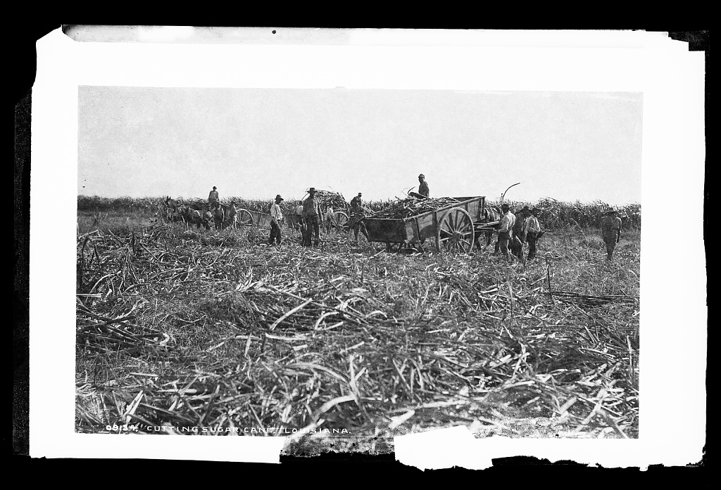
The transition from the institution of slavery to free labor was difficult and sometimes violent in Louisiana. The experiences of African American sugarcane workers in 1887 were very similar to the experiences of enslaved people before the Thirteenth Amendment passed. Many lived in old slave cabins and earned very low wages. Sugar cane workers went on strike (refused to work) in attempts to receive higher pay in 1874 and 1880, but were met with violent opposition. In 1887, the Knights of Labor, the most powerful union in the United States, helped the sugar workers organize and collectively demand higher pay. The planters again refused their demands. Union members were fired and new workers not demanding higher pay were brought in. White local militias and men working for the sheriff were used to intimidate striking workers. Tensions continued and violence broke out. On November 23, 1887, 60 African American farm workers were murdered in Thibodaux, Louisiana, in an event now known as the Thibodaux Massacre. The violence that took place prevented African American farm workers from organizing for better working conditions for many decades.

After you read:

1. Describe the goals of the Progressive Era.

2. Why were better working conditions for farm workers in Louisiana difficult to achieve?

Formative Performance Task #1
Student Directions | Describe the characteristics of Bourbonism, Populism, and Progressivism in Louisiana during the late 19th century and early 20th century.

Political movement | Description
Bourbonism
Populism
Progressivism

Lesson 5
Supporting Question 2: How did events in the late 1920s contribute to economic problems for people in Louisiana?

Student Directions | First, read and study Source O. Then, read Sources P and Q and answer the guiding questions in the right-hand columns. Next, study Source R. Finally, complete the after you read questions at the end of this lesson.
Featured Sources | Source O: Mississippi River Flood of 1927  Source P: “Great Flood of 1927”  Source Q: Excerpts from The Mississippi Valley Flood Disaster of 1927: Official Report of Relief Operations  Source R: Image Bank: Louisiana Flood of 1927

Source O: Mississippi River Flood of 1927
Devastating and costly floods during the early 20th century led the U.S. Congress to pass the Flood Control Act of 1917. The provisions of the 1917 Act were designed to reduce flood damage along the Mississippi, Ohio, and Sacramento Rivers. Specifically, it authorized flood-control work outside the Mississippi Valley, directed local communities to contribute half the cost of levee construction projects, and required these communities to maintain levees once construction was complete.

The map above shows the extent of flooding during 1927. Red crosses represent Red Cross Relief Camps set up to provide shelter and aid to those forced out of their homes. There were two periods of flooding in 1927. Green on the map above represents the area covered by the first flood of 1927, yellow represents the area covered by the second flood of 1927. Red arrows show breaks in levees.

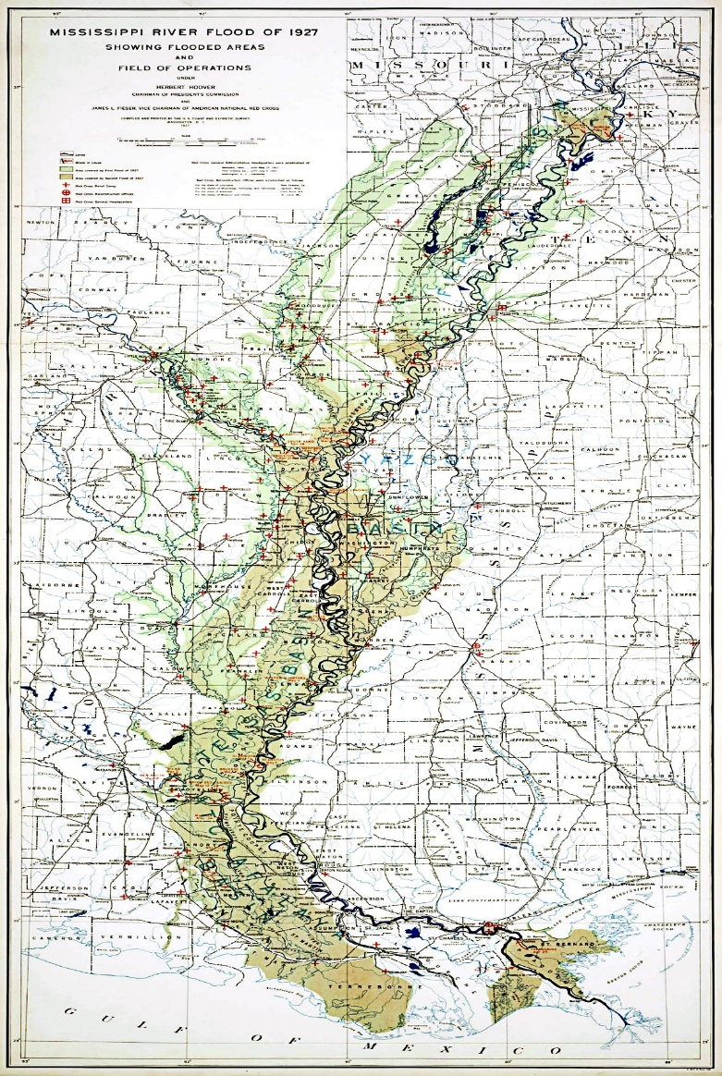

Source P: “Great Flood of 1927”
Text | Vocabulary | Guiding Questions
The Flood of 1927 was described by U.S. Secretary of Commerce Herbert Hoover as “the greatest peace-time calamity in the history of the country.” It inundated 16,570,627 acres (about 26,000 square miles) in 170 counties in seven states, driving an estimated 931,159 people from their homes. The Mississippi River remained at flood stage for a record 153 days. The flood caused more than $400,000,000 in losses; 92,431 businesses were damaged and 162,017 homes flooded. According to various estimates, there were between 250 and 500 flood-related deaths. In Louisiana alone, 10,000 square miles in 20 parishes went underwater. The congressional response to the devastation, the 1928 Flood Control Act, had far-reaching social, political, and physical consequences in Louisiana and throughout the Mississippi River Valley.  The prelude to the flood began in August 1926, when rainstorms began to swell streams in eastern Kansas, northwestern Iowa, and part of Illinois, all of which fed into the Mississippi River. In December, heavy rains in Oklahoma, Arkansas, and northern Louisiana filled the Arkansas and Red Rivers. During that fall, record rainfalls continued throughout the Mississippi River Valley. By the end of January, major tributaries such as the Ohio River were overflowing their banks. In earlier times, this would not have been the problem it was in 1927; the Mississippi River and its tributaries once overflowed into natural drainage areas. But in the late 1800s, the Mississippi River Commission adopted a “levees-only” policy, which entailed the construction of levees that ran almost the full length of the river. While these levees prevented flooding for a period, they proved unable to withstand the floodwaters of 1927.  Threat to New Orleans  Through the early spring of 1927, the rains continued and the flood pushed downriver toward Louisiana. New Orleans received 11.16 inches of rain in February—compared to an average of 4.4 inches for the month—and steady rainfalls thereafter. Then, on Good Friday, April 15, 1927, more than 14 inches of rain fell on New Orleans in a single day, disabling the pumps that normally drained the city. The levees were not breached; river water did not rush in. Instead, the levees held the rainwater inside the city. That downpour also added more water to the Mississippi River as it rushed past New Orleans. The levees there were under pressure from both sides, and concerned citizens began to buy boats and stockpile food. As heavy rains continued in the Mississippi River drainage area above Louisiana, more than 20,000 men were put to work sandbagging levees between Baton Rouge and New Orleans.  The threat continued to worsen, however, and state government officials believed the levees would inevitably break. If the break happened below New Orleans, it would relieve pressure and spare the city from massive flooding. An upstream break, on the other hand, would send a disastrous flood into New Orleans. Despite strenuous objections from people living downstream, Governor O. H. Simpson and his advisors acquiesced to a plea from New Orleans civic leaders to blast a breach in the levee. This would give the flood a shortcut to the sea and drop the river level at New Orleans, at the cost of flooding further south. Engineers chose a westward loop in the river at Caernarvon and began blowing the levee apart on April 29. Over the next ten days they used thirty-nine tons of dynamite to open a channel that released 250,000 cubic feet of water per second from the river.  For two days before the dynamiting began the National Guard and major retailers from New Orleans sent convoys of trucks to evacuate the 10,000 residents whose homes and livelihoods would be washed away when the levee was breached. Most of the refugees went to stay with relatives. Those who had no place to go were brought to a warehouse in New Orleans. White people were housed on the fifth floor, Black people on the sixth. All had been promised full compensation for their losses, but the lucky ones would get an average of only $274 each, and thousands of them would get nothing.  Part of that was because nobody realized how much would be washed away. The financial leaders from New Orleans estimated that claims against a fund set up to compensate the victims would be between $2 million and $6 million. Instead, they amounted to $35 million, and there wasn’t enough money to go around. Additionally, the fund had to bear the expense of feeding the refugees at a cost of $20,000 a week. Refugees had to file a claim to receive compensation under a complicated system that divided payments into various categories, provided that no partial payments could be made, and without legal representation.  The refugees were caught between a system of legalities they did not understand and marshes still filled with water that kept them from going home. Most settled for pennies on the dollar, and practically all of them remembered that it was a man-made catastrophe that put them where they were. Adding to their anger, a natural breach of the levees subsequently eased pressure on the New Orleans levee; the blasting had been unnecessary. Though New Orleans had been spared, other parts of southern Louisiana were still in trouble, particularly in the Atchafalaya River and Bayou Teche basins to the west of the city.  Inundation of Southern Louisiana  The Atchafalaya River forks away from the Mississippi River at Simmesport in Avoyelles Parish. Though it and its tributaries were lined by levees, they were filled to overflowing, and part of the Mississippi River sought this shorter, straighter course to the sea. Smaller levees had begun to break in northern and central Louisiana in mid-May, but a disastrous break in the Atchafalaya River levee came on May 17 at Melville in St. Landry Parish. River water poured through the breach and began to rush to the south, soon joined by floodwaters caused by a break in a Bayou des Glaises levee to the north of St. Landry, in Avoyelles Parish.  The two floods met just north of Port Barre in St. Landry Parish on May 18. They combined to send an estimated 1.3 million cubic feet of water per second roaring to the south. The flood inundated Arnaudville at the St. Landry-St. Martin Parish line on May 19; Breaux Bridge and St. Martinville in St. Martin Parish two days later; then New Iberia and Jeanerette in Iberia Parish; and Franklin and Morgan City in St. Mary Parish. By the end of May, sixty thousand refugees were either in southern Louisiana camps or receiving Red Cross aid elsewhere. Thousands of cattle drowned and farm crops were wiped out as southern Louisiana turned into a lake 200 miles long and 50 to 100 miles wide. It was not until June that the floodwaters began to drain into the Gulf of Mexico.  Once again, housing had to be found for tens of thousands of refugees who had no relatives to stay with. The Red Cross and local relief organizations set up tent cities and makeshift housing in Marksville, Mansura, Baton Rouge, Opelousas, Crowley, New Iberia, and elsewhere. Some twenty thousand people were housed at Lafayette alone. Parishes set up “rehabilitation committees” to find food and shelter for the displaced families.  When the water finally subsided, the Red Cross provided seed, tools, and rations to farm families facing the daunting task of surviving the winter and starting a new crop in the spring. Some six hundred prefabricated cabins were sent to St. Martin Parish and more like them elsewhere to temporarily replace destroyed housing. At the end of August 1927, an anonymous Associated Press reporter touring the Teche region was able to write, “Little farmhouses, bearing brown watermarks at various heights according to the depth of the water reached, are once more occupied, and some of the farmers are plowing in preparation for new plantings. A few have crops already growing, and cane and corn are making a brave attempt to put forth fruit despite the late start given them.”  Flood Policy Revision  The Flood of 1927 showed that levees alone would not solve the problem of flooding on the Mississippi River and forced the federal government to reconsider its flood control policy. As a result, huge tracts of lowland, called spillways, were set aside in south central and southeastern Louisiana. Massive gates were constructed to allow excess water to be diverted into these areas in times of severe flooding. Whole communities, such as Bayou Chêne, built upon a ridge in the Atchafalaya River basin, had to be abandoned because they were in the path of the floodwaters that might be diverted.  The flood drove many tenant farmers, most of whom were African American, off their land and, in many cases, out of the region. They migrated by the thousands to Chicago, Detroit, and other northern cities, changing the urban landscape in those places. In addition, a stingy fiscal policy that offered little aid to the flood victim, implemented under Republican President Calvin Coolidge, drove many African Americans from the party of Lincoln into the Democratic party, where they continue to be a considerable part of the constituency today. | inundated: covered, submerged  entailed: required | Describe the economic costs and property damage caused by the Great Flood of 1927.  ________________________________  ________________________________  ________________________________  ________________________________  ________________________________  ________________________________  ________________________________  ________________________________  ________________________________  ________________________________  ________________________________  ________________________________  ________________________________  ________________________________  ________________________________  ________________________________  ________________________________  Describe the natural events that strained the capacity of the levee system in and around New Orleans.  ________________________________  ________________________________  ________________________________  ________________________________  ________________________________  ________________________________  ________________________________  ________________________________  ________________________________  ________________________________  How was New Orleans spared from flooding in 1927?  ________________________________  ________________________________  ________________________________  ________________________________  ________________________________  ________________________________  ________________________________  ________________________________  ________________________________  Why were people who were impacted by the Flood of 1927 not fully compensated for their losses?  ________________________________  ________________________________  ________________________________  ________________________________  ________________________________  ________________________________  ________________________________  ________________________________  ________________________________  ________________________________  ________________________________  ________________________________  ________________________________  ________________________________  ________________________________  ________________________________  ________________________________  ________________________________  Describe the events that led to the flooding of St. Mary, St. Landry, and St. Martin parishes in 1927.  ________________________________  ________________________________  ________________________________  ________________________________  ________________________________  ________________________________  ________________________________  ________________________________  ________________________________  ________________________________  ________________________________  ________________________________  ________________________________  ________________________________  ________________________________  How did the Red Cross provide aid and relief for people impacted by the Flood of 1927?  ________________________________  ________________________________  ________________________________  ________________________________  ________________________________  ________________________________  ________________________________  ________________________________  ________________________________  ________________________________  ________________________________  ________________________________  How did flood policy change as a result of the flood of 1927?  ________________________________  ________________________________  ________________________________  ________________________________  ________________________________  ________________________________  ________________________________  ________________________________  ________________________________  ________________________________  How did the Flood of 1927 affect African Americans in Louisiana?  ________________________________  ________________________________  ________________________________  ________________________________  ________________________________  ________________________________  How did the Flood of 1927 affect politics?  ________________________________  ________________________________  ________________________________  ________________________________

The American Red Cross, a private nonprofit charitable institution, responded to the Great Flood of 1927. The organization provided shelter and relief to people in seven different states affected by the disaster for fourteen months after the flooding event. The organization published The Mississippi Valley Flood Disaster of 1927: Official Report of Relief Operations in 1929.

Source Q: Excerpts from The Mississippi Valley Flood Disaster of 1927: Official Report of Relief Operations
Text | Vocabulary | Guiding Questions
The American National Red Cross, in administering relief during and following the Mississippi Valley floods of 1927. . . carried through the greatest relief operation in the history of the organization. This was made possible because the American people entrusted to the Red Cross more than $17,000,000 for this operation and because. . . the Red Cross enjoyed the whole-hearted cooperation of the Government of the United States.  For the first time in the history of Mississippi Valley floods, there was considerable loss of human life. During the great floods of 1897, 1903, 1912, 1913, and 1922, there was no loss of human life directly attributable to the rising waters. The flood of 1927, however, moving . . . where the inhabitants had every reason to believe themselves safe, . . . proved a sad exception. The number of human lives reported lost was 246. Nearly all of these deaths occurred in the early stage of the disaster and before rescue facilities were organized under the Red Cross.  Agriculture suffered a heavier proportionate loss than any other industry. In addition, to wiping out all seeded and growing crops in … about 28.2 per cent of the entire agricultural acreage in the flooded counties, the water remained on the land for weeks in some sections and for months in others, making immediate replanting impossible. . .  Figures compiled by the Weather Bureau place crop losses at $101,562,395 and other farm property losses at $23,086,150. . .  Livestock constitutes a large item in this total tabulation. . .  The drowning of thousands of wild animals was another deplorable effect of the flood and one also of considerable economic significance, in as much as in many sections trapping and hunting are industries of importance. . .  The number of families whose homes were flooded was 162,017, of whom 40,451 owned their homes and 121,566 were tenants. A total of 8,947 of these houses were destroyed, as were 32,540 other buildings. . . |  | From where did the American Red Cross receive funding to provide relief during the Flood of 1927?  ________________________________  ________________________________  ________________________________  ________________________________  ________________________________  How was the Flood of 1927 different from previous floods in terms of human loss?  ________________________________  ________________________________  ________________________________  ________________________________  ________________________________  Describe the affect the Flood of 1927 had on the agricultural industry.  ________________________________  ________________________________  ________________________________  ________________________________  ________________________________  ________________________________  ________________________________  ________________________________  ________________________________  ________________________________  ________________________________  ________________________________

Source R: Image Bank: Louisiana Flood of 1927

Image 1: Tallulah 1927 Flood
The Great Flood of 1927 caused tremendous economic difficulties for people in Louisiana. In this image, a refugee is photographed with the belongings they were able to salvage from their flooded home.

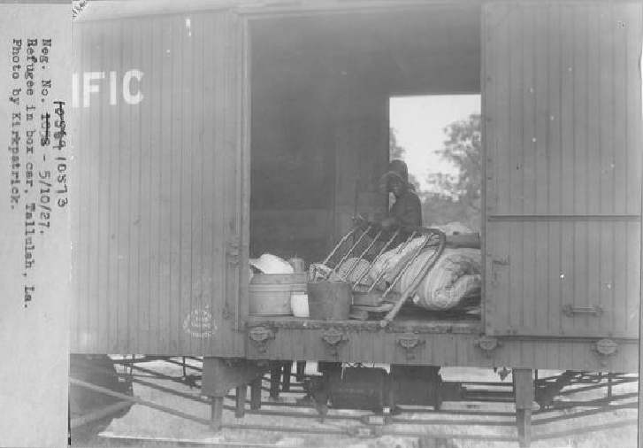

Image 2: General Summary of Relief Operations in Figures

Louisiana’s agriculture industry was damaged by the Great Flood of 1927. The chart below and the following excerpts represent the Red Cross report on all the states affected by the disaster, not just Louisiana, but provides some context for the amount of economic destruction caused by the flood.

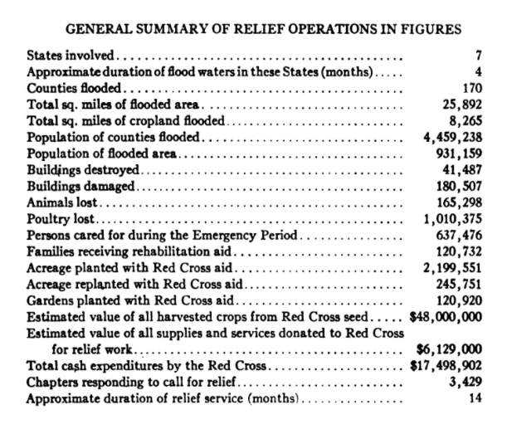

Image 3: Volunteer workers at Baton Rouge Red Cross Clothing Department participate in flood relief. June 6, 1927

Volunteers from the Red Cross worked throughout Louisiana to provide relief, including replacing belongings, for people affected by the Great Flood of 1927.

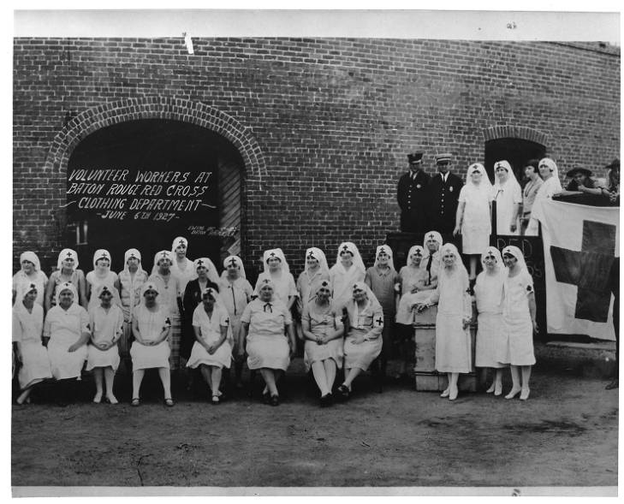

After you read:

1. How did the Great Flood of 1927 affect the economy of Louisiana?

Lesson 6
Supporting Question 2: How did events in the late 1920s contribute to economic problems for people in Louisiana?

Student Directions | First, read Source S and answer the guiding questions in the right-hand columns. Next, study Source T and then answer the after you read questions. Then, read Source U and answer the guiding questions in the right-hand columns. Finally, complete performance task #2 at the end of this lesson.
Featured Sources | Source S: “The Origins of the Great Depression”  Source T: Louisiana Resources Map  Source U: “Great Depression in Louisiana”

Source S: “The Origins of the Great Depression”
Text | Vocabulary | Guiding Questions
On Thursday, October 24, 1929, stock market prices suddenly plummeted. Ten billion dollars in investments (roughly equivalent to about $100 billion today) disappeared in a matter of hours. Panicked selling set in, stock values sank to sudden lows, and stunned investors crowded the New York Stock Exchange demanding answers. Leading bankers met privately at the offices of J. P. Morgan and raised millions in personal and institutional contributions to halt the slide. They marched across the street and ceremoniously bought stocks at inflated prices. The market temporarily stabilized but fears spread over the weekend and the following week frightened investors dumped their portfolios to avoid further losses. On October 29, Black Tuesday, the stock market began its long precipitous fall. Stock values evaporated. Shares of U.S. Steel dropped from $262 to $22. General Motors stock fell from $73 a share to $8. Four-fifths of J. D. Rockefeller’s fortune—the greatest in American history—vanished.  Although the crash stunned the nation, it exposed the deeper, underlying problems with the American economy in the 1920s. The stock market’s popularity grew throughout the decade, but the overwhelming majority of Americans had no direct personal stake in Wall Street. The stock market’s collapse, no matter how dramatic, did not by itself depress the American economy. Instead, the crash exposed a great number of factors that, when combined with the financial panic, sank the American economy into the greatest of all economic crises. Increasing inequality between the rich and poor, declining demand for consumer goods, collapse of the agricultural industry, overextended business investors, and the decreased value of stocks and investments brought by speculation all conspired to plunge the nation into the Great Depression.  For American farmers, hard times began long before the markets crashed. In 1920 and 1921, after several years of larger-than-average profits, farm prices in the South and West continued their long decline, plummeting as production climbed and domestic and international demand for cotton, foodstuffs, and other agricultural products stalled. Widespread soil exhaustion on western farms only compounded the problem. Farmers found themselves unable to make payments on loans taken out during the good years, and banks in agricultural areas tightened credit in response. By 1929, farm families were overextended, in no shape to make up for declining consumption, and in a precarious economic position even before the Depression wrecked the global economy. | overextended: committed to more than can be done  speculation: purchasing an investment with the hope that it will increase in value  Great Depression: worldwide economic downturn that lasted from 1929 until World War II | What happened on October 29, 1929?  ________________________________  ________________________________  ________________________________  ________________________________  ________________________________  ________________________________  ________________________________  ________________________________  ________________________________  ________________________________  In your own words, describe two factors that led to the Great Depression.  ________________________________  ________________________________  ________________________________  ________________________________  ________________________________  ________________________________  ________________________________  ________________________________  ________________________________  ________________________________  ________________________________  ________________________________  ________________________________  Why were farmers not prosperous during the 1920s?  ________________________________  ________________________________  ________________________________  ________________________________  ________________________________  ________________________________  ________________________________

Source T: Louisiana Resources Map

After you read:

1. Using Sources S and T, why did an agricultural depression in the 1920s affect people in Louisiana?

Source U: “Great Depression in Louisiana”
Text | Vocabulary | Guiding Questions
The Great Depression is widely attributed to the ongoing post–World War I economic malaise that engulfed Europe and the rest of the globe during the 1920s. In the United States, however, the dazzling growth of new technologies and the rapid advance of consumerism during the Jazz Age suggested that America was somehow immune to the chaos of the outside world. Yet protectionist trade policies, unchecked speculation, declining real wages, and the crisis of overproduction in industry and agriculture combined to undermine the soundness of the American economy by the end of the decade . . . In short, within three years, all the gains of the World War I years and the 1920s had been completely erased.  Depression-Era Louisiana  As a mostly agricultural state in the Deep South, Louisiana was greatly affected by the slumping economy, especially as farm prices declined to unheard-of lows. Cotton, for instance, dropped to less than five cents a pound, sugar to less than four. The value of the state’s other leading commodities—timber, oil, and rice—experienced a similar erosion. Although the vast majority of the rural population already lived in grinding poverty, the worsening conditions of the Depression pushed even these people to extremes. Further, the calamitous 1927 Mississippi River flood and the 1930–31 drought had displaced tens of thousands of farm laborers and their families (and many more from neighboring states), most of whom had yet to find a settled place in Louisiana society.  Traveling through Tensas Parish in the fall of 1933, relief fieldworker Lucille Watson found one of these families living in a plantation shack, the walls of which were “one big crack” that had been pasted over with old catalogue pages and newspaper to keep the “wind and the rain from blowing into the house as much.” Elsewhere, she found another migrant family with a mother who was “depressed and miserable over their present condition” and children who “looked more or less sick and puny.” In other cases, Watson stumbled upon families with only a few bushels of sweet potatoes to last the winter season. Hard times, then, abounded in the state’s rural areas. Even the upper classes, planters and large landowners, faced difficult prospects as farm income declined by two-thirds between 1929 and 1932. Many could not pay their taxes or keep up with their mortgages, eventually losing everything to the dreaded sheriff’s sale or to foreclosure by insurance companies and banks.  Yet rural distress hardly accounted for all of the suffering during the Depression years in Louisiana. The oil and natural gas industry, though more resilient than manufacturing, nonetheless endured a slowdown in production that necessitated cutbacks and layoffs. Still, the oil business proved a bulwark of sorts for the state’s economy throughout the 1930s, especially after a true recovery had gotten under way by 1934–35. Baton Rouge, home of the Standard Oil refinery and associated plants, continued to expand during the decade, as did Shreveport and Monroe, both nestled in the midst of vast petroleum fields.  New Orleans, however, experienced some of the worst aspects of the Depression in the state, more akin to the anguish felt in the metropolises of the North than in the city’s rural hinterlands. The South’s largest urban center in 1930, and still one of the nation’s biggest ports, New Orleans came face to face with the specter of the Depression almost immediately. With the precipitous decline in foreign trade, New Orleans’s warehouses emptied and its docks fell silent; the army of stevedores and handlers that serviced America’s, and the world’s, agricultural and industrial production, lay idle. By early 1930, in fact, one census counted at least 10,000 unemployed workers in the city, although the true figure was probably much higher. To handle the pressures of public relief, the city formed a Welfare Committee in early 1931 and raised more than a half million dollars from private sources. When this money ran out in 1932, municipal leaders floated a $750,000 bond issue, but this likewise proved insufficient to deal with the mass of the unemployed and their families. | malaise: trouble, unease  protectionist: protecting the industries of one’s own country from foreign competition  bulwark: defense  precipitous: abrupt, sharp, extreme  stevedores: people who load and unload cargo on ships | ________________________________  ________________________________  ________________________________  ________________________________  ________________________________  ________________________________  ________________________________  ________________________________  ________________________________  ________________________________  Describe the effects of the Great Depression on Louisiana’s small farmers and farm laborers.  ________________________________  ________________________________  ________________________________  ________________________________  ________________________________  ________________________________  ________________________________  ________________________________  ________________________________  Describe how the Great Depression affected Louisiana’s wealthier planters and large landowners.  ________________________________  ________________________________  ________________________________  ________________________________  ________________________________  ________________________________  ________________________________  Describe how the oil and natural gas industries faired in Louisiana during the Great Depression.  ________________________________  ________________________________  ________________________________  ________________________________  ________________________________  ________________________________  ________________________________  ________________________________  ________________________________  ________________________________  ________________________________  Why was New Orleans sharply affected by the Great Depression?  ________________________________  ________________________________  ________________________________  ________________________________  ________________________________  ________________________________

Formative Performance Task #2 – Constructed Response
Student Directions | Using the sources and your knowledge of social studies, explain how two different events in the late 1920s contributed to economic problems for people in Louisiana.

Lesson 7
Supporting Question 3: How did Huey Long gain popularity and power?

Student Directions | First read and study Source V. Then, read Sources W and X and answer the guiding questions in the right-hand column. Next, read and study Source Y. Then, read Source Z and answer the guiding questions in the right-hand column. Finally, complete the after you read questions at the end of this lesson.
Featured Sources | Source V: Huey P. Long Giving Speech in 1935  Source W: “Huey P. Long Jr.”  Source X: “Longism”  Source Y: Huey P. Long Field House  Source Z: Excerpts from “Share Our Wealth”

Source V: Huey P. Long Giving Speech in 1935

Huey P. Long was a Louisiana politician who served as governor of Louisiana from 1928 until 1932 and U.S. Senator from 1932 until his assassination in 1935. He was a member of the Democratic party and shared many of the same beliefs as the populist politicians of the 19th century. Long was a gifted and enthusiastic speaker and used speeches to increase support for his policies and actions.

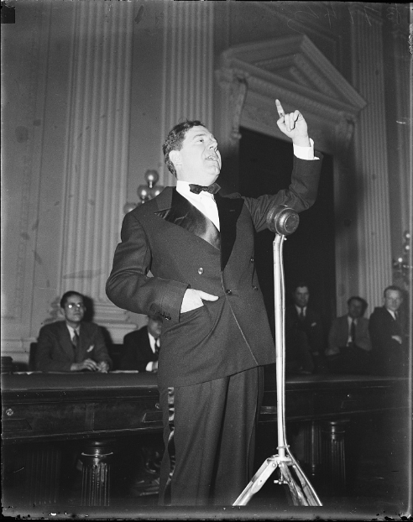

Source W: “Huey P. Long Jr.”
Text | Vocabulary | Guiding Questions
Huey Long rose from ordinary beginnings in Winn Parish to become Louisiana’s most notable politician. Despite meager formal education, Long passed the state bar examination at age twenty-two and earned a laudable reputation with his legal defense of common folk. In 1918 he launched a political career that ultimately propelled him into the governorship. Long fashioned a powerful statewide political organization and embarked on a program laden with public works, popular reforms, and heavy elements of corruption. In 1932 Long became a U.S. senator and a major voice for the redistribution of wealth on the national scene. In 1935 he fell victim to an assassin’s bullet.  Early Life  Long was born to Huey P. Long Sr. and his wife, Caledonia, in Winnfield on August 30, 1893. He attended public schools but never graduated. In 1910 he began a career as a traveling salesman in the Southwest, stopping briefly to attend the University of Oklahoma. In 1912 he married Rose McConnell. The couple had three children: Palmer Reed, Russell, and Rose. In 1915 Long attended Tulane University School of Law as a special student, passed the bar exam, and became an attorney. He then earned a solid reputation for his work on workers’ compensation cases and land and timber rights.  In 1918 Long ran successfully for the Louisiana Railroad Commission (renamed the Public Service Commission in 1921); four years later he became the commission’s chairman. Continuing to champion the causes of the common folk, Long sought lower rates from the utility companies and challenged corporate monopolies. In 1924 he campaigned unsuccessfully for governor on a platform of opposition to the Standard Oil Company, Governor John M. Parker, and traditional state politics. Observers contended that, despite a vigorous campaign that featured the extensive use of radio and sound trucks, Long’s failure to take a clear position on the Ku Klux Klan and a heavy rainstorm that kept potential voters at home caused his defeat.  The Governorship  In 1928 Long used tremendous energy, a populist appeal, and denunciation of the federal government’s inaction during the Mississippi River Flood of 1927 to win election to the governorship over Congressman Riley Wilson and O. H. Simpson. Long’s campaign, unlike the efforts of other contemporary southern politicos, was remarkably free of race baiting. In the state capital, the Kingfish, a nickname that Long expropriated from the popular Amos ‘n’ Andy radio program, pursued a progressive program that featured improved education for all ages, inexpensive natural gas for New Orleans, and wide-ranging public construction projects. Long also systematically removed his political foes from power and installed a new political hierarchy with himself at its head. In 1929 he sought innovative new taxes on the products of monopolistic oil companies, notably Standard Oil Corporation, an action that contributed directly to Long’s impeachment on various accusations from corruption to public profanity. The Kingfish, however, used his popularity with voters, brashness, and cunning legal scheming to evade the charges. The following year, Long created Louisiana Progress (later American Progress) to sidestep the newspapers that generally favored his opponents and convey his ideas straight to the voters.  Not all of Long’s plans, however, were successful. In 1930 state lawmakers defeated an impressive series of construction projects that Long favored. The Kingfish’s response was to campaign successfully for the U.S. Senate with the assurance that he would not leave the governorship until his term concluded. Long feared that his departure would allow the lieutenant governor, a fierce enemy, to gain political leverage in Louisiana. The Kingfish subsequently crafted a temporary partnership with his one-time rivals in the New Orleans Regular Democratic Organization (commonly referred to as “Old Regulars”), a powerful political group led by New Orleans Mayor T. Semmes Walmsley. This alliance made it possible for Long’s construction plans to move forward. Building plans for a new Louisiana State Capitol and a governor’s mansion, now known as the Old Louisiana Governor’s Mansion, were soon underway. Plans for road construction and increased spending on education, to be funded by a new gas tax, were not far behind. Special support went to Louisiana State University in Baton Rouge, Long’s favorite institution. In late 1931, Long used his control over the state court system to remove the lieutenant governor and place Oscar K. Allen, his longtime friend and business partner, in the vacant office. With the state firmly under control, Long resigned the governorship and left for Washington in January 1932.  The U.S. Senate  In the nation’s capital, Long declared himself a maverick. He resigned from all of his committee assignments and attacked both major political parties for their failure to redistribute wealth and resolve the problems of the Great Depression. In 1932 Long vigorously backed the presidential candidacy of Franklin D. Roosevelt and campaigned for him in the North. The Kingfish also campaigned for Hattie Caraway in Arkansas, using his widespread popularity and powerful speaking voice in an energetic seven-day assault on Louisiana’s neighboring state. With his help, she became the first woman elected to the U.S. Senate.  In 1933 the Kingfish broke with Roosevelt, contending that the president’s plans did not adequately help the nation’s poor or reallocate wealth. Long began to criticize various New Deal programs, including the Glass-Steagall Banking Act and the National Recovery Administration. He also aligned himself with the more isolationist, liberal wing of the Senate that included Gerald Nye, George Norris, and Burton K. Wheeler. Roosevelt, believing Long to be a dangerous demagogue, started to channel federal recovery revenues and political favors toward the Kingfish’s enemies. The president also challenged the honesty of electoral results in Louisiana and instructed agents of the Internal Revenue Service to look into the income sources of Long and his associates.  While Long continued his battle with the president, he frequently visited Louisiana and used loyal operatives to preserve his influence at home. Through his personal power and the employment of surrogates, he secured an end to the poll tax and created a homestead exemption. He also increased corporate levies and expanded the size and authority of state government. His foes in both Louisiana and Washington increasingly contended that Long was attaining the power and the demeanor of a dictator. Comparisons with Hitler and Mussolini abounded.  Share Our Wealth  In 1934 Long inaugurated the Share Our Wealth Society (SOWS), a national group that sought the legal confiscation of all annual incomes totaling more than $1 million and all personal fortunes topping $5 million. He intended to use the resultant revenue to provide all American citizens with free education, homes, radios, and automobiles. His plan also included a guaranteed minimum income for all citizens, including African Americans, and a pension for the elderly. Under the guidance of the Reverend Gerald L. K. Smith, a skilled organizer and captivating orator, SOWS branches spread across the country. In 1935 Smith and Long boasted that the organization had more than 7 million members and 27,000 chapters throughout the United States. Many observers contended that SOWS forced the president to move his administration toward the political left with the passage of the Social Security Act and the establishment of the Works Progress Administration. | laudable: deserving praise  public works: things built and funded by the government such as roads, schools, and reservoirs  workers’ compensation: providing relief to people who are injured while working  monopolies: companies that control one industry without competition  Standard Oil Company: controlled almost all oil production, processing, marketing, and transportation in the United States  John M. Parker: Democratic governor of Louisiana  race baiting: making damaging statements about a race of people (in order to influence actions of a group of people or in order to gain political support)  expropriated: took from  impeachment: to formally charge a public official with misconduct that may result in the public official’s removal from office  maverick: a person who rebels against what is expected of them  reallocate: distribute in a different way  New Deal: infrastructure and public works projects, financial reforms, and regulations directed and funded by the federal government under President Franklin Delano Roosevelt that were designed to help the United States economy during the Great Depression  revenues: funds  surrogates: people acting on another person’s behalf  homestead exemption: a tax break for homeowners  corporate levies: taxes on large companies  confiscation: to take  political left: more liberal | Describe Huey P. Long’s educational background.  ________________________________  ________________________________  ________________________________  ________________________________  ________________________________  ________________________________  ________________________________  ________________________________  ________________________________  ________________________________  How did Huey Long build a reputation as a fighter for common people?  ________________________________  ________________________________  ________________________________  ________________________________  ________________________________  ________________________________  ________________________________  Describe the factors that led to Huey Long’s successful election to governor.  ________________________________  ________________________________  ________________________________  ________________________________  ________________________________  ________________________________  ________________________________  ________________________________  ________________________________  ________________________________  ________________________________  ________________________________  How did Huey Long avoid criticism from his opponents?  ________________________________  ________________________________  ________________________________  ________________________________  ________________________________  ________________________________  ________________________________  ________________________________  ________________________________  ________________________________  ________________________________  ________________________________  How did Huey Long use his position as governor to guarantee the construction projects he favored were completed?  ________________________________  ________________________________  ________________________________  ________________________________  ________________________________  ________________________________  ________________________________  How did Huey Long guarantee that his will would be carried out in Louisiana after he left the governorship?  ________________________________  ________________________________  ________________________________  ________________________________  ________________________________  Why did Huey Long disagree with President Roosevelt’s policies? How did President Roosevelt react to his criticism?  ________________________________  ________________________________  ________________________________  ________________________________  ________________________________  ________________________________  ________________________________  ________________________________  ________________________________  ________________________________  ________________________________  How did Huey Long influence the politics of Louisiana while he was a U.S. Senator?  ________________________________  ________________________________  ________________________________  ________________________________  ________________________________  ________________________________  Describe Huey Long’s Share Our Wealth plan and its effect on federal policies.  ________________________________  ________________________________  ________________________________  ________________________________  ________________________________  ________________________________  ________________________________  ________________________________

Source X: “Longism”
Text | Vocabulary | Guiding Questions
The term “Longism” refers to both the political machine and the radical populist doctrine established by Huey P. Long in Louisiana from the time he was elected governor in 1928 and continuing until about 1960, decades after his assassination in 1935—a lengthy episode that testifies to Long’s influence in a state where he achieved near-mythic status during his mere forty-two years of life. As both the governor of Louisiana and a U.S. senator, Long identified himself as an advocate for the poor and developed policies to improve their situation and ensure their continued political support. In the process, he constructed a powerful and corrupt political legacy that shaped the history of Louisiana for years after his death. Some would argue that vestiges of Longism continue to influence politics in the state today.  The Development of Longism  After Reconstruction, a corrupt alliance of the conservative Democrats called “Bourbons” and a group of New Orleans political bosses had ruled state government. The grinding poverty that most Louisianans experienced in the late nineteenth and early twentieth century was a direct result of Bourbon neglect and the exploitation championed by distant capitalists. Although some reforms had been enacted beginning in 1900, Louisiana lagged behind the populist movements sweeping other Southern states. Meanwhile, Winn Parish, Long’s home territory, served as a nurturing ground for a radical challenge to the status quo—a majority of Winn residents even voted Socialist in the 1912 presidential election. Long and the political machine he built challenged the Bourbons’ exploitative system, knowing that whoever could motivate the masses held real power.  Long began his political career in 1918, when he was elected railroad commissioner with the campaign promise to lower freight rates for farmers. He used this position to enhance his reputation as a champion of the poor and an opponent of large oil and utility companies. Two years after taking office as governor, Long ascended to the U.S. Senate. With his fiery rhetoric and captivating charisma, he amassed unprecedented political power over the state. Long promised thousands of impoverished Louisianans a better life, assuring them that under his rule he would make “every man a king.”  In the midst of the Great Depression, Long implemented policies intended to improve the state infrastructure and the lives of his constituents, who were, largely, rural and poor. He authorized the construction of nine thousand miles of new roads and more than a hundred bridges. In addition, his administration established public schools statewide, with free busing and textbooks, allowing thousands of children to attend school; approximately 175,000 illiterate Louisianans entered adult night schools developed during Long’s reign. The number of beds in the state’s charity hospitals doubled, and the state university gained national stature in both size and scholarship. Long also advocated a homestead property tax exemption to lessen the burden on poor farmers, and he abolished the poll tax so that thousands of Louisianans could vote. Not surprisingly, these newly enfranchised citizens cast their ballots in favor of the candidate who had granted them the opportunity to do so.  Huey Long’s Failures  Although Long arguably did more good for Louisiana than had any politician before or since, his critics felt that his iron-fisted dictatorial machinations also bruised the body politic. By the time of his death in 1935, he had seized more control over an American state than had any politician in history. Giving state jobs and government contracts to loyalists while firing civil servants who opposed him, the “Kingfish,” as he came to be known, built a corrupt, spoils-ridden, and unstoppable political machine. He orchestrated elections, padded voting lists, and directed the counting of ballots. He assaulted freedom of the press by proposing a gag law prohibiting newspapers from criticizing him and by founding his own newspaper, the Louisiana Progress. In addition, Long deployed the state militia as his personal police force, declaring martial law in cities that refused to submit to his mastery. By packing the courts with his cronies, Long attempted to ensure that his increasing power would go unchecked. Most blatantly, he dominated the state legislature, ordering it to pass hundreds of bills that increased his power, destroyed his enemies, and stretched the very limits of constitutionalism. Despite Long’s political demagoguery, Louisiana’s poor continued to support him staunchly—likely because Long was a marked contrast to the neglect they had suffered under Bourbon politics. These residents were either unaware of or unconcerned about the ruthless political machine Long had constructed and the level of corruption in state government; some even looked the other way when Long pocketed money for himself.  Because Louisiana was a one-party state at the time, the conflict between those who supported Long and those who opposed him split the Democratic Party in half. Long allowed no compromises, demanding absolute loyalty from his followers. If they opposed him, even in part, they became enemies, and he crushed them relentlessly. After foiling a 1929 impeachment attempt in the Louisiana legislature, Long boasted, “I used to try to get things done by saying ‘please.’ Now I’m a dynamiter. I dynamite ‘em out of my path.” When Long was elected to the U.S. Senate, he opted to leave the seat in Washington empty and serve the remaining months of his term as governor in order to block Lt. Gov. Paul Cyr from assuming the office, since Cyr was by that time a bitter enemy. Cyr declared himself governor, on the grounds that Long had vacated the office upon election to the Senate. Long responded by deploying the state’s National Guard around the capitol building in Baton Rouge and used the state supreme court to oust Cyr. Long replaced him with his friend from childhood, Oscar K. Allen, dubbed “O. K.” Allen for his willingness to approve any measures Long proposed. For the three decades following Long’s rise to power, the Louisiana political arena was a battle between Longism and anti-Longism. | radical: political views or practices that represent extreme change  vestiges: small parts that are left over  capitalists: people who support an economy that is not regulated by the government  Socialist: people who believe in collective ownership of the economy  infrastructure: systems built for the public good like roads, bridges, railroads  abolished: stopped  dictatorial: like a dictator (a ruler who rules with complete power and in an oppressive way)  machinations: schemes or plans  body politic: the people of a nation, state, or society considered collectively as an organized group of citizens  civil servants: people who worked for the government  spoils: practice of giving government positions to people who supported an elected official or political party  martial law: rule by the military rather than the elected or appointed government | How did Bourbonism contribute to Huey Long’s rise to power?  ________________________________  ________________________________  ________________________________  ________________________________  ________________________________  ________________________________  ________________________________  ________________________________  ________________________________  What promises did Huey Long make that appealed to poor voters in Louisiana?  ________________________________  ________________________________  ________________________________  ________________________________  ________________________________  ________________________________  ________________________________  What actions did Huey Long take that appealed to poor people in Louisiana?  ________________________________  ________________________________  ________________________________  ________________________________  ________________________________  ________________________________  ________________________________  ________________________________  ________________________________  ________________________________  ________________________________  ________________________________  Describe one way Huey Long benefitted from abolishing the poll tax.  ________________________________  ________________________________  ________________________________  ________________________________  ________________________________  ________________________________  ________________________________  ________________________________  ________________________________  ________________________________  Describe three ways Huey Long acted as a dictator.  ________________________________  ________________________________  ________________________________  ________________________________  ________________________________  ________________________________  ________________________________  ________________________________  ________________________________  ________________________________  How did Oscar K. Allen become governor of Louisiana?  ________________________________  ________________________________  ________________________________  ________________________________  ________________________________  ________________________________  ________________________________  ________________________________  ________________________________  ________________________________  ________________________________  ________________________________  ________________________________  ________________________________  ________________________________  ________________________________

Source Y: Huey P. Long Field House

Huey Long was a supporter of Louisiana State University. He increased the university’s funding, expanded its enrollment to poorer students, and supported the football team and marching band. He was responsible for the construction of many new buildings on the campus, including a field house for the football team that is now used for LSU’s Department of Kinesiology and Social Work, and he expanded the football stadium. He was also criticized for interfering with the university’s affairs.

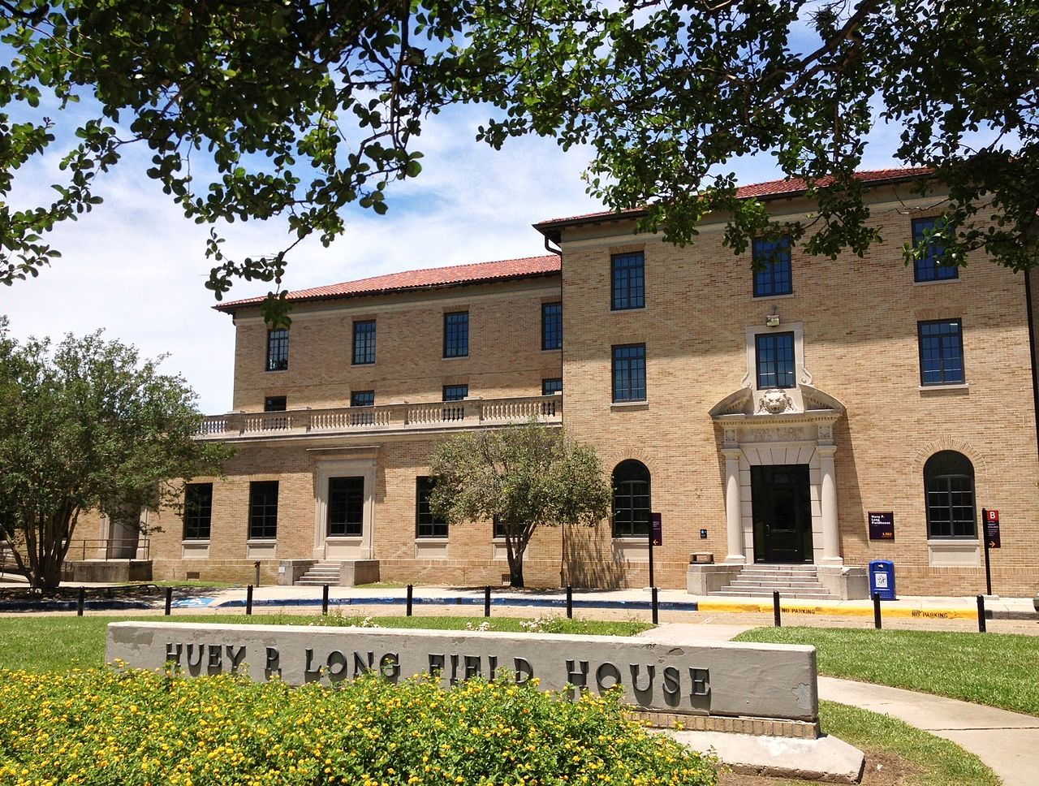

Source Z: Excerpts from “Share Our Wealth”
Text | Vocabulary | Guiding Questions
Here is the whole sum and substance of the share-our-wealth movement:  Every family to be furnished by the Government a homestead allowance, free of debt, of not less than one-third the average family wealth of the country, which means, at the lowest, that every family shall have the reasonable comforts of life up to a value of from $5,000 to $6,000. No person to have a fortune of more than 100 to 300 times the average family fortune, which means that the limit to fortunes is between $1,500,000 and $5,000,000, with annual capital levy taxes imposed on all above $1,000,000.  2. The yearly income of every family shall be not less than one-third of the average family income, which means that, according to the estimates of the statisticians of the United States Government and Wall Street, no family's annual income would be less than from $2,000 to $2,500. No yearly income shall be allowed to any person larger than from 100 to 300 times the size of the average family income, which means that no person would be allowed to earn in any year more than from $600,000 to $1,800,000, all to be subject to present income-tax laws.  3. To limit or regulate the hours of work to such an extent as to prevent overproduction; the most modern and efficient machinery would be encouraged, so that as much would be produced as possible so as to satisfy all demands of the people, but to also allow the maximum time to the workers for recreation, convenience, education, and luxuries of life.  4. An old-age pension to the persons over 60.  5. To balance agricultural production with what can be consumed according to the laws of God, which includes the preserving and storage of surplus commodities to be paid for and held by the Government for the emergencies when such are needed. Please bear in mind, however, that when the people of America have had money to buy things they needed, we have never had a surplus of any commodity. This plan of God does not call for destroying any of the things raised to eat or wear, nor does it countenance wholesale destruction of hogs, cattle, or milk.  6. To pay the veterans of our wars what we owe them and to care for their disabled.  7. Education and training for all children to be equal in opportunity in all schools, colleges, universities, and other institutions for training in the professions and vocations of life; to be regulated on the capacity of children to learn, and not on the ability of parents to pay the costs. Training for life's work to be as much universal and thorough for all walks in life as has been the training in the arts of killing.  8. The raising of revenue and taxes for the support of this program to come from the reduction of swollen fortunes from the top, as well as for the support of public works to give employment whenever there may be any slackening necessary in private enterprise. |  | How did Long propose to redistribute wealth from the wealthy to the poor?  ________________________________  ________________________________  ________________________________  ________________________________  ________________________________  ________________________________  ________________________________  ________________________________  ________________________________  ________________________________  How did Long propose to end poverty?  ________________________________  ________________________________  ________________________________  ________________________________  ________________________________  ________________________________  ________________________________  What protections for workers did Long propose?  ________________________________  ________________________________  ________________________________  ________________________________  ________________________________  What was Long’s plan to reform education?  ________________________________  ________________________________  ________________________________  ________________________________  ________________________________  ________________________________  ________________________________

After you read:

1. Describe the policies and actions of Huey Long that appealed to common people.

2. What methods did Huey Long use in order to silence those who opposed him?

3. Why was Long’s “Share Our Wealth” program attractive to people in Louisiana?

Lesson 8
Supporting Question 3: How did Huey Long gain popularity and power?

Student Directions | First, read and study Source AA. Then, read Source AB and answer the guiding questions in the right-hand column. Then, read and study Source AC. Finally, complete the after you read questions at the end of this lesson.
Featured Sources | Source AA: “LSU Stadium Dedication; Hopkins speaking (back)”  Source AB: “Great Depression in Louisiana”  Source AC: “WPA work on North Peters Street in the French Market, New Orleans”

Source AA: “LSU Stadium Dedication; Hopkins speaking (back)”
Harry Hopkins led federal programs that provided relief during the Great Depression. Federal funds were used for many buildings on Louisiana State University campus, including some construction on the football stadium. In the photograph below, Harry Hopkins speaks to a crowd in Tiger Stadium at Louisiana State University in Baton Rouge, Louisiana.

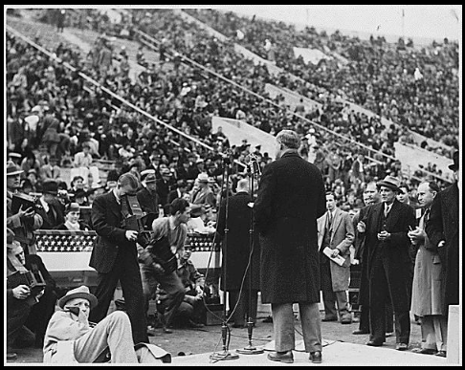

Source AB: “Great Depression in Louisiana”
Text | Vocabulary | Guiding Questions
During the Great Depression, public relief was not something that Huey Long ever endorsed, or ever really was forced to support. His early construction program poured money into public works projects that provided employment opportunities for many laborers around the state, while after about 1931, when he began to move into the national political picture, he cared more about maintaining his base of power in Louisiana than providing for his constituents. Local sources of public charity carried much of the load through then. In fact, churches, social clubs, benevolent societies, and other private sources had contributed more than 98 percent of all welfare expenditures in the state that year. And by the time these sources began to give out, even the Republican administration of Herbert Hoover had seen the necessity of a national relief program.  The Depression Lifts  Beginning with Hoover’s issuance of federal loans to the states in the late summer of 1932, a more regular approach to relief took shape. Between October 1932 and May 1933, Governor O.K. Allen’s administration paid out $6.5 million in these funds while handling approximately 115,000 cases a month. Once Franklin D. Roosevelt took office as president in March 1933, this system was reorganized under the control of the Federal Emergency Relief Agency (FERA). Following this, federal dollars flowed into the state at an impressive rate and, although often manipulated at the local level, nonetheless made a powerful impact on the state’s relief problems. Later, after Long’s death in 1935, an even greater amount of money cascaded into Louisiana for projects that eventually employed thousands of blue- and white-collar workers. | public relief: financial assistance from the government during times of hardship  public works: things built and funded by the government such as roads, schools, reservoirs | How did people in Louisiana receive financial help while Huey Long was in power? Why did they not receive public relief?  ________________________________  ________________________________  ________________________________  ________________________________  ________________________________  ________________________________  ________________________________  ________________________________  ________________________________  How did President Roosevelt contribute to economic recovery in Louisiana during the Great Depression?  ________________________________  ________________________________  ________________________________  ________________________________  ________________________________  ________________________________  _______________________________
Source AC: “WPA work on North Peters Street in the French Market, New Orleans”

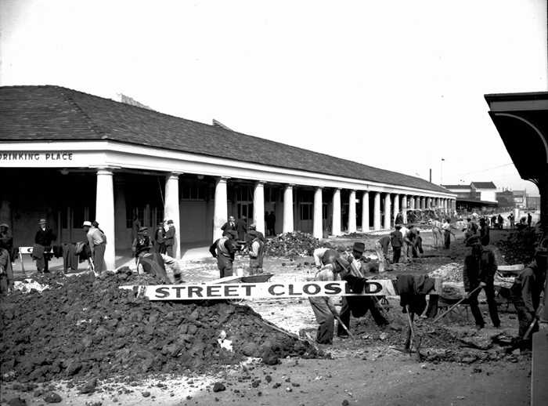

Roosevelt believed the national government could jump start the economy by spending federal money.
The first major help to large numbers of jobless Americans was the Federal Emergency Relief Act. This law gave $3 billion to state and local governments for direct relief payments. Under the direction of Harry Hopkins, FERA assisted millions of Americans in need. Although FERA lasted two years, efforts were soon shifted to "work-relief" programs. These agencies would pay individuals to perform jobs, rather than provide handouts. One of these work-relief programs, the Civilian Conservation Corps (CCC), gave work to over two million unemployed unmarried men between the ages of 17 and 25. CCC participants lived in camps in the countryside and built reservoirs and bridges, planted trees, dug ponds, and cleared lands. The largest relief program of all was the Works Progress Administration (WPA). Roosevelt appointed Hopkins to head the WPA, which employed nearly 9 million Americans before its expiration. Americans of all skill levels were given jobs to match their talents. Most of the resources were spent on public works programs such as roads and bridges, but WPA projects spread to artistic projects too. The above photograph was taken on January 5, 1937 in New Orleans, Louisiana.
After you read:

1. How were Huey Long’s actions in Louisiana similar to President Roosevelt’s actions during the Great Depression?

Lesson 9
Supporting Question 3: How did Huey Long gain and maintain power in Louisiana?
Student Directions | First, read Sources AD, AE, and AF and answer the guiding questions in the right-hand column. Then, read and study Source AG. Finally, complete performance task #3 at the end of this lesson.
Featured Sources | Source AD: “Anti-Longism”  Source AE: “Huey Long Statue at the Louisiana State Capitol”  Source AF: “Longism: Long’s Legacy”  Source AG: Edwin Edwards in 1986

Source AD: “Anti-Longism”
Text | Vocabulary | Guiding Questions
As with any emerging politician or political machine, each success brought Long increasing numbers of opponents. Many were conservative members of the Louisiana legislature; some were businessmen opposed to increased state spending. Still others were personally offended by Long’s iron-fisted methods. Though they represented diverse interests and ambitions, opponents of the Long machine shared one controlling certainty—determined hostility toward Huey Long. They rarely coalesced as an organized political entity, but because of this omnipresent shared goal, they were often referred to as anti-Longs or anti-Longites.  The Rise of Huey Long  . . .While Long offered relief to the poor that correspondingly annoyed those who were expected to pay for his social programs, the Long machine also included other qualities that ensured determined opposition would develop. Long’s personal character was a major part of the problem. Though energetic and hard working, Long was crass and profane. Not content to whip them at the polls, Long found it necessary to berate and insult his opponents at nearly every opportunity. In a state where many people regarded personal and familial honor as more important than life itself, Long ceaselessly taunted and denigrated those opposed to his policies, often mocking the physical characteristics of his opponents. He referred to veteran U.S. Senator Joseph Ransdell, a former ally and his opponent in the 1930 Senate race, as “Old Feather Duster”; Mayor T. Semmes Walmsley of New Orleans endured the epithet “Turkey Head”; aged former governor J. Y. Sanders was derided as “Buzzard Back” due to his stooped posture; the former governor’s son was regularly marginalized as “Little J. Y.” Few would declare Long a gentleman.  Abuse of Power  Still worse in the eyes of not merely his opponents but of those committed to the democratic process, was Long’s willingness to defy mandated legal procedures to advance his personal political power, even to the point of seeking to gain control of the state courts. As he delivered necessary reforms, Long seemed increasingly to be consumed by a ceaseless desire for more power. He rapidly concentrated virtually all aspects of state authority under his ultimate control in Baton Rouge and ruthlessly marginalized any who opposed him. A series of laws and constitutional amendments were passed by the Long-controlled legislature to expand the governor’s ability to appoint cronies to state offices. Local political entities were rendered almost exclusively dependent on state authority, and electoral districts were gerrymandered specifically to defeat Long opponents. Even when he was elected to the U.S. Senate in 1930, Long continued to exercise gubernatorial power in Louisiana through the office of his puppet successors, Alvin Olin King and Oscar K. Allen. In 1934 Long went so far as to order National Guard troops into New Orleans and declared martial law to wrest control of the city from Mayor Walmsley, who had led an anti-Long rally in Baton Rouge. Such heavy-handed disregard for the democratic process soon made anti-Longs out of powerful figures and corporations ranging from Standard Oil to President Franklin Roosevelt, who allegedly declared Long one of the two most dangerous men in America (the other being anti-Semitic radio evangelist Father Charles Coughlin). A coalition of conservatives in the Louisiana House of Representatives became known as the “Dynamite Squad” due to their willingness to detonate any proposal supported by Long.  Though Long continued to taunt and berate his opponents, he was clearly concerned about the determination of some anti-Longs. He became the first Louisiana governor to hire bodyguards, soon employing enough for a small military company. He found plots against him nearly everywhere, especially after anti-Longs coalesced into loose organizations such as the Square Deal Association. Formed originally by disgruntled Standard Oil employees, the Square Dealers eventually included diverse groups and individuals committed to one purpose—getting rid of Long by any means necessary. Long disrupted the ill-defined plans of the Square Dealers by sending the state National Guard against them during a gathering of anti-Longs at the East Baton Rouge Parish Courthouse. The Square Dealers left the courthouse but engaged in a brief armed skirmish at the Baton Rouge airport. Tear gas and bullets were fired; there was one injury but no fatalities.  A Legacy after Assassination  Contempt for Long continually increased. On the evening of September 8, 1935, Long was monitoring a session of the Louisiana legislature when an armed young physician approached him in a capitol corridor and initiated a confrontation that resulted in the deaths of both Long and his assailant. In the aftermath of the shootings it was revealed that the alleged assassin, Dr. Carl A. Weiss, was the son-in-law of anti-Long judge Benjamin Pavy, whose judicial district was being gerrymandered by Long’s supporters in the legislature that very night.  Despite Long’s death the Long machine continued as a potent force in Louisiana politics under the successive leadership of Governor Richard Leche and Long’s colorful brother Earl Long, who ascended to the governor’s office after Leche’s scandal-ridden resignation in 1939. As corrupt practices in the Long camp became increasingly public, so did the appeal of the anti-Longs, who in 1939 successfully elected reform-minded Sam Jones governor of Louisiana. The competition between the Long and anti-Long camps remained a guiding determinant of the Louisiana political scene into the 1970s, and it continues to influence some regions of the state to this day. | coalesced: united  omnipresent: widespread  cronies: friends  gerrymander-ed: to divide or arrange a region into election districts in a way that gives one political party an unfair advantage | Who were Huey Long’s supporters?  ________________________________  ________________________________  ________________________________  ________________________________  ________________________________  ________________________________  ________________________________  ________________________________  ________________________________  ________________________________  How did personality characteristics of Huey Long increase anti-Longism?  ________________________________  ________________________________  ________________________________  ________________________________  ________________________________  ________________________________  ________________________________  ________________________________  ________________________________  ________________________________  ________________________________  ________________________________  ________________________________  ________________________________  ________________________________  ________________________________  ________________________________  ________________________________  ________________________________  Describe two ways Huey Long achieved political power in corrupt ways.  ________________________________  ________________________________  ________________________________  ________________________________  ________________________________  ________________________________  ________________________________  ________________________________  ________________________________  ________________________________  ________________________________  ________________________________  What actions did Huey Long take in order to protect himself from violence from anti-Longs?  ________________________________  ________________________________  ________________________________  ________________________________  ________________________________  ________________________________  How did Long’s political career in Louisiana end?  ________________________________  ________________________________  ________________________________  ________________________________  ________________________________  ________________________________  ________________________________  ________________________________  ________________________________  ________________________________  ________________________________  ________________________________  ________________________________

Source AE: “Huey Long Statue at the Louisiana State Capitol”
Huey Long was buried in front of the state capital. The image above shows his grave marker. Over 200,000 people attended Huey Long’s funeral at the capital.
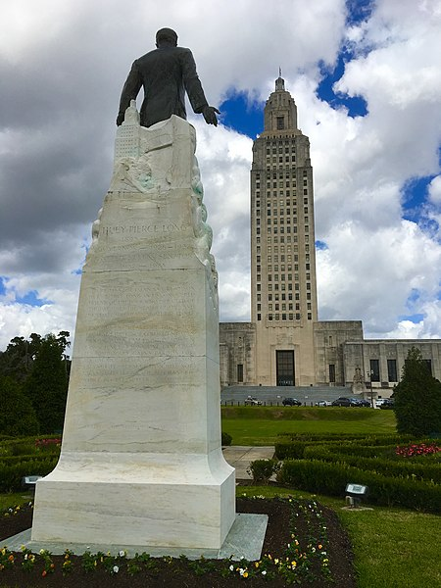

Source AF: “Longism: Long’s Legacy”
Text | Vocabulary | Guiding Questions
Long’s Legacy  In September 1935 Long was assassinated in the Louisiana State Capitol. . . Longism, however, did not die with Huey Long: for the next three decades, the Louisiana political arena continued to be a battle between Longism and anti-Longism. The four governors who served immediately after Long’s death were faithful followers of his political philosophy. Long’s handpicked successor, O. K. Allen, won election to Long’s Senate seat but died in 1936 while still governor. James A. Noe, a Share Our Wealth enthusiast, then served as interim governor and appointed Long’s widow, Rose McConnell Long, to fill the vacant U.S. Senate seat. Richard W. Leche, another Long insider, was elected governor in 1936. Across the state, other patrons of the Long machine won political office, including Robert Maestri, who served as mayor of New Orleans from 1936 to 1946.  Long’s followers saw him as a revered martyr and continued to run Louisiana with a tight grip—perhaps less ruthlessly but more corruptly. They continued his advocacy of road construction; free textbooks; and expanded hospitals, schools, and universities; but they generally abandoned his more radical campaign for wealth distribution and social programs. Making deals with Long’s former enemies, they ceased attacks on the oil industry and granted tax exemptions to business and industry. They also enacted a regressive sales tax.  Governor Leche—who once said, “When I took the oath of office, I didn’t take any vow of poverty”—resigned in 1939, when federal authorities indicted him and several of his cronies for misusing New Deal funds. A year later, he was convicted of mail fraud for accepting kickbacks in a deal involving trucks for the state highway department. Sentenced to ten years in an Atlanta penitentiary, Leche was released in 1945. Other high-ranking Longites convicted included Louisiana State University president James M. Smith, who went to prison for unlawfully investing half a million dollars of university funds in the futures market.  When Leche resigned, Lt. Gov. Earl K. Long became governor, serving until 1940, and he was later elected to two nonconsecutive terms from 1948 to 1952 and 1956 to 1960. Almost as notorious as his older brother, Earl Long imprinted his own brand of Longism on Louisiana. A wily politician, he recognized the potential voting power of disenfranchised African Americans. While not attempting to dismantle Jim Crow laws, he eased many governmental restrictions placed on African Americans, thereby allowing a considerable number of them to vote. Earl Long also convinced the legislature to equalize teacher pay between the races. In 1959, in response to legislative attempts to restrict African American suffrage, he called for full voting rights for Blacks. Although his family had him committed to a state mental asylum, Long, still governor, ordered his own release.  In 1960 Earl Long was elected to the U.S. House of Representatives but died before taking office, marking the end of a political era. Even before Earl Long’s death, Longism had already experienced several major defeats. In 1940, anti-Long reformist Sam Houston Jones defeated Earl Long for governor; four years later, popular singer Jimmie Davis defeated Lewis L. Morgan, the candidate supported by Earl Long and Robert Maestri. While Longism no longer exists as a potent political force, vestiges of its former power remain. The Long name still captures votes, especially in the rural parishes of the state. In 1948 Russell B. Long, son of Huey Long, was elected to the U. S. Senate, where he served until 1987. From 1966 to 1981, he chaired the Senate Finance Committee. A competent and shrewd leader, Russell Long influenced the nation’s taxes, Social Security, and welfare programs. Like his father, he favored a heavier tax burden on the wealthy.  Other Longs elected to high political office include George S. Long, a dentist and Huey Long’s older brother. He represented the now-defunct Eighth Louisiana Congressional District (a mostly rural north-central area of the state) in the U. S. House from 1953 until his death in 1958. In addition, two cousins, Gillis W. Long and Speedy O. Long, served in the U. S. House during the 1960s and 1970s. Jimmy D. Long, another member of the dynasty, served in the Louisiana House of Representatives from 1968 until 2000, and Gerald I. Long, a third cousin of Huey and a rare Republican member of the Long family, was elected to the state Senate in 2007.  Former governor Edwin W. Edwards perhaps best exemplified the modern-day version of Longism. Through his liberal political rhetoric and charismatic personality, he cast himself as a Louisiana populist in the tradition of both Huey and Earl Long. Edwards was elected to the U.S. House of Representatives, serving from 1965 to 1972. While in Congress, he was one of few Southern congressmen to support the extension of the Voting Rights Act of 1965. Serving an unprecedented four terms as governor (two terms spanning 1972 to 1980 as well as reelections in 1983 and in 1991), Edwards used windfall tax revenues from the oil industry to increase health and human services programs, create vocational-technical schools, and strengthen higher education.  Like Huey and Earl, however, Edwards frequently faced charges of corruption, especially when Louisiana reintroduced legalized gambling. He survived two dozen corruption investigations and remained enormously popular. During his gubernatorial campaign against former Klansman David Duke, Edwards’s supporters printed bumper stickers saying, “Vote for the Crook. It’s Important,” and the voters did. His luck finally ran out, however, in 2001, when he was convicted of extorting money from casino boat owners seeking licenses. A federal court convicted him on seventeen counts, including racketeering, money laundering, and wire fraud. He received a ten-year prison sentence. | martyr: person who dies for a cause they believe in  vestiges: small amounts | Why did Huey Long’s politics continue to influence Louisiana in the 1930s?  ________________________________  ________________________________  ________________________________  ________________________________  ________________________________  ________________________________  ________________________________  ________________________________  ________________________________  ________________________________  ________________________________  ________________________________  ________________________________  ________________________________  Why did Longism become further identified with corruption after Long’s death?  ________________________________  ________________________________  ________________________________  ________________________________  ________________________________  ________________________________  ________________________________  ________________________________  ________________________________  ________________________________  ________________________________  ________________________________  ________________________________  ________________________________  ________________________________  How did Earl Long improve the political and economic standing of African Americans?  ________________________________  ________________________________  ________________________________  ________________________________  ________________________________  ________________________________  ________________________________  ________________________________  How did Huey Long’s legacy influence politics into the 2000s?  ________________________________  ________________________________  ________________________________  ________________________________  ________________________________  ________________________________  ________________________________  ________________________________  ________________________________  ________________________________  ________________________________  ________________________________  How were Edwin W. Edwards’ policies similar to Huey and Earl Long’s policies?  ________________________________  ________________________________  ________________________________  ________________________________  ________________________________  ________________________________  ________________________________  ________________________________  ________________________________  ________________________________  ________________________________  ________________________________  ________________________________  ________________________________  ________________________________  ________________________________

Source AG: Edwin Edwards in 1986
After his release from prison in 2011, Edwin Edwards ran for U. S. Congress against Republican Garrett Graves in 2014. Edwards, who ran as a Democrat. In the first election, Edwards received 30.1 percent of the vote, Graves received 27.4, and other contestants earned the remaining votes. In Louisiana, an official must receive over 50 percent of the vote to win the election. Therefore, a second run-off election was held between just Edwards and Graves. Graves won by receiving 62.4 percent of the vote. Edwards won the remaining 37.6 percent.
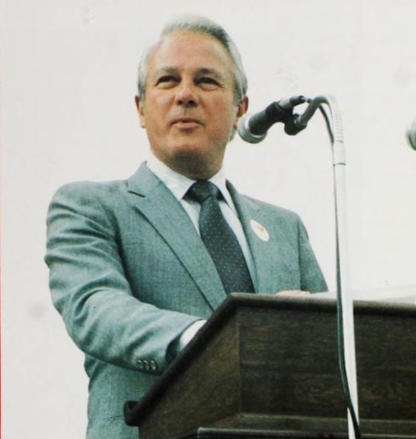

Formative Performance Task #3 – Constructed Response
Student Directions | Using the sources and your knowledge of social studies, explain two ways that Huey Long maintained power in Louisiana.

Lesson 10 – Summative Performance Task
Student Directions | Based on the sources from this packet and your knowledge of social studies, write an essay answering the following question: Why was Longism influential in Louisiana?

This text is in the public domain and is available online at https://www.loc.gov/static/collections/louisiana-european-explorations-and-the-louisiana-purchase/images/lapurchase.pdf.
This image is in the public domain and is available online at https://www.loc.gov/item/2003623374/.
This image is in the public domain and is available at https://www.loc.gov/item/84696980.
This image is licensed under the Creative Commons (CC BY) license and is available online at https://commons.wikimedia.org/wiki/File:Mississippian_cultures_HRoe_2010.jpg.
“Plaquemine Culture” by Mark A Rees and Rebecca Saunders is from 64parishes.org, a website produced by the Louisiana endowment for the Humanities. Used with Permission and downloaded on 6/1/2020
“Caddo Nation” by Dayna Bowker Lee is from 64parishes.org, a website produced by the Louisiana Endowment for the Humanities. Used with permission and downloaded on 5/15/20
This image is from 64parishes.org, a website produced by the Louisiana Endowment for the Humanities. Used with permission and downloaded on 6/1/20
This image is from 64parishes.org, a website produced by the Louisiana Endowment for the Humanities. Used with permission and downloaded on 6/1/20
This image is from 64parishes.org, a website produced by the Louisiana Endowment for the Humanities. Used with permission and downloaded on 6/1/20.
This image is from 64parishes.org, a website produced by the Louisiana Endowment for the Humanities. Used with permission and downloaded on 6/1/20
“Native American Basketry” by Dayna Bowker Lee is from 64parishes.org, a website produced by the Louisiana endowment for the Humanities. Used with Permission and downloaded on 6/1/20
This image is from 64parishes.org, a website produced by the Louisiana Endowment for the Humanities. Used with permission and downloaded on 6/1/20
This image is from 64parishes.org, a website produced by the Louisiana Endowment for the Humanities. Used with permission and downloaded on 6/2/20
This text is in the public domain and is available online at https://www.loc.gov/static/collections/louisiana-european-explorations-and-the-louisiana-purchase/images/lapurchase.pdf.
This image is in the public domain and is available online at https://commons.wikimedia.org/wiki/File:Lasalle_au_Mississippi.jpg.
This text is in the public domain and is available online at https://babel.hathitrust.org/cgi/pt?id=yale.39002006043914;view=1up;seq=48.
This text is in the Public Domain and is available online at https://www.loc.gov/static/collections/louisiana-european-explorations-and-the-louisiana-purchase/images/lapurchase.pdf.
“Le Commerce que les Indiens du Mexique Font avec Les Francois au Port de Missisipi” is from 64parishes.org, a website produced by the Louisiana Endowment for the Humanities. Used with permission.
This image is in the public domain and is available online at https://www.loc.gov/pictures/item/2017696881/.
This text is in the Public Domain and is available online at https://www.loc.gov/static/collections/louisiana-european-explorations-and-the-louisiana-purchase/images/lapurchase.pdf.
This image is licensed under the Creative Commons (CC BY) license and is available online at https://commons.wikimedia.org/wiki/File:New_orleans_plan_1728.jpg.
“French Colonial Louisiana” by Michael T. Pasquier is from 64parishes.org, a website produced by the Louisiana Endowment for the Humanities. Used with permission and downloaded on 6/1/20
This text is in the public domain and is available online at https://archive.org/details/historyoffoundat00villrich/page/174/mode/2up.
This text is in the public domain and is available online at https://www.loc.gov/static/collections/louisiana-european-explorations-and-the-louisiana-purchase/images/lapurchase.pdf.
“French Colonial Louisiana” by Michael T. Pasquier is from 64parishes.org, a website produced by the Louisiana endowment for the Humanities. Used with Permission and downloaded on 6/1/20
“Women in Colonial Louisiana” by Lee Smith is from 64parishes.org, a website produced by the Louisiana endowment for the Humanities. Used with permission and downloaded on 6/3/20
This image is from 64parishes.org, a website produced by the Louisiana Endowment for the Humanities. Used with permission and downloaded on 6/2/20
“Spanish Louisiana” by Charles Chamberlin and Lo Faber is from 64parishes.org, a website produced by the Louisiana Endowment for the Humanities. Used with permission and downloaded on 7/1/2020.
This image is licensed under the GNU Free Documentation License and is available online at https://commons.wikimedia.org/wiki/File:United_States_1789-08-1790.png
This file is licensed under the Creative Commons Attribution-Share Alike 2.5 Generic license and is available online at https://commons.wikimedia.org/wiki/File:Caribbean_map_blank.svg.
This image is in the public domain and is available online at https://en.wikipedia.org/wiki/File:G%C3%A9n%C3%A9ral_Toussaint_Louverture.jpg.
“The Saint-Domingue Revolution by Jim Bradshaw is from 64parishes.org, a website produced by the Louisiana Endowment for the Humanities. Used with permission and downloaded on 7/1/2020.
This letter was written by Thomas Jefferson on April 18, 1802. It is available online at https://founders.archives.gov/documents/Jefferson/01-37-02-0220.
Author: Roger Griswold. Annals of Congress, 8th Congress, 1st session, Volume 1. This document is in the public domain and is available online at https://memory.loc.gov/cgi-bin/ampage?collId=llac&fileName=013/llac013.db&recNum=228.
Map by William Morris. Licensed under the Creative Commons Attribution-Share Alike 3.0 Unported license. Available online at https://upload.wikimedia.org/wikipedia/commons/5/57/Louisiana_Purchase.png.
“Louisiana Purchase and Territorial Period by Pete J. Kastor is from 64parishes.org, a website produced by the Louisiana Endowment for the Humanities. Used with permission and downloaded on 7/1/2020.
While this term has many meanings and its usage has evolved over time, in this context, it refers to a white person descended from early French or Spanish settlers and preserving their speech and culture. Read “Creole” at 64Parishes.org
Permission is granted to copy, distribute and/or modify this document under the terms of the GNU Free Documentation License and is available online at https://commons.wikimedia.org/wiki/File:United_States_1804-10-1805-01.png.
“Slave Insurrection of 1811” by Robert L. Paquette is from 64parishes.org, a website produced by the Louisiana Endowment for the Humanities. Used with permission and downloaded on 7/1/2020.
People of mixed white and black ancestry; now considered offensive due to the etymology (origin) and history.
This map is in the public domain and is available online at https://commons.wikimedia.org/wiki/File:LouisianaMap1814.jpg.
This text is in the public domain and is available online at https://en.wikisource.org/wiki/Constitution_of_the_United_States_of_America.
Licensed under the Creative Commons Attribution-Share Alike 3.0 Unported license. Available online at https://en.wikisource.org/wiki/Louisiana_State_Constitution_of_1812.
The Battle of New Orleans by Jim Bradshaw is from 64parishes.org, a website produced by the Louisiana Endowment for the Humanities. Used with permission and downloaded on 7/1/2020.
This timeline was created by the LDOE.
“Battle of New Orleans” by Jean-Hyacinthe Laclotte is from 64parishes.org, a website produced by the Louisiana Endowment for the Humanities. Used with permission and downloaded on 7/2/2020.
This source was commissioned by LDOE for the EAGLE item bank
Jackson’s Triumph at New Orleans; ca. 1855; hand-colored wood engraving by Lossing-Barrit. Available online at http://www.hnoc.org/sites/default/files/lesson_plans/LessonPlan_BattleOfNewOrleans.pdf.
This image is licensed under the Creative Commons Attribution-Share Alike 3.0 Unported license and is available online at https://commons.wikimedia.org/wiki/File:Andrew_Jackson_NO.jpg.
“Antebellum Louisiana” by John M. Sacher is from 64parishes.org, a website produced by the Louisiana Endowment for the Humanities. Used with permission and downloaded on 9/21/2020.
This image is in the public domain and is available online at https://commons.wikimedia.org/wiki/File:SlavePopulationUS1860.jpg.
This text by American Yawp is licensed under the Creative Commons (CC BY) license. Available online at http://www.americanyawp.com/text/wp-content/uploads/SlavePopulationUS1860.jpg.
This text is in the public domain and is available online at http://www.gutenberg.org/files/45631/45631-h/45631-h.htm.
This text by Rice University is licensed under the Creative Commons (CC BY) license. Available online at https://openstax.org/books/us-history/pages/15-1-the-origins-and-outbreak-of-the-civil-war.
This text by American Yawp is licensed under the Creative Commons (CC BY) license. Available online at http://www.americanyawp.com/text/14-the-civil-war/#II_The_Election_of_1860_and_Secession.
Adapted from an image licensed under the Creative Commons (CC BY) license. Available online at https://commons.wikimedia.org/wiki/File:US_map_1864_Civil_War_divisions.svg.
This text is in the public domain and is available online at https://www.digitalhistory.uh.edu/disp_textbook.cfm?smtID=3&psid=3953.
This text is in the public domain and is available online at http://www.civilwarcauses.org/gwill.htm.
“Civil War Louisiana” by John M. Sacher is from 64parishes.org, a website produced by the Louisiana Endowment for the Humanities. Used with permission and downloaded on 9/21/2020.
This text is in the public domain and is available online at https://www.ourdocuments.gov/doc.php?flash=false&doc=34&page=transcript.
This text by Rice University is licensed under the Creative Commons (CC BY) license. Available online at https://openstax.org/books/us-history/pages/15-4-the-union-triumphant.
This text by American Yawp is licensed under the Creative Commons (CC BY) license. Available online at http://www.americanyawp.com/text/15-reconstruction/#II_Politics_of_Reconstruction.
This text is in the public domain and available online at https://constitutioncenter.org/learn/educational-resources/historical-documents/the-reconstruction-amendments.
This image is in the public domain and is available online at https://www.loc.gov/pictures/item/2008661827/.
Adapted from text that is licensed under the Creative Commons (CC BY) license. Available online at http://www.americanyawp.com/text/15-reconstruction/.
This text by Rice University is licensed under the Creative Commons (CC BY) license. Available online at https://openstax.org/books/us-history/pages/16-2-congress-and-the-remaking-of-the-south-1865-1866.
This image is in the public domain and is available online at https://commons.wikimedia.org/wiki/File:The_Misses_Cooke%27s_school_room,_Freedman%27s_Bureau,_Richmond,_Va._-_from_a_sketch_by_Jas._E._Taylor._LCCN98510871.jpg.
This text by Rice University is licensed under the Creative Commons (CC BY) license. Available online at https://openstax.org/books/us-history/pages/16-2-congress-and-the-remaking-of-the-south-1865-1866.
This image is in the public domain and available online at https://commons.wikimedia.org/wiki/File:African_American_workers_on_Cape_Fear_River_rice_plantation,_N.C._Weeding_LCCN2007677023.jpg.
This text by American Yawp is licensed under the Creative Commons (CC BY) license. Available online at http://www.americanyawp.com/text/15-reconstruction/#VI_Economic_Development_during_the_Civil_War_and_Reconstruction.
“Sharecropping” by Matthew Reonas is from 64parishes.org, a website produced by the Louisiana Endowment for the Humanities. Used with permission and downloaded on 9/21/2020.
“Convict Leasing” by Matthew J. Mancini is from 64parishes.org, a website produced by the Louisiana Endowment for the Humanities. Used with permission and downloaded on 9/25/2020.
This image is in the public domain and is available online at https://www.loc.gov/item/2016809662/.
This text by American Yawp is licensed under the Creative Commons (CC BY) license. Available online at http://www.americanyawp.com/text/15-reconstruction/#II_Politics_of_Reconstruction.
“P.B.S. Pinchback” by Justin A. Nystrom is from 64parishes.org, a website produced by the Louisiana Endowment for the Humanities. Used with permission and downloaded on 9/21/2020.
“Reconstruction” by Justin A. Nystrom from 64parishes.org, a website produced by the Louisiana Endowment for the Humanities. Used with permission and downloaded on 9/21/2020.
This image is in the public domain and available online at https://www.loc.gov/item/98514397/.
“Colfax Massacre” by Leanna Keith is from 64parishes.org, a website produced by the Louisiana Endowment for the Humanities. Used with permission and downloaded on 9/21/2020.
Adapted rom text licensed under the Creative Commons (CC BY) license. Available online at https://openstax.org/books/us-history/pages/16-introduction.
This text is in the public domain and is available online https://www.facinghistory.org/reconstruction-era/louisiana-white-league-platform-1874.
“Coushatta Massacre” by Ted Tunnell is from 64parishes.org, a website produced by the Louisiana Endowment for the Humanities. Used with permission and downloaded on 9/22/2020.
This image is in the public domain and available online at https://commons.wikimedia.org/wiki/File:Harpers1874LouisianaOutrage.jpg.
This image is licensed under the Creative Commons (CC BY) license. Available online at https://commons.wikimedia.org/wiki/File:NOLAWhiteLeagueMonumentByTracks.jpg.
This text is in the public domain and available online at https://www.dropbox.com/sh/xt8bgeulwhe2f4l/AAAGu5-NThaA2b5-KL0NlWgra?dl=0&fbclid=IwAR2N63rN3a82VOOZK-h1bT8MeThYn2MS2FxASUDyxYp6dEYNYTOSzz8Ydw0&preview=New+Orleans+Republican+-+October+12%2C+1868+-+%22The+St.+Landry+Massacre%22.pdf.
This text by American Yawp is licensed under the Creative Commons (CC BY) license. Available online at http://www.americanyawp.com/text/15-reconstruction/#II_Politics_of_Reconstruction.
This text is in the public domain and is available online at https://college.cengage.com/history/us/resources/students/primary/blackcode.htm.
Adapted from an image licensed under the Creative Commons (CC BY) license. Available online at http://www.americanyawp.com/text/15-reconstruction/#VII_The_End_of_Reconstruction.
This text by Khan Academy is licensed under the Creative Commons (CC BY) license. Available online https://www.khanacademy.org/humanities/us-history/civil-war-era/reconstruction/a/compromise-of-1877#:~:text=The%20Compromise%20of%201877%20resolved,Hayes.
This image is in the public domain and is available online at https://www.loc.gov/resource/fsa.8a26761/.
This text has been labeled for fair use for educational purposes, and made available by balletpedia.org. It can be found at https://ballotpedia.org/Jim_Crow_laws.
This text by Khan Academy is licensed under the Creative Commons (CC BY) license. Available online https://www.khanacademy.org/humanities/us-history/the-gilded-age/south-after-civil-war/a/jim-crow.
“Jim Crow and Segregation” by Nikki Brown is from 64parishes.org, a website produced by the Louisiana Endowment for the Humanities. Used with permission and downloaded on October 30, 2020.
This image is in the public domain and is available online at https://64parishes.org/entry-image/white-and-jim-crow-railcars.
This image is from a State Library of Louisiana collection in the Louisiana Digital Library and can be found at https://louisianadigitallibrary.org/islandora/object/state-lhp%3A10421. Used with permission.
“Jim Crow and Segregation” by Nikki Brown is from 64parishes.org, a website produced by the Louisiana Endowment for the Humanities. Used with permission and downloaded on October 30, 2020.
Created by the LDOE.
“Bourbon Louisiana” by Justin A. Nystrom is from 64parishes.org, a website produced by the Louisiana Endowment for the Humanities. Used with permission and downloaded on October 30, 2020.
This text is in the public domain and is available online at https://resources.billofrightsinstitute.org/wp-content/uploads/2017/03/GA-003-HandoutD.pdf.
This text is in the public domain and is available online at https://www.digitalhistory.uh.edu/disp_textbook.cfm?smtID=3&psid=4067.
“Populism” by Samuel C. Hyde is from 64parishes.org, a website produced by the Louisiana Endowment for the Humanities. Used with permission and downloaded on October 30, 2020.
This text by The American Yawp is licensed under the Creative Commons (CC BY) license. Available online at http://www.americanyawp.com/text/20-the-progressive-era/#III_Womens_Movements.
“Progressive Era in Louisiana” by Justin A. Nystrom is from 64parishes.org, a website produced by the Louisiana Endowment for the Humanities. Used with permission and downloaded on October 30, 2020.
This image is in the public domain and is available online at https://www.loc.gov/item/2016817576/.
This map is in the public domain and is available online at https://collections.carli.illinois.edu/digital/collection/wiu_rmaps/id/79.
This text is in the public domain and is available online at https://www.fema.gov/media-library-data/1463585486484-d22943de4883b61a6ede15aa57a78a7f/History_of_Levees_0512_508.pdf.
“Great Flood of 1927” by Jim Bradshaw is from 64parishes.org, a website produced by the Louisiana Endowment for the Humanities. Used with permission and downloaded on October 30, 2020.
This text is in the public domain and is available online at https://babel.hathitrust.org/cgi/pt?id=mdp.39015033926133&view=2up&seq=22.
This image is from a State Library of Louisiana collection in the Louisiana Digital Library and can be found at https://louisianadigitallibrary.org/islandora/object/ulm-p15140coll27%3A226. Courtesy of ULM Special Collections.
This text is in the public domain and is available online at https://babel.hathitrust.org/cgi/pt?id=mdp.39015033926133&view=2up&seq=22.
Image courtesy of the East Baton Rouge Parish Library. Available online at https://batonrougedigitalarchive.contentdm.oclc.org/digital/collection/p15196coll2a/id/3355.
This text is adapted from text licensed under the Creative Commons (CC BY) license. Available online at http://www.americanyawp.com/text/23-the-great-depression/#II_The_Origins_of_the_Great_Depression.
This source was commissioned by LDOE for the EAGLE item bank.
“Great Depression in Louisiana” by Matthew Reonas is from 64parishes.org, a website produced by the Louisiana Endowment for the Humanities. Used with permission and downloaded on October 30, 2020.
“Huey P. Long Jr.” by Edward F. Haas is from 64parishes.org, a website produced by the Louisiana Endowment for the Humanities. Used with permission and downloaded on October 30, 2020.
“Longism” by Richard White is from 64parishes.org, a website produced by the Louisiana Endowment for the Humanities. Used with permission and downloaded on October 30, 2020.
This image is licensed under the Creative Commons (CC BY) license. Available online https://commons.wikimedia.org/wiki/File:Huey_P._Long_Field_House_(Baton_Rouge,_Louisiana).jpeg.
This text is in the public domain and is available online at http://web.mit.edu/21h.102/www/Primary%20source%20collections/The%20New%20Deal/Long,%20Share%20Our%20Wealth.htm.
This image is in the public domain and is available online at https://catalog.archives.gov/id/195772.
“The Great Depression in Louisiana” by Matthew Reonas is from 64parishes.org, a website produced by the Louisiana Endowment for the Humanities. Used with permission and downloaded on October 30, 2020.
This image is in the public domain and is available at https://commons.wikimedia.org/wiki/File:NorthPetersMorningCallWPAConstruction37.jpg.
This text was adapted by is licensed under the Creative Commons (CC BY) license. Available online https://www.ushistory.org/us/49b.asp.
“Anti-Longism” by Samuel C. Hyde is from 64parishes.org, a website produced by the Louisiana Endowment for the Humanities. Used with permission and downloaded on October 30, 2020.
This image is licensed under the Creative Commons (CC BY) license. Available online https://commons.wikimedia.org/wiki/File:Huey_Long_Statue_at_Louisiana_State_Capitol.jpg.
“Longism” by Richard White is from 64parishes.org, a website produced by the Louisiana Endowment for the Humanities. Used with permission and downloaded on October 30, 2020.
This image is in the public domain and is available online at https://commons.wikimedia.org/wiki/File:Edwin_Edwards_(1986).png.

