Unit 1
Unit 2
Unit 3
Unit 4
Name________________________________________________ Date ________________
How Successful Was the Progressive Movement at Improving Society?
Introduction
Student Directions | Over the next two weeks, you will explore the sources in this packet to learn about the Progressive Era. You will identify issues present during the Gilded Age that spurred Progressive reformers to action such as wealth inequality, corruption in business practices, corruption in the government, and social inequality. You will identify the actions Progressive reformers, such as the muckrakers, took in order to solve issues in society, as well as Progressive legislation that aimed to do the same. At the end of the packet, you will express your understanding by writing an essay answering the following question: How successful was the Progressive movement at improving society? This packet includes four supporting questions which will help you develop your claim. After you read each text or analyze each image, you will be asked to answer questions about it. Some words are defined to help you better understand each source and answer the questions. Some sources have digital extensions, which are optional sources you can explore if you have internet access.

Lesson 1 – Setting the Context
Student Directions | Read Source A: Definition of Progressive, Source B: “The Progressive Era: Introduction” and Source C: “The Origins of the Progressive Spirit in America” and answer the questions below the text.
Featured Sources | Source A: Definition of Progressive  Source B: “The Progressive Era: Introduction”  Source C: “The Origins of the Progressive Spirit in America”
Optional Digital Extensions | How Progressivism Happened

Source A: Definition of Progressive
According to Webster’s dictionary, progressive can be defined as:
- “one believing in moderate political change and especially social improvement by governmental action”
- “of, relating to, or characterized by progress”

Note: Progressivism is a political philosophy subscribed to by those who support social progress and reform. In the modern political era, a progressive movement is “a social or political movement that aims to represent the interests of ordinary people through political change and the support of government actions.” There have been various progressive movements throughout history. In this packet, you will learn about the American Progressive movement that lasted from the end of the 19th century through the 1920s.

Source B: “The Progressive Era: Introduction”

Text
Widespread dissatisfaction with new trends in American society spurred the Progressive Era, named for the various progressive movements that attracted various constituencies around various reforms. Americans had many different ideas about how the country’s development should be managed and whose interests required the greatest protection. Reformers sought to clean up politics; Black Americans continued their long struggle for civil rights; women demanded the vote with greater intensity while also demanding a more equal role in society at large; and workers demanded higher wages, safer workplaces, and the union recognition that would guarantee these rights. Whatever their goals, reform became the word of the age, and the sum of their efforts, whatever their ultimate impact or original intentions, gave the era its name.

Progressive Era: period in U.S. history from 1890s to 1920s
constituencies: supporters
reform: the process of making changes to improve

Source C: “The Origins of the Progressive Spirit in America”

Text
The Progressive Era was a time of wide-ranging causes and varied movements, where activists and reformers from diverse backgrounds and with very different agendas pursued their goals of a better America. These reformers were reacting to the challenges that faced the country at the end of the nineteenth century: rapid urban sprawl, immigration, corruption, industrial working conditions, the growth of large corporations, women’s rights, and surging anti-black violence and white supremacy in the South. Investigative journalists of the day uncovered social inequality and encouraged Americans to take action. The campaigns of the Progressives were often grassroots in their origin. While different causes shared some underlying elements, each movement largely focused on its own goals, be it the right of women to vote, the removal of alcohol from communities, or the desire for a more democratic voting process.

urban sprawl: spread of cities outward from the center

What did Progressive reformers have in common?

__________________________________________________________________________________________

__________________________________________________________________________________________

__________________________________________________________________________________________

__________________________________________________________________________________________

__________________________________________________________________________________________

__________________________________________________________________________________________

In your own words, what characterized the Progressive Era?

__________________________________________________________________________________________

__________________________________________________________________________________________

__________________________________________________________________________________________

__________________________________________________________________________________________

__________________________________________________________________________________________

__________________________________________________________________________________________

__________________________________________________________________________________________

__________________________________________________________________________________________

__________________________________________________________________________________________

__________________________________________________________________________________________

Lesson 2
Supporting Question 1: What issues were facing society at the end of the Gilded Age?
Student Directions | Read Source D: “The Progressive Era: Introduction” and answer the questions in the column on the right.  Read Source E: “The Rise of Inequality” and answer the questions in the column on the right.  Study Source F: Jacob Riis Photographs and answer the questions under the images.  Study Source G: “The Protectors of Our Industries” and answer the question under the image.  Read Source H: ”Targeting the Trusts” and answer questions in the column on the right.  Study Source I: “The Bosses of the Senate” and answer the question under the image.
Featured Sources | Source D: “The Progressive Era: Introduction”  Source E: “The Rise of Inequality”  Source F: Jacob Riis Photographs  Source G: “The Protectors of Our Industries”  Source H: ”Targeting the Trusts”  Source I: “The Bosses of the Senate”

Source D: “The Progressive Era: Introduction”
Text | Vocabulary | Guiding Questions
The many problems associated with the Gilded Age—the rise of unprecedented fortunes and unprecedented poverty, controversies over imperialism, urban squalor, a near-war between capital and labor, loosening social mores, unsanitary food production, the onrush of foreign immigration, environmental destruction, and the outbreak of political radicalism—confronted Americans. Terrible forces seemed out of control and the nation seemed imperiled. Farmers and workers had been waging political war against capitalists and political conservatives for decades, but then, slowly, toward the end of the nineteenth century a new generation of middle-class Americans interjected themselves into public life and advocated new reforms to tame the runaway world of the Gilded Age. | Gilded Age: period in U.S. history from 1870s to 1900  squalor: poor and unsanitary living conditions  mores: customs embodying the moral views of a group | In your own words, describe what life was like in the United States during the Gilded Age. Describe some of the problems Americans faced.  _____________________________  _____________________________  _____________________________  _____________________________  _____________________________  _____________________________

Source E: “The Rise of Inequality”
Text | Vocabulary | Guiding Questions
Industrial capitalism realized the greatest advances in efficiency and productivity that the world had ever seen. Massive new companies marshaled capital on an unprecedented scale and provided enormous profits that created unheard-of fortunes. But it also created millions of low-paid, unskilled, unreliable jobs with long hours and dangerous working conditions. Industrial capitalism confronted Gilded Age Americans with unprecedented inequalities. The sudden appearance of the extreme wealth of industrial and financial leaders alongside the crippling squalor of the urban and rural poor shocked Americans. “This association of poverty with progress is the great enigma of our times,” economist Henry George wrote in his 1879 bestseller, Progress and Poverty.  The great financial and industrial titans, the so-called robber barons, including railroad operators such as Cornelius Vanderbilt, oilmen such as J. D. Rockefeller, steel magnates such as Andrew Carnegie, and bankers such as J. P. Morgan, won fortunes that, adjusted for inflation, are still among the largest the nation has ever seen. According to various measurements, in 1890 the wealthiest 1 percent of Americans owned one fourth of the nation’s assets; the top 10 percent owned over 70 percent. And inequality only accelerated. By 1900, the richest 10 percent controlled perhaps 90 percent of the nation’s wealth. | industrial capitalism: the economy of the United States in the 19th and 20th century  robber barons: term used to describe someone who had become incredibly rich through ruthless business practices | What were the negative effects of industrial capitalism in the United States in the 19th and 20th centuries?  ________________________________  ________________________________  _____________________________  _____________________________  ________________________________  ________________________________  _____________________________  _____________________________  Describe wealth inequality during the Gilded Age. Why would this have made working-class Americans want to change society?  ________________________________  ________________________________  _____________________________  _____________________________  ________________________________  ________________________________  _____________________________  _____________________________

Journalists shaped popular perceptions of Gilded Age injustice. In 1890, New York City journalist Jacob Riis published How the Other Half Lives, a scathing indictment of living and working conditions in the city’s slums. Riis not only vividly described the squalor he saw, he documented it with photography, giving readers an unflinching view of urban poverty. Riis’s book led to housing reform in New York and other cities and helped instill the idea that society bore at least some responsibility for alleviating poverty.
Source F: Jacob Riis Photographs
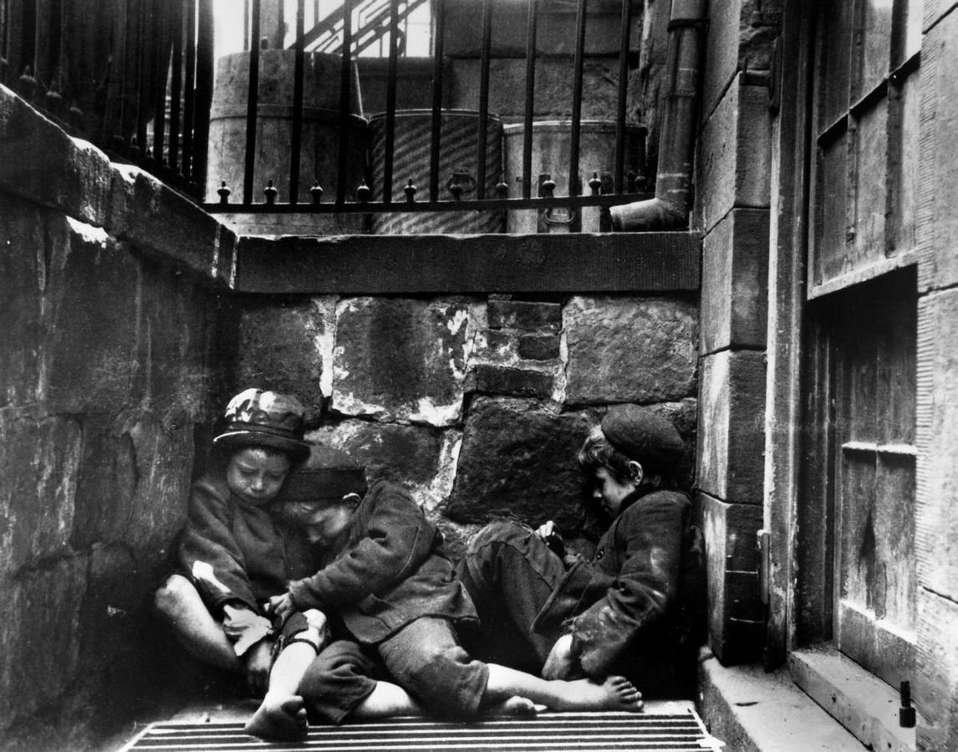
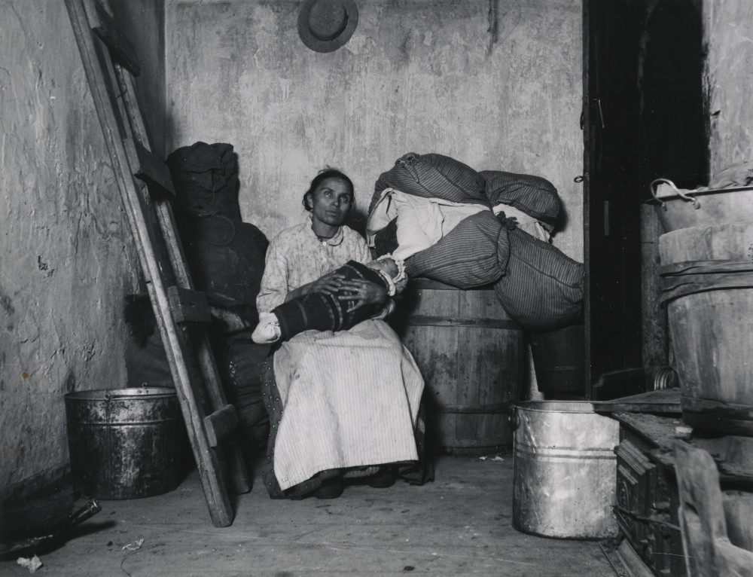
What was Jacob Riis trying to accomplish with his photographs? How do you think he wanted viewers to feel about the people in his photographs?
__________________________________________________________________________________________

__________________________________________________________________________________________

__________________________________________________________________________________________

__________________________________________________________________________________________

__________________________________________________________________________________________

__________________________________________________________________________________________

__________________________________________________________________________________________

__________________________________________________________________________________________

Describe wealth inequality during the Progressive Era. What were the causes? How did wealth inequality impact the lives of people in the United States?
__________________________________________________________________________________________

__________________________________________________________________________________________

__________________________________________________________________________________________

__________________________________________________________________________________________

__________________________________________________________________________________________

__________________________________________________________________________________________

__________________________________________________________________________________________

__________________________________________________________________________________________

__________________________________________________________________________________________

__________________________________________________________________________________________

__________________________________________________________________________________________

__________________________________________________________________________________________

Source G: “The Protectors of Our Industries”
by Puck, 1883

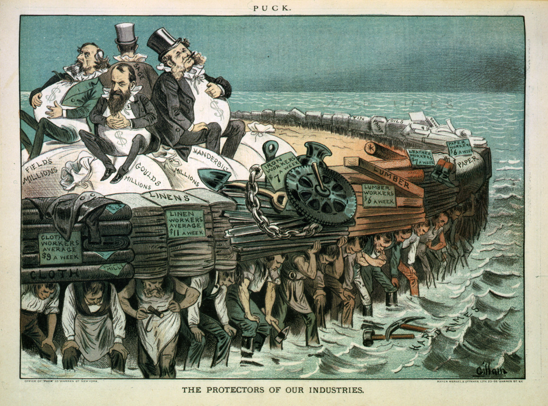
In this political cartoon of the Gilded Age, robber barons Cyrus Field, Jay Gould, Cornelius Vanderbilt, and Russell Sage are depicted on a raft made of the goods typically processed in factories during the industrial age in the United States: paper, lumber, and cloth. The people underneath the raft represent factory workers.

How does the political cartoon “The Protectors of Our Industries” depict how workers were treated during the Gilded Age? Does the cartoonist believe this is fair? Use specific details from the cartoon to support your answer.

__________________________________________________________________________________________

__________________________________________________________________________________________

__________________________________________________________________________________________

__________________________________________________________________________________________

__________________________________________________________________________________________

Source H: ”Targeting the Trusts”
Text | Vocabulary | Guiding Questions
In the late nineteenth and early twentieth centuries, a trust was a monopoly or cartel associated with the large corporations of the Gilded and Progressive Eras who entered into agreements—legal or otherwise—or consolidations to exercise exclusive control over a specific product or industry under the control of a single entity. Certain types of monopolies, specifically for intellectual property like copyrights, patents, trademarks, and trade secrets, are protected under the Constitution “to promote the progress of science and useful arts,” but for powerful entities to control entire national markets was something wholly new, and, for many Americans, wholly unsettling.  The rapid industrialization, technological advancement, and urban growth of the 1870s and 1880s triggered major changes in the way businesses structured themselves. The Second Industrial Revolution, made possible by available natural resources, growth in the labor supply through immigration, increasing capital, new legal economic entities, novel production strategies, and a growing national market, was commonly asserted to be the natural product of the federal government’s laissez faire, or “hands off,” economic policy. An unregulated business climate, the argument went, allowed for the growth of major trusts, most notably Andrew Carnegie’s Carnegie Steel (later consolidated with other producers as U.S. Steel) and John D. Rockefeller’s Standard Oil Company. Each displayed the vertical and horizontal integration strategies common to the new trusts: Carnegie first used vertical integration by controlling every phase of business (raw materials, transportation, manufacturing, distribution), and Rockefeller adhered to horizontal integration by buying out competing refineries. Once dominant in a market, critics alleged, the trusts could artificially inflate prices, bully rivals, and bribe politicians. | consolidations:  process by which multiple entities combine into one  unregulated: without government rules or regulations | What is a trust?  _______________________________  _______________________________  _______________________________  _______________________________  _______________________________  _______________________________  _______________________________  Why were trusts considered unfair?  _______________________________  _______________________________  _______________________________  _______________________________  _______________________________  _______________________________  _______________________________  _______________________________  _______________________________  _______________________________

Source I: “The Bosses of the Senate”
by Puck, 1889

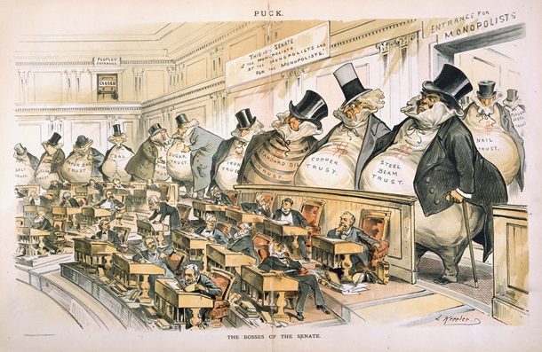

This political cartoon depicts the U.S. Senate, with large men standing behind senators labelled: Steel Beam Trust, Copper Trust, and Standard Oil Trust. They enter the Senate through a door labelled “Entrance for Monopolists.” In the top right corner of the Senate chamber, there is a small locked door labelled “People’s Entrance.”

How does the political cartoon “The Bosses of the Senate” depict who held political power during the Gilded Age? Does the cartoonist believe this is fair? Use specific details from the cartoon to support your answer.

__________________________________________________________________________________________

__________________________________________________________________________________________

__________________________________________________________________________________________

__________________________________________________________________________________________

__________________________________________________________________________________________

Lesson 3
Supporting Question 1: What issues were facing society at the end of the Gilded Age?
Student Directions | Read Source J: “Social Justice” and answer the questions in the column on the right.  Study Source K: Lewis Hine's Photographs and then answer the questions under the images.  Read Source L: Jane Addams, “The Subjective Necessity for Social Settlements” (1892)  Read Source M: “Women’s Movements” and answer the questions in the column on the right.  Read Source N: “Leaders Emerge in the Early Civil Rights Movement” and answer the questions in the column on the right.  Study Source O: “The first picket line - College day in the picket line” and answer the question under the images.  Then, using the sources from lessons 2 and 3, identify and describe three problems facing society at the end of the Gilded Age.
Featured Sources | Source J: “Social Justice”  Source K: Lewis Hine's Photographs  Source L: Jane Addams, “The Subjective Necessity for Social Settlements” (1892)  Source M: “Women’s Movements”  Source N: “Leaders Emerge in the Early Civil Rights Movement”  Source O: “The first picket line - College day in the picket line”

Source J: “Social Justice”
Text | Vocabulary | Guiding Questions
The Progressives’ work towards social justice took many forms. In some cases, it was focused on those who suffered due to pervasive inequality, such as African Americans, other ethnic groups, and women. In others, the goal was to help those who were in desperate need due to circumstance, such as poor immigrants from southern and eastern Europe who often suffered severe discrimination, the working poor, and those with ill health. Women were in the vanguard of social justice reform. Jane Addams, Lillian Wald, and Ellen Gates Starr, for example, led the settlement house movement of the 1880s. Their work to provide social services, education, and health care to working-class women and their children was among the earliest Progressive grassroots efforts in the country. | social justice: fairness in society  vanguard: leading the way  grassroots: from the people | Describe the conditions people were facing that made Progressive Era reformers such as Jane Addams take action.  _______________________________  _______________________________  _______________________________  _______________________________  _______________________________  _______________________________

Lewis Hine was a photojournalist and muckraker. Below are two examples of his photographs.
Source K: Lewis Hine's Photographs
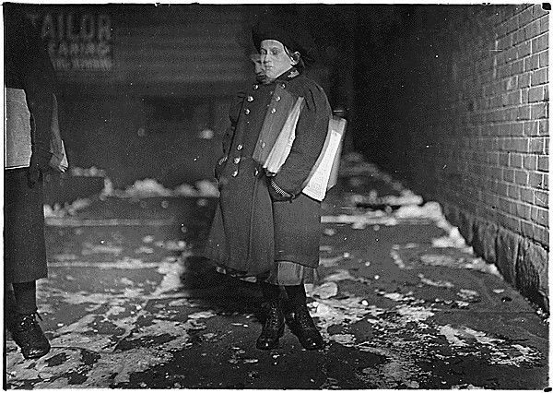
A nine- year- old newsgirl. She sold later than 8 P.M. sometimes. Been selling two years. Hartford, Conn.

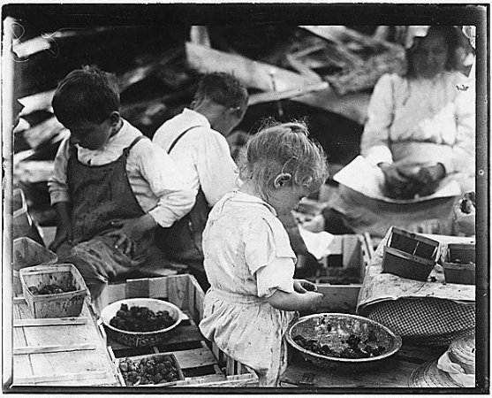
Three-year old and two boys hulling berries at Johnson's Canning Camp. Seaford, Del

Describe the workers in the images in Source K. What problem in society was Lewis Hine exposing using photography?

__________________________________________________________________________________________________

__________________________________________________________________________________________________

__________________________________________________________________________________________________

__________________________________________________________________________________________________

__________________________________________________________________________________________________

__________________________________________________________________________________________________

Note: Hull House, Chicago’s famed “settlement house,” was designed to uplift urban populations. Here, Jane Addams explains why she believes reformers must “add the social function to democracy.” In her writing, Jane Addams uses terms that were commonly used in the 19th century but are outdated now, such as “negro.”

Source L: Jane Addams, “The Subjective Necessity for Social Settlements” (1892)
Text | Vocabulary | Guiding Questions
It is not difficult to see that although America is pledged to the democratic ideal, the view of democracy has been partial, and that its best achievement thus far has been pushed along the line of the franchise. Democracy has made little attempt to assert itself in social affairs. We have refused to move beyond the position of its eighteenth-century leaders, who believed that political equality alone would secure all good to all men. We conscientiously followed the gift of the ballot hard upon the gift of freedom to the negro, but we are quite unmoved by the fact that he lives among us in a practical social ostracism. We hasten to give the franchise to the immigrant from a sense of justice, from a tradition that he ought to have it, while we dub him with epithets deriding his past life or present occupation . . .  . . . Our consciences are becoming tender in regard to the lack of democracy in social affairs. We are perhaps entering upon the second phase of democracy. . . . The social organism has broken down through large districts of our great cities. Many of the people living there are very poor, the majority of them without leisure or energy for anything but the gain of subsistence. . . . Practically nothing is done to remedy this. . . . Their ideas and resources are cramped. The desire for higher social pleasure is extinct. They have no share in the traditions and social energy which make for progress. Too often their only place of meeting is a saloon, their only host a bartender; a local demagogue forms their public opinion. Men of ability and refinement, of social power and university cultivation, stay away from them. Personally, I believe the men who lose most are those who thus stay away. But the paradox is here: when cultivated people do stay away from a certain portion of the population, when all social advantages are persistently withheld, it may be for years, the result itself is pointed at as a reason, is used as an argument, for the continued withholding. | franchise: right to vote  ostracism: exclusion from a group  epithets: names  deriding: expressing contempt or ridicule  subsistence: minimum needed for survival  demagogue: leader who appeals to prejudices to gain support | According to Jane Addams, how has the United States defined equality for African Americans and immigrants? Does she think this is sufficient?  _______________________________  _______________________________  _______________________________  _______________________________  _______________________________  _______________________________  _______________________________  _______________________________  According to Addams, how are the poor, including immigrants, treated by elites in the United States?  _______________________________  _______________________________  _______________________________  _______________________________  _______________________________  _______________________________  _______________________________  _______________________________

Source M: “Women’s Movements”
Text | Vocabulary | Guiding Questions
Many American reformers associated alcohol with nearly every social ill. Alcohol was blamed for domestic abuse, poverty, crime, and disease. The 1912 Anti-Saloon League Yearbook, for instance, presented charts indicating comparable increases in alcohol consumption alongside rising divorce rates. The WCTU called alcohol a “home wrecker.” More insidiously, perhaps, reformers also associated alcohol with cities and immigrants, necessarily maligning America’s immigrants, Catholics, and working classes in their crusade against liquor. Still, reformers believed that the abolition of “strong drink” would bring about social progress, obviate the need for prisons and insane asylums, save women and children from domestic abuse, and usher in a more just, progressive society. | consumption: use, ingestion  insidiously: harmful | What societal ills was the consumption of alcohol associated with? What were the anti-immigrant assumptions underpinning this reasoning?  ____________________________  ____________________________  ____________________________  ____________________________  ____________________________  ____________________________  ____________________________  ____________________________

Source N: ”Leaders Emerge in the Early Civil Rights Movement”
Text | Vocabulary | Guiding Questions
Racial mob violence against African Americans permeated much of the “New South”—and, to a lesser extent, the West, where Mexican Americans and other immigrant groups also suffered severe discrimination and violence—by the late nineteenth century. The Ku Klux Klan and a system of Jim Crow laws governed much of the South. White middle-class reformers were appalled at the violence of race relations in the nation but typically shared the belief in racial characteristics and the superiority of Anglo-Saxon whites over African Americans, Asians, “ethnic” Europeans, Indians, and Latin American populations. Southern reformers considered segregation a Progressive solution to racial violence; across the nation, educated middle-class Americans enthusiastically followed the work of eugenicists who identified virtually all human behavior as inheritable traits and issued awards at county fairs to families and individuals for their “racial fitness.” It was against this tide that African American leaders developed their own voice in the Progressive Era, working along diverse paths to improve the lives and conditions of African Americans throughout the country. | permeated: spread throughout  Anglo-Saxon: imprecise term used to describe people of English descent; often used to invoke prejudice  eugenicists: advocates for controlled selective breeding, as by the sterilization of individuals deemed "unfit to reproduce"; later practiced by the Nazi regime during the Holocaust; associated with white supremacist ideology | Describe some problems African-Americans faced during the Progressive era.  _______________________________  _______________________________  _______________________________  _______________________________  _______________________________  _______________________________  _______________________________  _______________________________  _______________________________  _______________________________  _______________________________  _______________________________  _______________________________  _______________________________  _______________________________  _______________________________  _______________________________  _______________________________
Source O: “The first picket line - College day in the picket line”
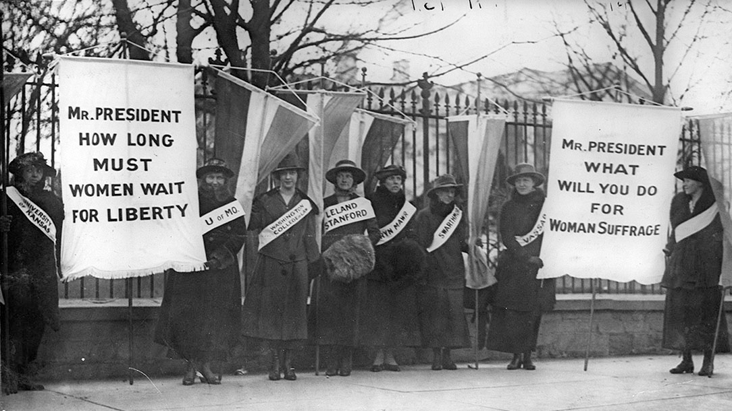
Women protested silently in front of the White House for over two years before the passage of the Nineteenth Amendment. Here, women represent their colleges as they picket the White House in support of women’s suffrage. 1917. Library of Congress (LC-USZ62-31799).

What was one issue women faced at the end of the Gilded Age?

__________________________________________________________________________________________________

__________________________________________________________________________________________________

Formative Performance Task #1 – Constructed Response
Student Directions | Using the sources from lessons 2 and 3, identify and describe three problems facing society at the end of the Gilded Age.
________________________________________________________________________________________
________________________________________________________________________________________
________________________________________________________________________________________
________________________________________________________________________________________
________________________________________________________________________________________
________________________________________________________________________________________
________________________________________________________________________________________
________________________________________________________________________________________
________________________________________________________________________________________
________________________________________________________________________________________
________________________________________________________________________________________
________________________________________________________________________________________
________________________________________________________________________________________

Lesson 4
Supporting Question 2: How did Progressive reformers attempt to improve society?
Student Directions | Read Source P: “The Muckrakers” and answer the questions in the column on the right.  Read Source Q: “Killing the Messenger: Ida Wells-Barnett Protests a Postmaster’s Murder in 1898” and answer the questions in the column on the right.  Read Source R: The Jungle by Upton Sinclair and answer the questions below the text.  Read Source S: The History of the Standard Oil Company, Ida Tarbell, 1904, Chapter 10 and answer the questions in the column on the right.
Featured Sources | Source P: “The Muckrakers”  Source Q: “Killing the Messenger: Ida Wells-Barnett Protests a Postmaster’s Murder in 1898”  Source R: The Jungle by Upton Sinclair  Source S: The History of the Standard Oil Company, Ida Tarbell, 1904, Chapter 10

Source P: “The Muckrakers”
Text | Vocabulary | Guiding Questions
A group of journalists and writers collectively known as muckrakers provided an important spark that ignited the Progressive movement. . . Muckrakers exposed problems in American society and urged the public to identify solutions. Whether those problems were associated with corrupt machine politics, poor working conditions in factories, or the questionable living conditions of the working class (among others), muckrakers shined a light on the problem and provoked outraged responses from Americans. President Theodore Roosevelt knew many of these investigative journalists well and considered himself a Progressive. Yet, unhappy with the way they forced agendas into national politics, he was the one who first gave them the disparaging nickname “muckrakers,” invoking an ill-spirited character obsessed with filth from The Pilgrim’s Progress, a 1678 Christian allegory written by John Bunyan.  Beginning in the second half of the nineteenth century, these Progressive journalists sought to expose critical social problems and exhort the public to take action. In his book How the Other Half Lives (1890), journalist and photographer Jacob Riis used photojournalism to capture the dismal and dangerous living conditions in working-class tenements in New York City. Ida Tarbell, perhaps the most well-known female muckraker, wrote a series of articles on the dangers of John D. Rockefeller’s powerful monopoly, Standard Oil.  Her articles followed Henry Demarest Lloyd’s book, Wealth Against Commonwealth, published in 1894, which examined the excesses of Standard Oil. Other writers, like Lincoln Steffens, explored corruption in city politics, or, like Ray Standard Baker, researched unsafe working conditions and low pay in the coal mines.  The work of the muckrakers not only revealed serious problems in American society, but also agitated, often successfully, for change. Their articles, in magazines such as McClure’s as well as books, garnered attention for issues such as child labor, anti-trust, big business break-ups, and health and safety. Progressive activists took up these causes and lobbied for legislation to address some of the ills troubling industrial America. | exhort: encourage  tenements: urban apartment buildings that were overcrowded and unsanitary | Define muckraker. What were they trying to achieve?  ________________________________  ________________________________  ________________________________  ________________________________  ________________________________  ________________________________  ________________________________  How did muckrakers' writings and photos affect American society?  ________________________________  ________________________________  ________________________________  What was the problem that Ida Tarbell tried to expose?  ________________________________  ________________________________  ________________________________  What was the problem that Lincoln Steffens tried to expose?  ________________________________  ________________________________  ________________________________  What was the problem that Ray Standard Baker tried to expose?  ________________________________  ________________________________  ________________________________  ________________________________

*Note: Sources Q, R, and S below are examples of muckraking journalists.

Source Q: “Killing the Messenger: Ida Wells-Barnett Protests a Postmaster’s Murder in 1898”
Text | Vocabulary | Guiding Questions
The prevalence of lynchings of Black Americans across the South led to a national anti-lynching movement. Ida B. Wells-Barnett, a journalist, newspaper editor, and outspoken advocate, led anti-lynching efforts. Wells-Barnett joined a group of Illinois congressmen who visited the White House in March, 1898, to protest the murder of a Black postmaster from South Carolina. The writing below is her petition to President McKinley to urge punishment for those responsible for the postmaster’s shooting.  Mr. President, the colored citizens of this country in general, and Chicago in particular, desire to respectfully urge that some action be taken by you as chief magistrate of this great nation, first for the apprehension and punishment of the lynchers of Postmaster Baker, of Lake City, S.C.; second, we ask indemnity for the widow and children, both for the murder of the husband and father, and for injuries sustained by themselves; third, we most earnestly desire that national legislation be enacted for the suppression of the national crime of lynching.  For nearly twenty years lynching crimes, which stand side by side with Armenian and Cuban outrages, have been committed and permitted by this Christian nation. Nowhere in the civilized world save the United States of America do men, possessing all civil and political power, go out in bands of 50 and 5,000 to hunt down, shoot, hang or burn to death a single individual, unarmed and absolutely powerless. Statistics show that nearly 10,000 American citizens have been lynched in the past 20 years. To our appeals for justice the stereotyped reply has been that the government could not interfere in a state matter. Postmaster Baker’s case was a federal matter, pure and simple. He died at his post of duty in defense of his country’s honor, as truly as did ever a soldier on the field of battle. We refuse to believe this country, so powerful to defend its citizens abroad, is unable to protect its citizens at home. Italy and China have been indemnified by this government for the lynching of their citizens. We ask that the government do as much for its own. | lynchings: killings (often racially motivated) for an alleged offence without a legal trial as a means of social control; usually enacted by mobs  indemnified: compensated | What problem in society was Ida Wells-Barnett fighting against?  ________________________________  ________________________________  What did Ida Wells-Barnett want from President McKinley? What action did she take to achieve this?  ________________________________  ________________________________  ________________________________  ________________________________  ________________________________  ________________________________  ________________________________  ________________________________  According to Wells-Barnett, why is the lynching of Postmaster Baker a federal crime? Why is this relevant?  ________________________________  ________________________________  ________________________________  ________________________________  ________________________________  ________________________________  ________________________________  ________________________________  ________________________________  ________________________________

Source R: The Jungle by Upton Sinclair
Excerpt 1
There would be meat stored in great piles in rooms; and the water from leaky roofs would drip over it, and thousands of rats would race about on it. It was too dark in these storage places to see well, but a man could run his hand over these piles of meat and sweep off handfuls of the dried dung of rats. These rats were nuisances, and the packers would put poisoned bread out for them; they would die, and then rats, bread, and meat would go into the hoppers together. This is no fairy story and no joke; the meat would be shoveled into carts, and the man who did the shoveling would not trouble to lift out a rat even when he saw one—there were things that went into the sausage in comparison with which a poisoned rat was a tidbit. There was no place for the men to wash their hands before they ate their dinner, and so they made a practice of washing them in the water that was to be ladled into the sausage.

Using Excerpt 1, what problem in society was Upton Sinclair exposing in the meatpacking industry?
__________________________________________________________________________________________________

__________________________________________________________________________________________________

Excerpt 2
There were the men in the pickle rooms, for instance, where old Antanas had gotten his death . . . Let a man so much as scrape his finger pushing a truck in the pickle rooms, and he might have a sore that would put him out of the world; all the joints in his fingers would be eaten by the acid one by one. Of the butchers and floorsmen, the beef boners and trimmers, and all those who used knives, you could scarcely find a person who had the use of his thumb; time and time again the base of it had been slashed, till it was a mere lump of flesh against which the man pressed the knife to hold it. The hands of these men would be crisscrossed with cuts, until you could no longer pretend to count them or trace them. They would have no nails—they had worn them off pulling hides; their knuckles were swollen so that their fingers spread out like a fan.

Using Excerpt 2, what problem in society was Upton Sinclair exposing in the meatpacking industry?
__________________________________________________________________________________________________

__________________________________________________________________________________________________

Describe the actions Upton Sinclair took in order to address problems in society.
__________________________________________________________________________________________________

__________________________________________________________________________________________________

__________________________________________________________________________________________________

__________________________________________________________________________________________________

Source S: “The History of the Standard Oil Company, Ida Tarbell, 1904, Chapter 10”
Text | Vocabulary | Guiding Questions
To know every detail of the oil trade, to be able to reach at any moment its remotest point, to control even its weakest factor—this was John D. Rockefeller’s ideal of doing business. It seemed to be an intellectual necessity for him to be able to direct the course of any particular gallon of oil from the moment it gushed from the earth until it went into the lamp of a housewife. There must be nothing—nothing in his great machine he did not know to be working right. It was to complete this ideal, to satisfy this necessity, that he undertook, late in the seventies [1870s], to organize the oil markets of the world, as he had already organized oil refining and oil transporting. Mr. Rockefeller was driven to this new task of organization not only by his own curious intellect; he was driven to it by that thing so abhorrent to his mind— competition.  If, as he claimed, the oil business belonged to him, and if, as he had announced, he was prepared to refine all the oil that men would consume, it followed as a corollary that the markets of the world belonged to him. . . . |  | What issue in society was Ida Tarbell trying to expose?  ________________________________  ________________________________  ________________________________  ________________________________  ________________________________  ________________________________  ________________________________  What action did Ida Tarbell take in order to address problems in society?  ________________________________  ________________________________  ________________________________  ________________________________  ________________________________  ________________________________

Lesson 5
Supporting Question 2: How did Progressive reformers attempt to improve society?
Student Directions | Read Source T: “Women’s Movements” and answer the questions in the column on the right.  Read Source U: Susan B. Anthony: Women's Right to Vote 1873 and answer the questions in the column on the right.  Study Source V: “Pre-election suffrage parade, New York City, October 23, 1915. 20,000 women marched” and answer the question below the source using all sources from lesson 5.
Featured Sources | Source T: “Women’s Movements”  Source U: Susan B. Anthony: Women's Right to Vote 1873  Source V: “Pre-election suffrage parade, New York City, October 23, 1915. 20,000 women marched”

Source T: “Women’s Movements”
Text | Vocabulary | Guiding Questions
Reform opened new possibilities for women’s activism in American public life and gave new impetus to the long campaign for women’s suffrage. Much energy for women’s work came from female “clubs,” social organizations devoted to various purposes. Some focused on intellectual development; others emphasized philanthropic activities. Increasingly, these organizations looked outward, to their communities and to the place of women in the larger political sphere.  Women’s clubs flourished in the late nineteenth and early twentieth centuries. In the 1890s women formed national women’s club federations. Particularly significant in campaigns for suffrage and women’s rights were the General Federation of Women’s Clubs (formed in New York City in 1890) and the National Association of Colored Women (organized in Washington, D.C., in 1896), both of which were dominated by upper-middle-class, educated, northern women. Few of these organizations were biracial, a legacy of the sometimes uneasy mid nineteenth-century relationship between socially active African Americans and white women. Rising American prejudice led many white female activists to ban inclusion of their African American sisters. The segregation of black women into distinct clubs nonetheless still produced vibrant organizations that could promise racial uplift and civil rights for all blacks as well as equal rights for women.  Other women worked through churches and moral reform organizations to clean up American life. And still others worked as moral vigilantes. The fearsome Carrie A. Nation, an imposing woman who believed she worked God’s will, won headlines for destroying saloons. In Wichita, Kansas, on December 27, 1900, Nation took a hatchet and broke bottles and bars at the luxurious Carey Hotel. Arrested and charged with causing $3,000 in damages, Nation spent a month in jail before the county dismissed the charges on account of “a delusion to such an extent as to be practically irresponsible.” But Nation’s “hatchetation” drew national attention. Describing herself as “a bulldog running along at the feet of Jesus, barking at what He doesn’t like,” she continued her assaults, and days later she smashed two more Wichita bars.  Few women followed in Nation’s footsteps, and many more worked within more reputable organizations. Nation, for instance, had founded a chapter of the Woman’s Christian Temperance Union (WCTU), but the organization’s leaders described her as “unwomanly and unchristian.” The WCTU was founded in 1874 as a modest temperance organization devoted to combating the evils of drunkenness. But then, from 1879 to 1898, Frances Willard invigorated the organization by transforming it into a national political organization, embracing a “do everything” policy that adopted any and all reasonable reforms that would improve social welfare and advance women’s rights. Temperance, and then the full prohibition of alcohol, however, always loomed large.  . . .  Powerful female activists emerged out of the club movement and temperance campaigns. Perhaps no American reformer matched Jane Addams in fame, energy, and innovation. . . An idealist, Addams sought the means to make the world a better place. She believed that well-educated women of means, such as herself, lacked practical strategies for engaging everyday reform. After four years at Rockford, Addams embarked on a multiyear “grand tour” of Europe. She found herself drawn to English settlement houses, a kind of prototype for social work in which philanthropists embedded themselves among communities and offered services to disadvantaged populations. After visiting London’s Toynbee Hall in 1887, Addams returned to the United States and in 1889 founded Hull House in Chicago with her longtime confidant and companion Ellen Gates Starr.  Hull House workers provided for their neighbors by running a nursery and a kindergarten, administering classes for parents and clubs for children, and organizing social and cultural events for the community. Reformer Florence Kelley, who stayed at Hull House from 1891 to 1899, convinced Addams to move into the realm of social reform. Hull House began exposing conditions in local sweatshops and advocating for the organization of workers. She called the conditions caused by urban poverty and industrialization a “social crime.” Hull House workers surveyed their community and produced statistics on poverty, disease, and living conditions. Addams began pressuring politicians. Together Kelley and Addams petitioned legislators to pass anti-sweatshop legislation that limited the hours of work for women and children to eight per day. Yet Addams was an upper-class white Protestant woman who, like many reformers, refused to embrace more radical policies. While Addams called labor organizing a “social obligation,” she also warned the labor movement against the “constant temptation towards class warfare.” Addams, like many reformers, favored cooperation between rich and poor and bosses and workers, whether cooperation was a realistic possibility or not.  Addams became a kind of celebrity. In 1912, she became the first woman to give a nominating speech at a major party convention when she seconded the nomination of Theodore Roosevelt as the Progressive Party’s candidate for president. Her campaigns for social reform and women’s rights won headlines and her voice became ubiquitous in progressive politics.  It would be suffrage, ultimately, that would mark the full emergence of women in American public life. Generations of women—and, occasionally, men—had pushed for women’s suffrage. Suffragists’ hard work resulted in slow but encouraging steps forward during the last decades of the nineteenth century. Notable victories were won in the West, where suffragists mobilized large numbers of women and male politicians were open to experimental forms of governance. By 1911, six western states had passed suffrage amendments to their constitutions.  The final push for women’s suffrage came on the eve of World War I. Determined to win the vote, the National American Woman Suffrage Association developed a dual strategy that focused on the passage of state voting rights laws and on the ratification of an amendment to the U.S. Constitution. Meanwhile, a new, more militant, suffrage organization emerged on the scene. Led by Alice Paul, the National Woman’s Party took to the streets to demand voting rights, organizing marches and protests that mobilized thousands of women. Beginning in January 1917, National Woman’s Party members also began to picket the White House, an action that led to the arrest and imprisonment of over 150 women. Women protested silently in front of the White House for over two years before the passage of the Nineteenth Amendment. | impetus: force that makes something happen  suffrage: right to vote  reputable: respectable  temperance: prohibiting alcohol  suffragists: people working to give women the right to vote  militant: radical | Describe how women were politically active before they had the right to vote at the federal level.  ____________________________  ____________________________  ____________________________  ____________________________  ____________________________  ____________________________  ____________________________  ____________________________  ____________________________  ____________________________  Describe the women that participated in women's clubs. Were these women’s clubs progressive? Why or why not?  ____________________________  ____________________________  ____________________________  ____________________________  ____________________________  ____________________________  ____________________________  ____________________________  ____________________________  ____________________________  ____________________________  What Progressive cause was Carrie Nation fighting for? What actions did she take?  ____________________________  ____________________________  ____________________________  ____________________________  ____________________________  ____________________________  ____________________________  ____________________________  ____________________________  ____________________________  ____________________________  ____________________________  ____________________________  ____________________________  ____________________________  What kind of services did Jane Addams provide at the Hull House?  ____________________________  ____________________________  ____________________________  ____________________________  ____________________________  ____________________________  ____________________________  ____________________________  Which Progressive reforms did Jane Addams focus on outside of the Hull House?  ____________________________  ____________________________  ____________________________  ____________________________  ____________________________  ____________________________  ____________________________  ____________________________  ____________________________  ____________________________  Describe the tactics used by suffragists to gain the right to vote for women.  ____________________________  ____________________________  ____________________________  ____________________________  ____________________________  ____________________________  ____________________________  ____________________________  ____________________________  ____________________________  ____________________________  ____________________________  Which amendment to the Constitution gave women the right to vote?  ____________________________

*Note: Susan B. Anthony was one of the most well-known suffragists. This speech was delivered after she was arrested for voting in the presidential election of 1872.

Source U: Susan B. Anthony: Women's Right to Vote 1873
Text | Vocabulary | Guiding Questions
“We, the people of the United States, in order to form a more perfect union, establish justice, insure domestic tranquility, provide for the common defense, promote the general welfare, and secure the blessings of liberty to ourselves and our posterity, do ordain and establish this Constitution for the United States of America.”  It was we, the people; not we, the white male citizens; nor yet we, the male citizens; but we, the whole people, who formed the Union. And we formed it, not to give the blessings of liberty, but to secure them; not to the half of ourselves and the half of our posterity, but to the whole people —women as well as men. And it is a downright mockery to talk to women of their enjoyment of the blessings of liberty while they are denied the use of the only means of securing them provided by this democratic-republican government—the ballot. |  | Why does Susan B. Anthony include the Preamble to the Constitution in this speech? What point is she trying to make?  ____________________________  ____________________________  ____________________________  ____________________________  ____________________________  ____________________________  ____________________________  Describe the actions Susan B. Anthony took in order to achieve her Progressive goals.  ____________________________  ____________________________  ____________________________  ____________________________  ____________________________

Source V: “Pre-election suffrage parade, New York City, October 23, 1915. 20,000 women marched”
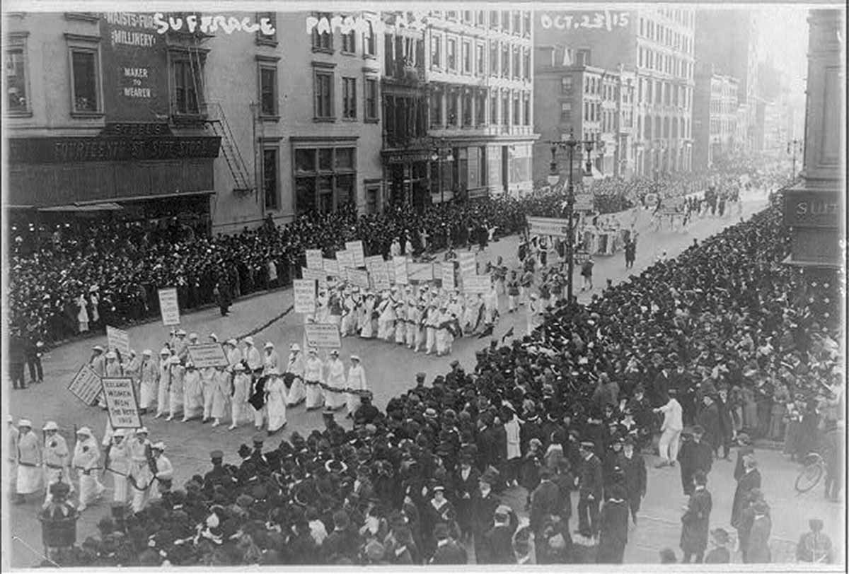
Suffragists campaigned tirelessly for the vote in the first two decades of the twentieth century, taking to the streets in public displays like this 1915 pre-election parade in New York City. During this one event, 20,000 women defied the gender norms that tried to relegate them to the private sphere and deny them the vote.
After you read:
How did women participate in the Progressive movement? How did they want to improve society? Describe their actions.
__________________________________________________________________________________________
__________________________________________________________________________________________
__________________________________________________________________________________________
__________________________________________________________________________________________
__________________________________________________________________________________________
Lesson 6
Supporting Question 2: How did Progressive reformers attempt to improve society?
Student Directions | Read Source W: “Leaders Emerge in the Early Civil Rights Movement” and answer the questions in the column on the right.  Read Source X: “The Atlanta Compromise” by Booker T. Washington and answer the questions in the column on the right.  Read Source Y: The Souls of Black Folk by W. E. B. Dubois and answer the questions in the column on the right.
Featured Sources | Source W: “Leaders Emerge in the Early Civil Rights Movement”  Source X: “The Atlanta Compromise” by Booker T. Washington  Source Y: The Souls of Black Folk by W. E. B. Dubois

Source W: “Leaders Emerge in the Early Civil Rights Movement”
Text | Vocabulary | Guiding Questions
Born into slavery in Virginia in 1856, Booker T. Washington became an influential African American leader at the outset of the Progressive Era. In 1881, he became the first principal for the Tuskegee Normal and Industrial Institute in Alabama, a position he held until he died in 1915. Tuskegee was an all-Black “normal school”—an old term for a teachers’ college—teaching African Americans a curriculum geared towards practical skills such as cooking, farming, and housekeeping. Graduates would often then travel through the South, teaching new farming and industrial techniques to rural communities. Washington extolled the school’s graduates to focus on the black community’s self-improvement and prove that they were productive members of society even in freedom—something white Americans throughout the nation had always doubted.  In a speech delivered at the Cotton States and International Exposition in Atlanta in 1895, which was meant to promote the economy of a “New South,” Washington proposed what came to be known as the Atlanta Compromise. Speaking to a racially mixed audience, Washington called upon African Americans to work diligently for their own uplift and prosperity rather than preoccupy themselves with political and civil rights. Their success and hard work, he implied, would eventually convince southern whites to grant these rights. Not surprisingly, most whites liked Washington’s model of race relations, since it placed the burden of change on blacks and required nothing of them. Wealthy industrialists such as Andrew Carnegie and John D. Rockefeller provided funding for many of Washington’s self-help programs, as did Sears, Roebuck & Co. co-founder Julius Rosenwald, and Washington was the first African American invited to the White House by President Roosevelt in 1901. At the same time, his message also appealed to many in the black community, and some attribute this widespread popularity to his consistent message that social and economic growth, even within a segregated society, would do more for African Americans than an all-out agitation for equal rights on all fronts.  Yet, many African Americans disagreed with Washington’s approach. Much in the same manner that Alice Paul felt the pace of the struggle for women’s rights was moving too slowly under the NAWSA, some within the African American community felt that immediate agitation for the rights guaranteed under the Thirteenth, Fourteenth, and Fifteenth Amendments, established during the immediate aftermath of the Civil War, was necessary. In 1905, a group of prominent civil rights leaders, led by W. E. B. Du Bois, met in a small hotel on the Canadian side of Niagara Falls—where segregation laws did not bar them from hotel accommodations—to discuss what immediate steps were needed for equal rights. Du Bois, a professor at the all-black Atlanta University and the first African American with a doctorate from Harvard, emerged as the prominent spokesperson for what would later be dubbed the Niagara Movement. By 1905, he had grown wary of Booker T. Washington’s calls for African Americans to accommodate white racism and focus solely on self-improvement. Du Bois, and others alongside him, wished to carve a more direct path towards equality that drew on the political leadership and litigation skills of the black, educated elite, which he termed the “talented tenth.”  At the meeting, Du Bois led the others in drafting the “Declaration of Principles,” which called for immediate political, economic, and social equality for African Americans. These rights included universal suffrage, compulsory education, and the elimination of the convict lease system in which tens of thousands of blacks had endured slavery-like conditions in southern road construction, mines, prisons, and penal farms since the end of Reconstruction. Within a year, Niagara chapters had sprung up in twenty-one states across the country. By 1908, internal fights over the role of women in the fight for African American equal rights lessened the interest in the Niagara Movement. But the movement laid the groundwork for the creation of the National Association for the Advancement of Colored People (NAACP), founded in 1909. Du Bois served as the influential director of publications for the NAACP from its inception until 1933. As the editor of the journal The Crisis, Du Bois had a platform to express his views on a variety of issues facing African Americans in the later Progressive Era, as well as during World War I and its aftermath.  In both Washington and Du Bois, African Americans found leaders to push forward the fight for their place in the new century, each with a very different strategy. Both men cultivated ground for a new generation of African American spokespeople and leaders who would then pave the road to the modern civil rights movement after World War II. |  | What problems did African Americans face during the Progressive Era?  _______________________________  _______________________________  _______________________________  _______________________________  _______________________________  _______________________________  _______________________________  _______________________________  _______________________________  _______________________________  ___________________________  _______________________________  _______________________________  _______________________________  _______________________________  _______________________________  Describe Booker T. Washington's views on how African Americans should improve their place in society. Why were many whites receptive to his message? How were his views problematic?  _______________________________  _______________________________  _______________________________  _______________________________  _______________________________  _______________________________  _______________________________  _______________________________  _______________________________  _______________________________  _______________________________  _______________________________  _______________________________  _______________________________  _______________________________  _______________________________  _______________________________  _______________________________  Why did W. E. B. Du Bois disagree with Washington? How did his plan for improving the lives of African Americans differ from Washington’s?  _______________________________  _______________________________  _______________________________  _______________________________  _______________________________  _______________________________  _______________________________  _______________________________  _______________________________  _______________________________
*Note: In their writing, Booker T. Washington and W. E. B. Dubois use terms that were commonly used in the 19th century but are outdated now, such as “negro.”

Source X: “The Atlanta Compromise” by Booker T. Washington
Text | Vocabulary | Guiding Questions
A ship lost at sea for many days suddenly sighted a friendly vessel. From the mast of the unfortunate vessel was seen a signal, “Water, water; we die of thirst!” The answer from the friendly vessel at once came back, “Cast down your bucket where you are.” A second time the signal, “Water, water; send us water!” ran up from the distressed vessel, and was answered, “Cast down your bucket where you are.” And a third and fourth signal for water was answered, “Cast down your bucket where you are.” The captain of the distressed vessel, at last heading the injunction, cast down his bucket, and it came up full of fresh, sparkling water from the mouth of the Amazon River. To those of my race who depend on bettering their condition in a foreign land or who underestimate the importance of cultivating friendly relations with the Southern white man, who is their next-door neighbour, I would say: “Cast down your bucket where you are” — cast it down in making friends in every manly way of the people of all races by whom we are surrounded.  Cast it down in agriculture, mechanics, in commerce, in domestic service, and in the professions. And in this connection it is well to bear in mind that whatever other sins the South may be called to bear, when it comes to business, pure and simple, it is in the South that the Negro is given a man’s chance in the commercial world, and in nothing is this Exposition more eloquent than in emphasizing this chance. Our greatest danger is that in the great leap from slavery to freedom we may overlook the fact that the masses of us are to live by the productions of our hands, and fail to keep in mind that we shall prosper in proportion as we learn to dignify and glorify common labour and put brains and skill into the common occupations of life; shall prosper in proportion as we learn to draw the line between the superficial and the substantial, the ornamental gewgaws [sic] of life and the useful. No race can prosper till it learns that there is as much dignity in tilling a field as in writing a poem. It is at the bottom of life we must begin, and not at the top. Nor should we permit our grievances to overshadow our opportunities.  . . .  The wisest among my race understand that the agitation of questions of social equality is the extremest folly, and that progress in the enjoyment of all the privileges that will come to us must be the result of severe and constant struggle rather than of artificial forcing. No race that has anything to contribute to the markets of the world is long in any degree ostracized [sic]. It is important and right that all privileges of the law be ours, but it is vastly more important that we be prepared for the exercises of these privileges. The opportunity to earn a dollar in a factory just now is worth infinitely more than the opportunity to spend a dollar in an opera-house.  . . . | injunction: warning | What does Booker T. Washington mean when he says that “those of my race” should “cast down your bucket where you are?” What does Washington want African Americans to do?  ________________________________  ________________________________  ________________________________  ________________________________  ________________________________  ________________________________  ________________________________  ________________________________  ________________________________  ________________________________  What kind of employment does Washington want African Americans to have? What is his justification for this?  ________________________________  ________________________________  ________________________________  ________________________________  ________________________________  ________________________________  ________________________________  ________________________________  ________________________________  ________________________________  How does Washington explain the rationale behind his economically- focused approach?  ________________________________  ________________________________  ________________________________  ________________________________  ________________________________  ________________________________  ________________________________  ________________________________  ________________________________

Source Y: The Souls of Black Folk by W. E. B. Dubois
Text | Vocabulary | Guiding Questions
Easily the most striking thing in history of the American Negro since 1876 is the ascendancy of Mr. Booker T. Washington. . . . Mr. Washington represents in Negro thought the old attitude of adjustment and submission; but adjustment at such a peculiar time as to make his programme unique. This is an age of unusual economic development, and Mr. Washington’s programme naturally takes an economic cast, becoming a gospel of Work and Money to such an extent as apparently almost completely to overshadow the higher aims of life. Moreover, this is an age when the more advanced races are coming in closer contact with the less developed races, and the race-feeling is therefore intensified; and Mr. Washington’s programme practically accepts the alleged inferiority of the Negro races. Again, in our own land, the reaction from the sentiment of war time has given impetus to race-prejudice against Negroes, and Mr. Washington withdraws many of the high demands of Negroes as men and American citizens. In other periods of intensified prejudice all the Negro’s tendency to self-assertion has been called forth; at this period a policy of submission is advocated. In the history of nearly all other races and peoples the doctrine preached at such crises has been that manly self-respect is worth more than lands and houses, and that a people who voluntarily surrender such respect, or cease striving for it, are not worth civilizing.  In answer to this, it has been claimed that the Negro can survive only through submission. Mr. Washington distinctly asks that black people give up, at least for the present, three things, —  First, political power,  Second, insistence on civil rights,  Third, higher education of Negro youth,–  and concentrate all of their energies on industrial education, the accumulation of wealth, and the conciliation of the South. This policy has been courageously and insistently advocated for over fifteen years, and has been triumphant for perhaps ten years. As a result of this tender of the palm-beach, what has been the return? In these years there have occurred:  The disfranchisement of the Negro.  The legal creation of a distinct status of civil inferiority for the Negro.  The steady withdrawal of aid from institutions for the higher training of the Negro.  These movements are not, to be sure, direct results of Mr. Washington’s teachings; but his propaganda has, without a shadow of doubt, helped their speedier accomplishment. The question then comes: Is it possible, and probable, that nine millions of men can make effective progress in economic lines if they are deprived of political rights, made a servile caste, and allowed only the most meager chance for developing their exceptional men? If history and reason give any distinct answer to these questions, it is an emphatic No. | gospel: principles or beliefs  propaganda: information represented in a biased or misleading way  caste: social class based on hereditary characteris-tics | According to Du Bois, what does Washington value more than the “higher aims of life”? What does Du Bois mean by “higher aims of life”?  ________________________________  ________________________________  ________________________________  ________________________________  ________________________________  ________________________________  ________________________________  ________________________________  ________________________________  ________________________________  In your own words, describe Du Bois’ criticism of Washington’s approach.  ________________________________  ________________________________  ________________________________  ________________________________  ________________________________  ________________________________  ________________________________  ________________________________  ________________________________  ________________________________  ________________________________  ________________________________  ________________________________  ________________________________  ________________________________  ________________________________  What evidence does Du Bois provide to show that Washington's approach has not been effective?  ________________________________  ________________________________  ________________________________  ________________________________  ________________________________

After you read:
How did Booker T. Washington and W. E. B. Dubois each want to improve society? How were their approaches different?
__________________________________________________________________________________________

__________________________________________________________________________________________

__________________________________________________________________________________________

__________________________________________________________________________________________

__________________________________________________________________________________________

__________________________________________________________________________________________

__________________________________________________________________________________________

Formative Performance Task #2 – Constructed Response
Student Directions | Using the sources from lessons 4, 5, and 6, identify and describe three actions Progressive reformers took to improve society.
________________________________________________________________________________________

________________________________________________________________________________________

________________________________________________________________________________________

________________________________________________________________________________________

________________________________________________________________________________________

________________________________________________________________________________________

________________________________________________________________________________________

________________________________________________________________________________________

________________________________________________________________________________________

________________________________________________________________________________________

________________________________________________________________________________________

________________________________________________________________________________________

________________________________________________________________________________________

________________________________________________________________________________________

________________________________________________________________________________________

________________________________________________________________________________________

________________________________________________________________________________________

Lesson 7
Supporting Question 3: What Progressive reforms did the local, state, and federal governments enact?
Student Directions | Read Source Z: “Progressivism in the Grassroots Level” and answer questions in the right column.  Read Source AA: “18th and 19th Amendment to the United States Constitution” and answer questions in the right column.  Then, begin adding information to the chart at the end of lesson 8.
Featured Sources | Source Z: “Progressivism at the Grassroots Level”  Source AA: 18th and 19th Amendment to the United States Constitution

Source Z: “Progressivism at the Grassroots Level”
Text | Vocabulary | Guiding Questions
Expanding Democracy  One of the key ideals that Progressives considered vital to the growth and health of the country was the concept of a perfected democracy. They felt, quite simply, that Americans needed to exert more control over their government. This shift, they believed, would ultimately lead to a system of government that was better able to address the needs of its citizens. Grassroots Progressives pushed forward their agenda of direct democracy through the passage of three state-level reforms.  The first law involved the creation of the direct primary. Prior to this time, the only people who had a hand in selecting candidates for elections were delegates at conventions. Direct primaries allowed party members to vote directly for a candidate, with the nomination going to the one with the most votes. This was the beginning of the current system of holding a primary election before a general election. South Carolina adopted this system for statewide elections in 1896; in 1901, Florida became the first state to use the direct primary in nominations for the presidency. It is the method currently used in three-quarters of U.S. states.  Another series of reforms pushed forward by Progressives that sought to sidestep the power of special interests in state legislatures and restore the democratic political process were three election innovations—the initiative, referendum, and recall. The first permitted voters to enact legislation by petitioning to place an idea, or initiative, on the ballot. In 1898, South Dakota became the first state to allow initiatives to appear on a ballot. By 1920, twenty states had adopted the procedure. The second innovation allowed voters to counteract legislation by holding a referendum—that is, putting an existing law on the ballot for voters to either affirm or reject. Currently twenty-four states allow some form of initiative and referendum. The third element of this direct democracy agenda was the recall. The recall permitted citizens to remove a public official from office through a process of petition and vote, similar to the initiative and referendum. While this measure was not as widely adopted as the others, Oregon, in 1910, became the first state to allow recalls. By 1920, twelve states had adopted this tool. It has only been used successfully a handful of times on the statewide level, for example, to remove the governor of North Dakota in 1921, and, more recently, the governor of California in 2003.  Progressives also pushed for democratic reform that affected the federal government. In an effort to achieve a fairer representation of state constituencies in the U.S. Congress, they lobbied for approval of the Seventeenth Amendment to the U.S. Constitution, which mandated the direct election of U.S. senators. The Seventeenth Amendment replaced the previous system of having state legislatures choose senators. William Jennings Bryan, the 1896 Democratic presidential candidate who received significant support from the Populist Party, was among the leading Progressives who championed this cause.  Expertise and Efficiency  In addition to making government more directly accountable to the voters, Progressives also fought to rid politics of inefficiency, waste, and corruption. Progressives in large cities were particularly frustrated with the corruption and favoritism of machine politics, which wasted enormous sums of taxpayer money and ultimately stalled the progress of cities for the sake of entrenched politicians, like the notorious Democratic Party Boss William Tweed in New York’s Tammany Hall. Progressives sought to change this corrupt system and had success in places like Galveston, Texas, where, in 1901, they pushed the city to adopt a commission system. A hurricane the previous year had led to the collapse of the old city government, which had proved incapable of leading the city through the natural disaster. The storm claimed over eight thousand lives—the highest death toll from a natural disaster in the history of the country—and afterwards, the community had no faith that the existing government could rebuild. The commission system involved the election of a number of commissioners, each responsible for one specific operation of the city, with titles like water commissioner, fire commissioner, police commissioner, and so on. With no single political “boss” in charge, the prevalence of graft and corruption greatly decreased. The commissioner system is widely used in modern cities throughout the United States. | direct democracy:  government in which the people can directly vote on laws and issues, as opposed to a representative democracy in which people elect representa-tives to pass laws  special interests: groups who lobby governments to vote for their cause  Populist Party: political party that advocated for government control of big business and help for farmers | Generally, to whom did Progressives want to give more governmental power?  ________________________________  ________________________________  ________________________________  ________________________________  ________________________________  What is the purpose of a direct primary? Was this Progressive reform successful? Why or why not?  ________________________________  ________________________________  ________________________________  ________________________________  ________________________________  Who gains more power when initiatives, referendums, and recalls are implemented? Were these Progressive reforms successful? Why or why not?  ________________________________  ________________________________  ________________________________  ________________________________  ________________________________  ________________________________  ________________________________  ________________________________  ________________________________  ________________________________  Describe how the 17th Amendment gave people more control of their government.  ________________________________  ________________________________  ________________________________  ________________________________  ________________________________  ________________________________  ________________________________  ________________________________  ________________________________  ________________________________  Describe how a natural disaster in Galveston, Texas, led to Progressive reforms in government. Describe those reforms.  ________________________________  ________________________________  ________________________________  ________________________________  ________________________________  ________________________________  ________________________________  ________________________________  ________________________________  ________________________________

Source AA: 18th and 19th Amendment to the United States Constitution
Text | Vocabulary | Guiding Questions
18th Amendment (Passed by Congress December 18, 1917. Ratified January 16, 1919. Repealed by amendment 21.)  After one year from the ratification of this article the manufacture, sale, or transportation of intoxicating liquors within, the importation thereof into, or the exportation thereof from the United States and all territory subject to the jurisdiction thereof for beverage purposes is hereby prohibited.  19th Amendment (Passed by Congress June 4, 1919. Ratified August 18, 1920.)  The right of citizens of the United States to vote shall not be denied or abridged by the United States or by any State on account of sex. | repealed: removed, erased  ratification: acceptance | How did the federal government attempt to solve the societal ills caused by alcohol use?  ________________________________  ________________________________  ________________________________  ________________________________  ________________________________  How did the federal government solve the issue of the disenfranchisement of women?  ________________________________  ________________________________  ________________________________  ________________________________  ________________________________  ________________________________  ________________________________  ________________________________  ________________________________  ________________________________

Lesson 8
Supporting Question 3: What Progressive reforms did the local, state,
and federal governments enact?
Student Directions | Read Source AB: “Progressivism in the White House” and answer the questions in the right column. Then, fill in the chart at the end of this lesson with information from the sources.
Featured Sources | Source AB: “Progressivism in the White House”
Optional Digital Extensions | Crash Course: Progressive Presidents  Roosevelt, Taft, and The Progressive Era

Source AB: “Progressivism in the White House”
Text | Vocabulary | Guiding Questions
Progressive groups made tremendous strides on issues involving democracy, efficiency, and social justice. But they found that their grassroots approach was ill-equipped to push back against the most powerful beneficiaries of growing inequality, economic concentration, and corruption—big business. In their fight against the trusts, Progressives needed the leadership of the federal government, and they found it in Theodore Roosevelt in 1901, through an accident of history.  In 1900, a sound economic recovery, a unifying victory in the Spanish-American War, and the annexation of the Philippines had helped President William McKinley secure his reelection with the first solid popular majority since 1872. His new vice president was former New York Governor and Assistant Secretary of the Navy, Theodore Roosevelt. But when an assassin shot and killed President McKinley in 1901 . . . at the Pan-American Exposition in Buffalo, New York, Theodore Roosevelt unexpectedly became the youngest president in the nation’s history. More importantly, it ushered in a new era of progressive national politics and changed the role of the presidency for the twentieth century.  Busting the Trusts  Roosevelt’s early career showed him to be a dynamic leader with a Progressive agenda. Many Republican Party leaders disliked Roosevelt’s Progressive ideas and popular appeal and hoped to end his career with a nomination to the vice presidency—long considered a dead end in politics. When an assassin’s bullet toppled this scheme, Mark Hanna, a prominent Republican senator and party leader, lamented, “Now look! That damned cowboy is now president!”  As the new president, however, Roosevelt moved cautiously with his agenda while he finished out McKinley’s term. Roosevelt kept much of McKinley’s cabinet intact, and his initial message to Congress gave only one overriding Progressive goal for his presidency: to eliminate business trusts. In the three years prior to Roosevelt’s presidency, the nation had witnessed a wave of mergers and the creation of mega-corporations. To counter this trend, Roosevelt created the Department of Commerce and Labor in 1903, which included the Bureau of Corporations, whose job it was to investigate trusts. He also asked the Department of Justice to resume prosecutions under the Sherman Antitrust Act of 1890. Intended to empower federal prosecutors to ban monopolies as conspiracies against interstate trade, the law had run afoul of a conservative Supreme Court.  In 1902, Roosevelt launched his administration’s first antitrust suit against the Northern Securities Trust Company, which included powerful businessmen, like John D. Rockefeller and J. P. Morgan, and controlled many of the large midwestern railroads. The suit wound through the judicial system, all the way to the U.S. Supreme Court. In 1904, the highest court in the land ultimately affirmed the ruling to break up the trust in a narrow five-to-four vote. For Roosevelt, that was enough of a mandate; he immediately moved against other corporations as well, including the American Tobacco Company and—most significantly—Rockefeller’s Standard Oil Company.  Although Roosevelt enjoyed the nickname “the Trustbuster,” he did not consider all trusts dangerous to the public welfare. The “good trusts,” Roosevelt reasoned, used their power in the marketplace and economies of scale to deliver goods and services to customers more cheaply. For example, he allowed Morgan’s U.S. Steel Corporation to continue its operations and let it take over smaller steel companies. At the same time, Roosevelt used the presidency as a “bully pulpit” to publicly denounce “bad trusts”—those corporations that exploited their market positions for short-term gains—before he ordered prosecutions by the Justice Department. In total, Roosevelt initiated over two dozen successful anti-trust suits, more than any president before him.  Roosevelt also showed in other contexts that he dared to face the power of corporations. When an anthracite coal strike gripped the nation for much of the year in 1902, Roosevelt directly intervened in the dispute and invited both sides to the White House to negotiate a deal that included minor wage increases and a slight improvement in working hours. For Roosevelt, his intervention in the matter symbolized his belief that the federal government should adopt a more proactive role and serve as a steward of all Americans. This stood in contrast to his predecessors, who had time and again bolstered industrialists in their fight against workers’ rights with the deployment of federal troops.  The Square Deal  Roosevelt won his second term in 1904 with an overwhelming 57 percent of the popular vote. After the election, he moved quickly to enact his own brand of Progressivism, which he called a Square Deal for the American people. Early in his second term, Roosevelt read muckraker Upton Sinclair’s 1905 novel and exposé on the meatpacking industry, The Jungle. Although Roosevelt initially questioned the book due to Sinclair’s professed Socialist leanings, a subsequent presidential commission investigated the industry and corroborated the deplorable conditions under which Chicago’s meatpackers processed meats for American consumers. Alarmed by the results and under pressure from an outraged public disgusted with the revelations, Roosevelt moved quickly to protect public health. He urged the passage of two laws to do so. The first, the Meat Inspection Act of 1906, established a system of government inspection for meat products, including grading the meat based on its quality. This standard was also used for imported meats. The second was the Pure Food and Drug Act of 1906, which required labels on all food and drug products that clearly stated the materials in the product. The law also prohibited any “adulterated” products, a measure aimed at some specific, unhealthy food preservatives. For Sinclair, this outcome was a disappointment nonetheless, since he had sought to draw attention to the plight of workers in the slaughterhouses, not the poor quality of the meat products. “I aimed at the public’s heart, and by accident I hit it in the stomach,” he concluded with frustration.  Another key element of Roosevelt’s Progressivism was the protection of public land. Roosevelt was a longtime outdoorsman, with an interest that went back to his childhood and college days, as well as his time cattle ranching in the West, and he chose to appoint his good friend Gifford Pinchot as the country’s first chief of the newly created U.S. Forestry Service. Under Pinchot’s supervision, the department carved out several nature habitats on federal land in order to preserve the nation’s environmental beauty and protect it from development or commercial use. Apart from national parks like Oregon’s Crater Lake or Colorado’s Mesa Verde, and monuments designed for preservation, Roosevelt conserved public land for regulated use for future generations. To this day, the 150 national forests created under Roosevelt’s stewardship carry the slogan “land of many uses.” In all, Roosevelt established eighteen national monuments, fifty-one federal bird preserves, five national parks, and over one hundred fifty national forests, which amounted to about 230 million acres of public land.  In his second term in office, Roosevelt signed legislation on Progressive issues such as factory inspections, child labor, and business regulation. He urged the passage of the Elkins Act of 1903 and the Hepburn Act of 1906, both of which strengthened the position of the Interstate Commerce Commission to regulate railroad prices. These laws also extended the Commission’s authority to regulate interstate transportation on bridges, ferries, and even oil pipelines.  As the 1908 election approached, Roosevelt was at the height of popularity among the American public, if not among the big businesses and conservative leaders of his own Republican Party. Nonetheless, he promised on the night of his reelection in 1904 that he would not seek a third term. Roosevelt stepped aside as the election approached, but he did hand-pick a successor—Secretary of War and former Governor General of the Philippines William Howard Taft of Ohio—a personal friend who, he assured the American public, would continue the path of the “Square Deal.” With such a ringing endorsement, Taft easily won the 1908 presidential election, defeating three-time Democratic presidential nominee William Jennings Bryan, whose ideas on taxes and corporate regulations reminded voters of the more far-reaching Populist platforms of Bryan’s past candidacies. | annexation: add a new territory to a country  suits: lawsuit  corroborated: confirmed using other evidence | How did Roosevelt become president in 1901?  ________________________________  ________________________________  ________________________________  ________________________________  ________________________________  ________________________________  ________________________________  ________________________________  ________________________________  ________________________________  Which Progressive goal did Roosevelt focus on during his first term as president? How did he try to achieve it?  ________________________________  ________________________________  ________________________________  ________________________________  ________________________________  ________________________________  ________________________________  What government body did Roosevelt need to overcome in order to pursue antitrust cases?  ________________________________  ________________________________  ________________________________  ________________________________  ________________________________  ________________________________  ________________________________  ________________________________  ________________________________  ________________________________  ________________________________  ________________________________  How many antitrust suits did Roosevelt start? Why was that significant?  ________________________________  ________________________________  ________________________________  ________________________________  ________________________________  ________________________________  ________________________________  In the coal strike of 1902, how did Roosevelt’s leadership differ from his predecessors? Who would be more likely to support him because of this?  ________________________________  ________________________________  ________________________________  ________________________________  ________________________________  ________________________________  ________________________________  What was the name of Roosevelt’s Progressive agenda?  _____________________________  _____________________________  What two pieces of legislation were influenced by Upton Sinclair's The Jungle? What Progressive concern did these federal laws address?  ________________________________  ________________________________  ________________________________  ________________________________  ________________________________  ________________________________  ________________________________  ________________________________  ________________________________  Why was Sinclair disappointed with the legislation that came from his book, The Jungle?  ________________________________  ________________________________  ________________________________  ________________________________  ________________________________  ________________________________  ________________________________  Describe Roosevelt’s actions on environmental conservation.  ________________________________  ________________________________  ________________________________  ________________________________  ________________________________  ________________________________  ________________________________  ________________________________  ________________________________  ________________________________  Roosevelt continued to work on Progressive issues in his second term. Identify those issues.  ________________________________  ________________________________  ________________________________  ________________________________  ________________________________  Who became president after Theodore Roosevelt?  ________________________________  ________________________________

Source AB: “Progressivism in the White House”
Text | Vocabulary | Guiding Questions
The Taft Presidency  Although six feet tall and nearly 340 pounds, as Roosevelt’s successor, Taft had big shoes to fill. The public expected much from Roosevelt’s hand-picked replacement, as did Roosevelt himself, who kept a watchful eye over Taft’s presidency.  The new president’s background suggested he would be a strong administrator. He had previously served as the governor of the Philippines following the Spanish-American War, had a distinguished judicial career, and served as Roosevelt’s Secretary of War from 1904 to 1908. Republican leaders, however, were anxious to reestablish tighter control over the party after Roosevelt’s departure, and they left Taft little room to maneuver. He stayed the course of his predecessor by signing the Mann-Elkins Act of 1910, which extended the authority of the Interstate Commerce Commission over telephones and telegraphs. Additionally, during his tenure, Congress proposed constitutional amendments to authorize a federal income tax and mandate the direct election of U.S. senators. But even though Taft initiated twice as many antitrust suits against big business as Roosevelt, he lacked the political negotiating skills and focus on the public good of his predecessor, who felt betrayed when Taft took J.P. Morgan’s U.S. Steel Corporation to court over an acquisition that Roosevelt had promised Morgan would not result in a prosecution.  Political infighting within his own party exposed the limitations of Taft’s presidential authority, especially on the issue of protective tariffs. When House Republicans passed a measure to significantly reduce tariffs on several imported goods, Taft endorsed the Senate version, later known as the Payne-Aldrich Act of 1909, which raised tariff rates on over eight hundred products in the original bill. Taft also angered Progressives in his own party when he created the U.S. Chamber of Commerce in 1912, viewed by many as an attempt to offset the growing influence of the labor union movement at the time. The rift between Taft and his party’s Progressives widened when the president supported conservative party candidates for the 1910 House and Senate elections.  Taft’s biggest political blunder came in the area of land conservation. In 1909, Taft’s Secretary of the Interior, Richard Ballinger, approved the sale of millions of acres of federal land to a company for which he had previously worked over Gifford Pinchot’s objections. Pinchot publicly criticized the secretary for violating the principle of conservation and for his conflict of interest—a charge that in the public debate also reflected on the president. Taft fired Pinchot, a move that widened the gap between him and the former president. Upon his return from Africa, Roosevelt appeared primed to attack. He referred to the sitting president as a “fathead” and a “puzzlewit,” and announced his intention to “throw my hat in the ring for the 1912 presidential election.”  The 1912 Presidential Election  Although not as flamboyant or outwardly progressive as Roosevelt, Taft’s organizational skills and generally solid performance as president aligned with the party leadership’s concerns over another Roosevelt presidency and secured for him the Republican Party’s nomination. Angry over this snub, in 1912, Roosevelt and the other Progressive Republicans bolted from the Republican Party and formed the Progressive Party. His popularity had him hoping to win the presidential race as a third-party candidate. When he survived an assassination attempt in Milwaukee, Wisconsin, in October 1912—the assassin’s bullet hit his eyeglass case and only injured him superficially—he turned the near-death experience into a political opportunity. Insisting upon delivering the speech before seeking medical attention, he told the crowd, “It takes more than a bullet to kill a bull moose!” The moniker stuck, and Roosevelt’s Progressive Party would be known as the Bull Moose Party for the remainder of the campaign.  Theodore Roosevelt, now running as the Progressive Party, or Bull Moose Party, candidate, created an unprecedented moment in the country’s history, where a former president was running against both an incumbent president and a future president.  The Democrats realized that a split Republican Party gave them a good chance of regaining the White House for the first time since 1896. They found their candidate in the Progressive governor of New Jersey, Woodrow Wilson. A former history professor and president at Princeton University, Wilson had an academic demeanor that appealed to many Progressive reformers. Many Democrats also viewed Wilson as a Washington outsider who had made far fewer political enemies than Roosevelt and Taft.  Taft never truly campaigned for the post, did not deliver a single speech, and did not seem like a serious contender. In their campaigns, Roosevelt and Wilson formulated competing Progressive platforms. Wilson described his more moderate approach as one of New Freedom, which stood for a smaller federal government to protect public interests from the evils associated with big businesses and banks. Roosevelt campaigned on the promise of New Nationalism, a charge that he said required a vigorous and powerful federal government to protect public interests. He sought to capitalize on the stewardship approach that he had made famous during his previous administration.  Wilson won the 1912 election with over six million votes, with four million votes going to Roosevelt and three and one-half million for Taft. The internal split among Republicans not only cost them the White House but control of the Senate as well—and Democrats had already won a House majority in 1910. Wilson won the presidency with just 42 percent of the popular vote, which meant that he would have to sway a large number of voters should he have any aspirations for a second term. | tariffs: taxes placed on imports; these taxes raise the prices of goods from other countries and are meant to help businesses in the United States | What evidence from the passage can be used to support the assertion that William Howard Taft was just as progressive, or even more progressive, than his predecessor Roosevelt?  ________________________________  ________________________________  ________________________________  ________________________________  ________________________________  ________________________________  ________________________________  ________________________________  ________________________________  ________________________________  What actions did Taft take on tariffs that angered Progressives in his party?  ________________________________  ________________________________  ________________________________  ________________________________  ________________________________  ________________________________  ________________________________  What actions did Taft take on environmental conservation? Was this in line with Progressivism? Why or why not?  ________________________________  ________________________________  ________________________________  ________________________________  ________________________________  ________________________________  ________________________________  ________________________________  ________________________________  ________________________________  ________________________________  Who won the Republican nomination for president in 1912? Why did this happen?  ________________________________  ________________________________  ________________________________  ________________________________  ________________________________  ________________________________  Describe the three nominees of the 1912 Presidential election and their platforms. How Progressive were their platforms?  ________________________________  ________________________________  ________________________________  ________________________________  ________________________________  ________________________________  ________________________________  ________________________________  ________________________________  ________________________________  ________________________________  ________________________________  ________________________________  Which candidate won the 1912 presidential election?  ________________________________

Source AB: “Progressivism in the White House”
Text | Vocabulary | Guiding Questions
Wilson’s New Freedom  When Wilson took office in March 1913, he immediately met with Congress to outline his New Freedom agenda for how progressive interests could be best preserved. His plan was simple: regulate the banks and big businesses and lower tariff rates to increase international trade, increasing competition in the interest of consumers. Wilson took the unusual step of calling a special session of Congress in April 1913 to tackle the tariff question, which resulted in the Revenue Act of 1913, also known as the Underwood Tariff Act. This legislation lowered tariff rates across the board by approximately 15 percent and completely eliminated tariffs on several imports, including steel, iron ore, woolen products, and farm tools. To offset the potential loss of federal revenue, this new law reinstituted the federal income tax, which followed the ratification of the Sixteenth Amendment. This first income tax required married couples who earned $4000 or more, and single people who earned $3000 or more, to pay a 1-percent, graduated income tax, with the tax rate getting progressively higher for those who earned more.  Late in 1913, Wilson signed the Federal Reserve Act to regulate the banking industry and establish a federal banking system. Designed to remove power over interest rates from the hands of private bankers, the new system created twelve privately owned regional reserve banks regulated by a presidentially appointed Federal Reserve Board. The Board, known informally as the Fed, regulated the interest rate at which reserve banks loaned or distributed money to other banks around the country. Thus, when economic times were challenging, such as during a recession, the Fed could lower this “discount rate” and encourage more borrowing, which put more currency in circulation for people to spend or invest. Conversely, the Fed could curb inflationary trends with interest hikes that discouraged borrowing. This system is still the basis for the country’s modern banking model.  In early 1914, Wilson completed his New Freedom agenda with the passage of the Clayton Antitrust Act. This law expanded the power of the original Sherman Antitrust Act in order to allow the investigation and dismantling of more monopolies. The new act also took on the “interlocking directorates”—competing companies that still operated together in a form of oligopoly or conspiracy to restrain trade. His New Freedom agenda complete, Wilson turned his attention to foreign affairs, as war was quickly encompassing Europe.  The Final Vestiges of Progressivism  As the 1916 election approached, Wilson’s focus on foreign affairs, as well as the natural effect of his small government agenda, left the 60 percent of the American public who had not voted for him the first time disinclined to change their minds and keep him in office. Realizing this, Wilson began a flurry of new Progressive reforms that impressed the voting public and ultimately proved to be the last wave of the Progressive Era. Some of the important measures that Wilson undertook to pass included the Federal Farm Act, which provided oversight of low-interest loans to millions of farmers in need of debt relief; the Keating-Owen Child Labor Act, which, although later deemed unconstitutional by the U.S. Supreme Court, prohibited the interstate distribution of products by child workers under the age of fourteen; and the Adamson Act, which put in place the first federally mandated eight-hour workday for railroad workers.  Wilson also gained significant support from Jewish voters with his 1916 appointment of the first Jewish U.S. Supreme Court justice, Louis D. Brandeis. Popular among social justice Progressives, Brandeis went on to become one of the most renowned justices on the court for his defense of freedom of speech and right to privacy issues. Finally, Wilson gained the support of many working-class voters with his defense of labor and union rights during a violent coal strike in Ludlow, Colorado, as well as his actions to forestall a potential railroad strike with the passage of the aforementioned Adamson Act.  Wilson’s actions in 1916 proved enough, but barely. In a close presidential election, he secured a second term by defeating former New York governor Charles Evans Hughes by a scant twenty-three electoral votes, and less than 600,000 popular votes. Influential states like Minnesota and New Hampshire were decided by less than four hundred votes.  Despite the fact that he ran for reelection with the slogan, “He Kept Us Out of the War,” Wilson could not avoid the reach of World War I much longer. For Wilson and the American public, the Progressive Era was rapidly winding down. Although a few Progressive achievements were still to come in the areas of women’s suffrage and prohibition, the country would soon be gripped by the war that Wilson had tried to avoid during his first term in office. When he took the oath for his second term, on March 4, 1917, Wilson was barely five weeks away from leading the United States in declaring war on Germany, a move that would put an end to the Progressive Era. | Sixteenth Amendment: legislation passed through Congress that gave the federal government the ability to collect graduated income tax | Describe the Underwood Tariff Act. How did this differ from the policies of President Taft?  ________________________________  ________________________________  ________________________________  ________________________________  ________________________________  ________________________________  ________________________________  ________________________________  ________________________________  ________________________________  Explain the significance of the 16th Amendment.  ________________________________  ________________________________  ________________________________  ________________________________  ________________________________  ________________________________  ________________________________  Explain the significance of the Federal Reserve Act.  ________________________________  ________________________________  ________________________________  ________________________________  ________________________________  ________________________________  ________________________________  ________________________________  ________________________________  ________________________________  Explain the significance of the Clayton Antitrust Act.  ________________________________  ________________________________  ________________________________  ________________________________  ________________________________  ________________________________  What actions did Wilson take to improve conditions for workers and farmers?  ______________________________  ________________________________  ________________________________  ________________________________  ________________________________  ________________________________  ________________________________  ________________________________  ________________________________  ________________________________  Why did the Progressive Era end?  ________________________________  ________________________________  ________________________________  ________________________________  ________________________________

Formative Performance Task #3
Student Directions | Using the sources from lessons 7 and 8, list and describe the Progressive reforms passed by the local, state, and federal governments.

Local government reforms
State government reforms
Federal government reforms

Lesson 9
Supporting Question 4: What were the limitations of the Progressive movement?
Student Directions | Read Source AC: Speech by Alice Paul and “Lucretia Mott Amendment” and answer the question below the source.  Read Source AD: “Jim Crow and African American Life” and answer the question below the source.  Read Source AE: “Rebirth of the Ku Klux Klan (KKK)” and answer the questions below the source.  Read Source AF: James D. Phelan, “Why the Chinese Should Be Excluded” (1901) and answer the questions below the source.  Read Source AG: “History of child labor in the United States—part 2: the reform movement” and answer the questions below the source.  Source AH: “The Last Vestiges of Progressivism” and answer the question below the source.
Featured Sources | Source AC: Speech by Alice Paul and “Lucretia Mott Amendment”  Source AD: “Jim Crow and African American Life”  Source AE: “Rebirth of the Ku Klux Klan (KKK)”  Source AF: James D. Phelan, “Why the Chinese Should Be Excluded” (1901)  Source AG: “History of child labor in the United States—part 2: the reform movement”  Source AH: ”The Last Vestiges of Progressivism”

Source AC: Speech by Alice Paul and “Lucretia Mott Amendment”
While women’s suffrage became a reality with the ratification of the 19th amendment in 1920, the issue of equal rights remained. The first excerpt below is from a speech given by suffragist Alice Paul in 1923, in which she announced that she would be working for a new constitutional amendment called the “Lucretia Mott Amendment,” named after the famed women’s rights activist and abolitionist. The second excerpt is from the text of the amendment proposed to Congress. The proposed amendment later became known as the Equal Rights Amendment, or ERA. Versions of the ERA were proposed to Congress all the way through 1972, when it was passed, but not ratified by the states.
Excerpt from Alice Paul’s remarks as she introduced the Lucretia Mott Amendment in 1923:
“If we keep on this way, they will be celebrating the 150th anniversary of the 1848 Convention without being much further advanced in equal rights than we are. . . . If we had not concentrated on the Federal Amendment we should be working today for suffrage . . . We shall not be safe until the principle of equal rights is written into the framework of our government.”
Lucretia Mott Amendment, proposed to Congress by Alice Paul in 1923:
“Men and women shall have equal rights throughout the United States, and every place subject to its jurisdiction.”

What does Alice Paul mean when she says, “We shall not be safe until the principle of equal rights is written into the framework of our government”?
__________________________________________________________________________________________

__________________________________________________________________________________________

__________________________________________________________________________________________

__________________________________________________________________________________________

Source AD: “Jim Crow and African American Life” | Vocabulary
America’s tragic racial history was not erased by the Progressive Era. In fact, in all too many ways, reform removed African Americans ever farther from American public life. In the South, electoral politics remained a parade of electoral fraud, voter intimidation, and race-baiting. The region’s culture of racial violence and the rise of lynching as a mass public spectacle accelerated. And as the remaining African American voters threatened the dominance of Democratic leadership in the South, southern Democrats turned to what many white southerners understood as a series of progressive electoral and social reforms—disenfranchisement and segregation. Just as reformers would clean up politics by taming city political machines, white southerners would “purify” the ballot box by restricting black voting, and they would prevent racial strife by legislating the social separation of the races. The strongest supporters of such measures in the South were progressive Democrats and former Populists, both of whom saw in these reforms a way to eliminate the racial demagoguery that conservative Democratic party leaders had so effectively wielded. Leaders in both the North and South embraced and proclaimed the reunion of the sections on the basis of white supremacy. As the nation took up the “white man’s burden” to uplift the world’s racially inferior peoples, the North looked to the South as an example of how to manage nonwhite populations. The South had become the nation’s racial vanguard.  The question was how to accomplish disfranchisement. The Fifteenth Amendment clearly prohibited states from denying any citizen the right to vote on the basis of race. In 1890, a Mississippi state newspaper called on politicians to devise “some legal defensible substitute for the abhorrent and evil methods on which white supremacy lies.” The state’s Democratic Party responded with a new state constitution designed to purge corruption at the ballot box through disenfranchisement. African Americans hoping to vote in Mississippi would have to jump through a series of hurdles designed with the explicit purpose of excluding them from political power. The state first established a poll tax, which required voters to pay for the privilege of voting. Second, it stripped suffrage from those convicted of petty crimes most common among the state’s African Americans. Next, the state required voters to pass a literacy test. Local voting officials, who were themselves part of the local party machine, were responsible for judging whether voters were able to read and understand a section of the Constitution. In order to protect illiterate whites from exclusion, the so-called “understanding clause” allowed a voter to qualify if they could adequately explain the meaning of a section that was read to them. In practice these rules were systematically abused to the point where local election officials effectively wielded the power to permit and deny suffrage at will. The disenfranchisement laws effectively moved electoral conflict from the ballot box, where public attention was greatest, to the voting registrar, where supposedly color-blind laws allowed local party officials to deny the ballot without the appearance of fraud.  Between 1895 and 1908, the rest of the states in the South approved new constitutions including these disenfranchisement tools. Six southern states also added a grandfather clause, which bestowed suffrage on anyone whose grandfather was eligible to vote in 1867. This ensured that whites who would have been otherwise excluded through mechanisms such as poll taxes or literacy tests would still be eligible, at least until grandfather clauses were struck down by the Supreme Court in 1915. Finally, each southern state adopted an all-white primary and excluded Blacks from the Democratic primary, the only political contests that mattered across much of the South.  And yet many Black Americans of the Progressive Era fought back. Just as activists such as Ida Wells worked against southern lynching, Booker T. Washington and W. E. B. Du Bois vied for leadership among African American activists, resulting in years of intense rivalry and debated strategies for the uplifting of Black Americans. | demagoguery: using emotions to gain support rather than reason  vanguard: leading the way  disfranchisement: denying the right to vote

Describe the methods used to deprive African Americans of political rights during the Progressive Era.
__________________________________________________________________________________________

__________________________________________________________________________________________

__________________________________________________________________________________________

__________________________________________________________________________________________

__________________________________________________________________________________________

__________________________________________________________________________________________

Source AE: “Rebirth of the Ku Klux Klan (KKK)”
Text | Vocabulary
Suspicions of immigrants, Catholics, and modernists contributed to a string of reactionary organizations. None so captured the imaginations of the country as the reborn Ku Klux Klan (KKK), a white supremacist organization that expanded beyond its Reconstruction Era anti-Black politics to now claim to protect American values and the American way of life from Blacks, feminists (and other radicals), immigrants, Catholics, Jews, atheists, bootleggers, and a host of other imagined moral enemies.  Two events in 1915 are widely credited with inspiring the rebirth of the Klan: the lynching of Leo Frank and the release of The Birth of a Nation, a popular and groundbreaking film that valorized the Reconstruction Era Klan as a protector of feminine virtue and white racial purity. Taking advantage of this sudden surge of popularity, Colonel William Joseph Simmons organized what is often called the “second” Ku Klux Klan in Georgia in late 1915. This new Klan, modeled after other fraternal organizations with elaborate rituals and a hierarchy, remained largely confined to Georgia and Alabama until 1920, when Simmons began a professional recruiting effort that resulted in individual chapters being formed across the country and membership rising to an estimated five million. | Reconstruction Era: period after the Civil War

Which groups of people did the Ku Klux Klan target during and after the Progressive Era?
__________________________________________________________________________________________

__________________________________________________________________________________________

__________________________________________________________________________________________

After reading Source AD and AE, explain whether the Progressive movement was successful in improving the lives of African Americans. Why or why not?
__________________________________________________________________________________________

__________________________________________________________________________________________

__________________________________________________________________________________________

__________________________________________________________________________________________

__________________________________________________________________________________________

__________________________________________________________________________________________

__________________________________________________________________________________________

__________________________________________________________________________________________

__________________________________________________________________________________________

Note: Nativism is the idea that native-born Americans should have their interests protected over immigrants. This was a widely held belief during the Progressive Era. Source AF is an expression of that idea. The Chinese Exclusion Act was renewed in 1892 and made permanent in 1902. These restrictions on Chinese immigration remained in effect until 1943.

Source AF: Chinese Exclusion Act (1882)
Text | Vocabulary
Be it enacted by the Senate and House of Representatives of the United States of America in Congress assembled, That from and after the expiration of ninety days next after the passage of this act, and until the expiration of ten years next after the passage of this act, the coming of Chinese laborers to the United States be, and the same is hereby, suspended; and during such suspension it shall not be lawful for any Chinese laborer to come, or having so come after the expiration of said ninety days to remain within the United States. | enacted: turned into law
Drawing on multiple sources from this packet, evaluate the Progressive Era’s record with respect to the lives of immigrants.
__________________________________________________________________________________________

__________________________________________________________________________________________

__________________________________________________________________________________________

__________________________________________________________________________________________

__________________________________________________________________________________________

__________________________________________________________________________________________

__________________________________________________________________________________________

__________________________________________________________________________________________

__________________________________________________________________________________________

Source AG: “History of child labor in the United States—part 2: the reform movement” | Vocabulary
While there was no watershed event in the fight to reform child labor in the United States, the closest the movement may have come to such a moment was in 1912. In the wake of the public outcry, President Taft signed a bill establishing the Children’s Bureau. Although the agency had no administrative or legal powers, by collecting research data it was able to present a clearer picture of the conditions children faced. During this time, the public appeared to have become more supportive of a federal role in the reform efforts as well.  However, the newly elected President, Woodrow Wilson, expressed little sympathy for the cause; like his predecessors in the White House, he held that such laws at the federal level were unconstitutional. . . .  While Wilson was not yet a supporter of federal legislation, he eventually saw the political necessity of supporting it in light of the changing public perceptions of child labor. Despite his reservations, Wilson and the NCLC continued to work with the Congress to draft a new bill the NCLC could support. The NCLC ended up endorsing an extensive bill that banned children under age 14 from factories, workshops, and canneries and children under 16 from mines and quarries. It also prohibited children under 16 from working more than 8 hours a day and between the hours of 7 p.m. and 7 a.m. However, since several states already had more stringent laws on the books, the bill was not a drastic measure. In February 1914, the NCLC leadership met with President Wilson. Wilson reiterated his belief that such an act would be unconstitutional but agreed that he would not speak out against it. With this assurance, a bill was introduced by two Democrats, Representative A. Mitchell Palmer of Pennsylvania in the House and Robert L. Owen of Oklahoma in the Senate. There was little opposition to the Palmer-Owen measure. . . .  Although the Keating–Owen Child Labor Act of 1916 was not perfect, it was a milestone in the fight against child labor. Reformers had overcome many challenges to eventually pass a law that, while limited in scope, was the first nationwide victory in the battle against child labor. Child labor had officially become an issue of concern to the federal government. Hence, the law was a resounding victory for child-labor reformers.  The Keating–Owen Act was struck down by the Supreme Court in 1918. Congress, in 1919, attempted to use its taxing power to achieve the same goal by passing a 10-percent tax on the businesses that hired children. That law, too, was struck down by the Supreme Court. As a result, some children, particularly those in the states with the weakest legal protections, continued to work. Frustrated reformers and legislators sought to outlaw child labor through a constitutional amendment. This, too, failed. An attempt by President Franklin Roosevelt to eliminate child labor via executive action through the National Industrial Recovery Act also was defeated when that law was found unconstitutional. It was not until 1938 that Congress finally passed a child labor law (Fair Labor Standards Act, or FLSA) that would later be upheld by the Court. | NCLC: National Child Labor Committee

When was child labor outlawed in the United States on the federal level?
__________________________________________________________________________________________

How did the Progressive movement pave the way for future action on child labor laws?
__________________________________________________________________________________________

__________________________________________________________________________________________

__________________________________________________________________________________________

__________________________________________________________________________________________

__________________________________________________________________________________________

__________________________________________________________________________________________

__________________________________________________________________________________________

Source AH: ”The Last Vestiges of Progressivism”
Text | Vocabulary
Unfortunately for proponents of the Eighteenth Amendment, the ban on alcohol did not take effect until one full year following the end of the war. Almost immediately following the war, the general public began to oppose—and clearly violate—the law, making it very difficult to enforce. Doctors and druggists, who could prescribe whisky for medicinal purposes, found themselves inundated with requests. In the 1920s, organized crime and gangsters like Al Capone would capitalize on the persistent demand for liquor, making fortunes in the illegal trade. A lack of enforcement, compounded by an overwhelming desire by the public to obtain alcohol at all costs, eventually resulted in the repeal of the law in 1933. | inundated: overwhelmed

Was Prohibition a successful Progressive reform? Explain your answer.
__________________________________________________________________________________________

__________________________________________________________________________________________

__________________________________________________________________________________________

__________________________________________________________________________________________

__________________________________________________________________________________________

__________________________________________________________________________________________

Formative Performance Task #4 – Constructed Response
Student Directions | Using the sources from lesson 9, identify and describe three limitations of the Progressive movement.
________________________________________________________________________________________

________________________________________________________________________________________

________________________________________________________________________________________

________________________________________________________________________________________

________________________________________________________________________________________

________________________________________________________________________________________

________________________________________________________________________________________

________________________________________________________________________________________

________________________________________________________________________________________

________________________________________________________________________________________

________________________________________________________________________________________

________________________________________________________________________________________

Lesson 10 – Summative Performance Task
Student Directions | Based on the sources from this packet and your knowledge of social studies, write an essay answering the following question: How successful was the Progressive movement at improving the lives of people?

Name________________________________________________ Date ________________
To What Extent Did U.S. Policy Shift in the Era of New Imperialism?
Introduction
Student Directions | Over the next two weeks, you will explore the sources in this packet to learn about U.S. policy in the late 19th and early 20th centuries. At the end of the packet, you will express your understanding by writing an essay answering the following question: To what extent did U.S. policy shift in the era of New Imperialism? This packet includes three supporting questions which will help you develop your claim. After you read each text or analyze each image, you will be asked to answer questions about it. Some words are defined to help you better understand each source and answer the questions. Some sources have digital extensions, which are optional sources you can explore if you have internet access.

Lesson 1 – Setting the Context
Student Directions | First read Source A. Then, read Source B and answer the guiding questions in the right-hand column. Next, study Source C. Finally, read Sources D, E, F, and G and answer the guiding questions in the right-hand column. Finally, complete the after you read questions at the end of this lesson.
Featured Sources | Source A: Definition of Imperialism  Source B: “The End of Isolationism”  Source C: United States Expansion  Source D: “1830–1860: Diplomacy and Westward Expansion”  Source E: Adapted from “The Annexation of Texas, the Mexican-American War, and the Treaty of Guadalupe-Hidalgo, 1845–1848”  Source F: “The United States and the Opening to Japan, 1853”  Source G: “America’s Limited but Aggressive Push Outward”

Source A: Definition of Imperialism

According to Webster’s Dictionary, imperialism can be defined as follows:
- the policy, practice, or advocacy of extending the power and dominion of a nation especially by direct territorial acquisitions or by gaining indirect control over the political or economic life of other areas
- the extension or imposition of power, authority, or influence

Source B: “The End of Isolationism”
Text | Vocabulary | Guiding Questions
The United States had once been a colony, its fates and fortunes tied inextricably with those of Great Britain. Having observed the effect of foreign alliances on his administration, when George Washington left office he cautioned his successors to avoid entangling foreign alliances in his Farewell Address of 1796. For one hundred years, with few exceptions, his successors obeyed. With an ocean separating it from the travails of Europe, the United States quietly developed into a vast and productive country as wars and famines and revolutions elsewhere brought immigrants to its shores. Taking Washington's advice to heart, the United States pursued a policy of isolationism, avoiding alliances and international intrigue as best it could.  But in the late nineteenth century all of that changed rapidly. In the space of just a few years, from 1898 to 1901, the United States went from being a former colony of the British Empire to an imperial power in its own right, claiming territory or influence over no fewer than five islands outside its territorial boundaries (Cuba, Hawaii, Guam, Puerto Rico, and the Philippines).  Why, in such a short time, did the United States abandon its policy of isolationism and take on colonies of its own? | inextricably: inseparably  foreign: another country; in this context, countries other than the United States  isolationism: policy of staying out of the affairs of other nations  imperial: relating to an empire | Describe George Washington’s recommendation for U.S. foreign policy.  ________________________________  ________________________________  ________________________________  ________________________________  ________________________________  ________________________________  ________________________________  ________________________________  ________________________________  ________________________________  According to this text, how did the foreign policy of the United States shift after 1898?  ________________________________  ________________________________  ________________________________  ________________________________  ________________________________  ________________________________  ________________________________  ________________________________  ________________________________

*Note: New Imperialism characterizes a period of colonial expansion by Western European powers, the United States, Russia, and Japan during the late 19th and early 20th centuries. The qualifier "new" is used to differentiate modern imperialism from earlier imperial activity, such as the so-called first wave of European colonization between 1402 and 1815. The sources presented below describe events in the United States before the period of New Imperialism.

Source C: U.S. Expansion
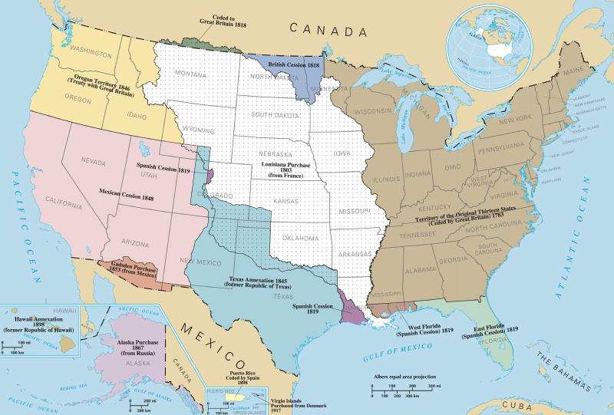
The above map shows the expansion of the United States into the 50 present-day states. Below is a timeline of this expansion.
Timeline of United Expansion into 50 States
1783 | Territory of the Original Thirteen States (Ceded by Great Britain)
1803 | Louisiana Purchase (from France)
1819 | East Florida (Spanish Cession)  West Florida (Spanish Cession)  Spanish Cession 1819 (present-day west Louisiana and part of present-day Colorado)
1845 | Texas Annexation (former Republic of Texas 1836-1845, part of Mexico 1821-1836)
1846 | Oregon Territory (Treaty with Great Britain)
1848 | Mexican Cession of present day California, Nevada, Utah, Arizona, parts of New Mexico and Colorado
1853 | Gadsden Purchase (from Mexico)
1867 | Alaska Purchase (from Russia)
1898 | Hawaii Annexation (former Republic of Hawaii)

Source D: “1830–1860: Diplomacy and Westward Expansion”
Text | Vocabulary | Guiding Questions
During this crucial period (1830-1860), the United States pursued a policy of expansion based on “manifest destiny,” the ideology that Americans were in fact destined to extend their nation across the continent.  The United States even proved to be willing to go to war to secure new territories. While it managed to negotiate an agreement with Great Britain to secure the Oregon territory, acquiring the valuable territory south of it—including California and its important Pacific harbors—required the use of force, and, in 1845, the United States embarked on its first offensive war by invading Mexico.  In addition to advancing westward, the United States also continued to expand economically through investment in foreign markets and international trade. With these growing commercial interests came a larger navy and increased international presence. The United States began to turn to the Pacific for new economic opportunities, establishing a presence in China, and opening Japan and Korea to western commercial interests. | ideology: belief or philosophy  economically: relating to money or resources  markets: places to sell goods | In your own words, what does “manifest destiny” mean?  ________________________________  ________________________________  ________________________________  ________________________________  ________________________________  How did the United States gain California?  ________________________________  ________________________________  ________________________________  ________________________________  ________________________________  ________________________________  ________________________________  ________________________________  ________________________________

Source E: Adapted from “The Annexation of Texas, the Mexican-American War, and the Treaty of Guadalupe-Hidalgo, 1845–1848”
Text | Vocabulary | Guiding Questions
During his tenure, U.S. President James K. Polk oversaw the greatest territorial expansion of the United States to date. Polk accomplished this through the annexation of Texas in 1845, the negotiation of the Oregon Treaty with Great Britain in 1846, and the conclusion of the Mexican-American War in 1848, which ended with the signing and ratification of the Treaty of Guadalupe-Hidalgo in 1848.  These events brought within the control of the United States the future states of Texas, California, Nevada, New Mexico, Arizona, Utah, Washington, and Oregon, as well as portions of what would later become Oklahoma, Colorado, Kansas, Wyoming, and Montana.  Following Texas’ successful war of independence against Mexico in 1836, President Martin van Buren refrained from annexing Texas after the Mexicans threatened war. In 1844 President John Tyler restarted negotiations with the Republic of Texas. His efforts culminated on April 12 in a Treaty of Annexation, an event that caused Mexico to sever diplomatic relations with the United States. Tyler, however, lacked the votes in the Senate to ratify the treaty, and was defeated by a wide margin in June in the presidential election. With the support of President-elect Polk, Tyler managed to get a joint resolution passed on March 1, 1845, and Texas was admitted into the United States on December 29.  While Mexico did not follow through with its threat to declare war if the United States annexed Texas, relations between the two nations remained tense due to Mexico’s disputed border with Texas. According to the Texans, their state included significant portions of what is today New Mexico and Colorado, and the western and southern portions of Texas itself, which they claimed extended to the Rio Grande River. The Mexicans, however, argued that the border only extended to the Nueces River, north of the Rio Grande.  In July, 1845, Polk, who had been elected on a platform of expansionism, ordered the commander of the U.S. Army in Texas, Zachary Taylor, to move his forces into the disputed lands that lay between the Nueces and Rio Grande rivers. In November, Polk dispatched Congressman John Slidell to Mexico with instructions to negotiate the purchase of the disputed areas along the Texas-Mexican border, and the territory comprising the present-day states of New Mexico and California.  Following the failure of Slidell’s mission in May 1846, Polk used news of skirmishes inside disputed territory between Mexican troops and Taylor’s army to gain Congressional support for a declaration of war against Mexico. On May 13, 1846, the United States declared war on Mexico.  Polk signed the Treaty of Guadalupe-Hidalgo in Mexico City on February 2, 1848, ending the Mexico-American War. Under the terms of the treaty, Mexico ceded to the United States approximately 525,000 square miles (55% of its prewar territory) in exchange for a $15 million lump sum payment, and the assumption by the U.S. Government of up to $3.25 million worth of debts owed by Mexico to U.S. citizens.  The war had another significant outcome. On August 8, 1846, Congressman David Wilmot introduced a rider to an appropriations bill that stipulated that “neither slavery nor involuntary servitude shall ever exist” in any territory acquired by the United States in the war against Mexico. While Southern senators managed to block adoption of the so-called “Wilmot Proviso,” it nonetheless provoked a political firestorm. The question of whether slavery could expand throughout the United States continue to fester until the defeat of the Confederacy in 1865. | annexation: act of adding a territory to one’s own territory  diplomatic relations: relationship where two countries negotiate with each other rather than use force  president-elect: person elected president who has not taken the office yet | Which states did President James K. Polk acquire for the United States?  ________________________________  ________________________________  ________________________________  ________________________________  ________________________________  ________________________________  ________________________________  ________________________________  ________________________________  ________________________________  ________________________________  ________________________________  Describe the boundary dispute between Texas and Mexico after Texas was admitted to the United States.  ________________________________  ________________________________  ________________________________  ________________________________  ________________________________  ________________________________  What actions did President Polk take in order to solve the boundary dispute between Texas and Mexico?  ________________________________  ________________________________  ________________________________  ________________________________  ________________________________  ________________________________  ________________________________  ________________________________  ________________________________  What were the results of the Mexico-American War?  ________________________________  ________________________________  ________________________________  ________________________________  ________________________________  ________________________________  ________________________________  ________________________________  ________________________________  ________________________________

Source F: “The United States and the Opening to Japan, 1853”
Text | Vocabulary | Guiding Questions
On July 8, 1853, American Commodore Matthew Perry led his four ships into the harbor at Tokyo Bay, seeking to re-establish for the first time in over 200 years regular trade and discourse between Japan and the western world.  Although he is often credited with opening Japan to the western world, Perry was not the first westerner to visit the islands. Portuguese, Spanish, and Dutch traders engaged in regular trade with Japan in the 16th and 17th centuries. Persistent attempts by the Europeans to convert the Japanese to Catholicism and their tendency to engage in unfair trading practices led Japan to expel most foreigners in 1639. For the two centuries that followed, Japan limited trade access to Dutch and Chinese ships with special charters.  There were several reasons why the United States became interested in revitalizing contact between Japan and the West in the mid-19th century. First, the combination of the opening of Chinese ports to regular trade and the annexation of California, creating an American port on the Pacific, ensured that there would be a steady stream of maritime traffic between North America and Asia. Then, as American traders in the Pacific replaced sailing ships with steam ships, they needed to secure coaling stations, where they could stop to take on provisions and fuel while making the long trip from the United States to China. The combination of its advantageous geographic position and rumors that Japan held vast deposits of coal increased the appeal of establishing commercial and diplomatic contacts with the Japanese. Additionally, the American whaling industry had pushed into the North Pacific by the mid-18th century, and sought safe harbors, assistance in case of shipwrecks, and reliable supply stations. In the years leading up to the Perry mission, a number of American sailors found themselves shipwrecked and stranded on Japanese shores, and tales of their mistreatment at the hands of the unwelcoming Japanese spread through the merchant community and across the United States.  The same combination of economic considerations and belief in Manifest Destiny that motivated U.S. expansion across the North American continent also drove American merchants and missionaries to journey across the Pacific. At the time, many Americans believed that they had a special responsibility to modernize and civilize the Chinese and Japanese. In the case of Japan, missionaries felt that Protestant Christianity would be accepted where Catholicism had generally been rejected. Other Americans argued that, even if the Japanese were unreceptive to Western ideals, forcing them to interact and trade with the world was a necessity that would ultimately benefit both nations.  Perry arrived in Japanese waters with a small squadron of U.S. Navy ships, because he and others believed the only way to convince the Japanese to accept western trade was to display a willingness to use its advanced firepower. At the same time, Perry brought along a variety of gifts for the Japanese Emperor, including a working model of a steam locomotive, a telescope, a telegraph, and a variety of wines and liquors from the West, all intended to impress upon the Japanese the superiority of Western culture. His mission was to complete an agreement with the Japanese Government for the protection of shipwrecked or stranded Americans and to open one or more ports for supplies and refueling. Displaying his audacity and readiness to use force, Perry’s approach into the forbidden waters around Tokyo convinced the Japanese authorities to accept the letter.  The following spring, Perry returned with an even larger squadron to receive Japan’s answer. The Japanese grudgingly agreed to Perry’s demands, and the two sides signed the Treaty of Kanagawa on March 31, 1854. According to the terms of the treaty, Japan would protect stranded seamen and open two ports for refueling and provisioning American ships: Shimoda and Hakodate. Japan also gave the United States the right to appoint consuls to live in these port cities, a privilege not previously granted to foreign nations. This treaty was not a commercial treaty, and it did not guarantee the right to trade with Japan. Still, in addition to providing for distressed American ships in Japanese waters, it contained a most-favored-nation clause, so that all future concessions Japan granted to other foreign powers would also be granted to the United States. As a result, Perry’s treaty provided an opening that would allow future American contact and trade with Japan. | western world: referring to Europe and the United States  maritime: having to do with ships and the ocean  provisioning: gathering needed goods, like food | Why did Japan cut off foreign relations with most countries in 1639?  ________________________________  ________________________________  ________________________________  ________________________________  ________________________________  ________________________________  ________________________________  ________________________________  ________________________________  ________________________________  How did the United States hope to use Japan to increase trade between the United States and Asia?  ______________________________  ________________________________  ________________________________  ________________________________  ________________________________  ________________________________  ________________________________  ________________________________  What beliefs in the United States promoted the “opening” of Japan by Commodore Perry? How are these beliefs problematic?  ________________________________  ________________________________  ________________________________  ________________________________  ________________________________  ________________________________  ________________________________  ________________________________  ________________________________  ________________________________  ________________________________  ________________________________  What actions did Commodore Perry take in order to convince Japan to open?  ________________________________  ________________________________  ________________________________  ________________________________  ________________________________  ________________________________  ________________________________  ________________________________  ________________________________  What were the results of Commodore Perry’s actions?  ________________________________  ________________________________  ________________________________  ________________________________  ________________________________  ________________________________

Source G: “America’s Limited but Aggressive Push Outward”
Text | Vocabulary | Guiding Questions
Despite such widespread isolationist impulses and the sheer inability to maintain a strong international position, the United States moved ahead sporadically with a modest foreign policy agenda in the three decades following the Civil War. Secretary of State William Seward, who held that position from 1861 through 1869, sought to extend American political and commercial influence in both Asia and Latin America. He pursued these goals through a variety of actions. A treaty with Nicaragua set the early course for the future construction of a canal across Central America. He also pushed through the annexation of the Midway Islands in the Pacific Ocean, which subsequently opened a more stable route to Asian markets. In frequent conversations with President Lincoln, among others, Seward openly spoke of his desire to obtain British Columbia, the Hawaiian Islands, portions of the Dominican Republic, Cuba, and other territories. He explained his motives to a Boston audience in 1867, when he professed his intention to give the United States “control of the world.”  Most notably, in 1867, Seward obtained the Alaskan Territory from Russia for a purchase price of $7.2 million. Fearing future loss of the territory through military conflict, as well as desiring to create challenges for Great Britain (which they had fought in the Crimean War), Russia had happily accepted the American purchase offer. In the United States, several newspaper editors openly questioned the purchase and labeled it “Seward’s Folly.” They highlighted the lack of Americans to populate the vast region and lamented the challenges in attempting to govern the native peoples in that territory. Only if gold were to be found, the editors decried, would the secretive purchase be justified. That is exactly what happened. Seward’s purchase added an enormous territory to the country—nearly 600,000 square miles—and also gave the United States access to the rich mineral resources of the region, including the gold that triggered the Klondike Gold Rush at the close of the century. As was the case elsewhere in the American borderlands, Alaska’s industrial development wreaked havoc on the region’s Indigenous and Russian cultures. | isolationist: policy of not interfering with other countries  foreign policy: policy or behavior of a country towards other countries  folly: a foolish act  Indigenous: people who are the original or earliest known inhabitants of a place | What actions taken by the United States under Secretary of State William Seward could be considered imperialistic? Explain your answer.  ________________________________  ________________________________  ________________________________  ________________________________  ________________________________  ________________________________  ________________________________  ________________________________  ________________________________  What was the result of “Seward’s Folly”?  ________________________________  ________________________________  ________________________________  ________________________________  ________________________________  ________________________________  ________________________________  ________________________________  ________________________________  ________________________________  ________________________________  ________________________________  ________________________________  ________________________________  ________________________________

After you read:

1. How did the United States gain territory prior to the period of New Imperialism?

2. Was the United States isolationist before the period of New Imperialism? Explain your answer.

Lesson 2 – Setting the Context
Student Directions | First, read and study Source H. Then, read Sources I, J, and K and answer the guiding questions in the right-hand columns. Next, study Source L and answer the guiding question below the source. Finally, complete the after you read questions at the end of this lesson.
Featured Sources | Source H: “Westward the Course of Empire Takes Its Way”  Source I: Adapted from “Conquering the West”  Source J: “Chester A. Arthur on American Indian Policy (1881)”  Source K: “Laura C. Kellogg on Indian Education (1913)”  Source L: Tom Torlino Photographs
Optional Digital Extensions | Crash Course US History: Westward Expansion
Source H: “Westward the Course of Empire Takes Its Way”
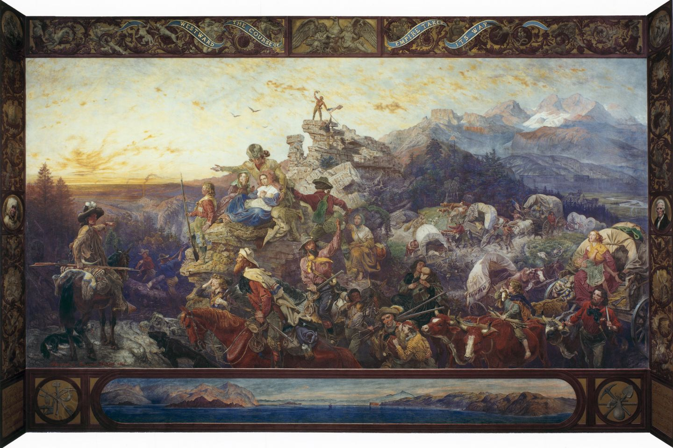
This mural by Emanuel Leutze was painted in 1862 in the U.S. Capitol building in Washington, D.C. Pioneers in covered wagons are depicted moving west. This painting represents a positive view of westward expansion.
*Note: Ethnocentrism is the practice of judging other groups of people using one’s own culture and behavior as the standard for what is right. The treatment of American Indians was driven by this practice. American Indians were called “uncivilized” and “savages” as a way to degrade their culture and behaviors.
Source I: Adapted from “Conquering the West”
Text | Vocabulary | Guiding Questions
Post-Civil War Westward Migration  In the decades after the Civil War, Americans poured across the Mississippi River in record numbers. No longer simply crossing over the continent for an imagined paradise in California or Oregon, they settled now in the vast heart of the continent.  It was land, ultimately, that drew the most migrants to the West. Family farms were the backbone of the agricultural economy that expanded in the West after the Civil War. In 1862, northerners in Congress passed the Homestead Act, which allowed male citizens (or those who declared their intent to become citizens) to claim federally owned lands in the West. Settlers could head west, choose a 160-acre surveyed section of land, file a claim, and begin “improving” the land by plowing fields, building houses and barns, or digging wells, and, after five years of living on the land, could apply for the official title deed to the land. Hundreds of thousands of Americans used the Homestead Act to acquire land. The treeless plains that had been considered unfit for settlement became the new agricultural capital for land-hungry Americans.  The Indian Wars  The “Indian wars,” so mythologized in western folklore, were a series of sporadic, localized, and often brief engagements between U.S. military forces and various American Indian groups. The more sustained and more impactful conflict, meanwhile, was economic and cultural. American Indians’ movement across the Great Plains to hunt buffalo, raid enemies, and trade goods was incompatible with new patterns of American settlement and railroad construction. Thomas Jefferson’s old dream that American Indian groups might live isolated in the West was, in the face of American expansion, no longer a viable reality. Political, economic, and even humanitarian concerns intensified American efforts to isolate American Indians on reservations. Although Indian removal had long been a part of federal American Indian policy, following the Civil War the U.S. government redoubled its efforts. If treaties and other forms of persistent coercion would not work, more drastic measures were deemed necessary. Against the threat of confinement and the extinction of traditional ways of life, American Indians battled the American army and the encroaching lines of American settlement.  As settler incursions continued to provoke conflict, Americans pushed for a new “peace policy.” Congress, confronted with these tragedies and further violence, authorized in 1868 the creation of an Indian Peace Commission. The commission’s study of American Indians decried prior American policy and galvanized support for reformers. After the inauguration of Ulysses S. Grant the following spring, Congress allied with prominent philanthropists to create the Board of Indian Commissioners, a permanent advisory body to oversee Indian affairs and prevent the further outbreak of violence. The board effectively Christianized American Indian policy. Much of the reservation system was handed over to Protestant churches, which were tasked with finding agents and missionaries to manage reservation life. Congress hoped that religiously-minded men might fare better at creating just assimilation policies and persuading Indians to accept them. Historian Francis Paul Prucha believed that this attempt at a new “peace policy . . . might just have properly been labelled the ‘religious policy.’”  Many female Christian missionaries played a central role in cultural reeducation programs that attempted to not only instill Protestant religion but also impose traditional American gender roles and family structures. They endeavored to replace Indians’ tribal social units with small, patriarchal households. Women’s labor became a contentious issue because few tribes divided labor according to the gender norms of middle- and upper-class Americans. Fieldwork, the traditional domain of white males, was primarily performed by Native women, who also usually controlled the products of their labor, if not the land that was worked, giving them status in society as laborers and food providers. For missionaries, the goal was to get Native women to leave the fields and engage in more proper “women’s” work—housework. Christian missionaries performed much as secular federal agents had. Few American agents could meet American Indians on their own terms. Most viewed reservation American Indians as lazy and thought of Native cultures as inferior to their own. The views of J. L. Broaddus, appointed to oversee several small Indian tribes on the Hoopa Valley reservation in California, are illustrative: in his annual report to the Commissioner of Indian Affairs for 1875, he wrote, “The great majority of them are idle, listless, careless, and improvident. They seem to take no thought about provision for the future, and many of them would not work at all if they were not compelled to do so. They would rather live upon the roots and acorns gathered by their women than to work for flour and beef.  The Allotment Era and Resistance in the Native West  As the rails moved into the West, and more and more Americans followed, the situation for Native groups deteriorated even further. Treaties negotiated between the United States and Native groups had typically promised that if tribes agreed to move to specific reservation lands, they would hold those lands collectively. But as American westward migration mounted and open lands closed, white settlers began to argue that Indians had more than their fair share of land, that the reservations were too big, that Indians were using the land “inefficiently,” and that they still preferred nomadic hunting instead of intensive farming and ranching.  By the 1880s, Americans increasingly championed legislation to allow the transfer of Indian lands to farmers and ranchers, while many argued that allotting lands to individual American Indians, rather than to tribes, would encourage American-style agriculture and finally put Indians who had previously resisted the efforts of missionaries and federal officials on the path to “civilization.”  Passed by Congress on February 8, 1887, the Dawes General Allotment Act divided reservations into individual family homesteads. Each head of a Native family was to be allotted 160 acres, the typical size of a claim that any settler could establish on federal lands under the provisions of the Homestead Act. Single individuals over age eighteen would receive an eighty-acre allotment, and orphaned children received forty acres. A four-year timeline was established for Indian peoples to make their allotment selections. If at the end of that time no selection had been made, the act authorized the secretary of the interior to appoint an agent to make selections for the remaining tribal members. To protect Indians from being swindled by unscrupulous land speculators, all allotments were to be held in trust—they could not be sold by allottees—for twenty-five years. Lands that remained unclaimed by tribal members after allotment would revert to federal control and be sold to American settlers.  Americans touted the Dawes Act as an uplifting humanitarian reform, but it upended American Indian lifestyles and left groups without sovereignty over their lands. The act claimed that to protect Indian property rights, it was necessary to extend “the protection of the laws of the United States . . . over the Indians.” Tribal governments and legal principles could be superseded, or dissolved and replaced, by U.S. laws. Under the terms of the Dawes Act, Native groups struggled to hold on to some measure of tribal sovereignty.  Individuals continued to resist the pressures of assimilation and preserve traditional cultural practices, but sustained military defeats, the loss of sovereignty over land and resources, and the onset of crippling poverty on the reservations marked the final decades of the nineteenth century as a particularly dark era for America’s western tribes. | deed: document showing ownership  reservations: areas of land designated by the federal government for the resettling of American Indian people forcibly relocated from their homelands  galvanized: increased, spurred  assimilation: process of a minority group adopting the culture of a dominant group  patriarchal: controlled by men  allotting: distributing shares  sovereignty: authority to govern themselves | Why did white settlers want to move west? Describe the government policy that drove this migration.  ________________________________  ________________________________  ________________________________  ________________________________  ________________________________  ________________________________  ________________________________  ________________________________  ________________________________  ________________________________  ________________________________  ________________________________  ________________________________  ________________________________  ________________________________  ________________________________  How were American Indians removed from lands to make room for white settlers?  ________________________________  ________________________________  ________________________________  ________________________________  ________________________________  ________________________________  ________________________________  ________________________________  ________________________________  ________________________________  ________________________________  ________________________________  ________________________________  What was the relationship between Christianity and the assimilation of American Indians?  ________________________________  ________________________________  ________________________________  ________________________________  ________________________________  ________________________________  ________________________________  ________________________________  ________________________________  ________________________________  ________________________________  ________________________________  ________________________________  What was the purpose of the Dawes Act?  ________________________________  ________________________________  ________________________________  ________________________________  ________________________________  ________________________________  ________________________________  ________________________________  ________________________________  ________________________________  ________________________________  ________________________________  Describe views of American Indians held by Americans that led to the passage of the Dawes Act.  ________________________________  ________________________________  ________________________________  ________________________________  ________________________________  _______________________________  What was the result of the Dawes Act for American Indians?  ________________________________  ________________________________  ________________________________  ________________________________  ________________________________  ________________________________  ________________________________  ________________________________  ________________________________  ________________________________  ________________________________  ________________________________  ________________________________  ________________________________  ________________________________

Source J: “First Annual Message to Congress” by Chester A. Arthur
Text | Vocabulary | Guiding Questions
The following is taken from President Chester A. Arthur’s First Annual Message to Congress, delivered December 6, 1881.  We have to deal with the appalling fact that though thousands of lives have been sacrificed and hundreds of millions of dollars expended in the attempt to solve the Indian problem, it has until within the past few years seemed scarcely nearer a solution than it was half a century ago. . .  First. I recommend the passage of an act making the laws of the various States and Territories applicable to the Indian reservations within their borders and extending the laws of the State of Arkansas to the portion of the Indian Territory not occupied by the Five Civilized Tribes.  The Indian should receive the protection of the law. He should be allowed to maintain in court his rights of person and property. He has repeatedly begged for this privilege. Its exercise would be very valuable to him in his progress toward civilization.  Second. Of even greater importance is a measure which has been frequently recommended by my predecessors in office. . .. The enactment of a general law permitting the allotment. . . to such Indians, at least, as desire it, of a reasonable quantity of land secured to them by patent, and for their own protection made inalienable for twenty or twenty-five years, is demanded for their present welfare and their permanent advancement.  In return for such considerate action on the part of the Government, there is reason to believe that the Indians in large numbers would be persuaded to sever their tribal relations and to engage at once in agricultural pursuits. Many of them realize the fact that their hunting days are over and that it is now for their best interests to conform their manner of life to the new order of things. By no greater inducement than the assurance of permanent title to the soil can they be led to engage in the occupation of tilling it.  The well-attested reports of their increasing interest in husbandry justify the hope and belief that the enactment of such a statute as I recommend would be at once attended with gratifying results. A resort to the allotment system would have a direct and powerful influence in dissolving the tribal bond, which is so prominent a feature of savage life, and which tends so strongly to perpetuate it.  Third. I advise a liberal appropriation for the support of Indian schools, because of my confident belief that such a course is consistent with the wisest economy. … They are doubtless much more potent for good than the day schools upon the reservation, as the pupils are altogether separated from the surroundings of savage life, and brought into constant contact with civilization. | Five Civilized Tribes: term used by the U.S. government to describe the Cherokee, Chickasaw, Choctaw, Creek, and Seminole; represents the ethnocentric view that only some American Indians were civilized  allotment: shares of land for farming  tilling: breaking up land to farm it  husbandry: domesticating animals and crops  savage: not civilized; term used to degrade American Indians | How did Chester A. Arthur want American Indians to change their way of life? What policies did he propose to aid that?  ________________________________  ________________________________  ________________________________  ________________________________  ________________________________  ________________________________  ________________________________  ________________________________  ________________________________  ________________________________  ________________________________  ________________________________  ________________________________  Based on the text, how does President Arthur view American Indians as compared to white Americans? How do his views reflect ethnocentrism?  ________________________________  ________________________________  ________________________________  ________________________________  ________________________________  ________________________________  ________________________________  ________________________________  ________________________________  ________________________________  ________________________________  ________________________________  ________________________________  ________________________________

Source K: Excerpts from “Some Facts and Figures on Indian Education” by Laura C. Kellogg
Text | Vocabulary | Guiding Questions
The United States used education to culturally assimilate Native Americans. Laura Cornelius Kellogg, an Oneida author, performer, and activist who helped found the Society of American Indians (SAI) in 1913, criticized the cultural chauvinism of American policy. Speaking to the SAI, she challenged her Indian audience to embrace modern American democracy while maintaining their own identity.  The word education has several meanings to our race, and at the start I wish to clear up in our minds a common misunderstanding of the term. To some of our Indians at home, going away to a government school means an education from which we may expect anything and everything. To some others, anything the Caucasian does is “educated” and anything “Indian” is not. To those who have gone the whole way of enlightenment, education has another meaning. With them, there is a proper appreciation of the real values of truth wherever they may be found, whether in an Indian or Paleface.  . . .  There are old Indians who have never seen the inside of a classroom whom I consider far more educated than the young Indian with his knowledge of Latin and Algebra. There is something behind the superb dignity and composure of the old bringing up; there is something in the discipline of the Red Man which has given him a place in the literature and art of this country, there to remain separate and distinct in his proud active bearing against all time, all change.  . . .  We want education, yes, we want to know all the educated Caucasian knows but we want our self-respect while we are getting his knowledge. In short, let us discriminate between the goods and bads of civilization and the goods and bads of his own heritage; weed out as many of the bads as we can and send him along the way a finer type of citizen than if we turned him into a very average ‘White man’ just to have him “white” in culture. This is what I mean by recognizing the real values of truth whether they are to be found in paleface or the Indian. | Oneida: an American Indian tribe  chauvinism: excessive or prejudiced support for one's own cause, group, or sex  Paleface: a white person; this term is not appropriate for use today  Red Man: an American Indian; this term is not appropriate for use today | What does Laura C. Kellogg think about the education of American Indians provided by the United States government?  ________________________________  ________________________________  ________________________________  ________________________________  ________________________________  ________________________________  ________________________________  What does Laura C. Kellogg want to change in the education of American Indians?  ________________________________  ________________________________  ________________________________  ________________________________  ________________________________  ________________________________  ________________________________  ________________________________

Source L: Tom Torlino Photographs
Tom Torlino, a member of the Navajo Nation, entered the Carlisle Indian School, a Native American boarding school founded by the U.S. government in 1879, on October 21, 1882 and departed on August 28, 1886. Torlino’s student file contained photographs from 1882 and 1885. These photographs are a representation of the process of assimilation of American Indians.

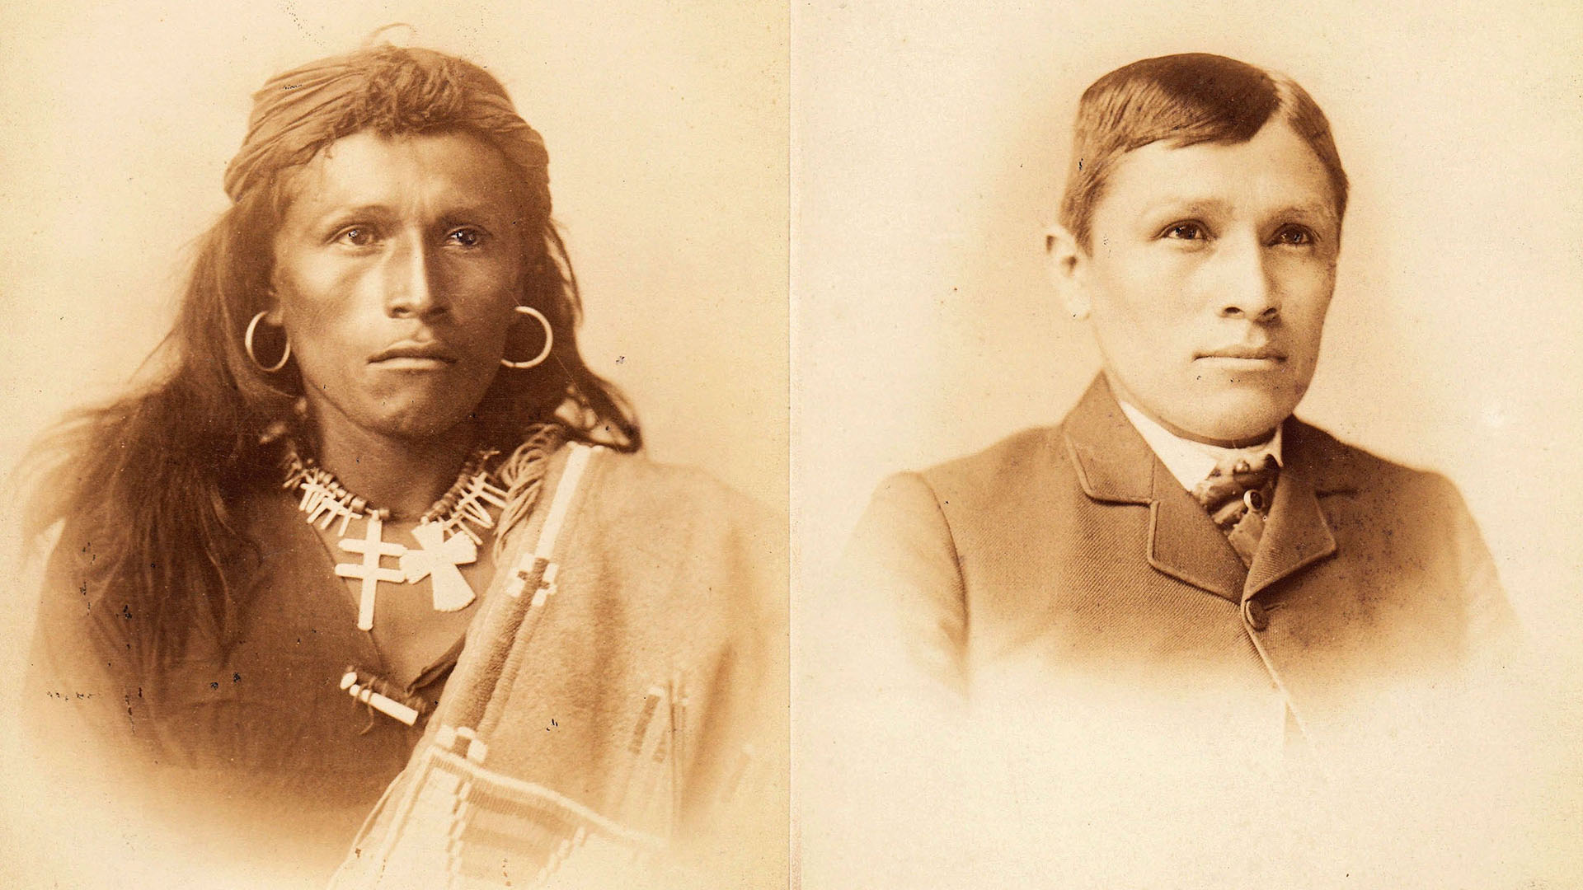

How did Tom Torlino’s appearance and clothing change in the time he was in the Carlisle Indian School?

__________________________________________________________________________________________

__________________________________________________________________________________________

__________________________________________________________________________________________

After you read:

1. Before the period of New Imperialism, where and how was the United States expanding its borders?

2. Describe the prejudices, economic motivations, and policies that led to the displacement of American Indians.

Lesson 3
Supporting Question 1: What motivated U.S. imperialism?
Student Directions | Study Source M. Then, read Sources N, O, P, and Q and answer questions in the right-hand column. Next, study Sources R and S and answer the question below each source. Then, read Source T and answer the questions in the right-hand column. Finally, complete the after you read questions at the end of this lesson.
Featured Sources | Source M: U.S. Expansion and Imperialism Timeline  Source N: Adapted from “The Scramble for Colonies”  Source O: Adapted from “Business, Religious, and Social Interests Set The Stage for Empire”  Source P: Excerpts from “The March of the Flag” by Albert Beveridge  Source Q: Excerpts from “Imperialism” by William Jennings Bryan, August 8, 1900  Source R: “What the United States Has Fought For”  Source S: “School Begins”  Source T: Excerpts from “White Man’s Burden” by Rudyard Kipling
Optional Digital Extensions | Crash Course US History: American Imperialism

Source M: U.S. Expansion and Imperialism Timeline
1848 | The Treaty of Guadalupe Hidalgo was signed, marking the end of the Mexican-American War. As a result, the United States gained all or parts of California, Nevada, Utah, and Arizona.
1853 | Commodore Perry led his four ships into the harbor at Tokyo Bay in order to open trade with Japan.
1867 | Alaska was purchased from Russia.
1893 | Queen Liliuokalani of Hawaii was overthrown.
1898 | Spanish-American War started and ended. As a result, Spain ceded Guam and Puerto Rico to the United States and gave up all claims to Cuba. The United States purchased the Philippines from Spain for $20 million dollars.
 | The United States annexed Hawaii.
1899-1901 | Filipinos fought the United States for independence in the Philippine-American War.
1899 | The Open Door Policy, which said that trade in China should remain open to all countries, was accepted by Great Britain, Germany, France, Italy, Russia, and Japan.
1901 | The Platt Amendment, pushed by the United States in order to prevent intervention in Cuba by other countries, was included in the Cuban constitution.
1903 | Panama gained independence from Columbia.

Source N: Adapted from “The Scramble for Colonies”
Text | Vocabulary | Guiding Questions
One explanation for the United States' entry into the imperial game was peer pressure. Between 1870 and 1890, the industrial nations of Europe and Asia, particularly Great Britain, France, Germany, and Japan, scrambled to seize territory. With unmatched firepower and technology, these imperial powers divided Africa and Asia among themselves. Many in the United States feared that if America didn't join the race for empire, the great powers would leave it behind.  What was the point of having colonies? Like the system of mercantilism, under which the American colonies had sent raw materials to Great Britain and purchased finished goods in return, colonialism was a system designed to benefit the imperial power, usually at the expense of the colony. Colonies not only provided sources of valuable raw materials (diamonds, gold, timber, oil, rubber, and many others) for the imperial power, their populations served as markets for the industrial products made in the home country.  Markets were particularly important for the United States, which had emerged as the world's leading industrial power in the wake of the Gilded Age. Capitalism could only thrive and expand as long as people purchased the products of industry, and at the end of the nineteenth century, Americans were beginning to fear that new markets within the United States were drying up now that Manifest Destiny (the belief that God intended the United States to occupy the North American continent from Atlantic to Pacific) had been achieved. In 1893, historian Frederick Jackson Turner declared that the American frontier was now closed, leading many to fear that the pioneering spirit central to the American identity was in jeopardy. | markets: places to sell goods | Why did the United States feel pressure to acquire colonies?  ________________________________  ________________________________  ________________________________  ________________________________  ________________________________  ________________________________  ________________________________  How did countries benefit from colonies?  ________________________________  ________________________________  ________________________________  ________________________________  Why was the United States looking for land outside of the North American continent?  ________________________________  ________________________________  ________________________________  ________________________________  ________________________________  ________________________________

Land Controlled by Imperialist Powers in 1822
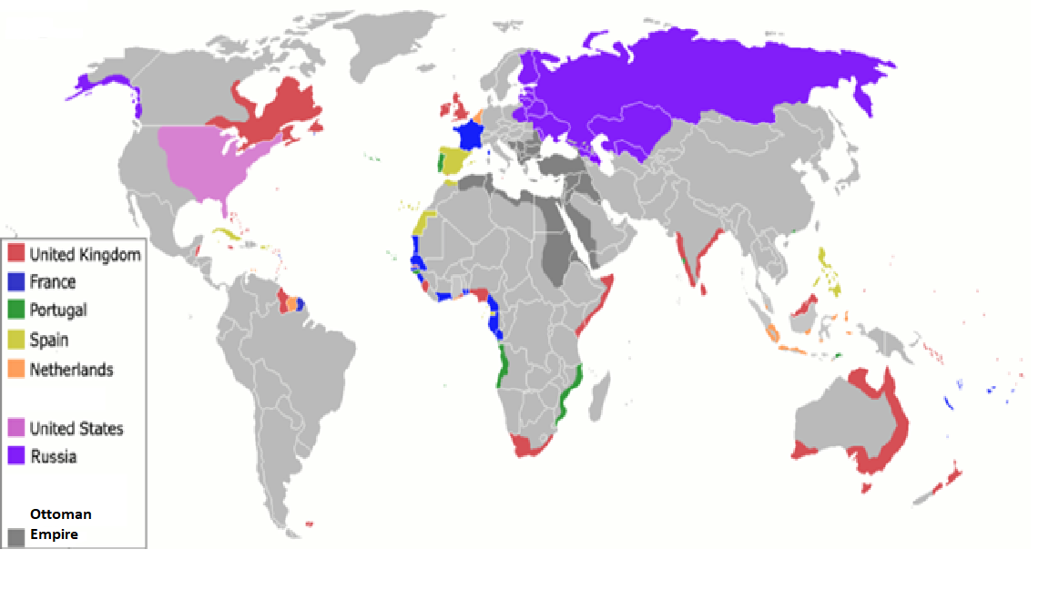

Source O: Adapted from “Business, Religious, and Social Interests Set the Stage for Empire”
Text | Vocabulary | Guiding Questions
While the United States slowly pushed outward and sought to absorb lands in the West (and the Indigenous cultures that lived there), the country was also changing how it functioned. As a new industrial United States began to emerge in the 1870s, economic interests began to lead the country toward a more expansionist foreign policy. By forging new and stronger ties overseas, the United States gained access to international markets for export, as well as better deals on the raw materials needed domestically. The concerns raised by the economic depression of the early 1890s further convinced business owners that they needed to tap into new markets, even at the risk of foreign entanglements.  As a result of these growing economic pressures, American exports to other nations skyrocketed in the years following the Civil War, from $234 million in 1865 to $605 million in 1875. By 1898, on the eve of the Spanish-American War, American exports had reached a height of $1.3 billion annually. Imports over the same period also increased substantially, from $238 million in 1865 to $616 million in 1898. Such an increased investment in overseas markets in turn strengthened Americans’ interest in foreign affairs.  Businesses were not the only ones seeking to expand. Religious leaders and Progressive reformers joined businesses in their growing interest in American expansion, as both sought to increase the democratic and Christian influences of the United States abroad. Imperialism and Progressivism were compatible in the minds of many reformers who thought the Progressive impulses for democracy at home translated overseas as well. Editors of such magazines as Century, Outlook, and Harper’s supported an imperialistic stance as the democratic responsibility of the United States. Several Protestant faiths formed missionary societies in the years after the Civil War, seeking to expand their reach, particularly in Asia. Influenced by such works as Reverend Josiah Strong’s Our Country: Its Possible Future and Its Present Crisis (1885), missionaries sought to spread the gospel throughout the country and abroad. Led by the American Board of Commissioners for Foreign Missions, among several other organizations, missionaries conflated Christian ethics with American virtues, and began to spread both gospels with zeal. This was particularly true among women missionaries, who composed over 60 percent of the overall missionary force. By 1870, missionaries abroad spent as much time advocating for the American version of a modern civilization as they did teaching the Bible.  Social reformers of the early Progressive Era also performed work abroad that mirrored the missionaries. Many were influenced by recent scholarship on race-based intelligence and embraced the implications of social Darwinist theory that alleged inferior races were destined to poverty on account of their lower evolutionary status. While certainly not all reformers espoused a racist view of intelligence and civilization, many of these reformers believed that the Anglo-Saxon race was mentally superior to others and owed the presumed less evolved populations their stewardship and social uplift—a service the British writer Rudyard Kipling termed “the white man’s burden.”  By trying to help people in less industrialized countries achieve a higher standard of living and a better understanding of the principles of democracy, reformers hoped to contribute to a noble cause, but their approach suffered from the same paternalism that hampered Progressive reforms at home. Whether reformers and missionaries worked with native communities in the borderlands such as New Mexico; in the inner cities, like the Salvation Army; or overseas, their approaches had much in common. Their good intentions and willingness to work in difficult conditions shone through in the letters and articles they wrote from the field. Often in their writing, it was clear that they felt divinely empowered to change the lives of other, less fortunate, and presumably, less enlightened, people. Whether oversees or in the urban slums, they benefited from the same passions but expressed the same paternalism. | expansionist: policy that advocates for expanding the territory of a country  export: send goods to another country to sell there  domestically: within a country  foreign entangle-ments: being deeply involved in the affairs of foreign countries  conflated: combined into one  social Darwinist: now-defunct theory that individuals, groups, and peoples are subject to the same Darwinian laws of natural selection as plants and animal  paternalism: people in power limit the rights and abilities of people they see as below their status; treating people as if they were children | Why did business leaders become more expansionist in the late 19th century?  ________________________________  ________________________________  ________________________________  ________________________________  ________________________________  ________________________________  ________________________________  ________________________________  ________________________________  ________________________________  What was the relationship between Progressivism and imperialism?  ________________________________  ________________________________  ________________________________  ________________________________  ________________________________  ________________________________  ________________________________  What was the relationship between Christianity and imperialism?  ________________________________  ________________________________  ________________________________  ________________________________  ________________________________  ________________________________  ________________________________  _____________________________  Describe how racism fueled imperialism.  ________________________________  ________________________________  ________________________________  ________________________________  ________________________________  ________________________________  How were many reformers at home and abroad paternalistic?  ________________________________  ________________________________  ________________________________  ________________________________  ________________________________  ________________________________  ________________________________  ________________________________  ________________________________  ________________________________  ________________________________

*Note: Albert Beveridge was a U.S. Senator from Indiana. Beveridge gave the following speech on the campaign trail in 1898, a few months after the start of the Spanish American War.

Source P: Excerpts from “The March of the Flag” by Albert Beveridge
Text | Vocabulary | Guiding Questions
It is a noble land that God has given us; a land that can feed and clothe the world; a land whose coastlines would inclose half the countries of Europe; a land set like a sentinel between the two imperial oceans of the globe, a greater England with a nobler destiny.  . . .  It is a glorious history our God has bestowed upon His chosen people; a history heroic with faith in our mission and our future; a history of statesmen who flung the boundaries of the Republic out into unexplored lands and savage wilderness; a history of soldiers who carried the flag across blazing deserts and through the ranks of hostile mountains, even to the gates of sunset; a history of a multiplying people who overran a continent in half a century; a history of prophets who saw the consequences of evils inherited from the past and of martyrs who died to save us from them; a history divinely logical, in the process of whose tremendous reasoning we find ourselves today.  Therefore, in this campaign, the question is larger than a party question. It is an American question. It is a world question. Shall the American people continue their march toward the commercial supremacy of the world? . . .  Have we no mission to perform no duty to discharge to our fellow man? Has God endowed us with gifts beyond our deserts and marked us as the people of His peculiar favor, merely to rot in our own selfishness. . .  The Opposition tells us that we ought not to govern a people without their consent. I answer, the rule of liberty that all just government derives its authority from the consent of the governed, applies only to those who are capable of self-government. We govern the Indians without their consent, we govern our territories without their consent, we govern our children without their consent. How do they know what our government would be without their consent? Would not the people of the Philippines prefer the just, humane, civilizing government of this Republic to the savage, bloody rule of pillage and extortion from which we have rescued them? | sentinel: guardian  commercial: having to do with money or wealth  consent of the governed:  refers to the idea that a government is only justified and lawful when the people being ruled consent to it  self-government: a people who rule themselves, like in a democracy  Indians: American Indians, or Indigenous people of the United States | How does Beveridge describe the United States and its citizens?  ________________________________  ________________________________  ________________________________  ________________________________  How does Beveridge describe western expansion?  ________________________________  ________________________________  ________________________________  ________________________________  ________________________________  ________________________________  ________________________________  ________________________________  ________________________________  ________________________________  ________________________________  ________________________________  ________________________________  What is Beveridge’s argument for the United States ruling over other nations, such as the Philippines?  ________________________________  ________________________________  ________________________________  ________________________________  ________________________________  ________________________________  ________________________________  ________________________________  ________________________________  ________________________________  ________________________________  ________________________________

Source Q: Excerpts from “Imperialism” by William Jennings Bryan, August 8, 1900
Text | Vocabulary | Guiding Questions
[77] The principal arguments, however, advanced by those who enter upon a defense of imperialism are:  [78] First– That we must improve the present opportunity to become a world power and enter into international politics.  [79] Second– That our commercial interests in the Philippine islands and in the Orient make it necessary for us to hold the islands permanently.  [80] Third– That the spread of the Christian religion will be facilitated by a colonial policy.  [81] Fourth– That there is no honorable retreat from the position which the nation has taken.  [82] The first argument is addressed to the nation’s pride and the second to the nation’s pocket-book. The third is intended for the church member and the fourth for the partisan. | Orient: refers to Asia, especially eastern Asia; outdated term  partisan: person who strongly supports their own political party | What are the arguments defenders of imperialism make according to William Jennings Bryan?  ________________________________  ________________________________  ________________________________  ________________________________  ________________________________  ________________________________  ________________________________  ________________________________  ________________________________  ________________________________  ________________________________  ________________________________  ________________________________  ________________________________

Source R: “What the United States Has Fought For”
This 1914 political cartoon shows a before and after: Spanish colonies before intervention by the United States and those same former colonies after.

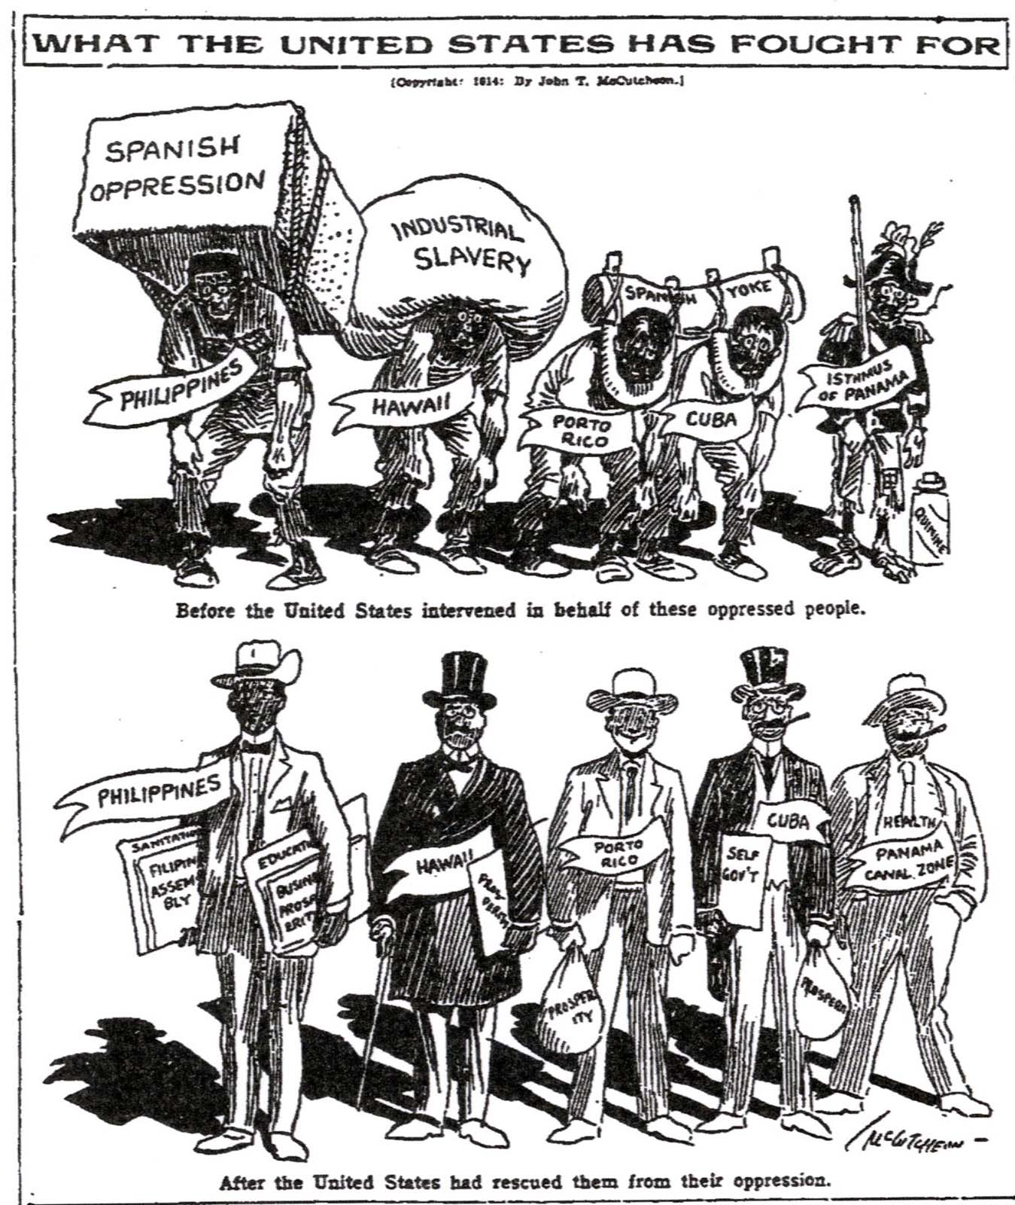

What does the illustrator think about U.S. imperialism? Explain your answer using evidence from the cartoon.

__________________________________________________________________________________________

__________________________________________________________________________________________

__________________________________________________________________________________________
Source S: “School Begins”
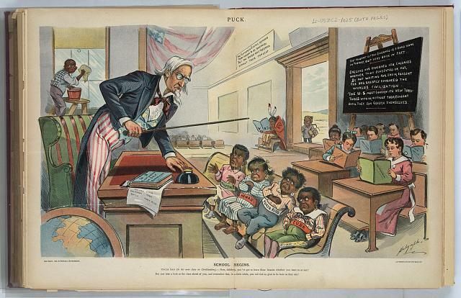

The print above depicts Uncle Sam as a teacher, standing behind a desk in front of his new students who are labeled "Cuba, Porto [i.e. Puerto] Rico, Hawaii, [and] Philippines." At the rear of the classroom are students holding books labeled "California, Texas, New Mexico, Arizona, [and] Alaska". At the far left, an African American boy cleans the windows, and in the background, a Native boy sits by himself, reading an upside-down book labeled "ABC," and a Chinese boy stands just outside the door. A book on Uncle Sam's desk is titled "U.S. First Lessons in Self-Government."

The caption at the bottom of the print reads: School Begins. Uncle Sam (to his new class in Civilization). Now, children, you've got to learn these lessons whether you want to or not! But just take a look at the class ahead of you, and remember that, in a little while, you will feel as glad to be here as they are!

The writing on the blackboard reads: The consent of the governed is a good thing in theory, but very rare in fact. — England has governed her colonies whether they consented or not. By not waiting for their consent she has greatly advanced the world's civilization. — The U.S. must govern its new territories with or without their consent until they can govern themselves.

What does the illustrator think about U.S. imperialism? Explain your answer using evidence from the cartoon.

__________________________________________________________________________________________

__________________________________________________________________________________________

__________________________________________________________________________________________

*Note: Rudyard Kipling was an English author born in India. He wrote the following poem in response to the United States taking over the Philippines after the Spanish American war.

Source T: Excerpts from “White Man’s Burden” by Rudyard Kipling
Text | Vocabulary | Guiding Questions
Take up the White Man's burden--  Send forth the best ye breed--  Go bind your sons to exile  To serve your captives' need;  To wait in heavy harness,  On fluttered folk and wild--  Your new-caught, sullen peoples,  Half-devil and half-child.  Take up the White Man's burden--  And reap his old reward:  The blame of those ye better,  The hate of those ye guard--  The cry of hosts ye humour  (Ah, slowly!) toward the light: --  "Why brought he us from bondage,  Our loved Egyptian night?"  Take up the White Man's burden--  Ye dare not stoop to less--  Nor call too loud on Freedom  To cloke your weariness;  By all ye cry or whisper,  By all ye leave or do,  The silent, sullen peoples  Shall weigh your gods and you. | burden: a duty or misfortune that causes hardship; the responsibility for achieving a specified aim or task  bondage: the state of being a slave | Who is the “captive” in this poem? How does Kipling describe them?  ________________________________  ________________________________  ________________________________  ________________________________  What does Kipling see as the responsibility of white men, or in this context, the United States?  ________________________________  ________________________________  ________________________________  ________________________________  ________________________________  Is this poem pro-imperialist or anti-imperialist? Explain your answer.  ________________________________  ________________________________  ________________________________

After you read:

1. Describe the attitudes and beliefs that drove U.S. imperialism.

2. How do the attitudes and beliefs that drove U.S. imperialism compare to the views and beliefs that drove westward expansion?

Lesson 4
Supporting Question 1: What motivated U.S. imperialism?
Student Directions | First, read Source U and answer the guiding questions in the right-hand column. Then, read and study Source V. Next, read Sources W and X and answer the guiding questions in the right-hand columns. Then, read and study Source Y. Next, read Source Z and answer the guiding questions in the right-hand columns. Next, complete the after you read questions at the end of this lesson. Finally, complete performance task #1 at the end of this lesson.
Featured Sources | Source U: Adapted from “Turner, Mahan, and the Plan for Empire”  Source V: “Columbia's Easter Bonnet”  Source W: Excerpts from the Monroe Doctrine, 1823  Source X: Excerpts from Theodore Roosevelt's Corollary to the Monroe Doctrine, 1905  Source Y: “The World Constable”  Source Z: “Patterns of American Interventions”

Source U: Adapted from “Turner, Mahan, and the Plan for Empire”
Text | Vocabulary | Guiding Questions
Historian Frederick Jackson Turner and naval strategist Alfred Thayer Mahan were instrumental in the country’s move toward foreign expansion. Turner announced his Frontier Thesis—that American democracy was largely formed by the American frontier—in 1893. He noted that “for nearly three centuries the dominant fact in American life has been expansion.” He continued: “American energy will continually demand a wider field for its exercise.”  Although there was no more room for these forces to proceed domestically, they would continue to find an outlet on the international stage. Turner concluded that “the demands for a vigorous foreign policy, for an interoceanic canal, for a revival of our power upon our seas, and for the extension of American influence to outlying islands and adjoining countries are indications that the forces [of expansion] will continue.” Such policies would permit Americans to find new markets. Also mindful of the mitigating influence of a frontier—in terms of easing pressure from increased immigration and population expansion in the eastern and Midwestern United States—he encouraged new outlets for further population growth, whether as lands for further American settlement or to accommodate more immigrants. Turner’s thesis was enormously influential at the time but has subsequently been widely criticized by historians. Specifically, the thesis is premised on pervasive racism and disregard for the Indigenous communities, cultures, and individuals in the American borderlands and beyond.  While Turner provided the idea for an empire, Mahan provided the more practical guide. In his 1890 work, The Influence of Seapower upon History, he suggested three strategies that would assist the United States in both constructing and maintaining an empire. First, noting the sad state of the U.S. Navy, he called for the government to build a stronger, more powerful version. Second, he suggested establishing a network of naval bases to fuel this expanding fleet. Seward’s previous acquisition of the Midway Islands served this purpose by providing an essential naval coaling station, which was vital, as the limited reach of steamships and their dependence on coal made naval coaling stations imperative for increasing the navy’s geographic reach. Future acquisitions in the Pacific and Caribbean increased this naval supply network. Finally, Mahan urged the future construction of a canal across the isthmus of Central America, which would decrease by two-thirds the time and power required to move the new navy from the Pacific to the Atlantic oceans. Heeding Mahan’s advice, the government moved quickly, passing the Naval Act of 1890, which set production levels for a new, modern fleet. By 1898, the government had succeeded in increasing the size of the U.S. Navy to an active fleet of 160 vessels, of which 114 were newly built of steel. In addition, the fleet now included six battleships, compared to zero in the previous decade. As a naval power, the country catapulted to the third strongest in world rankings by military experts, trailing only Spain and Great Britain. |  | What were Frederick Jackson Turner’s views on the role of westward expansion in U.S. history?  ________________________________  ________________________________  ________________________________  ________________________________  ________________________________  ________________________________  Why did Turner support U.S. imperialism?  ________________________________  ________________________________  ________________________________  ________________________________  ________________________________  ________________________________  Why have historians criticized Turner’s view on westward expansion and U.S. imperialism?  ________________________________  ________________________________  ________________________________  ________________________________  ________________________________  ________________________________  Describe Alfred T. Mahan’s strategies for building an empire.  ________________________________  ________________________________  ________________________________  ________________________________  ________________________________  ________________________________  ________________________________  ________________________________  How did Mahan influence U.S. foreign policy?  ________________________________  ________________________________  ________________________________  ________________________________

Source V: “Columbia's Easter Bonnet”

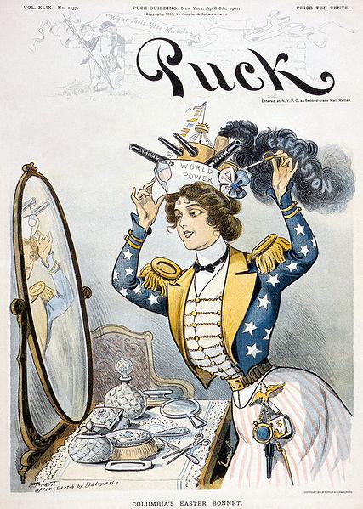

Cover of Puck magazine, April 6, 1901. The Columbia figure was a widely used depiction of the United States in political cartoons. In this image, Columbia is wearing a hat shaped as a ship that reads “World Power.” This image is a pro-imperialist view on the expansion of U. S. naval power.

Source W: Excerpts from the Monroe Doctrine, 1823
Text | Vocabulary | Guiding Questions
. . . [A]s a principle in which the rights and interests of the United States are involved, that the American continents, by the free and independent condition which they have assumed and maintain, are henceforth not to be considered as subjects for future colonization by any European powers. . .  . . . In the wars of the European powers in matters relating to themselves we have never taken any part, nor does it comport with our policy to do so. . .We. . . declare that we should consider any attempt on their part to extend their system to any portion of this hemisphere as dangerous to our peace and safety. With the existing colonies or dependencies of any European power we have not interfered and shall not interfere. But with the Governments who have declared their independence and maintain it, and whose independence we have, on great consideration and on just principles, acknowledged, we could not view any interposition for the purpose of oppressing them, or controlling in any other manner their destiny, by any European power in any other light than as the manifestation of an unfriendly disposition toward the United States. In the war between those new Governments and Spain we declared our neutrality at the time of their recognition, and to this we have adhered, and shall continue to adhere, provided no change shall occur which, in the judgement of the competent authorities of this Government, shall make a corresponding change on the part of the United States indispensable to their security. . . | henceforth: from now on | Which region does President Monroe declare is no longer open for colonization by European countries?  ________________________________  ________________________________  ________________________________  How does President Monroe describe the past policy of the United States in regard to European conflicts?  ________________________________  ________________________________  ________________________________  ________________________________  How does President Monroe justify keeping European countries out of the Western Hemisphere?  ________________________________  ________________________________  ________________________________  ________________________________  ________________________________

*Note: Roosevelt’s Corollary to the Monroe Doctrine was part of President Theodore Roosevelt’s annual State of Union address in 1904. It is an extension of the foreign policy articulated in the Monroe Doctrine.

Source X: Excerpts from Theodore Roosevelt's Corollary to the Monroe Doctrine, 1905
Text | Vocabulary | Guiding Questions
. . . It is not true that the United States feels any land hunger or entertains any projects as regards the other nations of the Western Hemisphere save such as are for their welfare. All that this country desires is to see the neighboring countries stable, orderly, and prosperous. Any country whose people conduct themselves well can count upon our hearty friendship. If a nation shows that it knows how to act with reasonable efficiency and decency in social and political matters, if it keeps order and pays its obligations, it need fear no interference from the United States. Chronic wrongdoing, or an impotence which results in a general loosening of the ties of civilized society, may in America, as elsewhere, ultimately require intervention by some civilized nation, and in the Western Hemisphere the adherence of the United States to the Monroe Doctrine may force the United States, however reluctantly, in flagrant cases of such wrongdoing or impotence, to the exercise of an international police power. . . We would interfere with them only in the last resort, and then only if it became evident that their inability or unwillingness to do justice at home and abroad had violated the rights of the United States or had invited foreign aggression to the detriment of the entire body of American nations. It is a mere truism to say that every nation, whether in America or anywhere else, which desires to maintain its freedom, its independence, must ultimately realize that the right of such independence cannot be separated from the responsibility of making good use of it. | impotence: inability to take action, helplessness  flagrant: shockingly obvious | According to President Roosevelt, what is the role of the United States in the Western Hemisphere?  ________________________________  ________________________________  ________________________________  ________________________________  ________________________________  ________________________________  ________________________________  ________________________________  ________________________________  ________________________________  What does President Roosevelt mean by “international police power”?  ________________________________  ________________________________  ________________________________  ________________________________  ________________________________  ________________________________
Source Y: “The World Constable”
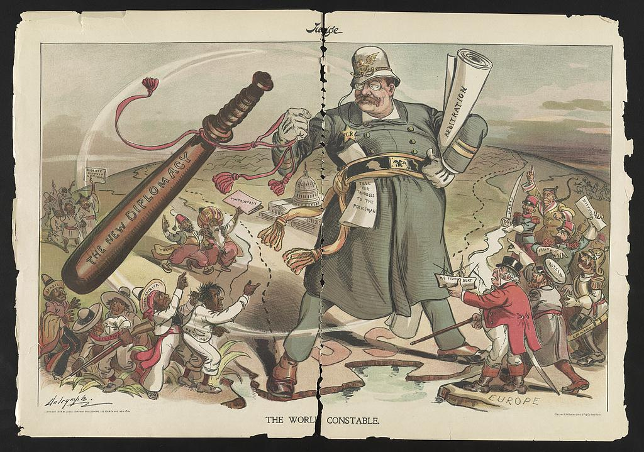
Print shows President Theodore Roosevelt as a constable (police officer) standing between Europe, Latin America, Asia, and Africa with a police baton labeled The New Diplomacy. The illustration appeared in Judge magazine in 1904.

Source Z: “Patterns of American Interventions”
Text | Vocabulary | Guiding Questions
The United States had long been involved in Pacific commerce. American ships had been traveling to China, for instance, since 1784. As a percentage of total American foreign trade, Asian trade remained comparatively small, and yet the idea that Asian markets were vital to American commerce affected American policy and, when those markets were threatened, prompted interventions. In 1899, secretary of state John Hay articulated the Open Door Policy, which called for all Western powers to have equal access to Chinese markets. Hay feared that other imperial powers—Japan, Great Britain, Germany, France, Italy, and Russia—planned to carve China into spheres of influence. It was in the economic interest of American business to maintain China for free trade. |  | What was the purpose of the Open Door Policy?  ________________________________  ________________________________  ________________________________  ________________________________  ________________________________  ________________________________  ________________________________  ________________________________  ________________________________

After you read:

1. How did Turner’s thesis contribute to U.S. imperialism?

2. How did the Roosevelt Corollary reflect both continuity and change with previous policy?

Formative Performance Task #1 – Constructed Response
Student Directions | Identify and describe three factors that motivated U.S. imperialism.

Lesson 5
Supporting Question 2: What were some actions taken by the United States
During the era of New Imperialism?
Student Directions | Read and study Source AA. Then, read Sources AB, AC, and AD and answer the guiding questions in the right-hand columns.
Featured Sources | Source AA: “U.S. Imperial Acquisitions, 1898”  Source AB: Adapted from “Hawaiian Annexation”  Source AC: Excerpts from Chapter 44 of Hawaii’s Story by Hawaii’s Queen by Liliuokalani  Source AD: “Page 6 of Men's Petition Against Annexation of Hawaii, September 11, 1897”

Source AA: “U.S. Imperial Acquisitions, 1898”
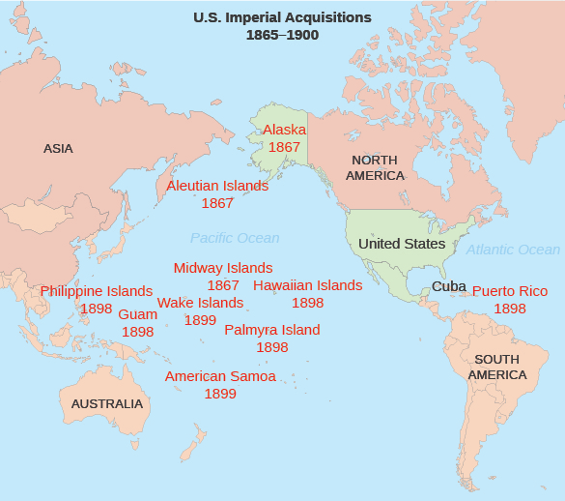
Note how the spread of island acquisitions across the Pacific Ocean fulfills Alfred Mahan’s call for more naval bases in order to support a larger and more effective U.S. Navy rather than mere territorial expansion.

Source AB: Adapted from “Hawaiian Annexation”
Text | Vocabulary | Guiding Questions
By the time the United States got serious about looking beyond its own borders to conquer new lands, much of the world had already been claimed. Only a few distant territories in Africa and Asia and remote islands in the Pacific remained free from imperial grasp. Hawaii, led by a hereditary monarch, remained an independent state.  Interest in Hawaii began in America as early as the 1820s, when New England missionaries tried in earnest to spread their faith. Since the 1840s, keeping European powers out of Hawaii became a principal foreign policy goal. Americans acquired a true foothold in Hawaii as a result of the sugar trade. The United States government provided generous terms to American sugar growers in Hawaii, and after the Civil War, profits began to swell. A turning point in U.S.-Hawaiian relations occurred in 1890, when Congress approved the McKinley Tariff, which raised import rates on foreign sugar. Sugar planters in Hawaii, mostly white Americans, were now being undersold in the American market, and as a result, a depression swept the islands. The sugar growers knew that if Hawaii were annexed by the United States, the tariff problem would naturally disappear. At the same time, the Hawaiian throne was passed to Queen Liliuokalani, who determined that the root of Hawaii's problems was foreign interference. A great showdown was about to unfold.  Annexing Hawaii  In January 1893, the American planters staged an uprising to overthrow the queen. At the same time, they appealed to the United States armed forces for protection. Without presidential approval, marines stormed the islands, and the American minister to the islands raised the flag of the United States in Honolulu. The queen was forced to abdicate, and the matter was left for Washington politicians to settle. By this time, Grover Cleveland had been inaugurated president. Cleveland was an outspoken anti-imperialist and thought Americans had acted shamefully in Hawaii. He withdrew the annexation treaty from the Senate and ordered an investigation into potential wrongdoings. Cleveland aimed to restore Liliuokalani to her throne, but American public sentiment strongly favored annexation.  The matter was prolonged until after Cleveland left office. When war broke out with Spain in 1898, the military significance of Hawaiian naval bases as a way station to the Spanish Philippines outweighed all other considerations. President William McKinley signed a joint resolution annexing the islands, much like the manner in which Texas joined the Union in 1845. Hawaii remained a territory until granted statehood as the fiftieth state in 1959. | earnest: serious intention  foothold: a secure position from which further progress may be made  abdicate: give up power | What economic interest did the United States have in Hawaii?  ________________________________  ________________________________  ________________________________  ________________________________  ________________________________  ________________________________  ________________________________  ________________________________  ________________________________  ________________________________  How did American sugar growers take over Hawaii?  ________________________________  ________________________________  ________________________________  ________________________________  ________________________________  ________________________________  ________________________________  ________________________________  ________________________________  ________________________________  ________________________________  ________________________________  ________________________________  ________________________________  What event led President William McKinley to annex Hawaii? Why was Hawaii beneficial to the United States?  ________________________________  ________________________________  ________________________________  ________________________________  ________________________________  ________________________________

Source AC: Excerpts from Chapter 44 of Hawaii’s Story by Hawaii’s Queen by Liliuokalani
Text | Vocabulary | Guiding Questions
...About the 22d of January a paper was handed to me by Mr. Wilson, which, on examination, proved to be a purported act of abdication for me to sign. It had been drawn out for the men in power by their own lawyer, Mr. A. S. Hartwell, whom I had not seen until he came with others to see me sign it. The idea of abdicating never originated with me. I knew nothing at all about such a transaction until they sent to me, by the hands of Mr. Wilson, the insulting proposition written in abject terms. For myself, I would have chosen death rather than to have signed it; but it was represented to me that by my signing this paper all the persons who had been arrested, all my people now in trouble by reason of their love and loyalty towards me, would be immediately released. . .  My persecutors have stated, and at that time compelled me to state, that this paper was signed and acknowledged by me after consultation with my friends whose names appear at the foot of it as witnesses.  ...I did as they commanded. Their motive in this as in other actions was plainly to humiliate me before my people and before the world... Although it was written in the document that it was my free act and deed, circumstances prove that it was not; it had been impressed upon me that only by its execution could the lives of those dear to me, those beloved by the people of Hawaii, be saved. | abject: without pride or dignity  persecutors: people who harass or punish another  impressed: pressure used to convince | Describe the events of Queen Liliuokalani’s abdication.  ________________________________  ________________________________  ________________________________  ________________________________  ________________________________  ________________________________  ________________________________  ________________________________  ________________________________  ________________________________  ________________________________  ________________________________  ________________________________  ________________________________  ________________________________

*Note: The Hui Aloha Aina for Women and the Hui Aloha Aina for Men organized a mass petition drive. They hoped that if the U.S. government realized that the majority of native Hawaiian citizens opposed annexation, the move to annex Hawaii would be stopped. Between September 11 and October 2, 1897, the two groups collected petition signatures at public meetings held on each of the five principal islands of Hawaii. The petition, clearly marked "Petition Against Annexation" and written in both the Hawaiian and English languages, was signed by 21,269 native Hawaiian people, or more than half the 39,000 native Hawaiians and mixed-blood persons reported by the Hawaiian Commission census for the same year.

Source AD: “Page 6 of Men's Petition Against Annexation of Hawaii, September 11, 1897”
Text | Vocabulary | Guiding Questions
To his Excellency William McKinley, President, and the Senate of the United States of America  Greetings -  Whereas there has been submitted to the Senate of the United States of America a Treaty for the Annexation of the Hawaiian Islands to the said United States of America for consideration at its regular session in December 1897; therefore  We the undersigned native Hawaiian citizens and residents of the District of Honolulu on the island of Oahu who are members of the Hawaiian Patriotic League of the Hawaiian Islands and others who are in sympathy with the said league earnestly protest against the annexation of the said Hawaiian Islands to the United States of America in any form or shape. |  | How did the Native Hawaiians who signed this petition feel about the United States annexing Hawaii?  ________________________________  ________________________________  ________________________________  ________________________________  ________________________________  ________________________________  What does this petition say about the actions the United States took in Hawaii in 1898?  ________________________________  ________________________________  ________________________________  ________________________________  ________________________________

Lesson 6
Supporting Question 2: What were some actions taken by the United States
during the era of New Imperialism?
Student Directions | Read Sources AE and AF and answer the guiding questions in the right-hand columns.
Featured Sources | Source AE: “The Spanish American War”  Source AF: Excerpts from the Platt Amendment

Source AE: “The Spanish American War”
Text | Vocabulary | Guiding Questions
Although the United States had a long history of international economic, military, and cultural engagement that stretched back deep into the eighteenth century, the Spanish-American and Philippine-American Wars (1898–1902) marked a crucial turning point in American interventions abroad. In pursuing war with Spain, and then engaging in counterrevolutionary conflict in the Philippines, the United States expanded the scope and strength of its global reach. Over the next two decades, the United States would become increasingly involved in international politics, particularly in Latin America. These new conflicts and ensuing territorial problems forced Americans to confront the ideological elements of imperialism. Should the United States act as an empire? Or were foreign interventions and the taking of territory antithetical to its founding democratic ideals? The Spanish-American and Philippine-American Wars brought these questions, which had always lurked behind discussions of American expansion, out into the open.  In 1898, Americans began in earnest to turn their attention southward to problems plaguing their neighbor, Cuba. Since the middle of the nineteenth century, Cubans had tried unsuccessfully again and again to gain independence from Spain. The latest uprising, and the one that would prove fatal to Spain’s colonial designs, began in 1895 and was still raging in the winter of 1898. By that time, in an attempt to crush the uprising, Spanish general Valeriano Weyler y Nicolau had been conducting a policy of reconcentration—forcing Cubans living in certain cities to relocate to military camps—for about two years.  Americans were largely sympathetic to the Cuban rebels’ cause, especially as the Spanish response was notably brutal. Evoking the same rhetoric of independence with which they fought the British during the American Revolution, several people quickly rallied to the Cuban fight for freedom. Shippers and other businessmen, particularly in the sugar industry, supported American intervention to safeguard their own interests in the region. Likewise, the “Cuba Libre” movement founded by José Martí, who quickly established offices in New York and Florida, further stirred American interest in the liberation cause. The difference in this uprising, however, was that supporters saw in the renewed U.S. Navy a force that could be a strong ally for Cuba. Additionally, American newspapers, eager to sell copies, whipped the public into a frenzy against the Spanish by reporting sensational stories (both true and untrue) in a practice known as yellow journalism. The oppressed Cubans, they claimed, were suffering at the hands of European tyrants just as the United States had done before the American Revolution.  In order to protect Americans and their assets in Cuba during the chaos, the United States sent the warship USS Maine into Havana harbor. Just nine days after its arrival, the Maine exploded, killing 260 American sailors. Immediately, yellow journalists jumped on the headline that the explosion was the result of a Spanish attack, and that all Americans should rally to war. The newspaper battle cry quickly emerged, “Remember the Maine!” The Spanish claimed, correctly, that the explosion had been the result of a malfunction aboard the ship, but Americans were convinced that the Maine had been destroyed by Spanish sabotage.  McKinley made one final effort to avoid war, when late in March, he called on Spain to end its policy of concentrating the native population in military camps in Cuba, and to formally declare Cuba’s independence. Spain refused, leaving McKinley little choice but to request a declaration of war from Congress on April 11, 1898. In order to prevent the possibility of U.S. annexation of Cuba, Congress passed the Teller Amendment, which proclaimed that the United States would help the Cuban people gain their freedom from Spain but would not annex the island after victory.  Although America’s war effort began haphazardly, Spain’s decaying military crumbled. Military victories for the United States came quickly. In the Pacific, on May 1, Commodore George Dewey engaged the Spanish fleet outside Manila, the capital of the Philippines (another Spanish colonial possession), destroyed it, and proceeded to blockade Manila harbor. Two months later, American troops took Cuba’s San Juan Heights in what would become the most well-known battle of the war, winning fame not for regular soldiers but for the irregular, especially Theodore Roosevelt and his Rough Riders. Roosevelt had been the assistant secretary of the navy but had resigned his position in order to see action in the war. His actions in Cuba made him a national celebrity. As disease began to eat away at American troops, the Spanish suffered the loss of Santiago de Cuba on July 17, effectively ending the war. Secretary of State John Hay memorably referred to the conflict as a “splendid little war,” and at the time it certainly appeared that way. Fewer than four hundred Americans died in battle in a war that lasted about fifteen weeks.  In the fall and winter of 1898, diplomats representing Spain and the United States met to hash out the terms of peace. In the Treaty of Paris, Spain agreed to free Cuba, and to cede the islands Guam and Puerto Rico to the United States. In addition, the United States agreed to pay Spain $20 million for the Philippines (which the Spanish wanted back as the Americans had captured Manila after the August 12 armistice, due to delayed communications). The United States had become an empire.  Tellingly, neither Cuban nor Filipino representatives were permitted to participate in the negotiations. Would the United States uphold its commitment to Cuba's freedom, or would it take Spain's place as a distant oppressor? The answer was a little bit of both: although the United States did not annex Cuba outright, it did force Cubans to recognize American control in their new Constitution. In the Platt Amendment, Cuba agreed to permit American diplomatic, economic, and military intervention and to lease Guantánamo Bay for American use.  For Filipinos, who had allied with U.S. forces to oust Spain, the outcome of the war was a cruel joke. Although the Americans were unwilling to allow the Philippines to remain in the hands of the Spanish, they were also unwilling to give Filipinos their freedom. U.S. politicians believed that their "little brown brothers" (as future American President William H. Taft called them) were incapable of self-government.  The Filipinos quickly realized they had traded one imperial power for another, and turned their rebellion against the United States. For two years, the United States fought to put down the Filipino insurrection, ironically resorting to the same tactics that the Spanish had used against the Cubans. In 1901, the United States defeated the rebels, and the Philippines became an American territory.  What did it mean to be an American territory? It wasn't quite clear; before the Spanish-American War, the United States had never annexed territory without the expectation that it would achieve eventual statehood. For Puerto Ricans, it meant they had American citizenship (eventually) but not self-rule. Filipinos were never given citizenship, but were finally granted independence in 1946. | counterrevo-lutionary: engaged in preventing or stopping a revolution of a people  antithetical: directly opposite of  reconcentra-tion: Spanish troops forced Cubans into camps; many Cubans died from the harsh conditions in the camps.  Cuba Libre: “free Cuba”  sensational: shocking, exaggerated  yellow journalism: newspapers who used sensationa-lized, and sometimes untrue, stories to sell papers | How were the Spanish-American and Philippine-American Wars a shift in foreign policy for the United States?  ________________________________  ________________________________  ________________________________  ________________________________  ________________________________  ________________________________  ________________________________  ________________________________  ________________________________  ________________________________  Describe Spain’s treatment of Cubans.  ________________________________  ________________________________  ________________________________  ________________________________  ________________________________  ________________________________  ________________________________  Other than helping the Cubans, what other factors led to support for U.S. intervention in Cuba?  ________________________________  ________________________________  ________________________________  ________________________________  ________________________________  ________________________________  ________________________________  What role did “yellow journalism” play in the start of the Spanish-American War?  ________________________________  ________________________________  ________________________________  ________________________________  ________________________________  ________________________________  ________________________________  ________________________________  ________________________________  ________________________________  ________________________________  What did the Teller Amendment promise?  ________________________________  ________________________________  ________________________________  ________________________________  ________________________________  What was Theodore Roosevelt’s position in the Spanish-American War?  ________________________________  ________________________________  ________________________________  What were the results of the Spanish-American War?  ________________________________  ________________________________  ________________________________  ________________________________  ________________________________  ________________________________  ________________________________  After the Spanish-American War, what actions did the United States take in Cuba?  ________________________________  ________________________________  ________________________________  ________________________________  ________________________________  ________________________________  ________________________________  ________________________________  ________________________________  ________________________________  ________________________________  ________________________________  ________________________________  After the Spanish-American War, what actions did the United States take in the Philippines?  ________________________________  ________________________________  ________________________________  ________________________________  ________________________________  ________________________________  ________________________________  ________________________________  ________________________________  ________________________________  ________________________________  ________________________________

Painting depicting the sinking of the USS Maine
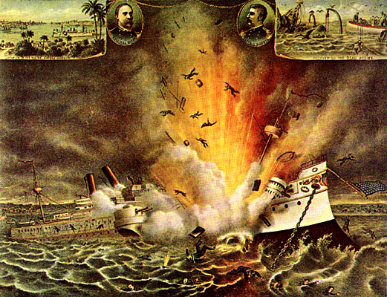

Source AF: Excerpts from the Platt Amendment
Text | Vocabulary | Guiding Questions
Whereas the Congress of the United States of America, by an Act approved March 2, 1901, provided as follows:  Provided further, That in fulfillment of the declaration contained in the joint resolution approved April twentieth, eighteen hundred and ninety-eight, entitled "For the recognition of the independence of the people of Cuba, demanding that the Government of Spain relinquish its authority and government in the island of Cuba, and withdraw its land and naval forces from Cuba and Cuban waters, and directing the President of the United States to use the land and naval forces of the United States to carry these resolutions into effect," the President is hereby authorized to "leave the government and control of the island of Cuba to its people" so soon as a government shall have been established in said island under a constitution which, either as a part thereof or in an ordinance appended thereto, shall define the future relations of the United States with Cuba, substantially as follows:  "I.-That the government of Cuba shall never enter into any treaty or other compact with any foreign power or powers which will impair or tend to impair the independence of Cuba. . .”  "II. That said government shall not assume or contract any public debt. . .”  "III. That the government of Cuba consents that the United States may exercise the right to intervene for the preservation of Cuban independence, the maintenance of a government adequate for the protection of life, property, and individual liberty. . .”  "IV. That all Acts of the United States in Cuba during its military occupancy thereof are ratified and validated, and all lawful rights acquired thereunder shall be maintained and protected."  "V. That the government of Cuba will execute, and as far as necessary extend, the plans already devised or other plans to be mutually agreed upon, for the sanitation of the cities of the island, to the end that a recurrence of epidemic and infectious diseases. . .”  "VII. That to enable the United States to maintain the independence of Cuba, and to protect the people thereof, as well as for its own defense, the government of Cuba will sell or lease to the United States lands necessary for coaling or naval stations at certain specified points to be agreed upon with the President of the United States."  "VIII. That by way of further assurance the government of Cuba will embody the foregoing provisions in a permanent treaty with the United States." |  | What did the government of Cuba have to include in the Constitution of Cuba in order for the United States to “leave the government and control of the island to its people”?  ________________________________  ________________________________  ________________________________  ________________________________  ________________________________  ________________________________  ________________________________  ________________________________  ________________________________  ________________________________  ________________________________  ________________________________  ________________________________  ________________________________  ________________________________  ________________________________  ________________________________  Did Cuba gain control of their island by agreeing to the terms of the Platt Amendment? Explain your answer using evidence from the text.  ________________________________  ________________________________  ________________________________  ________________________________  ________________________________  ________________________________  ________________________________  ________________________________  ________________________________  ________________________________  ________________________________  ________________________________

Lesson 7
Supporting Question 2: What were some actions taken by the United States
During the era of New Imperialism?
Student Directions | Read Source AG and answer the guiding questions in the right-hand column. Then, read and study Source AH. Finally, complete the after you read questions at the end of this lesson.
Featured Sources | Source AG: “General Jacob H. Smith & the Philippine War’s Samar Campaign American Imperialism at the Washington Hotel”  Source AH: Cover of Life magazine, May 22, 1902

Source AG: “General Jacob H. Smith & the Philippine War’s Samar Campaign

American Imperialism at the Washington Hotel”
Text | Vocabulary | Guiding Questions
The Philippine War, which lasted from 1899 through 1913, resulted from the foreign policy of a group of imperialists within the Republican Party of President William McKinley. After their quick victory in the Spanish-American War in 1898, the United States found themselves playing the part of an occupying army on the Philippine Islands, far away from the mainland in the South Pacific. A Filipino independence movement had been working to overthrow their Spanish colonizers for years. Emilio Aguinaldo, the charismatic leader of the movement, provided critical aid to the Americans during their war with Spain. But, when US forces did not withdraw from the islands and the US government did not recognize Philippine independence, Aguinaldo and his compatriots rose up against the United States and what they viewed to be a colonial occupying army.  It was a choice, ultimately the Ohioan McKinley’s choice, to annex the Philippine archipelago and deny the Filipinos their independence. As he famously explained in an interview with a Christian missionary magazine, “there was nothing left for us to do but to take them all, and to educate the Filipinos, and uplift and civilize and Christianize them, and by God’s grace do the very best we could by them, as our fellow-men for whom Christ also died.” Shouldering what was then known as the “White man’s Burden,” McKinley and the imperialists chose to conquer these far off islands in the Pacific and more Americans died fighting the Filipino insurgents than had died fighting the Spanish.  General Jacob Hurd Smith led American forces during one of the most brutal and controversial campaigns of the war. The Samar Campaign of 1902 was an offensive aimed at punishing and crushing the insurgency on the Island of Samar. An American garrison in the town of Balangiga had been attacked in September 1901 by the local population, with the support of the local police chief and members of the insurgency. The people of Balangiga had apparently revolted in reaction to their abuse at the hands of the American soldiers. The US commander at Balangiga had sent troops out to destroy crops and grain reserves, to keep such food from flowing into the hands of the insurgents; he had also ordered all males over the age of thirteen, at gun-point, to work at clearing brush and repairing the streets of the town.  Fifty-four of the seventy-eight American troops stationed at Balangiga were killed; their bodies were mutilated and burned; only four escaped uninjured. The massacre and mutilation of Americans triggered a massive response that left Samar in tatters and General Smith seated before a court-martial. The Balangiga Massacre occurred two months after the government of the Philippines was transferred from the US military to US civilian authorities, headed by future President William Howard Taft. Aguinaldo had been captured in March of 1901 and it was hoped that the transition to civilian rule marked the beginning of the end of the war. The Balangiga Massacre, however, ended all talk about the reduction of troop levels in the Philippines.  Jacob Smith took command of troops in the Philippines, where he was promoted to Brigadier-General in March of 1901. After fighting a number of successful campaigns against the Filipino insurgents, Smith was given the task of crushing the resistance on Samar and exacting revenge for the deaths of the American soldiers at Balangiga.  The Manila News reported on 4 November 1902, that General Smith ordered all inhabitants of Samar’s interior to relocate to coastal towns, “saying that those who were found outside would be shot and no questions asked. …. All suspects, including Spaniards and half-breeds, were rounded up in big stockades and kept under guard.” At the same time, Smith cut off all food shipments and trade from the towns into the backcountry, carrying out a policy designed to starve the resistance into submission. Detachments of American troops then traversed the island’s interior, in search of rebel bands, burning villages and destroying crops and livestock.  It was not these general policies that ended up getting Smith into trouble; rather, it was the specific orders he gave to one of his main subordinates, Marine Major Littleton W. T. Waller. At the beginning of the campaign when officers had gathered at the site of the Balangiga Massacre, Smith told Waller, “I want no prisoners. I wish you to kill and burn; the more you kill and burn the better it will please me. …. I want all persons killed who are capable of bearing arms in actual hostilities against the United States.” When Waller asked Smith to set an age limit for the kill orders, Smith said, “Kill everyone over ten.” Smith would later send Waller a written order “that the interior of Samar must be made a howling wilderness.” During the four and half month-long campaign, an estimated 15,000 Filipinos died on Samar as a result of the actions of US forces.  The Samar Controversy hit the American press just when the US Senate was investigating the abuse of Filipino prisoners of war by the American military. Soldiers back from the islands testified to having observed and participated in the torture of prisoners. They described the common practice of the so-called “water cure.” |  | Why did Emilio Aguinaldo fight against the United States after the Spanish-American War?  ________________________________  ________________________________  ________________________________  ________________________________  ________________________________  ________________________________  ________________________________  ________________________________  ________________________________  ________________________________  How did President McKinley justify U.S. actions in the Philippines?  ________________________________  ________________________________  ________________________________  ________________________________  ________________________________  ________________________________  ________________________________  Why did people in Balangiga revolt against U.S. rule?  ________________________________  ________________________________  ________________________________  ________________________________  Describe the events of the Balangiga Massacre.  ________________________________  ________________________________  ________________________________  ________________________________  ________________________________  ________________________________  ________________________________  ________________________________  What was the effect of the Balangiga Massacre on the U.S. war in the Philippines?  ________________________________  ________________________________  ________________________________  ________________________________  ________________________________  ________________________________  What were the results of the actions taken by the U.S. Military under General Smith?  ________________________________  ________________________________  ________________________________  ________________________________  ________________________________  ________________________________  ________________________________  ________________________________  ________________________________  ________________________________  ________________________________  ________________________________  ________________________________  ________________________________  ________________________________  ________________________________  ________________________________  ________________________________  ________________________________  ________________________________  ________________________________  ________________________________  ________________________________

Source AH: Cover of Life magazine, May 22, 1902
This political cartoon depicts the application of the "water cure" by United States Army soldiers on a Filipino. In the background soldiers representing various European nations look on smiling. The Europeans say, "Those pious Yankees can't throw stones at us any more," meaning that the United States no longer has the moral standing to criticize European colonial practices.
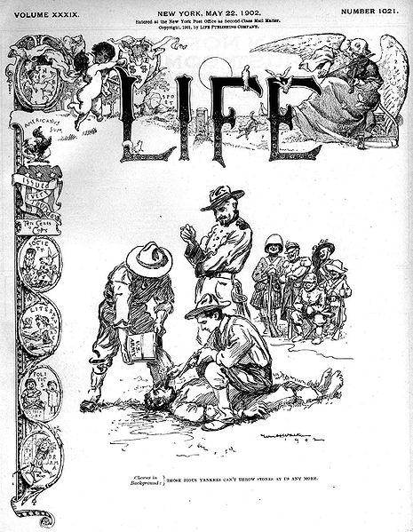

After you read:

1. How did the actions taken by the U.S. military in the Philippine-American War contradict U.S. principles?

2. Did the Philippine-American War represent a change in U.S. policy? Why or why not?

Lesson 8
Supporting Question 2: What were some actions taken by the United States
During the era of New Imperialism?
Student Directions | Read Source AI and answer the guiding questions in the right-hand column. Study and read Source AJ. Study and read Source AK and answer the question below the source. Then, complete performance task #2 at the end of this lesson.
Featured Sources | Source AI: “Roosevelt’s ‘Big Stick’ Foreign Policy”  Source AJ: “The Big Stick in the Caribbean Sea”  Source AK: “The News Reaches Bogota”

Source AI: “Roosevelt’s ‘Big Stick’ Foreign Policy”
Text | Vocabulary | Guiding Questions
While President McKinley ushered in the era of the American empire through military strength and economic coercion, his successor, Theodore Roosevelt, established a new foreign policy approach, allegedly based on a favorite African proverb, “speak softly, and carry a big stick, and you will go far.” At the crux of his foreign policy was a thinly veiled threat. Roosevelt believed that in light of the country’s recent military successes, it was unnecessary to use force to achieve foreign policy goals, so long as the military could threaten force.  Roosevelt believed that while the coercive power wielded by the United States could be harmful in the wrong hands, the Western Hemisphere’s best interests were also the best interests of the United States. He felt, in short, that the United States had the right and the obligation to be the policeman of the hemisphere. This belief, and his strategy of “speaking softly and carrying a big stick,” shaped much of Roosevelt’s foreign policy.  The Construction of the Panama Canal  As early as the mid-sixteenth century, interest in a canal across the Central American isthmus began to take root, primarily out of trade interests. The subsequent discovery of gold in California in 1848 further spurred interest in connecting the Atlantic and Pacific Oceans, and led to the construction of the Panama Railway, which began operations in 1855. Several attempts by France to construct a canal between 1881 and 1894 failed due to a combination of financial crises and health hazards, including malaria and yellow fever, which led to the deaths of thousands of French workers.  Upon becoming president in 1901, Roosevelt was determined to succeed where others had failed. Following the advice that Mahan set forth in his book The Influence of Seapower upon History, he sought to achieve the construction of a canal across Central America, primarily for military reasons associated with empire, but also for international trade considerations. The most strategic point for the construction was across the fifty-mile isthmus of Panama, which, at the turn of the century, was part of the nation of Colombia. Roosevelt negotiated with the government of Colombia, sometimes threatening to take the project away and build through Nicaragua, until Colombia agreed to a treaty that would grant the United States a lease on the land across Panama in exchange for a payment of $10 million and an additional $250,000 annual rental fee. The matter was far from settled, however. The Colombian people were outraged over the loss of their land to the United States, and saw the payment as far too low. Influenced by the public outcry, the Colombian Senate rejected the treaty and informed Roosevelt there would be no canal.  Undaunted, Roosevelt chose to now wield the “big stick.” In comments to journalists, he made it clear that the United States would strongly support the Panamanian people should they choose to revolt against Colombia and form their own nation. In November 1903, he even sent American battleships to the coast of Colombia, ostensibly for practice maneuvers, as the Panamanian revolution unfolded. The warships effectively blocked Colombia from moving additional troops into the region to quell the growing Panamanian uprising. Within a week, Roosevelt immediately recognized the new country of Panama, welcoming them to the world community and offering them the same terms—$10 million plus the annual $250,000 rental fee—he had previously offered Colombia. Following the successful revolution, Panama became an American protectorate, and remained so until 1939.  Once the Panamanian victory was secured, with American support, construction on the canal began in May 1904. | coercion: persuasion through force or threats  protectorate: a stronger state protects and partially controls a weaker state | In your own words, describe President Theodore Roosevelt’s foreign policy and his views on the role of the United States in the world.  ________________________________  ________________________________  ________________________________  ________________________________  ________________________________  ________________________________  ________________________________  ________________________________  ________________________________  ________________________________  ________________________________  ________________________________  ________________________________  ________________________________  ________________________________  ________________________________  ________________________________  Describe the canal construction deal that President Roosevelt originally negotiated with Columbia. Why was this deal rejected?  ________________________________  ________________________________  ________________________________  ________________________________  ________________________________  ________________________________  ________________________________  ________________________________  ________________________________  How did President Roosevelt use “big stick” policy to gain the land needed to build the Panama Canal?  ________________________________  ________________________________  ________________________________  ________________________________  ________________________________  ________________________________  ________________________________  ________________________________  ________________________________  ________________________________  ________________________________  ________________________________

Source AJ: “The Big Stick in the Caribbean Sea”
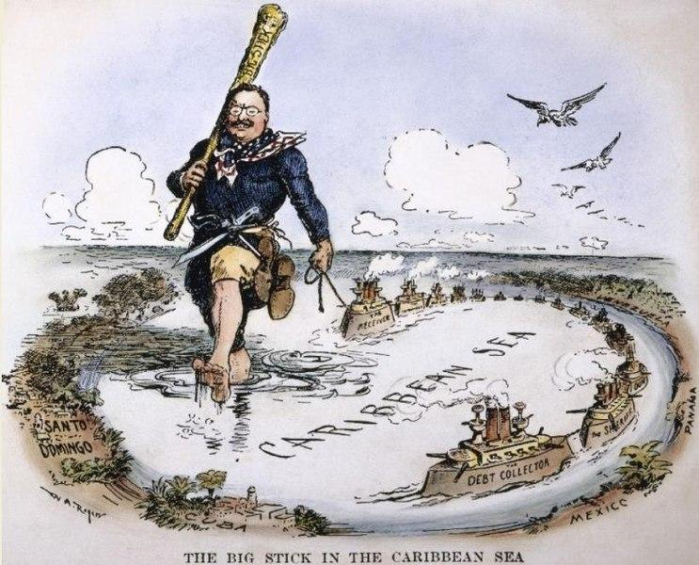
The political cartoon above is a representation of Roosevelt’s foreign policy, in which he backs up his speech with military might, in the Caribbean Sea.

Source AK: “The News Reaches Bogota”
Bogata is the capital of Columbia. The ships in the foreground may represent American battleships or commercial shipping vessels. The large figure digging through the land is President Theodore Roosevelt. The smaller figure holding the sign that reads “New Treaty” refers to negotiations between Columbia and the United States for a new treaty before Roosevelt supported the Panama independence attempt.
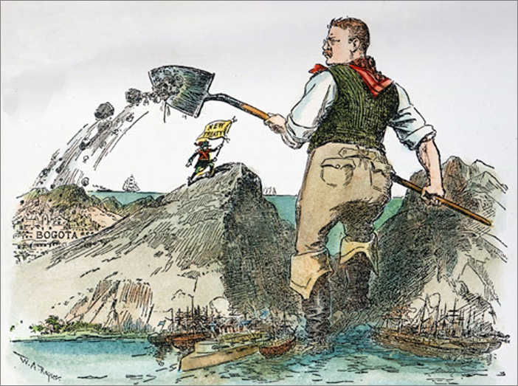

Does the illustrator of the above cartoon support President Roosevelt’s actions in Columbia? Why or why not? Explain your answer using evidence from the cartoon.

__________________________________________________________________________________________________

__________________________________________________________________________________________________

__________________________________________________________________________________________________

__________________________________________________________________________________________________

__________________________________________________________________________________________________

Formative Performance Task #2
Student Directions | Identify one action taken by the United States and the result of that action in each of the following: Hawaii, Cuba, Philippines, and Panama.

 | Action taken | Result
Hawaii
Cuba
Philippines
Panama

Lesson 9
Supporting Question 3: What characterized the opposition to imperialism?
Student Directions | Read Sources AL, AM, AN, and AO and answer the guiding questions in the right-hand columns. Then, complete performance task #3 at the end of this lesson.
Featured Sources | Source AL: Adapted from “Anti-Imperialism”  Source AM: “Platform of the American Anti­lmperialist League”  Source AN: From the New York Herald, by Mark Twain, October 15, 1900  Source AO: Excerpts from “Imperialism” by William Jennings Bryan, August 8, 1900

Source AL: Adapted from “Anti-Imperialism”
Text | Vocabulary | Guiding Questions
Debates about American imperialism dominated headlines and tapped into core ideas about American identity and the proper role of the United States in the larger world. Should a former colony, established on the principles of freedom, liberty, and sovereignty, become a colonizer itself? What was imperialism, anyway? Many framed the Filipino conflict as a Protestant, civilizing mission. Others framed American imperialism in the Philippines as nothing new, as simply the extension of a never-ending westward American expansion. It was simply destiny. Some saw imperialism as a way to reenergize the nation by asserting national authority and power around the globe. Others baldly recognized the opportunities the Philippine Islands presented for access to Asian markets. But critics grew loud. The American Anti-Imperialist League, founded in 1899 and populated by such prominent Americans as Mark Twain, Andrew Carnegie, and Jane Addams, protested American imperial actions and articulated a platform that decried foreign subjugation and upheld the rights of all to self-governance. Still others embraced anti-imperialist stances because of concerns about immigration and American racial identity, afraid that American purity stood imperiled by contact with strange and foreign peoples. For whatever reason, however, the onset or acceleration of imperialism was a controversial and landmark moment in American history. America had become a preeminent force in the world.  Although the most prominent public voices against imperialism were male, women made up a large proportion of the membership of organizations like the Anti-Imperialist League. For white women like Jane Addams and Josephine Shaw Lowell, anti-imperialist activism was an outgrowth of their work in opposition to violence and in support of democracy. Black female activists, meanwhile, generally viewed imperialism as a form of racial antagonism and drew parallels between the treatments of African Americans at home and, for example, Filipinos abroad. Indeed, Ida B. Wells viewed her anti-lynching campaign as a kind of anti-imperialist activism. | sovereignty: ability to govern oneself  subjugation: to make submissive  imperiled: in trouble | For what different reasons did people oppose imperialism? How were some anti-imperialist views themselves problematic?  ________________________________  ________________________________  ________________________________  ________________________________  ________________________________  ________________________________  ________________________________  ________________________________  ________________________________  ________________________________  ________________________________  ________________________________  ________________________________  What role did women play in the anti-imperialist movement? How were anti-imperialist views connected to domestic causes for activists such as Jane Addams and Ida B. Wells?  ________________________________  ________________________________  ________________________________  ________________________________  ________________________________  ________________________________

*Note: Mark Twain was an author and humorist most well-known for The Adventures of Tom Sawyer and
The Adventures of Huckleberry Finn.

Source AM: “Platform of the American Anti­lmperialist League”
Text | Vocabulary | Guiding Questions
We hold that the policy known as imperialism is hostile to liberty and tends toward militarism, an evil from which it has been our glory to be free. We regret that it has become necessary in the land of Washington and Lincoln to reaffirm that all men, of whatever race or color, are entitled to life, liberty and the pursuit of happiness. We maintain that governments derive their just powers from the consent of the governed. We insist that the subjugation of any people is "criminal aggression" and open disloyalty to the distinctive principles of our Government.  We earnestly condemn the policy of the present National Administration in the Philippines. It seeks to extinguish the spirit of 1776 in those islands. We deplore the sacrifice of our soldiers and sailors, whose bravery deserves admiration even in an unjust war. We denounce the slaughter of the Filipinos as a needless horror. We protest against the extension of American sovereignty by Spanish methods.  We demand the immediate cessation of the war against liberty, begun by Spain and continued by us. We urge that Congress be promptly convened to announce to the Filipinos our purpose to concede to them the independence for which they have so long fought and which of right is theirs.  . . .  Whether the ruthless slaughter of the Filipinos shall end next month or next year is but an incident in a contest that must go on until the Declaration of Independence and the Constitution of the United States are rescued from the hands of their betrayers. . .  We hold, with Abraham Lincoln, that "no man is good enough to govern another man without that other's consent. When the white man governs himself, that is self-government, but when he governs himself and also governs another man, that is more than self-government—that is despotism”. . . | militarism: belief in a strong military  1776: year the Declaration of Independence was written  deplore: regret  cessation: stop  despotism: the exercise of absolute power, especially in a cruel and oppressive way | Why does the Anti-Imperialist League view imperialism as opposed to the principles of the U.S. government?  ________________________________  ________________________________  ________________________________  ________________________________  ________________________________  ________________________________  What did the Anti-Imperialist League call for in the Philippines?  ________________________________  ________________________________  ________________________________  ________________________________  ________________________________  ________________________________  ________________________________  ________________________________  ________________________________  ________________________________  ________________________________  Why does the author reference President Abraham Lincoln?  ________________________________  ________________________________  ________________________________  ________________________________  ________________________________

Source AN: From the New York Herald, by Mark Twain, October 15, 1900
Text | Vocabulary | Guiding Questions
I left these shores, at Vancouver, a red-hot imperialist. I wanted the American eagle to go screaming into the Pacific. It seemed tiresome and tame for it to content itself with the Rockies. Why not spread its wings over the Philippines, I asked myself? And I thought it would be a real good thing to do.  I said to myself, here are a people who have suffered for three centuries. We can make them as free as ourselves, give them a government and country of their own, put a miniature of the American constitution afloat in the Pacific, start a brand new republic to take its place among the free nations of the world. It seemed to me a great task to which had addressed ourselves.  But I have thought some more, since then, and I have read carefully the treaty of Paris, and I have seen that we do not intend to free, but to subjugate the people of the Philippines. We have gone there to conquer, not to redeem. . .  It should, it seems to me, be our pleasure and duty to make those people free, and let them deal with their own domestic questions in their own way. And so I am an anti-imperialist. I am opposed to having the eagle put its talons on any other land. |  | Why did Mark Twain support imperialism at first?  ________________________________  ________________________________  ________________________________  ________________________________  ________________________________  ________________________________  ________________________________  ________________________________  Why did Mark Twain change his mind?  ________________________________  ________________________________  ________________________________  ________________________________  ________________________________  ________________________________  ________________________________

*Note: Some politicians expressed anti-imperialistic views. In this text, William Jennings Bryan expresses his concerns about expanding the United States.

Source AO: Excerpts from “Imperialism” by William Jennings Bryan, August 8, 1900
Text | Vocabulary | Guiding Questions
[86] “We make no hypocritical pretense of being interested in the Philippines solely on account of others. While we regard the welfare of these people as a sacred trust, we regard the welfare of the American people first. We see our duty to ourselves as well as to others. We believe in trade expansion. By every legitimate means within the province of government and constitution we mean to stimulate the expansion of our trade and open new markets.”  [87] This is the commercial argument. It is based upon the theory that war can be rightly waged for pecuniary advantage, and that it is profitable to purchase trade by force and violence. . . When Lord Howe asserted that the acts of Parliament which brought on the Revolution were necessary to prevent American trade from passing into foreign channels, Franklin replied:  [88] “To me it seems that neither the obtaining nor retaining of any trade, howsoever valuable, is an object for which men may justly spill each other’s blood; that the true and sure means of extending and securing commerce are the goodness and cheapness of commodities, and that the profits of no trade can ever be equal to the expense of compelling it and holding it by fleets and armies. I consider this war against us, therefore, as both unjust and unwise.”  [89] I place the philosophy of Franklin against the sordid doctrine of those who would put a price upon the life of an American soldier and justify a war of conquest upon the ground that it will pay. The democratic party is in favor of the expansion of trade. It would extend our trade by every legitimate and peaceful means; but it is not willing to make merchandise of human blood.  [90] But a war of conquest is as unwise as it is unrighteous. A harbor and coaling station in the Philippines would answer every trade and military necessity and such a concession could have been secured at any time without difficulty.  [91] It is not necessary to own people in order to trade with them. We carry on trade today with every part of the world, and our commerce has expanded more rapidly than the commerce of any European empire. We do not own Japan or China, but we trade with their people. We have not absorbed the republics of Central and South America, but we trade with them. It has not been necessary to have any political connections with Canada or the nations of Europe in order to trade with them. Trade cannot be permanently profitable unless it is voluntary. | pecuniary: having to do with money  sordid: vile, not moral | What is the pro-imperialism view William Jennings Bryan addresses in the text?  ________________________________  ________________________________  ________________________________  ________________________________  ________________________________  ________________________________  ________________________________  ________________________________  ________________________________  ________________________________  How does Bryan feel about going to war for financial gain?  ________________________________  ________________________________  ________________________________  ________________________________  ________________________________  ________________________________  ________________________________  Why does Bryan believe that “It is not necessary to own people in order to trade with them”?  ________________________________  ________________________________  ________________________________  ________________________________  ________________________________  ________________________________  ________________________________  ________________________________  ________________________________  ________________________________  ________________________________

Formative Performance Task #3 – Constructed Response
Student Directions | Identify and describe two arguments of anti-imperialists.

Lesson 10 – Summative Performance Task
Student Directions | Based on the sources from this packet and your knowledge of social studies, write an essay answering the following question: To what extent did U.S. policy shift in the era of New Imperialism?

Name________________________________________________ Date ________________
How “Roaring” Were the 1920s?
Introduction
Student Directions | Over the next two weeks, you will explore the sources in this packet to learn about cultural and economic trends of the United States during the 1920s. At the end of the packet, you will express your understanding by writing a response to the following question: How “roaring” were the 1920s? This packet includes four supporting questions which will help you develop your claim. After you read each text or analyze each image, you will be asked to answer questions about it. Some words are defined to help you better understand each source and answer the questions. Some sources have digital extensions, which are optional sources you can explore if you have internet access.

Lesson 1 – Setting the Context
Student Directions | First read and study Source A. Then, read Sources B and C and answer the guiding questions in the right-hand column. Finally, read and study Sources D and E.
Featured Sources | Source A: World War I Timeline  Source B: “Aftermath of World War I Globally”  Source C: “Aftermath of World War I in the United States”  Source D: “Step by Step”  Source E: The Evening World, November 8, 1919
Optional Digital Extensions | Khan Academy - U.S. Enters World War I  Khan Academy - World War I: Home front

Source A: World War I Timeline
June 28, 1914 | Archduke Franz Ferdinand was assassinated.
July 28, 1914 | Austria-Hungary declared war on Serbia, effectively starting World War I.
April 6, 1917 | United States entered World War I.
June 15, 1917 | Espionage Act of 1917 made it a crime to spread information that opposed the war effort.
May 16, 1918 | Sedition Act of 1918 made it illegal to “willfully utter, print, write or publish any disloyal, profane, scurrilous, or abusive language about the form of government of the United States or the Constitution of the United States, or the military or naval forces of the United States, or the flag of the United States, or the uniform of the Army or Navy of the United States” or to “willfully utter, print, write, or publish any language intended to incite, provoke, or encourage resistance to the United States, or to promote the cause of its enemies.”
June 28, 1919 | Treaty of Versailles ended World War I; Germany was blamed for causing the war and the Ottoman Empire broke apart.
Summer of 1919 | Known as “Red Summer,” racial violence and race riots occurred in cities throughout the United States.
January 10, 1920 | Proposed by Woodrow Wilson, the League of Nations was established as the first international cooperation organization.

Source B: “Aftermath of World War I Globally”
Text | Vocabulary | Guiding Questions
The American role in World War I was brief but decisive. While millions of soldiers went overseas, and many thousands paid with their lives, the country’s involvement was limited to the very end of the war. In fact, the peace process, with the international conference and subsequent ratification process, took longer than the time U.S. soldiers were “in country” in France. For the Allies, American reinforcements came at a decisive moment in their defense of the western front, where a final offensive had exhausted German forces. For the United States, and for Wilson’s vision of a peaceful future, the fighting was faster and more successful than what was to follow.  When the armistice was declared, a total of 117,000 American soldiers had been killed and 206,000 wounded. The Allies as a whole suffered over 5.7 million military deaths, primarily Russian, British, and French men. The Central powers suffered four million military deaths, with half of them German soldiers. The total cost of the war to the United States alone was in excess of $32 billion, with interest expenses and veterans’ benefits eventually bringing the cost to well over $100 billion. Economically, emotionally, and geopolitically, the war had taken an enormous toll.  In January 1918 Wilson announced his postwar peace plan before a joint session of Congress. Referring to what became known as the Fourteen Points, Wilson called for openness in all matters of diplomacy and trade, specifically, free trade, freedom of the seas, an end to secret treaties and negotiations, promotion of self-determination of all nations, and more. In addition, he called for the creation of a League of Nations to promote the new world order and preserve territorial integrity through open discussions in place of intimidation and war.  For six months, beginning in December 1918, Wilson remained in Paris to personally conduct peace negotiations. Although the French public greeted Wilson with overwhelming enthusiasm, other delegates at the conference had deep misgivings about the American president’s plans. Specifically, Great Britain, France, and Italy sought to obtain some measure of revenge against Germany for drawing them into the war, to secure themselves against possible future aggressions from that nation, and also to maintain or even strengthen their own colonial possessions. Great Britain and France in particular sought substantial monetary reparations, as well as territorial gains, at Germany’s expense. Japan also desired concessions in Asia, whereas Italy sought new territory in Europe. Finally, the threat posed by a Bolshevik Russia under Vladimir Lenin, and more importantly, the danger of revolutions elsewhere, further spurred on these allies to use the treaty negotiations to expand their territories and secure their strategic interests, rather than strive towards world peace.  In the end, the Treaty of Versailles that officially concluded World War I resembled little of Wilson’s original Fourteen Points. The Japanese, French, and British succeeded in carving up many of Germany’s colonial holdings in Africa and Asia.  The Ottoman Empire disintegrated into several nations, many created by European powers with little regard to ethnic realities. These Arab provinces were ruled by Britain and France, and the new nation of Turkey emerged from the former heartland of Anatolia. According to the League of Nations, mandates “were inhabited by peoples not yet able to stand by themselves under the strenuous conditions of the modern world.” Though allegedly for the benefit of the people of the Middle East, the mandate system was essentially a reimagined form of nineteenth-century imperialism. France received Syria; Britain took control of Iraq, Palestine, and Transjordan (Jordan). The United States was asked to become a mandate power but declined.  France also gained much of the disputed territory along their border with Germany, as well as passage of a “war guilt clause” that demanded Germany take public responsibility for starting and prosecuting the war that led to so much death and destruction. Great Britain led the charge that resulted in Germany agreeing to pay reparations in excess of $33 billion to the Allies.  As for Bolshevik Russia, Wilson had agreed to send American troops to their northern region to protect Allied supplies and holdings there, while also participating in an economic blockade designed to undermine Lenin’s power. This move would ultimately galvanize popular support for the Bolsheviks.  The sole piece of the original Fourteen Points that Wilson successfully fought to keep intact was the creation of a League of Nations. At a covenant agreed to at the conference, all member nations in the League would agree to defend all other member nations against military threats. Known as Article X, this agreement would basically render each nation equal in terms of power, as no member nation would be able to use its military might against a weaker member nation. | Wilson: Woodrow Wilson was U.S. president from 1913 to 1921  armistice: agreement to stop fighting  Allies: France, Britain, Russia (left the war in 1917), Italy, Japan, and the United States (joined in 1917)  Central powers: Germany, Austria-Hungary, the Ottoman Empire  diplomacy: the practice of conducting negotiations between countries  self-determination: people determine their own government  reparations: payment for war damages  Bolshevik Russia: radical revolutionary Marxists (communists) who took control of Russia in 1917  revolutions: forcible overthrow of governments  Ottoman Empire: a state that controlled most of Southeast Europe, West Asia, and North Africa for about 500 years; disbanded in the aftermath of WWI  ethnic: people with common national or cultural traditions  Anatolia: peninsula that was the center of the Ottoman Empire; location of modern-day Turkey  blockade: effort to cut off supplies to a particular area  galvanize: stimulate, energize | What were the human and economic costs of World War I for the United States?  ________________________________  ________________________________  ________________________________  ________________________________  ________________________________  ________________________________  ________________________________  ________________________________  ________________________________  ________________________________  What did President Woodrow Wilson want from peace negotiations after World War I?  ________________________________  ________________________________  ________________________________  ________________________________  ________________________________  ________________________________  ________________________________  How did other Allied powers’ plans for peace negotiations differ from President Wilson’s?  ________________________________  ________________________________  ________________________________  ________________________________  ________________________________  ________________________________  ________________________________  ________________________________  ________________________________  ________________________________  ________________________________  ________________________________  Why were the Allies concerned about the influence of Bolshevik Russia?  ________________________________  ________________________________  ________________________________  ________________________________  ________________________________  ________________________________  ________________________________  Why did the European powers believe a mandate system was necessary in the Middle East after World War I?  ________________________________  ________________________________  ________________________________  ________________________________  ________________________________  ________________________________  ________________________________  How did President Wilson attempt to undermine the power of Bolshevik leader Vladimir Lenin?  ________________________________  ________________________________  ________________________________  ________________________________  ________________________________  ________________________________  ________________________________

Source C: “Aftermath of World War I in the United States”
Text | Vocabulary | Guiding Questions
As world leaders debated the terms of the peace, the American public faced its own challenges at the conclusion of the First World War. Several unrelated factors intersected to create a chaotic and difficult time, just as massive numbers of troops rapidly demobilized and came home. A terrifying flu epidemic, economic uncertainty, racial tensions, and anticommunist hysteria all combined to leave many Americans wondering what, exactly, they had won in the war. Adding to these problems was the absence of President Wilson, who remained in Paris for six months, leaving the country leaderless. The result of these factors was that, rather than a celebratory transition from wartime to peace and prosperity, and ultimately the Jazz Age of the 1920s, 1919 was a tumultuous year that threatened to tear the country apart.  After the war ended, U.S. troops were demobilized and rapidly sent home. One unanticipated and unwanted effect of their return was the emergence of a new strain of influenza that medical professionals had never before encountered. Within months of the war’s end, over twenty million Americans fell ill from the flu. Eventually, 675,000 Americans died before the disease mysteriously ran its course in the spring of 1919. Worldwide, recent estimates suggest that 500 million people suffered from this flu strain, with as many as fifty million people dying. Throughout the United States, from the fall of 1918 to the spring of 1919, fear of the flu gripped the country. Americans avoided public gatherings, children wore surgical masks to school, and undertakers ran out of coffins and burial plots in cemeteries. Hysteria grew as well, and instead of welcoming soldiers home with a postwar celebration, people hunkered down and hoped to avoid contagion.  Another element that greatly influenced the challenges of immediate postwar life was economic upheaval. Wartime production had led to steady inflation; the rising cost of living meant that few Americans could comfortably afford to live off their wages. When the government’s wartime control over the economy ended, businesses slowly recalibrated from the wartime production of guns and ships to the peacetime production of toasters and cars. Public demand quickly outpaced the slow production, leading to notable shortages of domestic goods. As a result, inflation skyrocketed in 1919. By the end of the year, the cost of living in the United States was nearly double what it had been in 1916. Workers, facing a shortage in wages to buy more expensive goods, and no longer bound by the no-strike pledge they made for the National War Labor Board, initiated a series of strikes for better hours and wages. In 1919 alone, more than four million workers participated in a total of nearly three thousand strikes: both records within all of American history.  The Great Migration, the movement of millions of Black people from the south to the north in search of better jobs and less racial persecution, led to increases in racial conflicts in northern cities. After the war, white soldiers returned home to find black workers in their former jobs and neighborhoods, and were committed to restoring their position of white supremacy. Black soldiers returned home with a renewed sense of justice and strength, and were determined to assert their rights as men and as citizens. Meanwhile, southern lynchings continued to escalate. The mobs often used false accusations of indecency and assault on white women to justify the murders. During the “Red Summer” of 1919, northern cities recorded twenty-five bloody race riots that killed over 250 people. Among these was the Chicago Race Riot of 1919, where a white mob stoned a young black boy to death because he swam too close to the “white beach” on Lake Michigan. Police at the scene did not arrest the perpetrator who threw the rock. This crime prompted a week-long riot that left twenty-three blacks and fifteen whites dead, as well as millions of dollars’ worth of damage to the city.  Many Black Americans, who had fled the Jim Crow South and traveled halfway around the world to fight for the United States, would not so easily accept postwar racism. The overseas experience of Black Americans and their return triggered a dramatic change in Black communities. W. E. B. Du Bois wrote boldly of returning soldiers: “We return. We return from fighting. We return fighting. Make way for Democracy!” But white Americans desired a return to the status quo, a world that did not include social, political, or economic equality for Black people.  While illness, economic hardship, and racial tensions all came from within, another destabilizing factor arrived from overseas. As revolutionary rhetoric spreading from Bolshevik Russia intensified in 1918 and 1919, a Red Scare erupted in the United States over fear that Communist infiltrators sought to overthrow the American government as part of an international revolution. Fears grew significantly when investigators uncovered a collection of thirty-six letter bombs at a New York City post office. Recipients of these letter bombs included several federal, state, and local public officials, as well as industrial leaders such as John D. Rockefeller. And when eight additional bombs actually exploded simultaneously on June 2, 1919, including one that destroyed the entrance to U.S. attorney general A. Mitchell Palmer’s house in Washington, the country was convinced that all radicals, no matter what ilk, were to blame. Socialists, Communists, members of the Industrial Workers of the World (Wobblies), and anarchists: They were all threats to be taken down.  Private citizens, joined by discharged soldiers and sailors, raided radical meeting houses in many major cities, attacking any alleged radicals they found inside. By November 1919, Palmer’s new assistant in charge of the Bureau of Investigation, J. Edgar Hoover, organized nationwide raids on radical headquarters in twelve cities around the country. Subsequent “Palmer raids” resulted in the arrests of four thousand alleged American radicals who were detained for weeks in overcrowded cells. Almost 250 of those arrested were subsequently deported on board a ship dubbed “the Soviet Ark.”  A Return to Normalcy  By 1920, Americans had failed in their great expectations to make the world safer and more democratic. The flu epidemic had demonstrated the limits of science and technology in making Americans less vulnerable. The Red Scare signified Americans’ fear of revolutionary politics and the persistence of violent capital-labor conflicts. And race riots made it clear that the nation was no closer to peaceful race relations either. After a long era of Progressive initiatives and new government agencies, followed by a costly war that did not end in a better world, most of the public sought to focus on economic progress and success in their private lives instead. As the presidential election of 1920 unfolded, the extent of just how tired Americans were of an interventionist government—whether in terms of Progressive reform or international involvement—became exceedingly clear. Republicans, anxious to return to the White House after eight years of Wilson idealism, capitalized on this growing American sentiment to find the candidate who would promise a return to normalcy.  At a time when Americans wanted prosperity and normalcy, rather than continued interference in their lives, Harding won in an overwhelming landslide, with 404 votes to 127 in the Electoral College, and 60 percent of the popular vote. With the war, the flu epidemic, the Red Scare, and other issues behind them, American looked forward to Harding’s inauguration in 1921, and to an era of personal freedoms and hedonism that would come to be known as the Jazz Age. | hysteria: uncontrollable emotion or excitement  influenza: the flu  inflation: general increase in prices and decrease in purchasing power of currency  recalibrated: adjusted  National War Labor Board: agency established by the govern-ment to reach agreements between workers and owners in order to prevent production stopping during World War I  lynchings: killings (often racially motivated) for an alleged offence without a legal trial as a means of social control; usually enacted by mobs  Jim Crow: state and local laws that enforced racial segregation, or forced segregation, in the South  status quo: the current state of things  rhetoric: persuasive speaking or writing  infiltrators: people who enter into a country under cover  radicals: people with extreme beliefs that go against the norms of society  socialists: people who believe in collective ownership in the economy  Industrial Workers of the World: an international labor union founded in 1905  anarchists: people who oppose any form of government  intervention-ist: favoring taking action in other’s affairs  hedonism: self-indulgence | What were the effects of the influenza pandemic in the United States?  ________________________________  ________________________________  ________________________________  ________________________________  ________________________________  ________________________________  ________________________________  ________________________________  ________________________________  ________________________________  ________________________________  ________________________________  ________________________________  ________________________________  ________________________________  ________________________________  ________________________________  ________________________________  ________________________________  What factors led to economic instability and labor unrest directly after the end of World War I?  ________________________________  ________________________________  ________________________________  ________________________________  ________________________________  ________________________________  ________________________________  What factors led to racial conflict in the North directly after the end of World War I?  ________________________________  ________________________________  ________________________________  ________________________________  ________________________________  ________________________________  ________________________________  ________________________________  ________________________________  ________________________________  ________________________________  Why were many Black soldiers unwilling to accept racism in post-war United States?  ________________________________  ________________________________  ________________________________  ________________________________  ________________________________  ________________________________  ________________________________  Why were some people in the United States afraid of Bolshevik ideas?  ________________________________  ________________________________  ________________________________  ________________________________  ________________________________  ________________________________  ________________________________  ________________________________  ________________________________  ________________________________  ________________________________  ________________________________  ________________________________  ________________________________  ________________________________  ________________________________  What factors led to the “Palmer Raids” and what were the results?  ________________________________  ________________________________  ________________________________  ________________________________  ________________________________  ________________________________  ________________________________  ________________________________  ________________________________  Why did American voters seek a “return to normalcy” in the election of 1920?  ________________________________  ________________________________  ________________________________  ________________________________  ________________________________  ________________________________  ________________________________  ________________________________  ________________________________

Source D: “Step by Step”
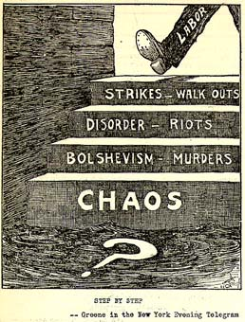

Major labor strikes organized by labor unions (organizations that fought for better working conditions for workers) after World War I increased fear of immigrants and radicals. This political cartoon shows the increasing anxiety towards labor organizations and those seen as radicals, such as socialists.

Source E: The Evening World, November 8, 1919
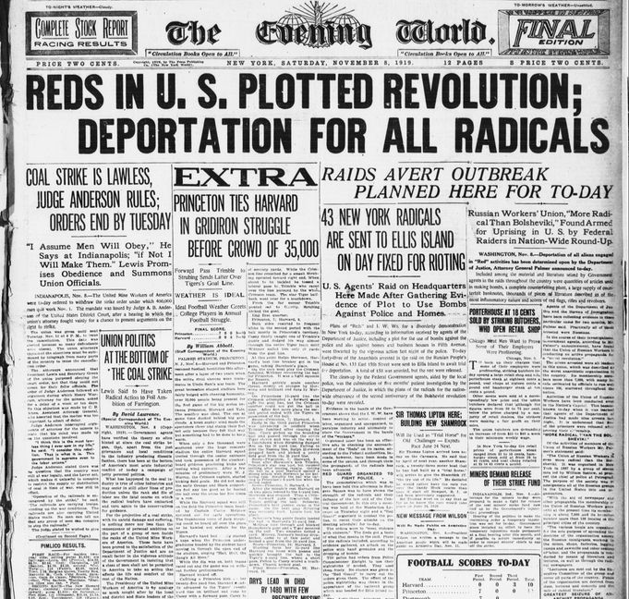

The Palmer Raids in late 1919 and early 1920 were a reaction to the increasing fear of radicals and immigrants sparked by the rise of Bolshevism in Russia.

Lesson 2
Supporting Question 1: Why did the United States experience economic
prosperity during the 1920s?
Student Directions | First read Source F. Then, read Sources G and H and answer the guiding questions in the right-hand column.
Featured Sources | Source F: Definition of Roaring  Source G: “Republican Ascendency”  Source H: “The Presidency of Herbert Hoover”

Source F: Definition of Roaring
According to Webster’s Dictionary, “roaring” can be defined as:
- marked by prosperity especially of a temporary nature
- great in intensity or degree

*Note: The Roaring Twenties is one moniker (nickname) given to the time period 1920 to 1929 in the United States. Others include the New Era and the Jazz Age. The culture associated with this time period includes flappers, defying Prohibition, and the rejection of many traditional and societal standards. The Roaring Twenties label also alludes to the economically prosperous aspects of the time period. The sources in this packet will examine trends and events of the 1920s to explore the extent to which shifts popularly associated with the decade were significant and widespread, as well as how those shifts generated backlash among some segments of the population.

Source G: “Republican Ascendency”
Text | Vocabulary | Guiding Questions
Warren Harding and the Return to Normalcy  In the election of 1920, professional Republicans were eager to nominate a man whom they could manage and control. Warren G. Harding, a senator from Ohio, represented just such a man. Before his nomination, Harding stated, “America’s present need is not heroics but healing; not nostrums but normalcy; not revolution but restoration.” Together with his running mate, Calvin Coolidge, the governor of Massachusetts, they attracted the votes of many Americans who sought Harding’s promised return to normalcy. In the election, Harding defeated Governor James Cox of Ohio by the greatest majority in the history of two-party politics: 61 percent of the popular vote.  Harding’s cabinet reflected his pro-business agenda. Herbert Hoover, a millionaire mechanical engineer and miner, became his Secretary of Commerce. Hoover had served as head of the relief effort for Belgium during World War I and helped to feed those in Russia and Germany after the war ended. He was a very effective administrator, seeking to limit inefficiency in the government and promoting partnerships between government and businesses. Harding’s Secretary of the Treasury, Andrew Mellon, was also a pro-business multimillionaire with a fortune built in banking and aluminum. Even more so than Hoover, Mellon entered public service with a strong sense that government should run as efficiently as any business, famously writing that “the Government is just a business, and can and should be run on business principles.”  Consistent with his principles of running government with business-like efficiency, Harding proposed and signed into law tax rate cuts as well as the country’s first formal budgeting process, which created a presidential budget director and required that the president submit an annual budget to Congress. These policies helped to reduce the debt that the United States had incurred during World War I. However, as Europe began to recover, U.S. exports to the continent dwindled. In an effort to protect U.S. agriculture and other businesses threatened by lower-priced imports, Harding pushed through the Emergency Tariff of 1921. This defensive tariff had the effect of increasing American purchasing power, although it also inflated the prices of many goods.  In July 1923, while traveling in Seattle, the president suffered a heart attack. On August 2, in his weakened condition, he suffered a stroke and died in San Francisco, leaving the presidency to his vice president, Calvin Coolidge.  A Man of Few Words  Coolidge had a strong belief in the Puritan work ethic: Work hard, save your money, keep your mouth shut and listen, and good things will happen to you.  Domestically, Coolidge adhered to the creed: “The business of America is business.” He stood in awe of Andrew Mellon and followed his fiscal policies, which made him the only president to turn a legitimate profit in the White House. Coolidge believed the rich were worthy of their property and that poverty was the wage of sin. Most importantly, Coolidge believed that since only the rich best understood their own interests, the government should let businessmen handle their own affairs with as little federal intervention as possible. Coolidge was quoted as saying, “The man who builds a factory builds a temple. The man who works there worships there.” Coolidge won the 1924 election easily. | normalcy: what is expected or usual  nostrums: medicines that do not work  cabinet: the vice-president and the leaders of executive departments, such as the Department of Commerce  pro-business: having to do with policies that encourage the growth of business profit, including tax cuts, less regulation, and fewer rights for workers  Andrew Mellon: believed that tax breaks for large companies would trickle down into the rest of the economy  tariff: tax on foreign goods; meant to protect goods produced within a country  inflated: made excessively high  wage: cost | In your own words, what did Warren Harding promise in his 1920 presidential campaign?  ________________________________  ________________________________  ________________________________  ________________________________  ________________________________  ________________________________  ________________________________  ________________________________  How did President Harding’s cabinet reflect pro-business interests?  ________________________________  ________________________________  ________________________________  ________________________________  ________________________________  ________________________________  How did Harding reduce U.S. debt from World War I?  ________________________________  ________________________________  ________________________________  ________________________________  ________________________________  ________________________________  ________________________________  ________________________________  ________________________________  ________________________________  Describe President Coolidge’s economic policies.  ________________________________  ________________________________  ________________________________  ________________________________  ________________________________

Source H: “The Presidency of Herbert Hoover”
Text | Vocabulary | Guiding Questions
Hoover won the Republican nomination in the 1928 presidential election after Republican President Calvin Coolidge announced that he would not be running for reelection. Hoover campaigned on Coolidge’s legacy of economic prosperity, pledging to support business, improve the quality of life of the nation’s farmers, and conduct a relatively isolationist foreign policy. Hoover was ambivalent about Prohibition, referring to it as a “great social and economic experiment,” but failing to back it wholeheartedly.  Hoover won the election in a landslide against his Democratic opponent.  Once in office, Hoover sought to reform the nation’s regulatory system. He was not an advocate of a laissez-faire economy, but instead encouraged the voluntary cooperation of the federal government and big business. At Hoover’s direction, the Internal Revenue Service and the Justice Department prosecuted gangsters, including Al Capone, for tax evasion. Hoover considered himself a progressive, and this was reflected in some of his administration’s policies, including the reorganization of the Bureau of Indian Affairs, the organization of the Federal Bureau of Prisons, the closing of tax loopholes for the wealthiest Americans, the expansion of national park lands, and the strengthening of protections for labor. | ambivalent: uncertain, unsure  laissez-faire: an economic system based on the belief that the less the government is involved in the economy through regulation and legislation, the better off businesses and society will be. | Which policies of President Coolidge did Hoover use to win election in 1928?  ________________________________  ________________________________  ________________________________  ________________________________  ________________________________  ________________________________  ________________________________  How did President Hoover’s policies differ from Presidents Harding and Coolidge?  ________________________________  ________________________________  ________________________________  ________________________________  ________________________________  ________________________________  ________________________________

Lesson 3
Supporting Question 1: Why did the United States experience economic
prosperity during the 1920s?
Student Directions | Read Sources I, K, N, and P and answer the guiding questions in the right-hand columns. Study and read Sources J, L, M, O, and Q. Complete performance task #1 at the end of this lesson.
Featured Sources | Source I: “Consumerism and Advertisements”  Source J: 1927 Palmolive Advertisement in Ladies Home Journal  Source K: “Automobiles and Airplanes”  Source L: “Bessie Coleman”  Source M: “Charles A. Lindbergh, with Spirit of St. Louis in background, May 31, 1927”  Source N: “Film and Radio”  Source O: “Rudolph Valentino”  Source P: “Sports and Escapism”  Source Q: “Babe Ruth, 1919”

Source I: “Consumerism and Advertisements”
Text | Vocabulary | Guiding Questions
“Change is in the very air Americans breathe, and consumer changes are the very bricks out of which we are building our new kind of civilization,” announced marketing expert and home economist Christine Frederick in her influential 1929 monograph, Selling Mrs. Consumer. The book Selling Mrs. Consumer, which was based on one of the earliest surveys of American buying habits, advised manufacturers and advertisers how to capture the purchasing power of women, who, according to Frederick, accounted for 90 percent of household expenditures. Aside from granting advertisers insight into the psychology of the “average” consumer, Frederick’s text captured the tremendous social and economic transformations that had been wrought over the course of her lifetime.  Indeed, the America of Frederick’s birth looked very different from the one she confronted in 1929. The consumer change she studied had resulted from the industrial expansion of the late nineteenth and early twentieth centuries. With the discovery of new energy sources and manufacturing technologies, industrial output flooded the market with a range of consumer products such as ready-to-wear clothing, convenience foods, and home appliances. By the end of the nineteenth century, output had risen so dramatically that many contemporaries feared supply had outpaced demand and that the nation would soon face the devastating financial consequences of overproduction. American businessmen attempted to avoid this catastrophe by developing new merchandising and marketing strategies that transformed distribution and stimulated a new culture of consumer desire.  The department store stood at the center of this early consumer revolution. By the 1880s, several large dry-goods houses blossomed into modern retail department stores. These emporiums concentrated a broad array of goods under a single roof, allowing customers to purchase shirtwaists and gloves alongside toy trains and washbasins. To attract customers, department stores relied on more than variety. They also employed innovations in service (such as access to restaurants, writing rooms, and babysitting) and spectacle (such as elaborately decorated store windows, fashion shows, and interior merchandise displays). Marshall Field & Co. was among the most successful of these ventures. Located on State Street in Chicago, the company pioneered many of these strategies, including establishing a tearoom that provided refreshment to the well-heeled female shoppers who composed the store’s clientele. Reflecting on the success of Field’s marketing techniques, Thomas W. Goodspeed, an early trustee of the University of Chicago, wrote, “Perhaps the most notable of Mr. Field’s innovations was that he made a store in which it was a joy to buy.”  The joy of buying infected a growing number of Americans in the early twentieth century as the rise of mail-order catalogs, mass-circulation magazines, and national branding further stoked consumer desire. Newly developed innovations like radios, phonographs, vacuum cleaners, washing machines, and refrigerators emerged on the market during this period. While expensive, new consumer-purchasing innovations like store credit and installment plans made them available to a larger segment of the population. Spurred by access to easy credit, consumer expenditures for household appliances, for example, grew by more than 120 percent between 1919 and 1929. Many of these devices promised to give women—who continued to have primary responsibility for housework—more opportunities to step out of the home and expand their horizons. Ironically, however, these labor-saving devices tended to increase the workload for women by raising the standards of domestic work. With the aid of these tools, women ended up cleaning more frequently, washing more often, and cooking more elaborate meals rather than gaining spare time.  Despite the fact that the promise of more leisure time went largely unfulfilled, the lure of technology as the gateway to a more relaxed lifestyle endured. This enduring dream was a testament to the influence of another growing industry: advertising. The mass consumption of cars, household appliances, ready-to-wear clothing, and processed foods depended heavily on the work of advertisers. Magazines like Ladies’ Home Journal and The Saturday Evening Post became vehicles to connect advertisers with middle-class consumers. Colorful and occasionally provocative print advertisements decorated the pages of these publications and became a staple in American popular culture. | consumer: a person who buys goods  social: having to do with how a people in society interact  wrought: achieved  industrial: having to do with factories and manufacturing goods  emporiums: large stores that sell many different types of goods  store credit and installment plans: methods that allowed people to buy goods when they could not pay the entire price at once | How did Frederick’s work change the way companies advertised to consumers?  ________________________________  ________________________________  ________________________________  ________________________________  ________________________________  ________________________________  ________________________________  ________________________________  ________________________________  ________________________________  What effects did the industrial expansion of the late 19th century have on consumerism in America?  ________________________________  ________________________________  ________________________________  ________________________________  ________________________________  ________________________________  ________________________________  How did early department stores change the consumer experience?  ________________________________  ________________________________  ________________________________  ________________________________  ________________________________  ________________________________  ________________________________  What factors drove consumption of expensive goods in the 1920s?  ________________________________  ________________________________  ________________________________  ________________________________  ________________________________  ________________________________  ________________________________  ________________________________  ________________________________  ________________________________  ________________________________  ________________________________  What was an unintended effect of the proliferation of household appliances on women?  ________________________________  ________________________________  ________________________________  ________________________________  ________________________________  ________________________________  ________________________________  ________________________________
Source J: 1927 Palmolive Advertisement in Ladies Home Journal
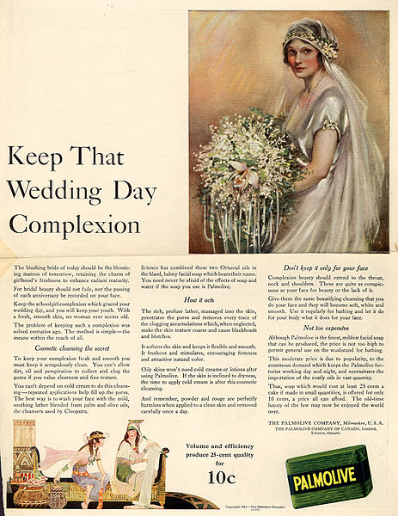

Many advertisements in the 1920s, like the above soap advertisement, targeted women and became a large part of popular culture.

Source K: “Automobiles and Airplanes”
Text | Vocabulary | Guiding Questions
The 1920s opened up new possibilities of mobility for a large percentage of the U.S. population, as automobile manufacturers began to mass produce what had once been a luxury item, and daring aviators both demonstrated and drove advancements in aircraft technology. The most significant innovation of this era was Henry Ford’s Model T Ford, which made car ownership available to the average American.  Henry Ford did not invent the automobile—the Duryea brothers in Massachusetts as well as Gottlieb W. Daimler and Karl Friedrich Benz in Germany were early pioneers. By the early twentieth century, hundreds of car manufacturers existed. However, they all made products that were too expensive for most Americans. Ford’s innovation lay in his focus on using mass production to manufacture automobiles; he revolutionized industrial work by perfecting the assembly line, which enabled him to lower the Model T’s price from $850 in 1908 to $300 in 1924, making car ownership a real possibility for a large share of the population. As prices dropped, more and more people could afford to own a car. Soon, people could buy used Model Ts for as little as five dollars, allowing students and others with low incomes to enjoy the freedom and mobility of car ownership. By 1929, there were over twenty-three million automobiles on American roads. Americans owned more cars than Great Britain, Germany, France, and Italy combined. In the late 1920s, 80 percent of the world’s cars drove on American roads. The automobile industry also fostered the new culture of consumption by promoting the use of credit. By 1927, more than 60 percent of American automobiles were sold on credit, and installment purchasing was made available for nearly every other large consumer purchase.  Ford’s emphasis on cheap mass production brought both benefits and disadvantages to its workers. Ford would not allow his workers to unionize, and the boring, repetitive nature of the assembly line work generated a high turnover rate. However, to reduce the turnover rate, he doubled workers’ pay to five dollars a day and standardized the workday to eight hours (a reduction from the norm). Ford’s assembly line also offered greater equality than most opportunities of the time, as he paid white and black workers equally. Seeking these wages, many African Americans from the South moved to Detroit and other large northern cities to work in factories.  The automobile changed the face of America, both economically and socially. Industries like glass, steel, and rubber processing expanded to keep up with auto production. The oil industry in California, Oklahoma, and Texas expanded, as Americans’ reliance on oil increased and the nation transitioned from a coal-based economy to one driven by petroleum. The need for public roadways required local and state governments to fund a dramatic expansion of infrastructure, which permitted motels and restaurants to spring up and offer new services to millions of newly mobile Americans with cash to spend. With this new infrastructure, new shopping and living patterns emerged, and streetcar suburbs gave way to automobile suburbs as private automobile traffic on public roads began to replace mass transit on trains and trolleys.  As the automobile became more popular and more reliable, more people traveled more frequently and attempted greater distances. Women increasingly drove themselves to their own activities as well as those of their children. Vacationing Americans sped to Florida to escape northern winters. Young men and women fled the supervision of courtship, exchanging the staid parlor couch for a more private dating experience in a sedan. In order to serve and capture the growing number of drivers, Americans erected gas stations, diners, motels, and billboards along the roadside. Automobiles themselves became objects of entertainment: nearly one hundred thousand people gathered to watch drivers compete for the $50,000 prize of the Indianapolis 500.  The 1920s not only witnessed a transformation in ground transportation but also major changes in air travel. By the mid-1920s, men—as well as some pioneering women like the African American stunt pilot Bessie Coleman—had been flying for two decades. But there remained doubts about the suitability of airplanes for long-distance travel. Orville Wright, one of the pioneers of airplane technology in the United States, once famously declared, “No flying machine will ever fly from New York to Paris [because] no known motor can run at the requisite speed for four days without stopping.” However, in 1927, this skepticism was finally put to rest when Charles Lindbergh became the first person to fly solo across the Atlantic Ocean, flying from New York to Paris in thirty-three hours.  Lindbergh’s flight made him an international hero: the best-known American in the world. On his return, Americans greeted him with a ticker-tape parade—a celebration in which shredded paper thrown from surrounding buildings creates a festive, flurry effect. His flight, which he completed in the monoplane Spirit of St. Louis, seemed like a triumph of individualism in modern mass society and exemplified Americans’ ability to conquer the air with new technology. Some historians have dubbed Lindbergh the “hero of the decade,” not only for his transatlantic journey but because he helped to restore the faith of many Americans in individual effort and technological advancement. In a world so recently devastated by machine guns, submarines, and chemical weapons, Lindbergh’s flight demonstrated that technology could inspire and accomplish great things. Outlook Magazine called Lindbergh “the heir of all that we like to think is best in America.” In addition to the inspiration Lindbergh brought to the country, he also expressed white supremacist and anti-Semitic views. This lead to the belief that Lindbergh was a Nazi sympathizer, although he never expressed direct support for Hitler or Nazi Germany.  Following his success, the small airline industry began to blossom, fully coming into its own in the 1930s, as companies like Boeing and Ford developed airplanes designed specifically for passenger air transport. | mobility: ability to move freely  credit: the ability to receive a good before paying for it in full  installment purchasing: paying for a good in small payments over time rather than in one lump payment | How did Henry Ford make automobile ownership possible for more people?  ________________________________  ________________________________  ________________________________  ________________________________  ________________________________  ________________________________  ________________________________  ________________________________  ________________________________  ________________________________  How did people who could not pay the full price for an automobile in one payment purchase automobiles?  ________________________________  ________________________________  ________________________________  ________________________________  ________________________________  ________________________________  ________________________________  In what ways did Henry Ford improve the conditions for workers?  ________________________________  ________________________________  ________________________________  ________________________________  ________________________________  ________________________________  Describe how the automobile industry spurred growth in other industries.  ________________________________  ________________________________  ________________________________  ________________________________  ________________________________  ________________________________  How did automobiles change the behavior of women, families, and youth in the 1920s?  ________________________________  ________________________________  ________________________________  ________________________________  ________________________________  ________________________________  ________________________________  ________________________________  ________________________________  ________________________________  ________________________________  ________________________________  ________________________________  ________________________________  Why did Charles Lindbergh become a celebrity in the 1920s? What did he represent?  ________________________________  ________________________________  ________________________________  ________________________________  ________________________________  ________________________________  ________________________________  ________________________________  ________________________________  ________________________________  How did airplane use change from the 1920s to 1930s?  ________________________________  ________________________________  ________________________________  ________________________________

Ford Motor Company Assembly Line
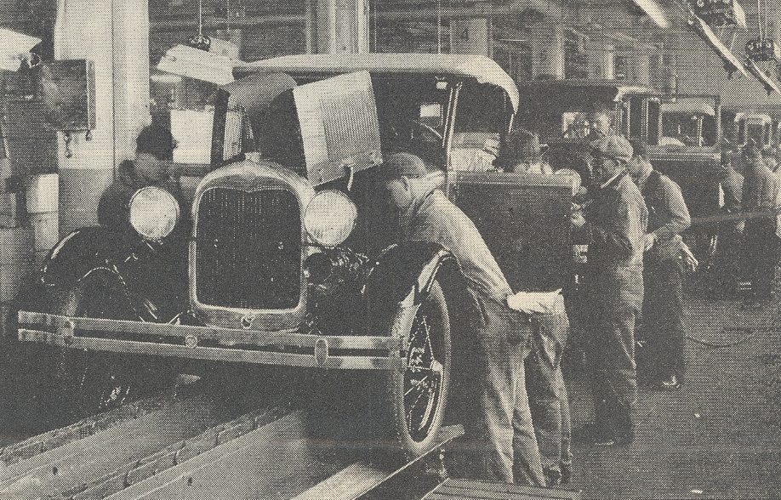
Source L: “Bessie Coleman”
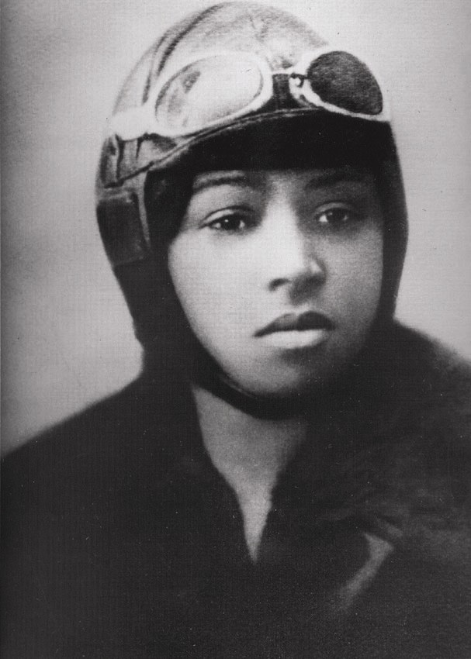

Bessie Coleman was the first Black American woman and first person of American Indian descent to gain a pilot’s license. She earned her license in France since flying schools in the United States would not admit her. She made a living by performing aerial stunt shows.

Source M: “Charles A. Lindbergh, with Spirit of St. Louis in background, May 31, 1927”
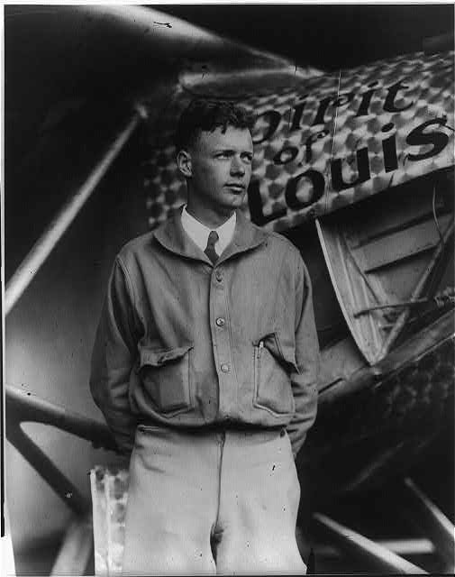
Charles Lindbergh’s aviation accomplishments made him a celebrity in the 1920s.

Source N: “Film and Radio”
Text | Vocabulary | Guiding Questions
In the 1920s, prosperity manifested itself in many forms, most notably in advancements in entertainment and technology that led to new patterns of leisure and consumption. Automobiles, film, and radio propelled not only consumption but also the famed popular culture in the 1920s. “We wish to escape,” wrote Edgar Burroughs, author of the Tarzan series, “. . . the restrictions of manmade laws, and the inhibitions that society has placed upon us.” Burroughs authored a new Tarzan story nearly every year from 1914 until 1939. “We would each like to be Tarzan,” he said. “At least I would; I admit it.” Like many Americans in the 1920s, Burroughs sought to challenge and escape the constraints of a society that seemed more industrialized with each passing day. The increased prosperity of the 1920s gave many Americans more disposable income to spend on entertainment. As the popularity of “moving pictures” grew in the early part of the decade, “movie palaces,” capable of seating thousands, sprang up in major cities. A ticket for a double feature and a live show cost twenty-five cents; for a quarter, Americans could escape from their problems and lose themselves in another era or world. People of all ages attended the movies with far more regularity than today, often going more than once per week. By the end of the decade, weekly movie attendance swelled to ninety million people.  Not content with distributing thirty-minute films in nickelodeons, film makers produced longer, higher-quality films and showed them in theaters that attracted those who had previously shunned the film industry.  The silent movies of the early 1920s gave rise to the first generation of movie stars. Rudolph Valentino and Clara Bow, the “It Girl,” filled the imagination of millions of American moviegoers. However, no star captured the attention of the American viewing public more than Charlie Chaplin. This sad-eyed tramp with a moustache, baggy pants, and a cane was the top box office attraction of his time.  In the 1920s Americans across the country bought magazines like Photoplay in order to get more information about the stars of their new favorite entertainment media: the movies. Advertisers took advantage of this broad audience to promote a wide range of goods and services to both men and women who enjoyed the proliferation of consumer culture during this time.  In 1927, the world of the silent movie began to wane with the New York release of the first “talkie”: The Jazz Singer. Both the story and the new sound technology used to present it were popular with audiences around the country. It quickly became a huge hit for Warner Brothers, one of the “big five” motion picture studios in Hollywood along with Twentieth Century Fox, RKO Pictures, Paramount Pictures, and Metro-Goldwyn-Mayer.  Whether it was the surroundings, the sound, or the production budgets, weekly movie attendance skyrocketed from sixteen million in 1912 to forty million in the early 1920s. Hungarian immigrant William Fox, founder of Fox Film Corporation, declared that “the motion picture is a distinctly American institution” because “the rich rub elbows with the poor” in movie theaters. With no seating restriction, the one-price admission was accessible for nearly all Americans (African Americans, however, were either excluded or segregated). Women represented more than 60 percent of moviegoers, packing theaters to see Mary Pickford, nicknamed “America’s Sweetheart,” who was earning one million dollars a year by 1920 through a combination of film and endorsements contracts. Pickford and other female stars popularized the “flapper,” a woman who favored short skirts, makeup, and cigarettes.  As Americans went to the movies more and more, at home they had the radio. Italian scientist Guglielmo Marconi transmitted the first transatlantic wireless (radio) message in 1901, but radios in the home did not become available until around 1920, when they boomed across the country. Around half of American homes contained a radio by 1930. Radio stations brought entertainment directly into the living room through the sale of advertisements and sponsorships. Soap companies sponsored daytime dramas so frequently that an entire genre—“soap operas”—was born, providing housewives with audio adventures that stood in stark contrast to common chores. Though radio stations were often under the control of corporations like the National Broadcasting Company (NBC) or the Columbia Broadcasting System (CBS), radio programs were less constrained by traditional boundaries in order to capture as wide an audience as possible, spreading popular culture on a national level.  Radio exposed Americans to a broad array of music. Jazz, a uniquely American musical style popularized by the African-American community in New Orleans, spread primarily through radio stations and records. The New York Times had ridiculed jazz as “savage” because of its racial heritage, but the music represented cultural independence to others. As Harlem-based musician William Dixon put it, “It did seem, to a little boy, that . . . white people really owned everything. But that wasn’t entirely true. They didn’t own the music that I played.” The fast-paced and spontaneity-laced tunes invited the listener to dance along. “When a good orchestra plays a ‘rag,’” dance instructor Vernon Castle recalled, “one has simply got to move.” Jazz became a national sensation, played and heard by both white and Black Americans. Jewish Lithuanian-born singer Al Jolson—whose biography inspired The Jazz Singer and who played the film’s titular character—became the most popular singer in America. | leisure: free time used for enjoyment  consumption: consuming and purchasing products  inhibitions: restrictions on behavior  nickelodeons: movie theaters that charged a nickel for admission | Describe the factors that led to the popularity of leisure activities like watching films.  ________________________________  ________________________________  ________________________________  ________________________________  ________________________________  ________________________________  ________________________________  ________________________________  ________________________________  ________________________________  ________________________________  ________________________________  ________________________________  How did celebrity culture contribute to consumerism in the 1920s?  ________________________________  ________________________________  ________________________________  ________________________________  ________________________________  ________________________________  ________________________________  ________________________________  ________________________________  ________________________________  ________________________________  ________________________________  ________________________________  ________________________________  Who made up the audiences of movies in the 1920s? Who was excluded?  ________________________________  ________________________________  ________________________________  ________________________________  ________________________________  How did radio contribute to consumerism in the 1920s?  ________________________________  ________________________________  ________________________________  ________________________________  ________________________________  ________________________________  ________________________________  ________________________________  ________________________________  ________________________________  What were some effects of the radio on American society?  ________________________________  ________________________________  ________________________________  ________________________________  ________________________________  ________________________________  ________________________________  ________________________________  ________________________________  ________________________________

Source O: “Rudolph Valentino”
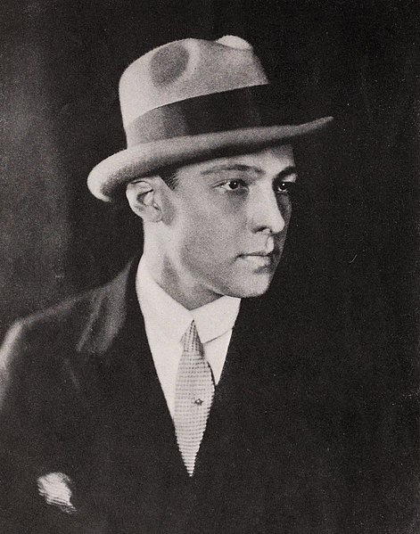

Actors were featured in celebrity magazines. This portrait is from a February 1923 edition of Photoplay.

Source P: “Sports and Escapism”
Text | Vocabulary | Guiding Questions
Americans sought out escapism in the 1920s. Whether through the automobile, Hollywood’s latest films, jazz records, or the hours spent listening to radio broadcasts of Jack Dempsey’s prizefights, the public wrapped itself in popular culture.  The 1920s witnessed the maturation of professional sports. Play-by-play radio broadcasts of major collegiate and professional sporting events marked a new era for sports, despite the institutionalization of racial segregation in most. Suddenly, Jack Dempsey’s left crosses and right uppercuts could almost be felt in homes across the United States. Dempsey, who held the heavyweight championship for most of the decade, drew million-dollar gates and inaugurated “Dempseymania” in newspapers across the country. Red Grange, who carried the football with a similar recklessness, helped popularize professional football, which was then in the shadow of the college game. Grange left the University of Illinois before graduating to join the Chicago Bears in 1925. “There had never been such evidence of public interest since our professional league began,” recalled Bears owner George Halas of Grange’s arrival.  Perhaps no sports figure left a bigger mark than did Babe Ruth. Born George Herman Ruth, the “Sultan of Swat” grew up in an orphanage in Baltimore’s slums. Ruth’s emergence onto the national scene was much needed, as the baseball world had been rocked by the so-called Black Sox Scandal in which eight players allegedly agreed to throw the 1919 World Series. Ruth hit fifty-four home runs in 1920, which was more than any other team combined. Baseball writers called Ruth a superman, and more Americans could recognize Ruth than they could then-president Warren G. Harding.  After an era of destruction and doubt brought about by World War I, Americans craved heroes who seemed to defy convention and break boundaries. Dempsey, Grange, and Ruth dominated their respective sports. | escapism: seeking out a distraction to provide relief from reality  convention: the way something is usually done | How did most people experience sports in the 1920s?  ________________________________  ________________________________  ________________________________  ________________________________  ________________________________  ________________________________  ________________________________  ________________________________  ________________________________  ________________________________  Why were sports figures like Dempsey, Grange, and Ruth so popular during the 1920s?  ________________________________  ________________________________  ________________________________  ________________________________  ________________________________  ________________________________  ________________________________  ________________________________  ________________________________  ________________________________  ________________________________

Source Q: “Babe Ruth, 1919”
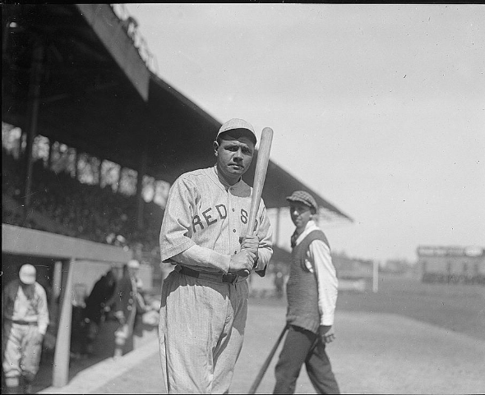

Baseball stadiums were a popular place to spend leisure time in the 1920s. Baseball games were broadcast on radios for even larger audiences.

Formative Performance Task #1 – Constructed Response
Student Directions | Explain two different factors that contributed to economic prosperity in the United States during the 1920s.

Lesson 4
Supporting Question 2: Why were there limitations to economic prosperity
in the United States during the 1920s?
Student Directions | Read and study Sources R and S. Read and study Source T and answer the question below the source. Read Source U and answer the guiding questions in the right-hand column. Read and study Source V and answer the question below the source. Read Source W and answer the guiding questions in the right-hand column. Finally, complete performance task #2 at the end of this lesson.
Featured Sources | Source R: “Farm Foreclosure in Iowa”  Source S: “A Little Log Cabin”  Source T: “US Annual real GDP from 1910 to 1960”  Source U: “The Origins of the Great Depression”  Source V: “The Unemployment Rate in the U.S. during 1910–60”  Source W: “The Great Crash”
Source R: “Farm Foreclosure in Iowa”
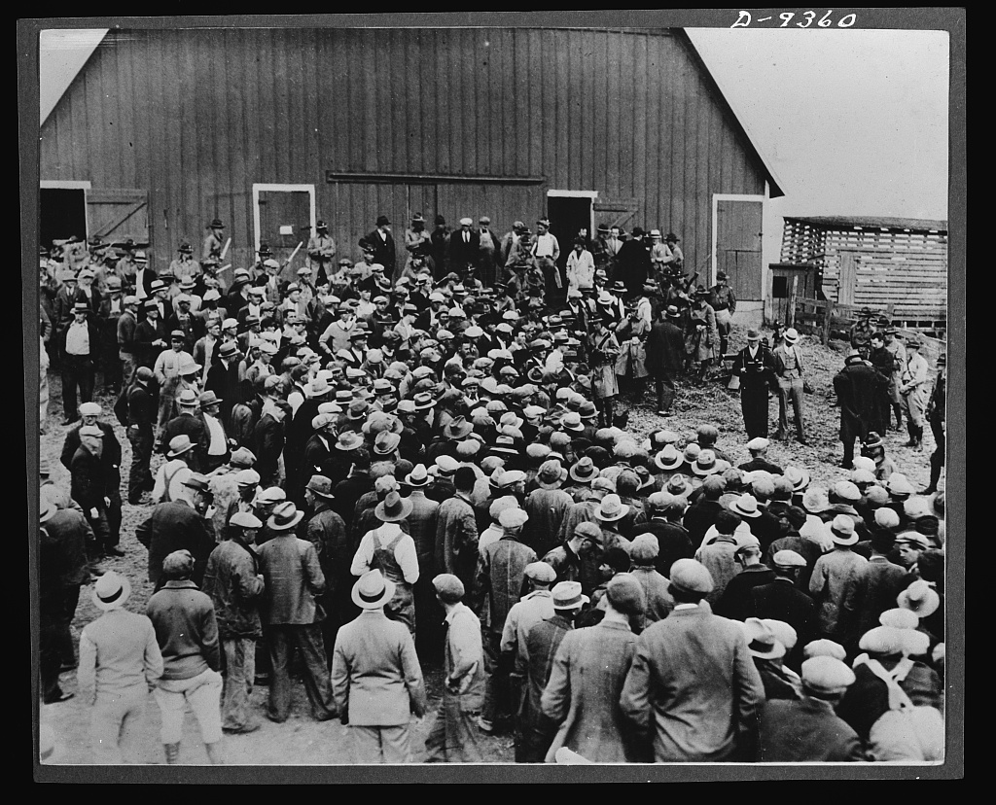
This image shows a foreclosed farm being auctioned in the early 1930s in Iowa. Military police were on hand to keep farmers from preventing the auction.

During World War I, demand for crops produced by farmers increased. Many farmers took out loans to meet war time production needs. After the war ended and the demand for crops decreased, farmers were in debt and unable to make enough money to pay off their loans. Despite agricultural overproduction and successive attempts in Congress to provide relief, the agricultural economy of the 1920s experienced an ongoing depression. Large surpluses were accompanied by falling prices at a time when American farmers were burdened by heavy debt. Between 1920 and 1932, one in four farms was sold to meet financial obligations and many farmers migrated to urban areas.

Source S: “A Little Log Cabin”
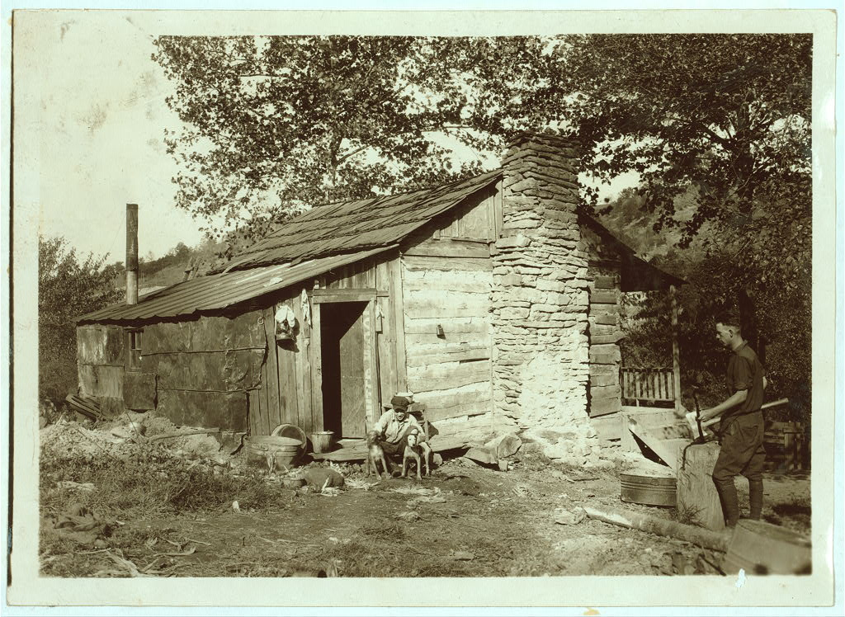
This photograph was taken on October 21, 1921 by Lewis W. Hine in Big Chimney, West Virginia. The family photographed in their aging log cabin were “gradually giving up farming and depending upon mining and odd jobs.” More than half of people in the United States lived below the poverty line in the 1920’s.

Source T: “US Annual real GDP from 1910 to 1960”
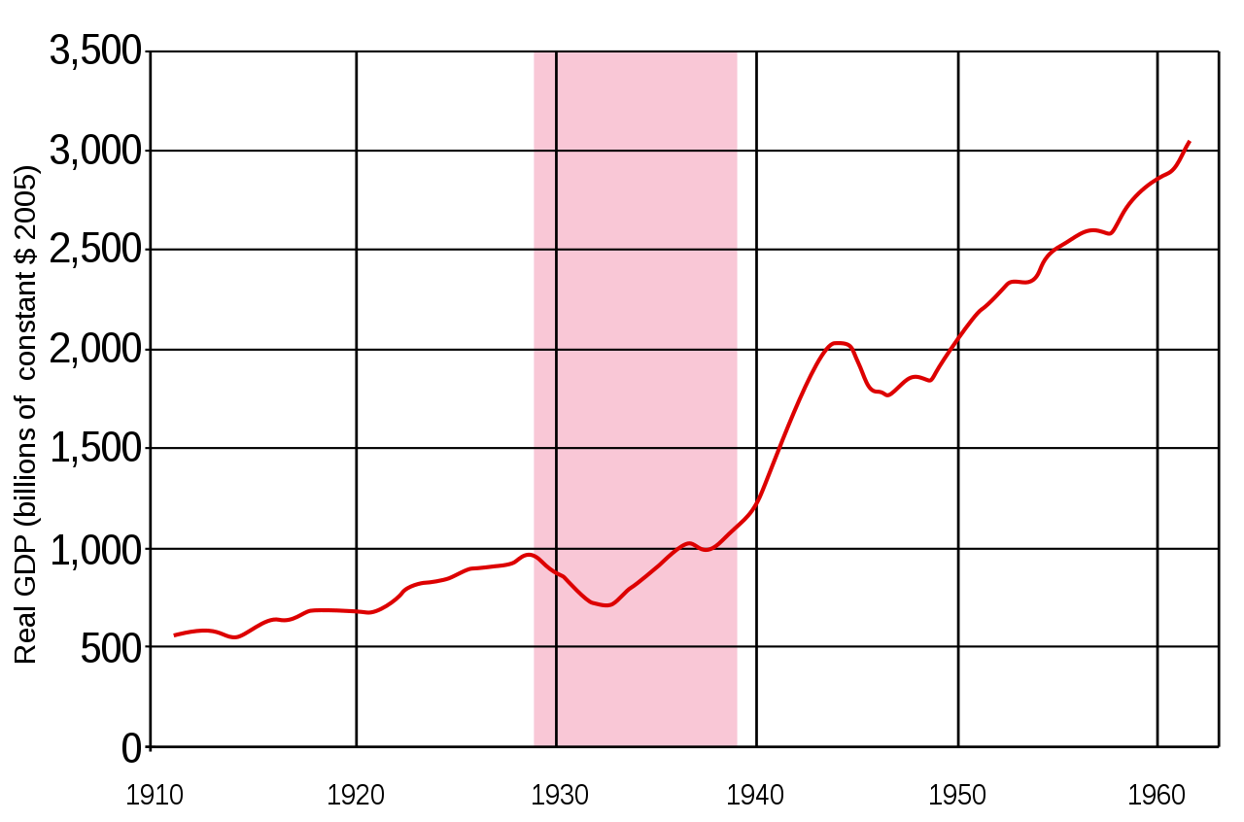

Real gross domestic product, or the GDP, is the measure of the value of all goods and services produced in an economy in a year. The years of the Great Depression, 1929 to 1939, are highlighted.

Describe the changes in the GDP in the years 1920 to 1930. How do these changes in the GDP compare to the changes in the GDP in the period 1930 to 1940?

__________________________________________________________________________________________

__________________________________________________________________________________________

__________________________________________________________________________________________

Source U: “The Origins of the Great Depression”
Text | Vocabulary | Guiding Questions
On Thursday, October 24, 1929, stock market prices suddenly plummeted. Ten billion dollars in investments (roughly equivalent to about $100 billion today) disappeared in a matter of hours. Panicked selling set in, stock values sank to sudden lows, and stunned investors crowded the New York Stock Exchange demanding answers. Leading bankers met privately at the offices of J. P. Morgan and raised millions in personal and institutional contributions to halt the slide. They marched across the street and ceremoniously bought stocks at inflated prices. The market temporarily stabilized but fears spread over the weekend and the following week frightened investors dumped their portfolios to avoid further losses. On October 29, Black Tuesday, the stock market began its long precipitous fall. Stock values evaporated. Shares of U.S. Steel dropped from $262 to $22. General Motors stock fell from $73 a share to $8. Four-fifths of J. D. Rockefeller’s fortune—the greatest in American history—vanished.  Although the crash stunned the nation, it exposed the deeper, underlying problems with the American economy in the 1920s. The stock market’s popularity grew throughout the decade, but the overwhelming majority of Americans had no direct personal stake in Wall Street. The stock market’s collapse, no matter how dramatic, did not by itself depress the American economy. Instead, the crash exposed a great number of factors that, when combined with the financial panic, sank the American economy into the greatest of all economic crises. Rising inequality, declining demand, rural collapse, overextended investors, and the bursting of speculative bubbles all conspired to plunge the nation into the Great Depression.  Despite resistance by Progressives, the vast gap between rich and poor accelerated throughout the early twentieth century. In the aggregate, Americans were better off in 1929 than in 1920. Per capita income had risen 10 percent for all Americans, but 75 percent for the nation’s wealthiest citizens. The return of conservative politics in the 1920s reinforced federal fiscal policies that exacerbated the divide: low corporate and personal taxes, easy credit, and depressed interest rates overwhelmingly favored wealthy investors who, flush with cash, spent their money on luxury goods and speculative investments in the rapidly rising stock market.  The pro-business policies of the 1920s were designed for an American economy built on the production and consumption of durable goods. Yet by the late 1920s, much of the market was saturated. The boom of automobile manufacturing, the great driver of the American economy in the 1920s, slowed as fewer and fewer Americans with the means to purchase a car had not already done so. More and more, the well-to-do had no need for the new automobiles, radios, and other consumer goods that fueled gross domestic product (GDP) growth in the 1920s. When products failed to sell, inventories piled up, manufacturers scaled back production, and companies fired workers, stripping potential consumers of cash, blunting demand for consumer goods, and replicating the downward economic cycle. The situation was only compounded by increased automation and rising efficiency in American factories. Despite impressive overall growth throughout the 1920s, unemployment hovered around 7 percent throughout the decade, suppressing purchasing power for a great swath of potential consumers.  For American farmers, meanwhile, hard times began long before the markets crashed. In 1920 and 1921, after several years of larger-than-average profits, farm prices in the South and West continued their long decline, plummeting as production climbed and domestic and international demand for cotton, foodstuffs, and other agricultural products stalled. Widespread soil exhaustion on western farms only compounded the problem. Farmers found themselves unable to make payments on loans taken out during the good years, and banks in agricultural areas tightened credit in response. By 1929, farm families were overextended, in no shape to make up for declining consumption, and in a precarious economic position even before the Depression wrecked the global economy.  Hoover made many mistakes. During his 1928 election campaign, Hoover promoted higher tariffs as a means for encouraging domestic consumption and protecting American farmers from foreign competition. Spurred by the ongoing agricultural depression, Hoover signed into law the highest tariff in American history, the Smoot-Hawley Tariff of 1930, just as global markets began to crumble. Other countries responded in kind, tariff walls rose across the globe, and international trade ground to a halt. Between 1929 and 1932, international trade dropped from $36 billion to only $12 billion. American exports fell by 78 percent. Combined with overproduction and declining domestic consumption, the tariff exacerbated the world’s economic collapse.  The Great Depression was the confluence of many problems, most of which had begun during a time of unprecedented economic growth. Fiscal policies of the Republican “business presidents” undoubtedly widened the gap between rich and poor and fostered a standoff over international trade, but such policies were widely popular and, for much of the decade, widely seen as a source of the decade’s explosive growth. With fortunes to be won and standards of living to maintain, few Americans had the foresight or wherewithal to repudiate an age of easy credit, rampant consumerism, and wild speculation. | `  Great Depression: worldwide economic downturn that lasted from 1929 until World War II  fiscal: having to do with finances, or money  exacerbated: made worst  speculative: purchasing an investment with the hope that it will increase in value  saturated: beyond the point at which the demand for a product is met  GDP: monetary value of all goods and services produced in a country  speculation: purchasing an investment with the hope that it will increase in value | What happened on October 29, 1929?  ________________________________  ________________________________  ________________________________  ________________________________  ________________________________  ________________________________  ________________________________  ________________________________  ________________________________  ________________________________  ________________________________  ________________________________  ________________________________  ________________________________  ________________________________  ________________________________  ________________________________  How did per capita income change in the 1920s? Who benefited most from this change?  ________________________________  ________________________________  ________________________________  ________________________________  How did federal policies increase inequality in income distribution?  ________________________________  ________________________________  ________________________________  Describe the factors that led to decreased production and steady unemployment in the 1920s.  ________________________________  ________________________________  ________________________________  ________________________________  ________________________________  ________________________________  ________________________________  ________________________________  ________________________________  ________________________________  Why were farmers not prosperous during the 1920s?  ________________________________  ________________________________  ________________________________  ________________________________  ________________________________  ________________________________  ________________________________  ________________________________  ________________________________  How did the Smoot-Hawley Tariff lead to a decline in international trade?  ________________________________  ________________________________  ________________________________  ________________________________  ________________________________  ________________________________  ________________________________  ________________________________

Source V: “The Unemployment Rate in the U.S. during 1910–60”
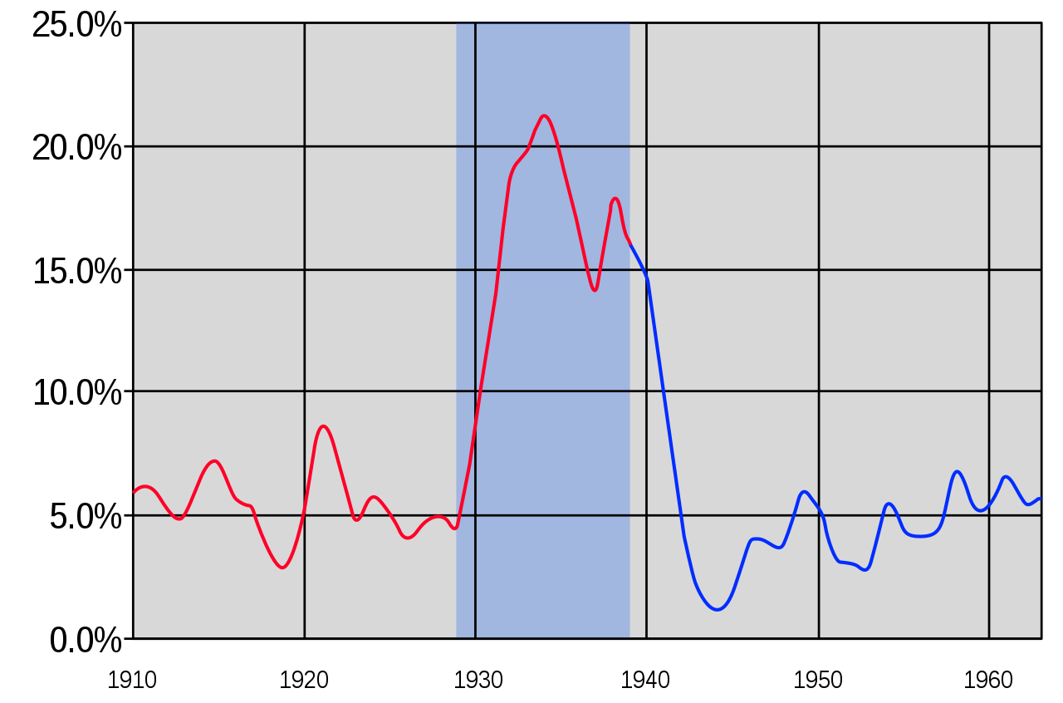

The unemployment rate measures the amount of unemployed people who are actively looking for work. The years of the Great Depression, 1929 to 1939, are highlighted.

Describe the changes in unemployment between the years 1920 and 1930. What led to higher unemployment at the start of the 1920s?

__________________________________________________________________________________________

__________________________________________________________________________________________

Source W: “The Great Crash”
Text | Vocabulary | Guiding Questions
To understand the crash, it is useful to address the decade that preceded it. The prosperous 1920s ushered in a feeling of euphoria among middle-class and wealthy Americans, and people began to speculate on wilder investments. The government was a willing partner in this endeavor: The Federal Reserve followed a brief postwar recession in 1920–1921 with a policy of setting interest rates artificially low, as well as easing the reserve requirements on the nation’s largest banks. As a result, the money supply in the U.S. increased by nearly 60 percent, which convinced even more Americans of the safety of investing in questionable schemes. They felt that prosperity was boundless and that extreme risks were likely tickets to wealth. Speculation, where investors purchased into high-risk schemes that they hoped would pay off quickly, became the norm. Several banks, including deposit institutions that originally avoided investment loans, began to offer easy credit, allowing people to invest, even when they lacked the money to do so. An example of this mindset was the Florida land boom of the 1920s: Real estate developers touted Florida as a tropical paradise and investors went all in, buying land they had never seen with money they didn’t have and selling it for even higher prices.  The Florida land boom went bust in 1925–1926. A combination of negative press about the speculative nature of the boom, IRS investigations into the questionable financial practices of several land brokers, and a railroad embargo that limited the delivery of construction supplies into the region significantly hampered investor interest. The subsequent Great Miami Hurricane of 1926 drove most land developers into outright bankruptcy. However, speculation continued throughout the decade, this time in the stock market. Buyers purchased stock “on margin”—buying for a small down payment with borrowed money, with the intention of quickly selling at a much higher price before the remaining payment came due—which worked well as long as prices continued to rise. | bust: to fail  bankruptcy: when someone cannot pay off debts | Why did actions of the Federal Reserve increase speculation?  ________________________________  ________________________________  ________________________________  ________________________________  ________________________________  ________________________________  ________________________________  ________________________________  ________________________________  ________________________________  ________________________________  ________________________________  How did speculation harm the economy in the 1920s?  ________________________________  ________________________________  ________________________________  ________________________________  ________________________________  ________________________________  ________________________________  ________________________________

Formative Performance Task #2 – Constructed Response
Student Directions | Explain two different factors that contributed to limitations of economic prosperity in the 1920s.

Lesson 5
Supporting Question 3: How did the culture and demographics of the
United States change during the 1920s, and why?
Student Directions | Read Sources X, AA, AC, AE and answer the guiding questions in the right-hand column. Read and study sources Y, Z, AB, AD, AF, and AG. Finally, complete the after you read questions at the end of this lesson.
Featured Sources | Source X: 18th Amendment to the Constitution, Ratified January 16, 1919  Source Y: “Amer. Fed. of Labor, Prohibition demonstration, June 14, 1919”  Source Z: “Woman with Flask”  Source AA: “Prohibition”  Source AB: “Police Commissioner John A. Leach Watching Agents Pour Liquor into Sewer”  Source AC: 21st Amendment to the Constitution, Ratified December 5, 1933  Source AD: “Louise Brooks”  Source AE: “The New Woman”  Source AF: “Members of the W.C.T.U. (Women’s Christian Temperance Union)”  Source AG: “Four Prize Winners in Annual Beauty Show, 1922”

Source X: 18th Amendment to the Constitution, Ratified January 16, 1919
Text | Vocabulary | Guiding Questions
Section 1  After one year from the ratification of this article the manufacture, sale, or transportation of intoxicating liquors within, the importation thereof into, or the exportation thereof from the United States and all territory subject to the jurisdiction thereof for beverage purposes is hereby prohibited. | importation: transporting a good into a country  exportation: transporting a good out of a country | What did the 18th Amendment make illegal?  ________________________________  ________________________________  ________________________________  ________________________________

Source Y: “Amer. Fed. of Labor, Prohibition demonstration, June 14, 1919”
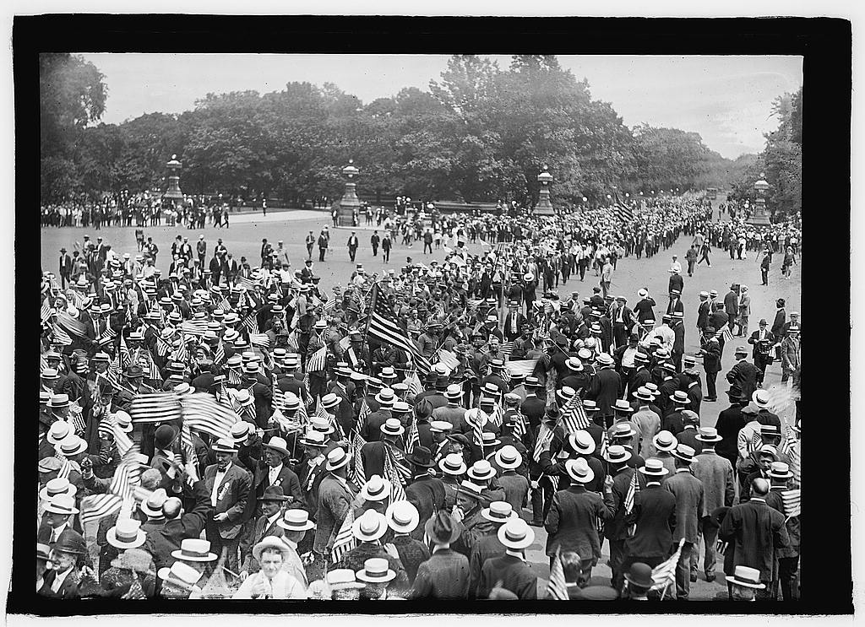
Not all people supported prohibition. In this photograph, members of the American Federation of Labor, a large labor union, protested the passage of the 18th Amendment.
Source Z: “Woman with Flask”
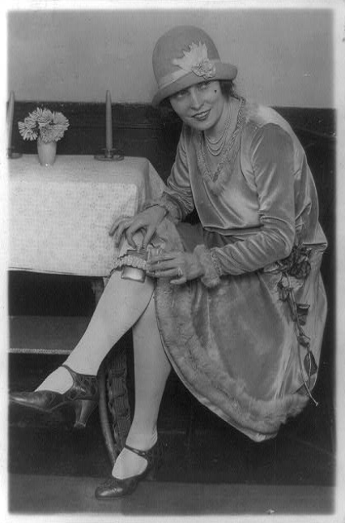
This photo shows a dancer showing off a garter flask Washington, January 26, 1926. Flasks were popularly used to hide illegal alcohol during Prohibition.

Source AA: “Prohibition”
Text | Vocabulary | Guiding Questions
After decades of organizing to reduce or end the consumption of alcohol in the United States, temperance groups and the Anti-Saloon League finally succeeded in pushing through the Eighteenth Amendment in 1919, which banned the manufacture, sale, and transportation of intoxicating liquors. The law proved difficult to enforce, as illegal alcohol soon poured in from Canada and the Caribbean, and rural Americans resorted to home-brewed “moonshine.” The result was an eroding of respect for law and order, as many people continued to drink illegal liquor. Rather than bringing about an age of sobriety, as Progressive reformers had hoped, it gave rise to a new subculture that included illegal importers, interstate smuggling (or bootlegging), clandestine saloons referred to as “speakeasies,” hipflasks, cocktail parties, and the organized crime of trafficking liquor.  Prohibition also revealed deep political divisions in the nation. The Democratic Party found itself deeply divided between urban, northern “wets” who hated the idea of abstinence, and rural, southern “dries” who favored the amendment. This divided the party and opened the door for the Republican Party to gain ascendancy in the 1920s. All politicians, including Woodrow Wilson, Herbert Hoover, Robert La Follette, and Franklin D. Roosevelt, equivocated in their support for the law. Publicly, they catered to the Anti-Saloon League; however, they failed to provide funding for enforcement.  Prohibition sparked a rise in organized crime. “Scarface” Al Capone ran an extensive bootlegging and criminal operation known as the Chicago Outfit or Chicago mafia. By 1927, Capone’s organization included a number of illegal activities including bootlegging, prostitution, gambling, loan sharking, and even murder. His operation was earning him more than $100 million annually, and many local police were on his payroll. Although he did not have a monopoly on crime, his organizational structure was better than many other criminals of his era. His liquor trafficking business and his Chicago soup kitchens during the Great Depression led some Americans to liken Capone to a modern-day Robin Hood. Still, Capone was eventually imprisoned for eleven years for tax evasion, including a stint in California’s notorious Alcatraz prison. | temperance: restraining from alcohol use  subculture: a group within a larger culture with beliefs and ideas that differ from the larger culture  clandestine: in secret  trafficking: deal or trade of something illegal  abstinence: not drinking liquor  ascendancy: position of power  equivocated: used misleading language in order to avoid commitment  Anti-Saloon League: organization that supported Prohibition  mafia: organized group of criminals  Robin Hood: hero from English folklore who robs the rich and gives to the poor | What were the long term effects of the 18th Amendment?  ________________________________  ________________________________  ________________________________  ________________________________  ________________________________  ________________________________  ________________________________  ________________________________  ________________________________  ________________________________  Describe the political and cultural divisions revealed by the passage of Prohibition.  ________________________________  ________________________________  ________________________________  ________________________________  ________________________________  ________________________________  ________________________________  ________________________________  How did Prohibition encourage organized crime?  ________________________________  ________________________________  ________________________________  ________________________________  ________________________________  ________________________________  ________________________________  ________________________________  ________________________________  ________________________________

Source AB: “Police Commissioner John A. Leach Watching Agents Pour Liquor into Sewer”
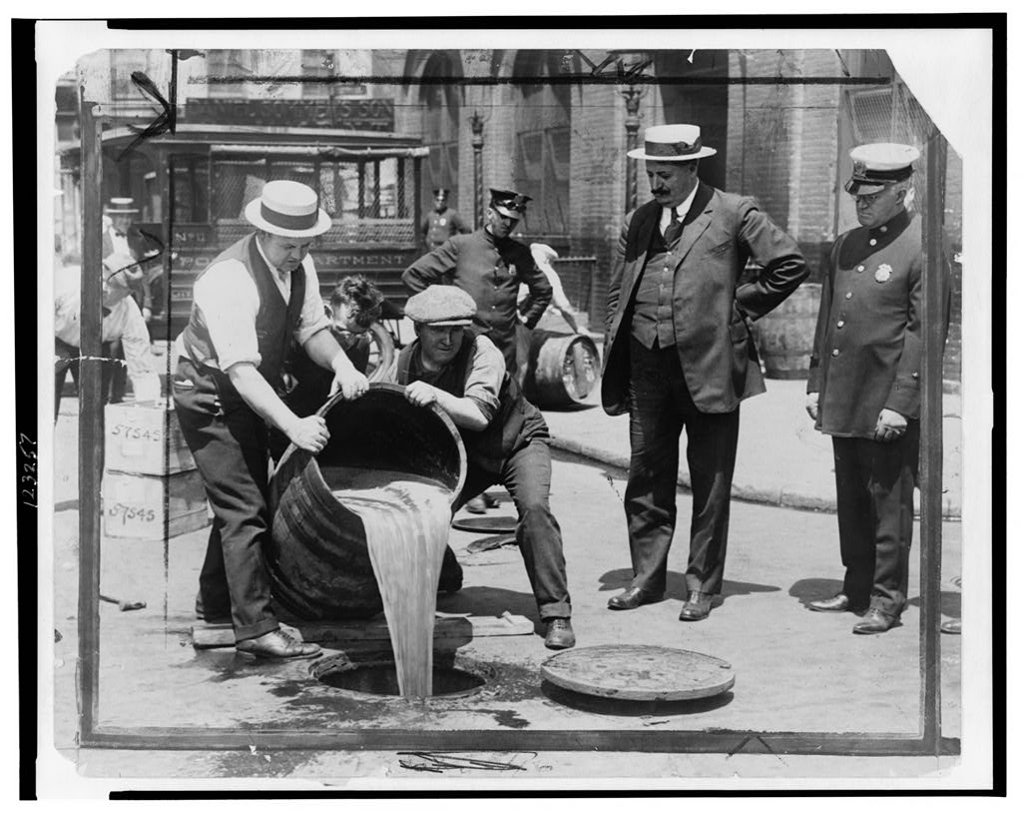

One reason prohibition was difficult to enforce was because so many people chose to break the law. In this image, New York City Deputy Police Commissioner John A. Leach, right, is watching agents pour liquor into the sewer following a raid during the height of prohibition.

Source AC: 21st Amendment to the Constitution, Ratified December 5, 1933
Text | Vocabulary | Guiding Questions
The eighteenth article of amendment to the Constitution of the United States is hereby repealed. | repealed: cancelled, reversed | What did the 21st Amendment do?  ________________________________  ________________________________  ________________________________

Source AD: “Louise Brooks”
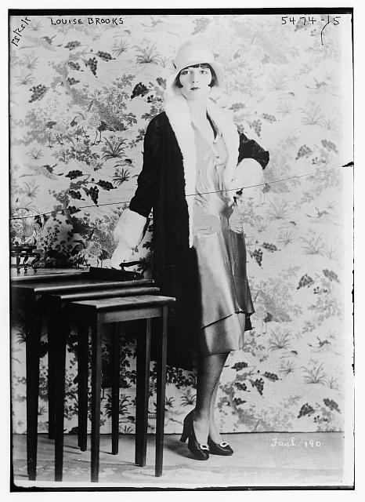

Louise Brooks was an actress and famous “flapper.” Flappers were women who went against gender expectations of the era, bobbing (cutting short) their hair, wearing short dresses, spending time in speakeasies, and listening to jazz. While liberating in many ways, these behaviors also reinforced stereotypes of female carelessness and obsessive consumerism that would continue throughout the twentieth century.
Source AE: “The New Woman”
Text | Vocabulary | Guiding Questions
The rising emphasis on spending and accumulation nurtured a national ethos of materialism and individual pleasure. These impulses were embodied in the figure of the flapper, whose bobbed hair, short skirts, makeup, cigarettes, and carefree spirit captured the attention of American novelists such as F. Scott Fitzgerald and Sinclair Lewis. Rejecting the old Victorian values of desexualized modesty and self-restraint, young “flappers” seized opportunities for the public coed pleasures offered by new commercial leisure institutions, such as dance halls, cabarets, and nickelodeons, not to mention the illicit blind tigers and speakeasies spawned by Prohibition. So doing, young American women had helped usher in a new morality that permitted women greater independence, freedom of movement, and access to the delights of urban living. In the words of psychologist G. Stanley Hall, “She was out to see the world and, incidentally, be seen of it.”  The Jazz Age and the proliferation of the flapper lifestyle of the 1920s was part of a larger women’s rights movement. The early 1920s, especially with the ratification of the Nineteenth Amendment guaranteeing full voting rights to women, was a period that witnessed the expansion of women’s political power. The public flaunting of social and sexual norms by flappers represented an attempt to match gains in political equality with gains in the social sphere. Women were increasingly leaving the Victorian era norms of the previous generation behind, as they broadened the concept of women’s liberation to include new forms of social expression such as dance, fashion, women’s clubs, and forays into college and the professions.  Beginning in the 1920s, women’s participation in the labor force increased steadily—not only in domestic service, but in retail, healthcare and education, offices, and manufacturing. Occupations such as law and medicine remained overwhelmingly male: most female professionals were in feminized professions such as teaching and nursing. And even within these fields, it was difficult for women to rise to leadership positions.  Most women were paid less than men for the same type of work based on the rationale that they did not have to support a family. While the employment of single and unmarried women had largely won social acceptance, married women often suffered the stigma that they were working for pin money—frivolous additional discretionary income.  Further, it is crucial not to overgeneralize the experience of all women based on the experiences of a much-commented-upon subset of the population. A woman’s race, class, ethnicity, and marital status all had an impact on both the likelihood that she worked outside the home and the types of opportunities that were available to her. While there were exceptions, for many minority women, work outside the home was not a cultural statement but rather a financial necessity (or both), and physically demanding, low-paying domestic service work continued to be the most common job type. Young, working-class white women were joining the workforce more frequently, too, but often in order to help support their struggling mothers and fathers.  Ultimately, the most enduring symbol of the changing notions of gender in the 1920s remains the flapper. And indeed, that image was a “new” available representation of womanhood in the 1920s. But it is just that: a representation of womanhood of the 1920s. There were many women in the decade of differing races, classes, ethnicities, and experiences, just as there were many men with different experiences. For some women, the 1920s were a time of reorganization, new representations, and new opportunities. For others, it was a decade of confusion, contradiction, new pressures, and struggles new and old. | ethos: belief or ideology  Victorian: late 1900s time period with conservative social expectations  blind tigers and speakeasies: illegal bars  subset: small group within a larger group | How did the image of the flapper represent a change in the cultural expectations for women?  ________________________________  ________________________________  ________________________________  ________________________________  ________________________________  ________________________________  ________________________________  ________________________________  ________________________________  ________________________________  How did women gain more political power in the 1920s?  ________________________________  ________________________________  ________________________________  ________________________________  ________________________________  ________________________________  ________________________________  How did some women gain more economic freedom in the 1920s? How was this freedom limited?  ________________________________  ________________________________  ________________________________  ________________________________  ________________________________  ________________________________  ________________________________  ________________________________  ________________________________  ________________________________  ________________________________  ________________________________  Why does the text caution against overgeneralization when it comes to women’s experiences in the 1920s?  ________________________________  ________________________________  ________________________________  ________________________________  ________________________________  ________________________________  ________________________________  ________________________________

Source AF: “Members of the W.C.T.U. (Women’s Christian Temperance Union)”
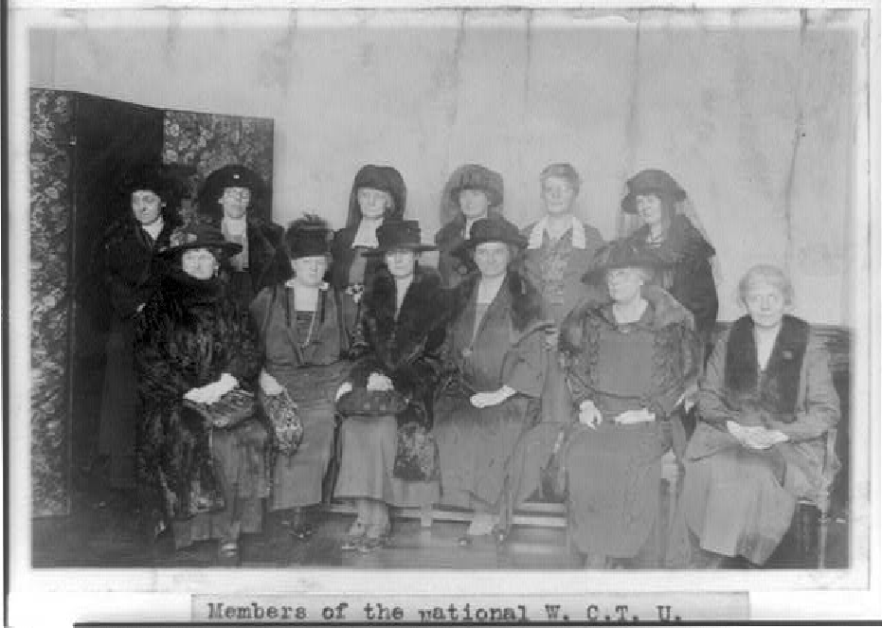
The above photograph was taken on March 1, 1922. Not all women during the 1920s chose to participate in the new styles and behaviors made popular by the “flappers”.

Source AG: “Four Prize Winners in Annual Beauty Show, 1922”
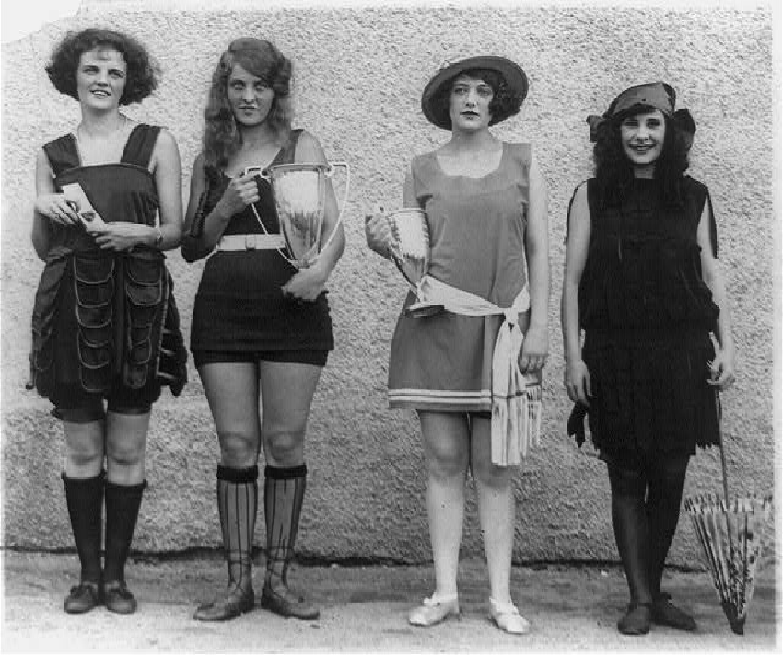

Young women were more likely to participate in the loosened restrictions on women in the 1920s.
After you read:

1. How did prohibition affect the culture of the 1920s?

2. How did the expectations for women change during the 1920s?

Lesson 6
Supporting Question 3: How did the culture and demographics of the
United States change during the 1920s, and why?
Student Directions | Read Sources AH, AI, AJ, and AK and answer the guiding questions in the right-hand column. Then, complete performance task #3 at the end of this lesson.
Featured Sources | Source AH: “The Harlem Renaissance and the New Negro”  Source AI: “If We Must Die” by Claude McKay  Source AJ: Excerpts from “Declaration of the Rights of the Negro Peoples of the World: The Principles of the Universal Negro Improvement Association”  Source AK: “Immigration and Urbanization”
Optional Digital Extensions | Khan Academy - 1920s Immigration and Urbanization

King & Carter Jazzing Orchestra, Houston Texas
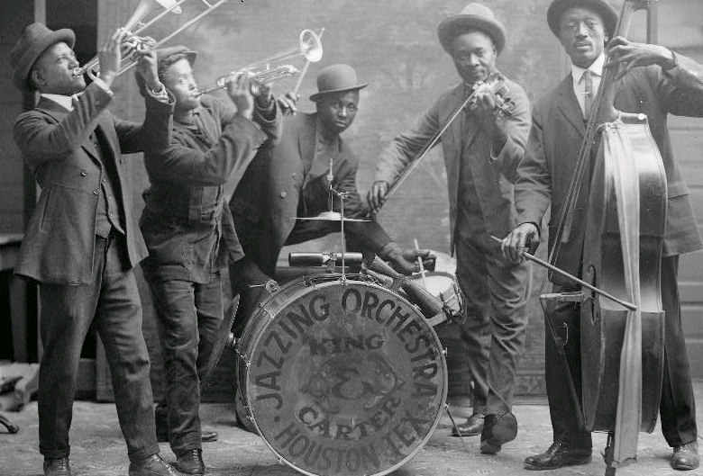

Source AH: “The Harlem Renaissance and the New Negro”
Text | Vocabulary | Guiding Questions
It wasn’t only women who found new forms of expression in the 1920s. African Americans were also expanding their horizons and embracing the concept of the “new Negro.” The decade witnessed the continued Great Migration of African Americans to the North, with over half a million fleeing the strict Jim Crow laws of the South. Life in the northern states, as many African Americans discovered, was hardly free of discrimination and segregation. Even without Jim Crow, businesses, property owners, employers, and private citizens typically practiced de facto segregation, which could be quite stifling and oppressive. Nonetheless, many southern Blacks continued to move north into segregated neighborhoods that were already bursting at the seams, because the North, at the very least, offered two tickets toward Black progress: schools and the vote. The Black population of New York City doubled during the decade. As a result, Harlem, a neighborhood at the northern end of Manhattan, became a center for Afro-centric art, music, poetry, and politics. Political expression in the Harlem of the 1920s ran the gamut, as some leaders advocated a return to Africa, while others fought for inclusion and integration.  Revived by the wartime migration and fired up by the white violence of the postwar riots, urban Blacks developed a strong cultural expression in the 1920s that came to be known as the Harlem Renaissance. In this rediscovery of Black culture, African American artists and writers formulated an independent Black culture and encouraged racial pride, rejecting any emulation of white American culture. Claude McKay’s poem “If We Must Die” called on African Americans to start fighting back in the wake of the Red Summer riots of 1919. Langston Hughes, often nicknamed the “poet laureate” of the movement, invoked sacrifice and the just cause of civil rights in “The Colored Soldier,” while another author of the movement, Zora Neale Hurston, celebrated the life and dialect of rural Blacks in a fictional, all-Black town in Florida. Hurston’s Their Eyes Were Watching God was published in 1937. In music, jazz rocketed in popularity. Eager to hear “real jazz,” whites journeyed to Harlem’s Cotton Club and Smalls. Next to Greenwich Village, Harlem’s nightclubs and speakeasies (venues where alcohol was publicly consumed) presented a place where sexual freedom and gay life thrived. Unfortunately, while headliners like Duke Ellington were hired to entertain at Harlem’s venues, the surrounding Black community was usually excluded. Furthermore, Black performers were often restricted from restroom use and relegated to service door entry. As the Renaissance faded to a close, several Harlem Renaissance artists went on to produce important works indicating that this movement was but one component in African American’s long history of cultural and intellectual achievements.  Alain Locke did not coin the term New Negro, but he did much to popularize it. In the 1925 book The New Negro, Locke proclaimed that the generation of subservience was no more—“we are achieving something like a spiritual emancipation.” Bringing together writings by men and women, young and old, Black and white, Locke produced an anthology that was of African Americans, rather than only about them. The new Negro found political expression in a political ideology that celebrated African Americans distinct national identity. This Negro nationalism, as some referred to it, proposed that African Americans had a distinct and separate national heritage that should inspire pride and a sense of community. An early proponent of such nationalism was W. E. B. Du Bois. One of the founders of the NAACP, a brilliant writer and scholar, and the first African American to earn a Ph.D. from Harvard, Du Bois openly rejected assumptions of white supremacy. His conception of Negro nationalism encouraged Africans to work together in support of their own interests, promoted the elevation of Black literature and cultural expression, and, most famously, embraced the African continent as the true homeland of all ethnic Africans—a concept known as Pan-Africanism.  Taking Negro nationalism to a new level was Marcus Garvey. Like many Black Americans, the Jamaican immigrant had become utterly disillusioned with the prospect of overcoming white racism in the United States in the wake of the postwar riots and promoted a “Back to Africa” movement. To return African Americans to a presumably more welcoming home in Africa, Garvey founded the Black Star Steamship Line. He also started the United Negro Improvement Association (UNIA), which attracted thousands of primarily lower-income working people. UNIA members wore colorful uniforms and promoted the doctrine of a “negritude” that reversed the color hierarchy of white supremacy, prizing blackness and identifying light skin as a mark of inferiority. Intellectual leaders like Du Bois, whose lighter skin put him low on Garvey’s social order, considered the UNIA leader a charlatan. Garvey was eventually imprisoned for mail fraud and then deported, but his legacy set the stage for Malcolm X, whose parents were Garveyites, and the Black Power movement of the 1960s. He inspired Kwame Nkrumah, the first president of Ghana. Garvey’s message, perhaps best captured by his rallying cry, “Up, you mighty race,” resonated with African Americans who found in Garveyism a dignity not granted them in their everyday lives. | de facto: exists in practice, but not by law  gamut: complete range or scope of something  inclusion: the action of being fully included within a group  integration: unification; opposite of segregation  subservience: the condition of being less important or the willingness to obey others without question  emancipation: freedom  disillusioned: hopeless  charlatan: a fake, fraud, imposter | Why did Black Americans move to the North from the South during the Great Migration?  ________________________________  ________________________________  ________________________________  How was the experience of Black Americans in the North similar to their experience in the South? How was it different?  ________________________________  ________________________________  ________________________________  ________________________________  ________________________________  ________________________________  ________________________________  What was the significance of Harlem to Black Americans in the 1920s?  In your own words, describe the Harlem Renaissance.  ________________________________  ________________________________  ________________________________  ________________________________  ________________________________  ________________________________  ________________________________  ________________________________  How did the Harlem Renaissance and the popularity of jazz help Black performers? How were Black performers excluded?  ________________________________  ________________________________  ________________________________  ________________________________  ________________________________  ________________________________  ________________________________  ________________________________  ________________________________  ________________________________  How did Alain Locke describe the new generation of Black Americans who were part of the “New Negro Movement” in the 1920s?  ________________________________  ________________________________  ________________________________  ________________________________  ________________________________  ________________________________  ________________________________  ________________________________  ________________________________  Describe the views of Marcus Garvey.  ________________________________  ________________________________  ________________________________  ________________________________  ________________________________  ________________________________  ________________________________  ________________________________

*Note: Claude McKay was a prominent Jamaican writer and poet in the Harlem Renaissance. He wrote this poem in 1919 in response to the anti-Black violence throughout the U.S. in that year.
Source AI: “If We Must Die” by Claude McKay
Text | Vocabulary | Guiding Questions
If we must die, let it not be like hogs  Hunted and penned in an inglorious spot,  While round us bark the mad and hungry dogs,  Making their mock at our accursèd lot.  If we must die, O let us nobly die,  So that our precious blood may not be shed  In vain; then even the monsters we defy  Shall be constrained to honor us though dead!  O kinsmen! we must meet the common foe!  Though far outnumbered let us show us brave,  And for their thousand blows deal one death-blow!  What though before us lies the open grave?  Like men we’ll face the murderous, cowardly pack,  Pressed to the wall, dying, but fighting back! | inglorious: shameful  accursèd: under a curse  lot: a group of people  nobly: bravely, with honor  in vain: without good cause | Who is the “we” Claude McKay is referring to in this poem? Explain your answer.  ________________________________  ________________________________  ________________________________  ________________________________  ________________________________  ________________________________  In your own words, describe the experience of Black Americans portrayed in this poem.  ________________________________  ________________________________  ________________________________  ________________________________  ________________________________  ________________________________  ________________________________  ________________________________

Marcus Garvey
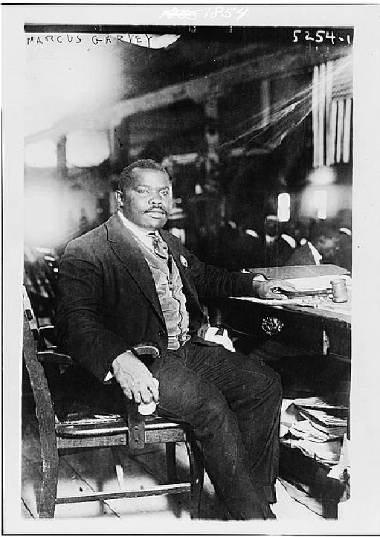

* The Universal Negro Improvement Association (UNIA) was founded by Marcus Garvey in 1919. This document was written by delegates of the organization in 1920.
Source AJ: Excerpts from “Declaration of the Rights of the Negro Peoples of the World: The Principles of the Universal Negro Improvement Association”
Text | Vocabulary | Guiding Questions
Be It Resolved, That the Negro people of the world, through their chosen representatives in convention assembled in Liberty Hall, in the City of New York and United States of America, from August 1 to August 31, in the year of Our Lord one thousand nine hundred and twenty, protest against the wrongs and injustices they are suffering at the hands of their white brethren, and state what they deem their fair and just rights, as well as the treatment they propose to demand of all men in the future.  We complain:  1. That nowhere in the world, with few exceptions, are black men accorded equal treatment with white men. . . for no other reason than their race and color.  We are not willingly accepted as guests in the public hotels and inns of the world for no other reason than our race and color.  2. In certain parts of the United States of America our race is denied the right of public trial accorded to other races when accused of crime, but are lynched and burned by mobs, and such brutal and inhuman treatment is even practiced upon our women.  4. In the southern portion of the United States of America, although citizens under the Federal Constitution, and in some States almost equal to the whites in population and are qualified land owners and taxpayers, we are, nevertheless, denied all voice in the making and administration of the laws and are taxed without representation by the State governments, and at the same time compelled to do military service in defense of the country.  5. On the public conveyances and common carriers in the southern portion of the United States we are jim-crowed and compelled to accept separate and inferior accommodations and made to pay the same fare charged for first-class accommodations. . .  6. . . . Our children are forced to attend inferior separate schools for shorter terms than white children, and the public school funds are unequally divided between the white and colored schools.  7. We are discriminated against and denied an equal chance to earn wages for the support of our families, and in many instances are refused admission into labor unions and nearly everywhere are paid smaller wages than white men.  10. That our people . . . are forced to work for lower wages than the average standard of white men and are kept in conditions repugnant to good civilized tastes and customs.  In order to encourage our race all over the world and to stimulate it to overcome the handicaps and difficulties surrounding it, and to push forward to a higher and grander destiny, we demand and insist on the following Declaration of Rights:  . . .  2. That we believe in the supreme authority of our race in all things racial; that all things are created and given to man as a common possession; that there should be an equitable distribution and apportionment of all such things, and in consideration of the fact that as a race we are now deprived of those things that are morally and legally ours, we believed it right that all such things should be acquired and held by whatsoever means possible.  . . .  4. We declare that Negroes, wheresoever they form a community among themselves should be given the right to elect their own representatives to represent them in Legislatures, courts of law, or such institutions as may exercise control over that particular community.  5. We assert that the Negro is entitled to even-handed justice before all courts of law and equity in whatever country he may be found, and when this is denied him on account of his race or color such denial is an insult to the race as a whole and should be resented by the entire body of Negroes.  6. We declare it unfair and prejudicial to the rights of Negroes in communities where they exist in considerable numbers to be tried by a judge and jury composed entirely of an alien race, but in all such cases members of our race are entitled to representation on the jury.  8. We declare taxation without representation unjust and tyrannous, and there should be no obligation on the part of the Negro to obey the levy of a tax by any law-making body from which he is excluded and denied representation on account of his race and color.  12. We believe that the Negro should adopt every means to protect himself against barbarous practices inflicted upon him because of color.  13. We believe in the freedom of Africa for the Negro people of the world, and by the principle of Europe for the Europeans and Asia for the Asiatics, we also demand Africa for the Africans at home and abroad. | jim-crowed: segregated | What was the purpose of the “Declaration of the Rights of the Negro Peoples”?  ________________________________  ________________________________  ________________________________  ________________________________  ________________________________  ________________________________  ________________________________  ________________________________  According to the document, why do Black people experience discrimination?  ________________________________  ________________________________  ________________________________  ________________________________  How did Black people experience the laws of the United States differently than white people?  ________________________________  ________________________________  ________________________________  ________________________________  ________________________________  ________________________________  ________________________________  ________________________________  ________________________________  ________________________________  What were some opportunities denied to Black people?  ________________________________  ________________________________  ________________________________  ________________________________  ________________________________  ________________________________  ________________________________  ________________________________  ________________________________  ________________________________  How did the UNIA believe Black people should acquire things that were denied them and that were “morally and legally ours”?  ________________________________  ________________________________  ________________________________  ________________________________  ________________________________  ________________________________  ________________________________  ________________________________  ________________________________  How did the UNIA propose Black people should acquire more political power and a more just court system?  ________________________________  ________________________________  ________________________________  ________________________________  ________________________________  ________________________________  ________________________________  ________________________________  ________________________________  ________________________________  How did the UNIA view segregation of races? Explain your answer.  ________________________________  ________________________________  ________________________________  ________________________________  ________________________________

Source AK: “Immigration and Urbanization”
Text | Vocabulary | Guiding Questions
Industry pulled ever more Americans into cities. Manufacturing needed the labor pool and the infrastructure. America’s urban population increased sevenfold in the half century after the Civil War. Soon the United States had more large cities than any country in the world. The 1920 U.S. census revealed that, for the first time, a majority of Americans lived in urban areas. Much of that urban growth came from the millions of immigrants pouring into the nation. Between 1870 and 1920, over twenty-five million immigrants arrived in the United States.  By the turn of the twentieth century, new immigrant groups such as Italians, Poles, and Eastern European Jews made up a larger percentage of arrivals than the Irish and Germans. The specific reasons that immigrants left their particular countries and the reasons they came to the United States (what historians call push and pull factors) varied. For example, a young husband and wife living in Sweden in the 1880s and unable to purchase farmland might read an advertisement for inexpensive land in the American Midwest and immigrate to the United States to begin a new life. A young Italian man might simply hope to labor in a steel factory long enough to save up enough money to return home and purchase land for a family. A Russian Jewish family persecuted in European pogroms might look to the United States as a sanctuary. Or perhaps a Japanese migrant might hear of fertile farming land on the West Coast and choose to sail for California. But if many factors pushed people away from their home countries, by far the most important factor drawing immigrants was economics. Immigrants came to the United States looking for work.  Industrial capitalism was the most important factor that drew immigrants to the United States between 1880 and 1920. Immigrant workers labored in large industrial complexes producing goods such as steel, textiles, and food products, replacing smaller and more local workshops. The influx of immigrants, alongside a large movement of Americans from the countryside to the city, helped propel the rapid growth of cities like New York, Pittsburgh, Cleveland, Milwaukee, and St. Louis. By 1890, immigrants and their children accounted for roughly 60 percent of the population in most large northern cities (and sometimes as high as 80 or 90 percent). Many immigrants, especially from Italy and the Balkans, always intended to return home with enough money to purchase land. But what about those who stayed? Did the new arrivals assimilate together in the American melting pot—becoming just like those already in the United States—or did they retain, and sometimes even strengthen, their traditional ethnic identities? The answer lies somewhere in between. Immigrants from specific countries—and often even specific communities—often clustered together in ethnic neighborhoods. They formed vibrant organizations and societies, such as Italian workmen’s clubs, Eastern European Jewish mutual aid societies, and Polish Catholic churches, to ease the transition to their new American home. Immigrant communities published newspapers in dozens of languages and purchased spaces to maintain their arts, languages, and traditions alive. And from these foundations they facilitated even more immigration: after staking out a claim to some corner of American life, they wrote home and encouraged others to follow them (historians call this chain migration).  While cities boomed, rural worlds languished. Some Americans scoffed at rural backwardness and reveled in the countryside’s decay, but many romanticized the countryside, celebrated rural life, and wondered what had been lost in the cities. Sociologist Kenyon Butterfield, concerned by the sprawling nature of industrial cities and suburbs, regretted the eroding social position of rural citizens and farmers: “Agriculture does not hold the same relative rank among our industries that it did in former years.” Butterfield saw “the farm problem” as part of “the whole question of democratic civilization.” He and many others thought the rise of the cities and the fall of the countryside threatened traditional American values. |  | How did cities change in the period between 1870 and 1920?  ________________________________  ________________________________  ________________________________  ________________________________  ________________________________  Describe some of the push and pull factors that drove immigration to the United States.  ________________________________  ________________________________  ________________________________  ________________________________  ________________________________  ________________________________  ________________________________  ________________________________  ________________________________  ________________________________  ________________________________  ________________________________  Where did immigrants to the United States most commonly live and work in their new country?  ________________________________  ________________________________  ________________________________  ________________________________  ________________________________  ________________________________  ________________________________  How did immigrants retain the culture of their homelands in the United States?  ________________________________  ________________________________  ________________________________  ________________________________  ________________________________  ________________________________  ________________________________  ________________________________  ________________________________  How did perceptions of rural life in the United States change at the beginning of the 20th century?  ________________________________  ________________________________  ________________________________  ________________________________  ________________________________  ________________________________

Formative Performance Task #3 – Constructed Response
Student Directions | Explain two different ways culture and demographics in the United States changed during the 1920s.

Lesson 7
Supporting Question 4: How did people react to the cultural and demographic changes in the United States during the 1920s, and why?
Student Directions | Read Sources AL, AM, and AN and answer the guiding questions in the right-hand column. Then, read and study Source AO. Finally, complete the after you read questions at the end of this lesson.
Featured Sources | Source AL: “Fundamentalist Christianity”  Source AM: “Scopes Trial Decision” July 21, 1925  Source AN: “Nativism”  Source AO: “Protest to Save Sacco and Vanzetti in London, England in 1921”

Source AL: “Fundamentalist Christianity”
Text | Vocabulary | Guiding Questions
In addition to alarms over immigration and the growing presence of Catholicism and Judaism, a new core of Christian fundamentalists were very much concerned about relaxed sexual mores and increased social freedoms, especially as found in city centers. Although never a centralized group, most fundamentalists lashed out against what they saw as a sagging public morality, a world in which Protestantism seemed challenged by Catholicism, women exercised ever greater sexual freedoms, public amusements encouraged selfish and empty pleasures, and critics mocked Prohibition through bootlegging and speakeasies.  On March 21, 1925, in a tiny courtroom in Dayton, Tennessee, fundamentalists gathered to tackle the issues of creation and evolution. A young biology teacher, John T. Scopes, was being tried for teaching his students evolutionary theory in violation of the Butler Act, a state law preventing evolutionary theory or any theory that denied “the Divine Creation of man as taught in the Bible” from being taught in publicly funded Tennessee classrooms. Seeing the act as a threat to personal liberty, the American Civil Liberties Union (ACLU) immediately sought a volunteer for a “test” case, hoping that the conviction and subsequent appeals would lead to a day in the Supreme Court, testing the constitutionality of the law. It was then that Scopes, a part-time teacher and coach, stepped up and voluntarily admitted to teaching evolution (Scopes’s violation of the law was never in question). Thus the stage was set for the pivotal courtroom showdown—“the trial of the century”—between the champions and opponents of evolution that marked a key moment in an enduring American “culture war.”  The case became a public spectacle. Clarence Darrow, an agnostic attorney and a keen liberal mind from Chicago, volunteered to aid the defense and came up against William Jennings Bryan. Bryan, the “Great Commoner,” was the three-time presidential candidate who in his younger days had led the political crusade against corporate greed. He had done so then with a firm belief in the righteousness of his cause, and now he defended biblical literalism in similar terms. The theory of evolution, Bryan said, with its emphasis on the survival of the fittest, “would eliminate love and carry man back to a struggle of tooth and claw.”  Newspapermen and spectators flooded the small town of Dayton. Across the nation, Americans tuned their radios to the national broadcasts of a trial that dealt with questions of religious liberty, academic freedom, parental rights, and the moral responsibility of education. For six days in July, the men and women of America were captivated as Bryan presented his argument on the morally corrupting influence of evolutionary theory. Darrow eloquently fought for academic freedom.  At the request of the defense, Bryan took the stand as an “expert witness” on the Bible. At his age, he was no match for Darrow’s famous skills as a trial lawyer and his answers came across as blundering and incoherent, Additionally, Darrow posed a series of unanswerable questions: Was the “great fish” that swallowed the prophet Jonah created for that specific purpose? What precisely happened astronomically when God made the sun stand still? Bryan, of course, could cite only his faith in miracles. Tied into logical contradictions, Bryan’s testimony was a public relations disaster, although his statements were expunged from the record the next day and no further experts were allowed—Scopes’s guilt being established, the jury delivered a guilty verdict in minutes. The case was later thrown out on a technicality. But few cared about the verdict. Darrow had, in many ways, at least to his defenders, already won: the fundamentalists seemed to have taken a beating in the national limelight.  Journalist and satirist H. L. Mencken characterized the “circus in Tennessee” as an embarrassment for fundamentalism, and modernists remembered the “Monkey Trial” as a smashing victory. If fundamentalists retreated from the public sphere, they did not disappear entirely. Instead, they went local, built a vibrant subculture, and emerged many decades later stronger than ever. | Christian fundamental-ists: people who believe in a literal interpretation of the Bible  Protestantism: Christian dominations that broke away from the Catholic church; most Christians in the United States are Protestant  creation: belief in the literal interpretation of the Biblical account of creation  evolutionary theory: species change over time; humans evolved from apes  culture war: conflict fought for dominance of one group’s values, beliefs, and practices  agnostic: someone who believes that the existence of God cannot be proven  biblical literalism: the events of the Bible happened exactly as they are written  technicality: a small detail  Monkey Trial: nickname for the trial that indicates the role evolution played in the trial | Describe the concerns of Christian fundamentalists in the 1920s.  ________________________________  ________________________________  ________________________________  ________________________________  ________________________________  ________________________________  ________________________________  ________________________________  ________________________________  ________________________________  Describe the events that led to John T. Scopes being put on trial.  ________________________________  ________________________________  ________________________________  ________________________________  ________________________________  ________________________________  ________________________________  How did the Scope trial showcase and contribute to a “culture war” within U.S. society?  ________________________________  ________________________________  ________________________________  ________________________________  ________________________________  ________________________________  ________________________________  ________________________________  ________________________________  ________________________________  ________________________________  ________________________________  What were the results of the Scopes Trial?  ________________________________  ________________________________  ________________________________  ________________________________  ________________________________  ________________________________  ________________________________  ________________________________  Was the Scopes trial a victory for fundamentalists or modernists? Explain your answer.  ________________________________  ________________________________  ________________________________  ________________________________  ________________________________  ________________________________

Source AM: “Scopes Trial Decision” July 21, 1925
Text | Vocabulary | Guiding Questions
“Court—Mr. Scopes, the jury has found you guilty under this indictment, charging you with having taught in the schools of Rhea county, in violation of what is commonly known as the anti-evolution statute, which makes it unlawful for any teacher to teach in any of the public schools of the state, supported in whole or in part by the public school funds of the state, any theory that denies the story of the divine creation of man, and teach instead thereof that man has descended from a lower order of animals. The jury have found you guilty. The statute makes this an offense punishable by fine of not less than $100 nor more than $500. The court now fixes your fine at $100, and imposes that fine upon you.  Court—Oh-Have you anything to say, Mr. Scopes, as to why the court should not impose punishment upon you?  Defendant J. T. Scopes—Your honor, I feel that I have been convicted of violating an unjust statute. I will continue in the future, as I have in the past, to oppose this law in any way I can. Any other action would be in violation of my ideal of academic freedom—that is, to teach the truth as guaranteed in our constitution of personal and religious freedom. I think the fine is unjust.” |  | What was John T. Scopes’ punishment for violating the Butler Act?  ________________________________  ________________________________  ________________________________  ________________________________  ________________________________  Did Scopes believe his punishment was fair? Why or why not?  ________________________________  ________________________________  ________________________________  ________________________________  ________________________________  ________________________________  ________________________________  ________________________________

Source AN: “Nativism”
Text | Vocabulary | Guiding Questions
Beginning at the end of the nineteenth century, immigration into the United States rocketed to never-before-seen heights. Many of these new immigrants were coming from eastern and southern Europe and, for many English-speaking, native-born Americans of northern European descent, the growing diversity of new languages, customs, and religions triggered anxiety and racial animosity. Many middle-class white Americans scapegoated Eastern European and Latin American immigrants (Asian immigration had already been almost completely prohibited), and African Americans who now pushed harder for civil rights. Protestants, meanwhile, continued to denounce the Roman Catholic Church and charged that American Catholics gave their allegiance to the pope and not to their country.  In reaction, some embraced nativism, prizing white Americans with older family trees over more recent immigrants, and rejecting outside influences in favor of their own local customs. Nativists also stoked a sense of fear over the perceived foreign threat, pointing to the anarchist assassinations of the Spanish prime minister in 1897, the Italian king in 1900, and even President William McKinley in 1901 as proof. Following the Bolshevik Revolution in Russia in November 1917, the sense of an inevitable foreign or communist threat only grew among those already predisposed to distrust immigrants.  Fear of foreign radicals led to the executions of Nicola Sacco and Bartolomeo Vanzetti, two Italian anarchists, in 1927. In May 1920, the two had been arrested for robbery and murder connected with an incident at a Massachusetts factory. Their guilty verdicts were appealed for years as the evidence surrounding their convictions was slim. For instance, while one eyewitness claimed that Vanzetti drove the getaway car, accounts of others described a different person altogether. Nevertheless, despite worldwide lobbying by radicals and a respectable movement among middle-class Italian organizations in the United States, the two men were executed on August 23, 1927. Vanzetti conceivably provided the most succinct reason for his death, saying, “This is what I say . . . . I am suffering because I am a radical and indeed I am a radical; I have suffered because I was an Italian, and indeed I am an Italian.”  To “preserve the ideal of American homogeneity,” the Emergency Immigration Act of 1921 introduced numerical limits on European immigration for the first time in U.S. history. The number of immigrants annually admitted to the United States from each nation was restricted to 2 percent of the population who had come from that country and resided in the United States in 1890. (By pushing back three decades, past the recent waves of “new” immigrants from southern and Eastern Europe, Latin America, and Asia, the law made it extremely difficult for immigrants outside northern Europe to legally enter the United States.) The act also explicitly excluded all Asians, although, to satisfy southern and western growers, it temporarily omitted restrictions on Mexican immigrants. The National Origins Act of 1924 went even further, lowering the level to 2 percent of the 1890 census, significantly reducing the share of eligible southern and eastern Europeans, since they had only begun to arrive in the United States in large numbers in the 1890s. Although New York congressmen Fiorello LaGuardia and Emanuel Celler spoke out against the act, there was minimal opposition in Congress, and both labor unions and the Ku Klux Klan supported the bill. When President Coolidge signed it into law, he declared, “America must be kept American.” | scapegoated: to blame another person or group of people for problems in society  Catholics: most Catholic immigrants to the United States in the 1920s were from Eastern Europe and Latin America | What factors led to an increase in nativist feelings?  ________________________________  ________________________________  ________________________________  ________________________________  ________________________________  ________________________________  ________________________________  ________________________________  ________________________________  What did the convictions and executions of Sacco and Vanzetti show about feelings towards immigrants and radicals?  ________________________________  ________________________________  ________________________________  ________________________________  ________________________________  ________________________________  ________________________________  ________________________________  ________________________________  ________________________________  ________________________________  ________________________________  ________________________________  ________________________________  How were “new” immigrant groups targeted in the Emergency Immigration Act of 1921?  ________________________________  ________________________________  ________________________________  ________________________________  How did nativist beliefs affect immigration policies?  ________________________________  ________________________________  ________________________________  ________________________________  ________________________________  ________________________________

Source AO: “Protest to Save Sacco and Vanzetti in London, England in 1921”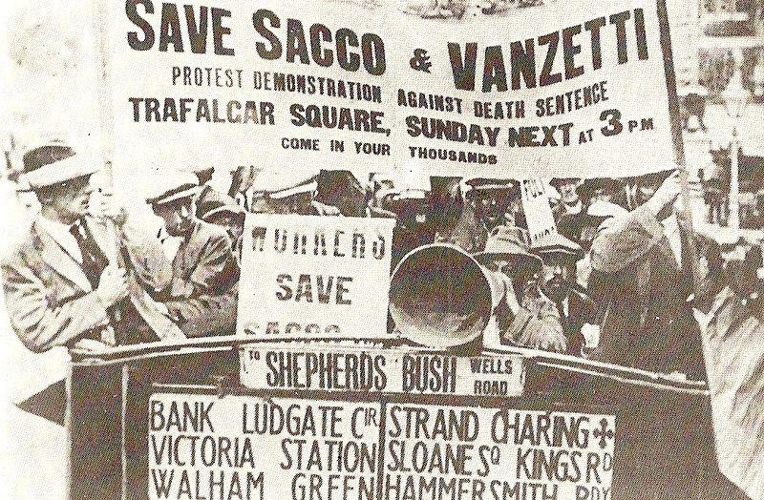

Protests in support of Sacco and Vanzetti were staged throughout the world. People protested what they saw as the unjust treatment of European immigrants in the United States.

After you read:

- How was the Scopes trial a reaction to cultural and demographic changes?

- Why did nativist feelings increase in the 1920s?

Lesson 8
Supporting Question 4: How did people react to the cultural and demographic changes in the United States during the 1920s, and why?
Student Directions | Read and study Sources AP and AQ and answer the question below the sources. Then, read and study Source AR. Then, read Sources AS, AT, and AU and answer the guiding questions in the right-hand column.
Featured Sources | Source AP: “Cop Measures Bathing Suits”  Source AQ: “A Flapper’s Appeal to Parents” by Ellen Welles Page  Source AR: “Women Ask President for Equal Rights Legislation”  Source AS: “The Woman’s Party Campaign for Equal Rights, Reprinted from the Christian Science Monitor” September 18, 1922  Source AT: “Greenwood Massacre”  Source AU: “The Tulsa Race Riot: Its Victims”

Source AP: “Cop Measures Bathing Suits”
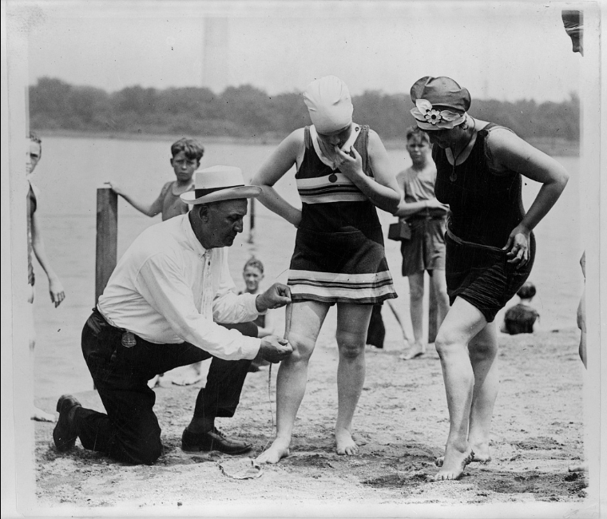

Photo shows Bill Norton, the bathing beach "cop", using a tape measure to determine the distance between a woman's knee and the bottom of her bathing suit on a beach in Washington, D.C., after Col. Sherrell, Supt. of Public Buildings and Grounds, issued an order that bathing suits at the beach must not be over six inches above the knee.
*Note: The Outlook was a news and opinion magazine published in New York City. In the following opinion article from December 6, 1922, Ellen Welles Page makes an appeal to older generations to accept the changes in society represented by the “flapper.”

Source AQ: “A Flapper’s Appeal to Parents” by Ellen Welles Page
Text | Vocabulary | Guiding Questions
If one judges by appearances, I suppose I am a flapper. I am within the age limit. I wear bobbed hair, the badge of flapperhood. (And, oh, what a comfort it is!). I powder my nose. I wear fringed skirts and bright-colored sweaters, and scarfs, and waists with Peter Pan collars, and low-heeled “finale hopper” shoes. I adore to dance. I spend a large amount of time in automobiles. I attend hops, and proms, and ball-games, and crew races, and other affairs at men’s colleges. But none the less some of the most thoroughbred superflappers might blush to claim sistership or even remote relationship with such as I. I don’t use rouge, or lipstick, or pluck my eyebrows. I don’t smoke (I’ve tried it, and don’t like it), or drink, or tell “peppy stories.” . . . But then—there are many degrees of flapper. There is the semi-flapper; the flapper; the superflapper. Each of these three main general divisions has its degrees of variation. I might possibly be placed somewhere in the middle of the first class.  …  I want to beg all you parents, and grandparents, and friends, and teachers, and preachers—you who constitute the “older generation”—to overlook our shortcomings, at least for the present, and to appreciate our virtues. I wonder if it ever occurred to any of you that it required brains to become and remain a successful flapper? Indeed it does! It requires an enormous amount of cleverness and energy to keep going at the proper pace. . .  “Brains?” you repeat, skeptically. “Then why aren’t they used to better advantage?” That is exactly it! And do you know who is largely responsible for all this energy being spent in the wrong directions? You! You parents, and grandparents, and friends, and teachers, and preachers—all of you! “The war!” you cry. “It is the effect of the war!” And then you blame prohibition. Yes! Yet it is you who set the example there! But this is my point: Instead of helping us work out our problems with constructive, sympathetic thinking and acting, you have muddled them for us more hopelessly with destructive public condemnation and denunciation.  Think back to the time when you were struggling through the teens. Remember how spontaneous and deep were the joys, how serious and penetrating the sorrows. Most of us, under the present system of modern education, are further advanced and more thoroughly developed mentally, physically, and vocationally than were our parents at our age. We hold the infinite possibilities of the myriads of new inventions within our grasp. We have learned to take for granted conveniences, and many luxuries, which not so many years ago were as yet undreamed of. We are in touch with the whole universe. We have a tremendous problem on our hands. You must help us. Give us confidence—not distrust. Give us practical aid and advice—not criticism. Praise us when praise is merited. Be patient and understanding when we make mistakes. |  | How does the author differentiate herself from other flappers?  ________________________________  ________________________________  ________________________________  ________________________________  ________________________________  ________________________________  ________________________________  ________________________________  ________________________________  ________________________________  ________________________________  ________________________________  ________________________________  ________________________________  ________________________________  ________________________________  ________________________________  How does the “older generation” criticize the flapper generation?  ________________________________  ________________________________  ________________________________  ________________________________  ________________________________  ________________________________  What advice does the author give to the “older generation”?  ________________________________  ________________________________  ________________________________  ________________________________  ________________________________  ________________________________

How did some people react to the women’s changing fashions and flapper culture?

__________________________________________________________________________________________

__________________________________________________________________________________________

__________________________________________________________________________________________
Source AR: “Women Ask President for Equal Rights Legislation”
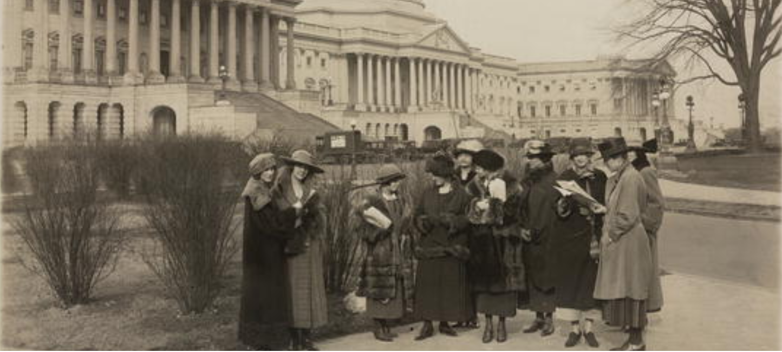

A group of young members of the National Woman's Party stand in front of the Capitol in 1923. They entered the offices of the senators and congressmen from their states to ask them to vote for the Equal Rights Bill after this photograph was taken. Women gained the right to vote with the ratification of the 19th amendment in 1920, but some suffragists continued fighting for equal rights for women. Alice Paul proposed the Equal Rights Amendment in 1923. Versions of the ERA were proposed to Congress all the way through 1972, when it was passed, but not ratified by the states.

*Note: The National Women’s party campaigned for the Wisconsin Equal Rights Bill which passed in 1921.

Source AS: “The Woman’s Party Campaign for Equal Rights, Reprinted from the Christian Science Monitor” September 18, 1922
Text | Vocabulary | Guiding Questions
It is salutary occasionally to take account of civilization's progress in one's own country, although the review may not always be particularly stimulating to national pride. Indeed, it is rather a check to one's sense of liberty to be reminded, for example, that it is still possible in the United States of America for fathers, if they elect, to will away children from the mothers; that a married woman's services and her earnings belong to her husband; that married women are classed with children and the insane, as unable to contract on their own responsibility; and that a married woman may not choose her legal residence for voting or taxation, or say of whom the family circle shall consist. Yet, in every state but one, there remain on the statute books some such discriminative shadows of the chattel slavery days. That these laws have fallen into disuse does not excuse their continuance.  Only the artless, indeed, could have imagined that the ratification of the National Suffrage Amendment to the Federal Constitution, in 1920, brought to women an equality with men under the law. The better informed recognized in this amendment but one step in the evolution toward that goal. As a matter of fact, American women are yet face to face with many legal discriminations, just as were the English women at the end of their suffrage campaign; and in every state but one their citizenship is lame. | contract: enter in to a legal agreement  chattel: property | Describe some ways women were restricted in the United States in the 1920’s.  ________________________________  ________________________________  ________________________________  ________________________________  ________________________________  ________________________________  ________________________________  ________________________________  ________________________________  According to the author, what were the limitations of the 19th Amendment?  ________________________________  ________________________________  ________________________________  ________________________________  ________________________________

Source AT: “Greenwood Massacre”
Text | Vocabulary | Guiding Questions
In 1921 Greenwood was one of the most affluent and commercially successful black communities in America. Originally attracted by the Oklahoma oil boom, Black workers, merchants, and professionals built a thriving business district that Booker T. Washington called the “Negro Wall Street.” Although they made up only about an eighth of the population, African Americans prospered in Tulsa.  The violence began when a 17-year old white woman ran out of an elevator in a public building and claimed a 19-year old Black shoe shiner named Dick Rowland had sexually assaulted her. Rowland was arrested by the county sheriff and newspapers picked up the story, running headlines announcing “To Lynch Negro Tonight” and “Nab Negro for Attacking Girl in Elevator.” A group of armed Black citizens including several Black business leaders arrived to prevent a lynch mob from taking Rowland from the jail. Shots were exchanged when the lynch mob arrived and tried to disarm the Blacks defending Rowland, resulting in ten white and two Black deaths.  As news of this fight spread, white rioters attacked Greenwood in force overnight and into the following day. Stores and homes were looted and set on fire. When Tulsa firefighters arrived, they were turned away by white vigilantes. A number of eyewitness accounts described private aircraft being used to shoot into Black crowds and drop turpentine firebombs onto Black-owned buildings. This is the first instance of aerial bombing in United States history. The death toll is uncertain, but probably amounted to several hundred Black deaths and up to a hundred white. About 6,000 Greenwood residents were arrested and briefly detained. Nearly a hundred people were indicted but no one was prosecuted for the riots. The Red Cross reported that 1,256 homes were burned and an additional 215 looted. About 10,000 people were left homeless. | affluent: wealthy  vigilantes: people who seek justice using illegal tactics  turpentine: liquid that can be used to make bombs | Describe the success of the Black population in Tulsa before the Greenwood Massacre.  ________________________________  ________________________________  ________________________________  ________________________________  ________________________________  What methods did white rioters use to terrorize Black people in during the Greenwood Massacre?  ________________________________  ________________________________  ________________________________  ________________________________  ________________________________  ________________________________  ________________________________  ________________________________  ________________________________  ________________________________  Describe the destruction to the Black community of Tulsa as a result of the Greenwood Massacre  ________________________________  ________________________________  ________________________________  ________________________________  ________________________________  ________________________________  ________________________________

Source AU: “The Tulsa Race Riot: Its Victims”
Text | Vocabulary | Guiding Questions
B.C. Franklin was a prominent Black lawyer in Tulsa, Oklahoma. A survivor of the Tulsa Massacre, he penned a first-person account ten years after the events. The manuscript was uncovered in 2015 and has been published by the Smithsonian.  “About mid-night, I arose and went to the north porch on the second floor of my hotel and, looking in a north-westerly direction, I saw the top of stand-pipe hill literally lighted up by blazes that came from the throats of machine guns, and I could hear bullets whizzing and cutting the air. There was shooting now in every direction, and the sounds that came from the thousands and thousands of guns were deafening....  I reached my office in safety, but I knew that that safety would be short-lived. I now knew the mob-spirit. I knew too that government and law and order had broken down. I knew that mob law had been substituted in all its fiendishness and barbarity. I knew that the mobbist cared nothing about the written law and the constitution and I also knew that he had neither the patience nor the intelligence to distinguish between the good and the bad, the law-abiding and the lawless in my race. From my office window, I could see planes circling in mid-air. They grew in number and hummed, darted and dipped low. I could hear something like hail falling upon the top of my office building. Down East Archer, I saw the old Mid-Way hotel on fire, burning from its top, and then another and another and another building began to burn from the top.” | mob: a large violent group of people  fiendishness: cruelty  mobbist: person who is part of a mob | How did B.C. Franklin describe the mob during Tulsa Race Riot/Massacre?  ________________________________  ________________________________  ________________________________  ________________________________  ________________________________  ________________________________  ________________________________  ________________________________  ________________________________  ________________________________  What action did the airplane B. C. Franklin describes take during the massacre?  ________________________________  ________________________________  ________________________________  ________________________________  ________________________________

The "Little Africa” section of Tulsa, OK, in flames during the 1921 race riot.
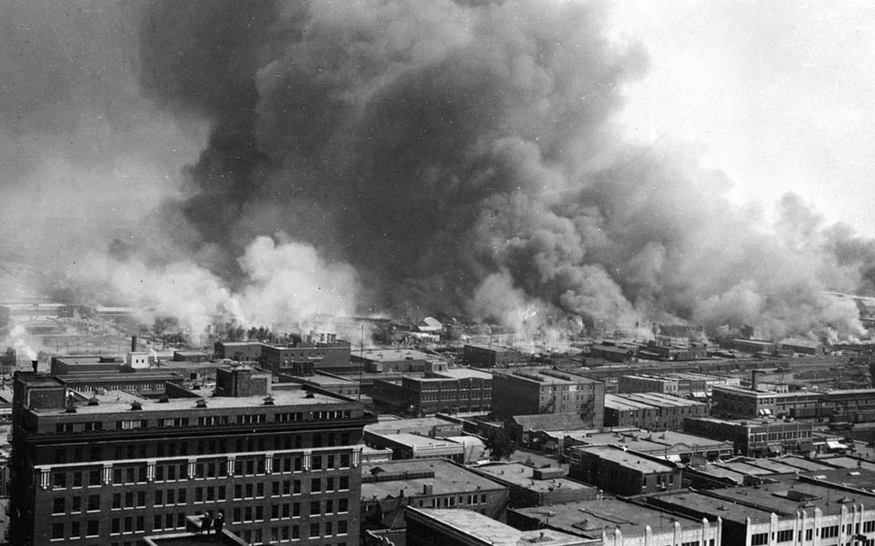

Lesson 9
Supporting Question 4: How did people react to the cultural and demographic changes in the United States during the 1920s, and why?
Student Directions | Read Source AV and answer the guiding questions in the right-hand column. Next, read and study Source AW. Then, read and study Source AX and complete the question below the source. Finally, complete performance task #4 at the end of this lesson.
Featured Sources | Source AV: “Rebirth of the Ku Klux Klan (KKK)”  Source AW: “Ku Klux Klan parade, Washington, D.C., Sept. 13, 1926”  Source AX: “Quota Areas Set by the Immigration Act of 1924”

Source AV: “Rebirth of the Ku Klux Klan (KKK)”
Text | Vocabulary | Guiding Questions
Suspicions of immigrants, Catholics, and modernists contributed to a string of reactionary organizations. None so captured the imaginations of the country as the reborn Ku Klux Klan (KKK), a white supremacist organization that expanded beyond its Reconstruction Era anti-Black politics to now claim to protect American values and the American way of life from Black people, feminists (and other radicals), immigrants, Catholics, Jews, atheists, bootleggers, and a host of other imagined moral enemies.  Two events in 1915 are widely credited with inspiring the rebirth of the Klan: the lynching of Leo Frank and the release of The Birth of a Nation, a popular and groundbreaking film that valorized the Reconstruction Era Klan as a protector of feminine virtue and white racial purity. Taking advantage of this sudden surge of popularity, Colonel William Joseph Simmons organized what is often called the “second” Ku Klux Klan in Georgia in late 1915. This new Klan, modeled after other fraternal organizations with elaborate rituals and a hierarchy, remained largely confined to Georgia and Alabama until 1920, when Simmons began a professional recruiting effort that resulted in individual chapters being formed across the country and membership rising to an estimated five million.  Partly in response to the migration of Black southerners to northern cities during World War I, the KKK expanded above the Mason-Dixon Line. Membership soared in Philadelphia, Detroit, Chicago, and Portland, while Klan-endorsed mayoral candidates won in Indianapolis, Denver, and Atlanta. The Klan often recruited through fraternal organizations such as the Freemasons and through various Protestant churches. In many areas, local Klansmen visited churches of which they approved and bestowed a gift of money on the presiding minister, often during services. The Klan also enticed people to join through large picnics, parades, rallies, and ceremonies. The Klan established a women’s auxiliary in 1923 headquartered in Little Rock, Arkansas. The Women of the Ku Klux Klan mirrored the KKK in practice and ideology and soon had chapters in all forty-eight states, often attracting women who were already part of the Prohibition movement, the defense of which was a centerpiece of Klan activism.  Contrary to its perception of as a primarily southern and lower-class phenomenon, the second Klan had a national reach composed largely of middle-class people. Sociologist Rory McVeigh surveyed the KKK newspaper Imperial Night-Hawk for the years 1923 and 1924, at the organization’s peak, and found the largest number of Klan-related activities to have occurred in Texas, Pennsylvania, Indiana, Illinois, and Georgia. The Klan was even present in Canada, where it was a powerful force within Saskatchewan’s Conservative Party. In many states and localities, the Klan dominated politics to such a level that one could not be elected without the support of the KKK. For example, in 1924, the Klan supported William Lee Cazort for governor of Arkansas, leading his opponent in the Democratic Party primary, Thomas Terral, to seek honorary membership through a Louisiana klavern so as not to be tagged as the anti-Klan candidate. In 1922, Texans elected Earle B. Mayfield, an avowed Klansman who ran openly as that year’s “klandidate,” to the U.S. Senate. At its peak the Klan claimed between four and five million members.  Despite the breadth of its political activism, the Klan is today remembered largely as a violent vigilante group—and not without reason. Members of the Klan and affiliated organizations often carried out acts of lynching and “nightriding”—the physical harassment of bootleggers, union activists, civil rights workers, or any others deemed “immoral” (such as suspected adulterers) under the cover of darkness or while wearing their hoods and robes. In fact, Klan violence was extensive enough in Oklahoma that Governor John C. Walton placed the entire state under martial law in 1923. Witnesses testifying before the military court disclosed accounts of Klan violence ranging from the flogging of clandestine brewers to the disfiguring of a prominent Black Tulsan for registering African Americans to vote. In Houston, Texas, the Klan maintained an extensive system of surveillance that included tapping telephone lines and putting spies in the local post office in order to root out “undesirables.” A mob organized and led by Klan members in Aiken, South Carolina, lynched Bertha Lowman and her two brothers in 1926, but no one was ever prosecuted: the sheriff, deputies, city attorney, and state representative all belonged to the Klan.  The Klan dwindled in the face of scandal and diminished energy over the last years of the 1920s. By 1930, the Klan only had about thirty thousand members and it was largely spent as a national force, only to appear again as a much diminished force during the civil rights movement in the 1950s and 1960s. | reactionary: opposing changes or reforms  Reconstruc-tion Era: the period after the Civil War  virtue: honor  Mason-Dixon Line: originally the line dividing Maryland and Pennsylvania; refers to the division between the cultural North and South of the United States  martial law: using the military to impose order on a civilian population | What caused a resurgence of the Ku Klux Klan in the late teens and 1920s? How was the “second” Klan different from the first?  ________________________________  ________________________________  ________________________________  ________________________________  ________________________________  ________________________________  ________________________________  ________________________________  How did the Ku Klux Klan attract people to join the organization?  ________________________________  ________________________________  ________________________________  ________________________________  ________________________________  ________________________________  ________________________________  How did the Ku Klux Klan influence politics in the United States?  ________________________________  ________________________________  ________________________________  ________________________________  ________________________________  ________________________________  ________________________________  ________________________________  ________________________________  ________________________________  ________________________________  ________________________________  Describe the violent tactics of the Ku Klux Klan. What was the purpose of these acts of violence?  ________________________________  ________________________________  ________________________________  ________________________________  ________________________________  ________________________________  ________________________________  ________________________________  ________________________________  ________________________________  ________________________________  ________________________________  ________________________________  ________________________________  Why were many members of the Ku Klux Klan not held accountable for acts of violence?  ________________________________  ________________________________  ________________________________  ________________________________  ________________________________
Source AW: “Ku Klux Klan parade, Washington, D.C., Sept. 13, 1926”
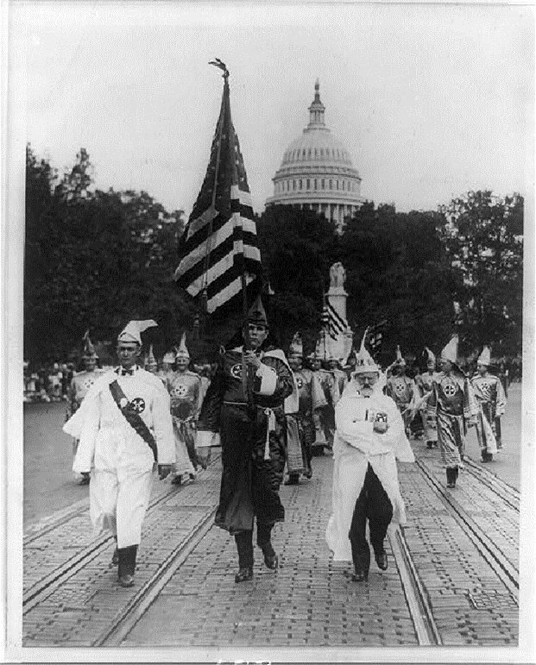
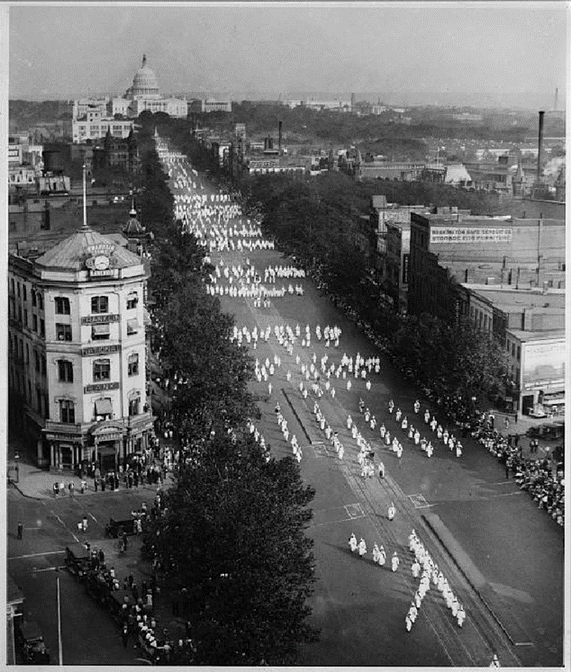

The Ku Klux Klan held a parade in Washington, D.C., in September of 1926. Many of the members exposed their faces, which shows that members were not ashamed or fearful of their involvement in the organization.

Source AX: “Quota Areas Set by the Immigration Act of 1924”
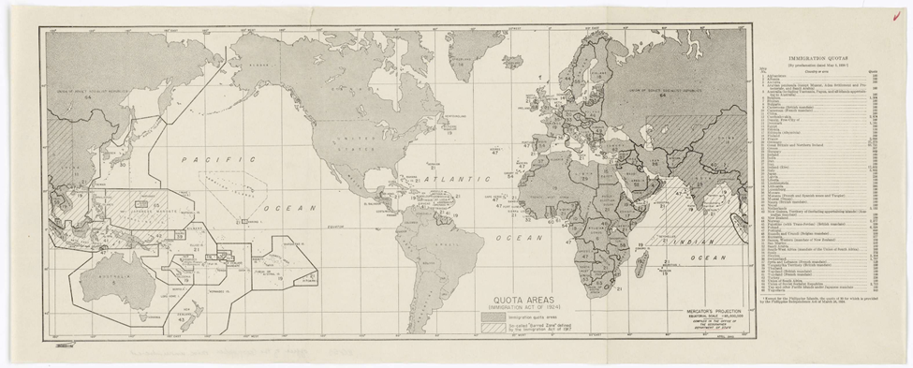
This map (produced in 1940) shows immigration quotas by country as set by the Immigration Act of 1924.
In 1921, the Emergency Quota Act had limited immigration by setting a limit on the number of people admitted from each country. Three percent of that nationality already living in the United States according to the 1910 census would be allowed entry per year.

The Immigration Act of 1924 further restricted immigration. It established the 1890 census as the new base for determining how many immigrants would be admitted and reduced the percentage admitted to 2 percent. Since the foreign-born population of the United States was much smaller in 1890 than in 1910, immigration was more restricted than it would have been by a simple reduction of the base percentage.

People from the Western Hemisphere were exempt. Fewer southern and eastern Europeans, and more northern and western Europeans, were permitted entry. The annual ceiling was lowered from 387,803 to 186,437 immigrants, and visas with photographs were required.

What groups of people were most strictly excluded from immigrating in to the United States in the 1920s? Why were these groups excluded?
__________________________________________________________________________________________

Formative Performance Task #4 – Constructed Response
Student Directions | Explain two different reactions to demographic and cultural changes in the United States during the 1920s.

Lesson 10 – Summative Performance Task
Student Directions | Based on the sources from this packet and your knowledge of social studies, write a response to the following question: How “roaring” were the 1920s?

Name________________________________________________ Date ________________
How Did Support for United States Entry into World War II Change Overtime?
Introduction
Student Directions | Over the next two weeks, you will explore the sources in this packet to learn about how support for U.S. involvement in World War II changed overtime. At the end of the packet, you will express your understanding by writing a response to the following question: How did support for United States entry into World War II change overtime? This packet includes three supporting questions which will help you develop your claim. After you read each text or analyze each image, you will be asked to answer questions about it. Some words are defined to help you better understand each source and answer the questions. Some sources have digital extensions, which are optional sources you can explore if you have internet access.

Lesson 1 – Setting the Context
Student Directions | First, read and study Sources A and B. Then, read Source C and answer the guiding questions in the right-hand columns. Next, study Source D. Then, read Source E and answer the guiding questions in the right-hand column. Next, read and study Source F. Next, read Sources G and H and answer the guiding questions in the right-hand columns. Finally, complete the after you read questions at the end of this lesson.
Featured Sources | Source A: “Battle of Estaires”  Source B: World War I Timeline  Source C: Excerpts from Treaty of Versailles  Source D: “German Money Being Used as Wallpaper, Germany, 1923”  Source E: “German Prewar Expansion”  Source F: Map of the Rhineland  Source G: “Totalitarianism in Europe”  Source H: “The Origins of the European War”
Optional Digital Extension | Paris Peace Conference and the Treaty of Versailles – Khan Academy

Source A: “Battle of Estaires”
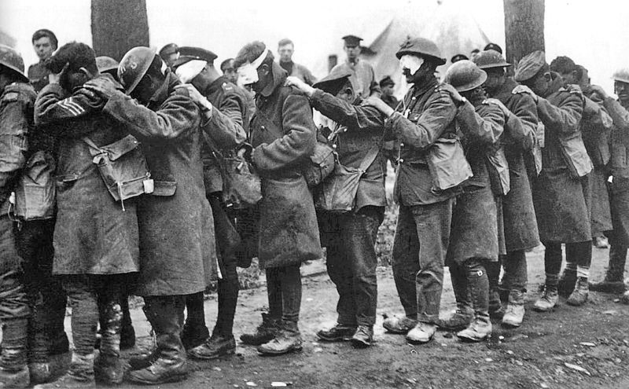

The events and aftermath of World War I directly caused the outbreak of World War II a mere twenty-one years later. The repercussions of the First World War were fresh in the minds of many Europeans. Estimates vary, but perhaps 15,000,000 soldiers and 45,000,000 civilians died as a result of World War I. New technology including airplanes, tanks, machine guns, and poisonous gas contributed to the high death tolls. The great loss of life and destruction of World War I prevented many people from supporting a new war. The sources in lesson 1 build background knowledge on the effects of World War I in Europe.

In the photograph above, a line of British troops blinded by tear gas were photographed while waiting to receive medical treatment at an Advanced Dressing Station near Bethune, France, on April 10, 1918. Each man has his hand on the shoulder of the man in front of him.

Source B: World War I Timeline
July 28, 1914 | Austria-Hungary declared war on Serbia after the assassination of Archduke Franz Ferdinand and failed negotiations between the two states.
August 1–3, 1914 | Germany declared war on Russia and France. Germany, Austria-Hungary, and later the Ottoman Empire made up the Central Powers during World War I.
August 4, 1914 | Britain declared war on Germany.
August 23, 1914 | Japan declared war on Germany.
April 6, 1917 | United States declared war on Germany and entered World War I on the side of the Allied Powers (Great Britain, France, and Russia).
November 9, 1918 | Kaiser Wilhelm II, the emperor of Germany, resigned from his position as the monarch of Germany. The Weimar Republic, a democratic government, was established in Germany.
November 11, 1918 | Armistice, or peace agreement, was signed by Germany and the Allies.
June 28, 1919 | The Treaty of Versailles was signed and officially ended the war between Germany and the Allied Powers. As a result of the treaty, Germany was blamed for causing the war and the Ottoman Empire broke apart.
January 10, 1920 | Proposed by Woodrow Wilson, the League of Nations was established as the first international cooperation organization. The United States never joined the League of Nations.

Source C: Excerpts from Treaty of Versailles
Text | Vocabulary | Guiding Questions
ARTICLE 42.  Germany is forbidden to maintain or construct any fortifications either on the left bank of the Rhine or on the right bank to the west of a line drawn 50 kilometres to the East of the Rhine.  ARTICLE 43  In the area defined above the maintenance and the assembly of armed forces, either permanently or temporarily, and military maneuvers of any kind, as well as the upkeep of all permanent works for mobilization, are in the same way forbidden.  ARTICLE 44  In case Germany violates in any manner whatever the provisions of Articles 42 and 43, she shall be regarded as committing a hostile act against the Powers signatory of the present Treaty and as calculated to disturb the peace of the world.  ARTICLE 119.  Germany renounces in favour of the Principal Allied and Associated Powers all her rights and titles over her oversea possessions.  ARTICLE 159.  The German military forces shall be demobilized and reduced as prescribed hereinafter.  ARTICLE 231.  The Allied and Associated Governments affirm and Germany accepts the responsibility of Germany and her allies for causing all the loss and damage to which the Allied and Associated Governments and their nationals have been subjected as a consequence of the war imposed upon them by the aggression of Germany and her allies.  ARTICLE 232.  The Allied and Associated Governments recognize that the resources of Germany are not adequate. . .to make complete reparation for all such loss and damage.  The Allied and Associated Governments, however, require, and Germany undertakes, that she will make compensation for all damage done to the civilian population of the Allied and Associated Powers and to their property. . . | Rhine: river on the west side of Germany that marks territory Germany occupied during World War I  mobilization: the act of preparing for war  oversea possessions: colonies  demobilized: troops taken out of active service  compensation: payments made to others to make up for loss, injury, or suffering. The Treaty of Versailles stipulated that Germany pay 132 billion gold marks to other European countries (about 269 billion U.S. dollars today) | How did Articles 42, 43, and 44 limit Germany?  ________________________________  ________________________________  ________________________________  ________________________________  ________________________________  ________________________________  ________________________________  ________________________________  ________________________________  ________________________________  ________________________________  ________________________________  ________________________________  ________________________________  ________________________________  ________________________________  ________________________________  ________________________________  ________________________________  Article 231 of the Treaty of Versailles is also known as the War Guilt Clause. What did this article require Germany to do?  ________________________________  ________________________________  ________________________________  ________________________________  ________________________________  ________________________________  ________________________________  ________________________________  ________________________________  What did Article 232 require Germany to do?  ________________________________  ________________________________  ________________________________  ________________________________  ________________________________  ________________________________

Source D: “German Money Being Used as Wallpaper, Germany, 1923”
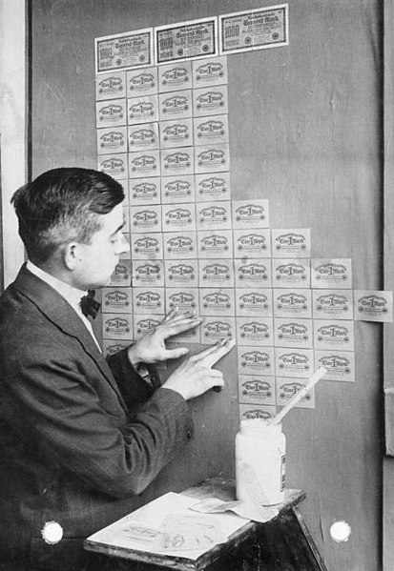
The Treaty of Versailles required that Germany accept responsibility and pay for the war. As a result, after World War I, Germany was in immense debt and suffered from hyperinflation, severe depreciation of their currency. In the image above, a German man uses German currency as wallpaper, since it was worth so little.

Source E: “German Prewar Expansion”
Text | Vocabulary | Guiding Questions
At the Lausanne Conference of 1932, Germany, Britain, and France agreed to the formal suspension of reparations payments imposed on the defeated countries after World War I. Thus, when Adolf Hitler became chancellor of Germany in January 1933, the financial provisions of the Treaty of Versailles (the post-World War I peace agreement) had already been revised. Hitler was determined to overturn the remaining military and territorial provisions of the treaty and include ethnic Germans in the Reich as a step toward the creation of a German empire in Europe.  The German armed forces engaged in secret rearmament even before the Nazi takeover of power. Thereafter, the Nazis supported rearmament and rapidly expanded arms production. Military conscription was reintroduced on March 16, 1935, in open violation of the Treaty of Versailles. At the same time, Hitler announced the expansion of the German army to more than 500,000 men.  In the 1925 Treaty of Locarno, Germany had recognized both the inviolability of its borders with France and Belgium and the demilitarization of the Rhineland. On March 7, 1936, however, Hitler repudiated this agreement and ordered the German armed forces (Wehrmacht) into the demilitarized Rhineland. Hitler's action brought condemnation from Britain and France, but neither nation intervened.  After a prolonged period of intense propaganda inside Austria, German troops entered the country on March 12, 1938, receiving the enthusiastic support of most of the population. Austria was incorporated into Germany on the following day. In April, this German annexation was retroactively approved in a plebiscite that was manipulated to indicate that about 99 percent of the Austrian people wanted the union (known as the "Anschluss") with Germany. Neither Jews nor Roma (Gypsies) were permitted to vote in the plebiscite. | Reich: the German state during the Nazi period  rearmament: building up a military  conscription: the draft, forced enlistment of people into the military  inviolability: something that cannot be violated  repudiated: refused to accept  plebiscite: citizens vote directly on an issue | How had the provisions of the Treaty of Versailles changed before Hitler came to power?  ________________________________  ________________________________  ________________________________  ________________________________  ________________________________  How did Germany break the Treaty of Versailles before Hitler came to power?  ________________________________  ________________________________  ________________________________  ________________________________  ________________________________  How did Hitler push the limits of and violate the Treaty of Versailles after coming to power?  ________________________________  ________________________________  ________________________________  ________________________________  ________________________________  ________________________________  ________________________________  How did other countries react to Hitler’s actions?  ________________________________  ________________________________  ________________________________  ________________________________

Source F: Map of the Rhineland
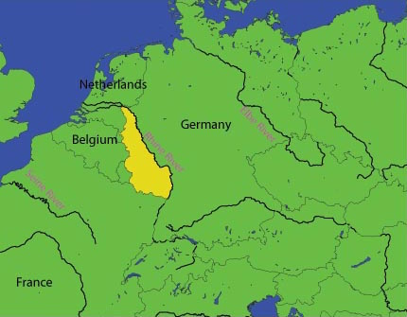
The Rhineland is the region to the west of the Rhine River that was occupied by Germany during World War I. The Treaty of Versailles forbade Germany from occupying the region. On March 7, 1936, German military, then under the control of the Nazi regime, entered the region.

Source G: “Totalitarianism in Europe”
Text | Vocabulary | Guiding Questions
Many European countries had been suffering even before the Great Depression began. A postwar recession and the continuation of wartime inflation had hurt many economies, as did a decrease in agricultural prices, which made it harder for farmers to buy manufactured goods or pay off loans to banks. In such an unstable environment, Benito Mussolini capitalized on the frustrations of the Italian people who felt betrayed by the Versailles Treaty. In 1919, Mussolini created the Fasci Italiani di Combattimento (Italian Combat Squadron). The organization’s main tenets of Fascism called for a heightened focus on national unity, militarism, social Darwinism, and loyalty to the state. Mussolini wanted a state organized to be what he called totalitario (totalitarian), which he insisted would mean “all within the state, none outside the state, none against the state.” With the support of major Italian industrialists and the king, who saw Fascism as a bulwark against growing Socialist and Communist movements, Mussolini became prime minister in 1922. Between 1925 and 1927, Mussolini transformed the nation into a single party state and removed all restraints on his power.  In Germany, a similar pattern led to the rise of the totalitarian National Socialist Party (Nazi Party). Political fragmentation through the 1920s accentuated the severe economic problems facing the country. As a result, the German Communist Party began to grow in strength, frightening many wealthy and middle-class Germans. In addition, the terms of the Treaty of Versailles had given rise to a deep-seated resentment of the victorious Allies. It was in such an environment that Adolf Hitler’s anti-Communist National Socialist Party—the Nazis—was born.  The Nazis gained numerous followers during the Great Depression, which hurt Germany tremendously, plunging it further into economic crisis. By 1932, nearly 30 percent of the German labor force was unemployed. Not surprisingly, the political mood was angry and sullen. Hitler, a World War I veteran and leader of the Nazi party, promised to return Germany to greatness. By the beginning of 1933, the Nazis had become the largest party in the German legislature. Germany’s president, Paul von Hindenburg, at the urging of large industrialists who feared a Communist uprising, appointed Hitler to the position of chancellor in January 1933. In the elections that took place in early March 1933, the Nazis gained the political power to pass the Enabling Act later that same month, which gave Hitler the power to make all laws for the next four years. Hitler thus effectively became the dictator of Germany and remained so long after the four-year term passed. Like Italy, Germany had become a one-party totalitarian state. Nazi Germany was an anti-Semitic nation, and in 1935, the Nuremberg Laws deprived Jews, whom Hitler blamed for Germany’s downfall, of German citizenship and the rights thereof.  Once in power, Hitler began to rebuild German military might. He commenced his program by withdrawing Germany from the League of Nations in October 1933. In 1936, in accordance with his promise to restore German greatness, Hitler dispatched military units into the Rhineland, on the border with France, which was an act contrary to the provisions of the Versailles Treaty. In March 1938, claiming that he sought only to reunite ethnic Germans within the borders of one country, Hitler invaded Austria. At a conference in Munich later that year, Great Britain’s prime minister, Neville Chamberlain, and France’s prime minister, Édouard Daladier, agreed to the partial dismemberment of Czechoslovakia and the occupation of the Sudetenland (a region with a sizable German population) by German troops. This Munich Pact offered a policy of appeasement, in the hope that German expansionist appetites could be satisfied without war. But not long after the agreement, Germany occupied the rest of Czechoslovakia as well.  Leaders in the Soviet Union, which developed its own form of brutal totalitarianism through communism, paid close attention to Hitler’s actions and public pronouncements. Soviet leader Joseph Stalin realized that Poland, part of which had belonged to Germany before the First World War, was most likely next. Although fiercely opposed to Hitler, Stalin, sobered by the French and British betrayal of Czechoslovakia and unprepared for a major war, decided the best way to protect the Soviet Union, and gain additional territory, was to come to some accommodation with the German dictator. In August 1939, Germany and the Soviet Union essentially agreed to divide Poland between them and not make war upon one another. | Great Depression: a global econo-mic downturn causing financial instability all over the world  Benito Mussolini: Italian prime minister from 1922 to 1943  fascism: strict dictatorship that emerged in Europe in the 1920s  social Darwinism: now-defunct theory that individuals, groups, and peoples are subject to the same Darwinian laws of natural selection as plants and animals  bulwark: protection  Socialist: political and economic philosophy where there is a state-controlled economy with no private market; labor and goods are publicly owned  Communist: political philosophy that has the same economic values as socialism but involves an authoritarian state  anti-Semitic: hostile or prejudiced feelings and actions against Jewish people  dismember-ment: the act of dividing up a territory  appeasement: giving in to demands in order to prevent more conflict | In your own words, describe the government that Benito Mussolini created in Italy in the 1920s.  ________________________________  ________________________________  ________________________________  ________________________________  ________________________________  ________________________________  ________________________________  ________________________________  How did the rise in popularity of the communist and socialist parties in Europe affect popularity of other parties?  ________________________________  ________________________________  ________________________________  ________________________________  ________________________________  ________________________________  ________________________________  ________________________________  ________________________________  ________________________________  ________________________________  ________________________________  What conditions in Germany after World War I made Hitler’s rise to power possible?  ________________________________  ________________________________  ________________________________  ________________________________  ________________________________  ________________________________  ________________________________  ________________________________  ________________________________  ________________________________  ________________________________  ________________________________  ________________________________  ________________________________  How did Great Britain and France try to appease Germany’s expansion? What was the result of this appeasement?  ________________________________  ________________________________  ________________________________  ________________________________  ________________________________  ________________________________  ________________________________  ________________________________  ________________________________  Why did Stalin agree to make a deal on Poland with Hitler?  ________________________________  ________________________________  ________________________________  ________________________________  ________________________________

Source H: “The Origins of the European War”
Text | Vocabulary | Guiding Questions
Hitler signed a secret agreement—the Molotov-Ribbentrop Pact—with the Soviet Union that coordinated the splitting of Poland between the two powers and promised nonaggression thereafter. The European war began when the German Wehrmacht invaded Poland on September 1, 1939. Britain and France declared war two days later and mobilized their armies. Britain and France hoped that the Poles could hold out for three to four months, enough time for the Allies to intervene. Poland fell in three weeks. The German army, anxious to avoid the rigid, grinding war of attrition that took so many millions in the stalemate of World War I, built their new modern army for speed and maneuverability. German doctrine emphasized the use of tanks, planes, and motorized infantry (infantry that used trucks for transportation instead of marching) to concentrate forces, smash front lines, and wreak havoc behind the enemy’s defenses. It was called Blitzkrieg, or lightning war.  After the fall of Poland, France and its British allies braced for an inevitable German attack. Throughout the winter of 1939–1940, however, fighting was mostly confined to smaller fronts in Norway. Belligerents called it the Sitzkrieg (sitting war). But in May 1940, Hitler launched his attack into Western Europe. Mirroring the German’s Schlieffen Plan of 1914 in the previous war, Germany attacked through the Netherlands and Belgium to avoid the prepared French defenses along the French-German border. Poland had fallen in three weeks; France lasted only a few weeks more. By June, Hitler was posing for photographs in front of the Eiffel Tower. Germany split France in half. Germany occupied and governed the north, and the south would be ruled under a puppet government in Vichy.  With France under heel, Hitler turned to Britain. Operation Sea Lion—the planned German invasion of the British Isles—required air superiority over the English Channel. From June until October the German Luftwaffe fought the Royal Air Force (RAF) for control of the skies. Despite having fewer planes, British pilots won the so-called Battle of Britain, saving the islands from immediate invasion and prompting the new prime minister, Winston Churchill, to declare, “Never before in the field of human conflict has so much been owed by so many to so few.”  If Britain was safe from invasion, it was not immune from additional air attacks. Stymied in the Battle of Britain, Hitler began the Blitz—a bombing campaign against cities and civilians. Hoping to crush the British will to fight, the Luftwaffe bombed the cities of London, Liverpool, and Manchester every night from September to the following May. Children were sent far into the countryside to live with strangers to shield them from the bombings. Remaining residents took refuge in shelters and subway tunnels, emerging each morning to put out fires and bury the dead. The Blitz ended in June 1941, when Hitler, confident that Britain was temporarily out of the fight, launched Operation Barbarossa—the invasion of the Soviet Union.  Hoping to capture agricultural lands, seize oil fields, and break the military threat of Stalin’s Soviet Union, Hitler broke the two powers’ 1939 nonaggression pact and, on June 22, invaded the Soviet Union. It was the largest land invasion in history. France and Poland had fallen in weeks, and German officials hoped to break Russia before the winter. And initially, the Blitzkrieg worked. The German military quickly conquered enormous swaths of land and netted hundreds of thousands of prisoners. But Russia was too big and the Soviets were willing to sacrifice millions to stop the fascist advance. After recovering from the initial shock of the German invasion, Stalin moved his factories east of the Ural mountains, out of range of the Luftwaffe. He ordered his retreating army to adopt a “scorched earth” policy, to move east and destroy food, rails, and shelters to stymie the advancing German army. The German army slogged forward. It split into three pieces and stood at the gates of Moscow, Stalingrad, and Leningrad, but supply lines now stretched thousands of miles, Soviet infrastructure had been destroyed, partisans harried German lines, and the brutal Russian winter arrived. Germany had won massive gains but the winter found Germany exhausted and overextended. In the north, the German army starved Leningrad to death during an interminable siege; in the south, at Stalingrad, the two armies bled themselves to death in the destroyed city; and, in the center, on the outskirts of Moscow, in sight of the capital city, the German army faltered and fell back. It was the Soviet Union that broke Hitler’s army. Twenty-five million Soviet soldiers and civilians died during the Great Patriotic War, and roughly 80 percent of all German casualties during the war came on the Eastern Front. The German army and its various conscripts suffered 850,000 casualties at the Battle of Stalingrad alone. In December 1941, Germany began its long retreat. | Wehrmacht: army, navy, and air force of Germany  doctrine: policy  Schlieffen Plan: plan used by Germany in World War I to focus on defeating one enemy at a time  Luftwaffe: air force  Great Patriotic War:  what Russians refer to as the parts of World War II where Russia and Germany fought | How long did it take for Germany to conquer Poland? How did Germany accomplish this?  ________________________________  ________________________________  ________________________________  ________________________________  ________________________________  ________________________________  ________________________________  ________________________________  ________________________________  ________________________________  How did Germany capture France?  ________________________________  ________________________________  ________________________________  ________________________________  ________________________________  ________________________________  ________________________________  ________________________________  ________________________________  ________________________________  ________________________________  ________________________________  Describe the effects of the Blitz.  ________________________________  ________________________________  ________________________________  ________________________________  ________________________________  ________________________________  ________________________________  ________________________________  ________________________________  ________________________________  ________________________________  ________________________________  ________________________________  How did Germany break the Molotov-Ribbentrop Pact, and what were the results?  ________________________________  ________________________________  ________________________________  ________________________________  ________________________________  ________________________________  ________________________________  ________________________________  ________________________________  ________________________________  ________________________________  ________________________________

After you read:

1. What were the results of World War I?

2. How did the Treaty of Versailles weaken the economic power and military power of Germany? How did this affect German citizens?

3. Describe the actions taken by Germany in the 1930s.

Lesson 2 – Setting the Context
Student Directions | First, read Source I and answer the guiding questions in the right-hand column. Then, read and study Source J. Please note: as part of learning about humanitarian issues surrounding World War II, Source I discusses an historical event where systemic rape as part of war occurred.
Featured Sources | Source I: “The Origins of the Pacific War”  Source J: Map of Participants in World War II

Source I: “The Origins of the Pacific War”
Text | Vocabulary | Guiding Questions
Although the United States joined the war in 1941, two years after Europe exploded into conflict in 1939, the path to the Japanese bombing of Pearl Harbor, the surprise attack that threw the United States headlong into war, began much earlier. For the Empire of Japan, the war had begun a decade before Pearl Harbor.  Militarism in Japan  Militaristic politicians took control of Japan in the 1930s. The Japanese had worked assiduously for decades to modernize, build their strength, and become a prosperous, respected nation. The sentiment in Japan was decidedly pro-capitalist, and the Japanese militarists were fiercely supportive of a capitalist economy. They viewed with great concern the rise of Communism in the Soviet Union and in particular China, where the issue was fueling a civil war, and feared that the Soviet Union would make inroads in Asia by assisting China’s Communists. The Japanese militarists thus found a common ideological enemy with Fascism and National Socialism, which had based their rise to power on anti-Communist sentiments. In 1936, Japan and Germany signed the Anti-Comintern Pact, pledging mutual assistance in defending themselves against the Comintern, the international agency created by the Soviet Union to promote worldwide Communist revolution. In 1937, Italy joined the pact, essentially creating the foundation of what became the military alliance of the Axis powers.  Japan’s Aggression in China  On September 18, 1931, a small explosion tore up railroad tracks controlled by the Japanese-owned South Manchuria Railway near the city of Shenyang (Mukden) in the Chinese province of Manchuria. The railway company condemned the bombing as the work of anti-Japanese Chinese dissidents. Evidence, though, suggests that the initial explosion was neither an act of Chinese anti-Japanese sentiment nor an accident but an elaborate ruse planned by the Japanese to provide a basis for invasion. In response, the privately operated Japanese Guandong (Kwangtung) army began shelling the Shenyang garrison the next day, and the garrison fell before nightfall. Hungry for Chinese territory and witnessing the weakness and disorganization of Chinese forces, but under the pretense of protecting Japanese citizens and investments, the Japanese Imperial Army ordered a full-scale invasion of Manchuria. The invasion was swift. Without a centralized Chinese army, the Japanese quickly defeated isolated Chinese warlords and by the end of February 1932, all of Manchuria was firmly under Japanese control. Japan established the nation of Manchukuo out of the former province of Manchuria.  This seemingly small skirmish—known by the Chinese as the September 18 Incident and the Japanese as the Manchurian Incident—sparked a war that would last thirteen years and claim the lives of over thirty-five million people. Comprehending Japanese motivations for attacking China and the grueling stalemate of the ensuing war are crucial for understanding Japan’s seemingly unprovoked attack on Pearl Harbor, Hawaii, on December 7, 1941, and, therefore, for understanding the involvement of the United States in World War II as well.  Despite their rapid advance into Manchuria, the Japanese put off the invasion of China for nearly three years. Japan occupied a precarious domestic and international position after the September 18 Incident. At home, Japan was driven by political factionalism due to its stagnating economy. Leaders were torn as to whether to address modernization and lack of natural resources through unilateral expansion (the conquest of resource-rich areas such as Manchuria to export raw materials to domestic Japanese industrial bases such as Hiroshima and Nagasaki) or international cooperation (a philosophy of pan-Asianism in an anti-Western coalition that would push the colonial powers out of Asia). Ultimately, after a series of political crises and assassinations enflamed tensions, pro-war elements within the Japanese military triumphed over the more moderate civilian government. Japan committed itself to aggressive military expansion.  Chinese leaders Chiang Kai-shek and Zhang Xueliang appealed to the League of Nations for assistance against Japan. The United States supported the Chinese protest, proclaiming the Stimson Doctrine in January 1932, which refused to recognize any state established as a result of Japanese aggression. Meanwhile, the League of Nations sent Englishman Victor Bulwer-Lytton to investigate the September 18 Incident. After a six-month investigation, Bulwer-Lytton found the Japanese guilty of inciting the September 18 incident and demanded the return of Manchuria to China. The Japanese withdrew from the League of Nations in March 1933.  Japan isolated itself from the world. Its diplomatic isolation empowered radical military leaders who could point to Japanese military success in Manchuria and compare it to the diplomatic failures of the civilian government. The military took over Japanese policy. And in the military’s eyes, the conquest of China would not only provide for Japan’s industrial needs, it would secure Japanese supremacy in East Asia.  The Japanese launched a full-scale invasion of China. It assaulted the Marco Polo Bridge on July 7, 1937, and routed the forces of the Chinese National Revolutionary Army led by Chiang Kai-shek. The broken Chinese army gave up Beiping (Beijing) to the Japanese on August 8, Shanghai on November 26, and the capital, Nanjing (Nanking), on December 13. Between 250,000 and 300,000 people were killed, and tens of thousands of women were raped, when the Japanese besieged and then sacked Nanjing. The Western press labeled it the Rape of Nanjing. To halt the invading enemy, Chiang Kai-shek adopted a scorched-earth strategy of “trading space for time.” His Nationalist government retreated inland, burning villages and destroying dams, and established a new capital at the Yangtze River port of Chongqing (Chungking). Although the Nationalists’ scorched-earth policy hurt the Japanese military effort, it alienated scores of dislocated Chinese civilians and became a potent propaganda tool of the emerging Chinese Communist Party (CCP).  Americans read about the brutal fighting in China, but the United States lacked both the will and the military power to oppose the Japanese invasion. After the gut-wrenching carnage of World War I, many Americans retreated toward isolationism by opposing any involvement in the conflagrations burning in Europe and Asia. And even if Americans wished to intervene, their military was lacking. The Japanese army was a technologically advanced force consisting of 4,100,000 men and 900,000 Chinese collaborators—and that was in China alone. The Japanese military was armed with modern rifles, artillery, armor, and aircraft. By 1940, the Japanese navy was the third-largest and among the most technologically advanced in the world.  Chinese Nationalists lobbied Washington for aid, but while the United States denounced Japanese aggression, it took no action.  As Chinese Nationalists fought for survival, the Communist Party was busy collecting people and supplies in the northwestern Shaanxi Province. China had been at war with itself when the Japanese came. Nationalists battled a stubborn communist insurgency. In 1935 the Nationalists threw the communists out of the fertile Chinese coast, but an ambitious young commander named Mao Zedong recognized the power of the Chinese peasant population. In Shaanxi, Mao recruited from the local peasantry, building his force from a meager seven thousand survivors at the end of the Long March in 1935 to a robust 1.2 million members by the end of the war.  Although Japan had conquered much of the country, the Nationalists regrouped and the communists rearmed. An uneasy truce paused the country’s civil war and refocused efforts on the invaders. The Chinese could not dislodge the Japanese, but they could stall their advance. The war mired in stalemate. | assiduously: with attention and effort  pro-capitalist: supporting a free market economy, and supporting pro-business policies  factionalism: divisions within a group that cause conflict  routed: defeated and caused to retreat  mired: held back | How far into the fighting in Europe did the United States enter World War II? What event led to the United States declaring war on Japan?  ________________________________  ________________________________  ________________________________  ________________________________  ________________________________  ________________________________  What factors led to Japan and Germany signing the Anti-Comintern Pact?  ________________________________  ________________________________  ________________________________  ________________________________  ________________________________  ________________________________  ________________________________  ________________________________  ________________________________  ________________________________  ________________________________  Describe the factors that led to war between Japan and China in 1931.  ________________________________  ________________________________  ________________________________  ________________________________  ________________________________  ________________________________  ________________________________  ________________________________  ________________________________  ________________________________  ________________________________  ________________________________  How did the United States and the League of Nations respond to the Manchuria incident? How did Japan react to their responses?  ________________________________  ________________________________  ________________________________  ________________________________  ________________________________  ________________________________  ________________________________  ________________________________  What factors led to the Japanese invasion of China in 1937?  ________________________________  ________________________________  ________________________________  ________________________________  ________________________________  ________________________________  ________________________________  Describe the events of the Japanese invasion of China in 1937.  ________________________________  ________________________________  ________________________________  ________________________________  ________________________________  ________________________________  ________________________________  ________________________________  ________________________________  ________________________________  How did Americans react to the Japanese invasion of China in 1937?  ________________________________  ________________________________  ________________________________  ________________________________  ________________________________  ________________________________  ________________________________  ________________________________  ________________________________  ________________________________  How did the Japanese invasion of China affect the civil war in China?  ________________________________  ________________________________  ________________________________  ________________________________  ________________________________  ________________________________  ________________________________  ________________________________

Source J: Map of Participants in World War II
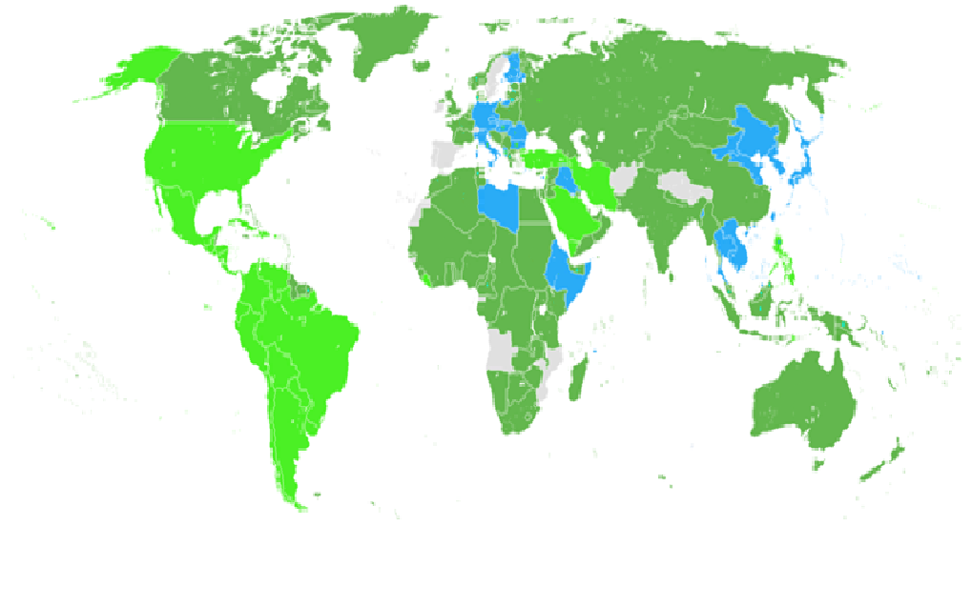
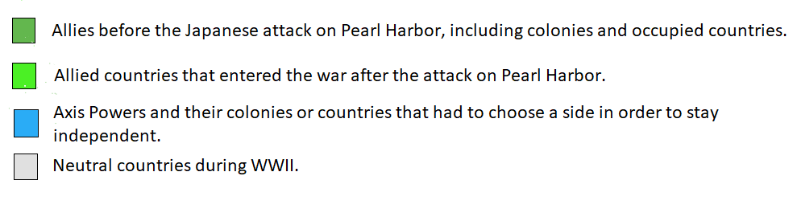

Lesson 3 – Setting the Context
Student Directions | First, read Sources K and L and answer questions in the right-hand column. Next, read and study Source M. Then, read Sources N and O and answer the questions in the right-hand column. Finally, complete the after you read questions at the end of this lesson.
Featured Sources | Source K: “Isolationism”  Source L: "Merchants of Death"  Source M: Senate Resolution 206  Source N: Excerpts from “America First” by Charles A. Lindbergh, April 23, 1941  Source O: Radio Address by Senator Burton Wheeler, December 31, 1940

Source K: “Isolationism”
Text | Vocabulary | Guiding Questions
While during the 1920s and 1930s there were Americans who favored active engagement in Europe, most Americans, including many prominent politicians, were leery of getting too involved in European affairs or accepting commitments to other nations that might restrict America’s ability to act independently, keeping with the isolationist tradition. Although the United States continued to intervene in the affairs of countries in the Western Hemisphere during this period, the general mood in America was to avoid becoming involved in any crises that might lead the nation into another global conflict.  Despite its largely noninterventionist foreign policy, the United States did nevertheless take steps to try to lessen the chances of war and cut its defense spending at the same time. President Warren G. Harding’s administration participated in the Washington Naval Conference of 1921–1922, which reduced the size of the navies of the nine signatory nations. In addition, the Four Power Treaty, signed by the United States, Great Britain, France, and Japan in 1921, committed the signatories to eschewing any territorial expansion in Asia. In 1928, the United States and fourteen other nations signed the Kellogg-Briand Pact, declaring war an international crime. Despite hopes that such agreements would lead to a more peaceful world—far more nations signed on to the agreement in later years—they failed because none of them committed any of the nations to take action in the event of treaty violations. | isolationist: favoring a policy of remaining distant from another country or group  noninterven-tionist: policy of not interfering in other countries’ affairs  eschewing: rejecting  territorial expansion: policy of increasing a country’s size by expanding its territory | In your own words, describe the isolationist sentiment felt by many Americans in the 1920s and 1930s.  ________________________________  ________________________________  ________________________________  ________________________________  ________________________________  ________________________________  How did the United States try to prevent another world war before World War II?  ________________________________  ________________________________  ________________________________  ________________________________  ________________________________  ________________________________  ________________________________  ________________________________  ________________________________  ________________________________  ________________________________

*Note: “Merchants of Death” was a term used to negatively describe the role of industries and banks during World War I.

Source L: "Merchants of Death"
Text | Vocabulary | Guiding Questions
On a hot Tuesday morning following Labor Day in 1934, several hundred people crowded into the Caucus Room of the Senate Office Building to witness the opening of an investigation that journalists were already calling “historic.” Although World War I had been over for 16 years, the inquiry promised to reopen an intense debate about whether the nation should ever have gotten involved in that costly conflict.  The so-called Senate Munitions Committee came into being because of widespread reports that manufacturers of armaments had unduly influenced the American decision to enter the war in 1917. These weapons suppliers had reaped enormous profits at the cost of more than 53,000 American battle deaths. As local conflicts reignited in Europe through the early 1930s, suggesting the possibility of a second world war, concern spread that these “merchants of death” would again drag the United States into a struggle that was none of its business. The time had come for a full congressional inquiry.  To lead the seven-member special committee, the Senate’s Democratic majority chose a Republican—42-year-old North Dakota senator Gerald P. Nye. Typical of western agrarian progressives, Nye energetically opposed U.S. involvement in foreign wars. He promised, “When the Senate investigation is over, we shall see that war and preparation for war is not a matter of national honor and national defense, but a matter of profit for the few.”  Over the next 18 months, the Nye Committee held 93 hearings, questioning more than 200 witnesses, including J. P. Morgan, Jr., and Pierre du Pont. Committee members found little hard evidence of an active conspiracy among arms makers, yet the panel’s reports did little to weaken the popular prejudice against “greedy munitions interests.”  The investigation came to an abrupt end early in 1936. The Senate cut off committee funding after Chairman Nye blundered into an attack on the late Democratic president Woodrow Wilson. Nye suggested that Wilson had withheld essential information from Congress as it considered a declaration of war. Democratic leaders, including Appropriations Committee chairman Carter Glass of Virginia, unleashed a furious response against Nye for “dirt-daubing the sepulcher of Woodrow Wilson.” Standing before cheering colleagues in a packed Senate Chamber, Glass slammed his fist onto his desk until blood dripped from his knuckles.  Although the Nye Committee failed to achieve its goal of nationalizing the arms industry, it inspired three congressional neutrality acts in the mid-1930s that signaled profound American opposition to overseas involvement. | inquiry: an investigation  munitions: military weapons  sepulcher: tomb  nationalizing: transfer from private to government ownership or control | What was the purpose of the Senate Munitions Committee?  ________________________________  ________________________________  ________________________________  ________________________________  ________________________________  ________________________________  ________________________________  ________________________________  ________________________________  Why did Senator Nye oppose the United States becoming involved in foreign wars?  ________________________________  ________________________________  ________________________________  ________________________________  ________________________________  ________________________________  ________________________________  ________________________________  ________________________________  Why did the Nye Committee end abruptly?  ________________________________  ________________________________  ________________________________  ________________________________  ________________________________  ________________________________
Source M: Senate Resolution 206
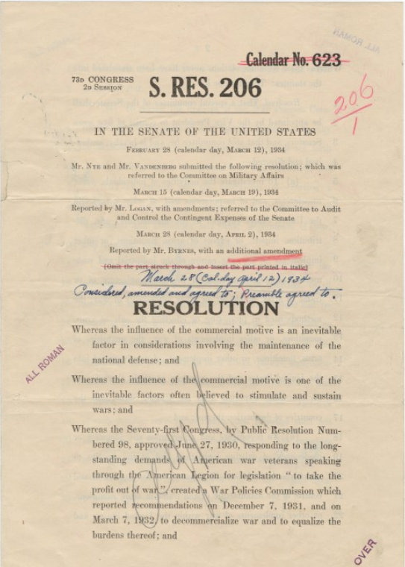
The Nye Committee was formed to in response to “long-standing demands of American war veterans speaking through the American Legion for legislation ‘to take the profit out of war.’” The proceedings of the Nye Committee made headlines in newspapers and linked involvement of the United States in World War I to the vast profits of munitions and banking companies. These proceedings gave ammunition to those pushing for the United States to remain neutral in the affairs of Europe leading up to World War II.

Source N is excerpts from a speech given by Charles Lindbergh, an American aviator and military officer who rose to fame for being the first person to make a nonstop flight across the Atlantic from New York to Paris. Lindbergh was also a political activist and a vocal proponent of the “America First” movement in the 1930s and 1940s which opposed American aid to the Allies in World War II. In addition to the inspiration Lindbergh brought to the country, he also expressed white supremacist and anti-Semitic views. This led to the belief that Lindbergh was a Nazi sympathizer, although he never expressed direct support for Hitler or Nazi Germany.

Source N: Excerpts from “America First” by Charles A. Lindbergh, April 23, 1941
Text | Vocabulary | Guiding Questions
There are many. . . interventionists in America, but there are more people among us of a different type. . . There is a policy open to this nation that will lead to success–a policy that leaves us free to follow our own way of life, and to develop our own civilization. It is not a new and untried idea. It was advocated by Washington. It was incorporated in the Monroe Doctrine. Under its guidance, the United States became the greatest nation in the world.  It is based upon the belief that the security of a nation lies in the strength and character of its own people. It recommends the maintenance of armed forces sufficient to defend this hemisphere from attack by any combination of foreign powers. It demands faith in an independent American destiny. This is the policy of the America First Committee today. It is a policy not of isolation, but of independence; not of defeat, but of courage. It is a policy that led this nation to success during the most trying years of our history, and it is a policy that will lead us to success again.  . . .  The United States is better situated from a military standpoint than any other nation in the world. Even in our present condition of unpreparedness no foreign power is in a position to invade us today. If we concentrate on our own defenses and build the strength that this nation should maintain, no foreign army will ever attempt to land on American shores.  War is not inevitable for this country. Such a claim is defeatism in the true sense. No one can make us fight abroad unless we ourselves are willing to do so. No one will attempt to fight us here if we arm ourselves as a great nation should be armed. Over a hundred million people in this nation are opposed to entering the war. If the principles of democracy mean anything at all, that is reason enough for us to stay out. If we are forced into a war against the wishes of an overwhelming majority of our people, we will have proved democracy such a failure at home that there will be little use of fighting for it abroad. . . | Intervention-ists: people who favor a policy of interfering in other countries’ or groups’ affairs  Monroe Doctrine:  United States policy that opposed European imperialism in the western hemisphere | How did the United States benefit from a policy of non-intervention, according to Charles A. Lindbergh?  ________________________________  ________________________________  ________________________________  ________________________________  ________________________________  In your own words, describe the policy of the American First Committee.  ________________________________  ________________________________  ________________________________  ________________________________  ________________________________  ________________________________  ________________________________  Why did Charles Lindbergh believe the United States would be safe from conflict during World War II?  ________________________________  ________________________________  ________________________________  ________________________________  ________________________________  ________________________________  ________________________________  ________________________________  ________________________________

Source O: Radio Address by Senator Burton Wheeler, December 31, 1940
Text | Vocabulary | Guiding Questions
The thoughts I am about to express are not based upon any fear of wild boasts of American conquest by Stalin, Hitler or Mussolini. I know that neither they nor their ideologies will capture the people of the United States or our imagination to the point that we would adopt fascism, communism or Nazism as an American doctrine. . .  We sympathize with the oppressed and persecuted everywhere. We also realize that we have great problems at home, that one-third of our population is ill-fed, ill-housed and ill-clad, and we have been told repeatedly, upon the highest authority, that unless and until this situation is corrected our democracy is in danger. I fully subscribe to this view.  Believing as I do, in this thesis, I cannot help but feel that we should settle our own problems before we undertake to settle the problems of Asia, Africa, Australasia, South America and Europe. As Americans, interested first in America, what is our present stake? Our stakes are our independence, our democracy and our trade and commerce. Every red-blooded American would fight to preserve them.  . . .  Our independence can only be lost or compromised if Germany invades the Western Hemisphere north of the equator. This would be fantastic, as it would require the transportation of at least 2,000,000 men, with planes, tanks, and equipment, in one convoy across the Atlantic. This would require two or three thousand transports plus a fleet larger than our Navy, plus thousands of fighter-escorted bombers.  . . .  The cost of this war will come out of the millions of poor people, the common folk of the world who will toil for generations to pay the cost of destruction. War inevitably means back-breaking debt, blighted lives, bedeviled futures. War means the end of civil liberties, the end of free speech, free press, free enterprise. It means dictatorship and slavery, and the things we abhor in Nazism, communism and fascism. It means Stalin or Hitler will have achieved their boasts for a totalitarian world without conquering America. . .  Though today we stand as close to the brink of war as we stood in January of 1917, some people still oppose a European peace. War-mongers, sordid romanticists, reckless adventurers and some whose sympathies and sentiments are stronger than their reasoning powers would plunge this nation into war. Plunge us into a war from which we would gain nothing. Plunge us into a war that would destroy democracy, that would bring deep harrowing anguish to millions of hearts. And how would they bring this to pass? They would take us in today as they did in 1917.…  I do not believe that the great majority of our people are eager to be embraced by war and I call upon them not to be afraid to say so. I, for one, believe the policy advocated by the interventionists is insane and it will lead to total war, and war is insanity… Americans! Do not let yourselves be swayed by mass hysteria. Do not travel again the road that took you in 1917. You hanged Bob LaFollette in effigy because he opposed war—and lived to repent your action and put him in the hall of fame.… Are the facts of yesterday no longer facts? Has this war a sweeter odor than the last? Don’t let yourselves be misled by the so-called notables. Numerically they are few—even though they command the newspaper headlines. But they do not speak for the mass of Americans. They do not represent labor, the farmer, the youth, the mothers or fathers of America. | fantastic: unlikely, improbable  blighted: ruined  bedeviled: troubled  abhor: hate  Bob LaFollette: politician and Senator from Wisconsin during World War I who was an outspoken opponent of the United States joining the war  in effigy: metaphorical-ly | Why did Senator Wheeler not feel threatened by the Axis powers?  ________________________________  ________________________________  ________________________________  ________________________________  ________________________________  ________________________________  What problems in the United States did Senator Wheeler believe needed attention before the United States considered war?  ________________________________  ________________________________  ________________________________  ________________________________  ________________________________  ________________________________  Why did Senator Wheeler feel that Germany invading the United States would be unlikely?  ________________________________  ________________________________  ________________________________  ________________________________  ________________________________  ________________________________  ________________________________  Why did Senator Wheeler oppose the United States entering World War II?  ________________________________  ________________________________  ________________________________  ________________________________  ________________________________  ________________________________  ________________________________  ________________________________  ________________________________  ________________________________  How did Senator Wheeler account for support for the United States to enter the war?  ________________________________  ________________________________  ________________________________  ________________________________  ________________________________  ________________________________  ________________________________  ________________________________  ________________________________

After you read:

1. How did the results of World War I influence the non-interventionist movement of the 1930s?

2. Describe two motivations of people who supported United States neutrality in the beginning of World War II.

Lesson 4
Supporting Question 1: How did President Roosevelt promote support for U.S. involvement in World War II?
Student Directions | Read Sources P, Q, R, S, and T and answer questions in the right-hand column. Then, complete the after you read questions and performance task #1 at the end of this lesson.
Featured Sources | Source P: “From Neutrality to Engagement”  Source Q: Radio Address Delivered by President Roosevelt From Washington, December 29, 1940  Source R: Four Freedom’s Speech, January 6, 1941  Source S: The Atlantic Charter, August 14, 1941  Source T: Address Delivered by President Roosevelt at Washington, October 27, 1941

Source P: “From Neutrality to Engagement”
Text | Vocabulary | Guiding Questions
President Franklin Roosevelt was aware of the challenges facing the targets of Nazi aggression in Europe and Japanese aggression in Asia. Although he hoped to offer U.S. support, Congress’s commitment to nonintervention was difficult to overcome. Such a policy in regards to Europe was strongly encouraged by Senator Gerald P. Nye of North Dakota. Nye claimed that the United States had been tricked into participating in World War I by a group of industrialists and bankers who sought to gain from the country’s participation in the war. The United States, Nye urged, should not be drawn again into an international dispute over matters that did not concern it. His sentiments were shared by other noninterventionists in Congress.  To ensure that the United States did not get drawn into another war, Congress passed a series of Neutrality Acts in the second half of the 1930s. The Neutrality Act of 1935 banned the sale of armaments to warring nations. The following year, another Neutrality Act prohibited loaning money to belligerent countries. The last piece of legislation, the Neutrality Act of 1937, forbade the transportation of weapons or passengers to belligerent nations on board American ships and also prohibited American citizens from traveling on board the ships of nations at war.  Once all-out war began between Japan and China in 1937, Roosevelt sought ways to help the Chinese that did not violate U.S. law. Since Japan did not formally declare war on China, a state of belligerency did not technically exist. Therefore, under the terms of the Neutrality Acts, America was not prevented from transporting goods to China. In 1940, the president of China, Chiang Kai-shek, was able to prevail upon Roosevelt to ship to China one hundred P-40 fighter planes and to allow American volunteers, who technically became members of the Chinese Air Force, to fly them.  War Begins in Europe  In 1938, the agreement reached at the Munich Conference failed to satisfy Hitler—in fact, the refusal of Britain and France to go to war over the issue infuriated the German dictator. In May of the next year, Germany and Italy formalized their military alliance with the “Pact of Steel.” On September 1, 1939, Hitler unleashed his Blitzkrieg, or “lightning war,” against Poland, using swift, surprise attacks combining infantry, tanks, and aircraft to quickly overwhelm the enemy. Britain and France had already learned from Munich that Hitler could not be trusted and that his territorial demands were insatiable. On September 3, 1939, they declared war on Germany, and the European phase of World War II began. Responding to the German invasion of Poland, Roosevelt worked with Congress to alter the Neutrality Laws to permit a policy of “Cash and Carry” in munitions for Britain and France. The legislation, passed and signed by Roosevelt in November 1939, permitted belligerents to purchase war materiel if they could pay cash for it and arrange for its transportation on board their own ships.  When the Germans commenced their spring offensive in 1940, they defeated France in six weeks with a highly mobile and quick invasion of France, Belgium, Luxembourg, and the Netherlands. In the Far East, Japan took advantage of France’s surrender to Germany to occupy French Indochina. In response, beginning with the Export Control Act in July 1940, the United States began to embargo the shipment of various materials to Japan, starting first with aviation gasoline and machine tools, and proceeding to scrap iron and steel.  The Atlantic Charter  Following the surrender of France, the Battle of Britain began, as Germany proceeded to try to bomb England into submission. As the battle raged in the skies over Great Britain throughout the summer and autumn of 1940, Roosevelt became increasingly concerned over England’s ability to hold out against the German juggernaut. In June 1941, Hitler broke the nonaggression pact with the Soviet Union that had given him the backing to ravage Poland and marched his armies deep into Soviet territory.  In August 1941, Roosevelt met with the British prime minister, Winston Churchill, off the coast of Newfoundland, Canada. At this meeting, the two leaders drafted the Atlantic Charter, the blueprint of Anglo-American cooperation during World War II. The charter stated that the United States and Britain sought no territory from the conflict. It proclaimed that citizens of all countries should be given the right of self-determination, self-government should be restored in places where it had been eliminated, and trade barriers should be lowered. Further, the charter mandated freedom of the seas, renounced the use of force to settle international disputes, and called for postwar disarmament.  In March 1941, concerns over Britain’s ability to defend itself also influenced Congress to authorize a policy of Lend Lease, a practice by which the United States could sell, lease, or transfer armaments to any nation deemed important to the defense of the United States. Lend Lease effectively ended the policy of nonintervention and dissolved America’s pretense of being a neutral nation. The program ran from 1941 to 1945, and distributed some $45 billion worth of weaponry and supplies to Britain, the Soviet Union, China, and other allies. | armaments: weapons and equipment used in war  belligerent countries: countries at war  materiel: military supplies, equipment, and weapons  embargo: block; an official ban on trade or commercial activity with a particular country  self-determination: a country forms its own government | How did of Congress prevent the United States from intervening in European conflict in the 1930s?  ________________________________  ________________________________  ________________________________  ________________________________  ________________________________  ________________________________  ________________________________  ________________________________  ________________________________  ________________________________  ________________________________  ________________________________  ________________________________  ________________________________  ________________________________  Why was President Roosevelt able to send goods to China?  ________________________________  ________________________________  ________________________________  ________________________________  ________________________________  ________________________________  ________________________________  ________________________________  ________________________________  ________________________________  ________________________________  ________________________________  ________________________________  ________________________________  How did the rules outlined in the Neutrality Laws change after Germany invaded Poland?  ________________________________  ________________________________  ________________________________  ________________________________  ________________________________  ________________________________  ________________________________  ________________________________  ________________________________  ________________________________  ________________________________  ________________________________  ________________________________  ________________________________  ________________________________  ________________________________  What did President Roosevelt and British Prime Minister Winston Churchill agree to in the Atlantic Charter?  ________________________________  ________________________________  ________________________________  ________________________________  ________________________________  ________________________________  ________________________________  ________________________________  ________________________________  ________________________________  ________________________________  ________________________________  ________________________________  How did the Lend Lease policy differ from the Cash and Carry policy? What were the results of the Lend Lease policy?  ________________________________  ________________________________  ________________________________  ________________________________  ________________________________  ________________________________

*Note: President Roosevelt became president in 1933. He served as president until his death in 1945, the only president ever elected four times. As president during the Great Depression and World War II, Roosevelt frequently delivered speeches over the radio explaining his policies and providing comfort during troubling times. These speeches were known as fireside chats, as people would listen in their living rooms on their radio, the primary form of communication at the time.

Source Q: Radio Address Delivered by President Roosevelt From Washington, December 29, 1940
Text | Vocabulary | Guiding Questions
. . .  Never before since Jamestown and Plymouth Rock has our American civilization been in such danger as now.  For, on September 27, 1940, by an agreement signed in Berlin, three powerful nations, two in Europe and one in Asia, joined themselves together in the threat that if the United States interfered with or blocked the expansion program of these three nations—a program aimed at world control—they would unite in ultimate action against the United States.  The Nazi masters of Germany have made it clear that they intend not only to dominate all life and thought in their own country, but also to enslave the whole of Europe, and then to use the resources of Europe to dominate the rest of the world.  Three weeks ago their leader stated, "There are two worlds that stand opposed to each other." Then in defiant reply to his opponents, he said this: "Others are correct when they say: `With this world we cannot ever reconcile ourselves.' . . . I can beat any other power in the world." So said the leader of the Nazis.  In other words, the Axis not merely admits but proclaims that there can be no ultimate peace between their philosophy of government and our philosophy of government.  . . .  Some of us like to believe that even if Great Britain falls, we are still safe, because of the broad expanse of the Atlantic and of the Pacific.  But the width of these oceans is not what it was in the days of clipper ships. At one point between Africa and Brazil the distance is less than from Washington to Denver—five hours for the latest type of bomber. And at the North end of the Pacific Ocean America and Asia almost touch each other. Even today we have planes which could fly from the British Isles to New England and back without refueling. And the range of the modern bomber is ever being increased.  . . .  Frankly and definitely there is danger ahead—danger against which we must prepare. But we well know that we cannot escape danger, or the fear of it, by crawling into bed and pulling the covers over our heads.  Some nations of Europe were bound by solemn non-intervention pacts with Germany. Other nations were assured by Germany that they need never fear invasion. Non-intervention pact or not, the fact remains that they were attacked, overrun, and thrown into the modern form of slavery at an hour's notice or even without any notice at all. As an exiled leader of one of these nations said to me the other day: "The notice was a minus quantity. It was given to my government two hours after German troops had poured into my country in a hundred places."  The fate of these nations tells us what it means to live at the point of a Nazi gun.  The Nazis have justified such actions by various pious frauds. One of these frauds is the claim that they are occupying a nation for the purpose of "restoring order." Another is that they are occupying or controlling a nation on the excuse that they are "protecting it" against the aggression of somebody else.  For example, Germany has said that she was occupying Belgium to save the Belgians from the British. Would she hesitate to say to any South American country, "We are occupying you to protect you from aggression by the United States"?  . . .  The experience of the past two years has proven beyond doubt that no nation can appease the Nazis. No man can tame a tiger into a kitten by stroking it. There can be no appeasement with ruthlessness. There can be no reasoning with an incendiary bomb. We know now that a nation can have peace with the Nazis only at the price of total surrender.  . . .  The people of Europe who are defending themselves do not ask us to do their fighting. They ask us for the implements of war, the planes, the tanks, the guns, the freighters, which will enable them to fight for their liberty and our security. Emphatically we must get these weapons to them in sufficient volume and quickly enough, so that we and our children will be saved the agony and suffering of war which others have had to endure.  . . .  We must be the great arsenal of democracy. For us this is an emergency as serious as war itself. We must apply ourselves to our task with the same resolution, the same sense of urgency, the same spirit of patriotism and sacrifice, as we would show were we at war.  . . .  We have no excuse for defeatism. We have every good reason for hope—hope for peace, hope for the defense of our civilization and for the building of a better civilization in the future. | an agreement signed in Berlin: Germany, Italy, and Japan signed the Tripartite Pact  pious: righteous, justified  implements: equipment  emphatically: forcefully, with energy  arsenal: a place where weapons and military equipment are stored or made | What did the Tripartite Pact threaten against the United States?  ________________________________  ________________________________  ________________________________  ________________________________  ________________________________  ________________________________  How did President Roosevelt characterize the goals of Nazi Germany?  ________________________________  ________________________________  ________________________________  ________________________________  ________________________________  ________________________________  ________________________________  ________________________________  ________________________________  ________________________________  ________________________________  According to President Roosevelt, why should the people in United States be concerned about their proximity to the war?  ________________________________  ________________________________  ________________________________  ________________________________  ________________________________  ________________________________  ________________________________  ________________________________  ________________________________  How does President Roosevelt describe the invasions tactics of Nazi Germany?  ________________________________  ________________________________  ________________________________  ________________________________  ________________________________  ________________________________  ________________________________  ________________________________  ________________________________  Why does President Roosevelt warn against Germany’s justifications for invading other nations?  ________________________________  ________________________________  ________________________________  ________________________________  ________________________________  ________________________________  What does President Roosevelt say about the appeasement of Nazi Germany?  ________________________________  ________________________________  ________________________________  ________________________________  ________________________________  How does President Roosevelt propose the United States supports the war?  ________________________________  ________________________________  ________________________________  ________________________________  ________________________________  ________________________________  ________________________________  ________________________________

*Note: President Roosevelt delivered the 1941 State of the Union address to Congress on January 6, 1941. During that address, he outlined his vision for the world in what became known as the Four Freedoms speech.

Source R: Four Freedom’s Speech, January 6, 1941
Text | Vocabulary | Guiding Questions
. . .  It is true that prior to 1914 the United States often had been disturbed by events in other Continents. We had even engaged in two wars with European nations and in a number of undeclared wars in the West Indies, in the Mediterranean and in the Pacific for the maintenance of American rights and for the principles of peaceful commerce. But in no case had a serious threat been raised against our national safety or our continued independence.  . . .  While the Napoleonic struggles did threaten interests of the United States because of the French foothold in the West Indies and in Louisiana, and while we engaged in the War of 1812 to vindicate our right to peaceful trade, it is nevertheless clear that neither France nor Great Britain, nor any other nation, was aiming at domination of the whole world.  In like fashion from 1815 to 1914—ninety-nine years—no single war in Europe or in Asia constituted a real threat against our future or against the future of any other American nation.  . . . no foreign power sought to establish itself in this Hemisphere; and the strength of the British fleet in the Atlantic has been a friendly strength. It is still a friendly strength.  . . .  We need not overemphasize imperfections in the Peace of Versailles. We need not harp on failure of the democracies to deal with problems of world reconstruction. We should remember that the Peace of 1919 was far less unjust than the kind of "pacification" which began even before Munich, and which is being carried on under the new order of tyranny that seeks to spread over every continent today. The American people have unalterably set their faces against that tyranny.  Every realist knows that the democratic way of life is at this moment being directly assailed in every part of the world—assailed either by arms, or by secret spreading of poisonous propaganda by those who seek to destroy unity and promote discord in nations that are still at peace.  During sixteen long months this assault has blotted out the whole pattern of democratic life in an appalling number of independent nations, great and small. The assailants are still on the march, threatening other nations, great and small.  Therefore, as your President, performing my constitutional duty to "give to the Congress information of the state of the Union," I find it, unhappily, necessary to report that the future and the safety of our country and of our democracy are overwhelmingly involved in events far beyond our borders.  Armed defense of democratic existence is now being gallantly waged in four continents. . .  The need of the moment is that our actions and our policy should be devoted primarily—almost exclusively—to meeting this foreign peril. For all our domestic problems are now a part of the great emergency. . . Our national policy is this:  First, by an impressive expression of the public will and without regard to partisanship, we are committed to all-inclusive national defense.  Second, . . . we are committed to full support of all those resolute peoples, everywhere, who are resisting aggression and are thereby keeping war away from our Hemisphere. By this support, we express our determination that the democratic cause shall prevail; and we strengthen the defense and the security of our own nation.  Third, . . . we are committed to the proposition that principles of morality and considerations for our own security will never permit us to acquiesce in a peace dictated by aggressors and sponsored by appeasers. . .  . . .  Therefore, the immediate need is a swift and driving increase in our armament production.  . . .  We are behind schedule in turning out finished airplanes; we are working day and night to solve the innumerable problems and to catch up.  We are ahead of schedule in building warships but we are working to get even further ahead of that schedule.  To change a whole nation from a basis of peacetime production of implements of peace to a basis of wartime production of implements of war is no small task. And the greatest difficulty comes at the beginning of the program, when new tools, new plant facilities, new assembly lines, and new ship ways must first be constructed before the actual materiel begins to flow steadily and speedily from them.  . . .  New circumstances are constantly begetting new needs for our safety. I shall ask this Congress for greatly increased new appropriations and authorizations to carry on what we have begun.  I also ask this Congress for authority and for funds sufficient to manufacture additional munitions and war supplies of many kinds, to be turned over to those nations which are now in actual war with aggressor nations.  Our most useful and immediate role is to act as an arsenal for them as well as for ourselves. They do not need man power, but they do need billions of dollars’ worth of the weapons of defense.  The time is near when they will not be able to pay for them all in ready cash. We cannot, and we will not, tell them that they must surrender, merely because of present inability to pay for the weapons which we know they must have.  I do not recommend that we make them a loan of dollars with which to pay for these weapons—a loan to be repaid in dollars.  I recommend that we make it possible for those nations to continue to obtain war materials in the United States, fitting their orders into our own program. Nearly all their materiel would, if the time ever came, be useful for our own defense.  . . .  Let us say to the democracies: "We Americans are vitally concerned in your defense of freedom. We are putting forth our energies, our resources and our organizing powers to give you the strength to regain and maintain a free world. We shall send you, in ever-increasing numbers, ships, planes, tanks, guns. This is our purpose and our pledge."  . . .  In the future days, which we seek to make secure, we look forward to a world founded upon four essential human freedoms.  The first is freedom of speech and expression—everywhere in the world.  The second is freedom of every person to worship God in his own way—everywhere in the world.  The third is freedom from want—which, translated into world terms, means economic understandings which will secure to every nation a healthy peacetime life for its inhabitants—everywhere in the world.  The fourth is freedom from fear—which, translated into world terms, means a world-wide reduction of armaments to such a point and in such a thorough fashion that no nation will be in a position to commit an act of physical aggression against any neighbor—anywhere in the world.  . . . | pacification: an attempt to maintain peace without war  Munich: the Munich Agreement, which was an attempt to appease Hitler  partisanship: bias for one’s own political party  resolute: determined  acquiesce: accept without a fight  materiel: military weapons and equipment  armaments: military weapons and equipment | According to President Roosevelt, how did the United States engage in wars? How were these wars different than World War II?  ________________________________  ________________________________  ________________________________  ________________________________  ________________________________  ________________________________  How does President Roosevelt describe the United States’ relationship with Great Britain?  ________________________________  ________________________________  ________________________________  ________________________________  ________________________________  ________________________________  ________________________________  ________________________________  ________________________________  ________________________________  ________________________________  What does President Roosevelt say is being threatened by Germany? How does this affect the United States?  ________________________________  ________________________________  ________________________________  ________________________________  ________________________________  ________________________________  ________________________________  ________________________________  ________________________________  ________________________________  ________________________________  ________________________________  ________________________________  ________________________________  ________________________________  ________________________________  ________________________________  ________________________________  ________________________________  Which side fighting in World War II does President Roosevelt say the United States should oppose? How does he propose the United States prepare to fight them?  ________________________________  ________________________________  ________________________________  ________________________________  ________________________________  ________________________________  ________________________________  ________________________________  Describe how the United States was preparing for war and providing help for their allies at the time of this speech.  ________________________________  ________________________________  ________________________________  ________________________________  ________________________________  ________________________________  ________________________________  ________________________________  ________________________________  ________________________________  ________________________________  ________________________________  ________________________________  ________________________________  ________________________________  ________________________________  ________________________________  ________________________________  ________________________________  ________________________________  ________________________________  ________________________________  ________________________________  ________________________________  ________________________________  ________________________________  In your own words, what are the four freedoms President Roosevelt wants to secure for the world?  ________________________________  ________________________________  ________________________________  ________________________________  ________________________________  ________________________________  ________________________________  ________________________________  ________________________________  ________________________________  ________________________________  ________________________________  ________________________________  ________________________________  ________________________________  ________________________________  ________________________________  ________________________________

Source S, The Atlantic Charter, is a joint statement from the United States and Britain that set out American and British goals for the world after the end of World War II.

Source S: The Atlantic Charter, August 14, 1941
Text | Vocabulary | Guiding Questions
The President of the United States of America and the Prime Minister, Mr. Churchill, representing His Majesty’s Government in the United Kingdom, being met together, deem it right to make known certain common principles in the national policies of their respective countries on which they base their hopes for a better future for the world.  First, their countries seek no aggrandizement, territorial or other;  Second, they desire to see no territorial changes that do not accord with the freely expressed wishes of the peoples concerned;  Third, they respect the right of all peoples to choose the form of government under which they will live; and they wish to see sovereign rights and self-government restored to those who have been forcibly deprived of them;  Fourth, they will endeavor, with due respect for their existing obligations, to further the enjoyment by all States, great or small, victor or vanquished, of access, on equal terms, to the trade and to the raw materials of the world which are needed for their economic prosperity;  Fifth, they desire to bring about the fullest collaboration between all nations in the economic field with the object of securing, for all, improved labor standards, economic advancement and social security;  Sixth, after the final destruction of the Nazi tyranny, they hope to see established a peace which will afford to all nations the means of dwelling in safety within their own boundaries, and which will afford assurance that all the men in all lands may live out their lives in freedom from fear and want;  Seventh, such a peace should enable all men to traverse the high seas and oceans without hindrance;  Eighth, they believe that all of the nations of the world, for realistic as well as spiritual reasons, must come to the abandonment of the use of force. Since no future peace can be maintained if land, sea or air armaments continue to be employed by nations which threaten, or may threaten, aggression outside of their frontiers, they believe, pending the establishment of a wider and permanent system of general security, that the disarmament of such nations is essential. They will likewise aid and encourage all other practicable measure which will lighten for peace-loving peoples the crushing burden of armaments. | aggrandize-ment: reward  accord: agree  sovereign: independent, self-governing  vanquished: conquered, defeated  traverse: travel across  hindrance: something that prevents something from happening  disarmament: reducing or limiting a country’s military and weapons | In your own words, describe the first three principles outlined in the Atlantic Charter.  ________________________________  ________________________________  ________________________________  ________________________________  ________________________________  ________________________________  ________________________________  ________________________________  ________________________________  ________________________________  What are the fourth and fifth principles of the Atlantic Charter concerned with protecting? Why would President Roosevelt and Prime Minister Churchill want to protect this?  ________________________________  ________________________________  ________________________________  ________________________________  ________________________________  ________________________________  ________________________________  How did President Roosevelt and Prime Minister Churchill characterize Nazi Germany in the Atlantic Charter?  ________________________________  ________________________________  ________________________________  ________________________________  ________________________________  ________________________________  ________________________________  ________________________________  What did President Roosevelt and Prime Minister Churchill propose should be done about countries that are aggressive to other countries?  ________________________________  ________________________________  ________________________________  ________________________________  ________________________________  ________________________________  ________________________________

Source T: Address Delivered by President Roosevelt at Washington, October 27, 1941
Text | Vocabulary | Guiding Questions
. . . Our Army and Navy are temporarily in Iceland in the defense of the Western Hemisphere. Hitler has attacked shipping in areas close to the Americas throughout the Atlantic.  Many American-owned merchant ships have been sunk on the high seas. One American destroyer was attacked on September fourth. Another destroyer was attacked and hit on October seventeenth. Eleven brave and loyal men of our Navy were killed by the Nazis.  We have wished to avoid shooting. But the shooting has started. And history has recorded who fired the first shot. In the long run, however, all that will matter is who fired the last shot.  . . .  The purpose of Hitler’s attack was to frighten the American people off the high seas—to force us to make a trembling retreat. This is not the first time he has misjudged the American spirit. . .  Hitler has often protested that his plans for conquest do not extend across the Atlantic Ocean. His submarines and raiders prove otherwise. So does the entire design of his new world-order.  For example, I have in my possession a secret map made in Germany. . .It is a map of South America and a part of Central America as Hitler proposes to reorganize it. Today in this area, there are 14 separate countries. The geographic experts of Berlin. . . have divided South America into five vassal states, bringing the whole continent under their domination. And they have also so arranged it that the territory of one of these new puppet states includes the Republic of Panama and our great life line—the Panama Canal.  This map makes clear the Nazi design not only against South America but against the United States itself. |  | How did the United States engage in armed conflict with Germany before entry into World War II?  ________________________________  ________________________________  ________________________________  ________________________________  ________________________________  ________________________________  ________________________________  ________________________________  ________________________________  ________________________________  What does President Roosevelt state is the threat of Nazi Germany to the United States and South America? How does he know this?  ________________________________  ________________________________  ________________________________  ________________________________  ________________________________  ________________________________  ________________________________  ________________________________  ________________________________  ________________________________  ________________________________

After you read:

1. How did President Roosevelt try to convince people in the United States to support the war? What arguments did President Roosevelt make against Nazi Germany?

2. How did President Roosevelt encourage participation in the war before the United States declared war on Japan on December 7, 1941?

3. Describe the policies passed by the United States government that increased U.S. participation in the war.

Formative Performance Task #1 – Constructed Response
Student Directions | Explain two different ways President Roosevelt promoted support for U.S. involvement in World War II.

Lesson 5
Supporting Question 2: How did the United States react to international humanitarian issues before the U.S. entered World War II?
Student Directions | First, read and study Source U. Then, read Source V and answer the guiding questions in the right-hand column. Then, complete the after you read questions. Next, read and study Source W. Then, read Source X and answer the guiding questions in the right-hand column. Next, read and study Sources Y and Z. Then, read Source AA and answer the guiding questions in the right-hand column. Next, read and study Source AB. Finally, complete performance task #2 at the end of this lesson. Please note: as part of learning about humanitarian issues surrounding World War II, Sources U and V discuss an historical event where systemic rape as part of war occurred.
Featured Sources | Source U: Nanking Telegram from Harold John Timperley  Source V: “Japan”  Source W: The Holocaust Timeline  Source X: “The United States and the Nazi Threat 1933–1937”  Source Y: “Destroyed Jewish Building”  Source Z: “Refugees Aboard the St. Louis”  Source AA: “United States and the Holocaust”  Source AB: “Eisenhower Tours a Newly Liberated Concentration Camp”

Source U: Nanking Telegram from Harold John Timperley
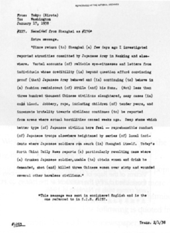
The image above is a telegram sent by Australian journalist Harold John Timperley describing the Nanking Massacre. The telegram was intercepted and decoded by American foreign intelligence in January 1938. The Nanking Massacre, called the Rape of Nanking in many newspapers in the United States, took place over six weeks starting on December 13, 1937. Estimates of the death toll vary, but the Chinese government estimates it at 300,000 Chinese killed during the conflict. The United States did not intervene in the conflict between China and Japan, despite the fact that the incident was reported in major U.S. newspapers.

The text of the telegram reads: "Since return to Shanghai a few days ago I investigated reported atrocities committed by Japanese Army in Nanking and elsewhere. Verbal accounts of reliable eye-witnesses and letters from individuals whose credibility is beyond question afford convincing proof that Japanese Army behaved and is continuing to behave in a fashion reminiscent of Attila and his Huns. Not less than three hundred thousand Chinese civilians slaughtered, many cases in cold blood. Robbery, rape, including children of tender years, an insensate brutality towards civilians continues to be reported from areas where actual hostilities ceased weeks ago. Deep shame which better type of Japanese civilian here feel—reprehensible conduct of Japanese troops elsewhere heightened by series of local incidents where Japanese soldiers run amok in Shanghai itself. Today North China Daily News reports a particularly revolting case where a drunken Japanese soldier, unable to obtain women and drink he demanded, shot and killed three Chinese women over sixty and wounded several other harmless civilians."

*Note: The United States declared war on Japan on December 8, 1941.

Source V: “Japan”
Text | Vocabulary | Guiding Questions
Like its European allies, Japan was intent upon creating an empire for itself. In 1931, it created a new nation, a puppet state called Manchukuo, which had been cobbled together from the three northernmost provinces of China. Although the League of Nations formally protested Japan’s seizure of Chinese territory in 1931 and 1932, it did nothing else. In 1937, a clash between Japanese and Chinese troops, known as the Marco Polo Bridge Incident, led to a full-scale invasion of China by the Japanese. By the end of the year, the Chinese had suffered some serious defeats. In Nanjing, then called Nanking by Westerners, Japanese soldiers systematically raped Chinese women and massacred hundreds of thousands of civilians, leading to international outcry. Public sentiment against Japan in the United States reached new heights. Members of Protestant churches that were involved in missionary work in China were particularly outraged, as were Chinese Americans. A troop of Chinese American Boy Scouts in New York City’s Chinatown defied Boy Scout policy and marched in protest against Japanese aggression. |  | How did the United States respond to the Nanking Massacre?  ________________________________  ________________________________  ________________________________  ________________________________  ________________________________  ________________________________  ________________________________  ________________________________  ________________________________  ________________________________  ________________________________

After you read:

1. How did news of the Nanking Massacre influence support for U.S. involvement?

*Note: The timeline below is meant to show some, not all, events of the Holocaust, in the time period before the United States entered World War II.
Source W: The Holocaust Timeline
January 30, 1933 | Adolf Hitler was appointed German chancellor of the coalition government, made up of Nazis and Nationalists, by President Paul von Hindenburg. This was the beginning of the Nazi state (also referred to as the Third Reich).
February 28, 1933 | Reichstag (German parliament) building burned in Berlin. As a result, President Hindenburg issued a declaration of emergency that allowed the coalition government, made up of Nazis and Nationalists, to arrest political opponents and suppress free press. This decree took away basic rights and was a key step in the establishment of the Nazi dictatorship.
March 22, 1933 | The first concentration camp opened to hold political opponents of the Nazi regime, homosexuals, Jehovah’s Witnesses, and others considered dangerous by the Nazis.
April 7, 1933 | The German government excluded Jews and political opponents from all civil service (government) positions and prohibited non-“Aryan” lawyers from practicing as lawyers.
May 7, 1933 | All Jewish workers and members of the German armed forces were dismissed from service.
August 2, 1934 | President von Hindenburg died and Hitler became President of Germany. Hitler then abolished the office of president and became the dictator of Germany.
September 15, 1935 | The German parliament passed the Nuremberg Race Laws. These laws classified a person as a Jew if they had three or four Jewish grandparents, rather than those who practiced Judaism. This law provided the legal framework for the persecution of Jews in Germany.
November 9–10, 1938 | Kristallnacht, meaning “night of broken glass,” took place. Violence against Jewish citizens and businesses was widespread and led by Nazi officials. Rioters destroyed hundreds of synagogues and looted more than 7,000 Jewish-owned businesses. Almost one hundred Jewish residents were killed.
February 9, 1939 | In response to persecution of Jews in Germany, United States Senator Robert Wagner of New York and Representative Edith Rogers of Massachusetts introduced a bill to permit the entry of 20,000 refugee children from Germany. The bill did not pass.
On May 13, 1939 | German transatlantic liner St. Louis left Hamburg, Germany, for Havana, Cuba. On board are over 900 passengers, almost all of them Jews fleeing from Nazi Germany.
September 1, 1939 | Germany invaded Poland and initiated World War II in Europe. Great Britain and France declared war on Germany two days later.
May 20, 1940 | The largest concentration camp complex of the Nazi regime at Auschwitz opened.
September 1, 1941 | All Jews in the Reich and in German occupied territories were required to wear a Star of David and the word “Jew” in the local language.
October 15, 1941 | “Operation Reinhard,” in which 1.7 million Jews were murdered, began.

Source X: “The United States and the Nazi Threat 1933–1937”
Text | Vocabulary | Guiding Questions
Early Reports of Persecution  On January 30, 1933, Adolf Hitler was appointed Chancellor of Germany. Immediately, newspapers in the United States printed articles speculating about how the Nazi Party’s anti-Semitic politics might transform Germany. Some journalists wondered whether power would tame Hitler’s bold and undemocratic pronouncements. Others worried that Jewish fears were justified; the Boston Globe, for example, reported on February 1 that the Nazis were already warning that “Jews who got out early would be wise.”  In the spring of 1933, Nazi attacks on German Jews increased. Dozens of American journalists stationed in Nazi Germany submitted reports to U.S. newspapers nationwide about what they witnessed. Americans could read about the April 1st boycott of Jewish businesses, the April 7th “Law for the Restoration of the Professional Civil Service” removing Jews from public employment, and the May 10th book burnings on the front pages of their newspapers, as well as see photographs of these events in popular American magazines such as Time, Newsweek, and others. Journalists also reported that Americans were being attacked by Nazi storm troopers (Sturmabteilung, or SA) or by pro-Nazi crowds on the streets of Germany for laughing at an anti-Nazi joke, refusing to salute the Nazi flag, or just because the attackers thought the victim looked Jewish. U.S. State Department diplomats protested some of the three dozen attacks on Americans in Germany in 1933 but did not issue a formal protest against the Nazi treatment of Germany’s Jews.  In response to these news reports, American Jewish organizations and labor unions drew tens of thousands of participants at protest rallies and marches in major U.S. cities intended to draw attention to the Nazi treatment of Jews. More than five hundred organizations—Jewish and non-Jewish—from across the United States sent petitions to government officials demanding an official response to Nazi anti-Semitic actions. The Jewish War Veterans of the United States of America organization and the American League for the Defense of Jewish Rights (which soon became the Non-Sectarian Anti-Nazi League) advocated boycotting German-made goods and the U.S. stores that carried them. Some Jewish organizations, which likewise opposed Nazism, argued against holding these rallies and boycotts, claiming that the Nazi regime might retaliate even more violently against Jews in Germany. These groups also worried that such public protests might contribute to widespread anti-Semitic stereotypes that grossly exaggerated Jewish influence in the United States.  As Americans read these press reports, the United States had been suffering through the effects of the Great Depression for nearly four years. Some twenty-five percent of workers were unemployed. The new U.S. President, Franklin Delano Roosevelt, inaugurated on March 4, 1933, promised the country a “New Deal” and immediately embarked upon an ambitious agenda to repair the U.S. economy. Many more Americans were focused on these serious domestic problems than on the persecution of a minority group thousands of miles away.  Immigration  Immigration to the United States was controlled by Congress, which in 1924 had passed the Johnson-Reed Immigration Act. The act set “national origins” quotas which privileged immigrants from northern and western Europe, who were believed to be able to assimilate more easily into the United States. After 1929, the act capped overall quota immigration at 153,879 people per year, and allocated 25,957 slots per year, the second highest quota of any country, to immigrants born in Germany.  At the beginning of the Great Depression in 1930, President Herbert Hoover issued instructions banning immigrants “likely to become a public charge,” meaning those who might not be able to financially support themselves. Immigration fell dramatically as a result of this “LPC” clause being strictly enforced. In 1933, only 8,220 quota immigrants arrived in the United States, a ninety-five percent decrease in immigration compared to the years prior to Hoover’s instruction. Although President Roosevelt liberalized Hoover’s instruction shortly after taking office, 83,013 prospective German immigrants were on the waiting list to enter the United States in June 1934. Most of them did not have the financial resources necessary to prove they would not become a “public charge,” but wanted to remain on the list in anticipation of the U.S. economy recovering and the restrictions being lifted.  In 1933, Secretary of Labor Frances Perkins, whose department housed the Immigration and Naturalization Service, drafted orders to rescind Hoover’s instruction and give preference to people seeking to escape racial or religious persecution. The Labor Department also planned to allow Americans to place bonds demonstrating financial support for relatives seeking to immigrate, which would have exempted applicants from being rejected under the “LPC” clause. The State Department opposed Perkins’ efforts, however, citing the facts that unemployment was still high, that consular officers were sympathetic to Jews, and that the quotas were still unfilled. President Roosevelt did not intervene in the conflict, and none of Perkins’ proposals succeeded. Though 29,456 German-born immigrants entered the United States between 1933–1937, this number represents about 23% of the number of immigrants who could have legally arrived within the existing German quota.  Neutrality  International unrest in the 1930s—including Japan’s occupation of Manchuria, Italy’s invasion of Ethiopia, Nazi Germany’s remilitarization and territorial seizures, and the outbreak of the Spanish Civil War—tested the ability of the United States to remain isolated from affairs abroad. To ensure this commitment to isolationism, the U.S. Congress passed a series of Neutrality Acts designed to prevent American involvement in these conflicts.  The Neutrality Act of 1935 prohibited exporting arms and ammunition to any foreign nation at war. Two years later, the Neutrality Act of 1937 reasserted the commitment to keep the United States out of war, but allowed the president to distinguish among nations at war when enforcing neutrality. The 1937 act permitted favored nations to purchase non-military products in the United States, provided they paid with cash and transported the goods on their own ships, an arrangement known as “cash and carry.”  Still, the vast majority of American people hoped that the United States would remain isolated from foreign conflicts. In 1937, 67% of Americans polled believed there would be another world war, and 73% agreed that a national vote should be required before the U.S. could declare war.  Boycott the 1936 Olympics?  In 1935, Americans debated whether to boycott the 1936 summer Olympics in Berlin. Jeremiah Mahoney, the president of the Amateur Athletic Union, opposed U.S. participation in the Games, claiming that it would “mean giving American moral and financial support to the Nazi regime, which is opposed to all that Americans hold dearest.” Avery Brundage, the chairman of the American Olympic Committee, went on a fact-finding tour of Germany, and was persuaded by the Nazis’ false assertions that Jewish athletes were being treated fairly. Brundage claimed that boycott advocates were injecting political concerns where they did not belong and implied that the boycott was a Jewish-led conspiracy of radicals and Communists.  African American athletes, including track-and-field star Jesse Owens, were pressured by both supporters and opponents of the boycott. The National Association for the Advancement of Colored People (NAACP) initially favored a boycott as a measure of solidarity with the persecuted German Jews, while others in the African American community saw potential Olympic victory as a way to disprove the Nazi regime’s claims to “Aryan” superiority.  Public opinion polls indicated that the American people were split on whether to boycott. In March 1935, fifty-seven percent of Americans said the United States should participate in the Games, while forty-three percent supported the protest. In a close vote in December, the Amateur Athletic Union voted to participate in the Olympics. Although eighteen African American athletes ultimately participated (and won fourteen medals) in Berlin, their victories did little to change racial prejudices in Germany or in the United States. The 1936 Olympics were also a public relations success for Hitler. Americans attending the Games were largely impressed by the Nazi regime, which temporarily hid the overt persecution of Jews, and newspapers predicted that Germany would now be "back in the fold of nations.”  A month after the closing ceremonies, prominent Nazi publisher Julius Streicher gave a speech to an international audience, explaining “to secure the safety of the whole world, they [i.e., the Jews] must be exterminated.” American newspapers reported on Streicher’s prediction, but with nearly seventeen percent of the U.S. workforce unemployed, the statement did not garner the same protests, rallies, petitions, and marches in the U.S. as the initial Nazi anti-Semitic attacks had three years earlier. | anti-Semitic: prejudiced against Jews  assimilate: to integrate into a larger society or culture | Describe the anti-Semitic incidents that occurred in Germany in 1933.  ________________________________  ________________________________  ________________________________  ________________________________  ________________________________  ________________________________  ________________________________  ________________________________  ________________________________  ________________________________  How were Americans informed about anti-Semitic incidents in Germany? How did the U.S. respond?  ________________________________  ________________________________  ________________________________  ________________________________  ________________________________  ________________________________  ________________________________  How did organizations like the Jewish War Veterans of the United States of America respond to anti-Semitic attacks in Germany? Why did some anti-Nazi groups oppose their tactics?  ________________________________  ________________________________  ________________________________  ________________________________  ________________________________  ________________________________  ________________________________  Describe the domestic problems in the United States that took focus away from humanitarian concerns in other countries.  ________________________________  ________________________________  ________________________________  ________________________________  ________________________________  ________________________________  ________________________________  ________________________________  How did President Herbert Hoover’s instructions on immigration impact the number of German refugees that could immigrate to the United States?  ________________________________  ________________________________  ________________________________  ________________________________  ________________________________  ________________________________  ________________________________  ________________________________  ________________________________  How did Secretary of Labor Frances Perkins want to change immigration rules? Why did her efforts not succeed?  ________________________________  ________________________________  ________________________________  ________________________________  ________________________________  ________________________________  ________________________________  ________________________________  ________________________________  ________________________________  ________________________________  ________________________________  What were the foreign pressures that threatened U.S. neutrality in the 1930s?  ________________________________  ________________________________  ________________________________  ________________________________  ________________________________  ________________________________  Describe American feelings about entering another war in 1937, according to polls.  ________________________________  ________________________________  ________________________________  ________________________________  ________________________________  ________________________________  ________________________________  ________________________________  ________________________________  Why did many Americans want to boycott the 1936 Olympics?  ________________________________  ________________________________  ________________________________  ________________________________  ________________________________  ________________________________  How did the 1936 Olympic games affect Nazi Germany?  ________________________________  ________________________________  ________________________________  ________________________________  ________________________________  ________________________________  ________________________________  ________________________________  ________________________________  ________________________________  ________________________________  ________________________________

Source Y: “Destroyed Jewish Building”

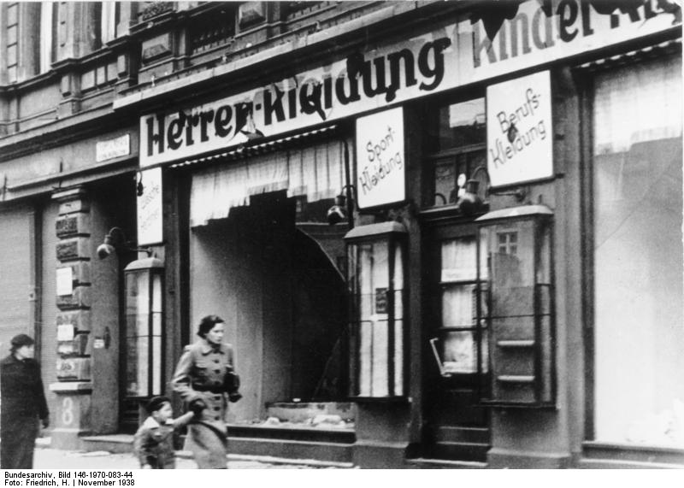

Nazi Party officials set off a nationwide riot against Jews in Germany and Austria on the night of November 9–10, 1938, an event known as Kristallnacht. Units of the Nazi Party’s SA militia and Hitler Youth destroyed hundreds of synagogues and thousands of Jewish-owned shops. Nearly 30,000 Jewish men were arrested and sent to concentration camps. American newspapers covered the Nazi terror attack against Jews in banner headlines on their front pages, and articles about the events continued to appear for several weeks. At his press conference five days after Kristallnacht, President Franklin D. Roosevelt said that the attack had “deeply shocked” the American public. He ordered the U.S. ambassador in Germany to return home as a sign of protest and allowed 12,000 Germans—most of them Jews—who were temporarily in the United States to remain indefinitely. “I cannot, in any decent humanity, throw them out,” he explained to reporters. But Roosevelt also said that U.S. immigration quotas would not be changed to admit more Jewish refugees.

Source Z: “Refugees Aboard the St. Louis”
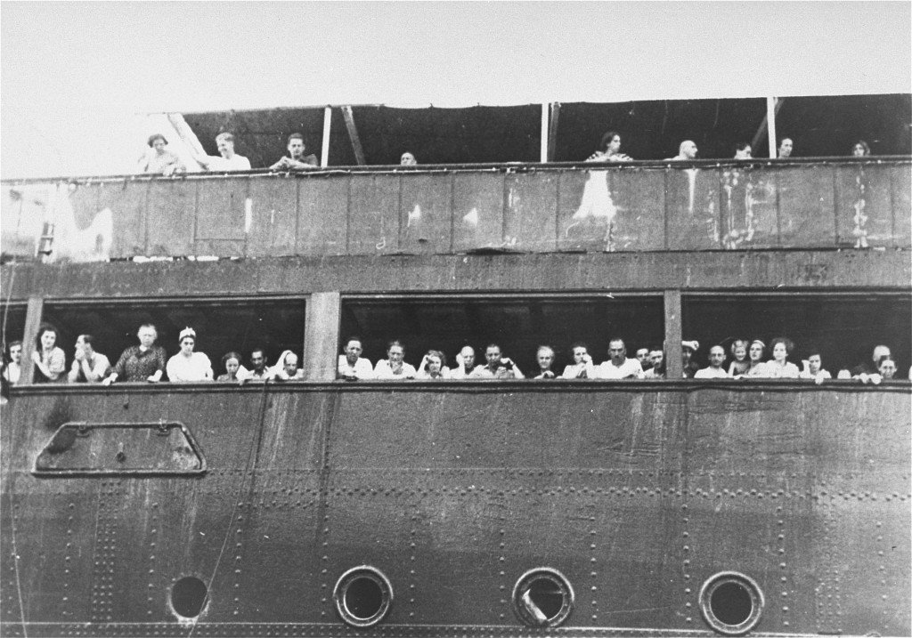
In May 1939, the German liner St. Louis sailed from Hamburg, Germany, to Havana, Cuba, carrying 937 passengers, almost all Jewish refugees. The Cuban government refused to allow the ship to land, and the United States and Canada were unwilling to admit the passengers. The St. Louis passengers were finally permitted to land in western European countries rather than return to Nazi Germany. 254 St. Louis passengers were killed in the Holocaust.

Roosevelt’s willingness to accede to the demands of the noninterventionists led him even to refuse assistance to those fleeing Nazi Germany. Although Roosevelt was aware of Nazi persecution of the Jews, he did little to aid them. In a symbolic act of support, he withdrew the American ambassador to Germany in 1938. He did not press for a relaxation of immigration quotas that would have allowed more refugees to enter the country, however. In 1939, he refused to support a bill that would have admitted twenty thousand Jewish refugee children to the United States. Again in 1939, when German refugees aboard the SS St. Louis, most of them Jews, were refused permission to land in Cuba and turned to the United States for help, the U.S. State Department informed them that immigration quotas for Germany had already been filled. Once again, Roosevelt did not intervene, because he feared that nativists in Congress might smear him as a friend of Jews.

Source AA: “United States and the Holocaust”
Text | Vocabulary | Guiding Questions
Initially, American officials expressed little official concern for Nazi persecutions. At the first signs of trouble in the 1930s, the State Department and most U.S. embassies did relatively little to aid European Jews. Roosevelt publicly spoke out against the persecution and even withdrew the U.S. ambassador to Germany after Kristallnacht. He pushed for the 1938 Evian Conference in France, in which international leaders discussed the Jewish refugee problem and worked to expand Jewish immigration quotas by tens of thousands of people per year. But the conference came to nothing, and the United States turned away countless Jewish refugees who requested asylum in the United States.  Anti-Semitism still permeated the United States. Even if Roosevelt wanted to do more—it’s difficult to trace his own thoughts and personal views—he judged the political price for increasing immigration quotas as too high. In 1938 and 1939, the U.S. Congress debated the Wagner-Rogers Bill, an act to allow twenty thousand German-Jewish children into the United States. First lady Eleanor Roosevelt endorsed the measure, but the president remained publicly silent. The bill was opposed by roughly two thirds of the American public and was defeated. Historians speculate that Roosevelt, anxious to protect the New Deal and his rearmament programs, was unwilling to expend political capital to protect foreign groups that the American public had little interest in protecting.  Knowledge of the full extent of the Holocaust was slow in coming. When the war began, American officials, including Roosevelt, doubted initial reports of industrial death camps. But even when they conceded their existence, officials pointed to their genuinely limited options. The most plausible response was for the U.S. military was to bomb either the camps or the railroads leading to them, but those options were rejected by military and civilian officials who argued that it would do little to stop the deportations, would distract from the war effort, and could cause casualties among concentration camp prisoners. Whether bombing would have saved lives remains a hotly debated question.  Late in the war, secretary of the treasury Henry Morgenthau, himself born into a wealthy New York Jewish family, pushed through major changes in American policy. In 1944, he formed the War Refugees Board (WRB) and became a passionate advocate for Jewish refugees. The WRB saved perhaps two hundred thousand Jews and twenty thousand others. Morgenthau also convinced Roosevelt to issue a public statement condemning the Nazi’s persecution. But it was already 1944, and such policies were far too little, far too late. | political capital: ability to influence a political cause | Describe the United States’ immigration rules for Jewish refugees under President Roosevelt.  ________________________________  ________________________________  ________________________________  ________________________________  ________________________________  ________________________________  ________________________________  ________________________________  ________________________________  ________________________________  ________________________________  ________________________________  ________________________________  ________________________________  Why was it difficult for President Roosevelt to increase aid to Jewish refugees in the late 1930s?  ________________________________  ________________________________  ________________________________  ________________________________  ________________________________  ________________________________  ________________________________  Describe the factors that prevented the U.S. from intervening in the persecution and genocide of Jews in Germany.  ________________________________  ________________________________  ________________________________  ________________________________  ________________________________  ________________________________  ________________________________  How did Henry Morgenthau help Jewish refugees late in the war?  ________________________________  ________________________________  ________________________________  ________________________________  ________________________________

Source AB: “Eisenhower Tours a Newly Liberated Concentration Camp”
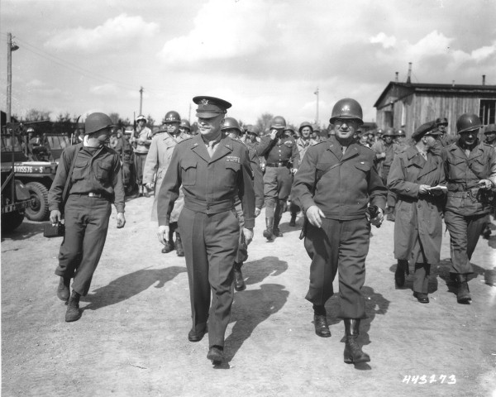
As Allied troops moved into Europe in a series of offensives against Nazi Germany, they encountered concentration camps, mass graves, and numerous other sites of Nazi crimes. Soviet forces were the first to overrun a major Nazi concentration camp, Lublin/Majdanek, near Lublin, Poland, in July 1944. On January 27, 1945, Soviet troops liberated Auschwitz. The U.S. military did not participate in the liberation of any extermination camps in Nazi-occupied Poland.

Though the liberation of Nazi camps was not a primary military objective, American soldiers advancing into the interior of Germany in the spring of 1945 liberated major concentration camps, including Buchenwald, Dachau, and Mauthausen, as well as hundreds of subcamps. They also encountered and liberated prisoners on forced marches and those who had been abandoned by their Nazi captors.

After touring the Ohrdruf concentration camp on April 12, 1945, General Dwight D. Eisenhower sent a telegram to Washington:

“The things I saw beggar description…. The visual evidence and the verbal testimony of starvation, cruelty and bestiality were…overpowering…. I made the visit deliberately in order to be in a position to give firsthand evidence of these things if ever, in the future, there develops a tendency to charge these allegations merely to propaganda.”

Eisenhower encouraged American soldiers in the vicinity of a concentration camp to tour the site, take photographs, and write letters to their families in the United States describing what they had seen. He also arranged for delegations of journalists and members of Congress to tour the newly liberated camps.

Formative Performance Task #2 – Constructed Response
Student Directions | Explain two different ways that the United States reacted to international humanitarian issues before the U.S. entered World War II.

Lesson 6
Supporting Question 3: Why did the United States enter World War II, and
what were the effects of U.S. involvement in the war?
Student Directions | First, read and study Source AC. Then, read Sources AD and AE and answer the guiding questions in the right-hand columns. Next, read and study Sources AF and AG. Then, read Source AH and answer the guiding questions in the right-hand column. Next, read and study Source AI. Finally, complete the after you read question at the end of this lesson.
Featured Sources | Source AC: “This is Not a Drill”  Source AD: The Ambassador in Japan (Grew) to the Secretary of State, 3 November 1941  Source AE: “A Date Which Will Live in Infamy”  Source AF: “Attack on Pearl Harbor Japanese Plane View”  Source AG: “USS California”  Source AH: Infamy Speech, December 8, 1941  Source AI: “Remember December 7th”

Source AC: “This is Not a Drill”
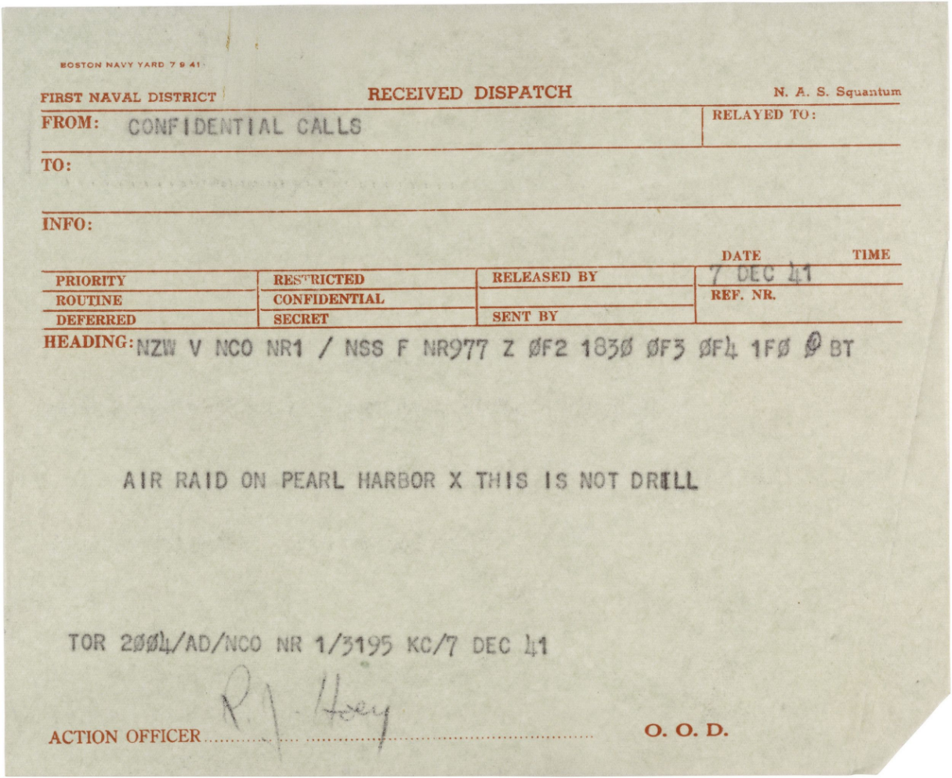
The Japanese government decided to attack Pearl Harbor after the United States cut off U.S. oil exports to Japan in the summer of 1941. Japan relied on the United States for eighty percent of its oil, and without U.S. oil supplies its navy would be unable to function. In attacking Pearl Harbor, the Japanese hoped to cripple or destroy the U.S. Pacific fleet so that the Japanese navy would have free reign in the Pacific.

Japan was also motivated strategically by ideas of creating an Asian co-prosperity sphere—“Asia for Asians”—in which Japan would take over the Asian colonial holdings of Europe and the United States. With the British, French, and Dutch caught up in the war in Europe, the Japanese believed the European powers would be unable to defend their Asian colonial holdings. Indeed, in the eight hours following the Pearl Harbor attack, Japan also attacked British-held Singapore, Hong Kong, and Malaya, and the U.S. territorial possessions of the Philippines, Guam, and Wake Island.

The United States had known that a Japanese attack was imminent somewhere in the Pacific, but U.S. military and government personnel had thought the Philippines or some other area of the South Pacific closer to Japan was the likely target. Pearl Harbor was 3,500 miles from Japan and had seemed to the U.S. government and military an unlikely target.

Source AD: The Ambassador in Japan (Grew) to the Secretary of State, 3 November 1941
Text | Vocabulary | Guiding Questions
. . I call your attention. . . to my telegram No. 827, September 12, 1940 . . . I sent this telegram under circumstances and at a time when it appeared unwise and futile for the United States to adopt conciliatory measures. The strong policy recommended in that telegram was subsequently adopted by the United States. This policy, together with the impact of world political events upon Japan brought the Japanese Government to the point of seeking conciliation with the United States. If these efforts fail, I foresee a probable swing of the pendulum in Japan once more back to the former Japanese position or even farther. This would lead to what I have described as an all-out, do-or-die attempt, actually risking national hara-kiri, to make Japan impervious to economic embargoes abroad rather than to yield to foreign pressure. It is realized by observers who feel Japanese national temper and psychology from day to day that, beyond peradventure, this contingency not only is possible but is probable.  (4) If the fiber and temper of the Japanese people are kept in mind, the view that war probably would be averted. . . by progressively imposing drastic economic measures is an uncertain and dangerous hypothesis upon which to base considered United States policy and measures. War would not be averted by such a course, if it is taken, is our own view. . . The primary point to be decided apparently involves the question whether war with Japan is justified by American national objectives, policies, and needs in the case of failure of the first line of national defense, namely, diplomacy. . .  . . . I do not at all mean to imply that Washington is pursuing an undeliberated policy. Nor do I intend to advocate for a single moment any "appeasement" of Japan by the United States . . .There should be no compromise with principles, though methods may be flexible. My purpose is only to ensure against the United States becoming involved in war with Japan because of any possible misconception of Japan's capacity to rush headlong into a suicidal struggle with the United States. While national sanity dictates against such action, Japanese sanity cannot be measured by American standards of logic. We have no need to be over concerned respecting the bellicose tone and substance at present of the Japanese press (which in the past several years has attacked the United States intensely in recurrent waves), but underestimating Japan's obvious preparations to implement a program in the event the alternative peace program fails, would be short-sighted. . . .Japan may resort with dangerous and dramatic suddenness to measures which might make inevitable war with the United States. | conciliatory: to win over, gain the favor of  conciliation: the act of coming to an agreement  hara-kiri: ritual suicide  impervious: not affected by  peradventure: doubt  averted: avoided  diplomacy: practice of using negotiations between to settle conflicts rather than war  misconcep-tion: a belief that is wrong  bellicose: aggressive | This telegram was sent over a month before Japan’s attack on Pearl Harbor. Describe the relationship between the United States and Japan when this telegram was sent.  ________________________________  ________________________________  ________________________________  ________________________________  ________________________________  ________________________________  ________________________________  ________________________________  ________________________________  ________________________________  ________________________________  ________________________________  ________________________________  What did Ambassador Grew warn would happen if the United States and Japan did not come to a diplomatic agreement?  ________________________________  ________________________________  ________________________________  ________________________________  ________________________________  ________________________________  ________________________________  ________________________________  ________________________________  ________________________________  ________________________________  ________________________________

Source AE: “A Date Which Will Live in Infamy”
Text | Vocabulary | Guiding Questions
By the second half of 1941, Japan was feeling the pressure of the American embargo. As it could no longer buy strategic material from the United States, the Japanese were determined to obtain a sufficient supply of oil by taking control of the Dutch East Indies. However, they realized that such an action might increase the possibility of American intervention, since the Philippines, a U.S. territory, lay on the direct route that oil tankers would have to take to reach Japan from Indonesia. Japanese leaders thus attempted to secure a diplomatic solution by negotiating with the United States while also authorizing the navy to plan for war. The Japanese government also decided that if no peaceful resolution could be reached by the end of November 1941, then the nation would have to go to war against the United States.  The American final counterproposal to various offers by Japan was for the Japanese to completely withdraw, without any conditions, from China and enter into nonaggression pacts with all the Pacific powers. Japan found that proposal unacceptable but delayed its rejection for as long as possible. Then, at 7:48 a.m. on Sunday, December 7, the Japanese attacked the U.S. Pacific fleet at anchor in Pearl Harbor, Hawaii. They launched two waves of attacks from six aircraft carriers that had snuck into the central Pacific without being detected. The attacks brought some 353 fighters, bombers, and torpedo bombers down on the unprepared fleet. The Japanese hit all eight battleships in the harbor and sank four of them. They also damaged several cruisers and destroyers. On the ground, nearly two hundred aircraft were destroyed, and twenty-four hundred servicemen were killed. Another eleven hundred were wounded. Japanese losses were minimal. The strike was part of a more concerted campaign by the Japanese to gain territory. They subsequently attacked Hong Kong, Malaysia, Singapore, Guam, Wake Island, and the Philippines.  Whatever reluctance to engage in conflict the American people had had before December 7, 1941, quickly evaporated. Americans’ incredulity that Japan would take such a radical step quickly turned to a fiery anger, especially as the attack took place while Japanese diplomats in Washington were still negotiating a possible settlement. President Roosevelt, referring to the day of the attack as “a date which will live in infamy,” asked Congress for a declaration of war, which it delivered to Japan on December 8. On December 11, Germany and Italy declared war on the United States in accordance with their alliance with Japan. Against its wishes, the United States had become part of the European conflict. | Dutch East Indies: present-day Indonesia | What did the United States ask of Japan during diplomatic negotiations in late 1941? How did Japan respond?  ________________________________  ________________________________  ________________________________  ________________________________  ________________________________  ________________________________  ________________________________  ________________________________  ________________________________  ________________________________  What were the results of the surprise attack on Pearl Harbor?  ________________________________  ________________________________  ________________________________  ________________________________  ________________________________  ________________________________  ________________________________  How did the United States’ declaration of war on Japan bring them into war with Germany?  ________________________________  ________________________________  ________________________________  ________________________________  ________________________________  ________________________________  ________________________________  ________________________________  ________________________________

Source AF: “Attack on Pearl Harbor Japanese Plane View”

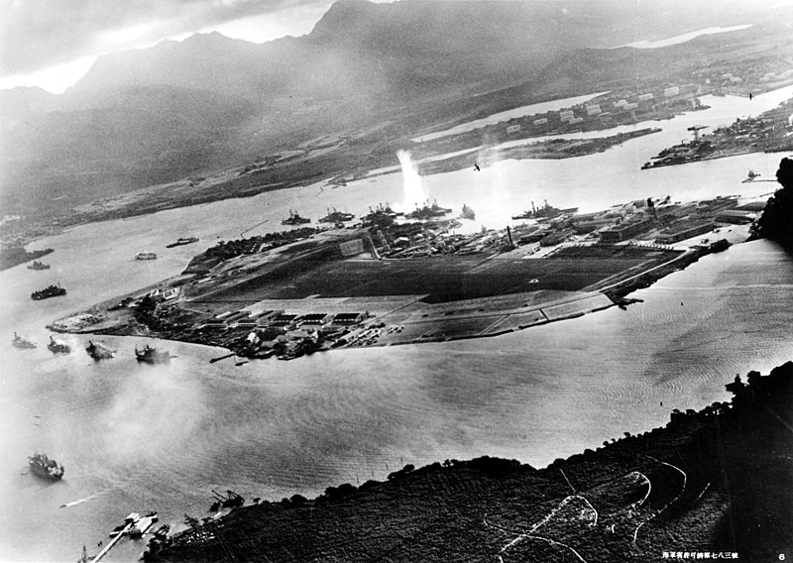

The Japanese surprise attack on Pearl Harbor began just before 8 a.m. local time Sunday morning, December 7, 1941. For over an hour, in two waves, some 350 Japanese aircraft attacked the naval base. In all, 2,403 Americans, including 68 civilians, died in the attack. The photograph above was taken from a Japanese plane during the attack.

Source AG: “USS California”

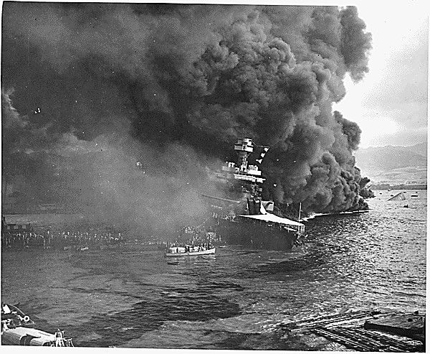
The photograph above was taken by the United States navy during the attack on Pearl Harbor. The photograph shows the USS California on fire and sinking.

*Note: In the United States, declarations of war are approved by Congress. In the speech below, President Roosevelt is speaking to Congress in order to ask them to declare war on Japan after the attack on Pearl Harbor. Only one member of Congress, Representative Jeannette Rankin, voted against the declaration of war.

Source AH: Infamy Speech, December 8, 1941
Text | Vocabulary | Guiding Questions
Yesterday, December 7th, 1941—a date which will live in infamy—the United States of America was suddenly and deliberately attacked by naval and air forces of the Empire of Japan.  The United States was at peace with that nation and, at the solicitation of Japan, was still in conversation with its government and its emperor looking toward the maintenance of peace in the Pacific.  Indeed, one hour after Japanese air squadrons had commenced bombing in the American island of Oahu, the Japanese ambassador to the United States and his colleague delivered to our Secretary of State a formal reply to a recent American message. And while this reply stated that it seemed useless to continue the existing diplomatic negotiations, it contained no threat or hint of war or of armed attack.  It will be recorded that the distance of Hawaii from Japan makes it obvious that the attack was deliberately planned many days or even weeks ago. During the intervening time, the Japanese government has deliberately sought to deceive the United States by false statements and expressions of hope for continued peace.  The attack yesterday on the Hawaiian Islands has caused severe damage to American naval and military forces. I regret to tell you that very many American lives have been lost. In addition, American ships have been reported torpedoed on the high seas between San Francisco and Honolulu.  Yesterday, the Japanese government also launched an attack against Malaya.  Last night, Japanese forces attacked Hong Kong.  Last night, Japanese forces attacked Guam.  Last night, Japanese forces attacked the Philippine Islands.  Last night, the Japanese attacked Wake Island.  And this morning, the Japanese attacked Midway Island.  Japan has, therefore, undertaken a surprise offensive extending throughout the Pacific area. The facts of yesterday and today speak for themselves. The people of the United States have already formed their opinions and well understand the implications to the very life and safety of our nation.  As Commander in Chief of the Army and Navy, I have directed that all measures be taken for our defense. But always will our whole nation remember the character of the onslaught against us.  No matter how long it may take us to overcome this premeditated invasion, the American people in their righteous might will win through to absolute victory.  I believe that I interpret the will of the Congress and of the people when I assert that we will not only defend ourselves to the uttermost, but will make it very certain that this form of treachery shall never again endanger us.  Hostilities exist. There is no blinking at the fact that our people, our territory, and our interests are in grave danger.  With confidence in our armed forces, with the unbounding determination of our people, we will gain the inevitable triumph—so help us God.  I ask that the Congress declare that since the unprovoked and dastardly attack by Japan on Sunday, December 7th, 1941, a state of war has existed between the United States and the Japanese empire. | solicitation: entreaty, request, or urging | How does President Roosevelt describe the relationship between the United States and Japan prior to the attack on Pearl Harbor?  ________________________________  ________________________________  ________________________________  ________________________________  ________________________________  ________________________________  How does President Roosevelt describe Japan’s planning of the attack on Pearl Harbor?  ________________________________  ________________________________  ________________________________  ________________________________  ________________________________  ________________________________  ________________________________  ________________________________  ________________________________  ________________________________  ________________________________  ________________________________  ________________________________  ________________________________  ________________________________  How did the attack on Pearl Harbor, as President Roosevelt says, make the people of the United States “understand the implications to the very life and safety of our nation”?  ________________________________  ________________________________  ________________________________  ________________________________  ________________________________  ________________________________  ________________________________  ________________________________  ________________________________  ________________________________  ________________________________

Source AI: “Remember December 7th”
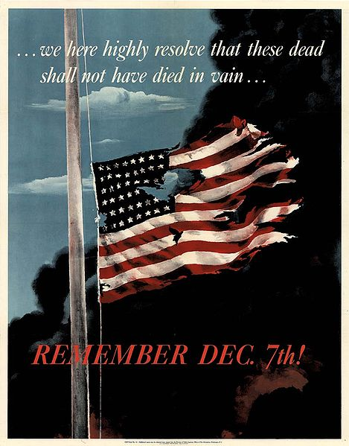
United States propaganda poster encouraging people to support the war effort. The Pearl Harbor attack increased public support for the United States’ entry into World War II and “Remember Pearl Harbor” became a slogan in support of the war.

After you read:

1. How did the Japanese attack on Pearl Harbor change the views of people in the United States?

Lesson 7
Supporting Question 3: Why did the United States enter World War II, and
what were the effects of U.S. involvement in the war?
Student Directions | First, read Source AJ and answer the guiding questions in the right-hand column. Next, read and study Sources AK, AL, AM, and AN. Finally, complete the after you read questions at the end of this lesson.
Featured Sources | Source AJ: “Japanese Internment”  Source AK: Map of World War I Japanese Internment Camps  Source AL: “Oakland, California, March 1942”  Source AM: “Tule Lake Relocation Center, Newell, California”  Source AN: “Bataan Death March”

Source AJ: “Japanese Internment”
Text | Vocabulary | Guiding Questions
Many Americans had to navigate prejudice, and America’s entry into the war left foreign nationals from the belligerent nations in a precarious position. The Federal Bureau of Investigation (FBI) targeted many on suspicions of disloyalty for detainment, hearings, and possible internment under the Alien Enemy Act. Those who received an order for internment were sent to government camps secured by barbed wire and armed guards. Such internments were supposed to be for cause. Then, on February 19, 1942, President Roosevelt signed Executive Order 9066, authorizing the removal of any persons from designated “exclusion zones”—which ultimately covered nearly a third of the country—at the discretion of military commanders. Thirty thousand Japanese Americans fought for the United States in World War II, but wartime anti-Japanese sentiment built on historical prejudices, and under the order, people of Japanese descent, both immigrants and American citizens, were detained and placed under the custody of the War Relocation Authority, the civil agency that supervised their relocation to internment camps. They lost their homes and jobs. Over ten thousand German nationals and a smaller number of Italian nationals were interned at various times in the United States during World War II, but American policies disproportionately targeted Japanese-descended populations, and individuals did not receive personalized reviews prior to their internment. This policy of mass exclusion and detention affected over 110,000 Japanese and Japanese-descended individuals. Seventy thousand were American citizens.  In its 1982 report, Personal Justice Denied, the congressionally-appointed Commission on Wartime Relocation and Internment of Civilians concluded that “the broad historical causes” shaping the relocation program were “race prejudice, war hysteria, and a failure of political leadership.” Although the exclusion orders were found to have been constitutionally permissible under the vagaries of national security, they were later judged, even by the military and judicial leaders of the time, to have been a grave injustice against people of Japanese descent. In 1988, President Reagan signed a law that formally apologized for internment and provided reparations to surviving internees. | internment: the state of being confined as a prisoner  nationals: citizens  hysteria: irrational panic  vagaries: oddities | Who signed Executive Order 9066 and what did it do?  ________________________________  ________________________________  ________________________________  ________________________________  ________________________________  ________________________________  ________________________________  ________________________________  ________________________________  ________________________________  How were Japanese and Japanese-descended people treated differently than German and Italian nationals during World War II?  ________________________________  ________________________________  ________________________________  ________________________________  ________________________________  ________________________________  ________________________________  How did the United States government view Japanese internment in the years after the war?  ________________________________  ________________________________  ________________________________  ________________________________  ________________________________  ________________________________  ________________________________

Source AK: Map of World War I Japanese Internment Camps
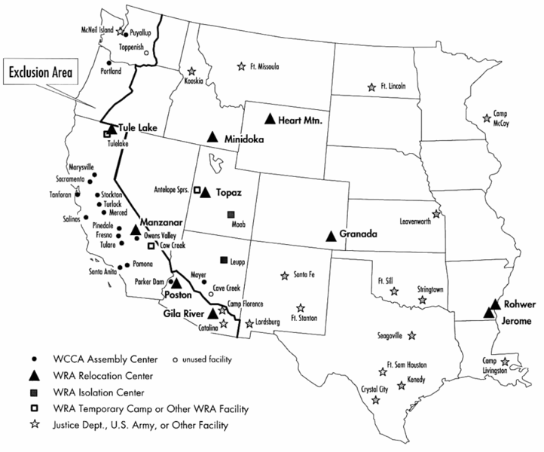

The Wartime Civil Control Administration (WCCA) was an agency set up as part of the Western Defense Command to implement the mass forced removal of Japanese Americans from the West Coast. In addition to engineering the logistics of removing some 110,000 people from their homes and businesses in a short period of time, the WCCA also quickly built and administered a series of seventeen temporary detention camps to hold those who had been removed through the spring and summer of 1942, before overseeing their transfer to more permanent camps administered by the War Relocation Authority by the end of fall 1942.

The War Relocation Authority (WRA) was the federal agency created in 1942 to care for the 110,000 Japanese Americans whom the army removed from the West Coast during World War II. Under the leadership of directors Milton Eisenhower (briefly) and Dillon S. Myer, the WRA built and operated a network of camps in the interior, where those removed were subjected to involuntary confinement. As part of the agency's mission to resettle Japanese Americans outside of the West Coast excluded zone, WRA officials implemented a controversial "loyalty program" that led to segregation and harsh treatment of those inmates deemed "disloyal," even as they took up the defense of those adjudged "loyal" and assisted them to find jobs and housing outside the camps. The legacy of the WRA, and the opinion of both former inmates and historians as to the agency, remains mixed and evolving.

Source AL: “Oakland, California, March 1942”

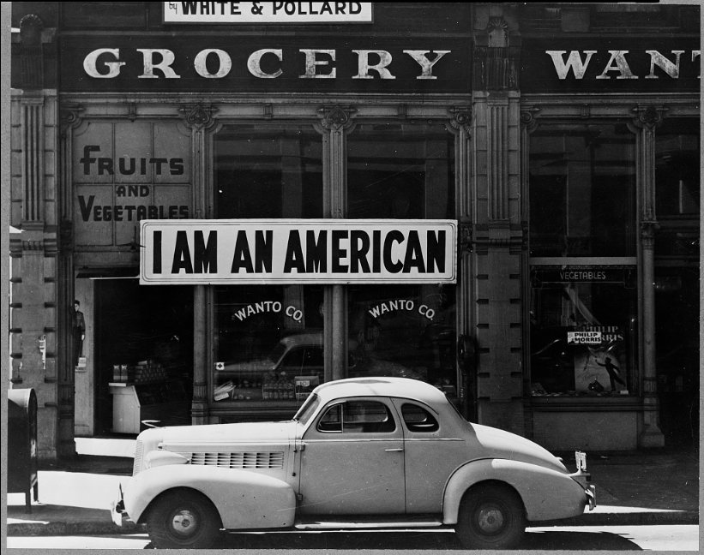

In this photograph by Dorothea Lange, a large sign reading "I am an American" was placed in the window of a store on December 8, the day after the attack on Pearl Harbor. The store was closed following orders to persons of Japanese descent to evacuate from certain West Coast areas. The owner, a University of California graduate, was housed in War Relocation Authority centers for the duration of the war.

Source AM: “Tule Lake Relocation Center, Newell, California”

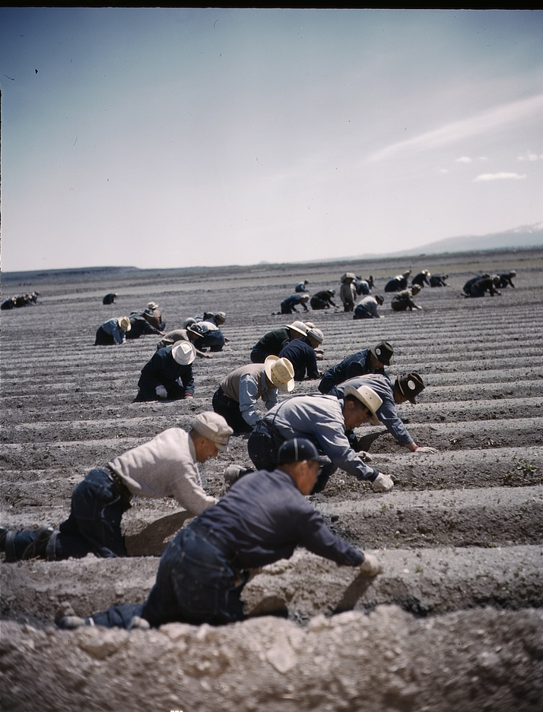

Tule Lake was one of the ten concentration camps built to imprison Japanese Americans forcibly removed from the West Coast states during World War II. Following the ill-conceived loyalty questionnaire that was administered in early 1943 to the imprisoned population, inmates who refused to give unqualified "yes" responses were segregated to Tule Lake and unjustly labeled as "disloyal." In the image above, prisoners of the camp are seen working in one of the farming areas of the camp.

*Note: Source AN highlights one instance of Japanese brutality during World War II that increased support of the war in the United States.
Source AN: “Bataan Death March”
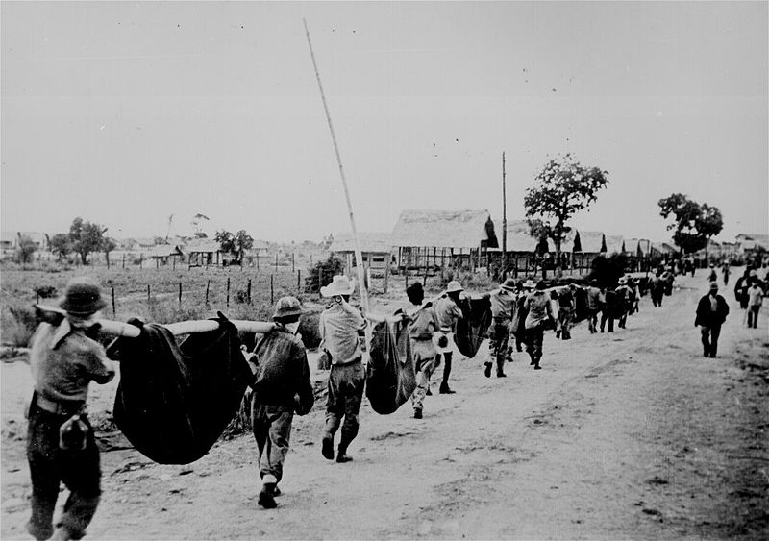

During the 1930s, Americans had caught glimpses of Japanese armies in action and grew increasingly sympathetic towards war-torn China. Stories of Japanese atrocities bordering on genocide and the shock of the attack on Pearl Harbor intensified racial animosity toward the Japanese. Wartime propaganda portrayed Japanese soldiers as uncivilized and barbaric, sometimes even inhuman. Stories of the dispiriting defeats at Bataan and the Japanese capture of the Philippines at Corregidor in 1942 revealed the Japanese cruelty and mistreatment of Americans. The “Bataan Death March,” during which as many as 650 American and 10,000 Filipino prisoners of war died, intensified anti-Japanese feelings. Kamikaze attacks that took place towards the end of the war were regarded as proof of the irrationality of Japanese martial values and mindless loyalty to Emperor Hirohito. In the image above, taken by the Japanese, American prisoners are carrying those of their comrades who, from the lack of food or water on the march from Bataan, fell along the road.

After you read:

1. How did the attack on Pearl Harbor affect people of Japanese descent in the United States?

2. How did the Bataan Death March contribute to anti-Japanese feelings already present in the United States?

Lesson 8
Supporting Question 3: Why did the United States enter World War II, and
what were the effects of U.S. involvement in the war?
Student Directions | First, read Source AO and answer the guiding questions in the right-hand column. Then, read and study Source AP. Finally, complete performance task #3 at the end of this lesson.
Featured Sources | Source AO: “The Home Front”  Source AP: “Buy War Bonds”

Source AO: “The Home Front”
Text | Vocabulary | Guiding Questions
Even before the official beginning of the war, the country started to prepare. In August 1940, Congress created the Defense Plant Corporation, which had built 344 plants in the West by 1945, and had funneled over $1.8 billion into the economies of western states. After Pearl Harbor, as American military strategists began to plan counterattacks and campaigns against the Axis powers, California became a training ground. Troops trained there for tank warfare and amphibious assaults as well as desert campaigns—since the first assault against the Axis powers was planned for North Africa.  Roosevelt and his administration already had experience in establishing government controls and taking the initiative in economic matters during the Depression. In April 1941, Roosevelt created the Office of Price Administration (OPA), and, once the United States entered the war, the OPA regulated prices and attempted to combat inflation. The OPA ultimately had the power to set ceiling prices for all goods, except agricultural commodities, and to ration a long list of items. During the war, major labor unions pledged not to strike in order to prevent disruptions in production; in return, the government encouraged businesses to recognize unions and promised to help workers bargain for better wages.  As in World War I, the government turned to bond drives to finance the war. Millions of Americans purchased more than $185 billion worth of war bonds. Children purchased Victory Stamps and exchanged full stamp booklets for bonds. The federal government also instituted the current tax-withholding system to ensure collection of taxes. Finally, the government once again urged Americans to plant victory gardens, using marketing campaigns and celebrities to promote the idea. Americans responded eagerly, planting gardens in their backyards and vacant lots.  The federal government also instituted rationing to ensure that America’s fighting men were well fed. Civilians were issued ration booklets, books of coupons that enabled them to buy limited amounts of meat, coffee, butter, sugar, and other foods. Wartime cookbooks were produced, such as the Betty Crocker Cookbook, telling housewives how to prepare tasty meals without scarce food items. Other items were rationed as well, including shoes, liquor, cigarettes, and gasoline. With a few exceptions, such as doctors, Americans were allowed to drive their automobiles only on certain days of the week. Most Americans complied with these regulations, but some illegally bought and sold rationed goods on the black market.  Civilians on the home front also recycled, conserved, and participated in scrap drives to collect items needed for the production of war materiel. Housewives saved cooking fats needed to produce explosives. Children collected scrap metal, paper, rubber, silk, nylon, and old rags. Some children sacrificed beloved metal toys in order to “win the war.” Civilian volunteers, trained to recognize enemy aircraft, watched the skies along the coasts and on the borders. | inflation: an increase in the price of goods while the value of money decreases  ration: limit the amount of a good or commodity for each person  bond: a cash loan made to a company or government with the promise of being paid back with interest | How did the United States mobilize (prepare) for war before the attack on Pearl Harbor?  ________________________________  ________________________________  ________________________________  ________________________________  ________________________________  ________________________________  How did President Roosevelt and his administration guarantee that the United States would be able to manufacture needed goods during World War II?  ________________________________  ________________________________  ________________________________  ________________________________  ________________________________  ________________________________  Why were bond drives and tax collection important during World War II?  ________________________________  ________________________________  ________________________________  ________________________________  ________________________________  Why were liberty gardens promoted and rations enforced during World War II?  ________________________________  ________________________________  ________________________________  ________________________________  ________________________________  ________________________________  How did people voluntarily participate in the war effort?  ________________________________  ________________________________  ________________________________  ________________________________  ________________________________

Source AP: “Buy War Bonds”
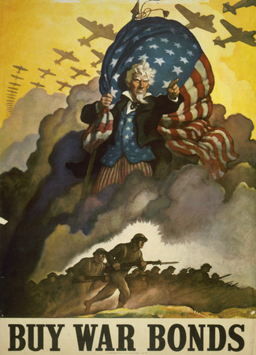

Guns, tanks, and bombs were the principal weapons of World War II, but there were other, more subtle forms of warfare as well. Words, posters, and films waged a constant battle for the hearts and minds of the American citizenry just as surely as military weapons engaged the enemy. Persuading the American public became a wartime industry, almost as important as the manufacturing of bullets and planes. The government launched an aggressive propaganda campaign with clearly articulated goals and strategies to galvanize public support, and it recruited some of the nation's foremost intellectuals, artists, and filmmakers to wage the war on that front.

Formative Performance Task #3 – Constructed Response
Student Directions | Explain one factor that contributed to U.S. entry into World War II, and explain one effect of U.S. involvement in the war.

Lesson 9 – Summative Performance Task
Student Directions | Based on the sources from this packet and your knowledge of social studies, write an essay answering the following question: How did support for U.S. involvement in World War II change over time?

The Merriam-Webster dictionary, https://www.merriam-webster.com/dictionary/progressives.
The Cambridge English dictionary, https://dictionary.cambridge.org/us/dictionary/english/progressivism.
This text by The American Yawp is licensed under the Creative Commons (CC BY) license. Available online at http://www.americanyawp.com/text/20-the-progressive-era/#III_Womens_Movements.
This text is licensed under the Creative Commons (CC BY) license. Available online at https://openstax.org/books/us-history/pages/21-1-the-origins-of-the-progressive-spirit-in-america.
This text by The American Yawp is licensed under the Creative Commons (CC BY) license. Available online at http://www.americanyawp.com/text/20-the-progressive-era/#III_Womens_Movements.
This text by The American Yawp is licensed under the Creative Commons (CC BY) license. Available online at http://www.americanyawp.com/text/16-capital-and-labor/.
This text by The American Yawp is licensed under the Creative Commons (CC BY) license. Available online at http://www.americanyawp.com/text/20-the-progressive-era/.
This image is in the public domain and is available online at https://commons.wikimedia.org/wiki/File:Riischildren.jpg.
This image is in the public domain and is available online at http://www.americanyawp.com/text/20-the-progressive-era/#II_Mobilizing_for_Reform.
This image is in the public domain and is available online at https://en.wikipedia.org/wiki/File:The_protectors_of_our_industries.jpg.
This text by The American Yawp is licensed under the Creative Commons (CC BY) license. Available online at http://www.americanyawp.com/text/20-the-progressive-era/.
This image is in the public domain and is available online at https://en.wikipedia.org/wiki/File:The_Bosses_of_the_Senate_by_Joseph_Keppler.jpg.
This text is licensed under the Creative Commons (CC BY) license. Available online at https://openstax.org/books/us-history/pages/21-2-progressivism-at-the-grassroots-level.
This image is in the public domain and is available online at https://www.docsteach.org/documents/document/a-nine-year-old-newsgirl-she-sold-later-than-8-pm-sometimes-been-selling-two-years-hartford-conn.
This image is in the public domain and is available online at https://www.docsteach.org/documents/document/3-year-old-and-2-boys-hulling-berries-at-johnsons-canning-camp-seaford-del.
This text is licensed under the Creative Commons (CC BY) license. Available online at http://www.americanyawp.com/reader/20-the-progressive-era/jane-addams-the-subjective-necessity-for-social-settlements-1892/.
This text by The American Yawp is licensed under the Creative Commons (CC BY) license. Available online at http://www.americanyawp.com/text/20-the-progressive-era/.
This text is licensed under the Creative Commons (CC BY) license. Available online at https://openstax.org/books/us-history/pages/21-3-new-voices-for-women-and-african-americans.
This image is in the public domain and is available online at https://www.loc.gov/pictures/item/97500299/.
This text is licensed under the Creative Commons (CC BY) license. Available online at https://openstax.org/books/us-history/pages/21-1-the-origins-of-the-progressive-spirit-in-america.
This text is in the public domain and is available online at http://historymatters.gmu.edu/d/56.
This text is in the public domain and is available online at http://www.gutenberg.org/ebooks/140.
This text is in the public domain and is available online at http://www.gutenberg.org/files/60692/60692-h/60692-h.htm.
This text by The American Yawp is licensed under the Creative Commons (CC BY) license. Available online at http://www.americanyawp.com/text/20-the-progressive-era/.
This text is in the public domain and is available online at https://sourcebooks.fordham.edu/mod/1873anthony.asp.
This image is in the public domain and is available online at http://www.americanyawp.com/text/20-the-progressive-era/#III_Womens_Movements.
This text by The American Yawp is licensed under the Creative Commons (CC BY) license. Available online at http://www.americanyawp.com/text/20-the-progressive-era/#III_Womens_Movements.
This text is licensed under the Creative Commons (CC BY) license. Available online at https://openstax.org/books/us-history/pages/21-3-new-voices-for-women-and-african-americans.
This text is in the public domain and is available online at http://www.americanyawp.com/reader/20-the-progressive-era/booker-t-washington-w-e-b-dubois-on-black-progress-1895-1903/.
This text is in the public domain and is available online at http://www.americanyawp.com/reader/20-the-progressive-era/booker-t-washington-w-e-b-dubois-on-black-progress-1895-1903/.
This text is licensed under the Creative Commons (CC BY) license. Available online at https://openstax.org/books/us-history/pages/21-2-progressivism-at-the-grassroots-level.
This text is in the public domain and is available online at https://constitutionus.com/.
This text is licensed under the Creative Commons (CC BY) license. Available online at https://openstax.org/books/us-history/pages/21-4-progressivism-in-the-white-house.
This text is licensed under the Creative Commons (CC BY) license. Available online at https://openstax.org/books/us-history/pages/21-4-progressivism-in-the-white-house.
This text is licensed under the Creative Commons (CC BY) license. Available online at https://openstax.org/books/us-history/pages/21-4-progressivism-in-the-white-house.
This text by The American Yawp is licensed under the Creative Commons (CC BY) license. Available online at http://www.americanyawp.com/text/20-the-progressive-era/#III_Womens.
This text is in the public domain and available at https://www.equalrightsamendment.org/history.
This text is in the public domain and available at https://history.house.gov/HouseRecord/Detail/15032436202.
This text by The American Yawp is licensed under the Creative Commons (CC BY) license. Available online at http://www.americanyawp.com/text/20-the-progressive-era/#VI_Jim_Crow_and_African_American_Life.
This text by The American Yawp is licensed under the Creative Commons (CC BY) license. Available online at http://www.americanyawp.com/text/22-the-twenties/#IX_Rebirth_of_the_Ku_Klux_Klan_KKK.
This text is in the public domain and is available online at https://www.ourdocuments.gov/doc.php?flash=false&doc=47&page=transcript.
This text is in the public domain and is available online at https://www.bls.gov/opub/mlr/2017/article/history-of-child-labor-in-the-united-states-part-2-the-reform-movement.htm.
This text is licensed under the Creative Commons (CC BY) license. Available online at https://openstax.org/books/us-history/pages/23-3-a-new-home-front.
The Merriam-Webster Dictionary, https://www.merriam-webster.com/dictionary/imperialism.
This text by Khan Academy is licensed under the Creative Commons (CC BY) license. Available online at https://www.khanacademy.org/humanities/us-history/rise-to-world-power/age-of-empire/a/intro-to-age-of-empire.
This image is in the public domain and is available online at https://commons.wikimedia.org/wiki/File:UnitedStatesExpansion.png.
This text is in the public domain and is available online at https://history.state.gov/milestones/1830-1860/foreword.
This text is in the public domain and is available online at https://history.state.gov/milestones/1830-1860/texas-annexation.
This text is in the public domain and is available online at https://history.state.gov/milestones/1830-1860/opening-to-japan.
This text by Rice University is licensed under the Creative Commons (CC BY) license. Available online at https://openstax.org/books/us-history/pages/22-1-turner-mahan-and-the-roots-of-empire.
This image is in the public domain and is available online at https://www.aoc.gov/explore-capitol-campus/art/westward-course-empire-takes-its-way.
This text by American Yawp is licensed under the Creative Commons (CC BY) license. Available online at http://www.americanyawp.com/text/17-conquering-the-west/.
This text is in the public domain and is available online at http://www.americanyawp.com/reader/17-conquering-the-west/chester-a-arthur-on-american-indian-policy-1881/.
This text is in the public domain and is available online at https://babel.hathitrust.org/cgi/pt?id=mdp.39015013515617&view=2up&seq=46.
This text by American Yawp is licensed under the Creative Commons (CC BY) license. Available online at http://www.americanyawp.com/reader/17-conquering-the-west/laura-c-kellogg-on-indian-education-1913/.
This image is in the public domain and is available online at http://www.americanyawp.com/text/17-conquering-the-west/ and http://carlisleindian.dickinson.edu/student_files/tom-torlino-student-file.
This timeline created by LDOE.
This text is licensed under the Creative Commons (CC BY) license. Available online at https://www.khanacademy.org/humanities/us-history/rise-to-world-power/age- of-empire/a/intro-to-age-of-empire.
Adapted. This image is licensed under the Creative Commons (CC BY) license. Available online at https://en.wikipedia.org/wiki/File:Colonisation_1822.png.
This text by Rice University is licensed under the Creative Commons (CC BY) license. Available online at https://openstax.org/books/us-history/pages/22-1-turner-mahan-and-the-roots-of-empire.
This text is in the public domain and is available online at https://sourcebooks.fordham.edu/mod/1898beveridge.asp.
This text is in the public domain and is available online at https://voicesofdemocracy.umd.edu/william-jennings-bryan-imperialism-speech-text/.
This image is in the public domain and is available online at https://commons.wikimedia.org/wiki/File:Free_from_Spanish.jpg.
This image is in the public domain and is available online at https://www.loc.gov/pictures/item/2012647459/.
This image is in the public domain and is available online at https://sourcebooks.fordham.edu/mod/kipling.asp.
This text by Rice University is licensed under the Creative Commons (CC BY) license. Available online at https://openstax.org/books/us-history/pages/22-1-turner-mahan-and-the-roots-of-empire.
This image is in the public domain and is available online at https://commons.wikimedia.org/wiki/File:Puck_cover2.jpg.
This text is in the public domain and is available online at https://www.ourdocuments.gov/doc.php?flash=false&doc=56&page=transcript.
This image is in the public domain and is available online at https://www.loc.gov/item/2014645367/.
This text by America Yawp is licensed under the Creative Commons (CC BY) license. Available online at http://www.americanyawp.com/text/19-american-empire/.
This text by Rice University is licensed under the Creative Commons (CC BY) license. Available online at https://openstax.org/books/us-history/pages/22-1-turner-mahan-and-the-roots-of-empire.
This text by Independence Hall Association is licensed under the Creative Commons (CC BY) license. Available online at https://www.ushistory.org/us/44b.asp.
This text is in the public domain and is available online at https://digital.library.upenn.edu/women/liliuokalani/hawaii/hawaii.html#XLIV.
This text is in the public domain and is available online at https://www.archives.gov/files/education/lessons/hawaii-petition/images/hawaii-petition-01.jpg.
This text is in the public domain and is available online at https://www.archives.gov/files/education/lessons/hawaii-petition/images/hawaii-petition-01.jpg.
Adapted from texts that are licensed under the Creative Commons (CC BY) license. Available online at 1898, The Challenge of Declaring War, and Consequences of the Spanish American War.
This image is in the public domain and is available online at https://commons.wikimedia.org/wiki/File:Maine_explosion.jpg.
This text is in the public domain and is available online at https://www.ourdocuments.gov/doc.php?flash=false&doc=55.
This text by Andrew Feight, Ph.D. is licensed under the Creative Commons (CC BY) license. Available online at https://sciotohistorical.org/items/show/109.
This image is in the public domain and is available online https://en.wikipedia.org/wiki/File:Life_05-22-1902.JPG.
This text by Rice University is licensed under the Creative Commons (CC BY) license. Available online at https://openstax.org/books/us-history/pages/22-4-roosevelts-big-stick-foreign-policy.
This image is in the public domain and is available online at https://commons.wikimedia.org/wiki/File:Tr-bigstick-cartoon.JPG.
This image is in the public domain and is available online at https://commons.wikimedia.org/wiki/File:Panam2.JPG.
This text by American Yawp is licensed under the Creative Commons (CC BY) license. Available online at http://www.americanyawp.com/text/19-american-empire/.
This text is in the public domain and is available online at https://sourcebooks.fordham.edu/mod/1899antiimp.asp.
This text in the public domain and is available online at https://www.loc.gov/rr/hispanic/1898/twain.html.
This text is in the public domain and is available online at https://voicesofdemocracy.umd.edu/william-jennings-bryan-imperialism-speech-text/ .
Adapted from texts that are licensed under the Creative Commons (CC BY) license. Available online at https://openstax.org/books/us-history/pages/23-4-from-war-to-peace and http://www.americanyawp.com/text/21-world-war-i/#IX_Aftermath_of_World_War_I.
Adapted from texts that are licensed under the Creative Commons (CC BY) license. Available online at http://www.americanyawp.com/text/21-world-war-i/#IX_Aftermath_of_World_War_I and https://openstax.org/books/us-history/pages/23-5-demobilization-and-its-difficult-aftermath.
This image is in the public domain and is available online at https://commons.wikimedia.org/wiki/File:Step_by_step_greene.jpg.
This image is in the public domain and is available online at https://commons.wikimedia.org/wiki/File:The_Evening_World_November_8_1919.jpg.
The Merriam-Webster Dictionary, https://www.merriam-webster.com/dictionary/roaring.
This text by Rice University is licensed under the Creative Commons (CC BY) license. Available online at https://openstax.org/books/us-history/pages/24-4-republican-ascendancy-politics-in-the-1920s.
This text by Dr. Michelle Getchell is licensed under the Creative Commons (CC BY) license. Available online at https://www.khanacademy.org/humanities/us-history/rise-to-world-power/great-depression/a/the-presidency-of-herbert-hoover.
Adapted from texts that are licensed under the Creative Commons (CC BY) license. Available online at http://www.americanyawp.com/text/22-the-twenties/#III_Culture_of_Consumption and https://openstax.org/books/us-history/pages/24-1-prosperity-and-the-production-of-popular-entertainment.
This image is in the public domain and is available online at https://commons.wikimedia.org/wiki/File:Palmolive_soap_1922_advertisement_ladies_home_journal.jpeg.
Adapted from texts that are licensed under the Creative Commons (CC BY) license. Available online at http://www.americanyawp.com/text/22-the-twenties/#III_Culture_of_Consumption, https://openstax.org/books/us-history/pages/24-1-prosperity-and-the-production-of-popular-entertainment, and http://www.americanyawp.com/text/22-the-twenties/#IV_Culture_of_Escape.
This image is in the public domain and is available online at https://commons.wikimedia.org/wiki/File:Ford_Motor_Company_assembly_line.jpg.
This image is in the public domain and is available online at https://commons.wikimedia.org/wiki/File:Bessie_Coleman,_First_African_American_Pilot_-_GPN-2004-00027.jpg.
This image is in the public domain and is available online at https://www.loc.gov/pictures/resource/cph.3a23920/.
Adapted from texts that are licensed under the Creative Commons (CC BY) license. Available online at http://www.americanyawp.com/text/22-the-twenties/#III_Culture_of_Consumption, https://openstax.org/books/us-history/pages/24-1-prosperity-and-the-production-of-popular-entertainment, and http://www.americanyawp.com/text/22-the-twenties/#IV_Culture_of_Escape.
This text is in the public domain and is available online at https://commons.wikimedia.org/wiki/File:Rudolph_Valentino_Photoplay_Feb_1923.jpg.
This text by American Yawp is licensed under the Creative Commons (CC BY) license. Available online at http://www.americanyawp.com/text/22-the-twenties/#IV_Culture_of_Escape.
This text is in the public domain and is available online at https://www.loc.gov/item/2016827094/.
This image is in the public domain and is available online https://www.loc.gov/item/2017696874/.
This text created by the LDOE.
This text is in the public domain and is available online https://memory.loc.gov/ammem/coolhtml/ccpres07.html.
This image is in the public domain and is available online https://www.loc.gov/item/2018678004/.
This image is licensed under the Creative Commons (CC BY) license. Available online at https://commons.wikimedia.org/wiki/File:Real_GDP_of_the_United_States_from_1910-1960.svg.
This text by American Yawp is licensed under the Creative Commons (CC BY) license. Available online at http://www.americanyawp.com/text/23-the-great-depression/#II_The_Origins_of_the_Great_Depression.
This image is licensed under the Creative Commons (CC BY) license. Available online at https://commons.wikimedia.org/wiki/File:US_Unemployment_from_1910-1960.svg.
This text by Rice University is licensed under the Creative Commons (CC BY) license. Available online at https://openstax.org/books/us-history/pages/25-1-the-stock-market-crash-of-1929.
This text is in the public domain and is available online at https://constitutioncenter.org/interactive-constitution/amendment/amendment-xxi.
This image is in the public domain and is available online at https://www.loc.gov/item/2016851276/.
This image is in the public domain and is available online at https://www.loc.gov/resource/cph.3b45958/.
This text by Rice University is licensed under the Creative Commons (CC BY) license. Available online at https://openstax.org/books/us-history/pages/24-3-a-new-generation.
This image is in the public domain and is available online at https://www.loc.gov/item/99405169/.
This text is in the public domain and is available online at https://constitutioncenter.org/interactive-constitution/amendment/amendment-xxi.
This image is in the public domain and is available online at https://www.loc.gov/pictures/item/2014712606/.
Adapted from texts that are licensed under the Creative Commons (CC BY) license. Available online at https://openstax.org/books/us-history/pages/24-3-a-new-generation and http://www.americanyawp.com/text/22-the-twenties/#V_The_New_Woman.
This image is in the public domain and is available online at https://www.loc.gov/item/96510572/.
This image is in the public domain and is available online at https://www.loc.gov/item/89711530/.
This image is in the public domain and is available online at https://commons.wikimedia.org/wiki/File:Jazzing_orchestra_1921.png.
Adapted from texts that are licensed under the Creative Commons (CC BY) license. Available online at https://openstax.org/books/us-history/pages/24-3-a-new-generation and http://www.americanyawp.com/text/22-the-twenties/#VI_The_New_Negro.
This text is in the public domain and is available online at https://en.wikisource.org/wiki/If_We_Must_Die.
This image is in the public domain and is available online at https://www.loc.gov/pictures/resource/cph.3a03567/.
This text is in the public domain and is available online at http://historymatters.gmu.edu/d/5122.html.
This text by American Yawp is licensed under the Creative Commons (CC BY) license. Available online at http://www.americanyawp.com/text/18-industrial-america/#III_Immigration_and_Urbanization.
This text by American Yawp is licensed under the Creative Commons (CC BY) license. Available online at http://www.americanyawp.com/text/22-the-twenties/#VIII_Fundamentalist_Christianity.
This text is in the public domain and is available online at http://moses.law.umn.edu/darrow/documents/Scopes%208th%20day%20&%20bryan%20speech.pdf.
Adapted from texts that are licensed under the Creative Commons (CC BY) license. Available online at http://www.americanyawp.com/text/22-the-twenties/#VII_Culture_War and https://openstax.org/books/us-history/pages/24-2-transformation-and-backlash.
This image is in the public domain and is available online at https://commons.wikimedia.org/wiki/File:Save_Sacco_and_Vanzetti.jpg.
This image is in the public domain and is available online at https://www.loc.gov/resource/cph.3b45864/.
This image is in the public domain and is available online at http://www.americanyawp.com/reader/22-the-new-era/ellen-welles-page-a-flappers-appeal-to-parents-1922/.
This image is in the public domain and is available online at https://www.loc.gov/resource/mnwp.160003.
This text is in the public domain and is available online at https://www.loc.gov/item/rbpe.2080340c/.
This text by Dan Allosso is licensed under the Creative Commons (CC BY) license. Available online at https://mlpp.pressbooks.pub/ushistory2/chapter/roaring-twenties/.
This text by Rice University is licensed under the Creative Commons (CC BY) license. Available online at https://openstax.org/books/us-history/pages/23-5-demobilization-and-its-difficult-aftermath.
This image is in the public domain and is available online at https://commons.wikimedia.org/wiki/File:Tulsa_race_riot_inflames-1921.jpg.
This text by American Yawp is licensed under the Creative Commons (CC BY) license. Available online at http://www.americanyawp.com/text/22-the-twenties/#IX_Rebirth_of_the_Ku_Klux_Klan_KKK.
This image is in the public domain and is available online at https://www.loc.gov/pictures/item/93513529/.
This image is in the public domain and is available online at https://www.loc.gov/item/89706547/.
This image is in the public domain and this text is licensed under the Creative Commons (CC BY) license. Both are available online at https://www.docsteach.org/documents/document/quota-areas-1924.
This image is in the public domain and is available online at https://www.iwm.org.uk/collections/item/object/205193875.
Created by the LDOE.
This text is in the public domain and is available online at https://wwi.lib.byu.edu/index.php/Peace_Treaty_of_Versailles.
This image is in the public domain and is available online at https://commons.wikimedia.org/wiki/File:Bundesarchiv_Bild_102-00104,_Inflation,_Tapezieren_mit_Geldscheinen.jpg.
This text has been labeled for fair use for educational purposes, and made available by The United States Holocaust Memorial Museum. It can be found at https://encyclopedia.ushmm.org/content/en/article/german-prewar-expansion.
This image is in the public domain and is available online at https://en.wikipedia.org/wiki/File:Rhineland.jpg.
This text by Rice University is licensed under the Creative Commons (CC BY) license. Available online at https://openstax.org/books/us-history/pages/27-1-the-origins-of-war-europe-asia-and-the-united-states.
This text by American Yawp is licensed under the Creative Commons (CC BY) license. Available online at http://www.americanyawp.com/text/24-world-war-ii/#III_The_Origins_of_the_European_War.
Adapted from texts that are licensed under the Creative Commons (CC BY) license. Available online at http://www.americanyawp.com/text/24-world-war-ii/#II_The_Origins_of_the_Pacific_War and https://openstax.org/books/us-history/pages/27-1-the-origins-of-war-europe-asia-and-the-united-states.
This image is adapted from an image licensed under the Creative Commons (CC BY) license. Available online at https://en.wikipedia.org/wiki/File:Map_of_participants_in_World_War_II.png.
This text by Rice University is licensed under the Creative Commons (CC BY) license. Available online at https://openstax.org/books/us-history/pages/27-1-the-origins-of-war-europe-asia-and-the-united-states.
This text is in the public domain and is available online at https://www.senate.gov/about/powers-procedures/investigations/merchants-of-death.htm.
This image is in the public domain and is available online at https://www.visitthecapitol.gov/exhibitions/artifact/s-res-206-resolution-make-certain-investigations-concerning-manufacture-and.
This text is in the public domain and is available online at http://www.americanyawp.com/reader/24-world-war-ii/charles-a-lindbergh-america-first-1941/.
This text is in the public domain and is available online at https://teachingamericanhistory.org/library/document/radio-address/.
This text by Rice University is licensed under the Creative Commons (CC BY) license. Available online at https://openstax.org/books/us-history/pages/27-1-the-origins-of-war-europe-asia-and-the-united-states.
This text is in the public domain and is available online at https://millercenter.org/the-presidency/presidential-speeches/december-29-1940-fireside-chat-16-arsenal-democracy.
This text is in the public domain and is available online at https://www.ourdocuments.gov/doc.php?flash=true&doc=70&page=transcript.
This text is in the public domain and is available online at http://www.americanyawp.com/reader/24-world-war-ii/937-2/.
This text is in the public domain and is available online at https://books.google.com/books?id=8i_cAAAAIAAJ&printsec=frontcover#v=onepage&q&f=false (page 767).
This image is in the public domain and is available online at https://en.wikipedia.org/wiki/File:Nanking_telegram_Harold_John_Timperley.gif.
This text by Rice University is licensed under the Creative Commons (CC BY) license. Available online at https://openstax.org/books/us-history/pages/27-1-the-origins-of-war-europe-asia-and-the-united-states.
Created by the LDOE.
This text has been labeled for fair use for educational purposes, and made available by The United States Holocaust Memorial Museum. It can be found at https://encyclopedia.ushmm.org/content/en/article/the-united-states-and-the-nazi-threat-1933-37?parent=en%2F3486.
This image from the German Federal Archives is licensed under the Creative Commons (CC BY) license. Available online at https://commons.wikimedia.org/wiki/File:Bundesarchiv_Bild_146-1970-083-44,_Magdeburg,_zerst%C3%B6rtes_j%C3%BCdisches_Gesch%C3%A4ft.jpg.
This text has been labeled for fair use for educational purposes, and made available by The United States Holocaust Memorial Museum. It can be found at https://exhibitions.ushmm.org/americans-and-the-holocaust/main/roosevelt-denounces-nazis.
This image is in the public domain and is available online at https://collections.ushmm.org/search/catalog/pa26989.
This text has been labeled for fair use for educational purposes, and made available by The United States Holocaust Memorial Museum. It can be found at https://encyclopedia.ushmm.org/content/en/article/voyage-of-the-st-louis.
This text by Rice University is licensed under the Creative Commons (CC BY) license. Available online at https://openstax.org/books/us-history/pages/27-1-the-origins-of-war-europe-asia-and-the-united-states.
This text by American Yawp is licensed under the Creative Commons (CC BY) license. Available online at http://www.americanyawp.com/text/24-world-war-ii/#IX_Race_and_World_War_II.
This text has been labeled for fair use for educational purposes, and made available by The United States Holocaust Memorial Museum. It can be found at https://encyclopedia.ushmm.org/content/en/photo/eisenhower-tours-a-newly-liberated-concentration-camp.
This text has been labeled for fair use for educational purposes, and made available by The United States Holocaust Memorial Museum. It can be found at https://encyclopedia.ushmm.org/content/en/article/the-united-states-and-the-holocaust-1942-45?parent=en%2F3486.
This image is in the public domain and is available online at https://www.docsteach.org/documents/document/this-is-not-a-drill-dispatch.
This text by Khan Academy is licensed under the Creative Commons (CC BY) license. Available online at https://www.khanacademy.org/humanities/us-history/rise-to-world-power/us-wwii/a/pearl-harbor.
This text is in the public domain and is available online at https://www.mtholyoke.edu/acad/intrel/WorldWar2/grew6.htm.
This text by Rice University is licensed under the Creative Commons (CC BY) license. Available online at https://openstax.org/books/us-history/pages/27-1-the-origins-of-war-europe-asia-and-the-united-states.
This image is in the public domain and is available online at https://commons.wikimedia.org/wiki/File:Attack_on_Pearl_Harbor_Japanese_planes_view.jpg.
This text by Khan Academy is licensed under the Creative Commons (CC BY) license. Available online at https://www.khanacademy.org/humanities/us-history/rise-to-world-power/us-wwii/a/pearl-harbor.
This image is in the public domain and is available online at https://catalog.archives.gov/id/295980.
This text is in the public domain and is available online at https://www.ushistory.org/documents//infamy.htm.
This image is in the public domain and is available online at https://commons.wikimedia.org/wiki/File:Remember_december_7th.jpg.
This text by American Yawp is licensed under the Creative Commons (CC BY) license. Available online at http://www.americanyawp.com/text/24-world-war-ii/#IX_Race_and_World_War_II.
This image in the public domain and is available online at https://commons.wikimedia.org/wiki/File:Map_of_World_War_II_Japanese_American_internment_camps.png.
This text is licensed under the Creative Commons (CC BY) license. Available online at https://encyclopedia.densho.org/Wartime_Civil_Control_Administration/.
This text is licensed under the Creative Commons (CC BY) license. Available online at http://encyclopedia.densho.org/War_Relocation_Authority/.
This image is in the public domain and is available online at https://www.loc.gov/resource/cph.3a24566/.
This image is in the public domain and is available online at https://www.loc.gov/item/2017878791/.
This text is licensed under the Creative Commons (CC BY) license. Available online at https://encyclopedia.densho.org/Tule_Lake/.
This image is in the public domain and is available online at https://commons.wikimedia.org/wiki/File:Ww2_131.jpg.
This text by Rice University is licensed under the Creative Commons (CC BY) license. Available online at https://openstax.org/books/us-history/pages/27-4-the-pacific-theater-and-the-atomic-bomb.
This text by Rice University is licensed under the Creative Commons (CC BY) license. Available online at https://openstax.org/books/us-history/pages/27-2-the-home-front.
This image is in the public domain and is available online at https://www.loc.gov/pictures/item/90712765/.
This text is in the public domain and is available online at https://www.archives.gov/exhibits/powers-of-persuasion.

