Jump Start Micro-Enterprise Credential: Guidelines for Selecting Mentors Teacher Guide
(Updated: july 2016)

One critical benefit of the Micro-Enterprise Credential is providing students with the opportunity to interact with unfamiliar workplace mentors. Whether these interactions are in-person or virtual, interacting with unfamiliar workplace experts in this way will help students improve their workplace “soft skills,” build their confidence, and prepare them for workplace success after graduation.

To attain the Micro-Enterprise Credential, students must complete a 10 to 20 minute Self-Assessment Presentation to a workplace mentor. These presentations can be to: a) in-person mentors recruited by schools and their local Chambers of Commerce; and/or b) virtual mentors recruited via Nepris.

One of the first tasks you should accomplish as early as possible is arranging for the mentors who will be work with individual students on their Self-Assessment Presentation (see Resource 02-05 – Mentor Network Outreach).

Determining the “Right” Mentor for Each Student
Teachers are responsible for selecting mentors for their students. You can decide to recruit small businesspeople locally and/or from Nepris and simply match the mentors you recruit with the mentors available.

Alternatively you can allow your students to indicate the industries they’re interested in for potential careers. A simple and effective way to do this is to: a) hold a class discussion on industries students are interested in; b) create a list of industries mentioned by your students; and then c) create a checklist of industries for possible speakers that you then circulate among your students, asking them to select their top three choices from the list.

Requesting In-Person Mentors
If you intend to use in-person mentors for some or all of your students’ Self-Assessment Presentations, you should contact your local Chamber of Commerce for assistance in identifying and scheduling appropriate mentors. (“Appropriate” mentors are those from industries that align with your students’ career interests.)

While most schools will likely ask the mentors to attend Self-Assessment Presentations at the students’ schools, teachers should ask the local Chamber if they are willing to host a group of students and mentors to hold the presentation at the Chamber offices. If transportation funds are available for this purpose, allowing students to make this presentation in an unfamiliar work setting will add to the value of the experience.

Requesting Virtual Mentors
If you intend to use virtual mentors for some or all of your students’ Self-Assessment Presentation, Nepris has made it easy for you to request and confirm appropriate virtual mentors. Please make sure to request virtual mentors as early as possible in the semester. The more time you allow, the more likely Nepris will be able to fill all your requests.

The steps to request virtual mentors for your students are:

Step 1: Sign up at www.nepris.com. Need help? Check out the help videos at https://nepris.com/HowItWorks

Step 2: Check out a sample request at https://app.nepris.com/#!sessions/view/44067 (see screenshot next page)

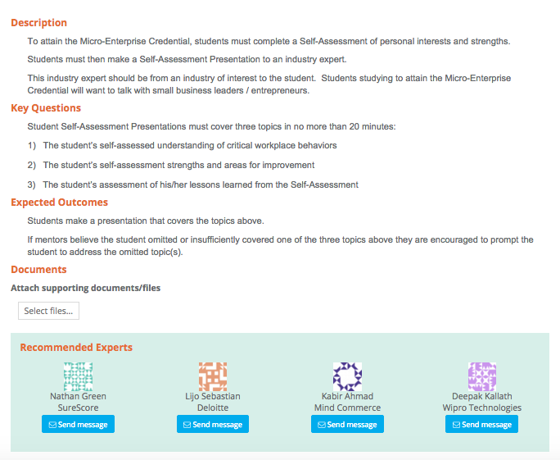

You can simply use this standard request within the Nepris system to recruit a mentor for your students.
Alternatively you can create a specific request for an industry expert from a specific industry your student(s) have requested (see screenshot on next page).
Step 3: Create your own request for industry expert at https://app.nepris.com/#sessions/add (screenshot below). Need help? Check out https://nepris.com/HowItWorks “Submit a Request for Virtual Mentors”
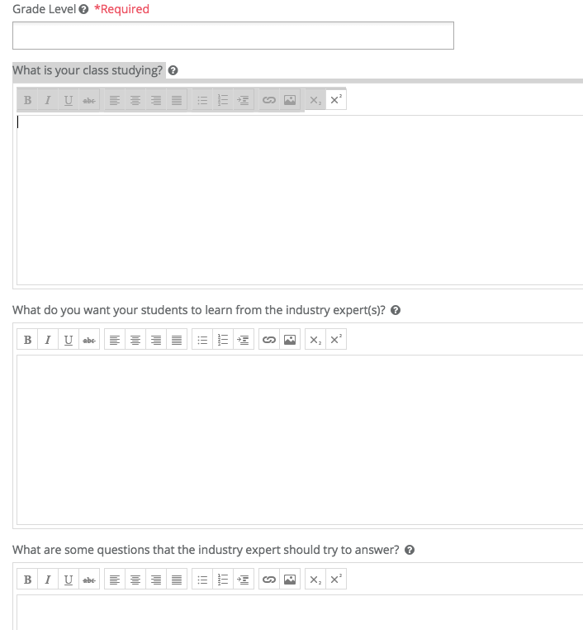

NOTE: Whether you choose to copy the above request for virtual mentors or you choose to create a new request, there are multiple tabs within this process that will allow you to choose the industry, company or career cluster that your students are interested in. The help video mentioned above can walk you through this process step by step.

Step 4: You’re done!

Nepris will match your request to the right industry professional, contact them and prepare them to connect with your student. Nepris will provide all necessary support to make a virtual live connection with your student. You will get email notifications and text reminders that will keep you on track.

Any questions contact: support@nepris.com

