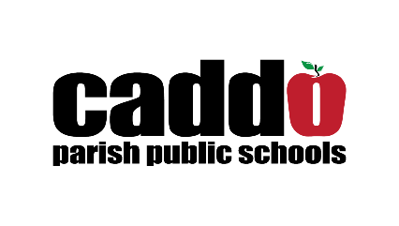

For more information, contact:
Mary Nash-Wood
Director of Communications and Strategic Initiatives
(318) 603-6339
(318) 422-7487
mwood@caddoschools.org

Caddo teacher earns Presidential Award for Excellence
Fairfield Elementary Teacher Stefani Farris will be recognized by President Trump at a later date

Fairfield Elementary teacher Stefani Farris has been recognized on the local and regional stage for her dynamic teaching style and love of science. This week Ms. Farris was also recognized at the national level when she was selected to receive a Presidential Award for Excellence in Mathematics and Science Teaching (PAEMST).
Caddo Schools Superintendent Dr. T. Lamar Goree congratulated Ms. Farris on the honor and celebrated her success.
“We are incredible proud of Ms. Farris and the recognition she has received for her hard work in changing the lives of students and providing them with a truly appreciation for science,” said Dr. Goree. “In recent months, Caddo has been recognized on the national stage for our great teachers and students and Ms. Farris is among the best of the best. We are thankful she has chosen to serve in Caddo and all she does for students.”
The PAEMST program, administered by the National Science Foundation (NSF) on behalf of The White House Office of Science and Technology Policy and recognizes outstanding teachers for their contributions to the teaching and learning of mathematics and science.
As an award winner, Ms. Farris will receive a citation signed by President Trump and a $10,000 award from NSF. She will also travel to Washington, DC, for an awards ceremony at a later date.
Ms. Farris is the first award winner from Caddo Parish since 2008 in the science teaching profession.
To learn more about the PAEMST program, visit www.paemst.org.

