Administrator’s Guide to Implementing a High Quality Online Educational Program
Courtesy of University View Academy
Dr. Michelle Clayton, Superintendent

Introduction:
With the ongoing COVID-19 pandemic and the potential need for online schooling options during the 2020-2021 school year, schools/school systems need access to high quality online educational programming options.

Components of a High Quality Online Educational Program

Learning Management System
- The Learning Management System (LMS) is the software your teachers will use for curriculum, assignments, grading, feedback, communication with students/parents, etc.
- The LMS can also be used for: professional development courses; onboarding and/or orientation courses for teachers and students; etc.
- Examples: Canvas; Moodle; Open edX; etc.
  - Note: The Learning Management System is what will allow schools and school systems to connect their teachers to the teaching and learning process. Teachers will assign and grade student work through this system as well as give feedback to students through this system.

High Quality Online Curriculum
- High quality online curriculum is built upon the same high expectations as a traditional curriculum. High quality online curriculum is rigorous, aligned with state standards, and leads to notable student academic gains.
- Steps for selecting and implementing a high-quality online curriculum:
  - Step 1: Select Tier 1 Curriculum for core four content areas and/or select core curriculum and modify it to align with the Louisiana Standards
  - Step 2: Place curriculum into your learning management system (LMS)
  - Step 3: Enroll teachers and students into the LMS through an upload from your Student Information System (SIS) – Note: A single sign-on platform/tool such as Clever may be helpful in transitioning your data back and forth between systems
  - Step 4: Provide training for teachers so that they can access the curriculum through the LMS
  - Step 5: Have teachers review all curriculum and adjust accordingly to meet the Louisiana standards and the needs of their students
  - Step 6: Set and communicate expectations to teachers regarding weekly workload for students as well as timely feedback on submitted assignments
  - Step 7: Train students and parents so that they can access their courses/curriculum though the LMS
  - Step 8: Set and communicate expectations to students and parents regarding weekly work completion expectations and timely response to teachers
  - Step 9: Provide technical support for teachers, students and staff. Note: Setting up a help desk could be beneficial here.
  - Step 10: Monitor teacher and student performance with respect to the expectations in steps 6 & 8.

Live Session Tool
- Secure web conferencing software that allows teachers to engage students in real-time, live classroom teaching sessions
  - Examples: AdobeConnect; Jigsaw; Zoom(business); Blackboard Collaborate; etc.
- Helpful hints for selecting/purchasing a Live Session Tool:
  - Does the platform allow you to record all sessions and manage them from an administrative level?
    - Note: This will allow you to conduct walkthroughs of every classroom every day should you choose to do so. This will also allow you to review live session footage should a student or student claim that there were inappropriate actions at any point in time.
  - Does the platform allow teachers the flexibility to set up their live sessions in a manner that makes sense for their classrooms?
    - Ex: Can the teacher separate the students into smaller groups and monitor all groups during the live instructional session?
    - Ex: Can the teacher post various “pods” that display the daily objectives, teacher web cam, PowerPoint, student chat pod, etc., simultaneously?
    - Ex: Can the teacher turn off the chat pod and/or remove a student from the chat pod if inappropriate things are being typed by students?
    - Ex: Can the teacher give and take away student microphone rights to encourage student participation while not having students be able to interrupt the class at will?
    - Ex: Can the live session tool be integrated into the learning management system so that students do not have to go outside of the system to access the live session tool?

Professional Development
- Consistent and comprehensive professional development should be offered to teachers throughout the summer and school year.
- Professional development should occur both synchronously and asynchronously for teachers.
  - Note: It might be beneficial to pair up experienced, online, mentor teachers assigned by grade level/subject area to brick and mortar teachers for support throughout the initial stages of implementation.

Devices & Internet Access for Students/Teachers
- Schools and school systems should survey teachers and students to evaluate the need for devices and internet access.
- Plans should be designed and implemented to get devices and access to appropriate staff and students.

Sample Implementation Timeline

Phase I – Technology Preparation Period

Component | Activities
Learning Management System | School/school system purchases LMS
High Quality Online Curriculum | School/school system purchases Tier 1 curriculum and/or other curriculum
Live Session tool | School/school system purchases live session tool
Single Sign-On Tool | School/school system purchases Clever or other single
Professional Development | School/school system notifies UVA (or other Louisiana online school) of the number of teachers by grade level and/or subject areas that will need Online Mentor
Teachers Devices & Internet Access for Students/Teachers | School/school system purchases devices and internet access for appropriate students and teachers

Phase II – Teacher Preparation Period

Component | Activities
Learning Management System | Student Demographic and Scheduling Data is “dumped” from Student Information System (SIS) into LMS
High Quality Online Curriculum | Teacher/Student logins are created.  Note: The following UVA courses/curriculum have already been adjusted to meet the Louisiana standards and can be copied and “dumped” into the school/school system’s LMS: ELA Guidebooks (Gr. 3-8); CKLA/Wit & Wisdom (Gr. K-2); ZEARN (Gr. K-5) Illustrative Math (Gr. 6-8); Florida Virtual (K-12)
Live Session tool | Teacher logins are created and teaching schedules are issued
Professional Development | School/school system teachers attend professional development sessions related to: LMS; Curriculum; Live Session Tool; and general online teaching best practices
Devices & Internet Access for Students/Teachers | School/school system sets up a technology help desk to assist students and teachers with technology-related issues.

Phase III – Student/Family Preparation Period

Component | Activities
Learning Management System | Students/Families receive login information and training on LMS
High Quality Online Curriculum | Students/Families receive information regarding assignments, grading, and general course expectations
Live Session tool | Students/Families receive information regarding Live Session schedules for students and login instructions
Professional Development | Students/Families are enrolled in an orientation course where they receive additional information regarding the school/school system’s online educational program
Devices & Internet Access for Students/Teachers | Students/Families are given the phone number and/or email address for tech support.

Phase IV – Initial Implementation Period

Component | Activities
Learning Management System | Students and teachers begin to login and assign/submit assignments, grade assignments, provide feedback on assignments, and communicate with each other. Teachers begin to log calls/emails/texts, etc.
High Quality Online Curriculum | Teachers and students begin to access curriculum through the LMS
Live Session tool | Teachers and students begin to engage in live instruction according to the prescribed schedule
Professional Development | Teachers continue to receive professional development from their school/school system, vendors, and/or mentor teachers. Administrators also receive professional development from vendors and/or mentor administrators regarding classroom walk-throughs, data analysis, teacher support, etc.
Devices & Internet Access for Students/Teachers | The school/school system continues to make the help desk available for their teachers and students

Phase V – Sustained Support Period

Component | Activities
Learning Management System | Students and teachers continue to login daily to submit assignments, grade assignments, provide feedback on assignments, communicate with each other, log calls/emails/texts, etc.
High Quality Online Curriculum | Teachers and students continue to access curriculum through the LMS; Teachers make adjustments as needed for their students
Live Session tool | Teachers and students continue to engage in live instruction according to the prescribed schedule
Professional Development | Teachers and administrators continue to receive professional development as needed.
Devices & Internet Access for Students/Teachers | The school/school system continues to make the help desk available for their teachers and students.

Information & Tools for Online School Administrators

It is difficult for many people to understand the role of the school principal in an online learning environment. The truth is, there are more similarities than differences when comparing the skill set and tasks required for running an online school as opposed to a brick and mortar school. The skills needed for both jobs are as follows:
- Leadership Skills
- Management skills
- Communication skills
- Decision-making skills
- Interpersonal skills
- Problem-solving skills
The principal is expected to be an instructional leader in both the online school and the brick and mortar school. The key differences in duties and responsibilities between online and brick and mortar principals can often be highlighted in “how” each skill set is used to address the teaching and learning in the school. For example, managing brick and mortar schools often involves creating building maintenance schedules and duty schedules for teachers, while managing an online school requires building live session schedules and coordinating communication logs between teachers and students.

Among other things, the following questions should be considered by brick and mortar principals when transitioning to an online learning environment:

School Organization
- Will teachers continue to report to the same individuals that they reported to under the brick and mortar structure?
- How will teacher evaluations be conducted and/or divided up among the administrative staff?
- Will policies have to be tweaked regarding attendance, truancy, academic honor code, etc.?
- How will the SBLC process be handled?
- How will technology issues be handled for both teachers and students?

Live Instruction by Teachers
- Who will we create the live session schedule for teachers and students?
- How will we ensure that no student has two live sessions occurring at the same time each day?
- What will be the frequency of live sessions for each core course and/or each elective course?
- What do we want the live sessions to focus on with respect to content?
- Do we want all live sessions to have a similar format (ex: length of session; setup of virtual classroom; exit tickets; student discussion opportunities; etc.)?

Curriculum
- How will curriculum be selected, modified, and/or implemented?
- How will pacing guides be established and implemented?
- How will the curriculum be monitored?
- How will courses that are difficult to implement in an online setting (ex: PE; band, art, CTE, etc.) be set up?

Assessment
- How will formative and summative assessment be conducted?
- How will you know that students have mastered material?
- How will you ensure that students are doing their own work?
- Will teachers create common assessments and/or “check points” for each course?

Teacher Evaluation
- Will we conduct daily walkthroughs of all or a sample of recorded live sessions by teachers?
- How will we monitor teacher performance and/or what do we expect of our teachers (ex: frequency of communication with students; failure rates; promptness in grading online submission of student work; frequency and/or performance in live sessions; amount of online curriculum made available to students; etc.)

Student Support
- Who will students contact when they have issues?
  - See “Advisory Teacher” information in the “Helpful Hints” section below.

Student and Teacher Attendance
- How will we track teacher and/or student attendance?
  - See “Sample Student Attendance Policy” in the “Student Engagement and Attendance” section below.
- Will teachers be required to come to the building each day or will they work from home at certain times?

School Meetings
- Will staff and/or leadership meetings be conducted face-to-face or online?
- How will student and/or teacher orientations be handled?

Communication
- How (format, frequency, etc.) will the administrative team communicate with teachers, students, and/or families?
- What are the communication requirements for teachers and/or students (both frequency and promptness)?

Professional Development
- How will professional development and/or PLC’s be implemented?

Beyond the Core Four
- How will students be given opportunities to participate in any activities beyond the core instructional program (ex: clubs; counseling; acceleration; tutoring/intervention)?
  - Note: See samples from UVA in the “Beyond the Core Four” section below.
- How will gifted, SPED, ELL, 504 students be accommodated in the online model?
  - Note: See samples from UVA in the “Beyond the Core Four” section below.

Helpful Hints for Online School Administrators

Advisory Teachers
In brick and mortar schools, students often have a “homeroom” teacher that they check in with each day. While communication may not be quite that frequent in an online learning environment, advisory teachers should be assigned a group of 15-25 students that they touch base with a few times per month to see how things are going. All conversations should be logged in the LMS where school administrators can monitor all attempted student contacts by teachers. As a side note, all failing students should be contacted weekly by the core teachers and small group/one-on-one live sessions offered to these students.
Advisory teachers can assist with:
- Motivating Students
- Progress Monitoring
- Supporting Students Academically and Otherwise
- Assisting with filling out school forms such as IGP, FASFA, etc.
- Mentoring Students

Student and Teacher Communication
- This is an area that should be well thought-out by both the school/school system and the school administrator(s)
- ALL communication between teachers and students as well as teachers and parents should be logged in the communication or LMS system
- If you use a system like Remind, you should be able to record teacher and student communication there, however, teachers will be making lots of phone calls in an online school and you need to make sure that they log that information in your LMS system.
- Just as issues sometimes arise regarding interactions between students and teachers in brick and mortar schools, this can also be true in the online environment.
- You need to decide if you want to allow students to contact each other through your LMS, email, and/or other communications systems.
- Students tend to be more isolated in an online environment, however, you will need to make sure that all communication is monitored between students if you allow student to student interaction through your system. UVA uses a system called Gaggle to monitor student to student emails, and we are notified in real time if there is “problematic” conversation (ex: suicide; bullying; curse words; etc.)
- You need to decide your expectations regarding the frequency and/or parameters for teacher and student communication
  - Ex: How often do you expect teachers to reach out to students?
  - Ex: How quickly do you expect students/teachers to respond to one another?
  - Ex: Are there certain times of the day where it is unacceptable for either teachers or students to initiate phone calls, emails, and/or text messages?
  - Ex: Is there certain information that should be reported to school administrators, such as students indicating that they are depressed, ill, having internet issues, etc.?

Sample Live Session & PLC Schedule
Students can easily get overwhelmed with a live session schedule that requires them to attend every single class every day. A sample daily live session for the 6th grade team at University View Academy has been posted below. The schedule includes two live sessions per week per core content area with opportunities for students to attend one-on-one, small group, and/or intervention/tutoring as needed throughout the week. This schedule also outlines the PLC schedule for teachers that occurs each Friday while students catch up on work for the week.

SAMPLE 6TH GRADE DAILY SCHEDULE
Monday | Tuesday | Wednesday | Thursday | Friday
08:00
One-on-One Sessions | One-on-One Sessions | One-on-One Sessions | One-on-One Sessions | Student Work Day & PLCs
08:30
Intervention/  Tutoring Intervention | Intervention/  Tutoring Intervention | Intervention/  Tutoring Intervention | Intervention/  Tutoring Intervention | Student Work Day & PLCs
09:00 AM
LIVE SESSION: 6th Gr - Math | LIVE SESSION: 6th Gr - ELA | LIVE SESSION: 6th Gr - Math | LIVE SESSION: 6th Gr - ELA | Student Work Day & PLCs
10:00 AM
LIVE SESSION: 6th Gr - Science | LIVE SESSION: 6th Gr - SS | LIVE SESSION: 6th Gr - Science | LIVE SESSION: 6th Gr - SS | Student Work Day & PLCs
11:00 AM
OFFICE HOURS: 6th Grade Teachers | OFFICE HOURS: 6th Grade Teachers | OFFICE HOURS: 6th Grade Teachers | OFFICE HOURS: 6th Grade Teachers | Student Work Day & PLCs
12:00 PM
LUNCH | LUNCH | LUNCH | LUNCH | LUNCH
01:00 PM
SMALL GROUP: 6th Gr - Math | SMALL GROUP: 6th Gr - ELA | SMALL GROUP: 6th Gr - Math | SMALL GROUP: 6th Gr - ELA | Student Work Day & PLCs
02:00 PM
SMALL GROUP: 6th Gr - Science | SMALL GROUP: 6th Gr - Social St. | SMALL GROUP: 6th Gr - Science | SMALL GROUP: 6th Gr - Social St. | Student Work Day & PLCs
03:00 PM
LIVE SESSION Keyboarding | LIVE SESSION Band | LIVE SESSION Art | LIVE SESSION PE | Student Work Day & PLCs

Sample Walkthrough Form
One of the advantages of the online learning environment is that school administrators can view every lesson every day because they are all recorded by the teachers. Just as walkthroughs can be conducted for a variety of reasons in the brick and mortar schools, they can also be conducted for various purposes in online schools. A sample ELA walkthrough form for University View Academy has been posted below. School administrators complete the form while viewing the live sessions or recorded sessions for teachers.

Sample Walkthrough Form
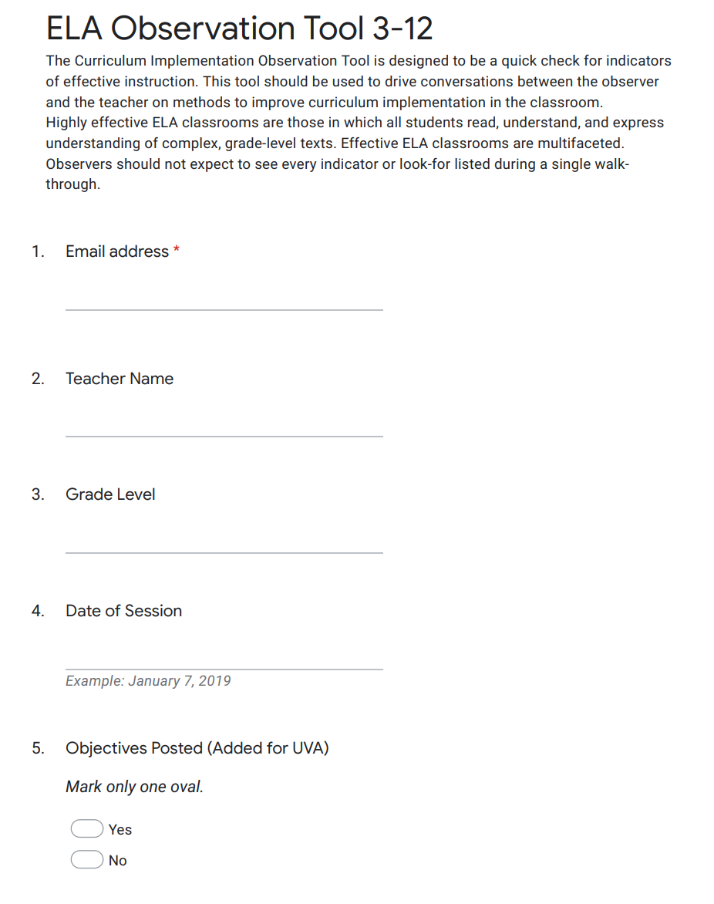 | 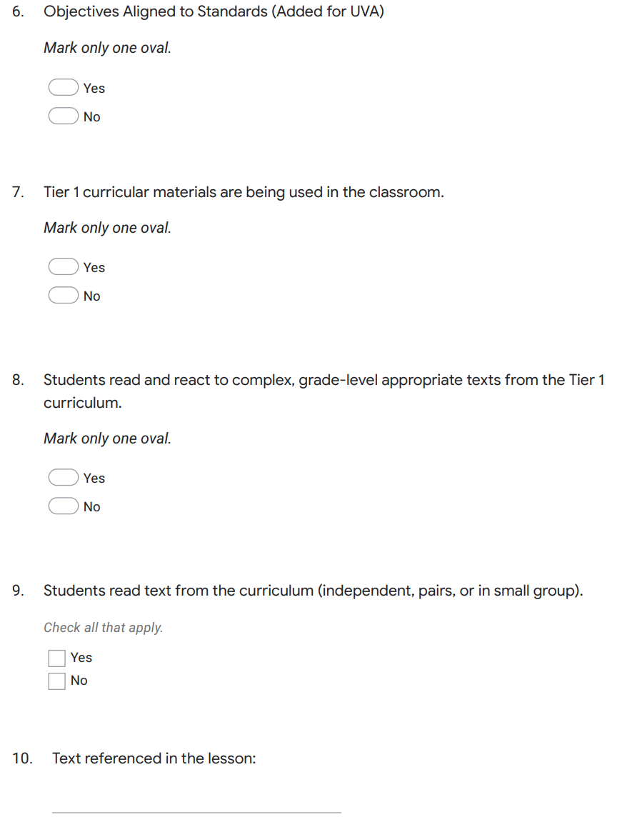
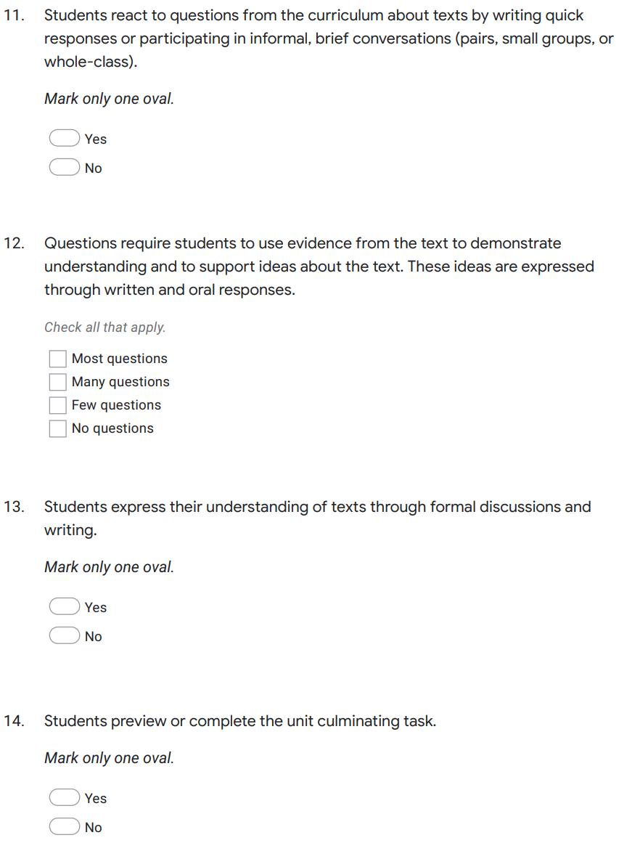 | 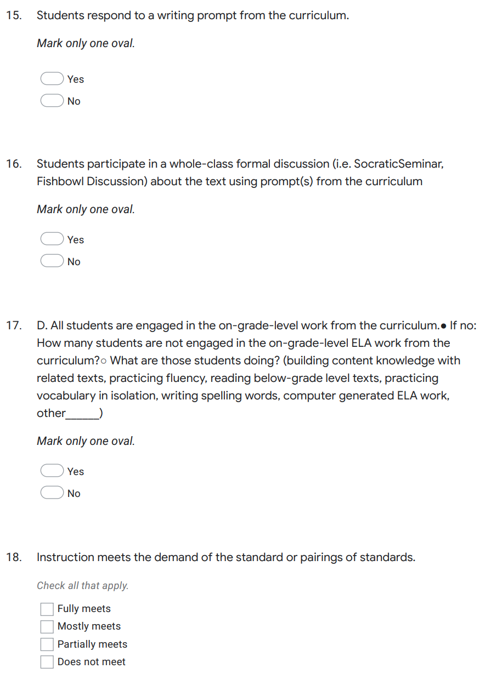
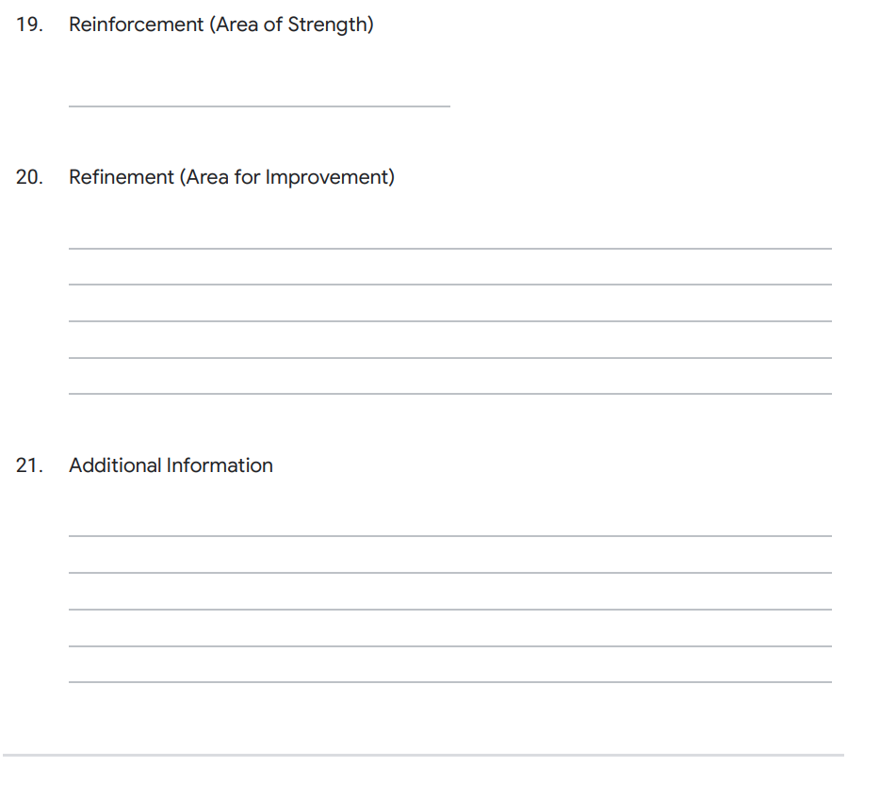

Beyond the Core Four

Students need opportunities for social engagement, acceleration, and fun rewards in online schools, just as they do in the brick and mortar schools. A few samples have been posted below of opportunities for students at UVA to participate beyond the traditional curriculum.

Sample Online SPED Service Delivery Model
Students with Disabilities:
Eligible students receive specialized instruction as indicated in their Individualized Education Plan, via Virtual Live Sessions of group or individual specialized instruction in ELA and or Math to address student needs in order to participate in, or work toward, regular instruction in their appropriate grade level.
All students with disabilities at UVA, also participate in diagnostic placement and further prescribed instruction in ELA and Math through the i-Ready online program (Curriculum Associates). Data is used to design and support IEP goals and objectives and progress monitoring and reporting , but most beneficial in providing an online platform for teachers to assign skills to support regular education instruction at appropriate grade levels.
Special Education teachers collaborate with regular classroom teachers in PLCs to align specialized instruction with classroom expectations considering accommodations and modifications allowed for students as documented on the IEP. Special Education teachers also join in regular classroom Live Sessions to assist the regular instruction teacher when appropriate.
Special Education teachers work closely with the students’ Learning Coaches (LC). This is a critical piece for this delivery model of specialized instruction for students with disabilities at UVA. Many LCs attend Live Sessions to later assist students in more fully understanding content and reviewing the recorded Live Sessions to reteach content to students. Communication with the LC is accomplished by regular phone calls, emails, and text messaging.
Daily “Office Hours” are also offered to provide regular availability of Special Education teachers. Students and Learning Coaches use this time to ask questions about assignments or set up an individual session, if needed.
Related Services are delivered via Zoom or AdobeConnect sessions scheduled individually in the areas of Speech/Language, Occupational Therapy, and Physical Therapy. Many of our students also attend “private clinics” in addition to our services.
Gifted and Talented Students:
Gifted and Talented students at University View Academy have many options at all levels, including Gifted Academic courses and Enrichment Courses, as well Social/Emotional Support. Academically Gifted students may work at advanced grade levels as determined by the IEP team. Many Gifted students at UVA also take advantage of our Advanced Placement and Dual Enrollment courses.
All areas of Talented are taught by “artists” in their respective discipline. Talented Art students receive art supplies, for home use, as selected by our Talented Art teachers in order for these students to produce quality work, as directed by our teachers. Student work is posted on our website and “Artsonia.”

Sample Online Club List for Students
When students enter a 100% online school setting, it is important to give them opportunities for socialization that go beyond the academics and live sessions. Just as in brick and mortar schools, it is important that these online social interactions and opportunities are supervised by school staff to ensure appropriate interactions between students. Below, you will find a sample list of some of the clubs that are available to students at University View Academy:

University View Club List
Strategy Game Club (K-8):
If you like to play strategy games, either online or the board game variety, this club might just be for you! What do we do in Strategy Game Club? We play and talk about our favorite strategy games, whether they be online mainstays such as Sid Meier’s Civilization and Medieval Total War; or board game all-time greats such as Risk, Axis and Allies, and Settlers of Catan. And we won’t stop there. In Strategy Game Club we’ll be sure to leave room to discuss RPGs (Role Playing Games) and MMOs (Massive Multiplayer Online) as well. Each club session will feature a spotlight game of the month, which we will either discuss or play together. As an added feature, our club page will make available several different discussion threads that, among other things, invite members to debate and discuss such topics as personal greatest strategy game moments, strategy game review, survey of greatest strategy games ever, current strategy games we’re playing, everything RPG, and strategy game pro-tips! All applicants for club membership welcome! Check the box below to sign up for Strategy Game Club.
Photography Club (K-8):
Student photographers of all levels and skills will use their talents to capture images showcasing their areas of interest. Each month, the photography club will have activities that focus on a different theme. Students are encouraged to explore, inspire, and experiment with digital photo technologies, emphasizing imagination and creativity. Various topics will be covered in the club, including demonstrations on how to use cameras, guest artist visits, working with Photoshop, as well as photography projects for our school and community. This club is for students from Kindergarten through 8th grade who have a passion and/or curiosity for photography. Check the box below to sign up for the Photography Club.
Chess Club (3-8):
Chess Club is designed to give students an opportunity to learn the game of chess. Students will discuss the origins of the game, while improving their chess skills and enjoying competition with their peers. Beginning players will learn the basic rules, the value of pieces, and the art of checkmate. The more experienced players will learn different opening and defense strategies, as well as various tactics, including the challenge of solving chess puzzles. While students will have the chance to measure their progress through wins and losses against their peers, our main focus will be on encouraging good sportsmanship and connecting with other students that share a love for this game. Check the box below to sign up for Chess Club. Club will begin in March 2018.
Art Club (K-8):
The purpose of Art Club is to have fun exploring art from around the world or even our own Louisiana "backyard", and for students to explore different art mediums through a monthly creative project. Each month in U-View Art Club a new artist will be featured. Students will explore the featured artist's work, as well as the processes and materials the artist has used for their art. Some months we might discover a local artist, and othermonths we will explore an artist that is well known nationally or internationally. Students in the Art Club will have an opportunity to try a monthly art project that they can work on at home and share with club members through photographs during our art club meetings. Check the box below to sign up for U-View Art Club.
Lower Elementary Book Club (K-2):
Teachers and students will read and discuss books each month related to Math and Science. Teachers may read books in live sessions (recordings), utilize youtube.com, MP4 files, and ebook pages of public libraries for book access. We will utilize guided discussion questions based on Louisiana State Grade Level standards K-2. We will send notification of live session time to discuss books. Discussions will be approximately 30 minutes once a month. Students will be notified a week in advance for club meetings/discussions in live sessions. We will send prizes and certificates for attendance. Check the box below to sign up for Lower Elementary Book Club.
Upper Elementary Book Club (3-5)
Join the adventure! A book club is one of the best ways to combine learning and fun. Each month we will take 1 volunteer to choose the book and lead the discussion. You can get the book from your local library, a bookstore, or purchase or borrow it online. We will meet in a Live Session room once a month to discuss the book of the month. If you would like to sign up to lead, you will present your book choice and discussion questions to your Club Sponsors by the end of the month. In the book club, you will discover the magic that comes with going on adventures together as we read the same books. Check the box below to sign up for the Upper Elementary Book Club.
Middle School Book Club (6-8):
In this club, students will have the opportunity to read and discuss a variety of books. Our goal is to promote a love for literature and a positive attitude towards reading, encourage extensive and intensive reading, foster student interaction, cooperation, and collaboration, and expose students to a diverse range of literature.
Youth Legislature (6-8):
Youth Legislature is a middle school program (Grades 6, 7, 8) that introduces students to the legislative process of the Louisiana state government. Students who participate in Youth Legislature receive teacher instruction and participate in a two-day mock legislative session at the Old State Capitol in Baton Rouge. Students from UVA and other schools from across the state elect Governor and House and Senate officers. They also sponsor, debate, and decide on passing and failing bills, which they have drafted. They lead and serve on legislative committees and speak publicly before an audience of students, parents, and teachers. Additionally, students can also participate in the mock session as a press delegate or photojournalist. Join Mr. Robert Handley and Mr. Simon Bowers in collaborating with your teachers and classmates as a team to become leaders in the Youth Legislature, your classes and communities, and maybe even the actual Louisiana government some day!
Students can join both of these clubs and one of the above clubs:
UView Running Club: (K-8):
Have you ever wanted to start running, but weren't sure where to begin? Would you love to be able to participate in local 5k races? Want to build your endurance, gain fitness, stay motivated, boost your energy, happiness, weight-loss, self-confidence, learn tips for success, get support and encouragement....and go from the sofa to 3.1 miles?! You can also use this for your required P.E. activity. This is a great program for the whole family! What are you waiting for? Get up and off the sofa today! Check the box below to sign up for the UView Runners Club.
University View Culinary Club Sessions (K-12):
Are you interested in healthy eating and cooking? Join us for four sessions of culinary yumminess with Mrs. Nita Martin of Small Fry's Cooking. Learn about healthy eating as she leads us in preparing delicious and healthy meals for any time of day. We will have one session per month with our first session being held on Friday, February 23rd at 5pm. The entire family is invited to participate. Gather around the screen and get ready for a fantastic cooking experience. Further details will be posted in your Advisory Course Card.
University View Coding Club (6-12):
Students explore various tools and websites that help students build computer programming skills in a language of their choosing. As we learn coding, we also look at applications of these programming skills and eventually get to remotely program small-scale robots! Languages that are recommended are: Javascript, Python, and HTML.
National Junior Honor Society (7-9):
The National Junior Honor Society creates enthusiasm for scholarship, stimulates a desire to render service, promotes leadership, develops character, and encourages citizenship in the students of University View Academy. Membership in this organization is an honor bestowed upon deserving students by the faculty and is based on the criteria of scholarship, service, leadership, character, and citizenship. Candidates eligible for selection to this chapter must be a 7th, 8th , or 9th grade student at UVA. To be eligible for selection to membership in this chapter, the candidate must have been enrolled the previous two semesters at UVA. Candidates eligible for election to the chapter shall have a minimum cumulative grade point average of 3.50 on a 4.0 scale for the previous two semesters at UVA and maintain a 3.5 GPA once he/she is a member. Upon meeting the grade level, enrollment, and GPA standards, candidates shall then be considered based on their service, leadership, character, and citizenship.

Sample Online Early College and Dual Enrollment Program Guidelines
Early college and/or dual enrollment initiatives can be implemented in an online schooling environment in a manner that is similar to implementation in a brick and mortar school. Schools/school systems can hire their own staff to serve as adjunct professors for the college/university or enroll students in online courses offered by the college/university. Sample guidelines for the UVA Early College Academy have been posted below:
Students enrolling in the Early College can graduate with an Associates of Arts in Humanities or an Associates of Science in Biological Sciences. All courses articulate to Louisiana public colleges and reduce the student’s time pursuing a Bachelor’s Degree. Once enrolled in the program, the college and career counselor will work with individual students to select the most appropriate degree that fits with the student’s intended bachelor program of study. For information on articulated credits between colleges, please visit the Louisiana Board of Regents website by clicking here.
Students enrolled in this program will typically pursue the TOPS University High School Diploma. The purpose of University View Early College is to promote individual student choice, success, and academic rigor.
A typical schedule allows for students to enroll in dual enrollment courses in the following year:
- 9th- 3 hours of college credit
- 10th- 3 to 9 hours of college credit
- 11th- 18- 24 hours of college credit
- 12th- 15-21 hours of college credit
All students graduate with a minimum of 24 Carnegie Units and 60 college credit hours. Within each year, Early College students are eligible to pursue the Community Service Diploma Endorsement. Students wishing to graduate with the Community Service Diploma Endorsement will have volunteer opportunities built into their high school course schedule to meet the requirements for the endorsement.
A key requirement for enrolling in the Early College is appropriate placement scores in English and math. Students are required to take the ACT and/or the Accuplacer prior to the student’s junior year. University View Academy will work with students to coordinate the testing sessions and provide a minimum of two testing sessions per student.
Students wishing to enroll in Early College must complete the student/parent/school compact each year which outlines annual expectations for the program and publishes important college deadlines. Failure to submit the compact annually jeopardizes the student’s participation in the program.

Sample Online PBIS Program Guidelines
In both brick and mortar and online schools, we need to find ways to motivate and reward students for doing the right things. A sample has been posted below of the UVA PBIS program that will be rolled out to students during the 2020-2021 school year:
Students will be given the opportunity to earn PBIS points and awards by meeting the criteria outlined below:
- Passing all core courses: students who have an A, B, C, or D in all of their core courses will meet this criterion.
- On-time lesson completion: students who have an on-time percentage of 90% or higher, or have increased their on-time percentage from the week prior will meet this criterion.
- Live Session attendance: at the end of each week, teachers of the courses the student is enrolled in will provide an attendance log for the week. Any student who is actively participating in at least 75% of the live sessions provided by their teacher will meet this criterion. Contact your teacher for the specific criteria of how you can meet this indicator should you need to miss a live session and watch the recording.
Students must meet two of the three criteria outlined in order to qualify for PBIS points or awards. The awards will be mailed to students the week immediately following the week in which the points/awards have been earned.
Note: Online Amazon gift cards (or other online options) could be emailed to students as part of the rewards system, however, the school/school system would need to secure appropriate approval if federal funds would be used to implement this rewards system.

Student Engagement & Attendance

Student engagement and attendance are two of the most challenging issues for online schools. A sample attendance policy and student engagement rubric have been posted below.

Sample Online Attendance Policy
Attendance and truancy are tracked, recorded and reported according to the following guidelines:
- Parents/Learning Coaches notify school personnel of their child’s absences and submit appropriate documentation regarding the absence(s). Absences are recorded by school personnel into the Student Information System and reported to the Louisiana Department of Education.
- Attendance is also determined by verifying student login information into the learning management system. Due to the flexibility afforded by the online school structure, students have the entire week (Monday through Sunday) to login and work in the learning management system (LMS).
  - Students failing to log into the LMS for an entire week will be marked absent at the end of the week. Parents/guardians will be contacted by phone, email and US mail by engagement personnel to advise them of the excessive absences.
  - Students failing to log into the LMS for two straight weeks who are non-responsive to school contact attempts, will be considered truant and will be marked absent for two weeks in the student information system. The school may contact local authorities, such as FINS, etc. and attempt to contact the parent/guardian via phone, email and US mail to advise them of their truant status.
  - Students failing to log into the LMS system for three straight weeks who are non-responsive to school contact attempts, will be considered habitually truant and will be marked absent for three weeks in the student information system. The school will send out a local sheriff’s officer to make a home visit to determine the status of the student and to inform them of their habitually truant status.
  - Students failing to log into the LMS for four straight weeks who are non-responsive to school contact attempts, will be considered a non- attending student and will be marked absent for four weeks in the student information system. The school will send out notification of the parent/guardian’s mandatory attendance at a school withdrawal hearing. Failure of the parent/guardian to attend the hearing will result in the withdrawal of the student from the online schooling option.

Sample Online Student Engagement Rubric

Category | 4  Excellent | 3  Satisfactory | 2  Below-Avg | 1  Unsatisfactory
Consistent Activity in LMS | Completes a  lesson/activity 5 times per week | Completes a lesson/activity 3 - 4 times per week | Completes a  lesson/activity  1-2 times per  week | Completes zero lessons per week
Time Spent in LMS | Core Courses  – 100 minutes  or more per course per week | Core Courses –  60-99 minutes per course per week | Core  Courses –  30-59  minutes per course per week | Core Courses – less  than 30 minutes per course per week
Regular  Communication | Answers all  phone calls and/or  responds to messages on  the same day | Answers  most phone  calls and/or responds to  Messages within  1-2 days | Answers  some phone  calls and/or responds to  Messages within  3-5 days | Seldom or never answers phone calls and/or  Does not respond to messages
Live Session  Participation | Attends or watches recordings of all  Live Sessions | Attends or watches recordings of most  Live Sessions | Attends or watches recordings of half of the  Live Sessions | Attends or watches recordings of less than half of the  Live Sessions.

0-4 = UNSATISFACTORY
5-8 = BELOW AVERAGE
9-12 = SATISFACTORY
13-16 = EXCELLENT

*Note: Students with an A, B, or C letter grade in a course will be considered “Satisfactory” or “Excellent” even if engagement scores would place them in a lower bracket.

